LABORATORY07: Report and Presentation of work on Beamer and Posters
PELE TETE
December 2025

700IntroductionBeamer - Basic Beamer Presentation
\documentclass{beamer}
\usetheme{Copenhagen}
\title{Présentation Beamer}
\author{PELE TETE}
\date{01 01 2025}
\begin{document}
\begin{frame}
\titlepage
\end{frame}
\begin{frame}
\frametitle{Introduction}
\begin{itemize}
\item COMMENT UTILISER BEAMER
\item COMMENT JE PEUX REUSSIR LES LABO DE KOULYABOV
\item COMMENT DOIS-JE REDIGER LES LABO DE KOULYABOV
\end{itemize}
\end{frame}
\begin{frame}
\frametitle{Méthodologie}
\begin{block}{Étapes de la méthode}
1. Préparation des labo\\
2. Analyse et lecture du livre\\
3. Compillation des codes-exemples et autres codes
\end{block}
\end{frame}
\begin{frame}
\frametitle{Résultats}
\begin{columns}
\begin{column}{0.5\textwidth}
\begin{itemize}
\item Résultat des labo
\item Résultat des retenus de la lecture
\item Résultat des compillations des codes
\end{itemize}
\end{column}
\begin{column}{0.5\textwidth}
\includegraphics[width=\textwidth]{faucon.jpg}
\end{column}
\end{columns}
\end{frame}
\begin{frame}
\frametitle{Conclusion}
\begin{alertblock}{Points clés}
\begin{itemize}
\item Conclusion principale
\item Implications pratiques
\item Directions futures
\end{itemize}
\end{alertblock}
\end{frame}
\end{document}

Generated figure (simulation)
Beamer presentation with title page, introduction, methodology, results, and conclusion slides.

Imported image
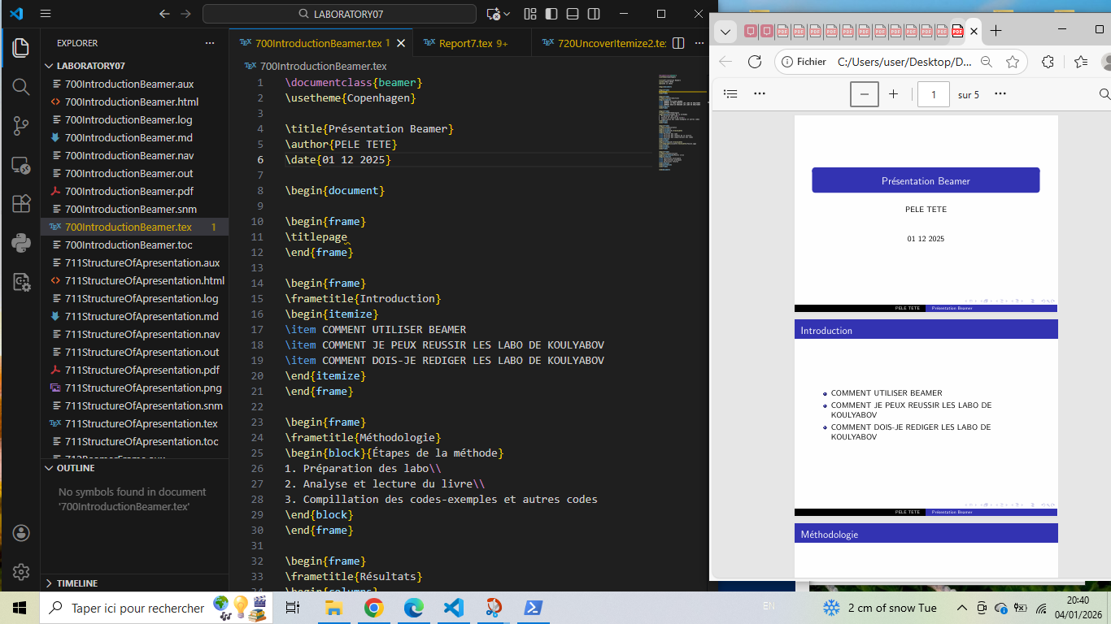

711StructureOfApresentation - Basic Beamer Structure
\documentclass{beamer}% use of beamer
\usetheme{Copenhagen}
\author{Bert}
\title{A tale of two primes}
\begin{document}
All is good
\end{document}

Generated figure (simulation)
Minimal Beamer document structure.

Screenshot
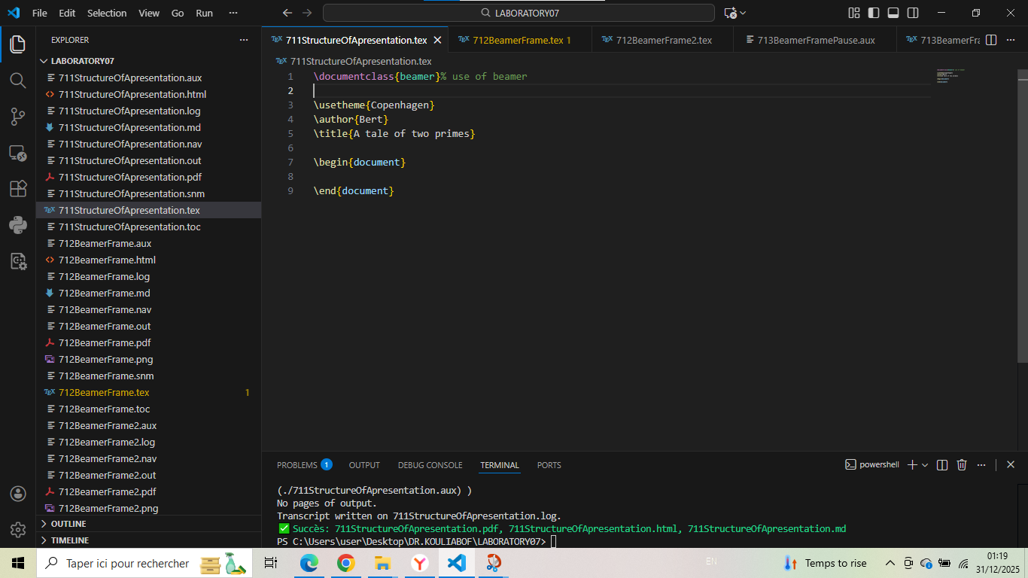

712BeamerFrame - Basic Frame Usage
\documentclass{beamer}
\begin{document}
\usetheme{Copenhagen}
\author{Bert}
\title{A tale of two primes}
\begin{frame}% use of frame (in beginner)
\titlepage
\end{frame}% use of frame (at the end)
\begin{frame}{Article}% use of frame (in beginner)
Some text about the article.
\end{frame}% use of frame (at the end)
\begin{frame}{Mathematica}%use of frame (in beginner)
A helpful tool for mathematicians.
\end{frame}% use of frame (at the end)
\end{document}

Generated figure
Beamer presentation with title page and two content frames.

Screenshot
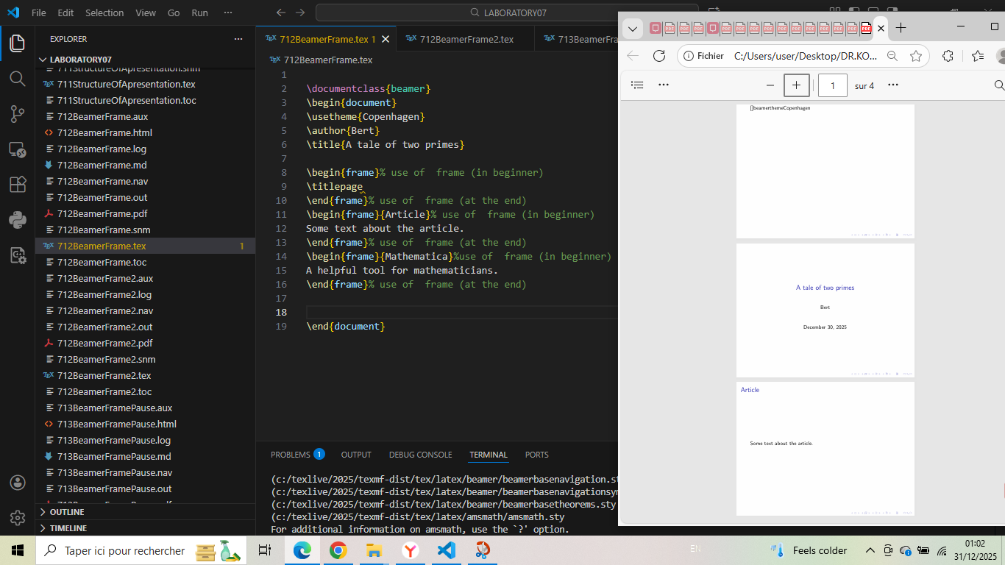

712BeamerFrame2 - Blocks in Frames
\documentclass{beamer}
\begin{document}
\usetheme{Copenhagen}
\author{Bert}
\title{A tale of two primes}
\begin{frame}{Article}
\begin{block}{Example}
This is an example of a block.
\end{block}
\begin{block}{Euclid's theorem}
This is a theorem.
\end{block}
\end{frame}
\end{document}

Generated figure
Frame with example and theorem blocks.

Screenshot
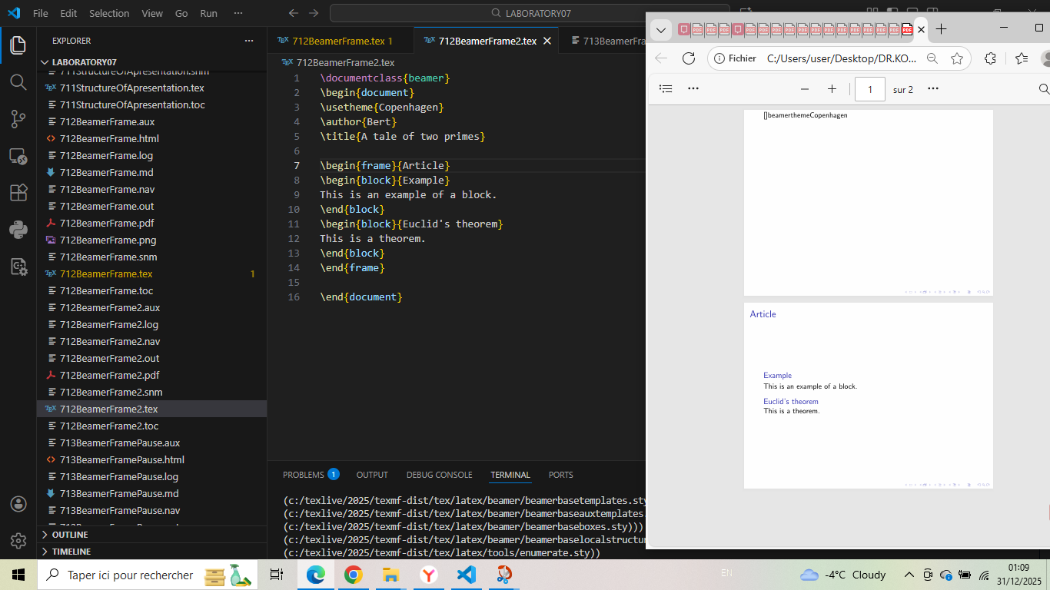

713BeamerFramePause - Pausing Between Blocks
\documentclass{beamer}
\begin{document}
\usetheme{Copenhagen}
\author{Bert}
\title{A tale of two primes}
\begin{frame}{Article}
\begin{block}{Definition}
This is a definition.
\end{block}
\pause% use of pause to get one by one the slide
\begin{block}{Euclid's theorem}
This is a theorem.
\end{block}
\end{frame}
\end{document}

Generated figure
Frame with pause between blocks.

Screenshot
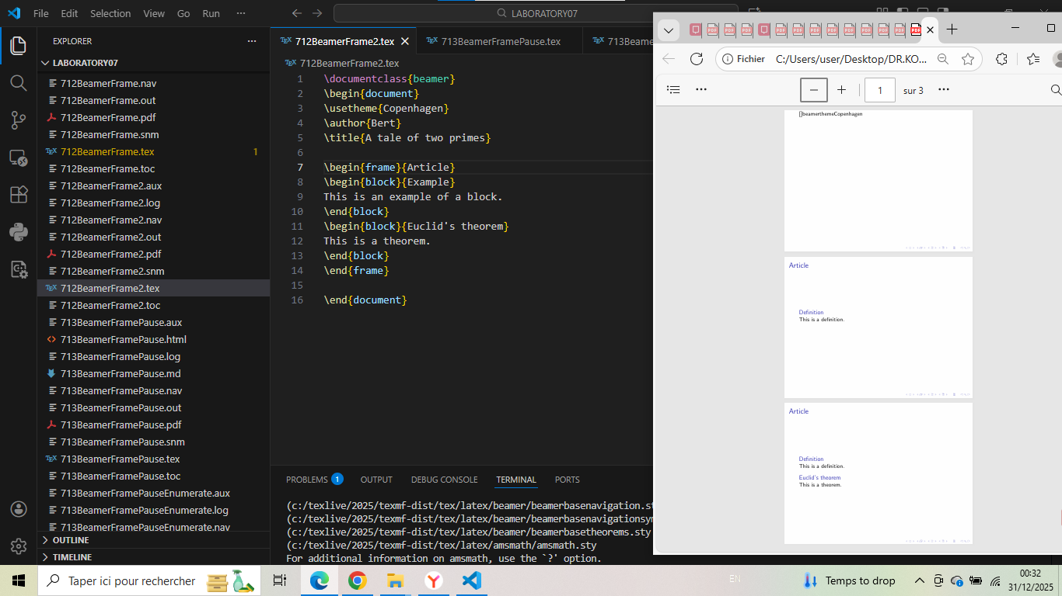

713BeamerFramePauseEnumerate - Pause with Enumerate
\documentclass{beamer}
\begin{document}
\usetheme{Copenhagen}
\author{Bert}
\title{A tale of two primes}
\begin{frame}{Title}
\begin{enumerate} %use of pause and enumerate in order to enumerate
\item Element
\pause%use of the pause for the slide
\item Element
\pause%use of the pause for the slide
\item Element
\end{enumerate}%use of pause and enumerate in order to enumerate
\end{frame}
\end{document}

Generated figure
Enumerated list with pauses.

Screenshot
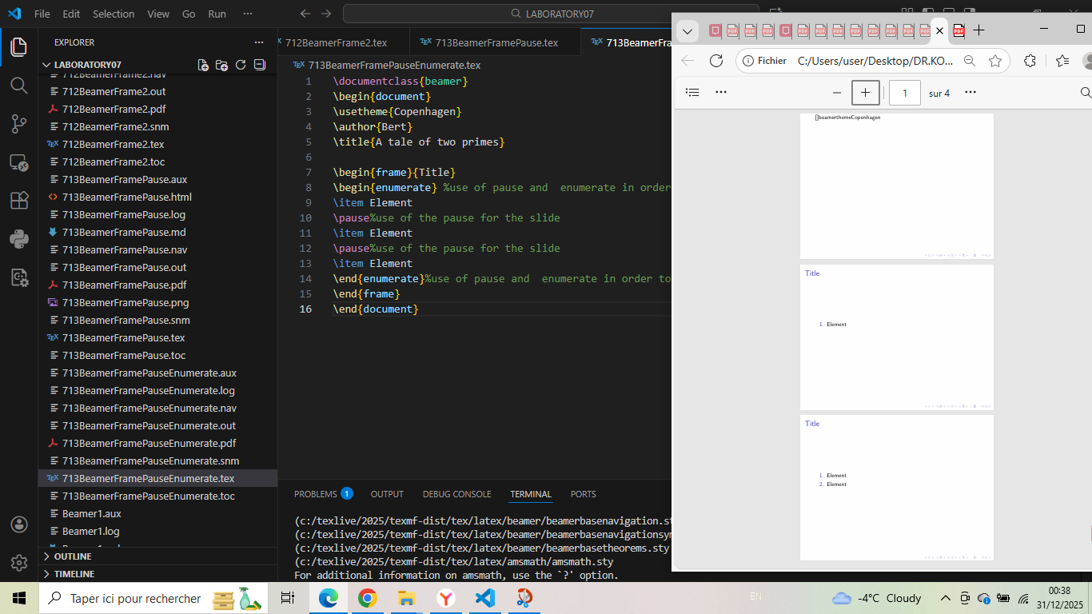

720Uncover - Basic Uncover Command
\documentclass{beamer}
\begin{document}
\usetheme{Copenhagen}
\author{Bert}
\title{A tale of two primes}
%We are going to see how by using \uncover, we can determine when each part of the slide will appear
\begin{frame}
\frametitle{Sets}
A \verb|\alert{set}| is a collection of objects.\verb|\uncover<2->|{ For example:
\[
Z=\{\text{cow},\text{pig},\text{elephant}\}.}
\]
\uncover<3->{We call the objects in $Z$ the \alert{elements} of $Z$.}\uncover<4->{ We write
\[
\text{cow} \in Z
\]}
\uncover<5->{with \`\`cow is an element of $Z$''.}\uncover<6->{ Frequently encountered sets are}
\[
\begin{split}
\uncover<7->{\mathbb{N}} \uncover<8->{= \{1,2,3,\ldots \}}&\uncover<9->{ \qquad (\text{\`\`natural numbers''})\\}
\uncover<10->{\mathbb{Z}} \uncover<11->{= \{\ldots,-2,-1,0,1,2,\ldots \}}&\uncover<12->{ \qquad (\text{\`\`integer numbers''})\\}
\uncover<13->{\mathbb{Q}} \uncover<14->{= \{p/q : p,q\in\mathbb{Z} \text{ and } q\neq 0\} }&\uncover<15->{\qquad (\text{\`\`rational numbers''})\\}
\uncover<16->{\mathbb{R}} \uncover<17->{= \{\hbox{decimal numbers}\}}&\uncover<18->{\quad\qquad (\text{\`\`real numbers''})}
\end{split}
\]
\end{frame}
\end{document}

Generated figure
Step-by-step revelation of set definitions.

Screenshot
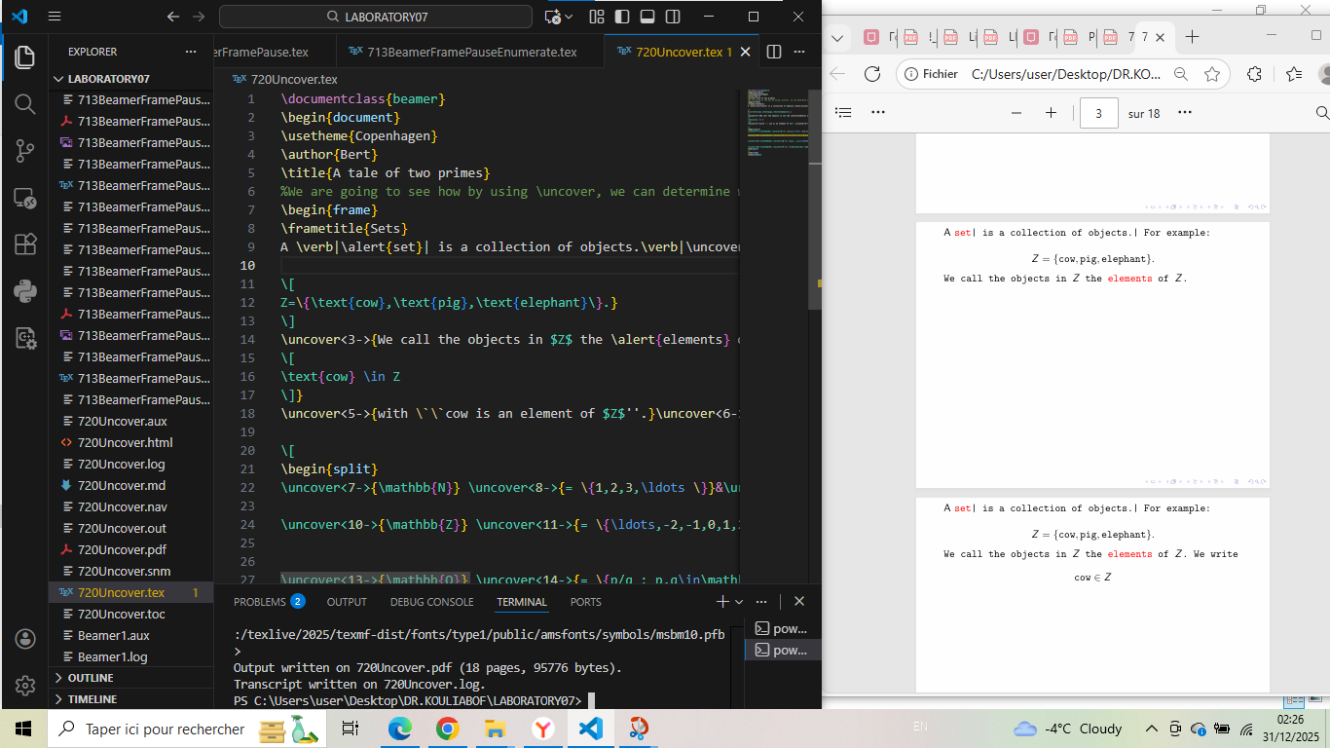

720UncoverInAlign2 - Uncover in Align Environment
\documentclass{beamer}
\begin{document}
\usetheme{Copenhagen}
\author{Bert}
\title{A tale of N primes}
%We can also use \uncover in the align environment.
\begin{frame}
The derivative of $f(x) = g(x) \cdot h(x)$, with $g(x) = x^2$ and $h(x) = \sin(x)$ equals
\begin{align*}
f'(x) \uncover<2->{&= g'(x) \cdot h(x) +} \uncover<3->{g(x) \cdot h'(x)} \\
&\uncover<4->{= 2x \cdot \sin(x) +} \uncover<5->{x^2\cdot \cos(x).}
\end{align*}
\end{frame}
\end{document}

Generated figure
Gradual derivation of product rule.

Screenshot
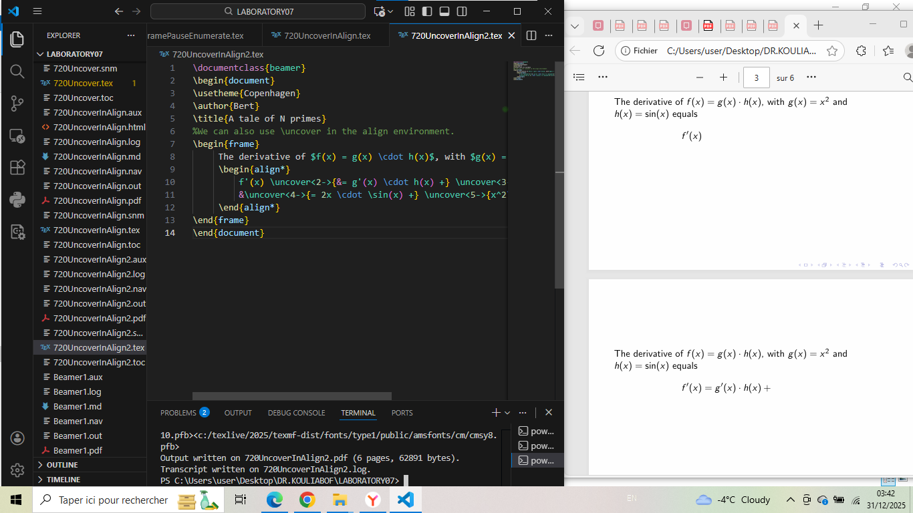

720UncoverItemize - Uncover in Itemize
\documentclass{beamer}
\begin{document}
\usetheme{Copenhagen}
\author{Bert}
\title{A tale of N primes}
% By using \itemize environment we can also indicate the order at which the various items will appear
\begin{itemize}
\item<4-> $[a,b]\uncover<5->{=\{x\in\mathbb{R} : a\leq x\leq b\}$,}
\item<6-> $(a,b)\uncover<7->{=\{x\in\mathbb{R} : a< x< b\}$,}
\item<8-> $(a,\infty)\uncover<9->{=\{x\in\mathbb{R} : x>a\}$.}
\end{itemize}
\end{document}

Generated figure
Interval definitions revealed stepwise.

Screenshot
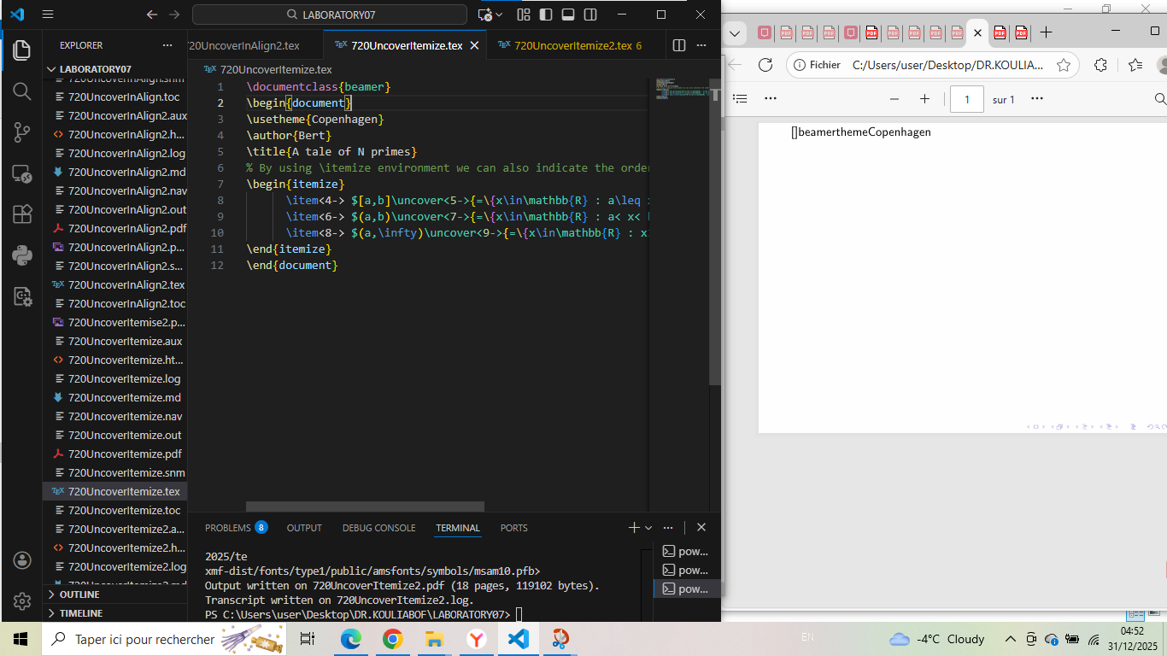

720UncoverItemize2 - Advanced Uncover with Mathematics
\documentclass{beamer}
\usepackage{amsmath, amssymb}
\begin{document}
\usetheme{Copenhagen}
\author{Bert}
\title{A tale of N primes}
% We can use \itemize to create or indicate a various quantities that we need. More and more
\begin{frame}{Applications - Function Domains}
\begin{block}{Example 3}
Find domain of: $f(x) = \sqrt{4 - x^2}$
\end{block}
\begin{itemize}
\item<2-> Need: $4 - x^2 \geq 0$
\item<3-> $x^2 \leq 4$
\item<4-> $-2 \leq x \leq 2$
\item<5-> Domain: $[-2, 2]$
\end{itemize}
\end{frame}
\begin{frame}{Important Theorems}
\begin{itemize}
\item<1-> \textbf{Intermediate Value Theorem:}
If $f$ continuous on $[a,b]$, takes all values between $f(a)$ and $f(b)$
\item<2-> \textbf{Extreme Value Theorem:}
Continuous on $[a,b]$ $\Rightarrow$ attains max and min
\item<3-> \textbf{Mean Value Theorem:}
If $f$ differentiable on $(a,b)$, $\exists c \in (a,b)$ with:
$$f'(c) = \frac{f(b)-f(a)}{b-a}$$
\end{itemize}
\end{frame}
\begin{frame}{Summary}
\begin{itemize}
\item<1-> Intervals: sets of real numbers
\item<2-> Notation: $[$ for included, $($ for excluded
\item<3-> Types: closed, open, half-open, infinite
\item<4-> Properties: intersection, length, center
\item<5-> Applications: inequalities, domains, theorems
\item<6-> Graphical: $\bullet$, $\circ$, $\rightarrow$
\item<7-> Fundamental in real analysis
\item<8-> Essential for calculus
\item<9-> Basis for advanced mathematics
\end{itemize}
\end{frame}
\end{document}

Generated figure
Three frames with mathematical content and stepwise reveals.

Screenshot
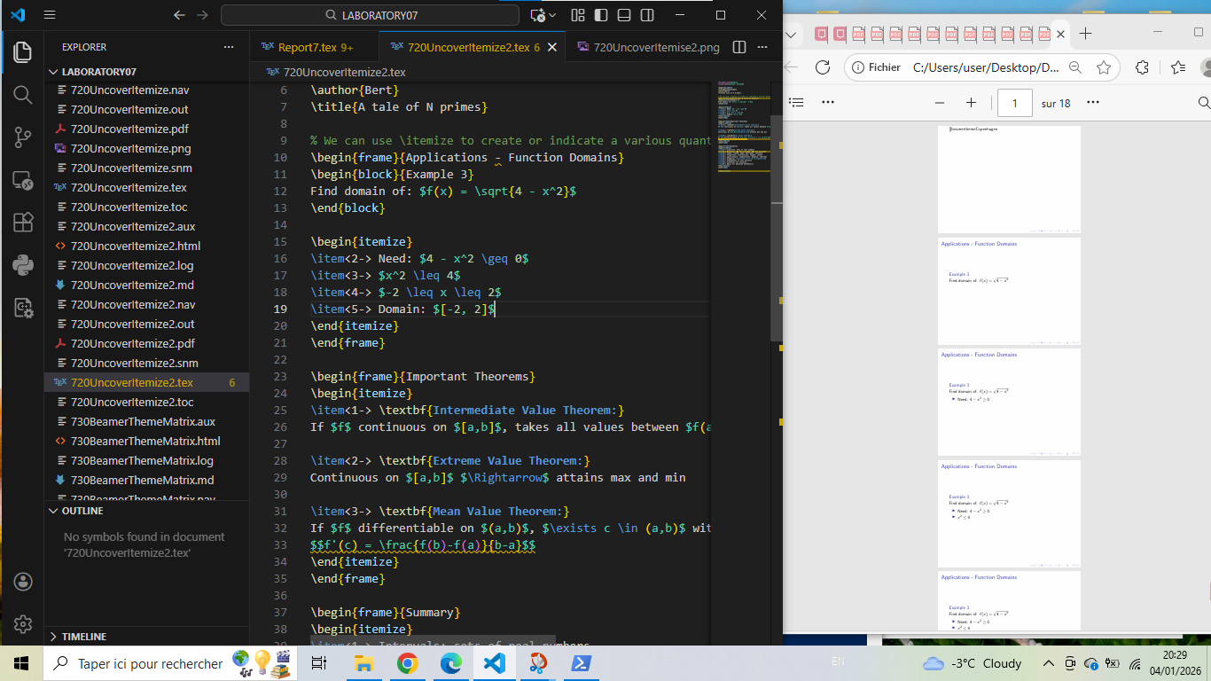

730BeamerThemeMatrix - Theme Selection
\documentclass{beamer}% use of beamer \documentclass{beamer}
\begin{document}
\usetheme{Sebastien@Pipping.org}%there more possibilities but I choose that
\usecolortheme{beaver}
\author{Institute}
\year{
November 15,2010}
\title{Beamer Theme Matrix}
\end{document}

Generated figure
Minimal theme selection example.

Screenshot
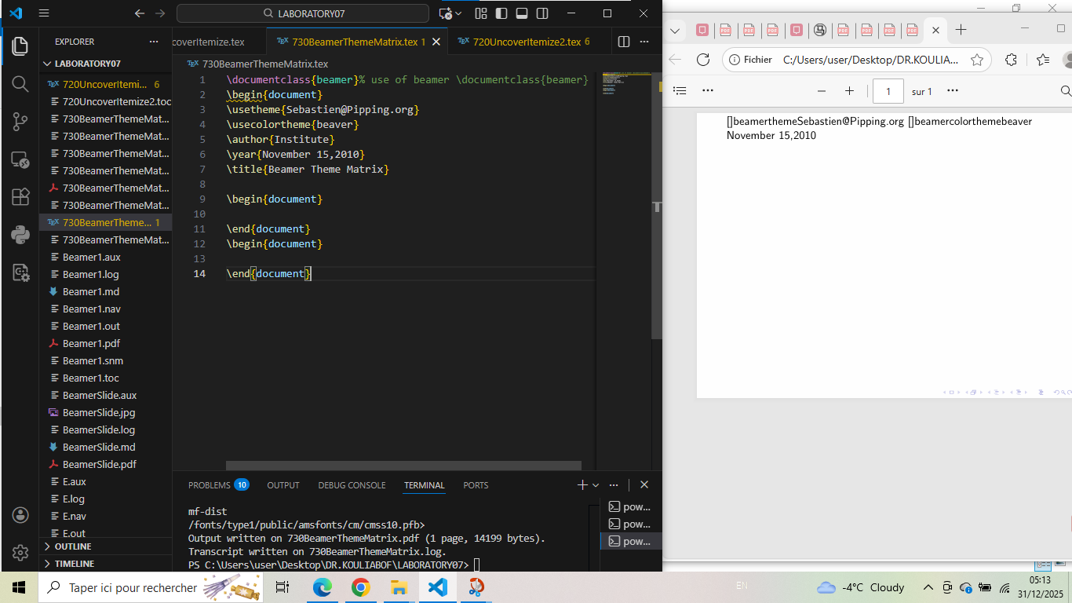

740TryingPresentation - Complete Presentation Example
\documentclass{beamer}
\usetheme{Camarades}
\title{Présentation Beamer}
\author{PELE TETE}
\date{01 01 2025}
\begin{document}
\Section{ Delivering messages to dears Camarades}
\begin{frame}
\titlepage
\end{frame}
\begin{frame}
\frametitle{Introduction}
\begin{itemize}
\item HOW TO USE BEAMER
\item HOW CAN I SUCCEED THE LABORATORIES OF KOULYABOV
\item HOW CAN I ITS WRITE THE LABORATORIES OF KOULYABOV
\end{itemize}
\end{frame}
\begin{frame}
\frametitle{Méthodology}
\begin{block}{METHODOLOGY'S STPES}
1. LABORATORIES'S PREPARATION\\
2.BOOK'S LECTURE AND ANALYZE\\
3. CODES COMPILATION AND OTHERS
\end{block}
\end{frame}
\begin{frame}
\frametitle{Résultats}
\begin{columns}
\begin{column}{0.5\textwidth}
\begin{itemize}
\item LABORATORIES'S ANSWERS
\item REZUME OF LECTURE
\item CODES COMPILATION'S ANSWERS (PDF,TEX,HTML AND MD )
\end{itemize}
\end{column}
\begin{column}{0.5\textwidth}
\includegraphics[width=\textwidth]{faucon.jpg}
\end{column}
\end{columns}
\end{frame}
\begin{frame}
\frametitle{Conclusion}
\begin{alertblock}{importantes parts}
\begin{itemize}
\item PRINCIPAL CONCLUSION
\item SOMESPRATICES AND IMPLICATIONS
\item LEARNING FOR THE FUTURE(ANTICIPATION)
\end{itemize}
\end{alertblock}
\end{frame}
\end{document}

Generated figure
Complete presentation with custom theme.

Screenshot
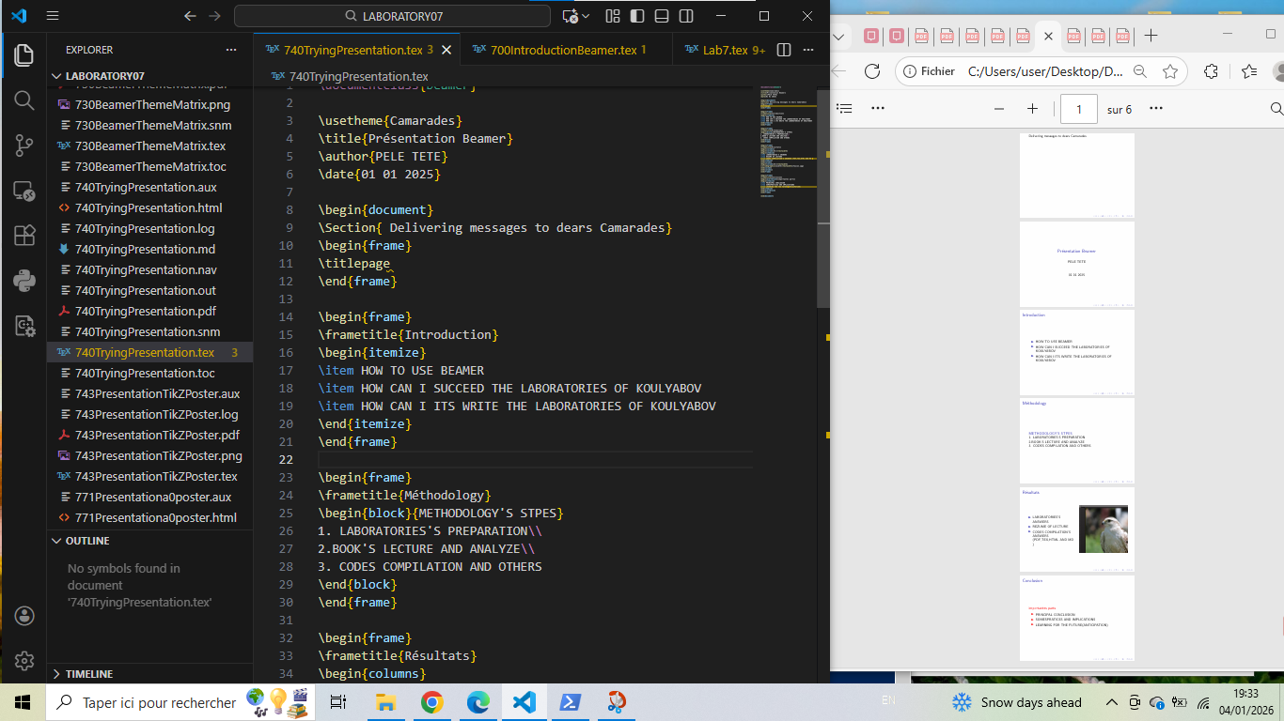

743PresentationTikZPoster - First TikZPoster Attempt
\documentclass[24pt, a0paper, portrait]{tikzposter}% begin the TikZ
\usepackage[multicol]
\usetheme{Transport theory}
\title{Boltzmann's antropie}
\author{TETE PELE}
\institute{RUDN University}
\begin{document}
\maketitle
Transport theory
\begin{columns}%
\column{.33}
MONGE Gaspard
\Section{ Definition and Developpment}
%1st column definition of transport
\column{.33}
Richi
\Section{ Definition and Developpment}
% Geometics definition
\column{.33}
Kantarovich
\Section{ Definition and Developpment}
%Transfortion in Lineare probleme
\end{columns}
%Synthese with Cedric V
\begin{columns}
Conclusion
\end{columns}
\end{document}

Generated figure
Basic poster structure with errors.

Screenshot
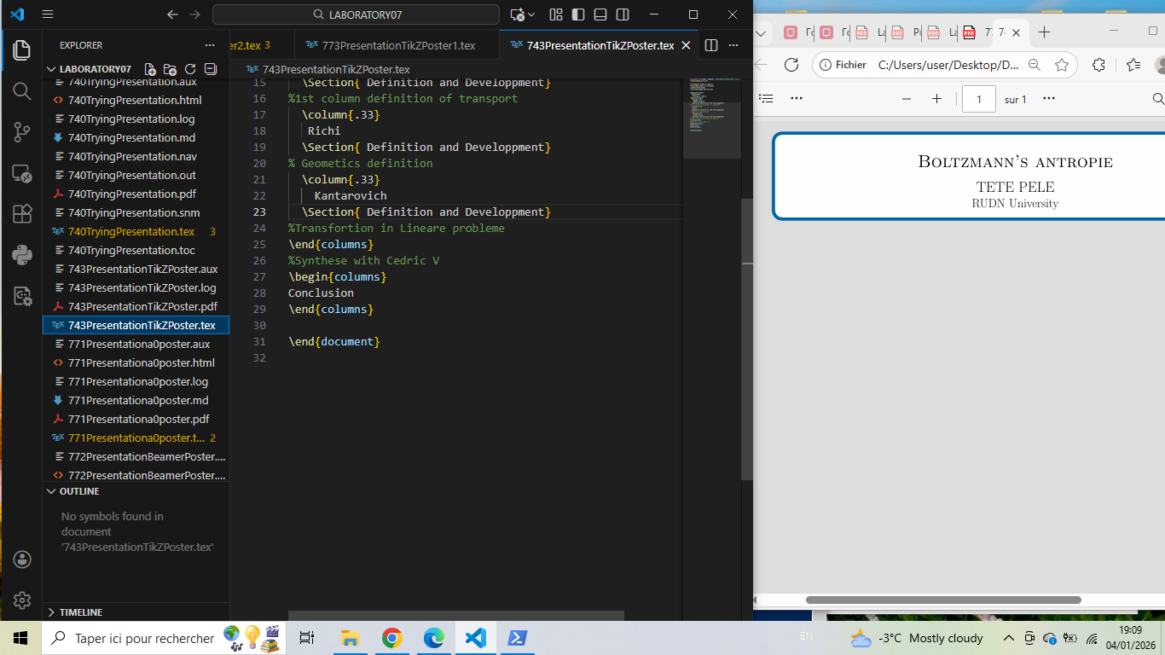

771Presentationa0poster - a0poster Package
\documentclass[a0, portrait]{a0poster}
\usepackage[utf8]{inputenc}
\usepackage[T1]{fontenc}
\usepackage{multicol}
\usepackage{graphicx}
\usepackage{tikz}
\usepackage{caption}
\usepackage[svgnames]{xcolor}
\columnsep=100pt
\begin{document}
\begin{minipage}{.7\textwidth}
\VeryHuge \textbf{Look I'm making a poster} \\ [0.75cm]
\Large Ostap S. Bender \\
\Large RUDN University
\end{minipage}
%
\begin{minipage}{.3\textwidth}
\includegraphics[width=\textwidth]{instituteLogo.png}
\end{minipage}
\vspace{2cm}
\begin{multicols}{2}
\section*{Abstract}
Here follows some regular text, \color{BlueViolet} from now on the text has changed colour, \color{Black} and then we are back to normal.
\section*{Introduction}
This is the introduction section of my poster.
\begin{center}
\includegraphics[width=0.8\columnwidth]{faucon.jpg}
\captionof{figure}{faucon.jpg}
\end{center}
\section*{Methods}
Details about the methodology used in this research.
\begin{center}
\begin{tikzpicture}
\draw[->] (0,0) -- (3,0) node[right] {x};
\draw[->] (0,0) -- (0,2) node[above] {y};
\draw[blue, thick] plot[domain=0:2.5] (\x, {0.5*\x*\x});
\end{tikzpicture}
\captionof{figure}{Example TikZ figure}
\end{center}
\section*{Results}
Presentation of research results.
\section*{Conclusion}
Summary and conclusions of the research.
\begin{thebibliography}{9}
\bibitem{ref1} Author, A. (2023). Title. Journal, Volume(Issue), Pages.
\end{thebibliography}
\end{multicols}
\end{document}

Generated figure
Poster using a0poster class.

Screenshot
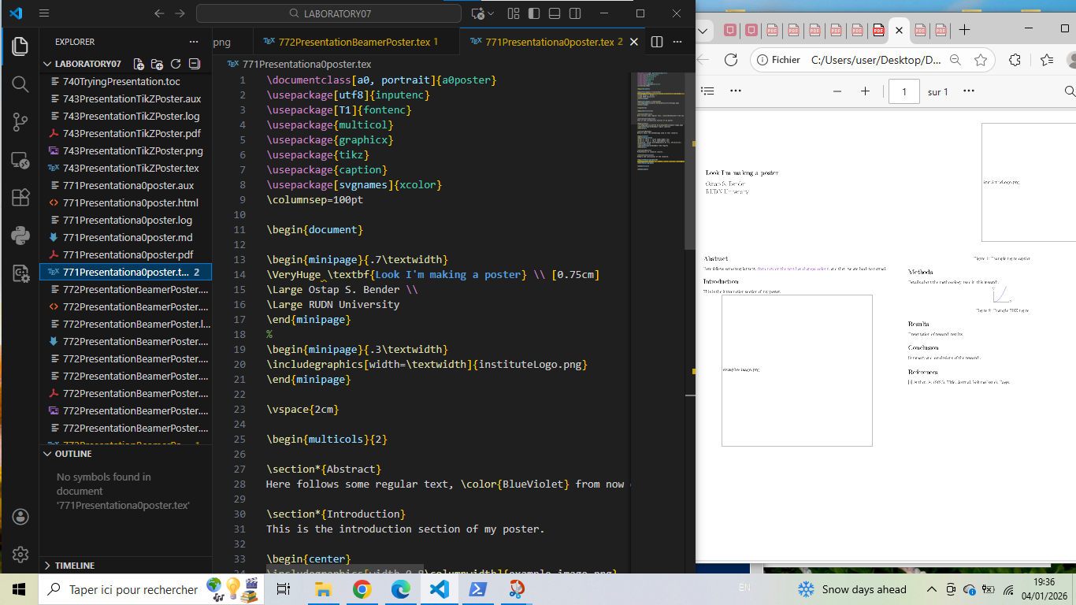

772PresentationBeamerPoster - Beamer as Poster
\documentclass[xcolor={svgnames}]{beamer}
\usepackage[utf8]{inputenc}
\usepackage[T1]{fontenc}
\usepackage{graphicx}
\usepackage{tikz}
\usetheme{Berlin}
\usecolortheme{seahorse}
\usepackage[orientation=portrait,size=a0,scale=1.4]{beamerposter}
\title{Look I'm making a poster}
\author{Ostap S. Bender}
\institute{RUDN University}
\begin{document}
\begin{frame}
\begin{columns}
\begin{column}{.33\textwidth}
\block{Introduction}
This is the introduction section. Here follows some regular text, \color{BlueViolet} from now on the text has changed colour, \color{Black} and then we are back to normal.
\begin{center}
\includegraphics[width=0.9\textwidth]{faucon.jpg}
\captionof{figure}{faucon.jpg}
\end{center}
\end{column}
%
\begin{column}{.33\textwidth}
\block{Methods}
Details about the methodology used.
\begin{exampleblock}{Example Block}
This is an example block with important information.
\end{exampleblock}
\begin{center}
\begin{tikzpicture}[scale=0.8]
\draw[->] (0,0) -- (4,0) node[right] {x};
\draw[->] (0,0) -- (0,3) node[above] {y};
\fill[red!20] (1,1) circle (1);
\node at (1,1) {Data};
\end{tikzpicture}
\end{center}
\end{column}
%
\begin{column}{.33\textwidth}
\block{Results}
Presentation of research results.
\alertblock{Alert Block}
Important findings or warnings.
\block{Conclusion}
Summary and conclusions of the research.
\end{column}
\end{columns}
\begin{columns}
\begin{column}{.7\textwidth}
\block{References}
\begin{thebibliography}{9}
\bibitem{ref1} Author, A. (2023). Title. Journal, Volume(Issue), Pages.
\bibitem{ref2} Researcher, B. (2022). Book Title. Publisher.
\end{thebibliography}
\end{column}
%
\begin{column}{.3\textwidth}
\block{Contact}
Ostap S. Bender \\
RUDN University \\
email@example.com
\end{column}
\end{columns}
\end{frame}
\end{document}

Generated figure
Poster using beamerposter package.

Screenshot
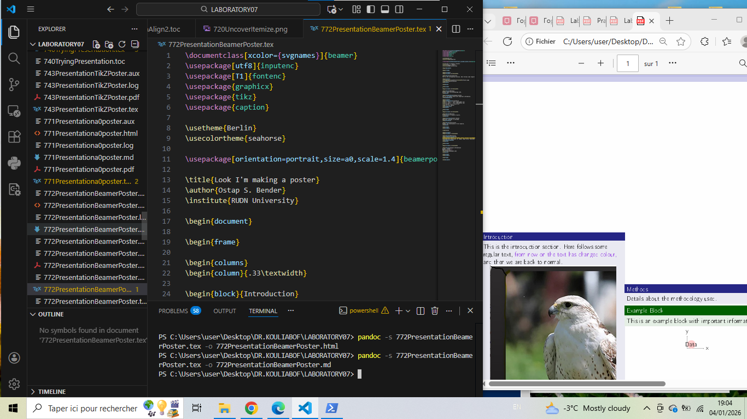

773PresentationTikZPoster1 - TikZPoster with Errors
\documentclass[25pt, a0paper, portrait]{tikzposter} % 25pt est une taille standard pour A0
\usepackage[utf8]{inputenc}
\usetheme{Board} % Thème standard
\title{Boltzmann's entropy} % Correction orthographe 'entropy'
\author{TETE PELE}
\institute{RUDN University}
\begin{document}
\maketitle
\begin{columns}
\column{.33}
\block{MONGE Gaspard}{Definition and Development: 1st column definition of transport}
\column{.33}
\block{Richi}{Definition and Development: Geometrics definition}
\column{.33}
\block{Kantorovich}{Definition and Development: Transformation in Linear problems}
\end{columns}
\block{Conclusion}{Synthèse avec Cédric V.}
\end{document}
\documentclass[24pt, a0paper, portrait]{tikzposter}% begin the TikZ
\usepackage[multicol]
\usetheme{Transport theory}
\title{Boltzmann's antropie}
\author{TETE PELE}
\institute{RUDN University}
\begin{document}
\maketitle
Transport theory
\begin{columns}%
\column{.33}{MONGE Gaspard}{ Definition and Developpment}
1st column definition of transport
\column{.33}
Richi
\Section{ Definition and Developpment}
Geometics definition
\column{.33}
Kantarovich
\Section{ Definition and Developpment}
Transfortion in Lineare probleme
\end{columns}
%Synthese with Cedric V
\begin{columns}
Conclusion
\end{columns}
\end{document}

Generated figure
TikZPoster with corrected and incorrect versions.

Screenshot
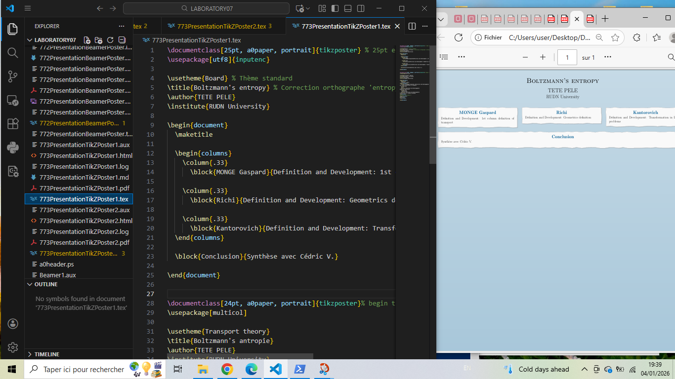

773PresentationTikZPoster2 - TikZPoster
\documentclass[24pt, a0paper, portrait]{tikzposter}
\usepackage[utf8]{inputenc}
\usepackage[T1]{fontenc}
\usepackage{multicol}
\usepackage{graphicx}
\usepackage{tikz}
\usepackage{caption}
\usepackage{color}
\definecolor{MyPink}{RGB}{194, 19, 182}
\definecolor{MyBlue}{RGB}{30, 100, 200}
\definecolor{MyGreen}{RGB}{50, 150, 100}
\usetheme{Default}
\title{Look I'm making a poster}
\author{Ostap S. Bender}
\institute{RUDN University}
\begin{document}
\maketitle
\begin{columns}
\column{.33}
\block{Introduction}{
This is the introduction section. Here follows some regular text, \color{MyPink} from now on the text has changed colour, \color{black} and then we are back to normal.
\vspace{3cm}
}
\note[targetoffsetx=-11cm, targetoffsety=-6.5cm, width=10cm]{This is an important note about the introduction}
\begin{center}
\includegraphics[width=0.9\colwidth]{faucon.jpg}
\captionof{figure}{faucon.jpg}
\end{center}
\column{.33}
\block{Methods}{
Details about the methodology used in this research.
}
\begin{center}
\begin{tikzpicture}[scale=0.7]
\draw[->, thick] (0,0) -- (5,0) node[right] {Time};
\draw[->, thick] (0,0) -- (0,4) node[above] {Value};
\draw[MyBlue, very thick] plot[domain=0:4.5, samples=50] (\x, {1.5 + sin(\x*100)});
\draw[MyGreen, very thick] plot[domain=0:4.5, samples=50] (\x, {2.5 + 0.5*cos(\x*120)});
\node[MyBlue] at (2,3.5) {Method A};
\node[MyGreen] at (3,1.5) {Method B};
\end{tikzpicture}
\captionof{figure}{Comparison of methods}
\end{center}
\column{.33}
\block{Results}{
Presentation of research results and findings.
}
\block{Conclusion}{
Summary and conclusions of the research. Key findings and future work.
}
\end{columns}
\begin{columns}
\column{.7}
\block{References}{
\begin{multicols}{2}
\begin{thebibliography}{9}
\bibitem{ref1} Author, A. (2023). Title. Journal, Volume(Issue), Pages.
\bibitem{ref2} Researcher, B. (2022). Book Title. Publisher.
\bibitem{ref3} Scientist, C. (2021). Conference Proceedings.
\bibitem{ref4} Scholar, D. (2020). Technical Report.
\end{thebibliography}
\end{multicols}
}
\column{.3}
\block{Contact Information}{
\textbf{Ostap S. Bender} \\
RUDN University \\
Department of Mathematics \\
\texttt{email@rudn.ru} \\
+7 (906) 000-00-00
}
\block{Acknowledgements}{
This research was supported by RUDN University.
}
\end{columns}
\end{document}

Generated figure
Complete TikZPoster with colors, figures, and proper structure.

Screenshot
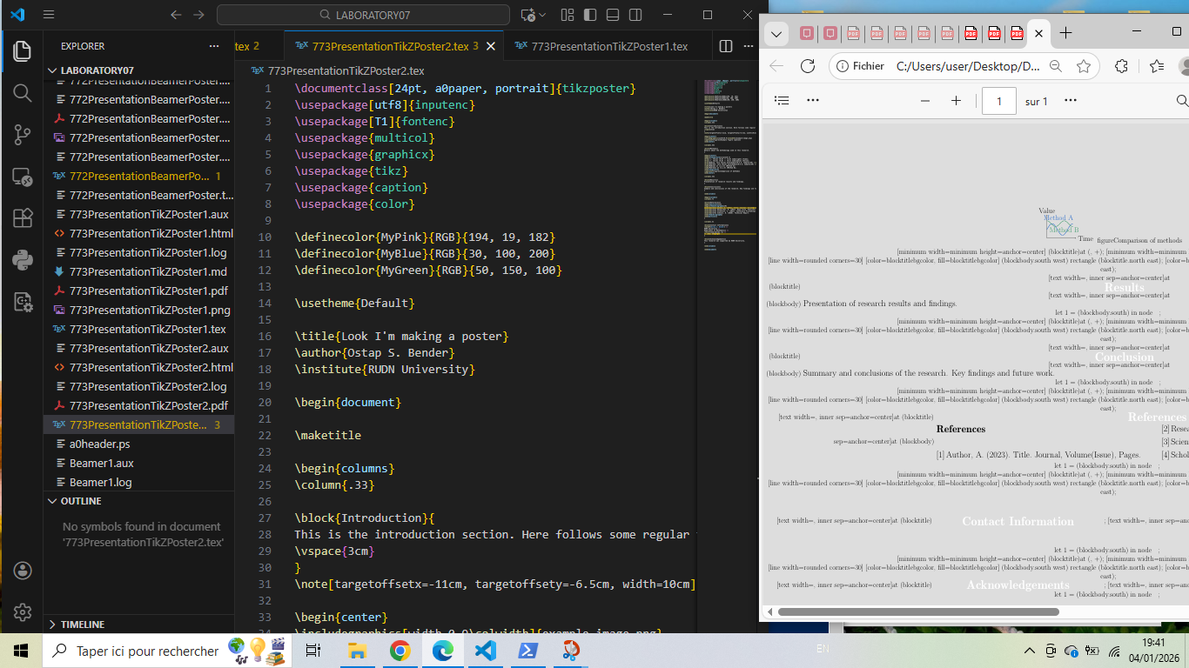

Conclusion: Methodology for creating successful Beamer and Poster presentations
After exhaustive study of Beamer and Poster examples, here is the structured methodology for creating successful presentations:

1. Essential basic structure for Beamer
\documentclass{beamer}
\usetheme{ThemeName} % Choose a theme
\usecolortheme{ColorTheme} % Optional color theme
\title{Presentation Title}
\author{Your Name}
\date{\today}
\begin{document}
\begin{frame}
\titlepage
\end{frame}
\begin{frame}{Frame Title}
% Content here
\end{frame}
\end{document}

2. Essential basic structure for TikZPoster
\documentclass[24pt, a0paper, portrait]{tikzposter}
\usepackage[utf8]{inputenc}
\usepackage{graphicx}
\usepackage{tikz}
\usetheme{Default}
\title{Poster Title}
\author{Your Name}
\institute{Your Institution}
\begin{document}
\maketitle
\begin{columns}
\column{.33}
\block{Section Title}{
Content here
}
\end{columns}
\end{document}

3. Recommended progressive approach
Step 1: Planning
- Define presentation structure (title, sections, content)
- Choose appropriate theme and colors
- Prepare visual elements (images, diagrams)
Step 2: Build in layers
- Basic structure (title page, sections)
- Content (text, blocks, items)
- Visual elements (images, TikZ graphics)
- Animations and overlays (pause, uncover)
- Final polish (notes, references)
Step 3: Optimize
- Use consistent formatting
- Balance text and visuals
- Test on different screen sizes (for presentations)
- Check printability (for posters)

4. Essential best practices
Practice | Example
Use appropriate themes | \usetheme{Copenhagen}
Organize with blocks | \begin{block}{Title}...\end{block}
Add visual elements | Images, TikZ diagrams
Use overlays effectively | \pause, \uncover
Maintain consistency | Same fonts, colors, sizes

5. Synthetic conclusion
To create successful presentations:
1. Structure: Title → Introduction → Content → Conclusion → References
2. Visuals: Balance text and graphics, use consistent theme
3. Animation: Use pause and uncover for stepwise revelation
4. Posters: Use appropriate classes (tikzposter, a0poster, beamerposter)
5. Testing: Compile frequently, test on target display/print
Final reminder: Beamer and poster creation tools are powerful for academic communication. Start with simple templates, gradually add complexity, and always prioritize clarity and readability over visual effects.

