LABORATORY08: Report and Presentation of work on TikZ
PELE TETE
December 2025

801TikZ - Basic LaTeX Document
\documentclass[a4paper,12pt]{article}
\usepackage[T1]{fontenc}
\begin{document}
\section{This is a simple introduction to TikZ}
There is a variety of different toolsets for creating graphical objects in a TeX doc
ument. Themostwellknownandprobablymostwidelyusedofthesetoolsetsis
TikZ, which is a recursive acronym for “TikZ ist kein Zeichenprogramm” (German
for TikZ is not a drawing programme). Fromthenameofthetoolsetyoucansee
that generating a figure in TikZ will not work through drawing the figure like you
might befamiliar with doing in Paint or similar drawing programmes. To create a
figure using TikZ we will need to code it by using specific TeX commands. We will
take a look at the basics of TikZ here.
Three useful references and sources of inspiration for creating TikZ figure are:
• TheWikibooksentryonTikZ:https://en.wikibooks.org/wiki/LaTeX/PGF/TikZ.
• TheCTANentryonTikZwiththeofficialhandbookandotherdocumentation:
https://www.ctan.org/pkg/pgf.
• TheTeXampleTikZdatabasefullofexamplesandinspiration: https://texa
mple.net/tikz/.
My work is extremely based on the first link. In the following lines,
we will see how we can code by using TikZ.
\end{document}

Generated figure (simulation)
Standard text document without TikZ graphics.

Imported image
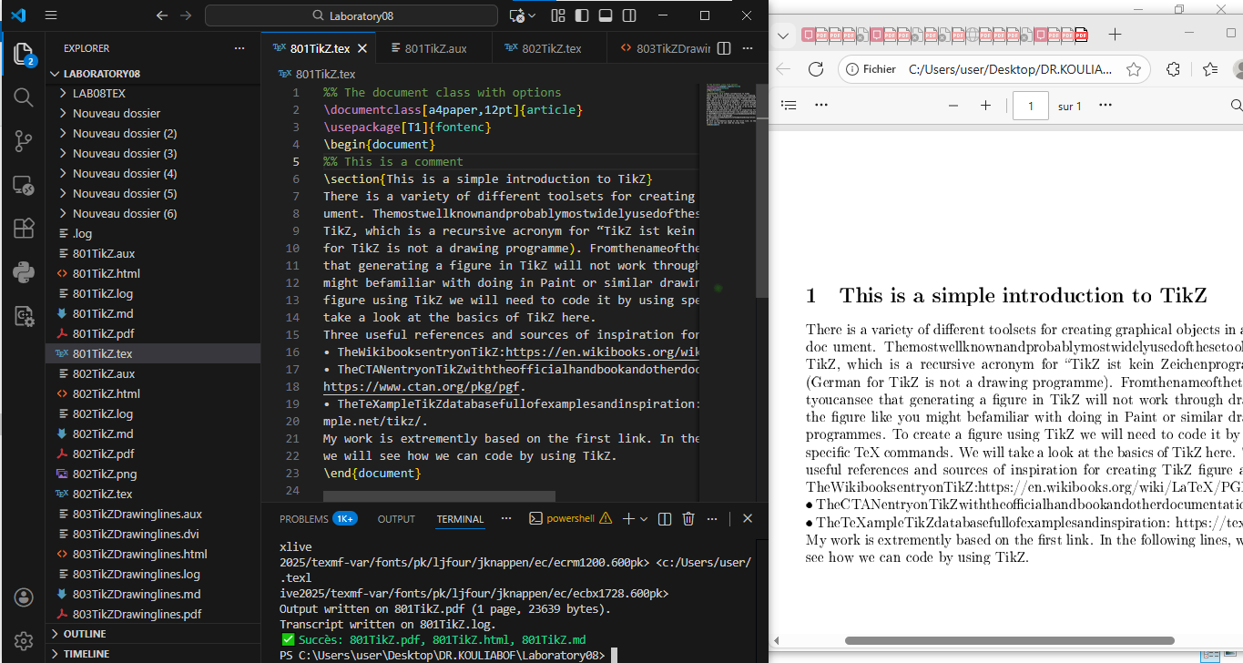

802TikZ.tex - Introduction to key concepts
\documentclass[a4paper,12pt]{article}
\usepackage[T1]{fontenc}
\begin{document}
In this section, we will talking about five(05) Importants keys.
To succeed to work from TikZ
First to remember to start coding by \usepackage{tikz}
second use \begin{figure} this helps us make the reference.
third use \begin{tikzpicture} in other to manage the graphic.
fouth never forget to close by \end{tikzpicture}
at the and we have the rule the use of semicolon(';').
\end{document}

Generated figure (simulation)
Explanatory text about TikZ.

Screenshot
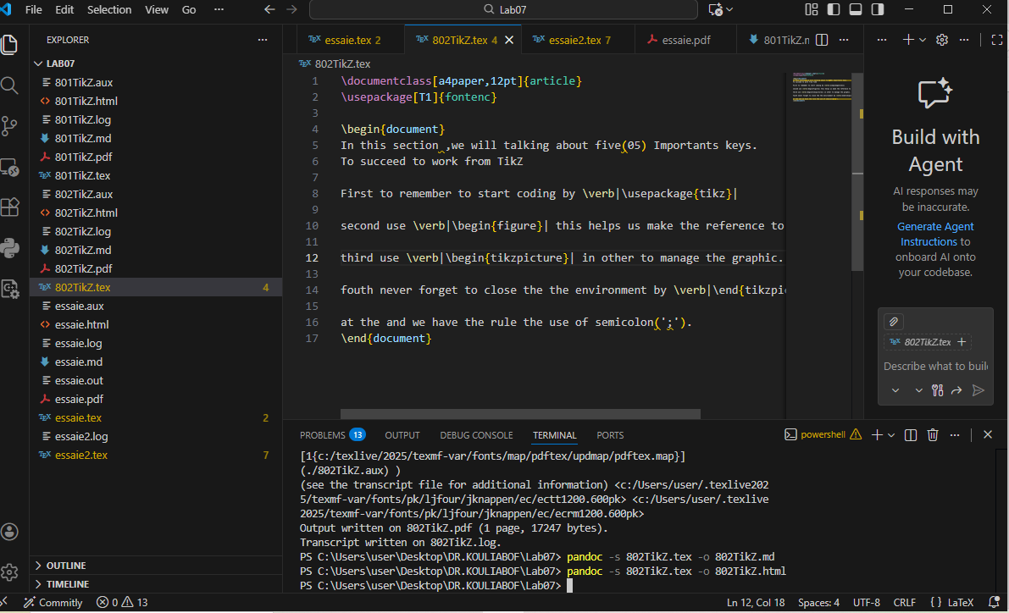

803TikZDrawinglines - Drawing simple lines
\documentclass{article}
\usepackage{tikz}
\begin{document}
\begin{tikzpicture}
\draw (-1,0) -- (3,10pt) -- (35:3);
\end{tikzpicture}
\end{document}

Generated figure

Screenshot
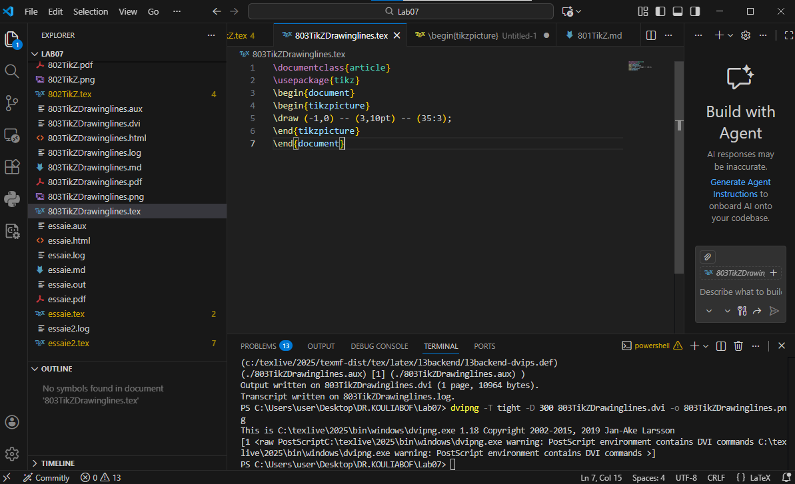

804TikZDrawinglines - Line styles
\documentclass{article}
\usepackage{tikz}
\begin{document}
\begin{tikzpicture}
\draw[->] (-1,0) -| (3,10pt);
\draw[red] (3,10pt) -- (35:3);
\end{tikzpicture}
\end{document}

Generated figure

Screenshot
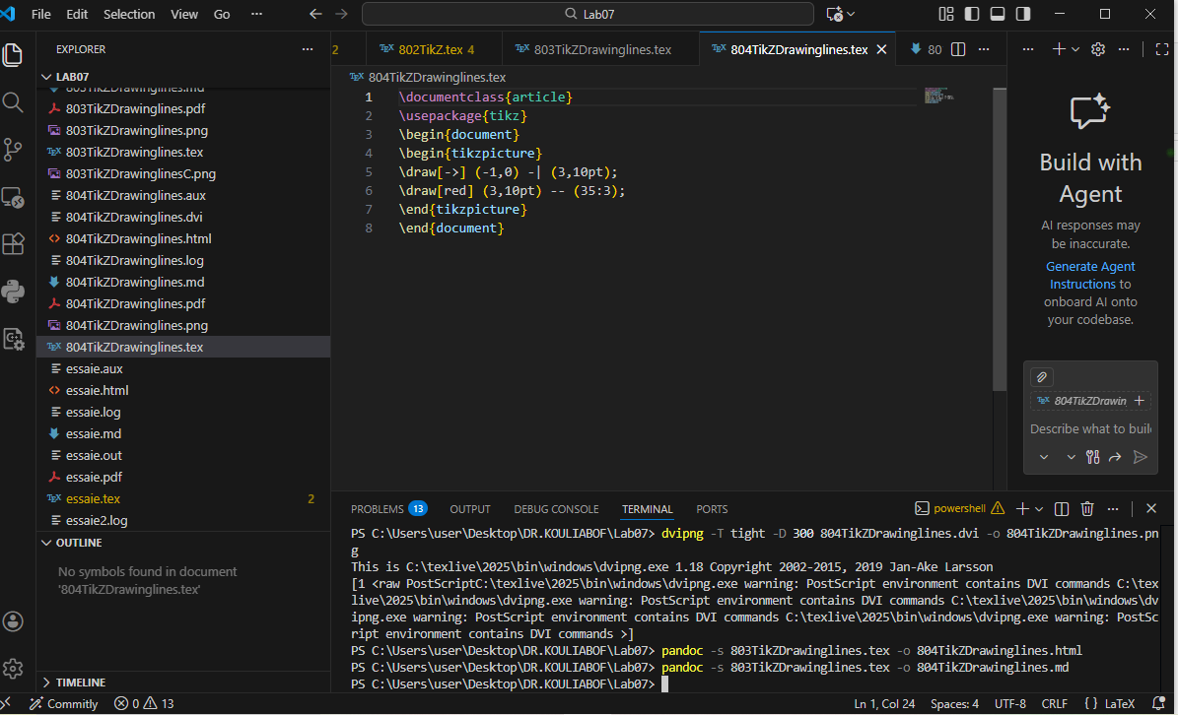

805TikZDrawinglines - Curves with controls
\documentclass{article}
\usepackage{tikz}
\begin{document}
\begin{tikzpicture}
\draw (-1,0) to (5,1);
\draw[green] (-1,0) to[out=90,in=135] (5,1);
\draw[cyan] (-1,0) .. controls (0,-2) .. (5,1);
\end{tikzpicture}
\end{document}

Generated figure

Screenshot
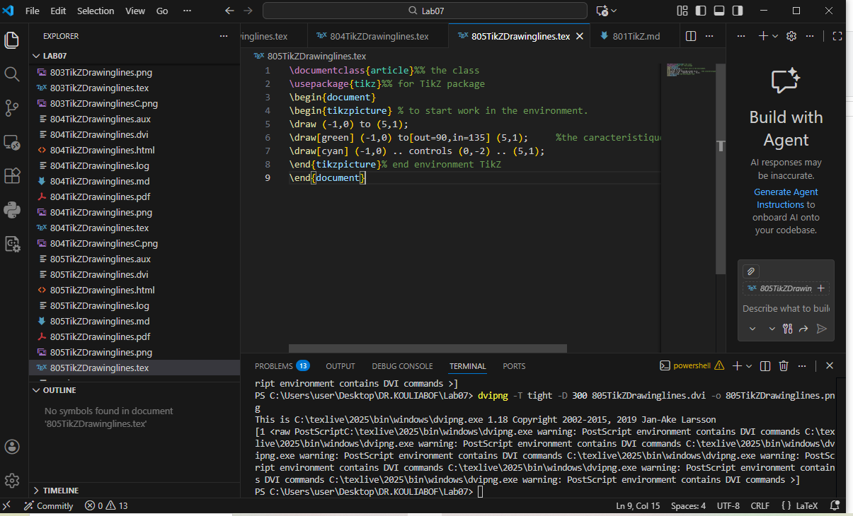

806TikZDrawinglines - Advanced curves
\documentclass{article}
\usepackage{tikz}
\begin{document}
\begin{tikzpicture}
\draw[dotted,gray] (-1,0) -- (5,1);
\draw (-1,0) .. controls (0,-2) and (4,2) .. (5,1);
\end{tikzpicture}
\end{document}

Generated figure

Screenshot
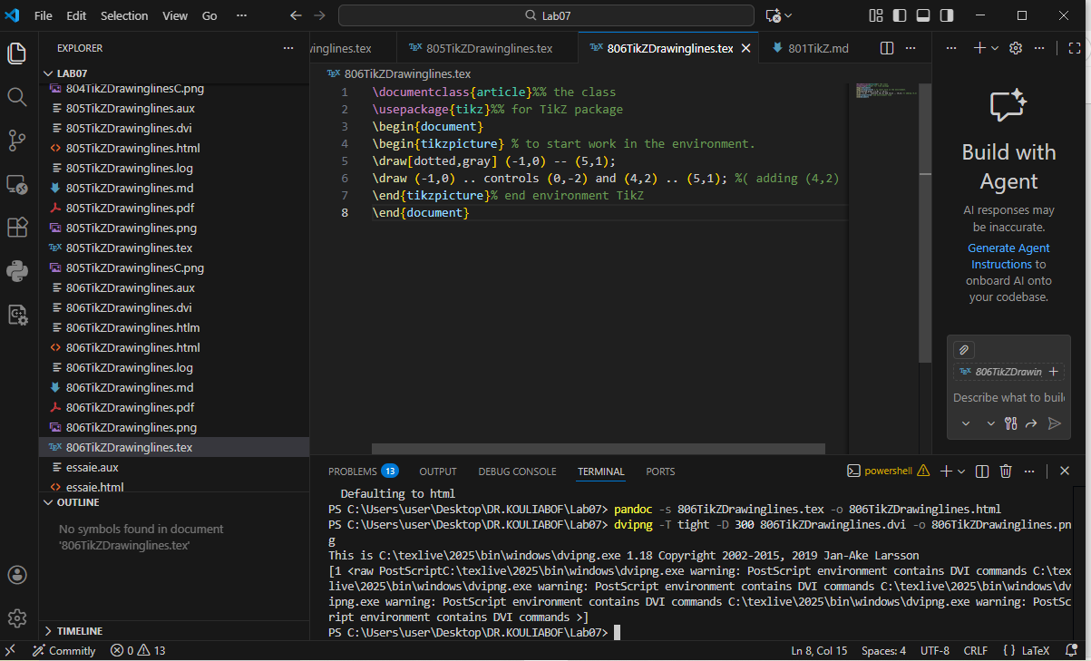

810TikZNodes - Introduction to nodes
\documentclass{article}
\usepackage{tikz}
\begin{document}
\begin{tikzpicture}[scale=4]
\draw (0,0) node {hello} -- (1,1) node {world};
\end{tikzpicture}
\end{document}

Generated figure

Screenshot
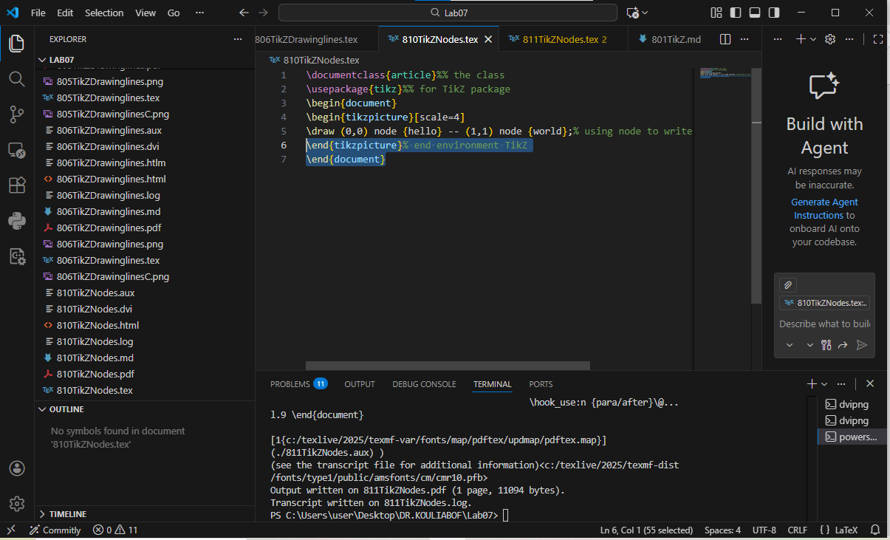

811TikZNodes - Node positioning
\documentclass{article}
\usepackage{tikz}
\begin{document}
\begin{tikzpicture}[scale=3]
\draw (0,0) -- (1,1) node[midway]{A} node[pos=0.75,above]{B} node[right]{C};
\draw (0,0) -- (1,1) node[left]{D};
\end{tikzpicture}
\end{document}

Generated figure

Screenshot
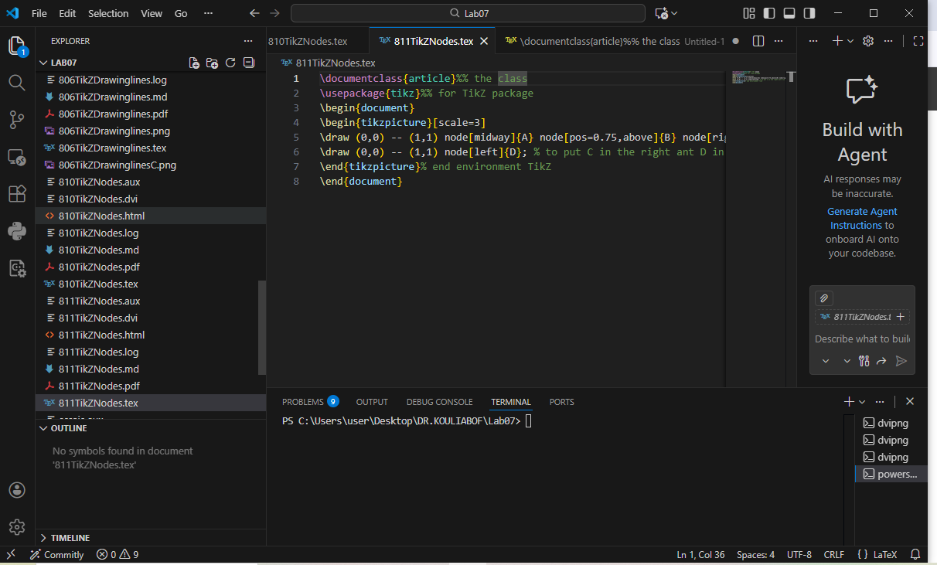

812TikZNodes - Nodes with ’to’ command
\documentclass{article}
\usepackage{tikz}
\begin{document}
\begin{tikzpicture}[scale=3]
\draw (0,0) to node[midway]{A} node[pos=0.75, above]{B} (1,1) node[right]{C};
\end{tikzpicture}
\end{document}

Generated figure

Screenshot
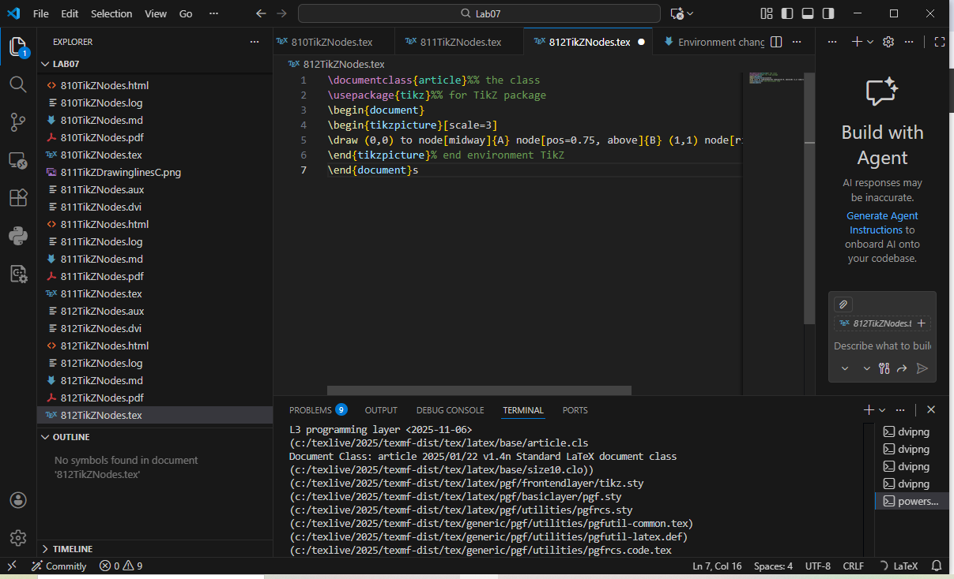

813TikZNodes.tex - Mathematical forms
\documentclass{article}
\usepackage{tikz}
\begin{document}
\begin{tikzpicture}[scale=3]
\draw (0,0) node[circle, draw]{$\sum_{i=1}^{n}n^2$} -- (1,1)
node[rectangle,draw]{$\frac{1}{\sqrt{2}}$};
\end{tikzpicture}
\end{document}

Generated figure

Screenshot
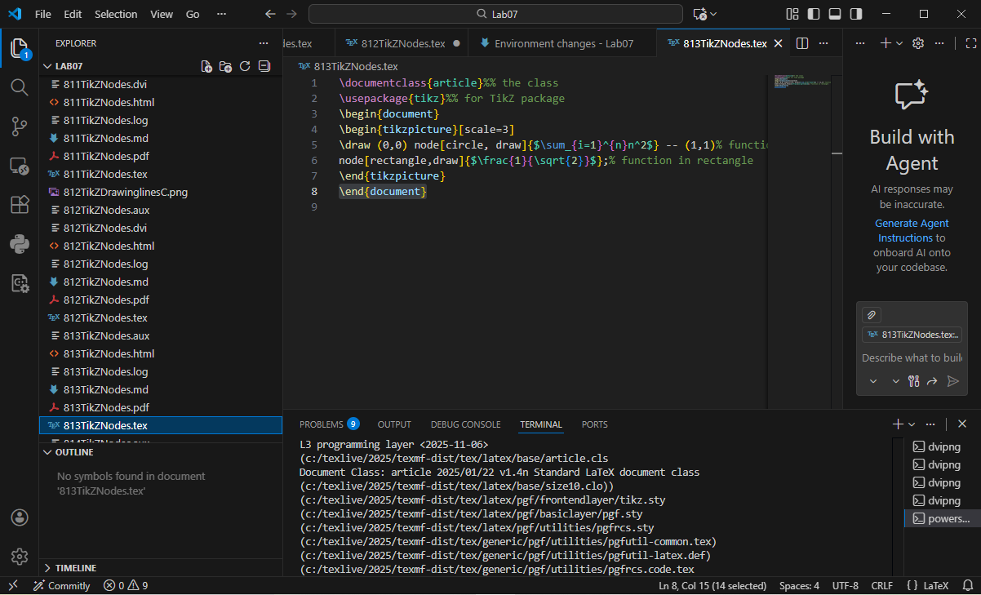

814TikZNodes - Named nodes
\documentclass{article}
\usepackage{tikz}
\begin{document}
\begin{tikzpicture}[scale=3]
\node[circle,draw] (label1) at (0,0) {$\sum_{i=1}^{n}n^2$};
\node[rectangle,draw] (label2) at (1,1) {$\frac{1}{\sqrt{2}}$};
\draw (label1) -- (label2);
\end{tikzpicture}
\end{document}

Generated figure

Screenshot
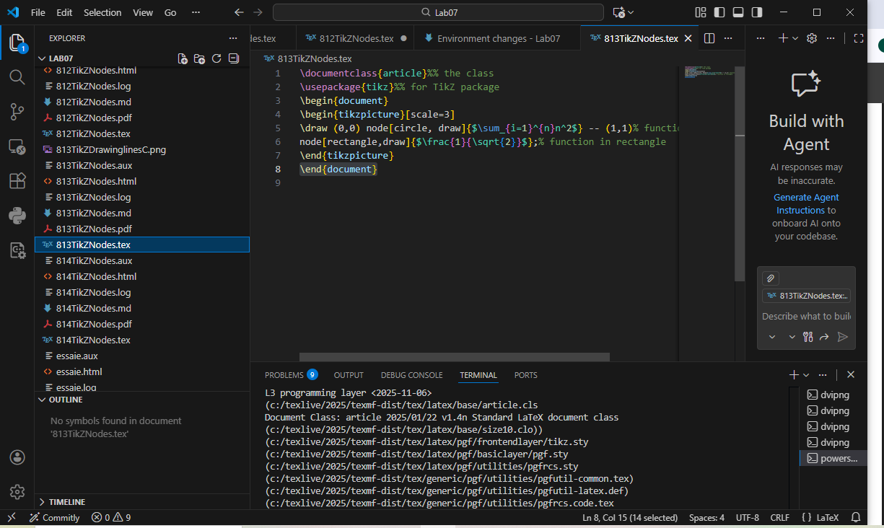

815TikZNodesGenerateGraph - Complex graph
\documentclass{article}
\usepackage{tikz}
\begin{document}
\begin{tikzpicture}[scale=2]
\node[circle, draw] at (0,0) (a) {A};
\node[rectangle, fill] at (3,0) (b) {};
\node at (3,0.4) (blabel) {B};
\node[rectangle,rounded corners, draw] at (5,2) (c) {C};
\draw[->, green] (a) -- (b) node[midway, below,black]{2};
\draw[<->, blue] (a) to[out=45, in=135] (b);
\draw[->,red] (b)--(c);
\draw[yellow,dotted,very thick] (b) |- (c);
\draw[<-,cyan] (b) -| (c);
\draw[thick,black] (a).. controls (1,5) .. (c)
node[midway,above]{$\frac{1}{2}$};
\end{tikzpicture}
\end{document}

Generated figure

Screenshot
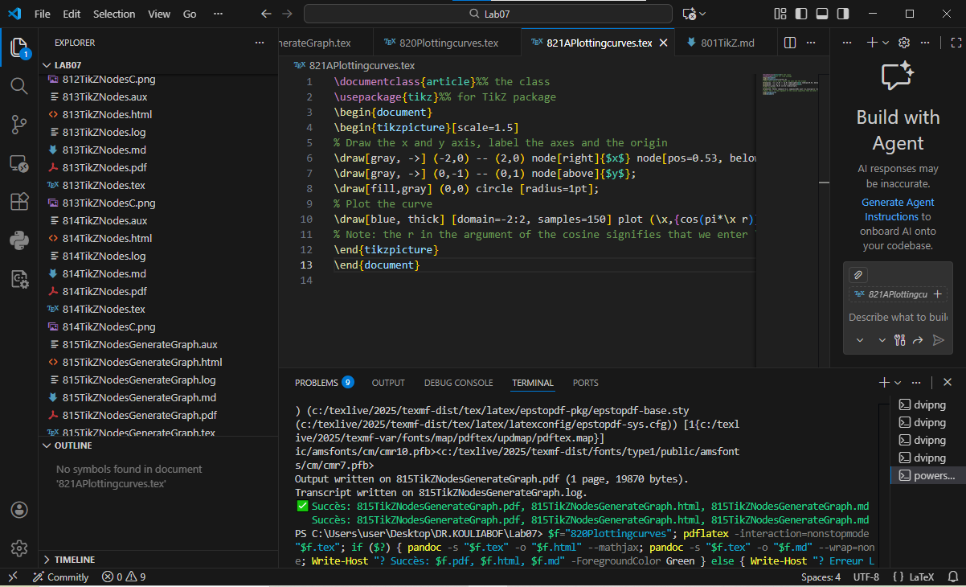

820Plottingcurves - Simple curve plotting
\documentclass{article}
\usepackage{tikz}
\begin{document}
\begin{tikzpicture}
\draw [domain=-2:2] plot (\x, {pow(\x,2)});
\end{tikzpicture}
\end{document}

Generated figure

Screenshot
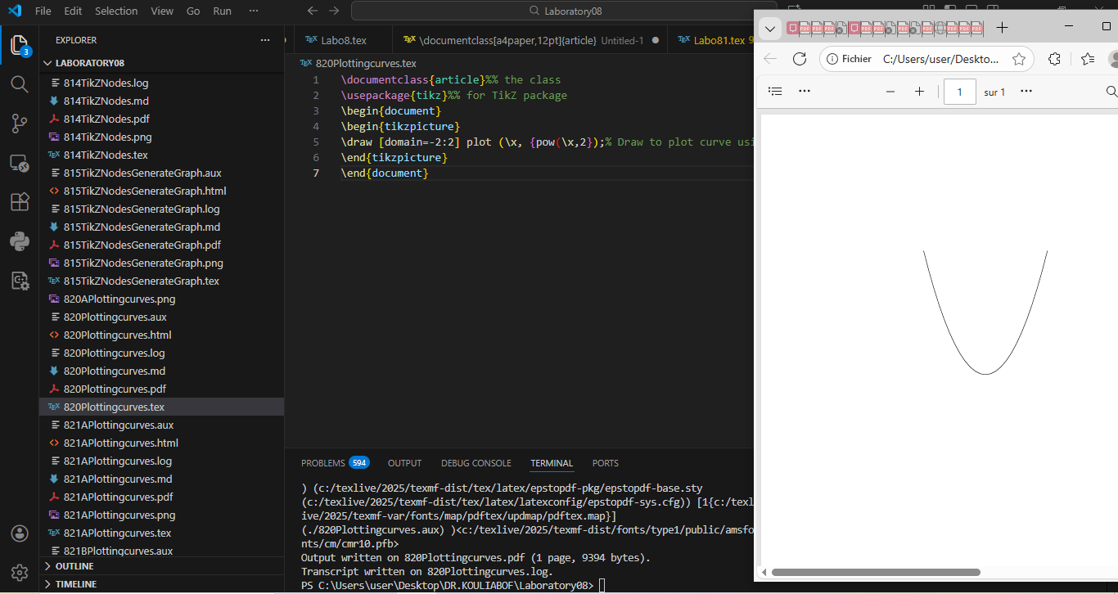

821APlottingcurves - Cosine with axes
\documentclass{article}
\usepackage{tikz}
\begin{document}
\begin{tikzpicture}[scale=1.5]
\draw[gray, ->] (-2,0) -- (2,0) node[right]{$x$} node[pos=0.53, below]{$O$};
\draw[gray, ->] (0,-1) -- (0,1) node[above]{$y$};
\draw[fill,gray] (0,0) circle [radius=1pt];
\draw[blue, thick] [domain=-2:2, samples=50]
plot (\x,{cos(pi*\x r)})
node[right]{$y = \cos(x)$};
\end{tikzpicture}
\end{document}

Generated figure

Screenshot
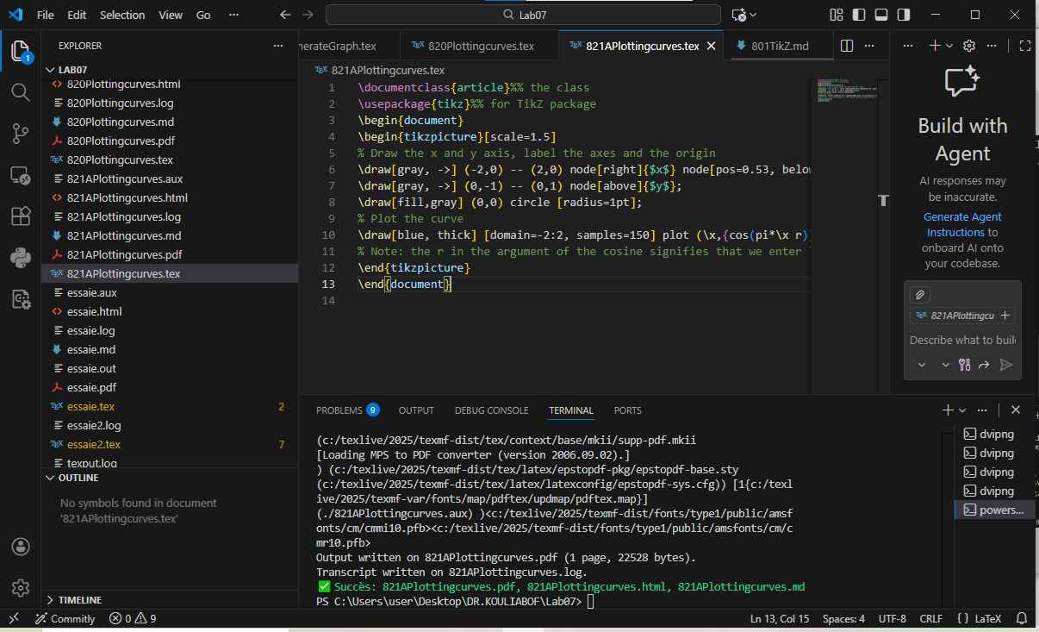

821BPlottingcurves - Parabola with axes
\documentclass{article}
\usepackage{tikz}
\begin{document}
\begin{tikzpicture}
\draw[gray, ->] (-3,0) -- (3,0) node[right]{$x$} node[pos=0.53, below]{$O$};
\draw[gray, ->] (0,-2) -- (0,2) node[above]{$y$};
\draw[fill,gray] (0,0) circle [radius=1pt];
\draw [domain=-2:2] plot (\x, {pow(\x,2)}) node[right] {$y = x^2$};
\end{tikzpicture}
\end{document}

Generated figure

Screenshot
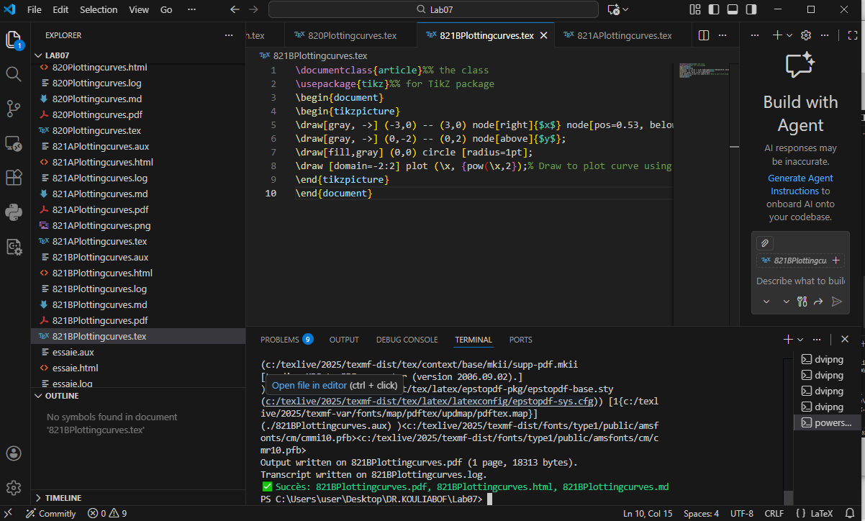

830TikZWorkingWithLoops - Simple loops
\documentclass{article}
\usepackage{tikz}
\begin{document}
\begin{tikzpicture}[scale=0.75]
\foreach \x in {0,1,2,3}
\draw[red,thick] (0,\x) circle [radius=\x+1];
\end{tikzpicture}
\end{document}

Generated figure

Screenshot
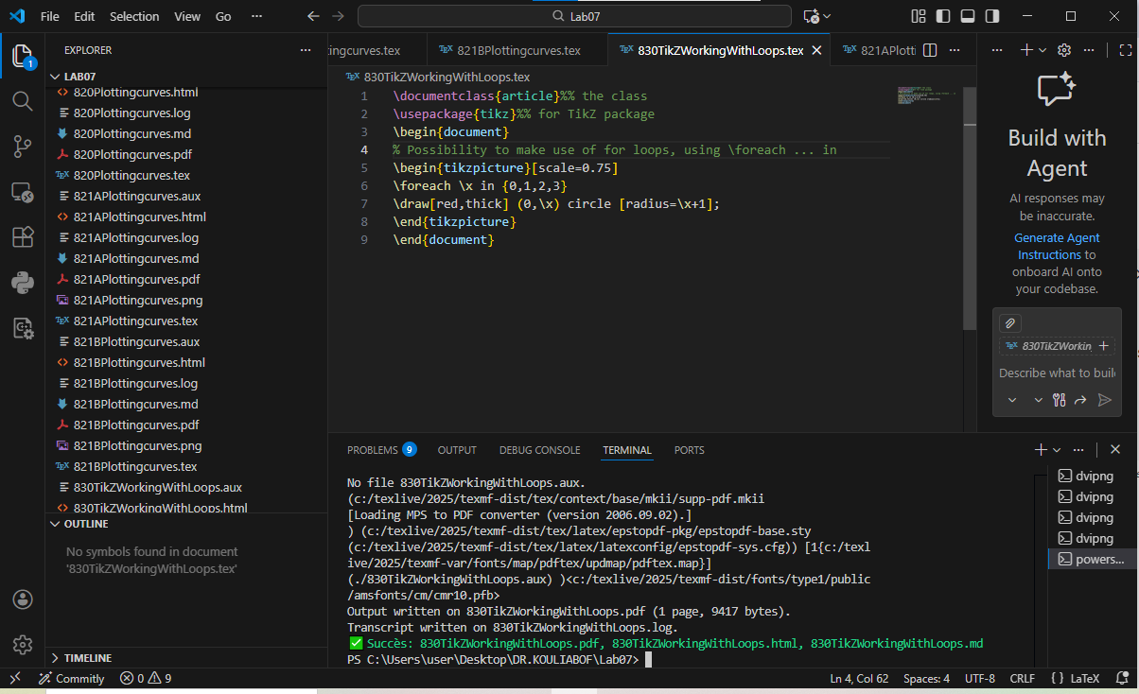

831TikZWorkingWithLoopsSierpiński - Sierpiński triangle
\documentclass[border=1cm]{standalone}
\usepackage{tikz}
\usetikzlibrary{math}
\newcommand\Triangle[2]{
\draw #1 coordinate(a)-- ++(0:#2) coordinate(b);
\draw (a)-- ++(60:#2) coordinate(c);
\fill (a)-- (b)-- (c)-- cycle;
}
\begin{document}
\begin{tikzpicture}
\tikzmath{
function sierpinski(\x, \y, \s, \d) {
if (\d == 0) then {
{ \Triangle{(\x,\y)}{\s}; };
} else {
\u1 = 0.25*\s;
\u2 = \u1*sqrt(3);
\u3 = 0.5*\s;
sierpinski(\x,\y,\u3,\d-1);
sierpinski(\x+\u3,\y,\u3,\d-1);
sierpinski(\x+\u1,\y+\u2,\u3,\d-1);
};
};
\S = 4;
for \d in {0,...,5}{
% To situate all plots nicely under and next to each other, define the coords
% of the lower left corners preemptively
\x = (\S+1)*mod(\d,2);
\y = int(\d/2) * (\S+1);
sierpinski(\x,-\y,\S,\d);
};
}
\end{tikzpicture}
\end{document}

Generated figure

Screenshot
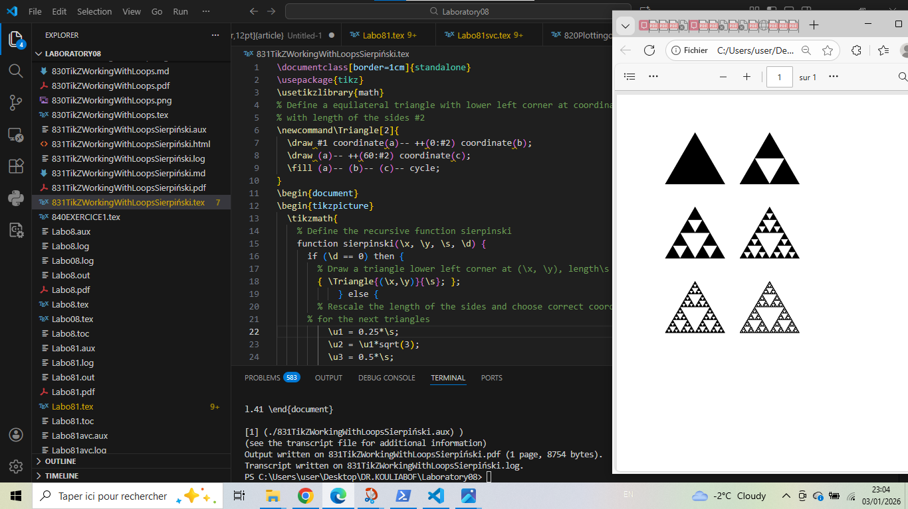

840EXERCICE1 - Exercise: Pentagon
\documentclass{article}
\usepackage{tikz}
\begin{document}
\begin{tikzpicture}
\foreach \a/\i in {0/1,72/2,144/3,216/4,288/5}
\node[circle,draw] (v\i) at (\a:2) {$v_{\i}$};
\draw (v1)--(v2)--(v3)--(v4)--(v5)--cycle;
\draw[red] (v1)--(v3)--(v5)--(v2)--(v4)--cycle;
\end{tikzpicture}
\end{document}

Generated figure

Screenshot
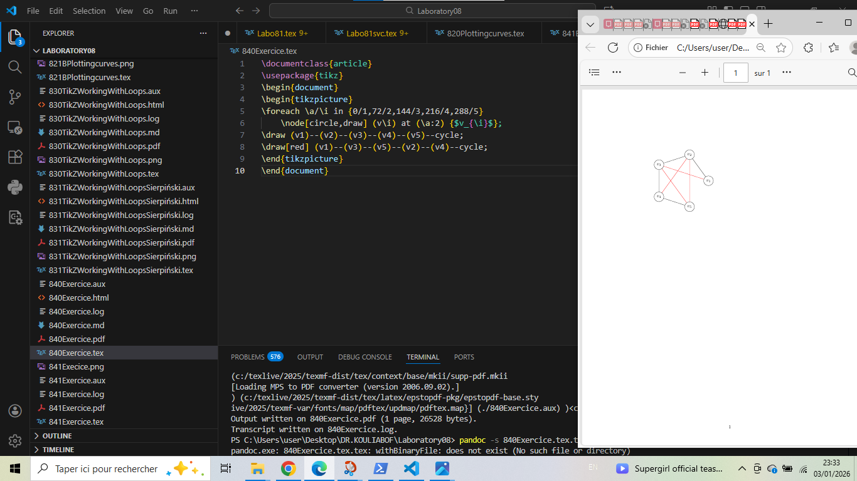

841EXERCICE - Exponential and logarithmic functions
\documentclass[border=1cm]{standalone}
\usepackage{tikz}
\usepackage{amsmath}
\begin{document}
\begin{tikzpicture}[>=stealth, scale=1.2]
\draw[very thin, gray!30] (-2,-2) grid (4,4);
\draw[->, thick] (-2.5,0) -- (4.5,0) node[right] {$x$};
\draw[->, thick] (0,-2.5) -- (0,4.5) node[above] {$y$};
\node[below left] at (0,0) {$O$};
\draw[blue, thick, domain=-2.2:1.4, samples=50]
plot (\x, {exp(\x)}) node[right] {$y=e^x$};
\draw[red, thick, domain=0.12:4.2, samples=50]
plot (\x, {ln(\x)}) node[above right] {$y=\ln(x)$};
\filldraw[blue] (0,1) circle (2pt);
\node[left, blue] at (0,1) {$A(0,1)$};
\filldraw[red] (1,0) circle (2pt);
\node[below right, red] at (1,0) {$B(1,0)$};
\end{tikzpicture}
\end{document}

Generated figure

Screenshot
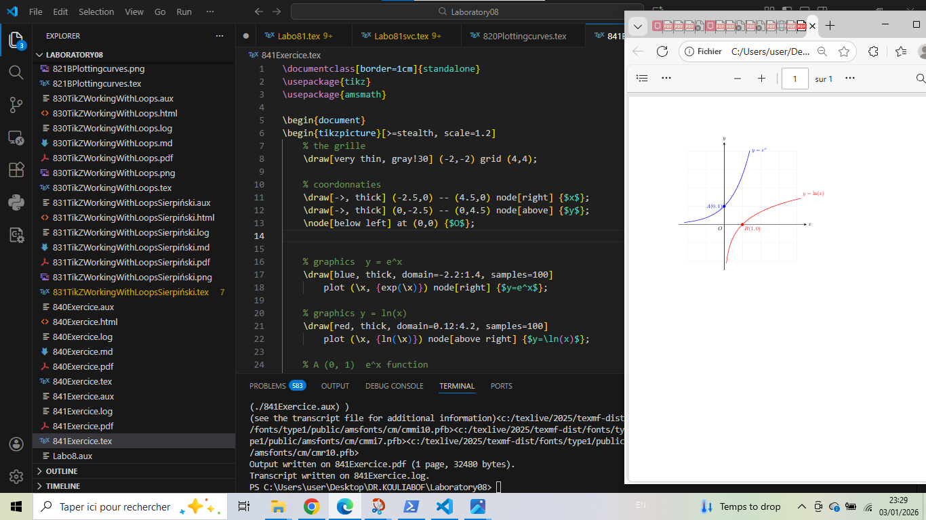

842EXERCICE3 - Fractal tree
\documentclass[border=1cm]{standalone}
\usepackage{tikz}
\usetikzlibrary{math}
\begin{document}
\begin{tikzpicture}[x=1cm, y=1cm]
\tikzmath{
function drawtree(\x, \y, \angle, \size, \depth) {
if (\depth > 0) then {
\nextx = \x + \size * cos(\angle);
\nexty = \y + \size * sin(\angle);
{
\draw[line width=\size*2, color=green!\depth!brown]
(\x, \y) -- (\nextx, \nexty);
};
\newsize = \size * 0.75;
\newdepth = \depth - 1;
drawtree(\nextx, \nexty, \angle + 25, \newsize, \newdepth);
drawtree(\nextx, \nexty, \angle - 35, \newsize, \newdepth);
};
};
drawtree(0, 0, 90, 1.5, 9);
}
\end{tikzpicture}
\end{document}

Generated figure

Screenshot
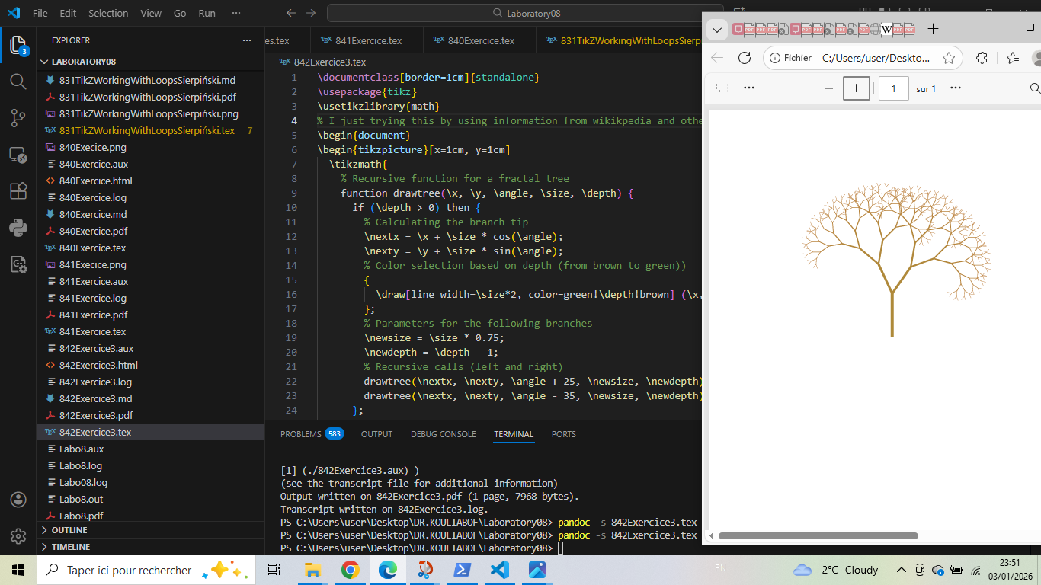

Conclusion: Methodology for creating successful TikZ documents
After exhaustive study of TikZ examples, here is the structured methodology for creating successful TikZ documents:

1. Essential basic structure
\documentclass{article} % or standalone for figures only
\usepackage{tikz} % REQUIRED first
\usepackage{amsmath} % For mathematical formulas
% Other packages as needed
\begin{document}
\begin{tikzpicture}[options]
% Your TikZ code here
\end{tikzpicture}
\end{document}

2. Recommended progressive approach
Step 1: Planning
- Define dimensions (min/max coordinates)
- Identify graphical elements (lines, shapes, text)
- Choose appropriate scale
Step 2: Build in layers
- Reference grid (draw[gray, thin] (0,-8) grid (5,5);)
- Axes and reference marks
- Main elements
- Details and annotations
- Legends and text
Step 3: Optimize
- Use custom styles: \tikzset{monstyle/.style={red, thick}}
- Define reusable nodes
- Organize with relative coordinates

3. Essential best practices
Practice | Example
Comment code | % X-axis
Name nodes | (A) at (0,0)
Use loops | \foreach for repetitions
Separate style/content | Styles in preamble, drawing in tikzpicture
Test frequently | Compile often to detect errors

4. Synthetic conclusion
To create successful TikZ documents:
1. Structure: Preamble → Environment → Commands → Closure
2. Iterate: Simple → Complex, Grid → Axes → Shapes → Details
3. Optimize: Styles, Loops, Named nodes
4. Verify: Semicolons, Names, Scale
5. Document: Comments, Separate files, Notes
Final reminder: TikZ is a powerful tool requiring practice. Always start with simple examples, gradually increase complexity, and don’t hesitate to break down complex figures into several independent tikzpicture environments.

