PHASE 5 PROJECT SUBMISSION

WATER QUALITY ANAYSIS

TEAM MEMBERS:
- Aazam Khan - 2021504002
- Sasmitha A – 2021504038
- Swetha K – 2021504051
- Gokul R – 2021504515

PROJECT DEFINITION:
The project involves analyzing water quality data to assess the suitability of water for specific purposes, such as drinking. The objective is to identify potential issues or deviations from regulatory standards and determine water potability based on various parameters. This project includes defining analysis objectives, collecting water quality data, designing relevant visualizations, and building a predictive model.

PHASE OBJECTIVE:
In this technology projects you will continue building your project by performing different analysis, model building and evaluation as per the project requirement. Perform different analysis and visualization using IBM Cognos.

Dataset Link: https://www.kaggle.com/datasets/adityakadiwal/₌water-potability

PROJECT APPROACH:
Water quality analysis using data analytics typically involves a combination of data preprocessing, feature engineering, and the application of machine learning algorithms. Below is a simplified algorithmic outline for water quality analysis:
1. Data Collection:
- Gather water quality data from various sources, such as sensors, monitoring stations, or laboratory tests. Ensure that the data includes relevant parameters (e.g., pH, temperature, dissolved oxygen, contaminants).
2. Data Preprocessing:
- Clean the data by handling missing values and outliers.
- Normalize or scale the data as needed.
- Perform any necessary data transformations.
3. Feature Engineering:
- Select relevant features (water quality parameters) that will be used for analysis.
- Create new features if domain knowledge suggests they might be informative.
4. Data Splitting:
- Split the dataset into training and testing sets to evaluate model performance.
5. Algorithm Selection (SVM MODEL):
Support Vector Machine (SVM) is a powerful machine learning algorithm that can be used for water quality analysis, especially for classification tasks where you want to categorize water quality as safe or polluted

FLOWCHART:
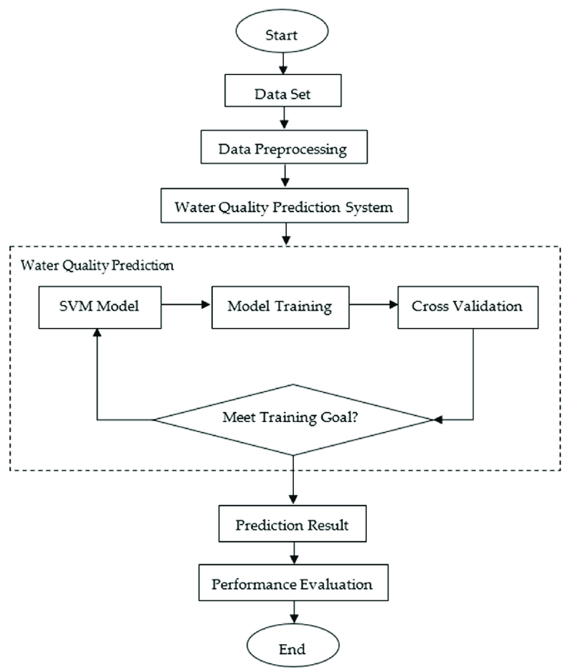

SMOTE:
RANDOM FOREST:

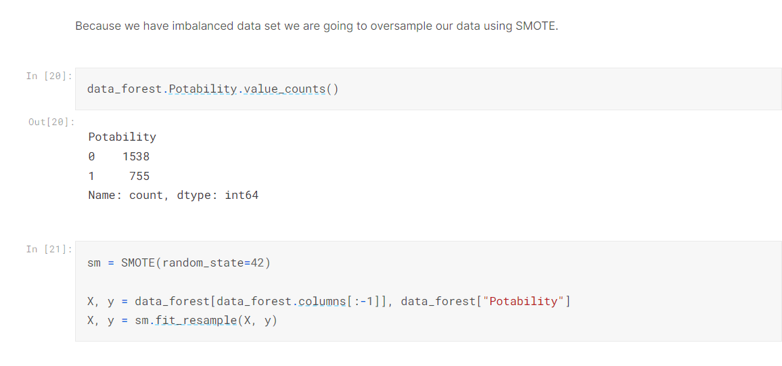

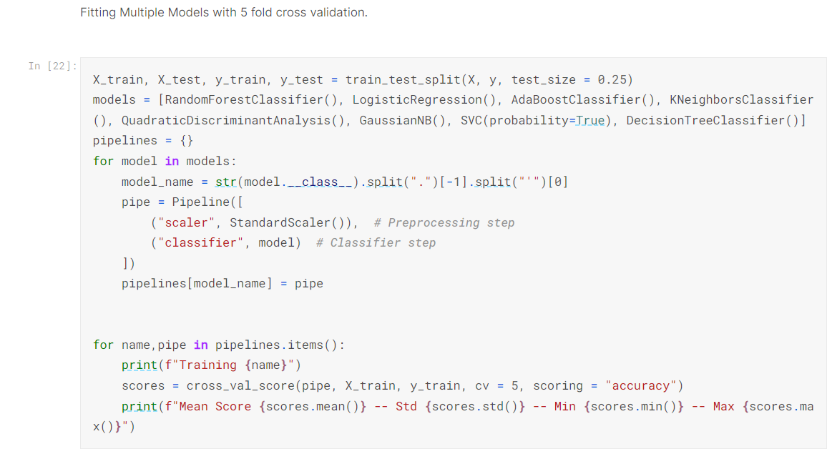
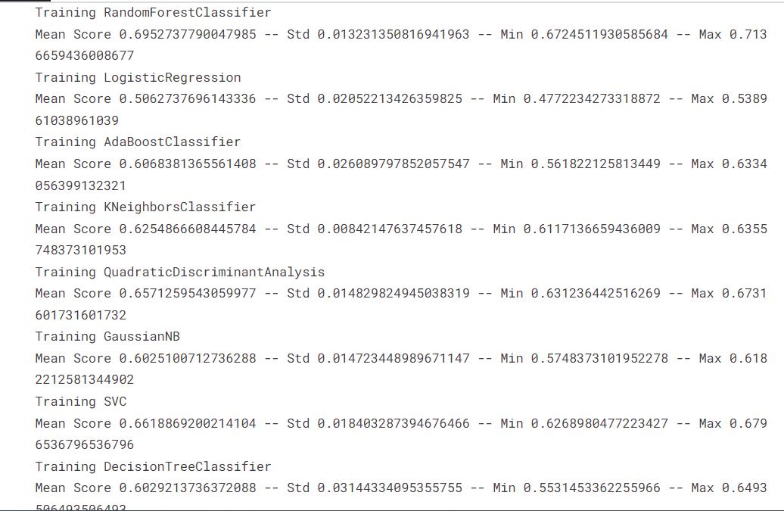

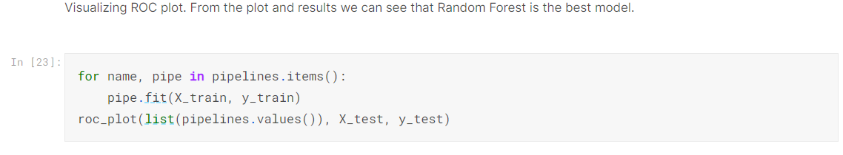
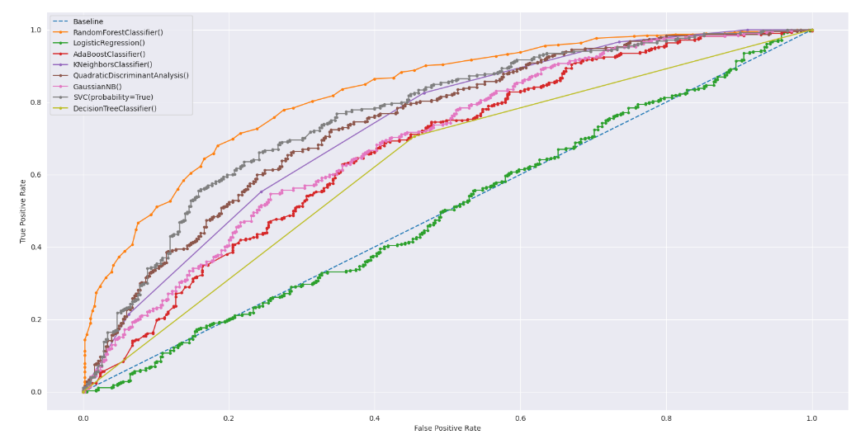
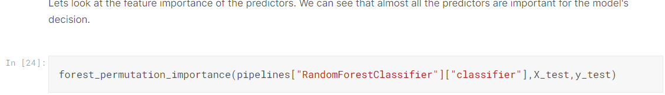
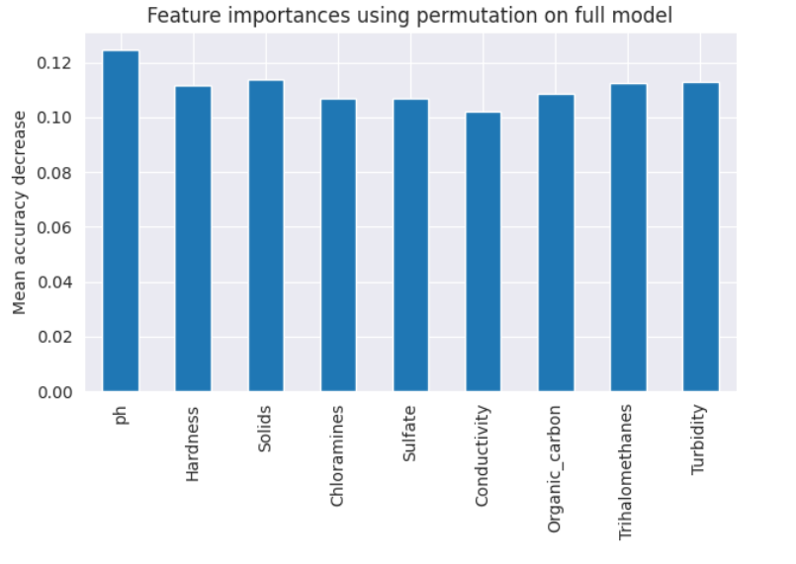
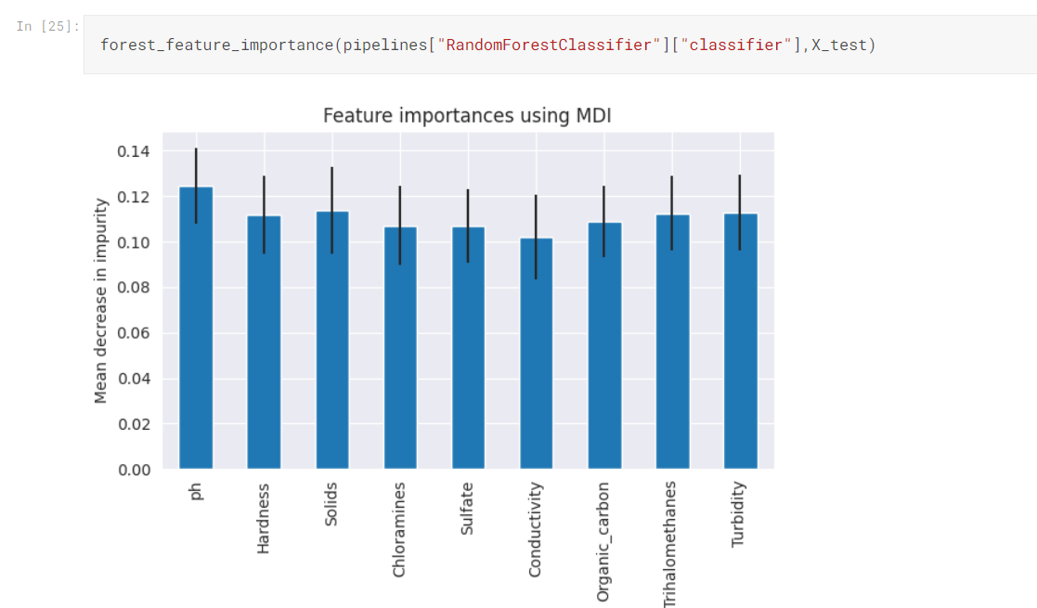
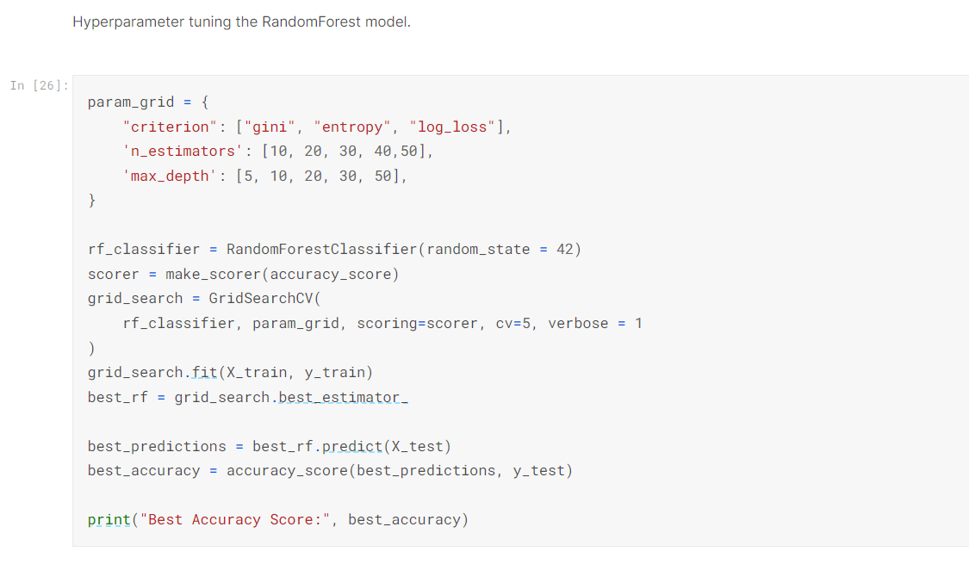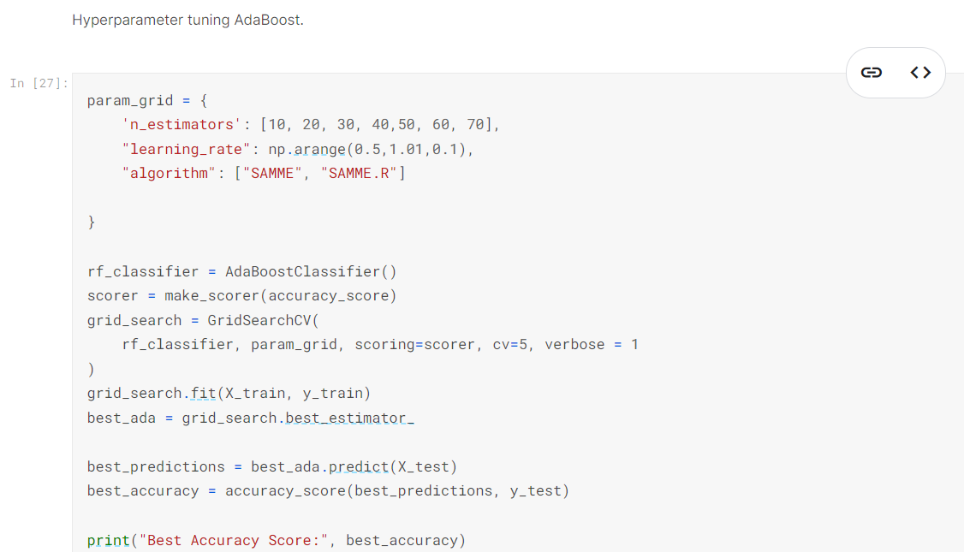
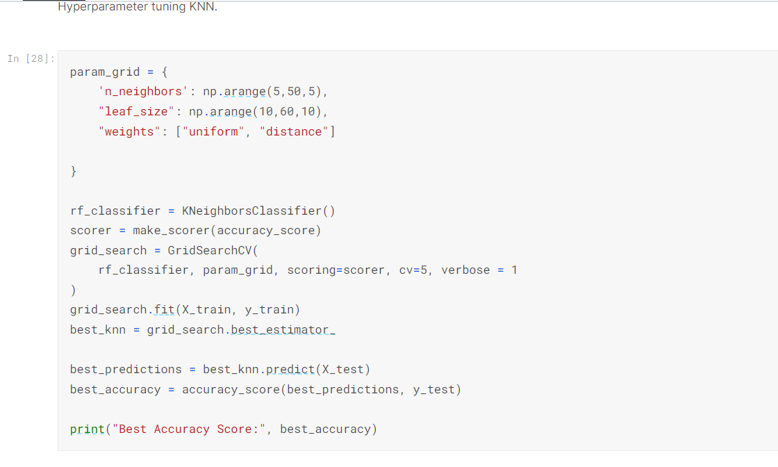
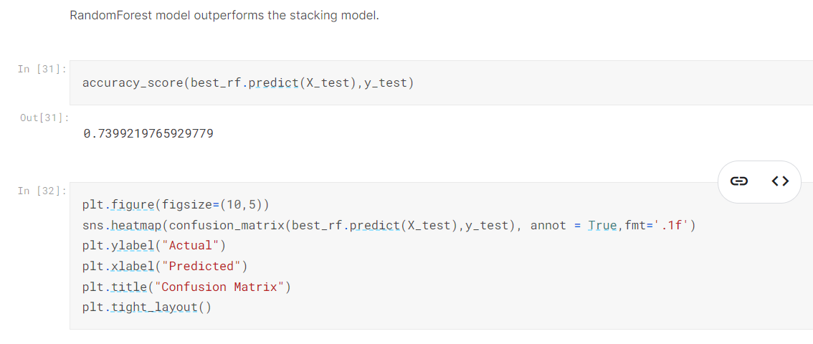
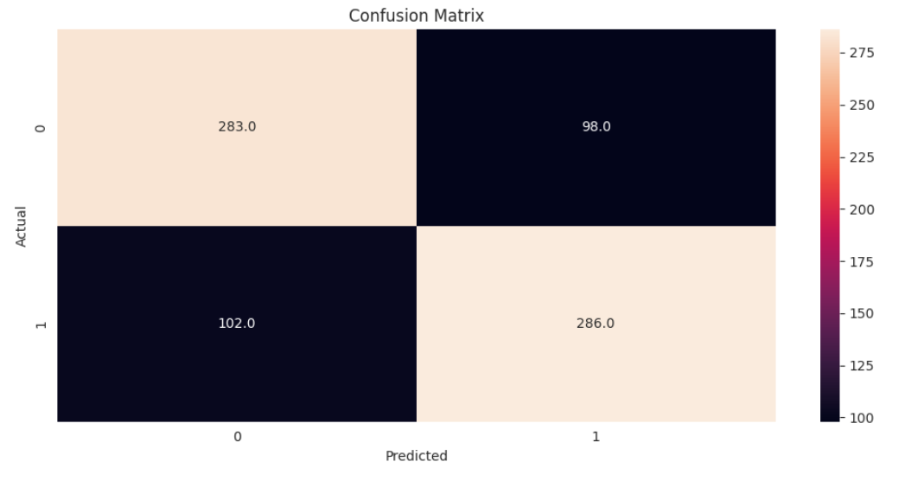
The following insights were obtained from IBM Cognos based upon the data:

A Bar graph was plotted for the given data:

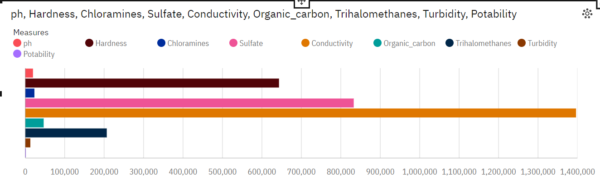

- The overall number of results for Chloramines, Conductivity, Hardness, Organic carbon, Potability and Turbidity is almost 3500.
- The overall number of results for Sulphate is almost 2500.
- The overall number of results for Trihalomethanes and ph is over three thousand.

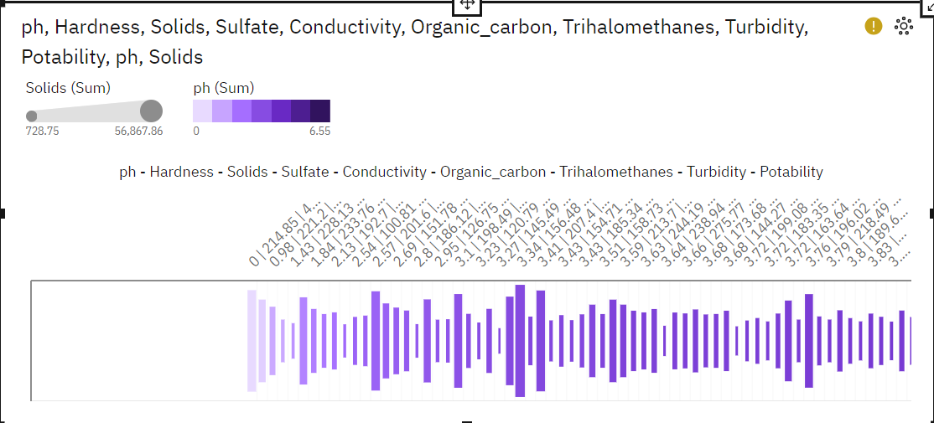

FUTURE SCOPE:
The water quality analysis project has reached a substantial milestone by diligently addressing data cleaning, preprocessing, and employing a variety of models such as Isolation Forest, Random Forest, SMOTE, and Logistic Regression for anomaly detection and classification. To further advance this project, several promising future directions can be explored.

Firstly, improving model performance is essential. Advanced machine learning techniques like deep learning, ensemble methods, or state-of-the-art anomaly detection algorithms may be considered to enhance accuracy and generalization on complex water quality datasets. Fine-tuning hyperparameters and optimizing feature selection could also play a crucial role.

Secondly, real-time data integration can provide timely insights into water quality. Incorporating streaming data sources or sensor networks could enable continuous monitoring and immediate detection of anomalies, allowing for quicker response to potential contamination events.

Moreover, the integration of Internet of Things (IoT) devices can revolutionize data collection and analysis. Implementing sensors and smart devices for real-time data acquisition, alongside automated data processing, can enhance the project's efficiency and accuracy.

Collaboration with environmental agencies and local authorities is another avenue to consider. Sharing findings and insights with relevant stakeholders can lead to more effective water quality management strategies and quicker response to pollution incidents.

In summary, the project's future scope entails harnessing advanced machine learning techniques, embracing real-time data streams, incorporating IoT technology, and collaborating with relevant authorities. By doing so, this project can significantly contribute to the preservation and sustainable management of precious water resources, ensuring clean and safe water for communities and ecosystems.

CONCLUSION:
Thus the predictive models were built and water quality analysis was performed and different visualizations were performed using IBM cognos.

