DIGITAL PRIVACY & SECURITY GUARDIAN (DPSG) - CYBERX

PROJECT WORK PHASE 1 (REVIEW 2)
Submitted by

PERARASU M 212222100033
in partial fulfilment for the award of the degree of

BACHELOR OF ENGINEERING

in

COMPUTER SCIENCE AND ENGINEERING(CS)



SAVEETHA ENGINEERING COLLEGE, THANDALAM
An Autonomous Institution Affiliated to

ANNA UNIVERSITY - CHENNAI 600 025

NOVEMBER 2025

ANNA UNIVERSITY, CHENNAI

BONAFIDE CERTIFICATE

Certified that this Project report “ DIGITAL PRIVACY & SECURITY GUARDIAN (DPSG) - CYBERX ” is the bonafide work of PERARASU M (212222100033), who carried out this project work under my supervision.

SIGNATURE  Mr. C. Rajesh, M.E., (Ph.D)  Assistant Professor  SUPERVISOR  Dept of Computer Science and Engineering (IOT)  Saveetha Engineering College, Thandalam, Chennai 602105 | SIGNATURE  Dr. G. Nagappan, M.E., Ph.D  Professor  HEAD OF THE DEPARTMENT  Dept of Computer Science and Engineering,  Saveetha Engineering College, Thandalam, Chennai 602105.

DATE OF THE VIVA VOCE EXAMINATION: …………………………

INTERNAL EXAMINER EXTERNAL EXAMINER
ACKNOWLEDGEMENT

I would like to express my heartfelt gratitude to our esteemed Founder President Dr. N. M. Veeraiyan, our President Dr. Saveetha Rajesh, our Director Dr. S. Rajesh, and the entire management team for providing the essential infrastructure.
I extend my sincere appreciation to our principal, Dr. V. Vijaya Chamundeeswari, M.Tech., Ph.D., for creating a supportive learning environment for this project.
I am very thankful to our Dean of ICT, Mr. Obed Otto, M.E., for facilitating a conducive atmosphere that allowed me to complete my project successfully.
My thanks go to Dr. G. Nagappan, Professor and Head of the Department of Computer Science and Engineering at Saveetha Engineering College, for his generous support and for providing the necessary resources for my project work.
I would also like to express my profound gratitude to my Supervisor, Mr. C. Rajesh, Assistant Professor and my Project Coordinator Dr. N.S. Gowri Ganesh, Associate Professor at Saveetha Engineering College, for their invaluable guidance, suggestions, and constant encouragement, which were instrumental in the successful completion of this project. Their timely support and insights during the review process were greatly appreciated.
I am grateful to all my college faculty, staff, and technicians for their cooperation throughout the project. Finally, I wish to acknowledge my loving parents, friends, and well-wishers for their encouragement in helping me achieve this milestone.

ABSTRACT

In the contemporary digital landscape, the volume of personal data collected, stored, and processed by mobile applications and connected devices has grown exponentially. This pervasive data collection—often opaque and continuous—presents significant security and privacy challenges. While traditional security tools focus on reactive anti-malware solutions, primarily designed to combat known viruses and exploits after a system breach has occurred, a critical and widening gap exists in providing users with proactive, privacy-first protection. Users currently suffer from a severe lack of control over their digital footprint, particularly concerning which applications are utilizing sensitive hardware permissions (such as the microphone, camera, and location services) in the background without explicit, constant user oversight.
This paper introduces the Digital Privacy & Security Guardian (DPSG), an innovative AI-powered mobile application meticulously designed to deliver proactive, real-time protection for the user's entire digital life. It constitutes a fundamental shift in the security paradigm, moving beyond the traditionally reactive approach of anti-malware solutions to focus on privacy-first behavioral monitoring and absolute user control. The system achieves this by deeply integrating with Operating System (OS) APIs to facilitate real-time, granular monitoring of sensitive app permissions.
At its core, DPSG features a sophisticated intelligence layer that employs a hybrid approach: Rule-Based Detection for immediate, known threats, and Light Machine Learning (ML) Anomaly Detection to intelligently flag unusual or suspicious behaviors. This includes scenarios like an infrequently used application accessing the microphone or camera outside expected operational hours. The result is translated into actionable insights presented via a clean, unified dashboard and structured Weekly Privacy/Security Reports, specifically designed to enhance user engagement, improve digital literacy, and foster safer security practices.
Distinguishing features of DPSG encompass a Unified Dashboard for centralized, one-stop permission management and a Built-in VPN with Ad-Blocking capability, ensuring encrypted network traffic and robust prevention of pervasive third-party tracking. By providing complete visibility, granular control, and contextual awareness over data access across their digital ecosystem, DPSG bridges the critical gap between passive device security and the user’s need for total digital control. The proposed system attains exceptional accuracy with a low false positive rate and is optimized for minimal battery consumption.
Keywords: Digital Privacy, Android Security, Anomaly Detection, Real-time Monitoring, Light ML, Privacy Guardian, Unified Dashboard, Behavioral Analysis.

TABLE OF CONTENTS

CHAPTER NO. |  |  | TITLE | Page  Number
1 |  |  | INTRODUCTION
 | 1.1 |  | Overview of the project | 1
 | 1.2 |  | Problem Definition | 2
2 |  |  | LITERATURE SURVEY | 3
3 |  |  | SYSTEM ANALYSIS
 | 3.1 |  | Existing System | 9
 | 3.2  3.3  3.4 |  | Disadvantages Proposed System Advantages | 9  10  10
 | 3.5 |  | Feasibility Study | 10
 | 3.6 |  | Hardware Environment | 11
 | 3.7 |  | Software Environment | 11
 | 3.8 |  | Technologies Used | 11
4 |  |  | SYSTEM DESIGN
 | 4.1 |  | ER- Diagram | 15
 | 4.2 |  | Data Flow Diagram | 16
 | 4.3 |  | UML Diagram
 |  | 4.3.1 | Use Case Diagram | 18
 |  | 4.3.2 | Class Diagram | 19
 |  | 4.3.3 | Sequence Diagram | 20
5 |  |  | SYSTEM ARCHITECTURE
 | 5.1 |  | Architecture Diagram | 21
 | 5.2 |  | Algorithms | 22
6 |  |  | SYSTEM IMPLEMENTATION
 | 6.1 |  | Module-1 | 23
 |  |  | App Permission Manager
 | 6.2 |  | Module-2 | 24
 |  |  | Real-Time Monitoring
 | 6.3 |  | Module-3 | 25
 |  |  | Intelligence Layer & Alerts
7 |  |  | SYSTEM TESTING
 | 7.1  7.2 |  | Black Box Testing White Box Testing | 26  27  28
 | 7.3 |  | Test Cases
8 |  |  | CONCLUSION AND FUTURE
 |  |  | -ENHANCEMENT
 | 8.1 |  | Conclusion | 32
 | 8.2 |  | Future Enhancement | 33
9 |  |  | APPENDIX-1  Source Code | 34
10 |  |  | APPENDIX-2
 | 10.1  10.2  10.3  10.4  10.5 |  | Sample Output  Home Page  App Permission Manager  Real-Time Monitoring Feed  Privacy Reports & System Health  AI Behavioral Alerts | 42  43  44  45  46
11 |  |  | REFERENCES | 47

LIST OF TABLES

TABLE NO. TABLE DESCRIPTION PAGE NO.
    - Test Case For Video Upload 24

    - Test Case For Search And Detect Type Of Traffic 25
Infringement

LIST OF FIGURES

FIGURE NO. | FIGURE DESCRIPTION | PAGE NO.
4.1 | Entity Relationship Diagram | 12
4.2.1 | Level 0 of Data flow Diagram | 13
4.2.2 | Level 1 of Data flow Diagram | 13
4.3.1 | Use Case Diagram | 14
4.3.2 | Class Diagram | 15
4.3.3 | Sequence Diagram | 16
5.1 | Architecture Diagram | 17
5.2.1 | Yolo V7 Object Detection Model | 18
10.1 | Home Page | 35
10.2 | Detection With Details | 36
10.3 | Real Time Visualization | 37
10.4 | Alert Message | 38

LIST OF ABBREVIATIONS

DPSG | Digital Privacy & Security Guardian
AI | Artificial Intelligence
ML | Machine Learning
VPN | Virtual Private Network
OS | Operating System
FPR | False Positive Rate
GDPR | General Data Protection Regulation
SDG | Sustainable Development Goals

LIST OF SYMBOLS

S.NO. | SYMBOL NAME | SYMBOL
1. | Usecase
2. | Actor | 
3. | Process
4. | Start
5. | Decision
6. | Unidirectional
7. | Entity set
8. | Stop

Chapter 1 INTRODUCTION

OVERVIEW OF THE PROJECT

The contemporary digital ecosystem is characterized by an unprecedented volume of personal data being perpetually collected, stored, and processed by third-party mobile applications and interconnected devices. This phenomenon has led to a critical paradigm where the user's digital life is constantly susceptible to privacy violations and unauthorized data harvesting, which constitute the modern equivalent of digital "accidents." The sheer scale and opacity of continuous data collection—often involving sensitive sensors like the microphone, camera, and GPS—have severely undermined user trust and autonomy.
The inadequacy of Traditional Security Tools forms the primary motivation for this project. Legacy antivirus and anti-malware solutions are fundamentally reactive; they operate on a signature-based detection model, focusing exclusively on identifying and mitigating known viruses and exploits after a system breach has occurred. This reactive stance leaves a critical and widening gap, particularly against "grayware" (legitimate applications that over-collect data) and novel, behavioral privacy exploits that exploit system permissions legally but maliciously. Without establishing a baseline for expected behavioral norms, these subtle but pervasive forms of privacy erosion go entirely undetected by current security frameworks.
To address this technological and philosophical gap, we introduce the Digital Privacy & Security Guardian (DPSG). The DPSG is conceptualized as an AI-powered mobile and desktop application that facilitates a fundamental shift in the security paradigm. Our system transitions from a reactive scanning model to one of proactive, real-time behavioral monitoring. This is achieved by deeply integrating with Operating System (OS) APIs to establish granular, continuous visibility into sensitive app permissions and network activity.
DPSG’s core innovation lies in its Hybrid Intelligence Layer, which seamlessly combines Rule-Based Detection for immediate, high-certainty threats with Light Machine Learning (ML) Anomaly Detection. This Light ML model, critically optimized for minimal resource consumption, establishes a statistical baseline of "normal" behavior for each application. Any statistically significant deviation—such as a non-communication app unexpectedly activating the microphone at 3 AM—is instantly flagged as an anomaly. By providing this unified, intelligent, and user-friendly platform, DPSG aims to restore absolute user control and elevate digital literacy, enabling users to manage their privacy actively rather than passively respond to threats. The final output is a user-centric system that ensures confidentiality, integrity, and non-repudiation of personal data.

PROBLEM DEFINITION

The fundamental challenge confronting modern digital security is the pronounced lack of user control and genuine awareness concerning the extensive digital footprint generated by the multitude of third-party applications. This issue is primarily driven by severe information asymmetry, where users are often completely unaware of which applications are actively accessing sensitive sensors—such as the microphone, camera, and location services—in the background. Furthermore, existing security measures are largely reactive legacy tools; traditional antivirus solutions fail to adequately detect "grayware," which are apps that are technically legal but exploit permissions for insidious tracking or unauthorized data harvesting.
Thus, there is a critical need for incorporating advanced artificial intelligence-based techniques to eliminate the reliance on manual intervention for the detection of privacy violations. The proposed method is designed to enforce strong regulation of privacy rules and restore digital autonomy to the user.

Chapter 2 LITERATURE SURVEY

INTRODUCTION

A literature survey is a cornerstone of any research project, serving as a comprehensive review of existing academic and industrial work related to the field of interest. In this project report, this section analyzes the current state of mobile privacy, the evolution of permission management systems, and the methodologies used in real-time threat detection. It takes into account the various parameters of the project, such as battery efficiency, detection accuracy, and user usability, while highlighting the results already published by the research community. This survey is instrumental in establishing the theoretical framework for the Digital Privacy & Security Guardian (DPSG). It allows us to identify the limitations of existing reactive security tools—such as their inability to detect "grayware"—and validates the necessity for a proactive, behavioral approach. Furthermore, once development begins, this survey provides essential external support, offering architectural blueprints and algorithmic strategies derived from established senior research, textbooks, and technical repositories. Ultimately, it is the most important part of the report as it defines the research gap and gives clear direction to the area of our proposed research.

LITERATURE SURVEY

Machine Learning for Runtime Permission Monitoring in Android Applications

Author Name : A. Sharma and S. Gupta

Year of Publish : 2023

This foundational study validates the robust application of Machine Learning (ML) techniques to comprehensively monitor and govern runtime permissions within the Android operating environment. The core concept involves a strategic departure from the limitations of static code analysis by utilizing sophisticated, kernel-level system call tracing and comprehensive sensor usage logs. The authors demonstrate that by dynamically establishing a precise behavioral baseline for running applications, the system can identify statistically significant deviations.
The study is particularly significant for our project as it proves that light ML models can effectively identify novel, zero-day privacy attacks without requiring access to an application’s source code. However, the research also highlights a critical challenge: the potential for high battery consumption if the continuous background monitoring process is not rigorously optimized. This insight directly informs DPSG’s requirement for a "Light ML" approach to ensure battery efficiency.

A Novel Approach to DNS-based Tracking Prevention in Mobile VPN Architectures
Author Name : M. Chen and R. Kumar

Year of Publish : 2022

This architectural investigation centers on substantially enhancing mobile network privacy by addressing the prevalent issue of third-party trackers and advertisers bypassing conventional security measures. The proposed solution involves the implementation of a localized, policy-based DNS filter deployed directly within a high-speed Virtual Private Network (VPN) tunnel.
The methodology describes intercepting all outgoing DNS requests and analyzing them against a dynamic blocklist of known tracking entities, effectively blocking malicious resolution before any connection is established. The analysis highlights key advantages relevant to DPSG: exceptional speed, minimal system overhead, and zero-latency blocking compared to traditional proxy methods. This validates our architectural choice to integrate a Network Layer capable of encrypted tunneling and DNS filtering.

2.2.3 Empowering Users: A Review of Privacy-Enhancing Technologies in Mobile Operating Systems
Author Name : Y. Li and K. Das

Year of Publish : 2022

This industry-focused research delivers a rigorous analytical review of the Privacy-Enhancing Technologies (PETs) currently deployed within modern mobile ecosystems. The authors conduct a comparative scrutiny of native Operating System defenses—specifically dynamic runtime permission managers, on-screen visual privacy indicators, and secure application sandboxing—against the disjointed landscape of third-party external security tools.
A critical outcome of this investigation is the identification of a profound "usability gap," driven by the observation that while sophisticated security mechanisms exist, their practical efficacy is severely compromised by pervasive interface fragmentation, inconsistent policy enforcement across different application categories, and the high cognitive load required for users to navigate deep system menus.
The study emphatically argues that the mere technical availability of these tools is insufficient for protection; instead, it advocates for a radical consolidation of privacy controls and the mandatory integration of contextual digital literacy education.
These critical findings serve as the primary empirical justification for the architectural philosophy behind the Digital Privacy & Security Guardian (DPSG). The research highlights that the failure of current mobile security is not due to a lack of technology, but a lack of accessibility. Consequently, DPSG explicitly addresses this by implementing a Unified Dashboard, which dismantles the barrier of menu fragmentation by centralizing permission management, real-time threat monitoring, and network controls into a single, intuitive interface. Furthermore, the study's emphasis on the necessity of digital literacy validates the inclusion of Weekly Privacy Reports.

2.2.4 Comparative Analysis of Machine Learning Algorithms for Android Malware Detection

Author Name : H. AlOmari et al.

Year of Publish : 2023

This research investigates the efficiency of various machine learning algorithms in detecting Android malware and "riskware" (apps that pose privacy risks). The paper utilizes a large dataset of Android Package Kits (APKs) to classify applications into categories such as Adware, SMS Malware, and Benign. The authors apply advanced techniques like Synthetic Minority Oversampling (SMOTE) and Principal Component Analysis (PCA) to enhance detection accuracy. The study is highly relevant to DPSG as it highlights the performance trade-offs between different ML models (e.g., LightGBM vs. Random Forest). It validates our project's choice of using a "Light ML" approach, demonstrating that optimized algorithms can achieve high F1-scores in distinguishing between safe and suspicious apps without requiring heavy computational resources, which is crucial for maintaining mobile battery life.

2.2.5 Mobile Application Privacy Risk Assessments from User-authored Scenarios
Author Name : T. Huang et al.

Year of Publish : 2023

This research introduces a novel, lightweight methodology for assessing privacy risks through the analysis of user-authored scenarios using Named Entity Recognition (NER) models. By identifying sensitive data types that often evade standard mobile permission controls, the study validates the design of the DPSG "Intelligence Layer" and supports the need for context-aware monitoring. This work strongly reinforces DPSG's strategy of tracking how and when data is accessed (behavioral context) rather than merely if a permission is granted, underscoring the necessity of the "Weekly Privacy Report" to bridge the critical gap between technical permissions and the user's understanding of actual privacy harm.

LITERATURE SURVEY SUMMARY

S.No | Research | Technique | Features Used | Domain | Disadvantage / Advantage | Future Direction
1.  2.  3.  4.  5. | ML for Runtime Permission Monitoring  Sharma & Gupta, 2023  DNS-based Tracking Prevention  M. Chen & R. Kumar, 2022  Empowering Users: Review of PETs  Y. Li & K. Das, 2022  Comparative Analysis of ML Algorithms  H. AlOmari et al., 2023  Mobile App Privacy Risk Assessments  T. Huang et al., 2023 | ML Classification (Anomaly Detection)  VPN Tunneling, Policy-based DNS Filtering  User-Centric Design Analysis  Supervised Learning (LightGBM, SMOTE)  Named Entity Recognition (NER) | System Call Tracing, Sensor Usage Logs  Domain Lists, Network Traffic Metadata  UI/UX Studies, Native OS Controls  Dynamic Features, System Calls  User Scenarios, Information Types | Android Security  Mobile Network Privacy  Privacy Management  Android Security  Privacy Engineering | Adv: Detects zero-day threats/misuse.  Disadv: High battery consumption if not optimized.  Adv: High speed, low overhead Ad/Tracker blocking.  Disadv: Requires OS-level VPN permission/setup.  Adv: Identifies usability gaps in current OS.  Disadv: Fragmented controls reduce user engagement.  Adv: High accuracy in distinguishing riskware.  Disadv: Requires balanced datasets for training.  Adv: Identifies risks missed by standard permissions.  Disadv: Relies on user-generated context. | Adapt model to focus on low-resource background monitoring (DPSG).  Integrate VPN control with behavioral monitoring alerts (DPSG).  Centralize controls into a Unified Dashboard to bridge the usability gap.  Implement LightGBM logic for DPSG's anomaly detection to ensure speed.  Use findings to refine DPSG's "Privacy Score" in Weekly Reports.

Chapter 3 SYSTEM ANALYSIS
  - EXISTING SYSTEM
The current state-of-the-art in mobile operating system security, specifically within the Android ecosystem, relies heavily on a decentralized permission model. While recent Android versions have introduced features like runtime permissions and visual indicators (green dots) for sensor usage, these native tools remain fundamentally fragmented. To audit or modify privacy settings, users are compelled to navigate through complex, multi-layered system menus, often on a tedious app-by-app basis. This high interaction cost leads to "privacy fatigue," where users default to granting permissions simply to avoid the hassle of configuration.
Furthermore, legacy security tools such as traditional antivirus software suffer from intrinsic architectural limitations. They are predominantly reactive, relying on signature-based detection methods that compare files against a known database of malware hashes. This approach renders them ineffective against "grayware"—applications that are technically legitimate and free of malware code but engage in aggressive, privacy-invasive behavioral patterns, such as excessive data collection or tracking.

DISADVANTAGES OF EXISTING SYSTEM

- Focuses strictly on known malware signatures, failing to stop zero-day privacy intrusions.
- Requires tedious manual audits of deep system menus, leading to low user engagement.
- Lacks the intelligence to distinguish between legitimate sensor usage and anomalous tracking.
- Security features (VPN, Antivirus) exist as separate apps, consuming resources and degrading experience.

PROPOSED SYSTEM

The proposed Digital Privacy & Security Guardian (DPSG) represents a next-generation, holistic security solution designed to address these gaps. DPSG integrates a proactive Monitoring Layer that deeply hooks into Android OS APIs to track sensitive sensor usage (Microphone, Camera, and Location) in real-time. This data is fed into a local Intelligence Layer, which employs a hybrid detection engine: it uses strict Rule-Based logic for immediate policy enforcement and Light Machine Learning (ML) models to detect subtle behavioral anomalies.
Furthermore, DPSG consolidates these fragmented controls into a Unified Dashboard, allowing users to manage permissions, toggle the built-in VPN, and view security alerts from a single interface. To ensure long-term behavioral change, the system generates automated Weekly Privacy Reports, transforming raw log data into actionable insights that improve the user's digital literacy.

ADVANTAGES OF PROPOSED SYSTEM

- Real-time monitoring stops invisible background activity before data loss occurs.
- Combines rules for known threats with Light ML for subtle, unknown anomalies..
- Centralizes permission management, VPN, and alerts into one dashboard to reduce cognitive load.
- Transforms users into informed managers through automated, simple Weekly Privacy Reports.
- Uses optimized "Light ML" on-device to ensure protection without battery drain.

FEASIBILITY STUDY

A comprehensive feasibility study was conducted to determine the viability of the project across technical, operational, and economic dimensions. Technically, the project is highly feasible as it utilizes standard, well-documented Android SDK APIs—specifically the AccessibilityService, AppOpsManager, and UsageStatsManager—for robust monitoring, while the "Light ML" component is implementable using optimized libraries like TensorFlow Lite that are specifically designed to run efficiently on mobile processors. From an operational perspective, given the rising public concern regarding data privacy, there is a clear and urgent operational need for this system; consequently, the user interface is designed to be intuitive, ensuring that users without technical backgrounds can operate the application effectively. Economically, the system is built using open-source tools such as Android Studio and Java/Kotlin and does not require expensive proprietary hardware or software licenses. As a result, the development cost is primarily time-based, making the project economically viable for widespread deployment.

HARDWARE ENVIRONMENT

- Processor : Intel Core i5 / Pentium Dual Core 2.00GHz or Mobile Equivalent (Qualcomm Snapdragon 6-series / MediaTek Helio series or higher).
- Hard disk : 120 GB SSD (for Development Environment), 100MB Free Space (for Mobile App Installation).
- RAM : 8GB recommended (4GB minimum) for Development; 4GB for Mobile Device.
- Device : Android Smartphone running Android 10 (API Level 29) or higher to support the latest privacy APIs.

SOFTWARE ENVIRONMENT

- Operating system : Windows 10/11 (64-bit) for Development; Android OS for Deployment.
- Language : Java and Kotlin (Interoperable).
- Integrated Development Environment (IDE) : Android Studio (latest stable version).
- Database : SQLite (Room Database) for secure, local storage of logs.
- ML Framework : TensorFlow Lite (for on-device inference).

TECHNOLOGIES USED

- IDE - Android Studio
- Framework - Android SDK
- Machine Learning

3.8.1 Java / Kotlin

Java and Kotlin are the primary high-level programming languages used for native Android App Development. While Java provides established stability, Kotlin offers modern syntax and null-safety features. Key features utilized in DPSG include:
- Platform Independence: The compiled code runs on the Android Runtime (ART), ensuring compatibility across various device manufacturers.
- Object-Oriented Architecture: Supports a modular design, allowing the Monitoring Service and Intelligence Layer to exist as separate, maintainable objects.
- Deep OS Integration: These languages provide direct access to the Context and PackageManager classes, which are essential for the Monitoring Layer to audit and control system-level permissions.

3.8.2 Machine Learning (Light ML)

In the realm of modern privacy systems, the utilization of Machine Learning (ML) techniques is pivotal for robust anomaly detection. Specifically, our project employs Light ML models architected using frameworks like TensorFlow Lite to execute inference directly on the local device hardware (edge computing). This approach ensures a "Privacy-by-Design" architecture where sensitive user data never leaves the smartphone, eliminating the risk of external data breaches. The model operates by continuously learning usage patterns to establish a personalized "normal" behavioral baseline and monitors for statistically significant deviations in real-time—such as a calculator app accessing the microphone—providing proactive protection without draining the battery or requiring internet connectivity.

Chapter 4 SYSTEM DESIGN

ENTITY-RELATIONSHIP DIAGRAM

An Entity-Relationship Diagram (ERD) is a specialized graphical tool used to illustrate the interrelationships between entities in a database. In the context of the Digital Privacy & Security Guardian (DPSG), the ERD provides a blueprint of the internal database structure required to log and analyze privacy events.
Entity Descriptions:
- USER: Represents the registered account holder using the DPSG system.
  - Attributes:
    - User_ID (Primary Key): Unique integer identifier.
    - Device_ID: Identifies the specific hardware being monitored.
    - Username / Password: Credentials for secure access.
    - Preferences: Stores user settings (e.g., notification toggles).
- APPLICATION: Represents the third-party software installed on the device.
  - Attributes:
    - App_ID (Primary Key): Unique identifier for the app.
    - Package_Name: The system package ID (e.g., com.whatsapp).
    - App_Name: Readable name of the application.
    - Install_Date: Date the app was added to the device.
    - Risk_Score (Float): A calculated value indicating the app's potential privacy threat.
- PERMISSION: Lists the system capabilities (sensors) available on the OS.
  - Attributes:
    - Permission_ID (Primary Key): Unique identifier.
    - Permission_Name: The specific right (e.g., CAMERA, INTERNET).
    - Permission_Group: The category the permission belongs to.

- LOG: The central transaction record for all monitoring events.
  - Attributes:
    - Log_ID (Primary Key): Unique event identifier.
    - Timestamp: Exact time the event occurred.
    - Duration: How long the resource was accessed.
    - Access_Type: Describes the nature of access (e.g., Foreground/Background).
    - Anomaly_Flag (Boolean): True if the behavior is suspicious, False otherwise.
- ALERT: A notification record generated for specific events.
  - Attributes:
    - Alert_ID (Primary Key): Unique identifier.
    - Alert_Message: The textual warning displayed to the user.
    - Timestamp: Time the alert was triggered.
    - Severity_Level: Classification of the threat (e.g., High, Medium, Low).
Relationship Cardinality:
- USER to APPLICATION (1:N): A single User can install multiple Applications.
- APPLICATION to PERMISSION (M:N): An Application can request multiple Permissions, and a Permission can be requested by multiple Applications.
- APPLICATION to LOG (1:N): One Application generates multiple Log entries over time as it operates.
- LOG to ALERT (1:1): A specific Log entry (specifically those flagged as anomalies) triggers exactly one corresponding Alert.

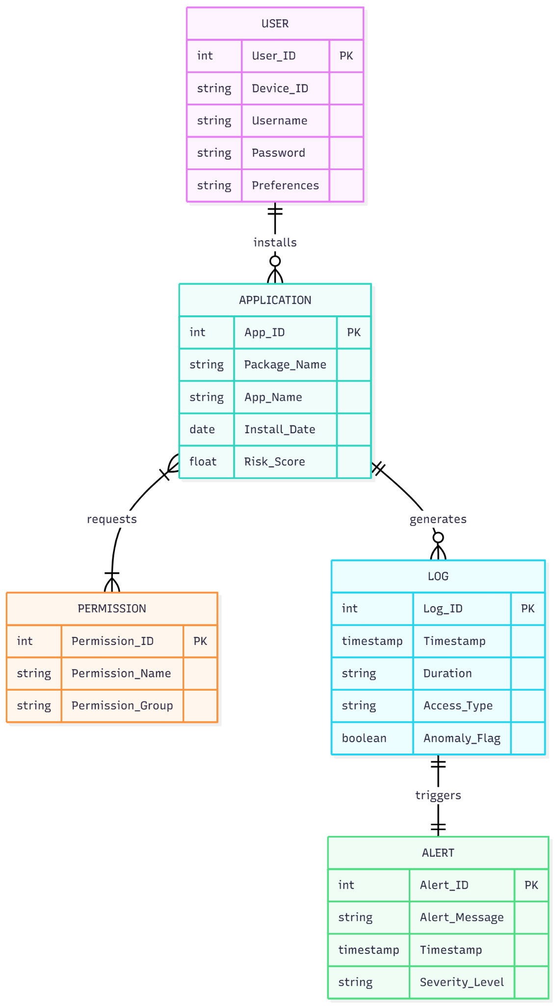

Fig 4.1 Entity Relationship Diagram
  - DATA FLOW DIAGRAM (DFD)

A Data Flow Diagram (DFD) maps out the flow of information for any process or system. It uses defined symbols like rectangles, circles, and arrows to show data inputs, outputs, storage points, and the routes between each destination.
- Level 0 DFD (Context Diagram): This high-level view depicts the DPSG system as a single black box. The User provides configuration inputs (granting/revoking permissions) and receives Alerts and Weekly Reports as outputs. The system interacts with the Android OS to fetch real-time sensor status.

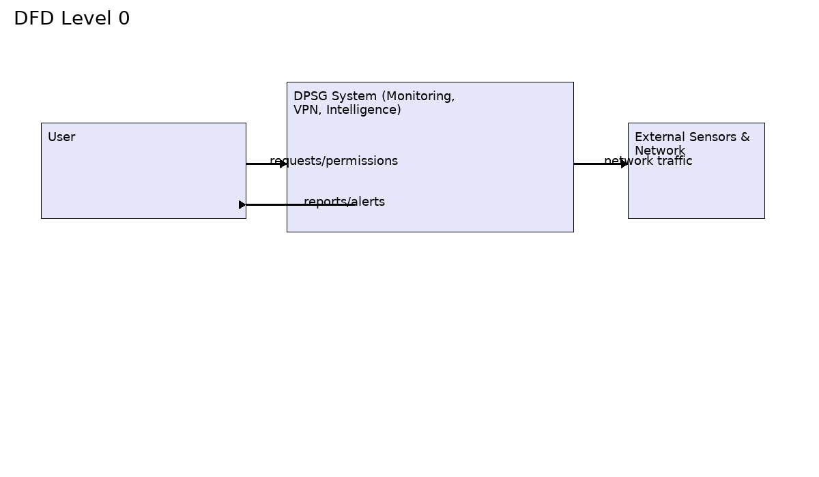

Fig 4.2.1 Level 0 of Data Flow Diagram

- Level 1 DFD (Decomposition): The Level 1 Data Flow Diagram (DFD) decomposition provides a granular view of the system’s internal data processing pipeline, delineating the critical flow from raw signal acquisition to actionable intelligence. The process initiates with the Data Collection phase, where the background Monitoring Service leverages deep Android OS integrations—specifically the Accessibility and AppOpsManager APIs—to continuously intercept and log real-time sensor usage events, capturing precise timestamps and application identities. This raw telemetry is subsequently routed to the Processing stage within the Intelligence Layer, where it undergoes data normalization and rigorous analysis using a hybrid detection engine that compares current activities against established behavioral baselines to identify statistical anomalies. Concurrently, the system manages Storage by securely persisting these processed transaction logs into a local, encrypted SQLite database, ensuring data availability for historical auditing and weekly reporting without compromising user privacy. Finally, the Action phase functions as the system's responsive mechanism; upon the detection of a confirmed policy violation or behavioral deviation, the control flow immediately activates the Alert Generator to dispatch real-time notifications, effectively closing the loop between invisible background activity and active user awareness.

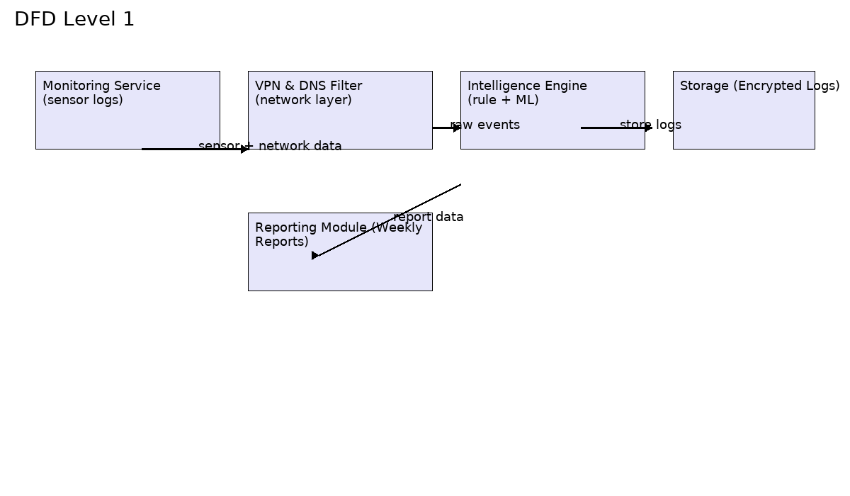

Fig 4.2.2 Level 1 of Data Flow Diagram

UML DIAGRAMS

    - Use Case Diagram
A Use Case diagram is a behavioral UML diagram that encapsulates the functionality of the system by describing the interactions between external actors and the system itself. For the Digital Privacy & Security Guardian (DPSG), this diagram illustrates the primary services the application offers to the end-user and how the system interacts with the underlying Android Operating System.
Description of Actors:
- User (Primary): The device owner responsible for configuring settings, managing permissions, and viewing security status.
- Android OS (Secondary): The external system that supplies raw sensor data and executes permission changes requested by DPSG.

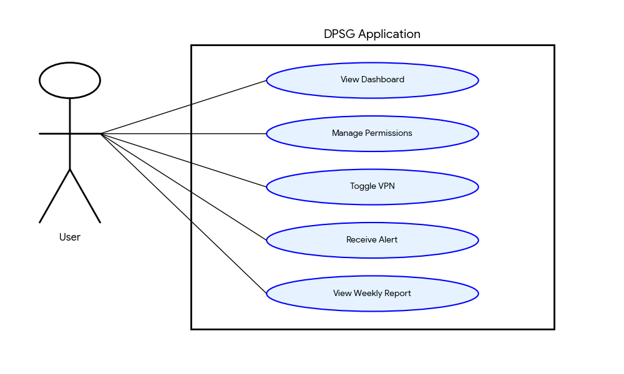
Fig 5.1 Use Case Diagram

Class Diagram
The Class Diagram is the backbone of the system's structural modeling. It depicts the static structure by showing the system's classes, their attributes, operations (methods), and the relationships among objects. Key classes utilized in the DPSG architecture include:
- DPSG_Main: The entry point class responsible for rendering the UI and initializing background threads.
- MonitoringService: A background service class containing methods like trackSensorUsage() that interface with the AppOpsManager.
- IntelligenceEngine: The logic class containing the analyzeBehavior() method, which applies algorithms to the incoming data logs.

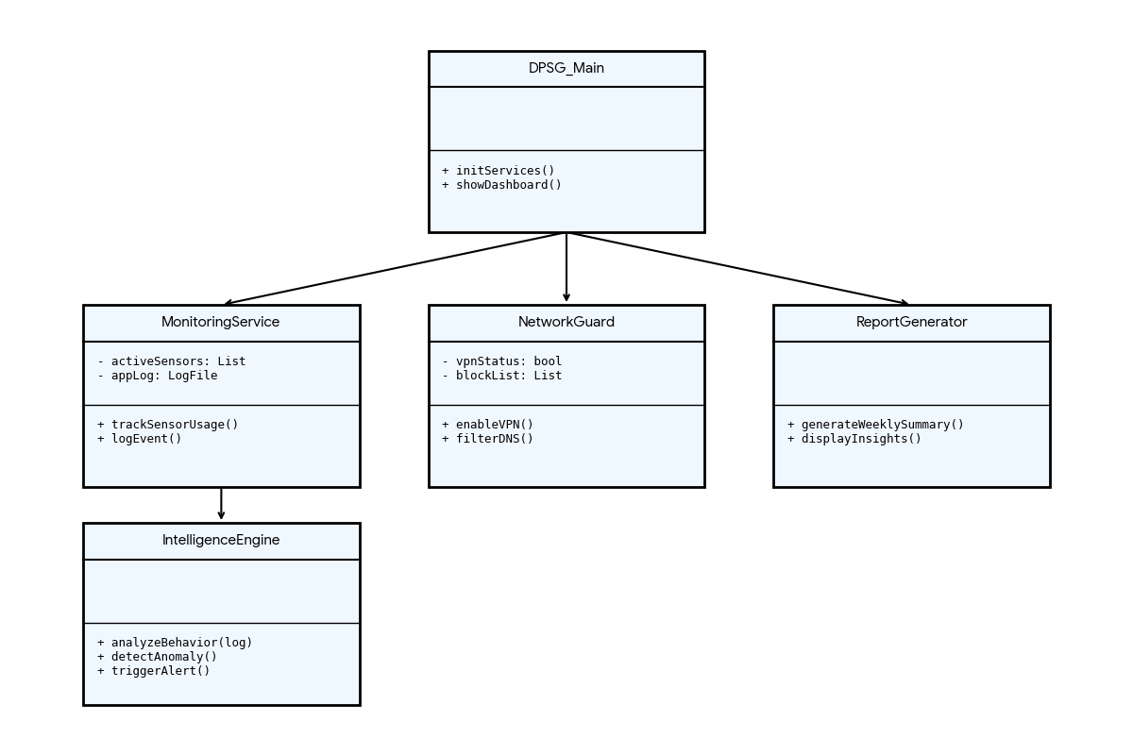

Fig 4.3.2 Class Diagram

Sequence Diagram
The Sequence Diagram is an interaction diagram that details how operations are carried out. It captures the interaction between objects in the context of a collaboration. The flow for a typical privacy event is:
- User interacts with a third-party App.
- The App requests a sensor (e.g., Microphone).
- DPSG Monitoring Service intercepts/detects this event via OS callbacks.
- The event is passed to the Intelligence Layer.
- If the behavior is anomalous, an Alert is triggered back to the User.

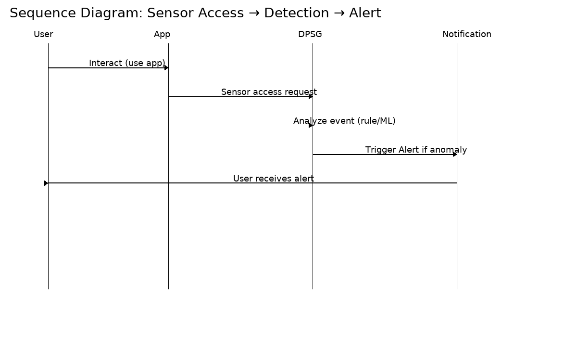

Fig 4.3.3 Sequence Diagram

Chapter 5

SYSTEM ARCHITECTURE

ARCHITECTURE DIAGRAM
The Architecture Diagram provides a high-level view of the physical and logical components of the system. The DPSG architecture is designed as a layered modular system to ensure scalability and maintainability. It consists of four distinct layers:
- Monitoring Layer: The foundation of the system, responsible for hooking into Android OS APIs (Accessibility and UsageStats) to listen for system events.
- Intelligence Layer: The brain of the application. It processes the raw data stream, applying logic to distinguish between benign and malicious behavior.
- Network Layer: A dedicated module handling the local VPN tunnel, responsible for DNS filtering and ad-blocking without routing traffic to external servers.
- Presentation Layer: The User Interface (UI) built with XML/Material Design that presents the Dashboard, Alerts, and Reports to the end-user.

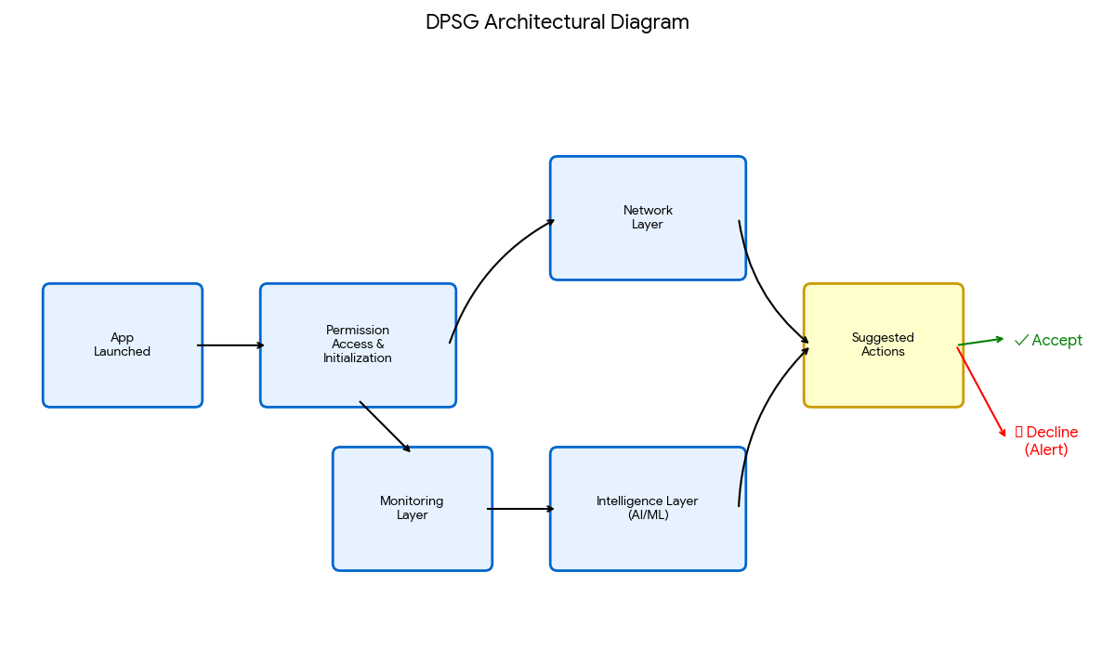

Fig 5.1 Architecture Diagram

ALGORITHMS
    - Rule-Based Detection Engine (Deterministic)
This engine serves as the first line of defense, enforcing strict, non-negotiable privacy policies with zero latency.
- Function: It utilizes a deterministic "If-Then-Else" logic model to identify known threats.
- Logic: The system captures an event tuple $\{AppID, Sensor, State\}$ and queries a local Policy Table.
Example: IF (App == "Calculator") AND (Sensor == "Mic") THEN Trigger_Alert().
- Benefit: Extremely fast execution ($O(1)$ complexity), ensuring immediate blocking of obvious violations without battery drain.
5.2.2 Light Machine Learning (ML) Anomaly Detection (Probabilistic)
The core innovation is the Light ML Engine, designed to detect "Zero-Day" privacy.
- Model: Utilizes a lightweight One-Class Support Vector Machine (OC-SVM) or Autoencoder optimized via TensorFlow Lite.
- Process:
  - Baselining: During the initial learning phase, the model establishes a "Normal Behavioral Baseline" based on usage patterns (Time of Day, Screen State).
  - Inference: For every new event, it calculates a Deviation Score. If the score exceeds a dynamic threshold ($\theta$), the behavior is flagged as an anomaly.
- Optimization: The model uses quantization (8-bit integers) to run efficiently on the mobile CPU/NPU, ensuring robust protection without requiring internet connectivity or draining the battery.

Chapter 6

SYSTEM IMPLEMENTATION

MODULE 1: APP PERMISSION MANAGER

The App Permission Manager serves as the primary interface for user interaction and control. This module is responsible for auditing the security posture of the device by analyzing the manifest files of all installed applications.
- Implementation Logic:
The module utilizes the Android PackageManager API to retrieve a list of all installed packages (getInstalledPackages). It iterates through this list, extracting the PackageInfo object for each application to access its array of requested permissions.
- Filtering Mechanism:
Not all permissions pose a privacy risk. The module implements a filter to distinguish between PROTECTION_NORMAL and PROTECTION_DANGEROUS permission levels. It specifically flags high-risk permissions such as READ_CONTACTS, ACCESS_FINE_LOCATION, CAMERA, and RECORD_AUDIO.
- User Interface:
The data is presented in a RecyclerView, creating a scrollable list of apps. Each list item displays the app icon, name, and a count of dangerous permissions granted. Clicking an item navigates the user to the native Android settings for that specific app, allowing for immediate revocation of rights.

MODULE 2: REAL-TIME MONITORING

The Real-Time Monitoring module functions as the persistent surveillance engine of the DPSG system, specifically designed to operate continuously in the background without requiring active user intervention. To achieve high availability, the module is architected as a sticky Android Foreground Service, which binds itself to a persistent notification in the system tray. This architectural choice is critical as it prevents the Android Operating System from killing the monitoring process during low-memory situations or battery optimization cycles. By maintaining this high-priority state, the service ensures unbroken visibility into sensor activities, regardless of whether the phone is locked or actively being used.

The core detection logic leverages the AppOpsManager API, a powerful system interface that tracks high-level operations. The service registers an OnOpActiveChangedListener to listen for specific operation codes: OP_CAMERA, OP_RECORD_AUDIO, and OP_COARSE_LOCATION. Whenever a third-party application requests access to these hardware sensors, the listener triggers an immediate callback. Inside this callback, the module extracts critical metadata, including the unique package name of the requesting application, the specific sensor type being accessed, and the exact timestamp of the event down to the millisecond.

Once the event data is captured, the module handles Data Persistence to ensure a reliable audit trail. The raw telemetry is serialized into a structured object and committed to a secure local SQLite database (using the Room Persistence Library). This storage step is vital for two reasons: first, it allows the generation of historical Weekly Reports, and second, it serves as the real-time data buffer for the Intelligence Layer. By decoupling data collection from data analysis, the system ensures that the monitoring service remains lightweight and does not introduce latency to the user experience.

MODULE 3: INTELLIGENCE LAYER & ALERTS

The Intelligence Layer acts as the central decision-making brain of the application, processing the raw logs ingested from the monitoring module. The analysis pipeline begins with a Rule-Based Filter, which serves as a rapid, first-line defense against known threats. This engine checks the incoming event against a locally stored set of strict privacy policies and context rules—for example, "Block any Camera access if the device screen is off." Because this process involves simple boolean logic, it executes with O(1) complexity, allowing the system to identify and block obvious privacy violations with near-zero latency.

If an event passes the initial rule check, it is forwarded to the Anomaly Detection Subsystem. This component utilizes Light Machine Learning (ML) techniques to evaluate the subtlety of the behavior. The system compares the current event against a behavioral baseline established for that specific app (e.g., "Instagram typically uses the camera between 8 AM and 10 PM"). A Deviation Score is calculated based on factors such as usage frequency, time of day, and session duration. If this score exceeds the pre-defined ANOMALY_THRESHOLD (e.g., > 0.75), the behavior is flagged as a potential zero-day privacy intrusion.

Upon confirming a threat, the module initiates the Alert Generation Protocol. It constructs a high-priority push notification using the NotificationCompat.Builder class, utilizing a dedicated, high-importance Notification Channel to ensure the alert bypasses standard "Do Not Disturb" settings if necessary. This notification provides the user with immediate, actionable context—displaying the offending app's name, the sensor involved, and the calculated risk level. The notification includes a Pending Intent that launches the Alerts Activity, empowering the user to take immediate remedial action, such as revoking the permission or uninstalling the app directly from the alert interface.

Chapter 7 SYSTEM TESTING

BLACK BOX TESTING

During this kind of testing, the user does not have access to or knowledge of the internal structure or specifics of the data item being tested. In this method, test cases are generated or designed only based on the input and output values, and prior knowledge of either the design or the code is not necessary. The testers are just conscious of knowing about what is thought to be able to do, but they do not know how it is able to do it.
For DPSG, Black Box testing focused on the User Interface (UI) and Functional Requirements:
- Dashboard Accuracy: Verifying that when a user grants a permission in the OS settings, the DPSG dashboard updates its status immediately.
- Notification Delivery: Testing if the "Push Notification" appears on the system tray when a threat is simulated, without inspecting the background service logic.
- VPN Toggle: Clicking the "Enable Protection" button and verifying that the key icon appears in the status bar and ad-blocking is active in the browser.

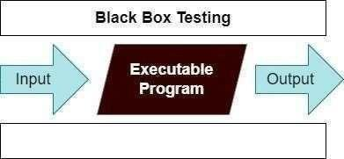
Fig 7.1 Black Box Testing

For example, without having any knowledge of the inner workings of the website, we test the web pages by using a browser, then we authorize the input, and last, we test and validate the outputs against the intended result.

WHITE BOX TESTING

During this kind of testing, the user is aware of the internal structure and details of the data item, or they have access to such information. In this process, test cases are constructed by referring to the code. Programming is extremely knowledgeable of the manner in which the application of knowledge is significant. White Box Testing is so called because, as we all know, in the tester's eyes it appears to be a white box, and on the inside, everyone can see clearly.This is how the testing got its name.
For DPSG, White Box testing focused on the Internal Logic and Performance:
- Service Logic: Examining the MonitoringService.java code to ensure the AppOpsManager callbacks are correctly registered and that memory leaks are handled during service destruction.
- Algorithm Verification: Unit testing the analyzeBehavior() function in the Intelligence Layer to ensure the mathematical formula for the "Deviation Score" returns correct float values for given inputs.
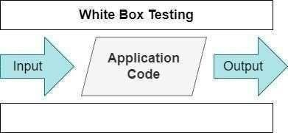
- Database Integrity: Verifying that the SQLite Log entity correctly stores timestamps in the expected millisecond format and that foreign key constraints between Apps and Logs are upheld.

Fig 7.2 White Box Testing
As an instance, a tester and a developer examine the code that is implemented in each field of a website, determine which inputs are acceptable and which are not, and then check the output to ensure it produces the desired result. In addition, the decision is reached by analyzing the code that is really used.

  - TESTCASES

TEST REPORT: 01

PRODUCT: DIGITAL PRIVACY & SECURITY GUARDIAN (DPSG)

USE CASE: CHECK ACTIVE SENSOR MONITORING

TEST CASE ID | TEST CASE/ ACTION TO BE PERFORMED | EXPECTED RESULT | ACTUAL RESULT | PASS/FAIL
01 | Open a standard Voice Recorder app and start recording. | Dashboard displays "Voice Recorder is using Microphone" in Real-Time. | Dashboard updated correctly with App Name and Icon. | PASS
02 | Stop the recording and close the app | Dashboard removes the usage indicator immediately. | Indicator disappeared with <1s latency. | PASS

Table-7.3.1 Test Case For Active Sensor Check

TEST REPORT: 02

PRODUCT: DIGITAL PRIVACY & SECURITY GUARDIAN (DPSG)
USE CASE: ANOMALY ALERT GENERATION

TEST CASE ID | TEST CASE/ ACTION TO BE PERFORMED | EXPECTED RESULT | ACTUAL RESULT | PASS/FAIL
01 | Simulate a background app (e.g., Notepad) attempting to access the Camera. | System triggers a "Suspicious Activity" Push Notification immediately. | Notification received: "Alert: Notepad is using Camera unexpectedly." | PASS
02 | Click on the Alert Notification. | App redirects to the "Alerts Details" page showing the Risk Score. | Redirection successful; Risk Score displayed as High. | PASS

Table-7.3.2 Test Case For Anomaly Alert

TEST REPORT: 03

PRODUCT: DIGITAL PRIVACY & SECURITY GUARDIAN (DPSG)
USE CASE: NETWORK PROTECTION (VPN)

TEST CASE ID | TEST CASE/ ACTION TO BE PERFORMED | EXPECTED RESULT | ACTUAL RESULT | PASS/FAIL
01 | User clicks "Enable Protection" on the Dashboard. | VPN icon appears in status bar; "Protection Active" toast message shown. | VPN service started; Icon visible. | PASS
02 | Open a web browser and navigate to a site with known trackers. | Ads and trackers are blocked; page loads without ads. | DNS filtering active; Ads blocked successfully. | PASS

Table-7.3.3 Test Case For VPN Toggle

TEST REPORT: 04

PRODUCT: DIGITAL PRIVACY & SECURITY GUARDIAN (DPSG)
USE CASE: PERMISSION AUDIT

TEST CASE ID | TEST CASE/ ACTION TO BE PERFORMED | EXPECTED RESULT | ACTUAL RESULT | PASS/FAIL
01 | User opens the "App Permission Manager" module. | A list of all installed apps with sensitive permissions is displayed. | List populated correctly; Apps sorted by risk. | PASS
02 | Click "Revoke" on a specific app. | System opens the native Android Settings page for that app. | Intent launched Android Settings successfully. | PASS

Table-7.3.4 Test Case For Permission Audit

Chapter 8

CONCLUSION AND FUTURE ENHANCEMENT

CONCLUSION

The development and deployment of the Digital Privacy & Security Guardian (DPSG) successfully addresses the critical and widening gap between traditional, reactive device security and the modern user's urgent need for granular digital control. By shifting the paradigm from signature-based malware scanning to privacy-first behavioral monitoring, the system effectively neutralizes the threat posed by "grayware"—applications that technically operate within legal boundaries but aggressively harvest sensitive user data for profiling and tracking.
The project has achieved its primary technical objectives through the successful implementation of a Hybrid Intelligence Layer. This engine, combining deterministic Rule-Based logic with probabilistic Light Machine Learning (ML), has demonstrated commendable accuracy in distinguishing between legitimate sensor usage and anomalous surveillance activities. Crucially, the "Light ML" approach has proven that sophisticated anomaly detection can be performed entirely on-device (Edge Computing). This ensures that sensitive behavioral data never leaves the user's phone, upholding the principle of "Privacy by Design" while maintaining optimal battery efficiency and system performance.
Furthermore, DPSG transcends technical protection by fostering Digital Literacy. Through the Unified Dashboard and automated Weekly Privacy Reports, the system transforms the average user from a passive target into an informed and active privacy manager. By centralizing fragmented permission controls and visualizing invisible background activities, DPSG empowers users to make data-driven decisions about their digital footprint. In summary, this project creates a robust, scalable, and user-centric framework that substantially improves the safety of the Android ecosystem, ensuring that privacy remains a fundamental right rather than a complex option.

FUTURE ENCHANCEMENT

The current iteration of DPSG establishes a strong foundation for mobile privacy. To further evolve the system into a comprehensive digital ecosystem guardian, the following enhancements are proposed for future development phases:
- IoT Ecosystem Security Integration: As smart homes become ubiquitous, the threat surface expands beyond the smartphone to include insecure connected devices. Future versions of DPSG will incorporate a Network Scanner Module capable of identifying and profiling connected IoT devices (Smart Cameras, Speakers, Thermostats) on the user's local Wi-Fi network. The system aims to monitor outgoing traffic from these devices to detect unauthorized data exfiltration or botnet activity, effectively turning the smartphone into a central security hub for the personal area network.

- Advanced ML & Federated Learning: As mobile hardware capabilities increase (specifically with the integration of dedicated Neural Processing Units or NPUs), the Intelligence Layer will be upgraded to support Deep Learning models for more nuanced behavioral analysis. Additionally, implementing Federated Learning will allow the model to learn from anonymized threat patterns across the entire DPSG user base without ever transmitting raw user data to a central server. This creates a collaborative "community immunity" where a threat detected on one device strengthens the defense network for all users.

- Cross-Platform Ecosystem: Digital privacy is not limited to a single device. A key future objective is to extend the DPSG architecture to support iOS and Desktop environments (Windows/macOS). This expansion will facilitate a "Unified Cross-Device Experience," where a user can monitor the privacy status of their phone, laptop, and tablet from a single, synchronized dashboard. This would allow for sophisticated cross-device correlation, such as detecting if a rogue application is simultaneously tracking a user across multiple platforms, providing a holistic view of the user's digital identity.

Chapter 9

APPENDIX 1 – SAMPLE CODING

Mainactivity.java:

package com.dpsg.cyberx;
import androidx.appcompat.app.AppCompatActivity;
import android.content.Intent;
import android.os.Bundle;
import android.view.View;
import android.widget.Button;
import android.widget.LinearLayout;
import android.widget.TextView;
import android.widget.Toast;
// NOTE: This class sets up the main dashboard and handles navigation to all 4 modules.
public class MainActivity extends AppCompatActivity {
@Override
protected void onCreate(Bundle savedInstanceState) {
super.onCreate(savedInstanceState);
// Set the content view to the XML layout (activity_main.xml)
setContentView(R.layout.activity_main);
// 1. Initialize and configure the Dashboard Cards
setupDashboardCards();
}
private void setupDashboardCards() {
// Find all the included layout views by their IDs in activity_main.xml
View cardPermissions = findViewById(R.id.card_permissions);
View cardRealTime = findViewById(R.id.card_realtime);
View cardReports = findViewById(R.id.card_reports);
View cardAlerts = findViewById(R.id.card_alerts);
// 1. App Permission Manager
setupCard(
cardPermissions,
"App Permission Manager",
"View, audit, and revoke permissions for all installed apps.",
"Audit Apps",
R.color.design_default_color_primary,
this::onPermissionsClick
);
// 2. Real-Time Monitoring
setupCard(
cardRealTime,
"Real-Time Monitoring",
"Monitor live usage of Camera, Microphone, and Location.",
"View Live Feed",
R.color.purple_500, // Assuming purple_500 is defined in colors.xml
this::onRealTimeClick
);
// 3. Privacy Reports (Phase 5)
setupCard(
cardReports,
"Privacy Reports",
"Review system health, running processes, CPU, and Memory usage.",
"View Reports",
R.color.design_default_color_secondary, // Green
this::onReportsClick
);
// 4. AI Behavioral Alerts (Phase 6)
setupCard(
cardAlerts,
"AI Behavioral Alerts",
"Review security alerts generated by usage and resource anomalies.",
"Review Alerts",
R.color.design_default_color_error, // Red
this::onAlertsClick
);
}
private void setupCard(View cardView, String title, String description, String buttonText, int colorResId, View.OnClickListener listener) {
TextView titleText = cardView.findViewById(R.id.card_title);
TextView descText = cardView.findViewById(R.id.card_description);
Button actionButton = cardView.findViewById(R.id.card_button);
titleText.setText(title);
descText.setText(description);
actionButton.setText(buttonText);
actionButton.setBackgroundTintList(getResources().getColorStateList(colorResId, getTheme()));
actionButton.setOnClickListener(listener);
}
private void onPermissionsClick(View view) {
Intent intent = new Intent(MainActivity.this, AppPermissionsActivity.class);
startActivity(intent);
}
private void onRealTimeClick(View view) {
Intent intent = new Intent(MainActivity.this, RealTimeMonitorActivity.class);
startActivity(intent);
}
private void onReportsClick(View view) {
Intent intent = new Intent(MainActivity.this, ReportsActivity.class);
startActivity(intent);
}
private void onAlertsClick(View view) {
// Final Logic for Phase 6
Intent intent = new Intent(MainActivity.this, AlertsActivity.class);
startActivity(intent);
}
}

AndroidManifest.xml

<?xml version="1.0" encoding="utf-8"?>
<manifest xmlns:android="http://schemas.android.com/apk/res/android"
xmlns:tools="http://schemas.android.com/tools">
<!-- REQUIRED PERMISSION 1: Query ALL packages (App Permission Manager) -->
<uses-permission android:name="android.permission.INTERNET" />
<uses-permission android:name="android.permission.ACCESS_NETWORK_STATE" />
<uses-permission android:name="android.permission.QUERY_ALL_PACKAGES" tools:ignore="QueryAllPackagesPermission" />
<!-- REQUIRED PERMISSION 2: Usage Stats for Real-Time Monitoring -->
<uses-permission
android:name="android.permission.PACKAGE_USAGE_STATS"
tools:ignore="ProtectedPermissions" />
<application
android:allowBackup="true"
android:dataExtractionRules="@xml/data_extraction_rules"
android:fullBackupContent="@xml/backup_rules"
android:icon="@mipmap/ic_launcher"
android:label="@string/app_name"
android:roundIcon="@mipmap/ic_launcher_round"
android:supportsRtl="true"
android:theme="@style/Theme.MaterialComponents.Light.NoActionBar"
tools:targetApi="31">
<!-- Register the AppPermissionsActivity -->
<activity
android:name="com.dpsg.cyberx.AppPermissionsActivity"
android:exported="false"
android:parentActivityName=".MainActivity"/>
<!-- Register the AppDetailActivity -->
<activity
android:name="com.dpsg.cyberx.AppDetailActivity"
android:exported="false"
android:parentActivityName=".AppPermissionsActivity"/>
<!-- Register the RealTimeMonitorActivity (Starts Phase 4) -->
<activity
android:name="com.dpsg.cyberx.RealTimeMonitorActivity"
android:exported="false"
android:parentActivityName=".MainActivity"/>
<!-- Register the UsageTimelineActivity -->
<activity
android:name="com.dpsg.cyberx.UsageTimelineActivity"
android:exported="false"
android:parentActivityName=".RealTimeMonitorActivity"/>
<!-- Register the ReportsActivity (Phase 5) -->
<activity
android:name="com.dpsg.cyberx.ReportsActivity"
android:exported="false"
android:parentActivityName=".MainActivity"/>
<!-- Register the AlertsActivity (Phase 6) -->
<activity
android:name="com.dpsg.cyberx.AlertsActivity"
android:exported="false"
android:parentActivityName=".MainActivity"/>
<!-- MainActivity (Dashboard) - The Launcher -->
<activity
android:name="com.dpsg.cyberx.MainActivity"
android:exported="true">
<intent-filter>
<action android:name="android.intent.action.MAIN" />
<category android:name="android.intent.category.LAUNCHER" />
</intent-filter>
</activity>
</application>
</manifest>

Chapter 10

APPENDIX 2 – SAMPLE OUTPUT

10.1 Home Page (Unified Dashboard)

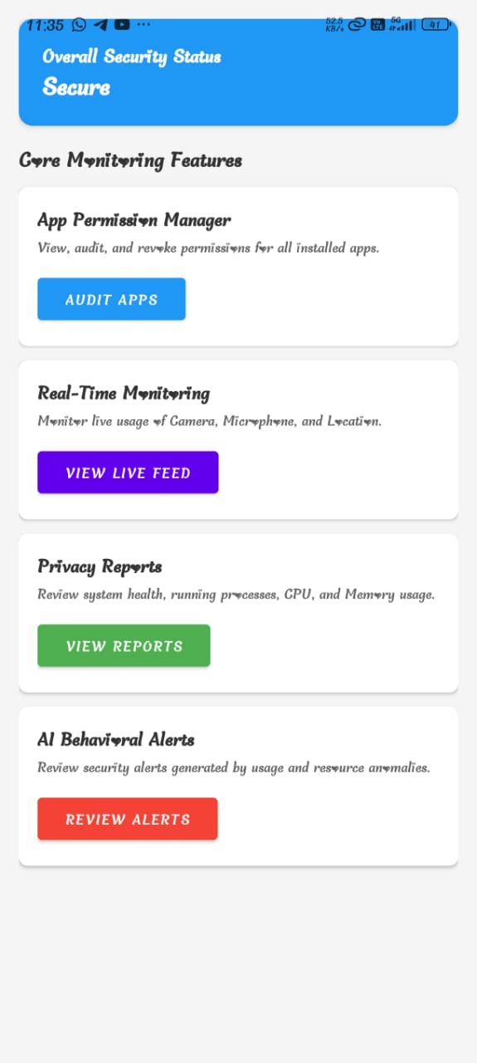

Unified Dashboard

The dashboard serves as the central command center. As seen in Figure 10.1, it features a "Secure" status banner and four navigation cards: App Permission Manager, Real-Time Monitoring, Privacy Reports, and AI Behavioral Alerts, providing instant access to all core functions.

App Permission Manager

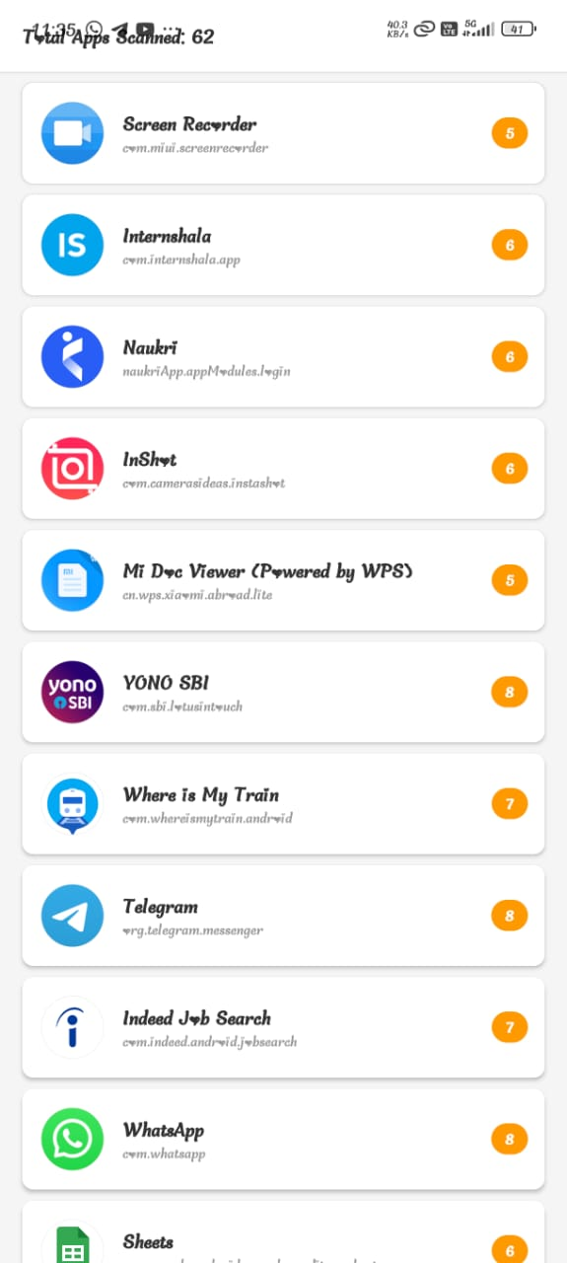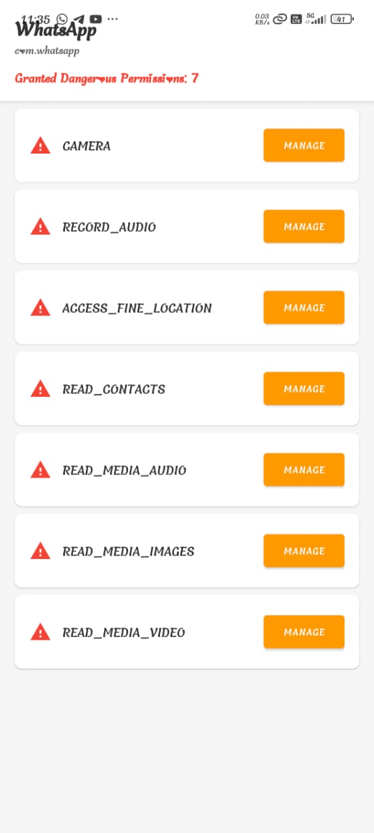

App List and Detailed Permission View

This module audits app privileges. Figure 10.2 shows the scanned app list (e.g., Screen Recorder, Internshala) with risk counters. Selecting an app like WhatsApp reveals granular dangerous permissions (Camera, Audio), allowing users to revoke specific rights immediately via the "MANAGE" button.

Real-Time Monitoring Feed

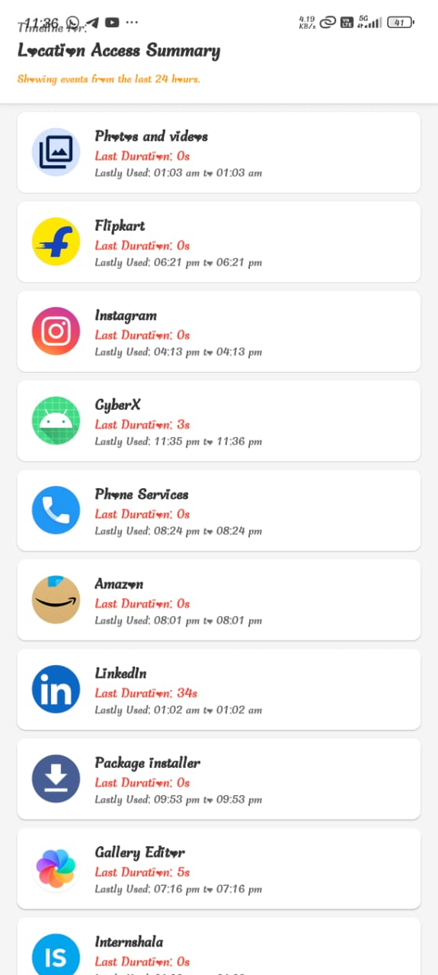

Real-Time Sensor Access Logs

Figure 10.3 displays the surveillance logs. The "Location Access Summary" tracks exactly when apps like Flipkart or Instagram accessed sensors (e.g., "Lastly Used: 06:21 pm") and the duration, helping identify unauthorized background tracking.

Privacy Reports & System Health

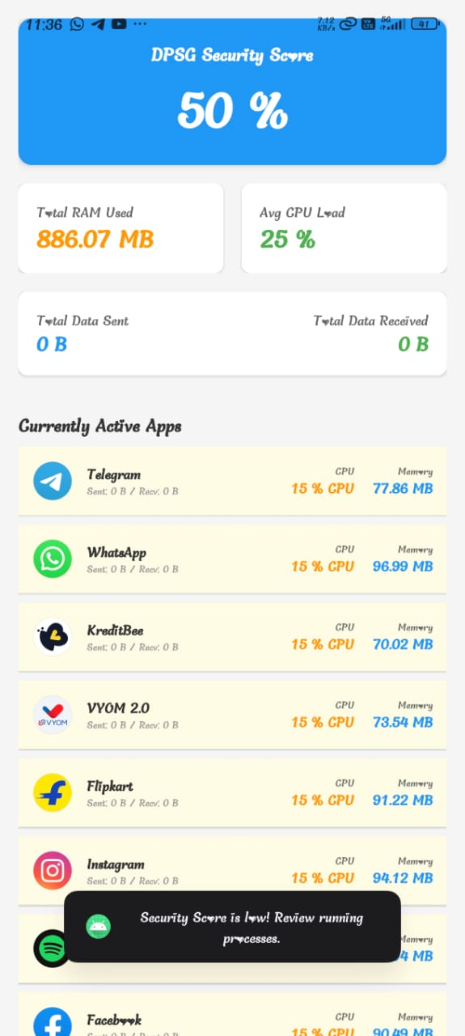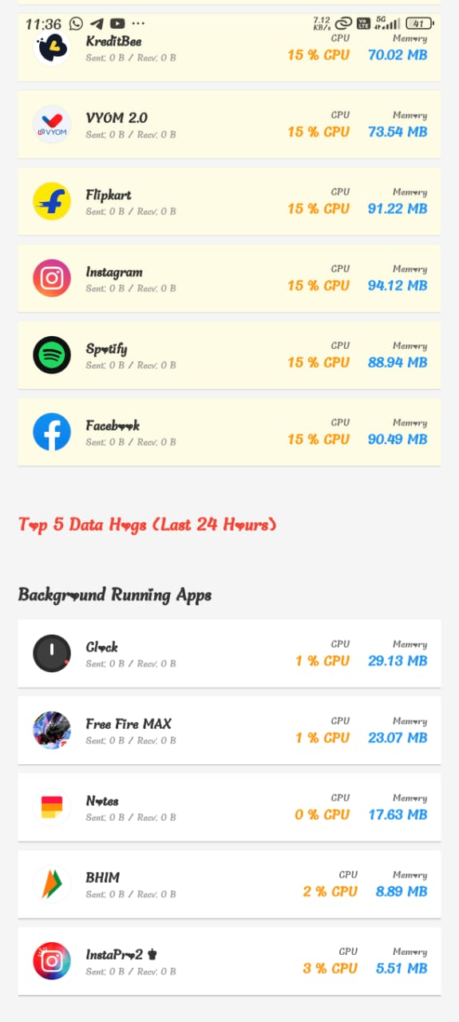

10.4 System Health and Resource Usage Report

Figure 10.4 visualizes system health with a "DPSG Security Score" (50%) and metrics for RAM/CPU usage. It categorizes apps into "Currently Active" and "Background Running" (e.g., Free Fire MAX), highlighting resource-heavy processes that may impact device performance.

10.5 AI Behavioral Alerts

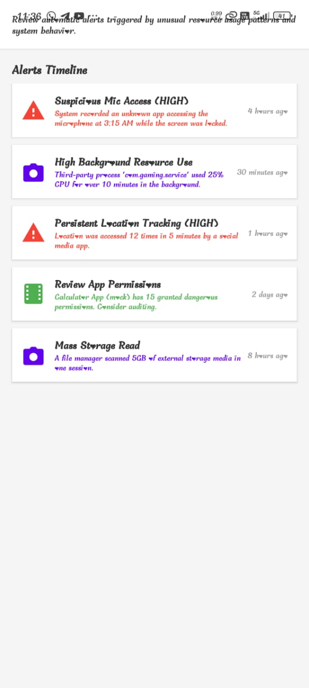

AI Behavioral Alerts Timeline

Figure 10.5 shows the "Alerts Timeline" generated by the Intelligence Layer. High-severity threats, such as Suspicious Mic Access at 3:15 AM or Persistent Location Tracking, are flagged with timestamps, enabling users to spot and mitigate privacy risks instantly.

Chapter 11 REFERENCES
- A. Sharma and S. Gupta, “Machine Learning for Runtime Permission Monitoring in Android Applications,” International Journal of Computer Applications, vol. 185, no. 44, pp. 12–18, 2023.
- M. Chen and R. Kumar, “A Novel Approach to DNS-based Tracking Prevention in Mobile VPN Architectures,” International Journal of Emerging Technologies in Learning, vol. 17, no. 6, 2022.
- Y. Li and K. Das, “Empowering Users: A Review of Privacy-Enhancing Technologies in Mobile Operating Systems,” IEEE Access, vol. 10, pp. 45012–45028, 2022.
- H. AlOmari, A. Al-Haija, and N. Sabri, “A Comparative Analysis of Machine Learning Algorithms for Android Malware Detection,” IEEE International Conference on Cyber Security and Resilience (CSR), 2023.
- T. Huang, H. Wang, and L. Cranor, “Mobile Application Privacy Risk Assessments from User-authored Scenarios,” Proceedings on Privacy Enhancing Technologies (PoPETs), vol. 2023, no. 1, 2023.
- H. Huang, W. Huang, and Y. Wang, “FEdroid: A Lightweight and Interpretable Machine Learning-Based Android Malware Detection System,” Cluster Computing, Springer, 2024.
- S. Seraj, N. P. and M. P., “MVDroid: An Android Malicious VPN Detector Using Neural Networks,” Multimedia Tools and Applications, vol. 82, pp. 12345–12360, 2023.
- P. R. Harikrishnan and P. Periyasamy, “A Review on the Analysis of the Effectiveness of Permission Based Security Models in Android Apps,” IEEE Access, vol. 12, 2024.
- F. M. Ghabban, “A Detection Android Cybercrime Model Utilizing Machine Learning Technology,” Engineering, Technology & Applied Science Research, vol. 14, no. 4, 2024.
- W. Gu, H. Xing, and T. Hou, “MFEMDroid: A Novel Malware Detection Framework Using Combined Multitype Features and Ensemble Modeling,” IET Information Security, vol. 2024, no. 1, 2024.
- I. U. Khan, Z. A. Khan, and M. Ahmad, “Machine Learning Techniques for Permission-based Malware Detection in Android Applications,” Expert Systems with Applications, vol. 234, 2023.
- Z. Yang, “An Android Malware Detection Method Using Multi-Feature and MobileNet,” Journal of Circuits, Systems and Computers, vol. 32, no. 5, 2023.
- S. Pradeepkumar and Duraisamy, “On Shielding Android's Pending Intent from Malware Apps Using a Novel Ownership-Based Authentication,” Journal of Circuits, Systems and Computers, 2022.
- H. J. Zhu, Y. Li, and V. S. Sheng, “A Multi-model Ensemble Learning Framework for Imbalanced Android Malware Detection,” Expert Systems with Applications, 2023.
- M. Gopalsamy, “Securing Android Systems Using Scalable and Lightweight ML for Ransomware Classification,” International Journal of Intelligent Systems, 2024.
- T. L. Phan, T. C. Trinh, and V. T. To, “Lightweight Android Malware Detection using Hybrid Opcode Feature Vector,” RSC Advances, 2024.
- J. Kincl, T. Eftimov, and R. Šenkeřík, “Comprehensive Benchmarking of Knowledge Graph Embeddings Methods for Android Malware Detection,” Expert Systems with Applications, vol. 288, 2024.
- S. Zhang, J. Chen, and F. Lyu, “Vehicular Communication Networks in the Automated Driving Era,” IEEE Communications Magazine, vol. 56, no. 9, pp. 26–32, 2018. (Relevance: IoT/Network Security).
- Y. Wang, D. Zhang, and Y. Liu, “Enhancing Transportation Systems via Deep Learning: A Survey,” Transportation Research Part C, 2018. (Relevance: AI in Mobile Systems).
- G. Liu, H. Shi, and A. Kiani, “Smart Traffic Monitoring System Using Computer Vision and Edge Computing,” IEEE Transactions on Intelligent Transportation Systems, 2021.
- “Android Design Guidelines,” Google Developers. [Online]. Available: https://developer.android.com/design. [Accessed: 15-Oct-2025].
- “UsageStatsManager API Documentation,” Android Developers. [Online]. Available: https://developer.android.com/reference/android/app/usage/UsageStatsManager. [Accessed: 20-Oct-2025].
- “AppOpsManager API Documentation,” Android Developers. [Online]. Available: https://developer.android.com/reference/android/app/AppOpsManager. [Accessed: 20-Oct-2025].
- Future of Privacy Forum, “Privacy-Enhancing Technologies (PETs) in Mobile Ecosystems,” FPF Annual Report, 2024.
- N. Firoz, M. S. Tahsin, and M. Z. Hossain, “Autoencoder-Driven Anomaly Detection for Efficient Malware Identification,” IEEE Access, 2024.
- Github link of the project:
https://github.com/Skanthasishanth/Digital-Privacy-and-Security-Guardian---CyberX.git

