dog

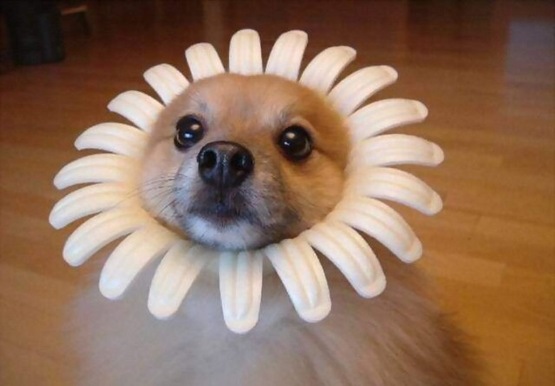



hello

yohi

{{insert_image img3 jpg 30 30}}

