RESUME 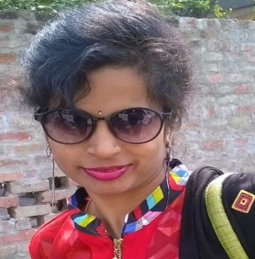
Mrs.Priyanka Contact No. 8896721088
House No.331-A,Kajikhera,
Harjendra Nagar,
Kanpur.

ACADEMIC CREDENTIAL
M.A with Economics from C.S.J.M. University ,Kanpur in 2008
EDUCATIONAL QUALIFICATION

HIGH SCHOOL passed from U.P. Board, Allahabad in 2001 with science Stream..

INTERMEDIATE passed from U.P.Board , Allahabad in 2003 with art’s stream.

GRADUATION passed from C.S.J.M. University ,Kanpur with Subjects- English - Lit.& Economics in 2006.

OTHER QUALIFICATION
15 months Computer Course M.D.C.I.M. (Master Diploma in Computer Information And System Management ) at EXCEL NET COMPUTER EDUCATION CENTER,KANPUR.
Courses are- M.S OFFICE,C, C++ & Tally.
SUMMER TRAINING
ONE MONTH TRAINING COURSE IN “ICICI PRUDENTIAL”.
WORK EXPERIENCE
- 4 MONTHS IN “ICICI PRUDENTIAL” AS A ADVISER.
- Computer Operator in Excel Net Institute in 2008.
- “Office Assistant “ in “DAY NIGHT MEDIA PVT LTD.”
1 JAN 2018 TO 10 APRIL 2018
- 2 Years Working in “KTL MARUTI SUZUKI” as a DDM.
PERSONAL VITAE

NAME :- Mrs.Priyanka
DATE OF BIRTH :- 10.09.1987
HUSBAND’S NAME :- Mr.Vikash Kumar
ADDRESS :- 331-A, HARJENDRA NAGAR,KAJI KHERA,
LAL BANGLA, KANPUR
MARITAL STATUS :- Married
NATIONALITY :- Indian

STRENGTH
- Positive Thinking
- Self Motivation
- Friendly & Extrovert Nature.
HOBBIES
Reading,Painting & Listening music.

DECLARATION
Ihereby declare that all the above informations provided by me are true and Best to my knowledge and belief.

Date :
Place : Kanpur (Priyanka)

