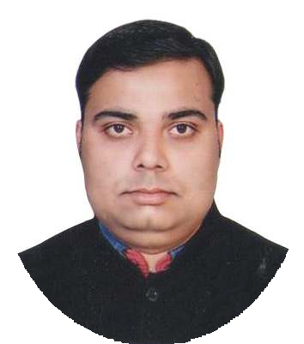
Akash Tripathi
Supervisor

Contact
Address: 124/131 Block B, Govind
Nagar, Kanpur 208006

Phone: +91 9450203543
+91 7860007771

Email: akashtripathi20@gmail.com
Personal Details
Date Of Birth: 20th Nov, 1992 Language: English & Hindi Marital Status: Unmarried

Skills

- Positive Attitude
- Self Motivated
- Leadership Style
- Honesty

Hobbies
- Travelling
- Listening Music

Summary
P

To work with an organization where I can learn more, improve myself and my abilities, utilize my skills and get the ability to the maximum in a good working and professional environment.

Experience
Supervisor – 1.5 Year
SPP Food Pvt. Ltd. Rudrapur
Supervisor – 2 Years
V.K. Packwell Pvt. Ltd. Kanpur

Shift Incharge – 2.5 years
Shiv Krishna Polytex Pvt Ltd Kanpur

Education
- Polytechnic Diploma (Electrical Engineering) From Prasad Polytechnic, BTEUP, Lucknow l 2016 l 70%
- Intermediate From SVM Inter College, Kanpur l 2009 l 56.2%
- High School From SVM Inter College, Kanpur l 2007 l 55.5%

Technical Qualification

- ITI in Electrician Trade (NCVT) in 2011 with marks of 87.8%
- CTI in Electrician Trade (NCVT) in 2018 by DGET
- CCC Computer Certificate from DOAECC by NIELIT
- One year Diploma in Computer Application
- Operating Systems: WINDOWS XP,WINDOWS 7, WINDOWS 10
- Microsoft Word, Microsoft PowerPoint, Microsoft Excel

Special Training

- 3 Months Training of Supervisor Development Program in Raffia Sector Woven Sack Industry from TTRC Lohia Corp Ltd Kanpur

Workshops

- Working knowledge of Lohia Tape Plant (Lorex & Duotech) & Looms
- 6 Years Experience in Raffia woven sack Industry

Summer Internship Program (Vocational Training)

- 1 month Training in Electric Loco shed Of Indian Railways, Kanpur
- 1 week Robot Building Training in IIT, Kanpur

Declaration
I solemnly declare that all the above information is correct to the best of my knowledge and belief.
Date:

