Software Architecture & Design Specification
for
Bank Management System
Version 1.0
Prepared by:
Abhishek Hanamant Kinagi (PES1UG24CS018), Adithya Ajeeth (PES1UG24CS022), Aditya M (PES1UG24CS027), Aditya Vats (PES1UG24CS032)
PES University — Software Engineering (UE24CS341A)
Reference: Software Requirements Specification, Bank Management System, v1.0

1. Introduction

1.1 Purpose
This Software Architecture and Design Specification (SADS) describes the architecture and detailed design of Version 1.0 of the Bank Management System. It translates the functional and non-functional requirements defined in the Software Requirements Specification (SRS) into a concrete architectural structure, component decomposition, and detailed design artifacts, providing the development team with a blueprint for implementation.

1.2 Scope
This document covers the architecture and design of the complete Bank Management System as scoped in the SRS: a browser-based presentation layer, an API layer, a C/C++ back-end core implementing all business logic, and a relational database. It includes the architectural pattern, component decomposition, security architecture, sequence-level interaction design, API design, and error-handling strategy. Design decisions for out-of-scope features (Appendix D of the SRS) are not addressed.

1.3 Definitions, Acronyms and Abbreviations
Term | Description
RBAC | Role-Based Access Control
API | Application Programming Interface
RDBMS | Relational Database Management System
FR / NFR | Functional Requirement / Non-Functional Requirement
ACID | Atomicity, Consistency, Isolation, Durability (transactional properties)
DTO | Data Transfer Object — structured payload exchanged across the API layer
Audit Trail | Append-only record of every balance-changing operation and its operator

1.4 References
- Software Requirements Specification (SRS) — Bank Management System, Version 1.0.
- IEEE Std. 830-1998, IEEE Recommended Practice for Software Requirements Specifications.
- IEEE Std. 1016-2009, IEEE Standard for Information Technology — Systems Design — Software Design Descriptions.

1.5 Overview
Section 2 presents the architectural design, including the chosen architectural pattern, the component diagram, security architecture, and traceability to requirements. Section 3 presents the detailed design, including sequence diagrams for the two most critical transaction flows, the API design, and error-handling strategy. Section 4 documents design constraints and their rationale.

2. Architectural Design

2.1 Architectural Pattern
The system adopts a layered (n-tier) architecture consisting of four logical layers: Presentation, API/Gateway, Business Logic (C/C++ core), and Data. This pattern was selected, consistent with SRS Section 2.5, because it:
- Cleanly separates presentation concerns from banking business rules, ensuring the front end contains no banking logic (SRS 2.5) and that the same rules apply regardless of client.
- Allows the C/C++ back-end core to be developed, tested, and evolved independently of the front end (supports NFR-8 Maintainability).
- Centralizes RBAC enforcement in a single layer rather than duplicating it across clients (supports NFR-4 Security).
- Is well suited to a small, four-person academic team, as each layer can be owned by a subset of the team with minimal cross-layer coupling.
An alternative microservices-based decomposition was considered and rejected: given the project's scope (single branch, single currency, three roles) and timeframe, the operational overhead of independently deployed services would outweigh any benefit, and would conflict with the requirement that a single C/C++ core owns all transaction logic.

2.2 Component Diagram
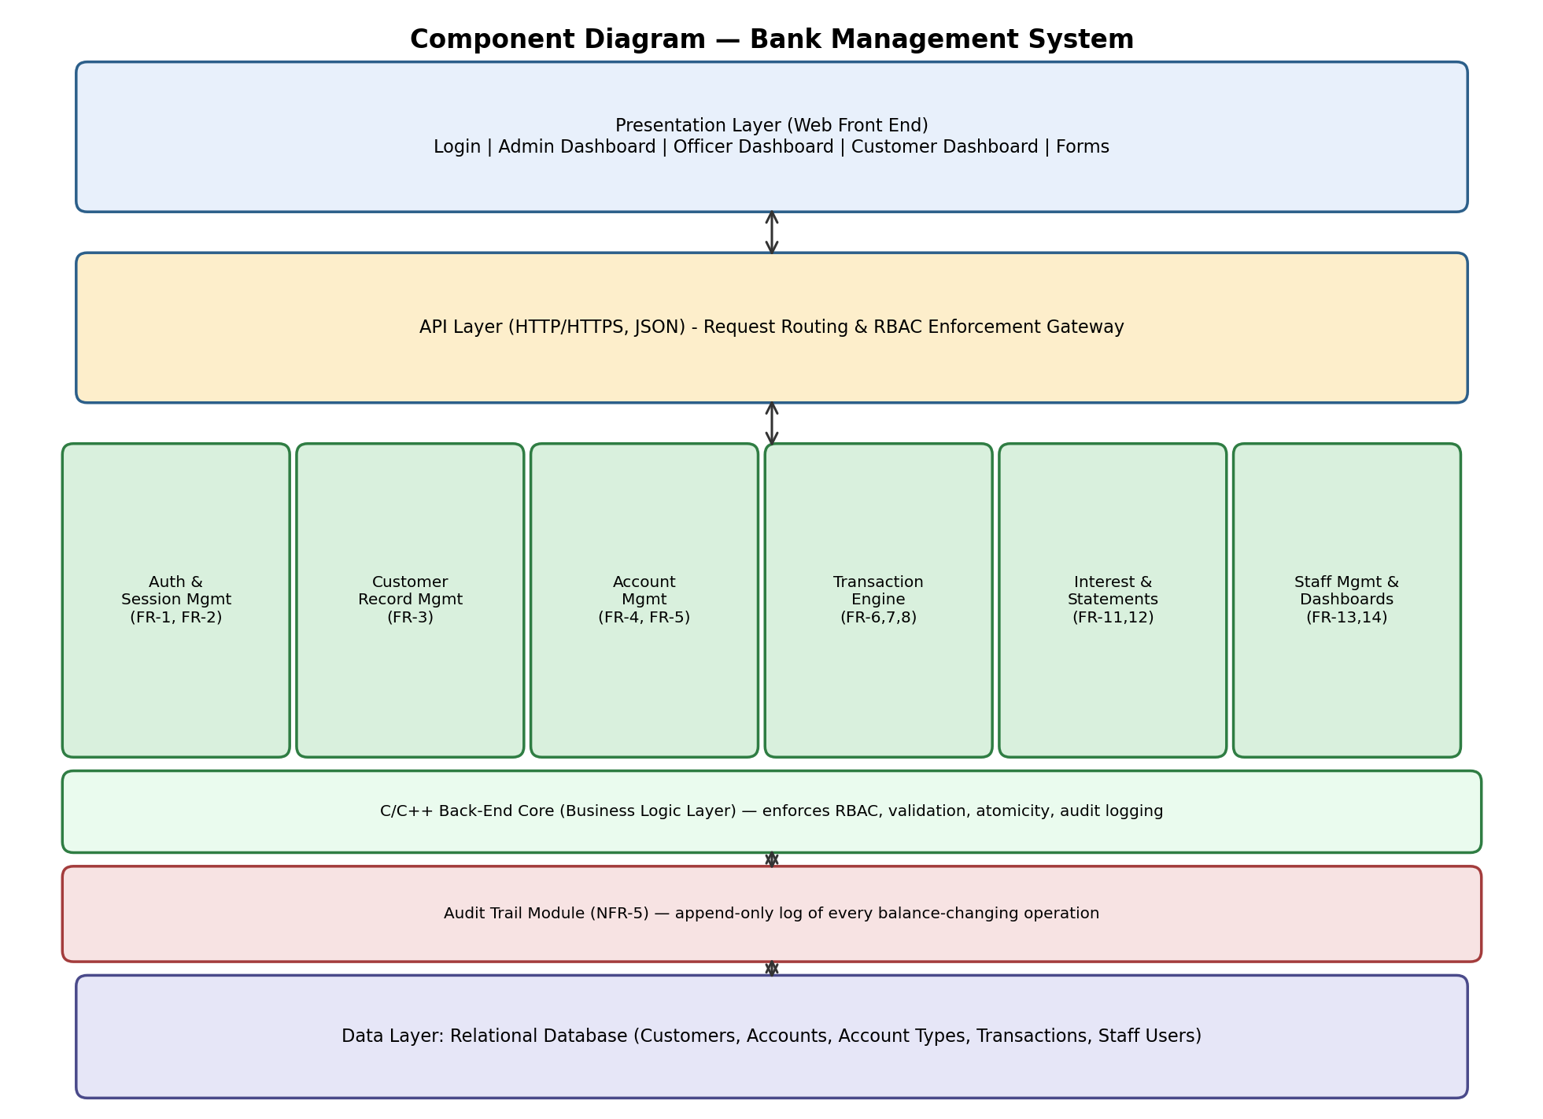
Figure 1: Component Diagram — Bank Management System

2.2.1 Component Description
Component | Responsibility
Presentation Layer | Renders role-specific dashboards and forms; performs client-side input formatting only; contains no balance-affecting logic.
API Layer / Gateway | Exposes REST endpoints over HTTPS; authenticates requests; performs the first-line RBAC check before delegating to the core; serializes/deserializes JSON.
Auth & Session Mgmt | Validates credentials, manages sessions, enforces the 3-strikes account lockout rule, issues session tokens.
Customer Record Mgmt | CRUD operations on customer master records; enforces deactivation rules.
Account Mgmt | Opens, freezes, unfreezes, and closes accounts; enforces minimum-balance-at-opening and zero-balance-at-closure rules.
Transaction Engine | Processes deposits, withdrawals, and transfers as atomic units of work; enforces minimum balance and daily withdrawal limit rules.
Interest & Statements | Computes and credits periodic interest; generates account statements for a selected date range.
Staff Mgmt & Dashboards | Administrator management of staff accounts; assembles role-specific dashboard summaries.
Audit Trail Module | Appends an immutable record of every balance-changing operation; not editable or deletable by any role.
Data Layer (RDBMS) | Persists all entities; provides transactional guarantees (ACID) that the Transaction Engine relies on for atomicity.

2.3 Traceability Matrix (Architecture to Requirements)
Component | Requirements Traced
Auth & Session Mgmt | FR-1, FR-2, NFR-4
Customer Record Mgmt | FR-3
Account Mgmt | FR-4, FR-5
Transaction Engine | FR-6, FR-7, FR-8, NFR-1, NFR-3
Interest & Statements | FR-11, FR-12
Staff Mgmt & Dashboards | FR-13, FR-14
Audit Trail Module | NFR-5
API Layer / Gateway | FR-1 (RBAC enforcement), NFR-4
Data Layer (RDBMS) | NFR-3 (atomicity), Section 6 (RDBMS requirement)

2.4 Security Architecture

2.4.1 Security Objectives
- Ensure that every request reaching the business logic layer is authenticated and authorized according to the requester's role, regardless of which client issued it (supports FR-1, NFR-4).
- Guarantee the confidentiality of credentials and financial data both at rest and in transit (supports NFR-4).
- Preserve a complete, tamper-evident record of every balance-changing action for accountability (supports NFR-5).

2.4.2 Security Requirements (Architecture-Level)
ID | Requirement
SEC-1 | The API Layer shall reject any request lacking a valid session token, and the Business Logic Layer shall independently re-verify the caller's role for every operation, so that RBAC is never enforced by the front end alone (traces to FR-1, NFR-4).
SEC-2 | Passwords and PINs shall be hashed using a one-way, salted hashing algorithm (e.g., bcrypt or Argon2) before persistence; plaintext credentials shall never be logged, cached, or transmitted (traces to NFR-4).
SEC-3 | All client-server communication in a network-accessible deployment shall use HTTPS/TLS to protect credentials, account numbers, and balances in transit (traces to SRS 3.4).
SEC-4 | Every balance-changing operation shall generate an append-only audit record (timestamp, accounts affected, amount, operator ID) that cannot be modified or deleted through the application (traces to NFR-5).

2.5 Deployment View
The system is deployed as a client-server configuration: any modern web browser (client) communicates over HTTPS with a server hosting the API layer and C/C++ business logic core, which in turn communicates with a relational database instance. All three tiers may be co-located on a single machine for development/testing, or distributed across separate hosts for a production-like deployment; this is left to the development team's discretion per SRS 2.4.

3. Detailed Design

3.1 Sequence Diagrams

3.1.1 Sequence Diagram 1: Deposit / Withdrawal Transaction
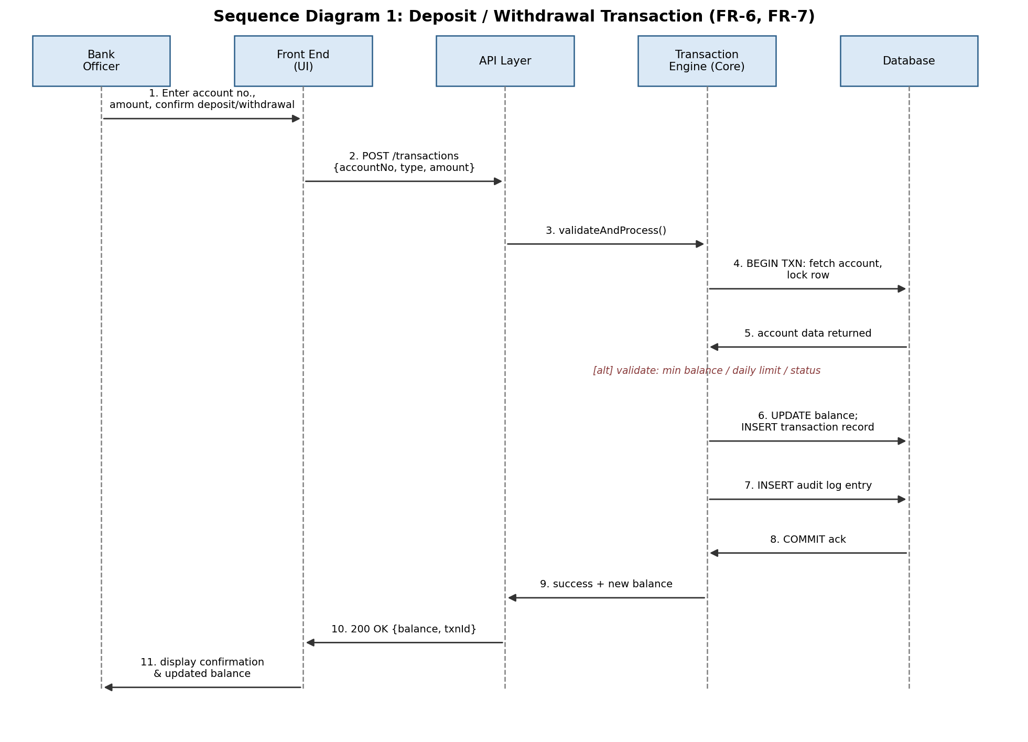
Figure 2: Sequence Diagram — Deposit / Withdrawal Transaction (traces to FR-6, FR-7, NFR-1, NFR-3)
This flow shows a Bank Officer initiating a deposit or withdrawal. The Transaction Engine fetches and locks the account row, validates the operation (minimum balance for withdrawals, daily withdrawal limit, account status), applies the balance update and transaction record within a single database transaction, writes an audit log entry, and commits — satisfying the atomicity requirement (NFR-3) and the 2-second performance target (NFR-1).
3.1.2 Sequence Diagram 2: Fund Transfer
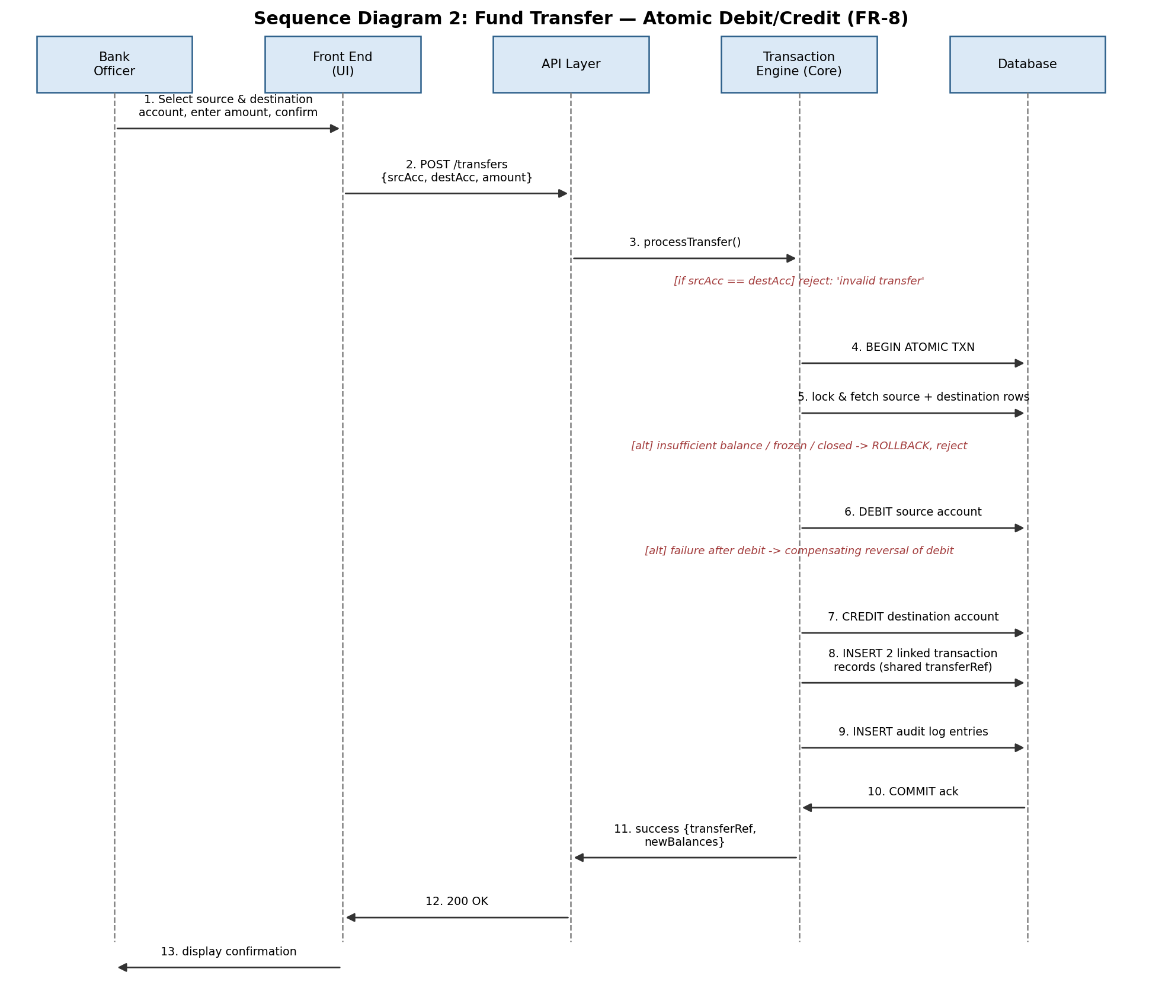
Figure 3: Sequence Diagram — Fund Transfer, Atomic Debit/Credit (traces to FR-8, NFR-3)
This flow shows a fund transfer between two accounts held at the bank. The Transaction Engine rejects same-account transfers immediately, then locks both account rows, validates balance/status on both sides, debits the source, credits the destination, and inserts two linked transaction records sharing a common transfer reference — all within one atomic unit of work. If a failure occurs after the debit but before the credit, a compensating reversal restores the source account, ensuring neither account is left in a partially updated state.

3.2 API Design
The API layer exposes REST-style endpoints over HTTP/HTTPS, exchanging JSON payloads. The table below summarizes the primary endpoints; all endpoints require a valid session token and are subject to RBAC enforcement in the business logic layer.
Method & Path | Description | Required Role
POST /auth/login | Authenticate user, issue session token | Any
POST /auth/logout | Terminate active session | Any (authenticated)
POST /customers | Create a new customer record | Officer, Admin
GET /customers/{id} | Retrieve a customer record | Officer, Admin
PUT /customers/{id} | Update / deactivate a customer record | Officer, Admin
POST /accounts | Open a new account for a customer | Officer, Admin
PATCH /accounts/{acc}/status | Freeze / unfreeze / close an account | Officer, Admin
POST /transactions | Process a deposit or withdrawal | Officer
POST /transfers | Process a fund transfer between two accounts | Officer
GET /accounts/{acc}/balance | Retrieve current balance | Officer, Customer (own)
GET /accounts/{acc}/transactions | Retrieve transaction history (filterable by date) | Officer, Customer (own)
POST /interest/run | Trigger interest computation for a period | Admin
GET /accounts/{acc}/statement | Generate a statement for a date range | Customer (own), Officer
POST /staff | Create a Bank Officer account | Admin
PATCH /staff/{id} | Update / deactivate / unlock a staff account | Admin
GET /dashboard | Retrieve role-specific dashboard summary | Any (authenticated)

3.3 Error Handling
The system applies a consistent error-handling strategy across all layers:
- Input validation (empty fields, non-numeric or negative amounts, malformed account numbers) is performed at the API layer before any request reaches the business logic core, and re-validated within the core itself, so that no invalid input can modify a stored balance or record (supports NFR-7).
- Business rule violations (insufficient balance, minimum balance breach, daily limit exceeded, frozen/closed account, same-account transfer) are returned as structured error responses with an error code and human-readable reason, leaving all balances unchanged.
- Any failure during a multi-step balance-changing operation (e.g., a crash between debit and credit in a transfer) triggers a rollback or compensating reversal so the account is never left in a partially updated state (supports NFR-3).
- Unexpected server-side errors are caught, logged internally (without exposing internal details to the client), and surfaced to the user as a generic failure message with guidance to retry or contact support.
- Concurrency conflicts (e.g., two operations on the same account) are handled via row-level locking at the database layer; a losing transaction is retried or rejected with a clear message rather than silently overwriting data.
Error Category | Example | System Response
Validation error | Negative or non-numeric amount | Reject before processing; no balance change; field-level error message
Business rule violation | Withdrawal breaches minimum balance | Reject; state specific reason; no balance change
Authorization failure | Customer attempts to view another customer's account | Deny request; log the attempt
Concurrency conflict | Two simultaneous withdrawals on the same account | Row-level lock serializes operations; second request processed against updated balance or rejected if now invalid
Partial failure | Crash between debit and credit in a transfer | Automatic rollback / compensating reversal; account restored to prior state

3.4 Data Design
The data layer uses a relational schema consistent with SRS Appendix B: Customer (1:N) Account, Account Type (1:N) Account, Account (1:N) Transaction, Transaction (1:1) Transaction (transfer pair), and Staff User (1:N) Transaction. Referential integrity constraints (foreign keys) enforce these relationships, and database-level transactions provide the atomicity guarantees required by NFR-3. Full attribute lists, primary/foreign keys, and cardinalities are maintained in the project repository's design/ directory, consistent with SRS Appendix B.

4. Design Constraints and Rationale
Constraint | Rationale
Business logic implemented in C/C++ | Mandated by the assigned project topic (SRS 2.5); centralizing logic in one core also enforces uniform rule application regardless of client.
Front end contains no banking logic | Ensures RBAC and validation cannot be bypassed by manipulating the client (SRS 2.5, NFR-4).
Relational database required | Referential integrity between customers, accounts, and transactions, and ACID guarantees for balance updates (SRS 2.5, Section 6).
Three fixed roles only | Scoped to the academic project's requirements; simplifies the RBAC model (SRS 2.5).
Layered architecture | Supports maintainability and independent testing by a four-person team (SRS 2.5, NFR-8).
Git/GitHub-based development | Required by the course for collaborative, version-controlled development (SRS 2.5, Section 6).

