Software Architecture and Design Specification
Project: Hostel Management System (HMS)
Version: 1.0
Authors: Team 3 - Shalik S (PES2UG24CS454), Shreyas Patil (PES2UG24CS492), Shreyas Mohanty (PES2UG24CS491), Shobhit Rachit Keshri (PES2UG24CS475)

Revision History
Version | Date | Author | Change Summary
1.0 | 05-10-2026 | Team 3 | First draft: architecture, component diagram, sequence diagrams, API design.

Approvals
Role | Name
QA Lead | Shalik S
Developer | Shreyas Mohanty
Product Owner | Shobhit Rachit Keshri

1. Introduction

1.1 Purpose
This document describes the architecture and design of the Hostel Management System (HMS). It shows how the system is split into parts, how those parts talk to each other, and why we made these choices.

1.2 Scope
HMS digitises the work of one college hostel. This document covers:
- Login and role-based access (Student and Admin/Warden)
- Student registration and profile
- Block and room setup
- Room application, allocation and availability
- Fee recording and receipts
- Complaint tracking
- Visitor log
- Admin dashboard, reports (CSV) and search/filter
Not covered (same as Test Plan Section 4): online payment gateway, email/SMS and multi-hostel support. Leave and outpass and mess management are also not part of this version.

1.3 Audience
Developers, QA engineers (testers), instructors and evaluators, and anyone who maintains HMS later.

1.4 Definitions
Term | Meaning
HMS | Hostel Management System
SRN | Student Registration Number
Admin / Warden | Same role: the person who manages the hostel
RBAC | Role-Based Access Control
CSRF | Cross-Site Request Forgery (an attack on web forms)
ORM | Object-Relational Mapping (Django's way to talk to the database)
ADR | Architecture Decision Record
STRIDE | Threat model: Spoofing, Tampering, Repudiation, Information disclosure, Denial of service, Elevation of privilege
PBKDF2 | Password hashing method used by Django
HTTPS | HTTP over TLS (encrypted web traffic)

2. Document Overview

2.1 How to Use This Document
Section 3 explains the architecture (diagram, components, pattern, security). Section 4 explains the design (sequence diagrams, interfaces, errors, UX). Developers should read both sections. Testers can use Sections 3.8 and 3.9 together with the Test Plan.

2.2 Related Documents
- Software Requirements Specification (SRS), Team 3
- Functional and Non-Functional Requirements document, Team 3
- Software Test Plan (STP), which holds the Requirements Traceability Matrix (RTM)
- Project Proposal, Team 3

3. Architecture

3.1 Goals and Constraints
Goals
- No double allotment: a room never holds more students than its capacity.
- Live occupancy, dues and complaint numbers for the warden at any time.
- Secure: hashed passwords, server-side role checks, HTTPS.
- Fast: main pages load within 2 seconds.
- Available during hostel office hours (09:00 to 18:00, working days) with minimal downtime.
- Easy to maintain: separate Django apps, each with its own tests.
Constraints
- Use Django's built-in authentication. No custom session or password code.
- Room number must be unique within a block, enforced by the database.
- One server only. No message queue, cache server or background worker.
- No budget for paid services, so no payment gateway, email or SMS.
- About six working weeks to finish, English-only interface.

3.2 Stakeholders and Concerns
Stakeholder | Main concerns
Students | Easy room application, correct fee balance, complaint status, privacy of own records
Admin / Warden | Simple screens, no double allotment, live dashboard, quick reports
Developers | Clear modules, easy changes, no hidden dependencies
QA / Testers | Testable rules, separate tests per app, concurrency can be tested
Instructors / Evaluators | Requirements covered, clear traceability
College / Hostel office | Daily database backup, stable running on one server

3.3 Component (UML) Diagram
HMS is a layered web application. A request goes from the browser down through the Presentation, Business and Data layers. The Business layer has one Django app for each feature area.
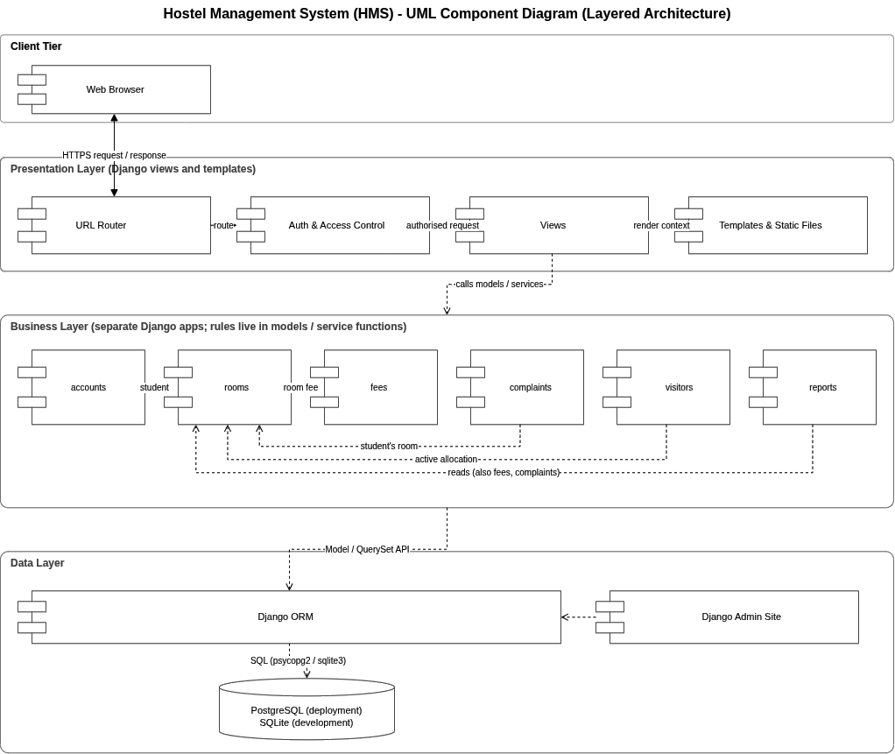
Figure 1: HMS UML Component Diagram (layered architecture)

3.4 Component Descriptions
Component | Layer | What it does
Web Browser | Client | Shows pages to Student and Admin. Chrome or Firefox, desktop or mobile.
URL Router | Presentation | Sends each URL to the correct view.
Auth & Access Control | Presentation | Checks login session, CSRF token and user role before a view runs. Blocks Students from Admin routes.
Views | Presentation | Handle requests for the Student and Admin screens and call the business apps.
Templates & Static Files | Presentation | HTML, CSS and a little JavaScript. Pages are rendered on the server.
accounts | Business | Registration, login/logout, roles, student profile.
rooms | Business | Blocks, rooms, room applications, allocation, deallocation, room availability.
fees | Business | Fee due and paid per term, balance, payment recording, receipts.
complaints | Business | Raise a complaint. Status moves Open, In Progress, Resolved.
visitors | Business | Visitor entry and exit, list of visitors still inside.
reports | Business | Admin dashboard, occupancy / fee-due / complaint reports, CSV download, search and filter.
Django ORM | Data | All database access goes through it. Handles transactions.
Django Admin Site | Data | For a superuser to correct data directly. Not the warden's daily tool.
Database | Data | PostgreSQL in deployment, SQLite in development.

3.5 Chosen Architecture Pattern and Rationale
Pattern: Layered architecture (Django MVT), built as one modular application.
Why we chose it:
- Clear separation: screens, business rules and data are kept apart.
- Fits our setup: one hostel, about 1000 students and 500 rooms, one server.
- Easy for a small team to build and test in six weeks.
- Each feature is its own Django app, so work can be shared and tested separately.
Rejected: Microservices. They need several services, networking and extra deployment work. This is too complex for one hostel on one server.
Key decisions (ADRs)
ADR | Decision | Reason
ADR-1 | Layered, modular single application | Simple to build, deploy and test on one server.
ADR-2 | Use Django's built-in auth | Safe, well tested password hashing and sessions.
ADR-3 | Database constraints and transactions for allocation | Stops double allotment even when two Admins act at the same time.
ADR-4 | Server-side rendered templates | No separate front-end app needed. Matches the SRS.
ADR-5 | SQLite for development, PostgreSQL for deployment | Easy local setup, stronger database for the real server.

3.6 Technology Stack and Data Stores
Area | Choice
Language / framework | Python 3.10+, Django 5.x
Front end | Django templates, HTML, CSS, small amount of JavaScript
Database | SQLite (development), PostgreSQL (deployment)
Data access | Django ORM (raw SQL only when unavoidable, and commented)
Security | Django auth (PBKDF2), CSRF protection, HTTPS in deployment
Reports | Python standard csv module
Testing tools | Django test runner, Selenium, Locust, GitHub Issues
Diagrams | draw.io
Data store: one relational database holds users and roles, blocks and rooms, applications and allocations, fees and payments, complaints and visitors. Indexes are added on room status, block, complaint status and student SRN to keep pages fast. Tables follow the field layouts in SRS Appendix B. The ER diagram will be added to the project repository.

3.7 Risks and Mitigations
Risk | Mitigation
Two Admins allot the last bed at the same time and overfill a room | Allocation runs in one transaction with a row lock. A separate test (TC-13) runs before every release.
SQLite and PostgreSQL behave differently | Run the tests on PostgreSQL as well before release.
Only one server, so testing or use stops if it goes down | Keep a database backup and a local setup on team laptops. Institution takes a daily backup.
Pages get slow as data grows | Database indexes and a limit of 20 queries per page.
A Student reaches Admin pages or other students' records | Role checks on the server for every Admin route. Tests TC-02 and TC-12.
Team is new to writing Django tests | Write the first modules' tests together in pairs.

3.8 Traceability to Requirements
Requirement IDs follow the SRS. Test case IDs come from the RTM in the Test Plan.
Requirement | Meaning | Component | Test case
FR-1.x | Login, generic error, role redirect, access control, logout | accounts, Auth & Access Control | TC-01, TC-02
FR-2.x | Registration and profile, no duplicate SRN or email | accounts | TC-03
FR-3.x | Blocks and rooms, unique room number, no delete if occupied | rooms | TC-04
FR-4.x | Room application, allotment, deallocation, availability | rooms | TC-05, TC-06
FR-5.x | Fees, balance, payments, receipts | fees | TC-07
FR-6.x | Complaints and status flow | complaints | TC-08, TC-09
FR-7.x | Visitor entry and exit | visitors | TC-10
FR-8.x | Admin dashboard | reports | -
SRS 3.1 | Reports and CSV download (Reports screen, no FR ID in SRS) | reports | -
FR-9.x | Search and filter | reports | TC-11
NFR-3 | Security | Auth & Access Control, accounts | TC-12
NFR-4 | Reliability (concurrent allotment) | rooms (transaction) | TC-13

3.9 Security Architecture
Threat model using STRIDE:
Threat | Mitigation
Spoofing | Login through Django auth. Passwords stored with PBKDF2. One generic error for wrong credentials.
Tampering | CSRF protection on every data-changing form. Server-side validation. Database constraints. HTTPS in deployment.
Repudiation | Server-clock timestamps on visitor entries, complaint status changes and payments. Receipts carry a receipt number.
Information disclosure | HTTPS. A Student can see only own records (changing the ID in the URL gives an authorisation error). No stack traces shown. Secrets kept in environment variables.
Denial of service | Indexes and a 20-query limit per page. Plain error page on failure. Login rate limiting is listed in Open Issues.
Elevation of privilege | RBAC checked on the server for every Admin route. A Student cannot edit own role or SRN.

4. Design

4.1 Design Overview
HMS is built from separate Django apps: accounts, rooms, fees, complaints, visitors and reports. The SRS lists the first five; we added reports so the dashboard, reports and CSV code stay in one place. Each app has its own models, views and tests. No app uses another app's internal helpers.
- Business rules live in models or service functions, not in templates.
- Any action that writes to more than one table runs in one database transaction, and rolls back fully on error.
- A Student acts only on own records. An Admin acts on all records.
- Every request passes through the Auth & Access Control check before it reaches a view.

4.2 UML Sequence Diagrams
Three main flows are shown: Login, Allot Room and Record Fee Payment. They cover the most important rules in the SRS.
Diagram 1: Login and role-based redirect. The system checks the password hash. A valid user goes to the Student or Admin dashboard. An invalid user gets one generic error (FR-1.1 to FR-1.3).
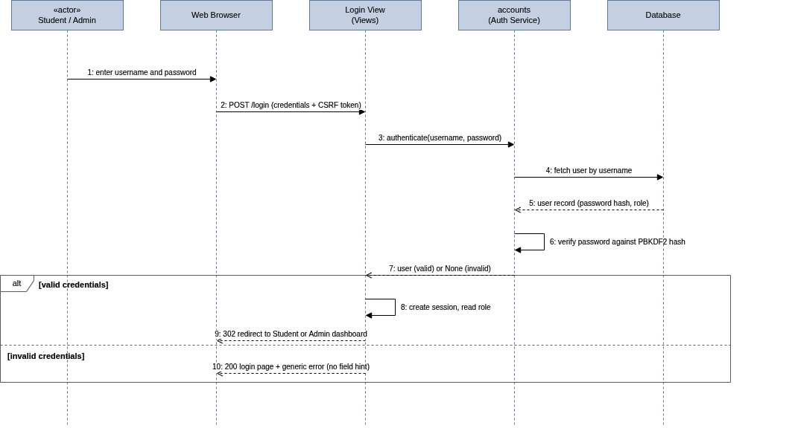
Figure 2: Sequence diagram - Login and role-based redirect
Diagram 2: Allot room. Allocation runs as one transaction with a row lock. If the room is full or the student already has a room, it rolls back. If two Admins allot the last bed together, the second one is rejected (FR-4.4 to FR-4.6, NFR-4).
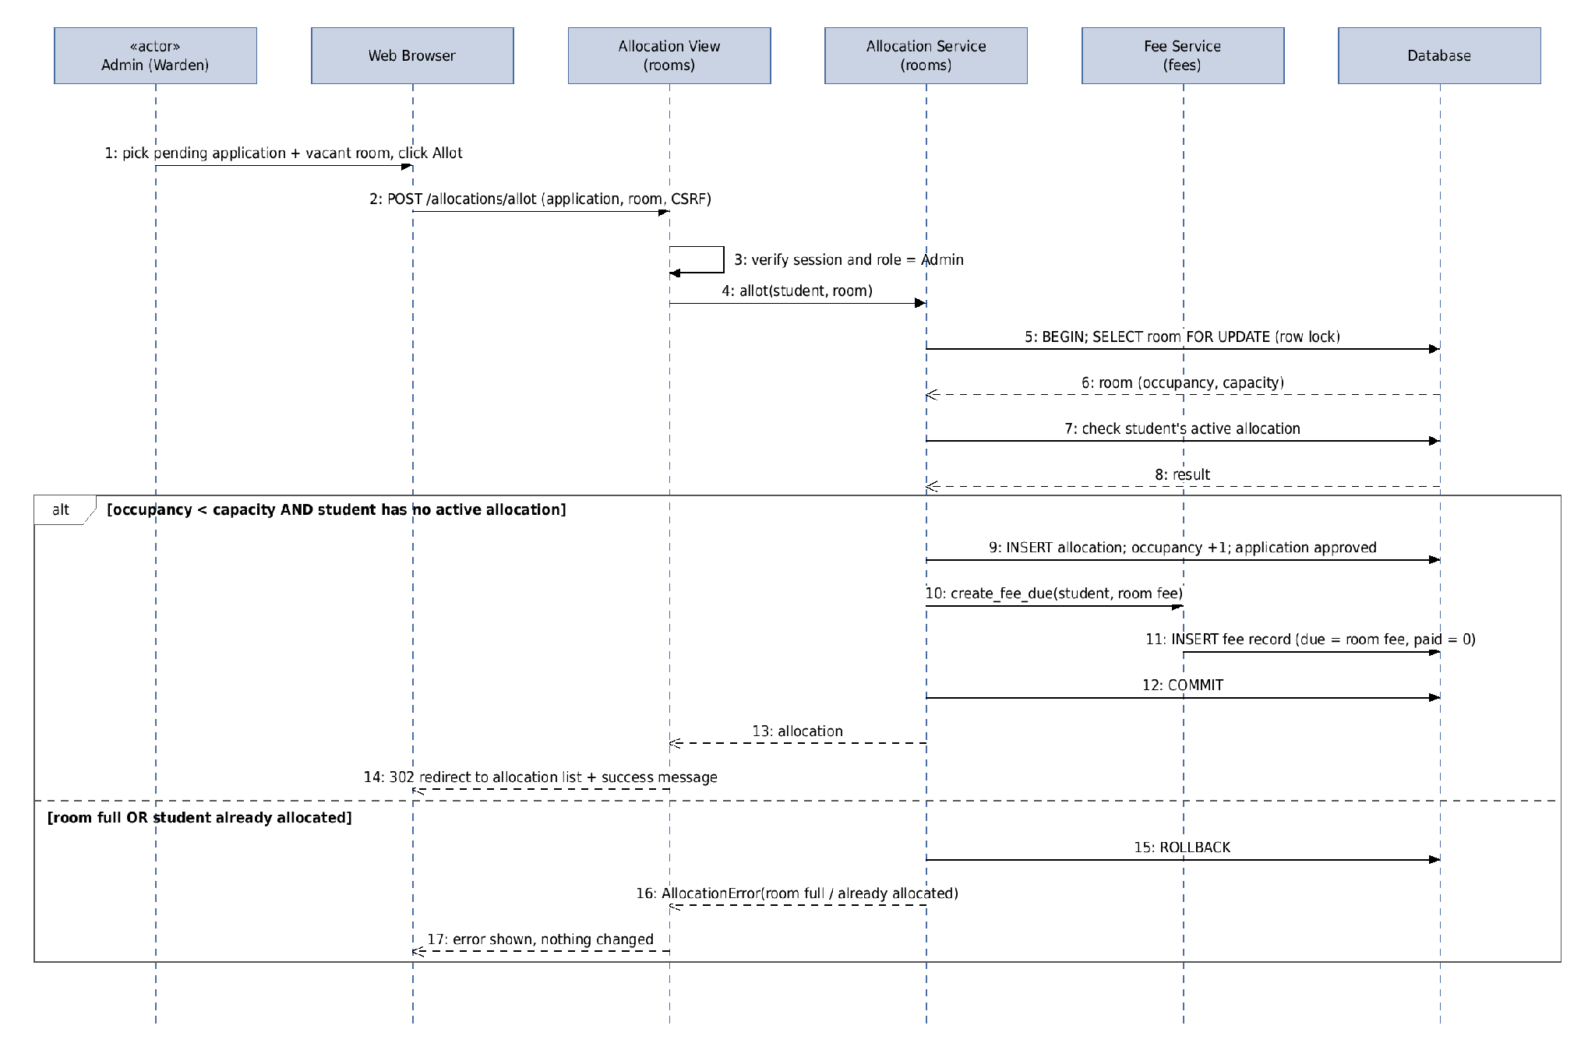
Figure 3: Sequence diagram - Allot room
Diagram 3: Record fee payment and receipt. The balance is due minus paid. A payment more than the balance is rejected (FR-5.3 to FR-5.6). We also reject zero or negative amounts as a basic input check.
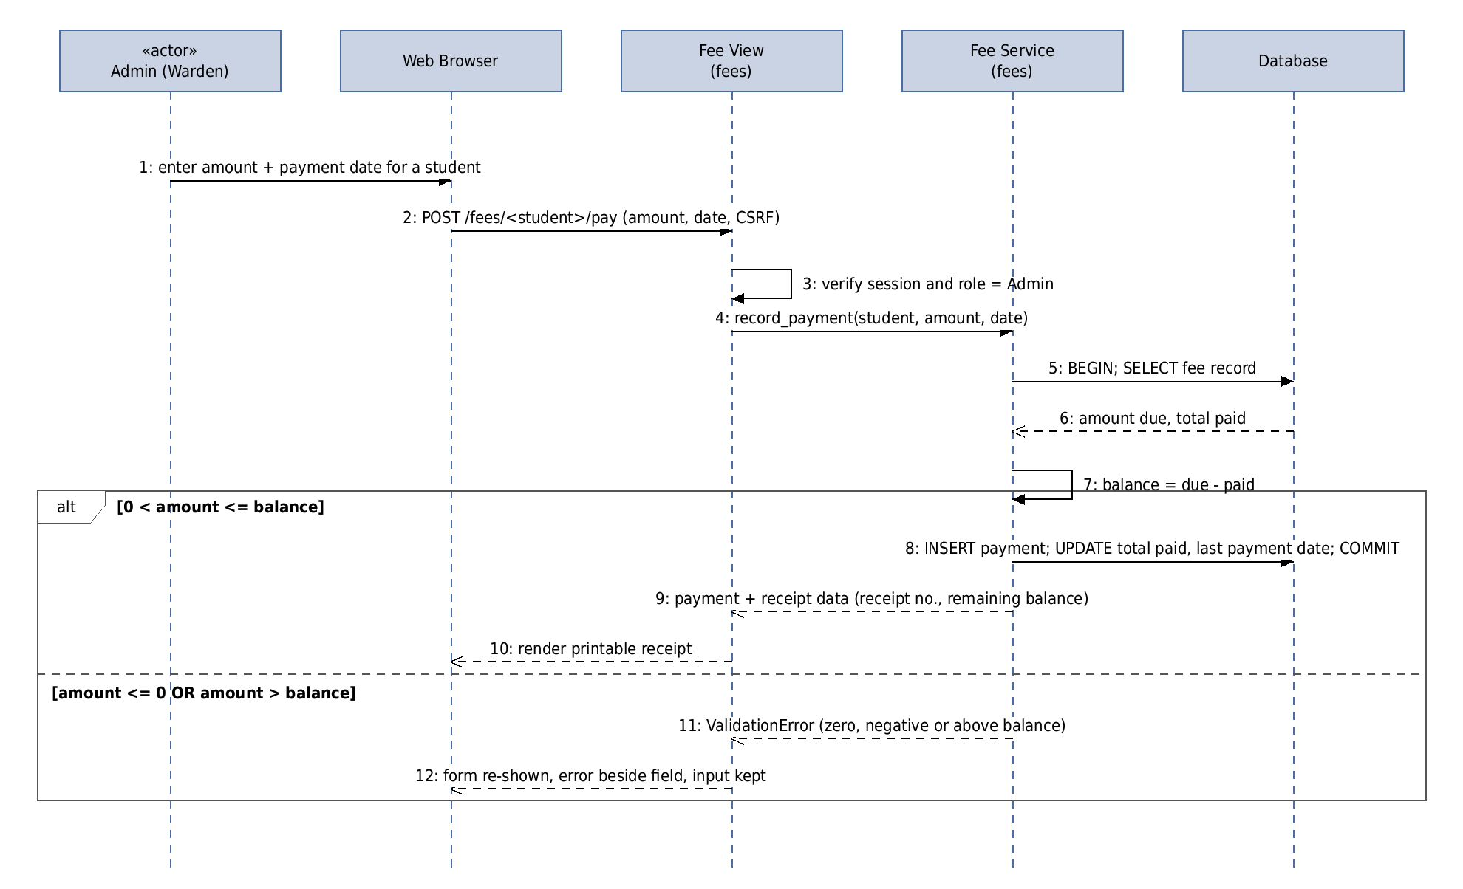
Figure 4: Sequence diagram - Record fee payment and receipt

4.3 API Design
HMS is a server-rendered web app, so its interfaces are URL routes handled by Django views. Each route is shown below for four components. Route names are planned and may change slightly during coding.
Common rules for all routes: a user who is not logged in is sent to the login page. A Student calling an Admin route gets 403 (not authorised). Every POST needs a CSRF token.
accounts
Endpoint | Method | Request | Response | Errors
/login | POST | {username, password} | 302 to Student or Admin dashboard | Same generic error for any wrong credential
/register | POST | {srn, name, email, contact, password} | 302 to login page | Duplicate SRN or email rejected
/logout | POST | none | 302 to login page | -
/profile | GET, POST | {contact, email} | Profile page | SRN and role cannot be changed
rooms
Endpoint | Method | Request | Response | Errors
/applications/apply | POST | {preferred_block, room_type} | Application status | -
/rooms | GET | filters: block, floor, type, status | Room list with occupancy | Empty list with message if no match
/allocations/allot | POST | {application_id, room_id} | 302 to allocation list | Room full, or student already has a room
/allocations/<id>/deallocate | POST | none | 302 to allocation list | -
/allocations/<id>/reassign | POST | {room_id} | 302 to allocation list | New room full
fees
Endpoint | Method | Request | Response | Errors
/fees/<student>/pay | POST | {amount, payment_date} | Printable receipt | Amount zero, negative or above balance
/fees/receipts/<id> | GET | none | Receipt page | Student can open only own receipts
complaints
Endpoint | Method | Request | Response | Errors
/complaints/new | POST | {category, description up to 500 chars} | Complaint saved as Open, with room and time | Description too long
/complaints/<id>/status | POST | {status} | Updated complaint | Student gets 403
Key service functions (used by views): authenticate(username, password), allot(student, room), create_fee_due(student, fee), record_payment(student, amount, date).

4.4 Error Handling, Logging and Monitoring
- Error messages: Form errors appear next to the field, in plain language. The data the user typed is kept.
- Unhandled errors: Users see a plain error page, never a stack trace. The error is written to the application log.
- Logging: No passwords, secret keys or database passwords in logs, code or the repository.
- Monitoring: Check the application log and server uptime during 09:00 to 18:00 on working days. Planned maintenance is announced on the login page 24 hours ahead.

4.5 UX Design
- Same header on every page, with menu for the user's role and a visible logout.
- Apply for a room and raise a complaint: within two clicks of the Student dashboard. Record a payment: within two clicks of the Admin dashboard.
- Student dashboard: room status, fee balance, own complaints, visitor entry form.
- Admin dashboard: occupancy, dues, open complaints, pending applications.
- Works on Chrome and Firefox, and stays usable at 360 px screen width.
- English only in this version.

4.6 Open Issues and Next Steps
- Leave and outpass management: first planned feature after version 1.0.
- Email/SMS notifications and an online payment gateway, if budget allows later.
- Login rate limiting or lockout to better handle repeated failed logins.
- Draw the ER diagram from SRS Appendix B, add it to the repository, and confirm final route names while coding.
- Check that HTTPS is switched on in the deployment settings (see Test Plan, Security Validation).

5. Appendices

5.1 Glossary
HMS, SRN, Admin/Warden, RBAC, CSRF, ORM, ADR, STRIDE, PBKDF2 and HTTPS are explained in Section 1.4.

5.2 References
- Hostel Management System SRS, Team 3
- Hostel Management System Software Test Plan, Team 3
- IEEE 42010: Architecture description
- OWASP Top 10
- Django documentation, version 5.x: https://docs.djangoproject.com/

5.3 Tools
draw.io (diagrams), Django, GitHub, Selenium, Locust.

