PES University
Software Engineering Mini-Project
Sprint 1
Sprint planning, review and retrospective
Project | CodeCraft: Early Metabolic Risk Detection (ML vs DL vs QML)
Team | CodeCraft
Members | Abhay TS (PES1UG24AM008)  Aarav Yuval B G (PES1UG24AM004)  Abhishek P H (PES1UG24AM013)
Instructor | Cvsn Reddy
Jira project | CODECRAFT (CodeCraft)
Version / date | 1.0 draft, 1 November 2026
Jira deliverable | CODECRAFT-42 / CODECRAFT-54 to 58 (3 marks)
Document status | RECONSTRUCTED

1. Sprint overview
Official window | 19 to 23 October 2026 (course Part 2)
Jira sprint | Sprint 3, "CODECRAFT Sprint 1": an empty, never-started placeholder
Document status | RECONSTRUCTED. Original records are missing.
Earliest Jira issue | 28 October 2026

2. Sprint goal (CODECRAFT-54)
Reconstructed goal (pending team confirmation):
"Deliver the first working increment of CodeCraft: import and validate the NHANES dataset, create the shared split, and run the three model families to a first comparison, with the GitHub Actions pull-request workflow enabled and a one-minute working-product video."
Source: course Part 2 requirements and the CodeCraft technical epics. The original Sprint 1 goal was not recorded; the team must supply it or confirm this reconstruction.

3. Selected work and prioritisation (CODECRAFT-55)
No evidence (Git history, notes, test records or dated Jira activity) attributes specific items to Sprint 1, so none is assigned to it. The table lists the candidate scope from the technical epics, prioritised by the must/should labels. These items are unattributed, not committed Sprint 1 scope.
Key | Summary | Priority | Pts
CC-9 | Import and validate the prepared NHANES dataset (schema, types, ranges, missingness, target) | Must | 5
CC-10 | Enforce safe CSV upload handling (type, size, executable and formula/script content) | Must | 3
CC-11 | Verify validation performance on a 50,000-row file (≤10 s) | Must | 2
CC-12 | Create a shared stratified 70/15/15 split with identical indices for all models | Must | 5
CC-13 | Fit all preprocessing and feature selection on training rows only | Must | 5
CC-14 | Exclude identity fields and target-proxy variables from features and reports | Must | 3
CC-15 | Define the common ModelAdapter interface and a replaceable stub adapter | Must | 3
CC-16 | Implement the classical ML model adapter | Must | 3
CC-17 | Implement the deep-learning model adapter with multi-seed protocol | Must | 5
CC-18 | Implement the QML (variational circuit, simulator) model adapter | Must | 8
CC-19 | Record run metadata and support reproducible repeat runs | Should | 5
CC-20 | Implement the shared evaluator (metrics, confusion matrix, validation-only threshold) | Must | 5
CC-21 | Build the side-by-side model comparison with a pre-fixed primary ranking metric | Must | 5
CC-22 | Implement the REST API and structured error handling per the SAD | Must | 5
CC-23 | Implement the run orchestrator with failure isolation and atomic result storage | Must | 8
CC-24 | Log runtime and peak memory and stop gracefully on memory-limit breach | Must | 3
CC-25 | Implement safe single-record prediction with non-diagnostic warning | Must | 5
CC-26 | Restore saved DL and QML models for prediction after server restart | Should | 5
CC-27 | Build the overview, dataset and run-models pages with live progress | Must | 5
CC-28 | Build the comparison dashboard and model-details views | Must | 5
CC-29 | Meet readability and accessibility requirements (non-colour cues, contrast, grayscale) | Must | 3
CC-30 | Verify browser compatibility and response times (Chrome and Firefox, 1366×768) | Must | 3
CC-31 | Generate aggregate-only comparison reports with provenance | Must | 5
CC-32 | Enforce local-only operation and repository hygiene (localhost, no external calls, no secrets) | Must | 3
Candidate points: 107 across 24 items (proposed estimates).

4. Team responsibilities (CODECRAFT-56)
Responsibilities in Jira are proposals (label alloc-proposed), not historical ownership. They are listed here for planning only.
Member | Proposed focus
Abhay TS | Data split and preprocessing, ML/DL/QML models, orchestration, Jira backlog and sprint planning
Aarav Yuval B G | Website, REST API, reproducibility, DevOps tools and CI
Abhishek P H | Testing, test reports and verification

5. Acceptance criteria and completion rule (CODECRAFT-57)
Reconstructed completion rule, because no original rule was written:
- The item is implemented.
- It is covered by a named test case (TC-nn) from the STP.
- Execution evidence is recorded.
The acceptance criteria of each item are in the Jira descriptions (CODECRAFT-9 to CODECRAFT-32) and are listed in the Product Backlog document.

6. Sprint review (CODECRAFT-58)
Item | Status
Completed items | Not evidenced for Sprint 1.
Velocity, commitment, completed points | Not stated: no evidence.
Working-product video (1 minute) | Existence not confirmed. CODECRAFT-36 requires a link or a "missing" record; none is fabricated.
GitHub Actions and PR workflow | Marked Done in Jira (CODECRAFT-35); no workflow file or run link supplied.

7. Retrospective
PENDING. These sections stay empty until the team provides real input; no discussion has been invented.
Question | Team input
What went well? | The product backlog gave every SRS requirement (all 42) a work item with acceptance criteria and a linked test case. Work was divided by area, so everyone had a clear focus.
What did not go well? | Sprint 1 was never planned in Jira, so its goal, scope and responsibilities had to be reconstructed afterwards. Jira’s earliest issue is dated 28 October, after the 19 to 23 October window. No velocity could be reported.
What will we change in the next sprint? | Create and start the sprint in Jira on day one. Record the sprint goal and chosen items at planning time. Capture dated evidence, such as commits and screenshots, as work happens.

8. Burnup report
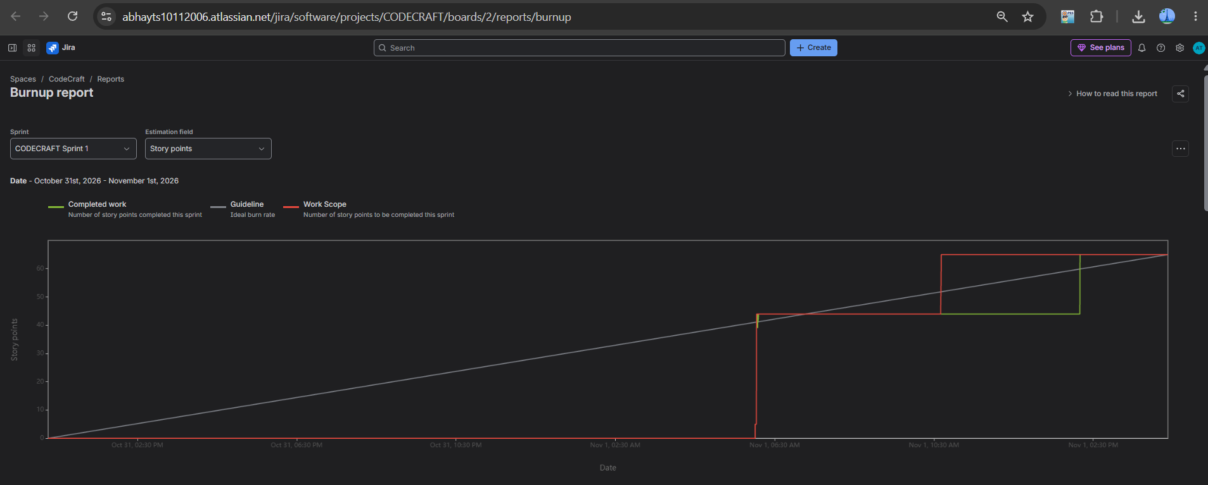

9. Sprint burndown chart
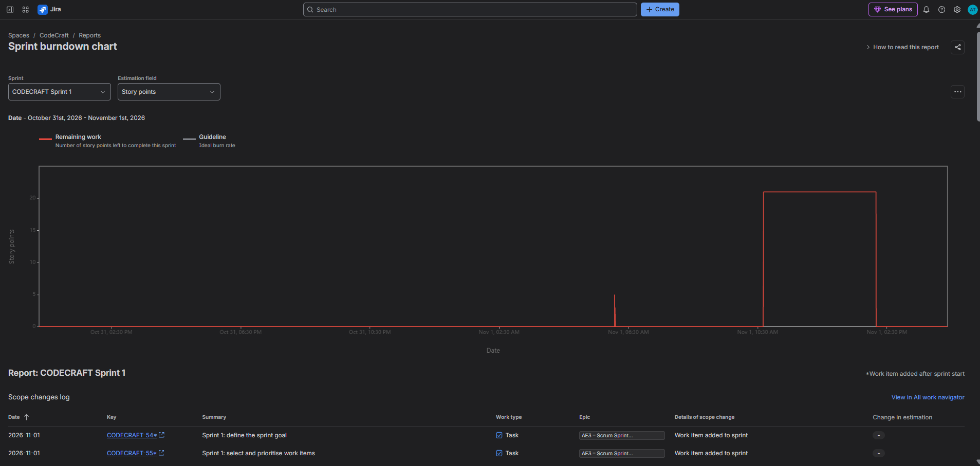

9. Velocity report


