PES University
Software Engineering Mini-Project
Sprint 2
Sprint planning, review and retrospective
Project | CodeCraft: Early Metabolic Risk Detection (ML vs DL vs QML)
Team | CodeCraft
Members | Abhay TS (PES1UG24AM008)  Aarav Yuval B G (PES1UG24AM004)  Abhishek P H (PES1UG24AM013)
Instructor | Cvsn Reddy
Jira project | CODECRAFT (CodeCraft)
Version / date | 1.0 draft, 1 November 2026
Jira deliverable | CODECRAFT-42 / CODECRAFT-59 to 63 (3 marks)
Document status | INTERIM

1. Sprint overview
Official window | 26 to 30 October 2026 (course Part 2)
Jira sprint | Sprint 4, "CODECRAFT Sprint 2": active, started 29 October 2026 05:50 UTC (not backdated to 26 October); Jira shows its end as 1 November 2026
Document status | INTERIM: the sprint has not been formally completed in Jira

2. Sprint goal (CODECRAFT-59)
Goal recorded in Jira sprint 4 (proposed 29 October 2026; team confirmation pending):
"Verify the delivered product against the STP with real evidence (TC-01 to TC-22), complete documentation and the deviation log, enable CI, record the 2-minute working-product video, and freeze the development cycle."

3. Sprint scope (CODECRAFT-60)
Selected testing and final-delivery items, with reasons:
Key | Summary | Pts | Reason
CC-33 | Re-run the automated suite (TC-01 to TC-22) and record evidence-based results | 3 | Independent evidence for TC-01 to TC-22
CC-34 | Execute and record manual test cases (TC-15, TC-17, TC-18, TC-19, TC-21) | 5 | Manual tests the automated suite does not cover
CC-35 | Enable GitHub Actions CI and the PR review workflow | 3 | Course requirement: CI and PR workflow
CC-36 | Record and upload the working-product sprint videos (1 min Sprint 1, 2 min Sprint 2) | 2 | Course requirement: working-product video
CC-37 | Complete documentation, deviation log and the STP execution/experiment records | 5 | Documentation and deviation log
CC-38 | Declare the selenium dependency used by the browser checklist script | 1 | Audit finding: undeclared dependency
CC-39 | Freeze the development cycle with a tagged final commit | 1 | Freeze the development cycle
CC-11 | Verify validation performance on a 50,000-row file (≤10 s) | 2 | TC-13 timing evidence
CODECRAFT-11 was added to the sprint after it started, so it is a scope change, not original scope. The team's selection rationale is not otherwise recorded.

4. Team responsibilities (CODECRAFT-61)
Key | Proposed owner
CC-33 | Abhishek P H
CC-34 | Abhishek P H
CC-35 | Aarav Yuval B G
CC-36 | Aarav Yuval B G
CC-37 | Abhishek P H
CC-38 | Abhishek P H
CC-39 | Aarav Yuval B G
CC-11 | Abhishek P H
Assignments are proposals (label alloc-proposed) until confirmed by the team.

5. Completion criteria (CODECRAFT-62)
- An item is complete only when its acceptance criteria are met and evidence is attached (command output, date, commit hash, link).
- Test statuses use only PASS, FAIL, BLOCKED or NOT RUN.
- Jira Done reflects the team's report and is kept separate from verified evidence.

6. Sprint review (CODECRAFT-63)
Measure | Value | Basis
Items in scope | 8 (7 planned + 1 added) | Jira sprint 4 membership
Items marked Done in Jira | 8 | Team-reported
Points on Done items | 22 | Proposed estimates; not a verified velocity
Verified evidence attached | None supplied | No run output, video link, workflow file or tag supplied
Final velocity will be added only after a proper sprint completion backed by evidence.

6.1 Open questions
- CODECRAFT-33: command, environment, commit hash and output for the 22-test re-run.
- CODECRAFT-35: GitHub Actions workflow file and a run link.
- CODECRAFT-36: the Sprint 2 video path or link.
- CODECRAFT-39: the tag or commit hash that marks the freeze.

7. Retrospective
PENDING. These sections stay empty until the team provides real input.
Question | Team input
What went well? | The sprint goal, scope and owners were recorded in Jira. Testing, CI, the video, documentation and the freeze were each broken into their own tracked item.
What did not go well? | CODECRAFT-11 was added after the sprint started, so scope grew mid-sprint. The Jira sprint started on 29 October rather than 26 October. Items were marked Done before test evidence such as run output, a CI run link and a freeze tag was attached. Open questions remain on the QML subsample deviation and the HW-01 test mapping.
What will we change? | Mark an item Done only after its evidence is attached. Settle the HW-01 mapping and log the deviations before the freeze. Finish the DevOps items and complete the sprint formally in Jira.

7. Burnup report
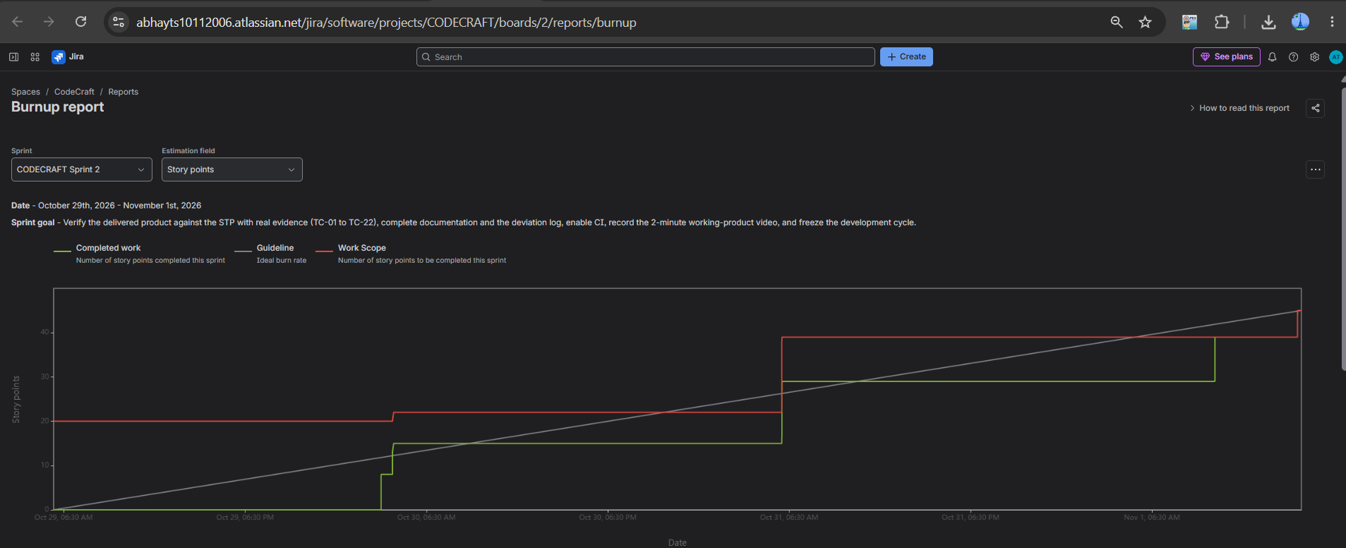

7. Sprint burndown chart
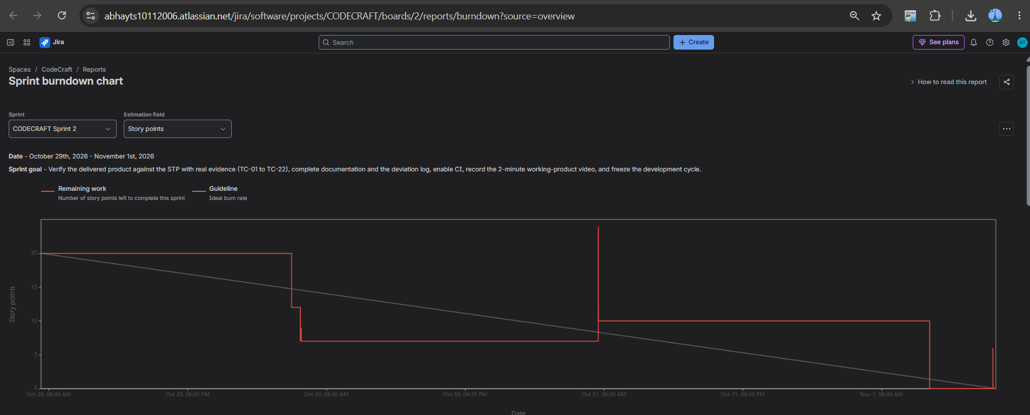

7. Velocity report


