Name: Nikhil Tej
SRN: PES1UG24AM311

SE Lab – 1

1. Requirements Table.

Req ID | Type | Description | Priority | Acceptance Criteria | Rationale  (Short) | Comments
FR-001 | Functional | The system shall enable physicians to author and digitally sign structured prescriptions that are automatically compiled into downloadable PDF records. | High | Pass: A valid cryptographic signature is attached to the prescription PDF and physician license is validated. Fail: Prescription is generated without valid physician license validation. | Ensures prescriptions are digitally authenticated and available as valid downloadable records.
  Verify physician license before allowing digital signing.
FR-002 | Functional |  | High |  | Helps patients identify a suitable physician before booking a consultation.
  The system shall allow patients to view available doctor specialties and the corresponding attending physicians.
  Pass: When a patient selects a specialty, the system displays the corresponding available physicians. Fail: The system displays physicians unrelated to the selected specialty.
  Specify that
  only currently
  available
  specialties and
  physicians
  should be
  displayed.
FR-003 | Functional |  | High | Pass: When a patient selects an available slot, the system confirms the booking and marks the slot as unavailable for further booking. Fail: The system confirms a slot that is already booked. | Provides the core functionality for scheduling remote healthcare consultations.
  The system shall allow patients to view and book available video consultation slots with an attending physician.
  Prevent double-booking of the same consultation slot.
FR-004 | Functional | The system shall generate and provide an encrypted tele-consultation room link to the patient for a confirmed video consultation. | High | Pass: After a successful booking, the patient receives a valid encrypted consultation-room link associated with the booked appointment. Fail: No link is generated or the link is accessible without the required authorization. | Protects access to the remote consultation and enables secure patient-physician communication. | Ensure the consultation link is accessible only to the authorized patient and physician.
FR-005 | Functional |  | High | Pass: The patient can download the prescription as a PDF containing the physician's valid digital signature. Fail: The prescription cannot be downloaded or the downloaded PDF lacks the valid signature. | Provides patients with a usable digital record of their prescribed treatment. | Verify the digital signature remains valid in the downloaded PDF.
  The system shall allow patients to download the digitally signed prescription generated by the attending physician as a PDF record.
NFR-001 | Non-Functional | The system shall encrypt all video session metadata and patient clinical notes in transit using TLS 1.3 and at rest using AES-256. | High | Pass: Security testing confirms TLS 1.3 for data in transit and AES-256 for data at rest. Fail: Any specified data is transmitted or stored without the required encryption. | Protects sensitive patient and consultation information from unauthorized access.
  Security standards must be verified through encryption testing.
NFR-002 | Non-Functional | The system shall make confirmed consultation appointments and their associated tele-consultation links available to authorized users within 5 seconds of successful booking. | Medium |  | Ensures timely access to booked consultations and reduces uncertainty for patients.
  Pass: In testing, the confirmed appointment and consultation link are displayed to the authorized patient within 5 seconds of successful booking. Fail: The information takes more than 5 seconds to become available.
  Specify the
  5-second
  response
  target and
  verify it under
  expected
  system load.

2. UML Use-Case Diagram.
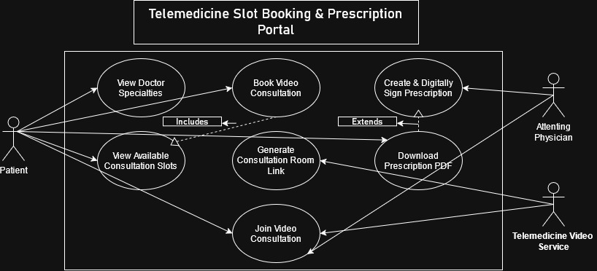

Actors
- Patient
- Attending Physician
- Telemedicine Video Service
Use Cases
- View Doctor Specialties
- View Available Consultation Slots
- Book Video Consultation
- Generate Consultation Room Link
- Join Video Consultation
- Create & Digitally Sign Prescription
- Download Prescription PDF

3. Use-Case Flow Document.

UC - Book Video Consultation: -
Pre Conditions
- The patient has access to the Telemedicine Slot Booking & Prescription Portal.
- The patient has selected a doctor specialty and an attending physician.
- At least one consultation slot is available for the selected physician.

Post Conditions
- The selected consultation slot is successfully booked for the patient.
- The booked slot is no longer available for another patient.
- A tele-consultation room link is generated for the confirmed appointment.
- The patient can access the details of the scheduled consultation.

Main Success Scenario
- Patient selects a doctor specialty from the portal.
- System displays the attending physicians available under the selected specialty.
- Patient selects an attending physician.
- System displays the physician's available video consultation slots.
- Patient selects an available consultation slot.
- System validates that the selected slot is still available.
- System confirms the consultation booking.
- System marks the selected slot as unavailable for further booking.
- System generates an encrypted tele-consultation room link.
- System displays the confirmed appointment details and consultation room link to the patient.
- Use case ends successfully.

Alternate Flow — Selected Slot No Longer Available
1. Consultation slot becomes unavailable
2. System detects that the selected slot has already been booked by another patient.
3. System informs the patient that the selected slot is no longer available.
4. System displays the physician's currently available consultation slots.
5. Patient selects another available slot.
6. System resumes the main success scenario from Step 6.

