Requirements Table
Name : BASAWARAJ PANCHAL SRN : PES1UG24AM350
Centralized Audit Trail Compliance Engine
Req ID | Type | Description | Priority | Acceptance Criteria | Rationale
FR-001 | Functional | The system shall parse structured JSON audit logs, identify sensitive PII fields such as Social Security Numbers and credit card numbers, and mask them before storing the records. | High | Pass: Stored audit record contains masked PII and no cleartext SSN or credit card number. Fail: Any sensitive PII remains in cleartext. | Protects sensitive information and supports GDPR compliance.
FR-002 | Functional | The system shall ingest enterprise application event logs and create audit records in the centralized audit trail. | High | Pass: A valid submitted JSON event log is processed and its corresponding audit record is available in the audit trail. Fail: The event is rejected or missing without an error being recorded. | Centralizes application events for compliance monitoring and auditing.
FR-003 | Functional | The system shall allow a Compliance Officer to query historical audit records using filtering criteria. | High | Pass: A valid query returns all matching audit records and applies the selected filters. Fail: Matching records are omitted or unrelated records are returned. | Enables efficient investigation and compliance review.
FR-004 | Functional | The system shall allow a Security Auditor to generate an immutable audit export containing selected audit records and a cryptographic integrity hash. | High | Pass: The exported audit file contains the selected records and a valid SHA-256 integrity hash. Fail: The export is missing records or has no valid integrity hash. | Provides verifiable evidence for security and compliance audits.
FR-005 | Functional | The system shall verify the integrity of an audit export by recalculating its cryptographic hash and reporting whether the export has been modified. | Medium | Pass: An unchanged export is reported as valid and a modified export is reported as invalid. Fail: The system gives the same result for both cases. | Helps auditors detect tampering with audit evidence.
NFR-001 | Nonfunctional — Performance & Security | The system shall support complex filtering across 10 million historical audit records in under 1 second. | High | Pass: Benchmarking confirms the query completes in less than 1 second under the specified dataset and simulated peak load. Fail: The query takes 1 second or longer. | This is the performance/security target specified in the problem statement.
NFR-002 | Nonfunctional — Security | The system shall ensure that sensitive PII is never persisted in cleartext in the audit storage. | High | Pass: Security testing of stored audit records finds no unmasked SSNs or credit card numbers. Fail: Any sensitive PII is found in cleartext. | Prevents exposure of sensitive personal and payment information.

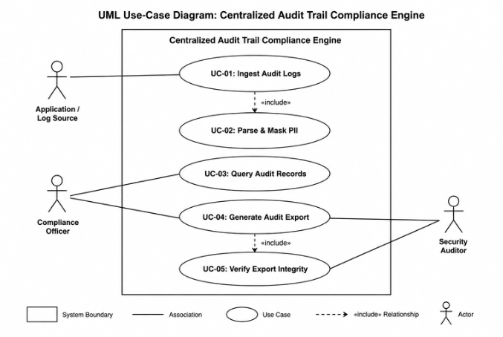

Use-Case Flow

Preconditions
• The Security Auditor is authorized to access the audit system.
• Required audit records have already been ingested and stored.
• The audit records have had sensitive PII masked.

Postconditions
• The requested audit records are exported.
• The export contains a cryptographic integrity hash.
• The generated export can be verified for integrity.

Main Success Scenario
1. Security Auditor selects “Generate Audit Export”.
2. System displays available audit records and filtering options.
3. Security Auditor specifies the records or criteria to include.
4. System retrieves the matching audit records.
5. System confirms that sensitive PII is masked.
6. System generates the audit export.
7. System calculates a SHA-256 integrity hash for the export.
8. System attaches the integrity hash to the audit export.
9. System makes the immutable audit export available to the Security Auditor.
10. Use case ends successfully.

Alternate Flow — No Matching Records
• 4a1. System finds no audit records matching the specified criteria.
• 4a2. System displays a message indicating that no matching records were found.
• 4a3. Security Auditor modifies the filtering criteria.
• 4a4. System returns to Step 3 of the Main Success Scenario.

