SmartDesk
Semantic IT & Facilities Helpdesk System
Project Report
DBMS Experiential Learning, Level 3
PES University

Item | Detail
Project title | SmartDesk - Semantic IT & Facilities Helpdesk System
Database option | Option 2: SQL + vector database (PostgreSQL with pgvector)
Team member 1 | [Name, SRN]
Team member 2 | [Name, SRN]
Course instructor | [Name]
Date | October 2026

Companion deliverables: the source repository with README, the presentation slides, and the documents in the docs folder (ER diagram, data dictionary, important queries, evaluation and performance results, screenshots).

Contents
- 1 Abstract
- 2 Problem statement and motivation
- 3 Objectives and scope
- 4 Requirements
- 5 System architecture
- 6 Database choice and justification
- 7 Database design
- 8 Vector database and semantic search
- 9 SQL implementation
- 10 Important queries
- 11 Application implementation
- 12 Application screenshots
- 13 Testing and results
- 14 Compliance with course requirements
- 15 Conclusion and future enhancements
- 16 Individual contributions
- Appendix: how to run the project

1. Abstract
Organisations receive a large number of IT and facilities support tickets ("Wi-Fi not working", "AC not cooling"). Conventional helpdesk tools only store these tickets: they match exact words, rely on people to categorise and assign each one, and keep no memory of how similar problems were fixed before. SmartDesk is a web-based helpdesk that understands the meaning of a ticket. Each description is converted into a 384-number embedding by a pre-trained model and compared, using cosine similarity in PostgreSQL with pgvector, with tickets that were already solved. Depending on how close the best match is, the system suggests the earlier fix, routes the ticket to the right department, or sends it to an administrator. A stored procedure then assigns the least-loaded technician, and database triggers set the SLA deadline, write an audit trail and raise breach alerts. The Gemini API, used only after retrieval, writes a short explanation of the suggested fix from the retrieved tickets.
The system is a Next.js application with three roles (Employee, Technician, Admin) and a simple white and orange dashboard. The database layer demonstrates constraints and a composite foreign key, triggers, stored procedures, views, full-text and vector indexes, and transactions. Automated tests cover the database (25 tests), the API (62 checks), the decision logic (15 unit tests) and a concurrency experiment that shows why technician assignment needs a lock.

2. Problem Statement and Motivation
In a campus, office or hospital, people report problems all day. Each report must be understood, sent to the right team, assigned to a person and fixed within an agreed time (the SLA, Service Level Agreement). The common problems are:
- Duplicate tickets: one outage is reported by many people and each report is handled separately.
- Slow routing: staff read every ticket and choose the department manually.
- Lost knowledge: fixes exist but cannot be found by meaning ("internet unstable" versus "Wi-Fi disconnects").
- Uneven workload: tickets are assigned by habit, not capacity.
- Missed deadlines: late tickets are noticed only when someone complains.
- No insight: recurring problems and technician workload are hard to see.
Problem statement. How can a helpdesk understand free-text problem descriptions well enough to reuse past solutions, route tickets correctly, balance technician workload and enforce deadlines, while keeping the data correct and secure?

3. Objectives and Scope
- Design a normalised relational schema for users, tickets, technicians, departments and SLA policies, with an ER diagram and data dictionary.
- Find similar resolved tickets by meaning and use the result to suggest fixes and route tickets.
- Assign technicians by workload, enforce SLA deadlines and keep a full audit trail inside the database.
- Provide role-based access for Employee, Technician and Admin, and dashboards for status, resolution time and workload.
- Use a pre-trained language model (Gemini) only to explain retrieved fixes, with safeguards against wrong or unsafe output.
- Measure the quality of the search against a keyword baseline instead of assuming it works.
In scope | Out of scope
Plain-English ticket submission  Automatic routing and suggested fixes  Workload-based assignment and SLA tracking  Role-based workflows and dashboards  Audit trail and database-level validation  LLM explanation with grounding checks  Measured accuracy against a baseline | Training or fine-tuning models  Multi-factor login, OAuth, email delivery  In-app notifications  Row-level security  A second, separate vector database

4. Requirements

4.1 Functional requirements
ID | Requirement | Role | Status
F1 | Sign in with email and password; session ends on logout or deactivation | All | Implemented
F2 | Submit a ticket in plain English with a priority | Employee | Implemented
F3 | Embed the text and search verified resolved tickets by cosine similarity | System | Implemented
F4 | Decide suggest / route / triage from the similarity scores | System | Implemented
F5 | Assign the least-loaded technician of the department without races | System | Implemented
F6 | Set the SLA deadline from the priority; raise breach alerts; scheduled overdue scan | System, Admin | Implemented
F7 | Ticket lists with filters and full-text search; detail page with status timeline | All | Implemented
F8 | Start work and resolve with a written resolution; resolution becomes searchable | Technician | Implemented
F9 | Feedback ("This solved it" / "Still need help"), reopen, withdraw (delete) an Open ticket | Employee | Implemented
F10 | Gemini explanation grounded in retrieved tickets, cached, with fallback | Employee | Implemented
F11 | Count similar open tickets from the last 48 hours (possible outage) | Employee | Implemented
F12 | Dashboard: totals, overdue, unassigned, average resolution time, status and priority, workload, department summary | Admin | Implemented
F13 | AI performance: decisions, deflection rate, routing accuracy; recurring issues | Admin | Implemented
F14 | Reassign department or technician; escalate priority; triage and unassigned queues | Admin | Implemented
F15 | Create and deactivate users | Admin | Implemented
F16 | Audit trail with the user who made each status change | System | Implemented

4.2 Non-functional requirements
Area | Requirement and how it is met
Integrity | All validation is enforced by the database (CHECK, FOREIGN KEY, UNIQUE, composite foreign key); the application validates as a second layer
Security | bcrypt password hashes, signed httpOnly cookie, server-side role and ownership checks, parameterized SQL, login rate limit, Origin check, secrets in environment variables
Reliability | The AI layer never blocks ticket creation: on any failure the ticket is saved and goes to triage; Gemini failure shows the raw past fix
Performance | Indexes for the dashboard filters, full-text search and vector search; model loaded once at server start
Usability | Simple single-column white and orange interface; one-click demo accounts; clear status and deadline badges
Maintainability | Thin routes, business logic in services, pure decision function, SQL in ordered files, one command rebuilds the database

5. System Architecture
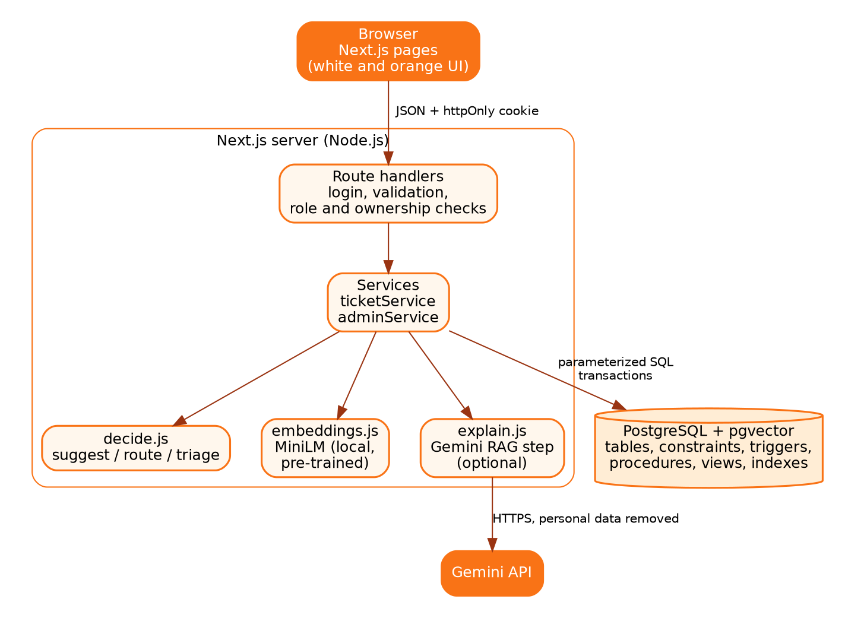
Figure 1. System architecture
Layer | Responsibility | Technology
Presentation | Pages and forms, role-based navigation | Next.js 14 (React), plain CSS
API | Authentication, validation, role and ownership checks, error mapping | Next.js route handlers
Services | Create ticket, resolve, feedback, reopen, withdraw, admin actions | lib/ticketService.js, lib/adminService.js
AI | Embedding, similarity query, decision logic, Gemini explanation | MiniLM via @xenova/transformers, pgvector, @google/genai
Data | Integrity, audit, assignment, SLA, vector search | PostgreSQL 14+ with pgvector

5.1 Ticket submission flow
- The server checks the cookie and role and validates the input.
- The local MiniLM model converts the description into 384 numbers (any failure sends the ticket to triage).
- PostgreSQL returns the 5 most similar verified, resolved tickets with cosine similarity.
- The decision logic chooses suggest, route or triage.
- One transaction saves the ticket (a trigger sets the SLA deadline and writes the audit row), records the decision, and calls the assignment procedure inside a savepoint.
- For suggest mode, a second request asks Gemini to explain the retrieved fixes; the answer is checked and cached.

6. Database Choice and Justification
The course requires the choice of database to follow the nature of the data. SmartDesk has two kinds of data, so it uses two paradigms in one PostgreSQL instance.
Data | Store | Justification
Users, roles, tickets, technicians, SLA policies, audit log | PostgreSQL tables | Structured, transactional data with relationships. It needs primary and foreign keys, constraints, joins, triggers, procedures and aggregation for dashboards
Ticket descriptions (unstructured text) | pgvector column in PostgreSQL | Finding the same problem in different words needs similarity search over embeddings. A relational database cannot do this efficiently; keyword search misses paraphrases

 | pgvector (chosen) | Separate store such as Chroma
Consistency | Ticket and vector saved in one transaction | Two stores to keep in sync; partial failures possible
Filtering | SQL filters and joins in the same query (status, verified, department) | Metadata filters only; joins in application code
Operations | One extension to install | Extra process and failure mode
Course rules | Listed as an accepted vector database | Also accepted
Why not training a model? About 120 labelled tickets are far too few to train a classifier, and a pre-trained embedding model needs no training data. Why not an LLM for routing? Routing must be testable and must not hallucinate, so plain rules over similarity scores decide; the LLM is used only for wording.

7. Database Design

7.1 ER diagram
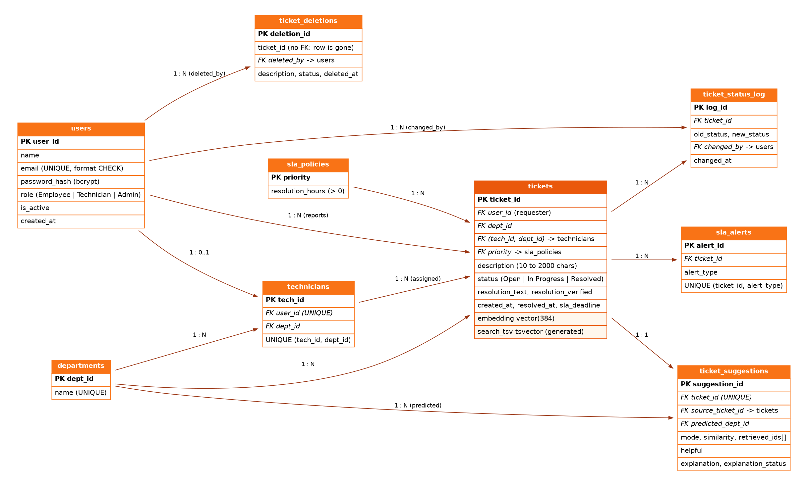
Figure 2. Entity-relationship diagram (PK = primary key, FK = foreign key)

7.2 Relational schema
Table | Key | Main attributes and rules
departments | PK dept_id | name (UNIQUE). Includes a "Triage" department for unrouted tickets
sla_policies | PK priority | resolution_hours (> 0)
users | PK user_id; UNIQUE email | name, password_hash, role (Employee | Technician | Admin), is_active; email format CHECK
technicians | PK tech_id; FK user_id (UNIQUE), FK dept_id | UNIQUE (tech_id, dept_id) is the target of the composite foreign key from tickets
tickets | PK ticket_id; FK user_id, dept_id, priority; composite FK (tech_id, dept_id) | description (10 to 2000), status, resolution_text, resolution_verified, created_at, resolved_at, sla_deadline, embedding vector(384), search_tsv (generated)
ticket_status_log | PK log_id; FK ticket_id, changed_by | old_status, new_status, changed_at (written by a trigger)
sla_alerts | PK alert_id; FK ticket_id | alert_type (Active Exceeded | Resolved Late); UNIQUE (ticket_id, alert_type)
ticket_suggestions | PK suggestion_id; FK ticket_id (UNIQUE), source_ticket_id, predicted_dept_id | mode, similarity, retrieved_ids[], helpful, explanation, explanation_status
ticket_deletions | PK deletion_id; FK deleted_by | Record of withdrawn tickets (no foreign key to the deleted ticket)

The complete column-level description (type, null, key, default, meaning, constraints) is in the generated data dictionary, docs/data_dictionary.md.

7.3 Normalisation
The schema is in third normal form: every non-key attribute depends on the key, the whole key and nothing but the key. Priority levels live once in sla_policies. Two columns are stored deliberately although they could be derived, and this is documented as a design decision:
- tickets.sla_deadline equals created_at plus the policy hours. It is stored as a snapshot so that a later change of policy does not rewrite the deadline of existing tickets.
- ticket_suggestions.predicted_dept_id can differ from tickets.dept_id after an Admin corrects the routing. Keeping both is what allows routing accuracy to be measured.

7.4 Integrity and validation at the database level
Rule | Enforced by
Description length 10 to 2000 characters | CHECK chk_ticket_description
Status is Open, In Progress or Resolved; role is Employee, Technician or Admin | CHECK chk_ticket_status, chk_users_role
Resolved requires a resolution text and a resolved time; otherwise resolved_at must be empty | CHECK chk_ticket_resolved_full, chk_ticket_resolved_at
Resolved time not before created time | CHECK chk_ticket_time_order
A resolution can be "verified" only on a resolved ticket | CHECK chk_ticket_verified
Valid email format; no duplicate email | CHECK chk_users_email_format; UNIQUE
A technician can only be assigned to a ticket of their own department | Composite FOREIGN KEY fk_ticket_tech_dept (tech_id, dept_id)
Only known priorities | FOREIGN KEY to sla_policies
One alert of each type per ticket | UNIQUE (ticket_id, alert_type)

8. Vector Database and Semantic Search
Question | Answer
What data is converted into embeddings? | The ticket description (tickets.description), when the ticket is created.
Which model is used? | Pre-trained all-MiniLM-L6-v2 (384 dimensions, normalised output), run locally through @xenova/transformers. Nothing is trained. An offline lexical fallback (EMBEDDING_PROVIDER=hash) exists for tests only.
How are vectors stored? | Column tickets.embedding of type vector(384) in PostgreSQL (pgvector), with a partial HNSW index over verified resolved tickets.
Which similarity metric? | Cosine similarity. pgvector operator <=> returns cosine distance, so similarity = 1 - distance.
How are results retrieved? | The 5 nearest verified resolved tickets by cosine distance, then the decision logic. The top 3 are passed to Gemini for the explanation.

8.1 Similarity query
SELECT t.ticket_id, t.dept_id, t.description, t.resolution_text,
1 - (t.embedding <=> $1::vector) AS similarity
FROM tickets t
WHERE t.status = 'Resolved' AND t.resolution_verified AND t.embedding IS NOT NULL
ORDER BY t.embedding <=> $1::vector
LIMIT 5;

8.2 One search, three outcomes
Mode | Condition | Action
suggest | Best similarity at or above SIM_HIGH | Show the past fix with source ticket and score; route to its department
route | Best between SIM_MID and SIM_HIGH, and one department holds at least half of the similarity-weighted vote | No fix shown; route by the weighted vote
triage | Best below SIM_MID, a split vote, or the AI step failed | Department = Triage; an Admin routes it
The thresholds are configuration values, not constants. The defaults are starting values for MiniLM and are tuned with the evaluation script on a hand-written test set.

8.3 Learning loop
A technician's resolution sets resolution_verified, so the ticket joins the searchable set at once; nothing is recomputed because its embedding was stored at creation. If an employee reopens a ticket, the flag is cleared and the possibly wrong fix stops being suggested. The dashboard reports the deflection rate (tickets employees closed themselves with a suggestion) and routing accuracy (predicted department compared with the final one).

9. SQL Implementation

9.1 DDL
The schema (db/schema.sql) creates nine tables with keys and constraints; db/indexes.sql, db/views.sql, db/triggers.sql and db/routines.sql add indexes, views, triggers and procedures. The reset script uses DROP SCHEMA ... CASCADE to rebuild everything. An excerpt of the central table:
CREATE TABLE tickets (
ticket_id SERIAL PRIMARY KEY,
user_id INT NOT NULL REFERENCES users(user_id) ON DELETE CASCADE,
dept_id INT NOT NULL REFERENCES departments(dept_id) ON DELETE RESTRICT,
tech_id INT,
description TEXT NOT NULL,
priority VARCHAR(20) NOT NULL REFERENCES sla_policies(priority),
status VARCHAR(20) NOT NULL DEFAULT 'Open',
resolution_text TEXT,
resolution_verified BOOLEAN NOT NULL DEFAULT false,
created_at TIMESTAMPTZ NOT NULL DEFAULT now(),
resolved_at TIMESTAMPTZ,
sla_deadline TIMESTAMPTZ,
embedding vector(384),
search_tsv tsvector GENERATED ALWAYS AS (
to_tsvector('english', coalesce(description,'') || ' ' ||
coalesce(resolution_text,''))) STORED,
CONSTRAINT fk_ticket_tech_dept FOREIGN KEY (tech_id, dept_id)
REFERENCES technicians (tech_id, dept_id),
CONSTRAINT chk_ticket_status CHECK (status IN ('Open','In Progress','Resolved')),
CONSTRAINT chk_ticket_description
CHECK (char_length(trim(description)) BETWEEN 10 AND 2000)
-- ... more CHECK constraints, see db/schema.sql
);

9.2 Indexes
Index | Type | Purpose
status; priority; created_at DESC; (user_id, created_at DESC); dept_id; (tech_id, status) | B-tree | Dashboard filters, "my tickets", technician queue
idx_tickets_fts on search_tsv | GIN | Full-text search in ticket lists
idx_tickets_embedding_resolved | HNSW (partial, cosine) | Nearest-neighbour search over verified resolved tickets; the query repeats the same WHERE predicate so the index can be used

9.3 Triggers
Trigger | Event | Purpose
trg_status_log | AFTER INSERT OR UPDATE OF status | Writes an audit row with the old and new status and the acting user (read from the transaction-local setting app.user_id)
trg_set_sla_deadline | BEFORE INSERT | Sets sla_deadline = created_at + hours from the priority
trg_sla_breach_alert | AFTER INSERT OR UPDATE | Raises "Resolved Late" or "Active Exceeded" alerts (once per ticket and type)
trg_log_ticket_deletion | BEFORE DELETE | Keeps a record of withdrawn tickets

9.4 Stored procedures
Procedure | What it does
assign_technician(ticket, INOUT tech) | Takes a per-department advisory lock, then picks the active technician with the fewest unresolved tickets (ties by lowest id) and assigns the ticket
escalate_ticket(ticket, priority) | Locks the ticket, refuses a priority that is not higher, raises it and restarts the SLA clock from the moment of escalation
scan_and_alert_sla_breaches(INOUT n) | Raises "Active Exceeded" alerts for open tickets already past their deadline and returns how many are new; idempotent
Why an advisory lock? The assignment decision reads an aggregate (the count of unresolved tickets per technician). Row locks cannot protect an aggregate, so two simultaneous tickets could both see the same technician as least loaded. A lock keyed by department serialises exactly that decision. Section 13.4 shows the effect. Why a scheduled scan? A trigger reacts to row changes, not to time passing, so overdue tickets that nobody touches are found by the scan.

9.5 Views
View | Content
technician_workload | Per technician: open, in progress, overdue, resolved, average resolution hours (JOIN, GROUP BY, FILTER)
resolution_summary | Per department: totals, average resolution time, SLA breaches
recurring_issues | Fixes suggested at least twice in 30 days (GROUP BY ... HAVING)
suggestion_performance | One row: decisions by mode, deflected tickets, routing accuracy

9.6 Transactions
Ticket submission is one transaction on one connection: BEGIN, set the acting user, INSERT the ticket, INSERT the suggestion, SAVEPOINT, CALL assign_technician, RELEASE (or ROLLBACK TO the savepoint if there is no technician, so the ticket is not lost), COMMIT. The isolation level is READ COMMITTED together with the advisory lock; SERIALIZABLE would also be correct but forces retry loops for no benefit here. Resolve, feedback, reopen, withdraw and admin actions are also single transactions with row locks (SELECT ... FOR UPDATE).

10. Important Queries
All queries are in docs/queries.sql and were executed against the seeded database (120 tickets, 20 users, 37 SLA alerts). Sample results are shown below.

Q1. GROUP BY and aggregates: average resolution time per department
SELECT d.name AS department, COUNT(*) AS tickets,
ROUND(AVG(EXTRACT(EPOCH FROM (t.resolved_at - t.created_at)) / 3600)::numeric, 1)
AS avg_hours
FROM tickets t JOIN departments d ON d.dept_id = t.dept_id
WHERE t.status = 'Resolved' GROUP BY d.name ORDER BY avg_hours DESC;

department | tickets | avg_hours
IT Hardware | 16 | 42.5
IT Software | 16 | 39.9
Facilities Electrical | 16 | 35.6
Facilities Plumbing & Civil | 16 | 27.4
Facilities HVAC | 16 | 22.8
IT Network | 20 | 21.9

Q2. HAVING: departments where more than 25 percent of resolved tickets breached the SLA
SELECT d.name, COUNT(*) AS resolved,
COUNT(*) FILTER (WHERE t.resolved_at > t.sla_deadline) AS breached
FROM tickets t JOIN departments d ON d.dept_id = t.dept_id
WHERE t.status = 'Resolved' GROUP BY d.name
HAVING COUNT(*) FILTER (WHERE t.resolved_at > t.sla_deadline) > 0.25 * COUNT(*);

department | resolved | breached
Facilities Plumbing & Civil | 16 | 6
IT Hardware | 16 | 6

Q3. Subquery: technicians with above-average active workload
SELECT te.tech_id, u.name, COUNT(*) AS active_tickets
FROM tickets t JOIN technicians te ON te.tech_id = t.tech_id
JOIN users u ON u.user_id = te.user_id
WHERE t.status <> 'Resolved' GROUP BY te.tech_id, u.name
HAVING COUNT(*) > (SELECT AVG(c) FROM (SELECT COUNT(*) AS c FROM tickets
WHERE status <> 'Resolved' AND tech_id IS NOT NULL GROUP BY tech_id) per_tech);

tech_id | name | active_tickets
5 | Farah Ali | 2
8 | Nikhil Verma | 2
6 | Manoj Das | 2

Q4. Full-text search (GIN index on a generated tsvector column)
SELECT ticket_id, description,
ts_rank(search_tsv, websearch_to_tsquery('english', 'printer paper')) AS rank
FROM tickets WHERE search_tsv @@ websearch_to_tsquery('english', 'printer paper')
ORDER BY rank DESC LIMIT 5;

ticket_id | description | rank
83 | Paper jam error keeps appearing but no paper is stuck | 0.107
28 | Office printer shows offline | 0.094
61 | Printer not printing | 0.094
77 | Print jobs stuck in the queue | 0.091

Q5. Vector similarity: tickets closest to ticket 4 ("VPN keeps disconnecting while working from home")
SELECT t.ticket_id, t.description, 1 - (t.embedding <=> q.embedding) AS similarity
FROM tickets t, (SELECT embedding FROM tickets WHERE ticket_id = 4) q
WHERE t.status = 'Resolved' AND t.resolution_verified AND t.ticket_id <> 4
ORDER BY t.embedding <=> q.embedding LIMIT 5;

ticket_id | description | similarity
62 | VPN not connecting from home | 0.491
86 | Wi-Fi is very slow and disconnects frequently | 0.211
49 | VPN client shows authentication failed | 0.187
26 | Laptop freezes while opening applications | 0.173
22 | Laptop dies within 30 minutes of unplugging | 0.120
These similarities come from the offline fallback embedding used in the test environment (see section 13.6); with the MiniLM model the scores differ. Further queries (joins, a correlated subquery, a window function, audit trail, SLA alerts, stored procedure calls, EXPLAIN ANALYZE) are in docs/queries.sql.

11. Application Implementation

11.1 Authentication and authorization
- Passwords are hashed with bcrypt. Login compares against a dummy hash for unknown emails and returns one message for every failure, so emails cannot be enumerated; repeated failures are rate limited.
- The session is a signed token in an httpOnly, SameSite cookie valid for 8 hours. The user row is re-read on every request, so deactivation and role changes apply immediately.
- Every API route checks the role; routes that take a ticket id also check ownership or assignment. A ticket the caller may not see returns 404, which does not reveal that it exists.
- State-changing requests are refused if the Origin header belongs to another site.
Action | Employee | Technician | Admin
Create a ticket | Yes | Yes | Yes
View a ticket | Own | Assigned or own department | All
Start work / resolve | No | Assigned tickets | All
Feedback on a suggestion | Own | No | No
Reopen / withdraw | Own | No | Yes
Reassign, escalate | No | No | Yes
Dashboard, alerts, users | No | No | Yes

11.2 The Gemini explanation step (RAG)
Retrieval is done by pgvector; generation by the Gemini API. The model never decides routing, assignment or access.
- Grounding: the prompt contains only the new ticket and the top retrieved tickets, and tells the model to use only them and to cite ticket numbers.
- Output check: the answer is accepted only if it cites ticket numbers that were supplied; otherwise the raw past fix is shown.
- Prompt injection: ticket text is delimited and declared to be data; the answer is shown as plain text.
- Privacy: emails and phone numbers are removed before sending; no user ids or names are sent.
- Cost and reliability: one call per ticket (cached in the database), per-user hourly limit, 10-second timeout with one retry, and a switch (LLM_ENABLED) that turns it off.
- Secrets: the API key and model name are environment variables, read only on the server.

11.3 Error handling
Database rule violations are mapped to readable responses (check violation to 400 with the rule name, foreign-key conflict to 409, unique violation to 409, procedure exceptions to 409). Unexpected errors return a generic message and are logged on the server.

12. Application Screenshots
The screenshots were captured from the running application (production build) using seeded demo data. The explanation card shows the label "mock (no API call)" because the Gemini API was not reachable in the test environment; with a key configured it shows the model name instead.
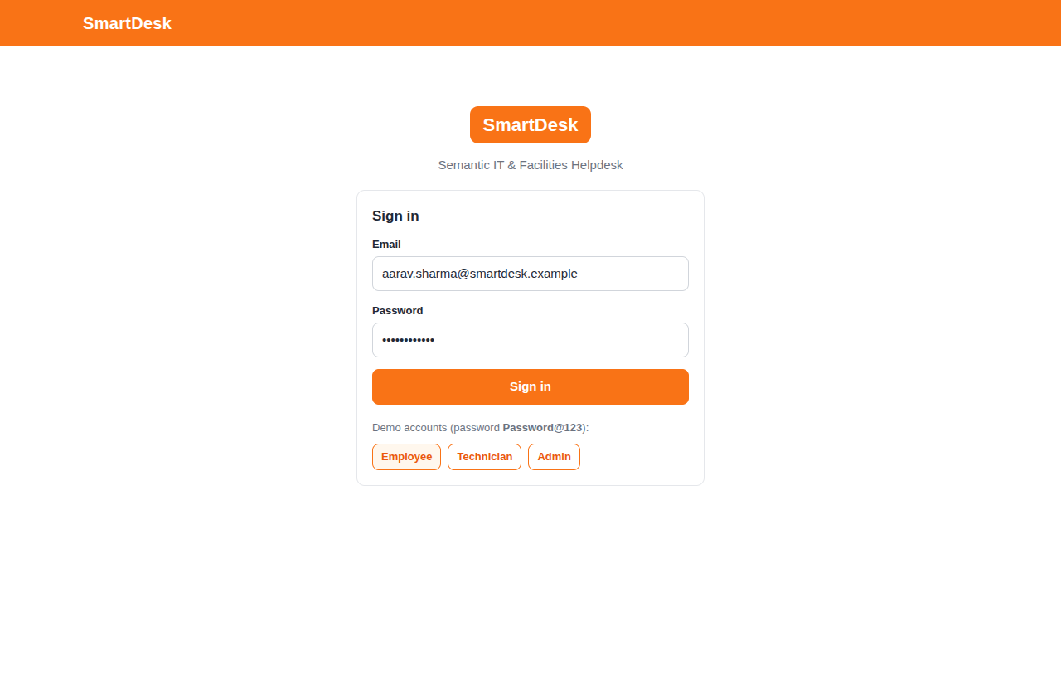
Figure 3. Sign-in page with one-click demo accounts
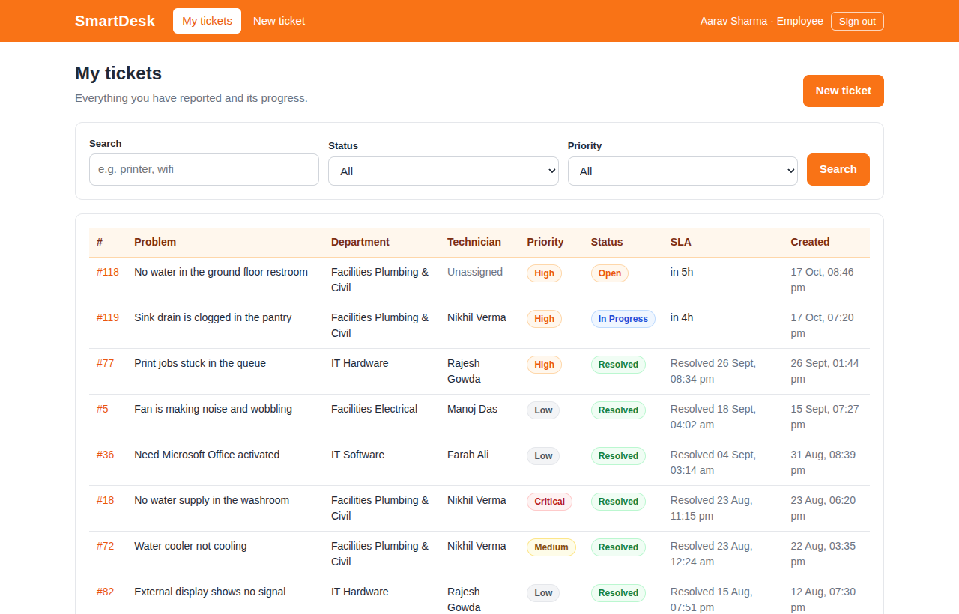
Figure 4. Employee: My tickets with search and filters
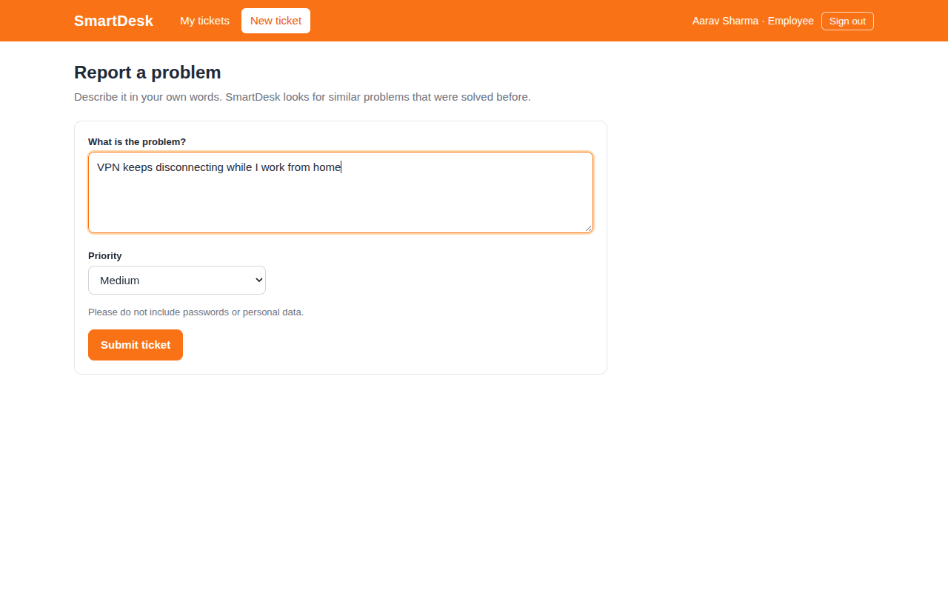
Figure 5. Employee: reporting a problem in plain English
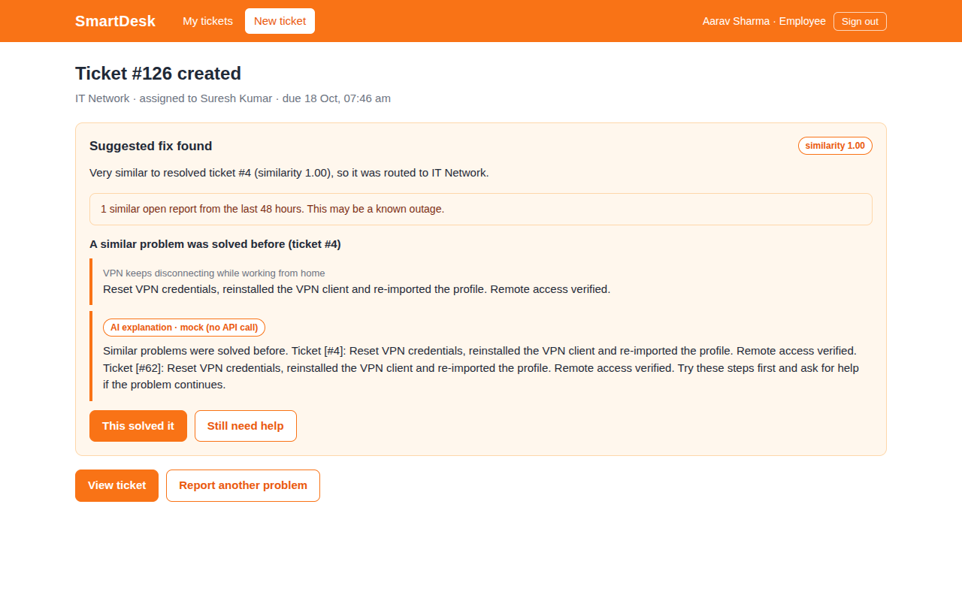
Figure 6. Result: suggested fix, similar open reports, AI explanation and feedback buttons
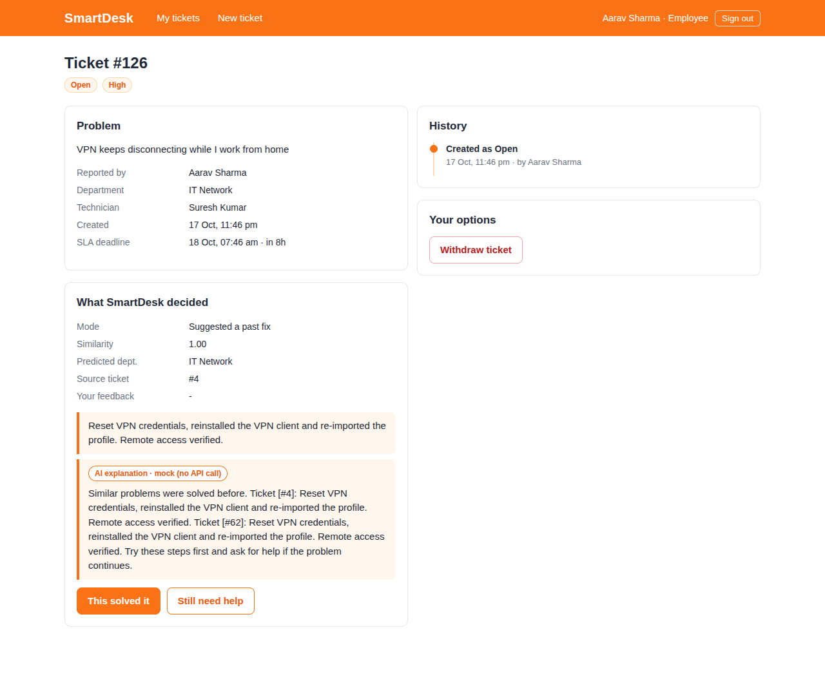
Figure 7. Ticket detail: decision, source ticket, timeline and options
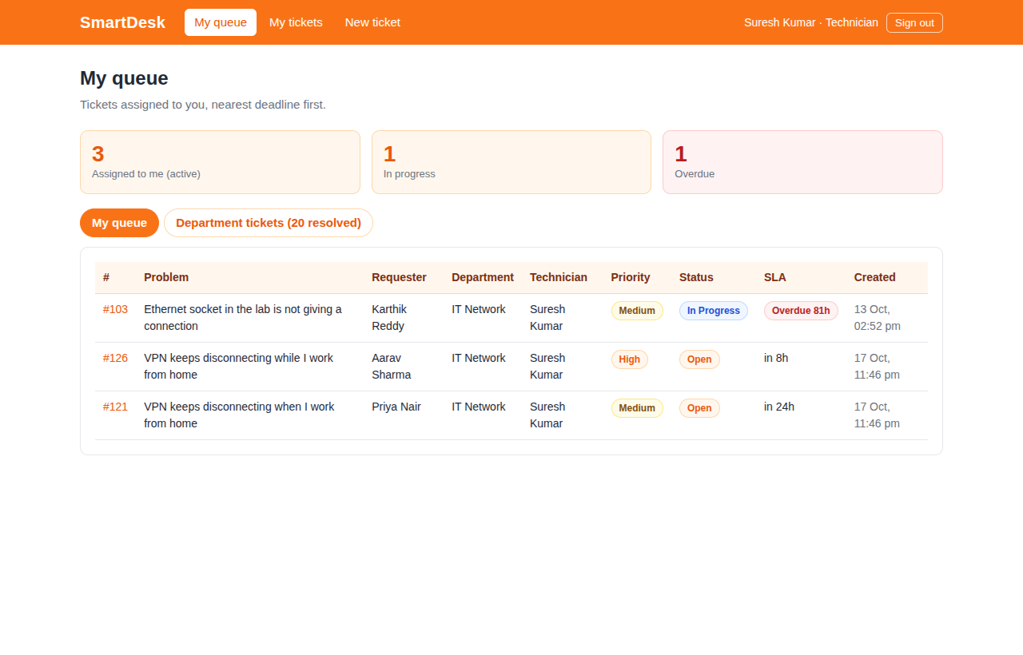
Figure 8. Technician: queue sorted by SLA deadline
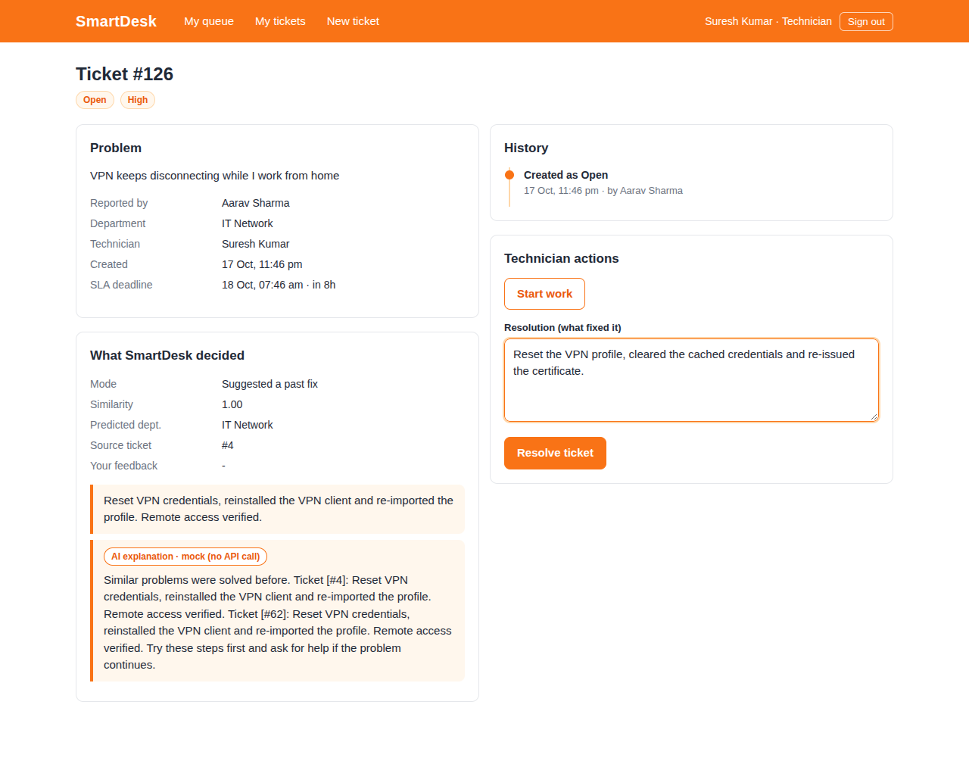
Figure 9. Technician: start work and resolve form
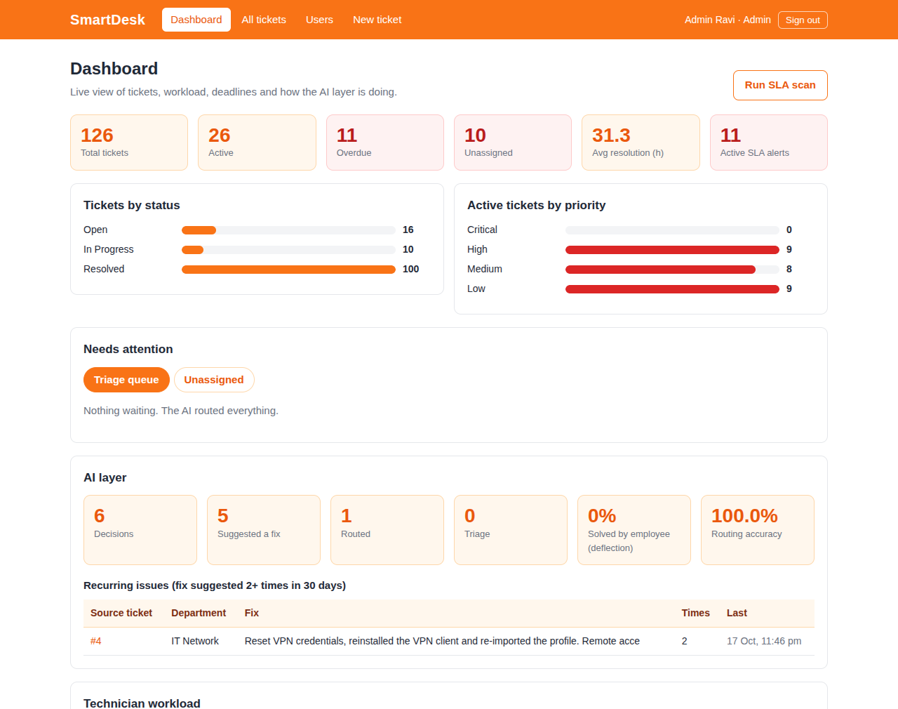
Figure 10. Admin dashboard: KPIs, status and priority, triage queue, AI layer
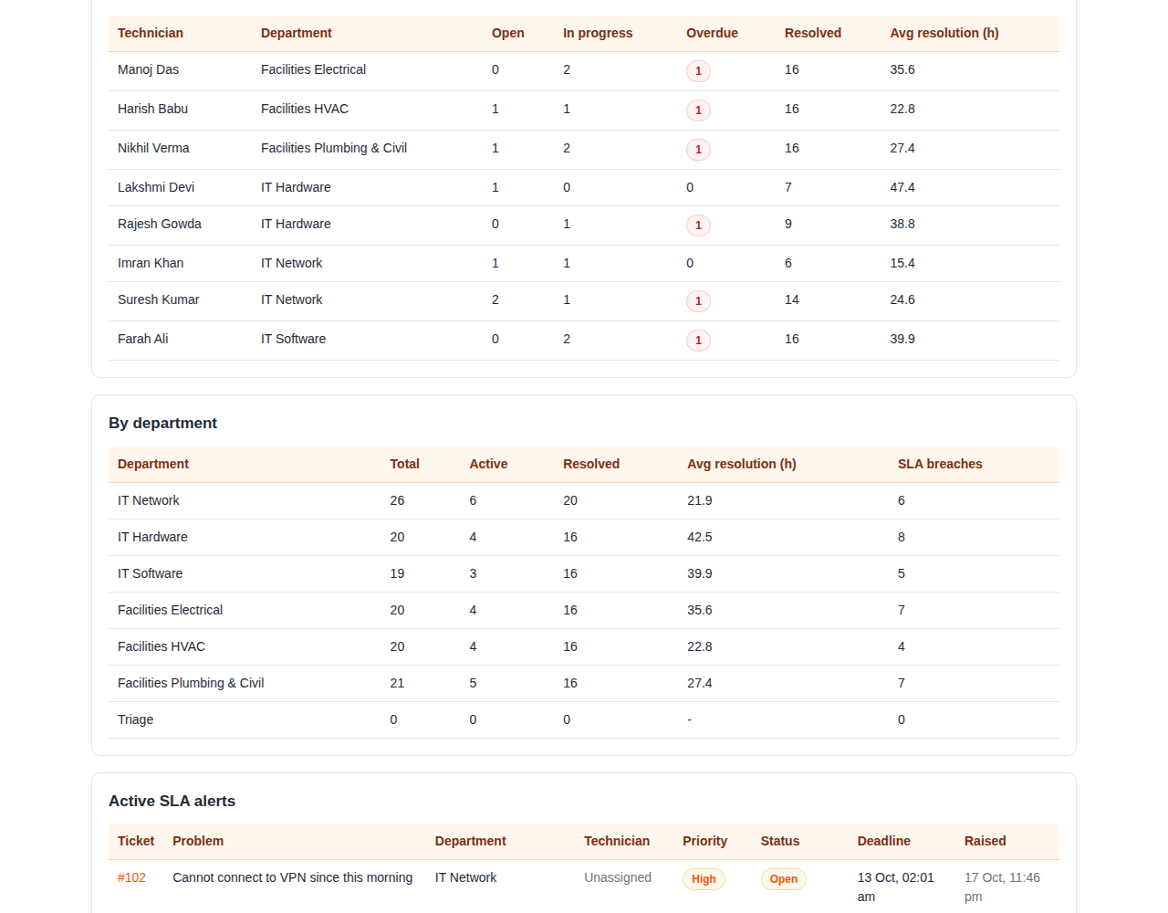
Figure 11. Admin dashboard: technician workload and department summary
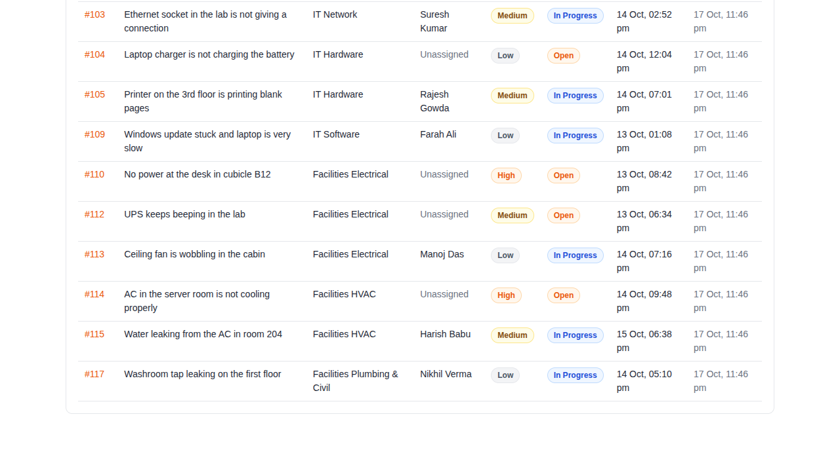
Figure 12. Admin dashboard: active SLA alerts
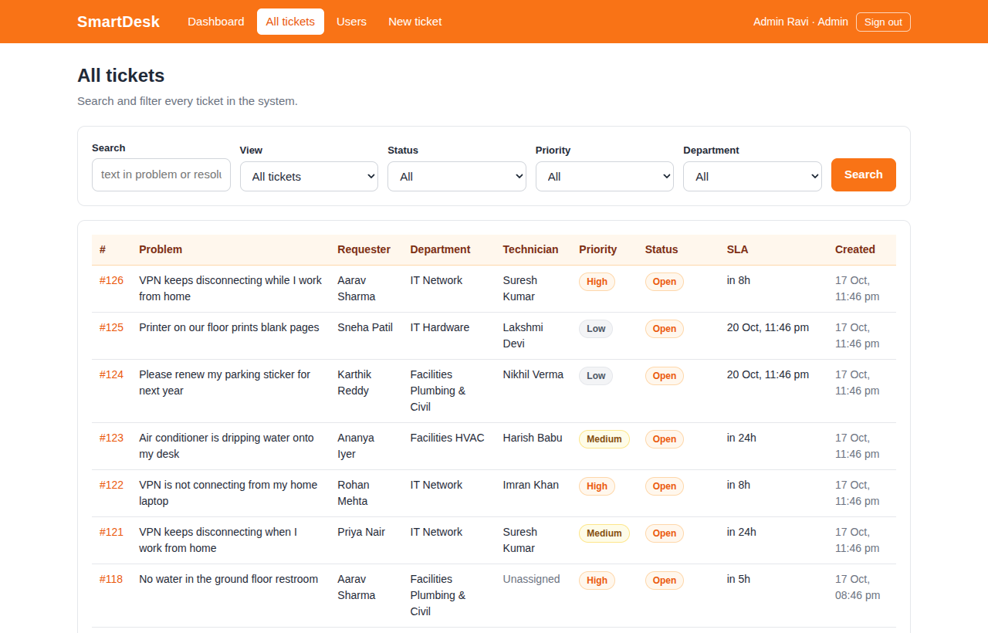
Figure 13. Admin: all tickets with text search and filters
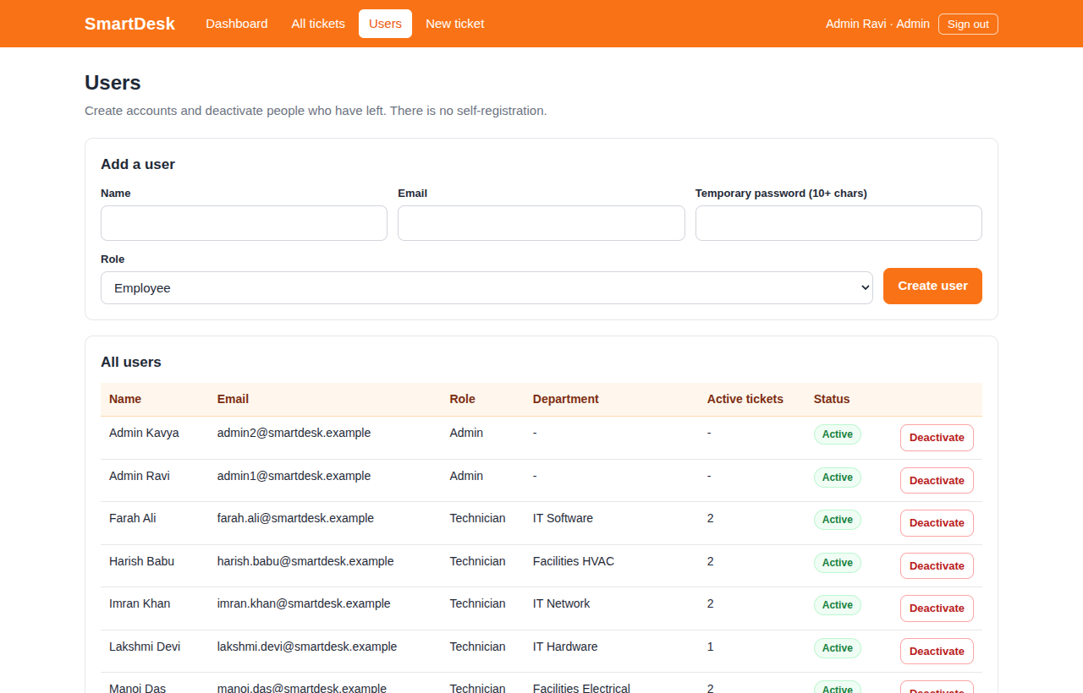
Figure 14. Admin: user management
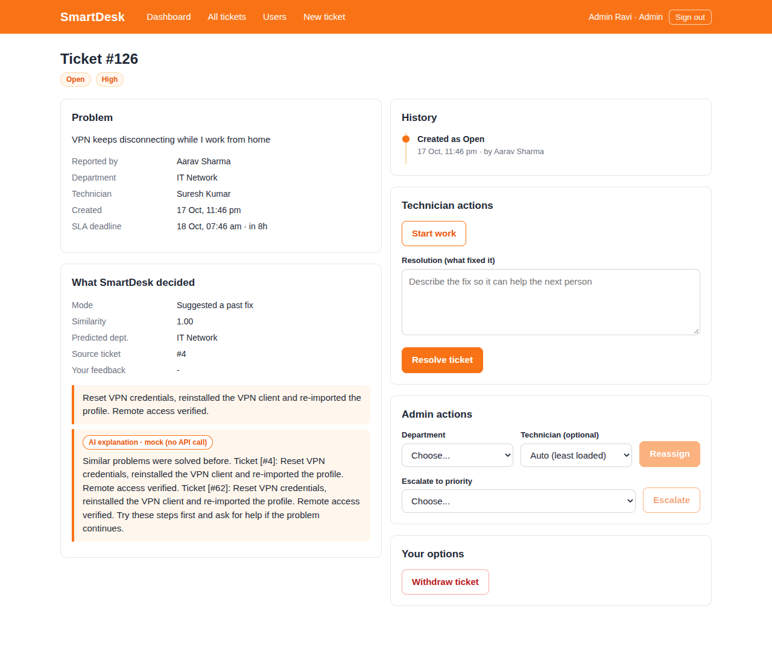
Figure 15. Admin: reassign and escalate controls on a ticket

13. Testing and Results

13.1 Overview
Suite | Result | What it covers
Unit tests (npm test) | 15 / 15 passed | Decision logic (all modes and edge cases), Gemini helper (grounding check, personal-data removal, mock, disabled), fallback embedding
Database tests (npm run test:db) | 25 / 25 passed | Constraints, composite foreign key, triggers, procedures, deletion log, views, full-text search, vector index
API checks (npm run test:api) | 62 / 62 passed | Login, rate limit, role matrix, IDOR, ticket lifecycle, AI flow, admin actions, CSRF
Concurrency (npm run test:concurrency) | 3 / 3 passed | 40 parallel assignments with and without the lock
Evaluation (npm run eval) | see 13.5 | Routing quality against a keyword baseline
Performance (npm run perf) | see 13.6 | EXPLAIN ANALYZE before and after indexes
Environment: PostgreSQL 16.13 with pgvector 0.6.0, Node.js 22, Next.js 14 production build. The web application connected as the restricted database role (no superuser, no DDL rights), so the tests also prove that its privileges are sufficient.

13.2 Database tests
Test | Result
rejects a too-short description | PASS
rejects Resolved without a resolution | PASS
rejects an invalid status | PASS
rejects an unknown priority (foreign key) | PASS
rejects a badly formatted email | PASS
rejects a duplicate email | PASS
rejects a technician from another department (composite FK) | PASS
rejects verified resolution on an open ticket | PASS
SLA trigger sets the deadline from the priority (High = 8 h) | PASS
audit trigger logs the creation with the acting user | PASS
audit trigger ignores updates that do not change the status | PASS
audit trigger logs a status change with who changed it | PASS
SLA breach trigger raises a "Resolved Late" alert | PASS
assign_technician picks a technician of the right department | PASS
assign_technician rejects an unknown ticket | PASS
escalate_ticket refuses a lower priority | PASS
escalate_ticket raises the priority and restarts the SLA clock | PASS
scheduled SLA scan finds an overdue untouched ticket and is idempotent | PASS
DELETE removes the ticket and the trigger records it | PASS
view technician_workload returns every technician | PASS
view resolution_summary returns every department | PASS
view recurring_issues (GROUP BY ... HAVING) lists a fix suggested twice | PASS
full-text search finds tickets | PASS
similarity query can use the partial HNSW index (when alternatives are disabled) | PASS
cosine similarity of a vector with itself is 1 | PASS

13.3 API checks
The 62 checks run against the running production server, logging in as each role. They include: unauthenticated access refused; wrong password and unknown email give the same message; six failed logins are rate limited; the login cookie is HttpOnly and SameSite; the role matrix for seven endpoints; another employee's ticket returns 404; the userId parameter is ignored; a technician of another department cannot open a ticket; the full lifecycle (submit, duplicate refused, assign, start, resolve, audit shows who changed it); a similar ticket from another employee is matched to the newly verified fix; suggestion accepted, feedback only once, reopen; withdraw (DELETE) of an Open ticket and refusal once it is in progress; SQL-injection text stored as plain text; admin reassign, composite foreign key refusal, escalation (and refusal of a lower priority); user creation, duplicate email, weak password, deactivation with immediate sign-out; cross-origin request refused; logout.
Selected checks | Result
repeated failed logins are rate limited (429) | PASS
login cookie is HttpOnly and SameSite | PASS
employee cannot open another employee's ticket (404) | PASS
?userId= parameter is ignored (only own tickets returned) | PASS
SQL-injection text is stored as plain text (201) and tables survive | PASS
another employee cannot request the explanation (404) | PASS
employee cannot withdraw a ticket that is already in progress (409) | PASS
the next similar ticket is matched to the newly verified fix | PASS
explanation step returns a grounded answer that cites a supplied ticket | PASS
explanation is cached after the first call (no second LLM call) | PASS
employee accepts the suggestion and the ticket closes (200) | PASS
reopen sets the ticket Open again and removes the fix from suggestions | PASS
employee withdraws an Open ticket (DELETE 200) | PASS
withdrawn ticket is really gone (404) | PASS
admin escalates priority (200) | PASS
escalating to a lower priority is refused (409) | PASS
admin deactivates the account (200) | PASS
a deactivated account is signed out immediately (401) | PASS
a deactivated account cannot sign in again (401) | PASS
admin cannot deactivate their own account (409) | PASS

13.4 Concurrency: why assign_technician takes a lock
Forty tickets for one department were submitted in parallel from 40 connections. Technician loads before and after:
Variant | Loads (tech 1, tech 2) | Difference
A. The real procedure (with lock) | 1,2 -> 22,21, spread 1 | 1
B. Copy without the lock (small delay added) | 1,2 -> 41,2, spread 39 | 39
C. Copy with the lock (same delay) | 1,2 -> 22,21, spread 1 | 1
Without the lock almost every ticket goes to the same technician, because each transaction cannot see the others' uncommitted assignments. With the lock the load is balanced to within one ticket. Variant B uses an artificial delay to make the race reliable; it demonstrates the problem the lock solves, not the production speed.

13.5 Evaluation of the search
A hand-written set of 56 tickets (48 real problems across six departments and 8 that should go to triage: out-of-scope, vague or mixed requests) is kept separate from the seed tickets. Thresholds were tuned on the even-numbered half and the results are reported on the held-out odd-numbered half. A baseline uses PostgreSQL full-text search with the same decision structure.
Metric | Embedding search (held-out) | Keyword baseline (held-out) | Embedding search (tuning half) | Embedding search (all)
Decision accuracy | 85.7% | 78.6% | 82.1% | 83.9%
Department accuracy among routed tickets | 95.2% | 87.0% | 100.0% | 97.6%
Coverage (real problems not sent to triage) | 87.5% | 95.8% | 87.5% | 87.5%
Triage recall (out-of-scope tickets caught) | 100.0% | 50.0% | 50.0% | 75.0%
Share of tickets answered with a suggested fix | 67.9% | n/a | 75.0% | 71.4%
Decision accuracy counts a ticket as correct when a real problem is routed to the right department, or an out-of-scope ticket is sent to triage. Thresholds chosen on the tuning half: HIGH = 0.4, MID = 0.35.
Important: these figures were produced with the offline fallback embedding (a lexical method with a small synonym table), because the sandbox used for testing had no internet access to download MiniLM. They show that the evaluation method and the system work, not the accuracy of MiniLM. Re-run npm run embed and npm run eval with EMBEDDING_PROVIDER=minilm on a machine with internet to obtain the real figures and to choose the thresholds, and replace this table before submission.
Mistakes on the held-out half: three real problems were sent to triage (lower coverage than the baseline) and one was routed to the wrong department (a laptop that overheats matched an electrical ticket). The held-out half contains only 4 tickets that should go to triage, so the triage-recall figures (100%, 50%, 75%) rest on very few cases.
- "Wireless signal is very weak near the cafeteria": expected IT Network, got triage (low_similarity)
- "Cannot log into VPN, it keeps saying credentials rejected": expected IT Network, got triage (low_similarity)
- "My laptop turns off by itself when it gets warm": expected IT Hardware, got Facilities Electrical (suggest, best similarity 0.43)
- "Email stays in the outbox and will not go out": expected IT Software, got triage (low_similarity)

13.6 Performance of indexes (generated data)
With only about 120 real tickets any index is irrelevant, so the effect is shown on generated data: 200,000 ticket rows for the B-tree indexes and 20,000 clustered 384-dimension vectors for HNSW. These are performance tests, not accuracy tests.
Query | Without index | With index | Plan with index
Last 20 open tickets (status filter, newest first) | 40.14 ms | 0.07 ms | Index Scan using perf_idx_status_created on perf_tickets
One employee's recent tickets | 25.03 ms | 0.06 ms | Index Scan using perf_idx_user_created on perf_tickets
High priority tickets in one department | 28.18 ms | 3.27 ms | Bitmap Heap Scan on perf_tickets

Search | Time (one query) | Plan
Exact (no index) | 17.33 ms | Sort
HNSW index | 2.56 ms | Index Scan using perf_hnsw on perf_vectors
Index build time: 23.7 s. Average recall@5 over 20 queries: 65% (the share of the exact 5 nearest neighbours that HNSW also returned). HNSW is approximate by design, so recall below 100 percent is expected; the setting hnsw.ef_search trades speed for recall. With about 100 real tickets the planner correctly prefers an exact scan, and the database test confirms that the partial HNSW index is usable by the similarity query.

13.7 Limits of the testing
- The real MiniLM model and the real Gemini API were not exercised end to end because the test environment had no internet access. The Gemini call was checked against the field names of the installed SDK (@google/genai 1.52.0) and the failure path was verified (when the model cannot load, the ticket is still created and goes to triage in under a second). Please run a few real tickets with a Gemini key before the demonstration.
- The seed data is synthetic and templated (24 distinct resolution texts across 100 resolved tickets), which is why accuracy is measured on a separate hand-written set.
- The hand-written evaluation set is small (56 tickets), so differences of a few percentage points are not statistically meaningful.

14. Compliance with Course Requirements
# | Requirement | How it is met
1 | Unique, not simple CRUD | Semantic search, automatic routing, SLA engine, grounded LLM explanation, measured evaluation (confirm the title is unique in the section)
2 | Two members; both on database and application | Work split by feature; section 16
3 | SQL + NoSQL or vector database | PostgreSQL + pgvector, justified in section 6
4 | ER diagram, relational schema, vector model | Sections 7 and 8; docs/ER_diagram.png
5 | DDL: CREATE, ALTER, DROP, keys, constraints, indexes, views | db/*.sql; DROP SCHEMA in the reset script; indexes and views in sections 9.2 and 9.5
6 | DML and queries: JOIN, GROUP BY, HAVING, subqueries | Section 10; INSERT, UPDATE and DELETE through the application
7 | At least four advanced concepts | Seven: transactions, triggers, procedures, views, indexing, full-text search, vector search
8 | Embeddings explained | Section 8
9 | Next.js interface with forms, tables, search, filtering, dashboards | Section 12
10 | API layer; no hard-coded credentials | Route handlers; environment variables only
11 | Authentication; at least two roles | Employee, Technician, Admin (section 11.1)
12 | Validation and integrity at the database level | Section 7.4
13 | Security basics; no plain-text passwords | Sections 11.1 and 11.2
14 | Documentation | This report, README, data dictionary, queries
15 | Git/GitHub with individual contributions and README | README with setup and run instructions; commit per feature branch
16 | Demonstration | Slides; test cases in section 13
17, 18 | Originality; beyond CRUD; choice justified | One search with three outcomes, race-free assignment, grounded explanations, measured evaluation

15. Conclusion and Future Enhancements
SmartDesk shows how a relational database and a vector search cooperate in one system: PostgreSQL guarantees the correctness of tickets, assignments, deadlines and audit, while pgvector finds earlier solutions by meaning. Putting the rules that must never be skipped (validation, deadline, audit, assignment lock) in the database made them testable independently of the web application, and the experiments show their effect: constraints reject bad data, the lock keeps the workload balanced, and indexes cut dashboard queries from tens of milliseconds to well under a millisecond on large tables. The language model is used only where it adds value (readable explanations) and is checked against the retrieved evidence.
Future enhancements: run the evaluation with the real MiniLM model on a larger, real corpus and tune the thresholds; an LLM-written weekly summary of recurring issues; in-app notifications; priority suggestion from similar tickets; row-level security in PostgreSQL; a shared store for the login rate limiter when running several servers; multilingual embeddings.

16. Individual Contributions
Work was divided by feature, so each member designed SQL and built Next.js pages for their own area.
 | Member 1: Ticket lifecycle and access | Member 2: Intelligence and analytics
Name / SRN | [Name, SRN] | [Name, SRN]
Database | Users and roles, constraints, audit and SLA triggers, assignment procedure with lock, escalation procedure, deletion log | pgvector column and HNSW index, similarity query, full-text search, workload, resolution, recurring-issue and performance views
Application | Login and sessions, role checks, My tickets, ticket detail, technician queue, admin users, SLA alerts and scan | Ticket submission and suggestion card, decision logic, embeddings, Gemini explanation, admin dashboard, evaluation
Evidence | [commits / pull requests] | [commits / pull requests]

Appendix: How to Run the Project
- Install Node.js 20.6 or newer and PostgreSQL 14+ with pgvector (for example the Docker image pgvector/pgvector:pg16).
- Run npm install, then copy .env.example to .env.local and set DATABASE_URL, ADMIN_DATABASE_URL, APP_DB_PASSWORD and JWT_SECRET.
- Run npm run db:reset to create all database objects and the demo data.
- Run npm run embed to create the search vectors (the first run downloads the MiniLM model, so internet is needed once).
- Run npm run dev and open http://localhost:3000. Demo password for all seeded users: Password@123 (for example aarav.sharma@smartdesk.example, suresh.kumar@smartdesk.example, admin1@smartdesk.example).
- For the Gemini explanation, set LLM_ENABLED=true, GEMINI_API_KEY and GEMINI_MODEL (current model name from Google's documentation).
- Run the tests: npm test, npm run test:db, and, with the server running, npm run test:api (use .env.test.example settings for deterministic offline runs).

