Software Architecture and Design Specification
Project: Peer-to-Peer Tutoring Scheduler
Team: Team 3
Version: 1.0
Authors: Shreyas K M, Mythri S, Mohammed Shahid Javed Mokashi, Vallabha Anand Bhilare
Date: 12-10-2026
Status: Draft

Revision History
Version | Date | Author | Change Summary
0.1 | 28-09-2026 | Shreyas K M | Initial outline of architecture, component list and technology choices
0.2 | 05-10-2026 | Mohammed Shahid Javed Mokashi | Added sequence diagrams, API design and error handling section
1.0 | 12-10-2026 | Team 3 | Added security architecture, traceability to SRS v1.1 and appendices; reviewed by team

Approvals
Role | Name | Signature/Date
Product Owner | Vallabha Anand Bhilare
Developer | Mohammed Shahid Javed Mokashi
QA Lead | Shreyas K M
Test Engineer | Mythri S
Course Coordinator

1. Introduction

1.1 Purpose
This document describes the architecture and design of the Peer-to-Peer Tutoring Scheduler, a web-based system where students publish tutoring slots and other students book them. It explains how the system is split into components, why the main design choices were made, and how the design satisfies the requirements in the SRS (v1.1).

1.2 Scope
Covers the browser-based frontend, the backend REST API, the relational database, and the background worker that sends reminder emails. Functionally this is registration and profiles, tutor availability, slot search and booking with conflict prevention, cancellation and rescheduling, email reminders, session history with ratings, and basic admin moderation. Payments, video-conferencing and integration with college student information systems are outside the scope, as in the SRS.

1.3 Audience
Developers, QA engineers, project evaluators and the course instructors. Testers should read sections 3.8 and 4.3 along with the Test Plan.

1.4 Definitions
API (Application Programming Interface), REST, JWT (JSON Web Token), TLS (Transport Layer Security), UTC, ICS (iCalendar), SMTP, RBAC (Role-Based Access Control), ADR (Architecture Decision Record), STRIDE (threat classification: Spoofing, Tampering, Repudiation, Information disclosure, Denial of service, Elevation of privilege). Domain terms such as Slot, Booking, Tutor, Tutee and Reminder job are defined in the SRS glossary (section 1.4) and are used the same way here.

2. Document Overview

2.1 How to use this document
Section 3 covers the architecture: goals, components, the chosen pattern, technology stack, risks and security. Section 4 goes into the detailed design with sequence diagrams for the booking and reminder flows, API definitions, error handling and UI notes. Section 5 has the glossary, references and tools.

2.2 Related Documents
Software Requirements Specification (SRS) v1.1, Software Test Plan (STP) v1.0, Requirements Traceability Matrix (RTM, SRS section 8).

3. Architecture

3.1 Goals & Constraints
Goals: no double bookings under any circumstance, reminders that are sent on time and only once, search and booking responses within 2 seconds for 95% of requests (TUT-NF-001), and 99.5% monthly uptime (TUT-NF-002).
Constraints: users must verify an institutional email before booking or publishing; all times are stored in UTC and shown in the local timezone; email delivery depends on an external provider and its rate limits; v1.0 serves a single institution only; the team has a fixed semester timeline, so the design avoids anything that needs heavy infrastructure.

3.2 Stakeholders & Concerns
Stakeholder | Main concerns
Tutors | Slots they publish must be correct, not overlap, and not be removed once booked
Tutees | Fast search, a booking that really is confirmed, reminders that arrive
Administrators | Ability to suspend accounts and remove listings; visibility of failed emails
Developers | Modular code, clear API contract, easy to run locally
QA team | Testable components, a staging setup with PostgreSQL and Redis, mockable email provider
Course evaluators | Traceability to requirements and clear design rationale

3.3 Component (UML) Diagram
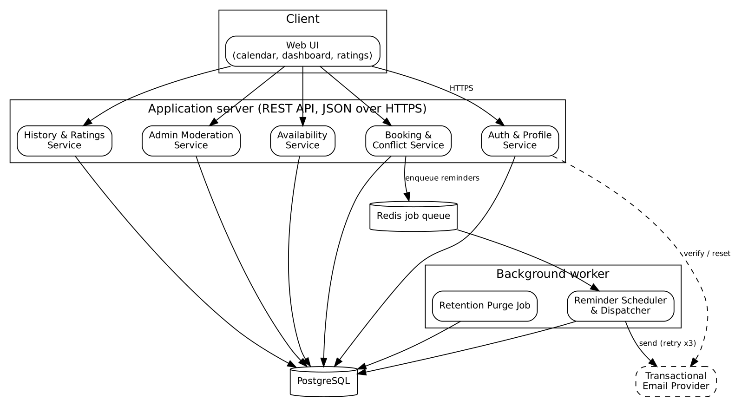
Figure 1: Component diagram of the Tutoring Scheduler

3.4 Component Descriptions
- Web UI: Responsive single-page frontend. Has the slot calendar/grid, booking confirmation dialog, dashboard and ratings widget. Talks to the API only.
- Auth & Profile Service: Registration with institutional email, email verification, login (issues JWT), password reset and profile/role management.
- Availability Service: Creating, editing and deleting one-off and recurring slots; rejects overlapping slots; blocks deletion of booked slots.
- Booking & Conflict Service: Search, reservation, cancellation and rescheduling. Does the atomic reservation check and enqueues reminder jobs when a booking is confirmed.
- History & Ratings Service: Dashboard data (upcoming vs past sessions) and 1-5 star ratings that update the tutor average.
- Admin Moderation Service: Suspend accounts, remove listings, view failed reminder deliveries.
- Background Worker: Separate process that picks up reminder jobs from the queue, sends emails with retries, and runs the scheduled purge of deleted-account data.
- PostgreSQL: Stores users, slots, bookings, ratings and reminder job records.
- Redis job queue: Holds scheduled reminder jobs so email sending stays out of the request cycle.
- Email provider: External transactional email service (SMTP/SendGrid-style API).

3.5 Chosen Architecture Pattern and Rationale
We went with a layered architecture (presentation, service/business logic, data access) deployed as one backend application, plus a separate background worker process. The layers keep the booking rules out of the controllers and make each service easy to test on its own.
Microservices were considered and rejected. The expected load (500 registered users, 100 concurrent sessions) does not justify the deployment and networking overhead, and the booking check needs a single database transaction, which becomes awkward if slots and bookings live in different services.
Key decisions (ADR summary):
ID | Decision | Reason
ADR-01 | Layered monolith + worker, not microservices | Small scale, simpler deployment, transactions stay in one database
ADR-02 | Double-booking prevented with a database row lock (SELECT ... FOR UPDATE) inside a transaction | Satisfies TUT-F-022 with exactly one winner under concurrent requests; no extra locking service needed
ADR-03 | Reminders sent by a queue-backed worker, not inside the booking request | Keeps booking fast; allows retry and backoff (TUT-F-033)
ADR-04 | Each reminder has a unique key of booking id + reminder type, checked before sending | Stops duplicate emails if a job is retried or the worker restarts (TUT-F-034)
ADR-05 | Stateless JWT sessions | No server-side session store needed; works with a simple REST API

3.6 Technology Stack & Data Stores
Layer | Technology
Frontend | React single-page app, responsive CSS (360px to 1920px)
Backend API | Node.js with Express, REST over HTTPS, JSON
Database | PostgreSQL (users, slots, bookings, ratings, reminder jobs)
Queue / worker | Redis with a BullMQ worker process
Email | Transactional email provider via API (sandbox mode in staging)
Security libraries | bcrypt for password hashing, jsonwebtoken, express-rate-limit, input validation middleware
Hosting | Cloud Linux server, TLS 1.2+ enforced at the web server

Data model: User, Slot, Booking, Rating and ReminderJob, as in the ER diagram in SRS section 7. A Slot has at most one active Booking, and a Booking has at most one Rating and zero or more ReminderJobs.

3.7 Risks & Mitigations
Risk | Mitigation
Two tutees book the same slot at the same moment | Row lock plus transaction on the slot; unique constraint on active booking per slot as a second safeguard
Email provider is slow or rate-limits us | Queue the emails, retry with exponential backoff up to 3 times, log failures for admin
Worker restarts and resends reminders | Idempotency key per booking and reminder type
Timezone mistakes in reminders and slot display | Store everything in UTC, convert only in the UI
Brute-force attacks on login | Rate limiting and temporary lockout on login and reset endpoints
Database loss | Daily backups, RPO of 24 hours, restore tested once before release

3.8 Traceability to Requirements
Requirement | Component(s)
TUT-F-001 to 005 (registration, verification, login, profile, reset) | Auth & Profile Service
TUT-F-010 to 014 (slot create/edit/delete, recurring, overlap) | Availability Service
TUT-F-020, 021 (search, reserve) | Booking & Conflict Service
TUT-F-022 (atomic reservation) | Booking & Conflict Service, PostgreSQL row lock
TUT-F-023, 024 (cancel, reschedule) | Booking & Conflict Service
TUT-F-025 (confirmation email) | Booking & Conflict Service, Email provider
TUT-F-030 to 034 (reminders, retry, idempotency) | Background Worker, Redis queue, Email provider
TUT-F-040, 041 (dashboard, ratings) | History & Ratings Service
TUT-F-042 (suspend/remove) | Admin Moderation Service
TUT-NF-001, 003 (performance, scalability) | API layer, database indexes on slot date and subject
TUT-NF-004, 005 (responsive, accessibility) | Web UI
TUT-NF-002, 006 (uptime, backups) | Hosting and database operations
PRJ-SR-001 to 005 | Security architecture (3.9)
PRJ-SR-006 (retention) | Retention purge job in Background Worker

3.9 Security Architecture
Threat modelling using STRIDE:
Threat | Where it applies | Control
Spoofing | Login, API calls | Email verification, bcrypt-hashed passwords, JWT with expiry, login rate limiting
Tampering | Booking and slot data in transit and in the API | TLS 1.2+, server-side validation of all input, ownership checks on every write
Repudiation | Cancellations, admin actions | Audit log with user id and timestamp for bookings, cancellations and moderation
Information disclosure | Profiles, emails, logs | HTTPS only, no passwords or tokens in logs, only the minimum profile fields are returned
Denial of service | Search, login, reset endpoints | Rate limiting, pagination on search, indexed queries
Elevation of privilege | Edit/cancel of other users' bookings, admin functions | Role checks (tutor, tutee, admin), 403 on cross-user modification (PRJ-SR-003)

Input is validated and sanitised on the server to prevent SQL injection and XSS (PRJ-SR-005); queries are parameterised. Deleted-account data is purged or anonymised after the retention window (PRJ-SR-006).

4. Design

4.1 Design Overview
The backend is organised into controllers (HTTP handling and validation), services (business rules such as conflict checks and notice windows) and repositories (SQL access). Services never write SQL directly, and controllers never contain business rules. The Web UI only knows the REST contract, so it can change independently. The worker reuses the same service and repository code so reminder logic is not duplicated.
Slot life cycle, as in the SRS state diagram: Available -> Booked -> Completed, with Booked -> Available on cancellation within the notice window and Available -> Removed when a tutor deletes an unbooked slot.

4.2 UML Sequence Diagrams
Flow 1: booking a slot (TUT-F-021, 022, 025, 030, 031)
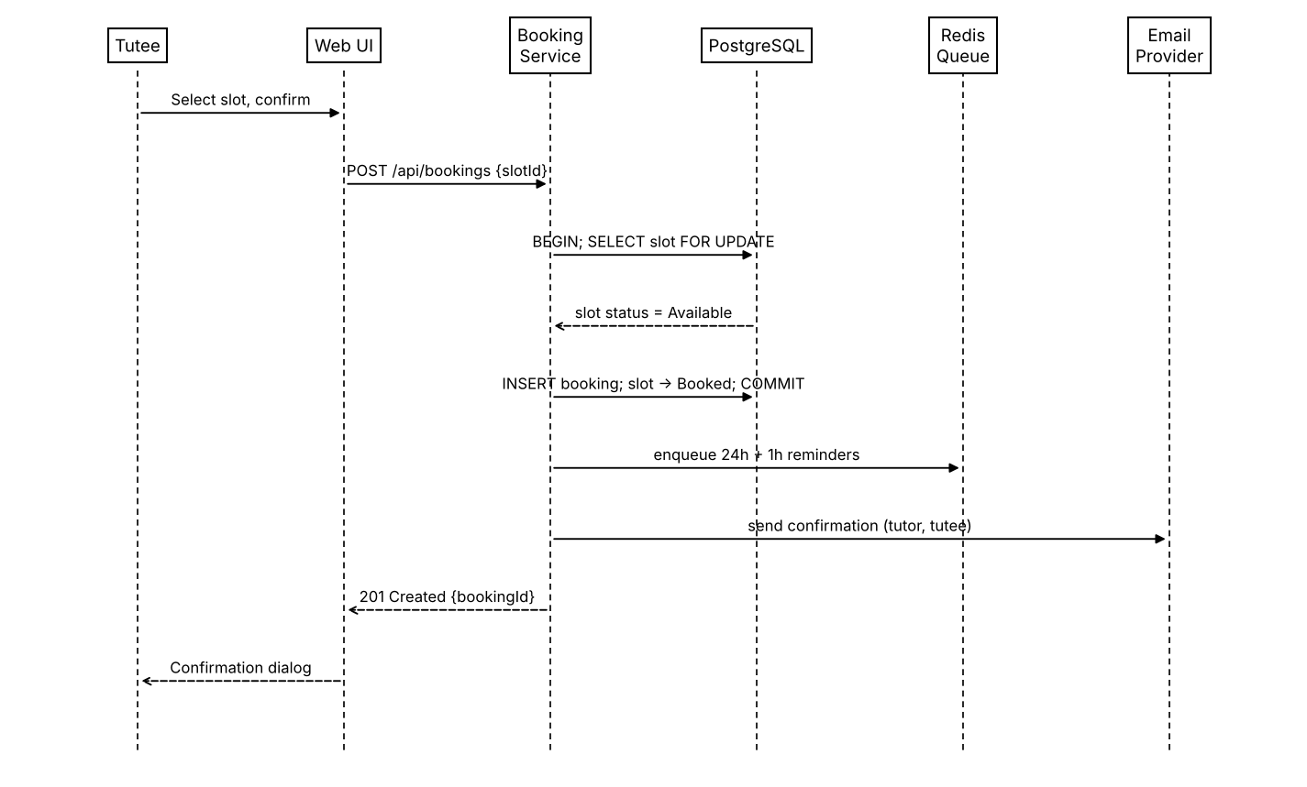
Figure 2: Sequence diagram for booking a slot
If the slot is already booked when the lock is acquired, the service rolls back and returns 409 Conflict, so the second tutee sees a clear error and nothing is written.
Flow 2: sending a reminder (TUT-F-030, 032, 033, 034)
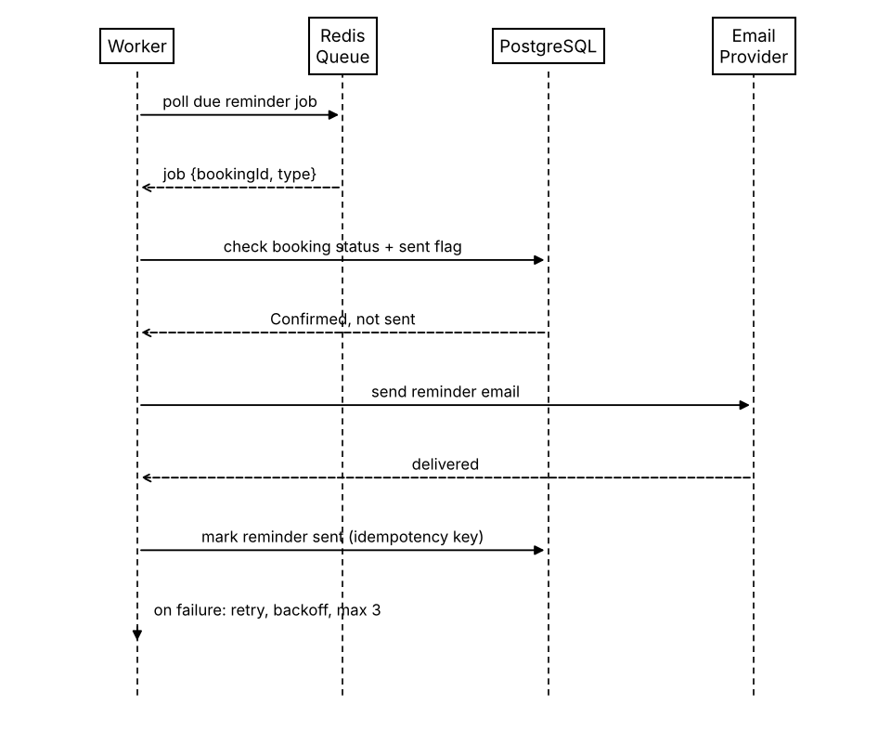
Figure 3: Sequence diagram for reminder delivery
When a booking is cancelled or rescheduled, its pending jobs are removed from the queue; the status check before sending is a second safeguard so no reminder goes out for a cancelled booking.

4.3 API Design
All endpoints are under /api, use JSON over HTTPS, and need a Bearer JWT except registration, login and verification.
Booking API
Endpoint | Method | Request | Response | Errors
/api/slots?subject=&from=&to=&minRating= | GET | Query filters | 200 [{slotId, tutor, subject, startUtc, duration, rating}] | 401 not logged in
/api/bookings | POST | {slotId} | 201 {bookingId, status, startUtc} | 401, 404 slot not found, 409 slot already booked
/api/bookings/{id} | DELETE | none | 200 {status: "cancelled", late: true|false} | 401, 403 not your booking, 404
/api/bookings/{id}/reschedule | POST | {newSlotId} | 202 {status: "pending tutor confirmation"} | 403, 409, 422 different tutor

Availability API
Endpoint | Method | Request | Response | Errors
/api/slots | POST | {subject, date, startTime, duration, recurring?, endDate?} | 201 {slotId} (or list of ids for recurring) | 401, 403 not a tutor, 422 invalid input, 409 overlaps existing slot
/api/slots/{id} | DELETE | none | 204 | 403, 404, 409 slot has a confirmed booking

Auth API (summary): POST /api/auth/register, POST /api/auth/verify, POST /api/auth/login returning {token}, POST /api/auth/reset-request and /api/auth/reset. Login and reset are rate-limited; reset links expire after 30 minutes.

4.4 Error Handling, Logging & Monitoring
Errors use one JSON shape: {error: {code, message}} with the proper HTTP status (400/422 validation, 401 unauthenticated, 403 forbidden, 404 not found, 409 conflict, 429 rate limited, 500 unexpected). Messages are written for users and do not reveal internals such as stack traces or SQL.
Logging: request id, user id, endpoint and status for every request; booking, cancellation and admin actions are logged as audit entries. Passwords, tokens and full email bodies are never logged.
Monitoring: API response times (95th percentile), booking conflict rate, reminder failure count after the 3 retries, queue length, and uptime checks against the 99.5% target. Failed reminders appear in the admin view (TUT-F-033).

4.5 UX Design
Responsive layout from 360px phones to 1920px desktops. Main screens: login/register, search page with a calendar grid and filters (subject, date range, rating), booking confirmation dialog, tutor availability page, dashboard (upcoming and past tabs), and a rating form shown after a completed session. Keyboard navigation, sufficient contrast and ARIA labels on calendar controls follow WCAG 2.1 AA where feasible (TUT-NF-005). Times are shown in the user's local timezone with the timezone name visible.

4.6 Open Issues & Next Steps
- Confirm the final email provider and its free-tier rate limit before the performance tests.
- Decide how long the notice window should be by default (currently a configurable value).
- Rescheduling needs tutor confirmation; the notification wording for this still has to be agreed.
- Possible later work: ICS calendar download for bookings, multi-institution support, in-app notifications.

5. Appendices
5.1 Glossary
Slot, Session, Booking, Tutor, Tutee, Recurring pattern, Conflict resolution, Notice window, Reminder job, Institutional email, Dashboard and Background worker are defined in SRS section 1.4. ADR: a short record of one architecture decision. Idempotency key: a value that lets the system detect and ignore a repeated operation.
5.2 References
- Peer-to-Peer Tutoring Scheduler SRS v1.1 (Team 3, 15-09-2026)
- IEEE Std 1016, Software Design Descriptions
- IEEE 42010, Architecture description
- OWASP Top 10
- W3C WCAG 2.1

5.3 Tools
Graphviz and draw.io for diagrams, Postman and Swagger/OpenAPI for API definitions, Jira for tracking, Git for version control.

