Software Requirements Specification (SRS)

Project: Peer-to-Peer Tutoring Scheduler

Team: Team 3
Version: 1.1
Authors: Team 3
Date: 15-09-2026
Status: Draft

Revision history
Version | Date | Author | Change summary | Approval
1.0 | 11-09-2026 | Team 3 | Initial SRS draft | Pending
1.1 | 11-09-2026 | Team 3 | Completed the RTM for all requirement IDs; added a glossary, references, requirement-priority definitions, an Assumptions & Dependencies section, an idempotent-delivery requirement (TUT-F-034), a data privacy/retention requirement (PRJ-SR-006), a risk register, and use-case, process-flow, state, and ER diagrams. | Pending

Approvals
Role | Name | Signature / Email | Date
Course Coordinator

Table of Contents

1. Introduction

1.1 Purpose

1.2 Scope

1.3 Audience

1.4 Definitions, Acronyms and Glossary

1.5 References

1.6 Requirement Priority Conventions

2. Overall description

2.1 Product perspective

2.2 Major product functions

2.3 User roles and characteristics

2.4 Operating environment

2.5 Constraints

2.6 Assumptions and Dependencies

3. External interface requirements

4. System features (detailed)

5. Non-functional requirements (detailed)

6. Quality attributes & Acceptance tests

7. System models and diagrams

8. Requirements Traceability Matrix (RTM)

9. Risks and open issues

1. Introduction

1.1 Purpose

This document is a Software Requirements Specification (SRS) for the Peer-to-Peer Tutoring Scheduler, a web-based booking system that lets students offer tutoring slots and lets peers browse availability and reserve one-on-one sessions. It defines the functional and non-functional requirements, external interfaces, and acceptance criteria for the system, and serves as a reference for the development team, evaluators, and stakeholders.

1.2 Scope

The system covers student registration and profile management, tutor availability publishing, browsing and searching of available slots, session booking with conflict resolution, cancellation/rescheduling, automated email reminders via background jobs, session history, and post-session ratings. It excludes payment processing, video-conferencing infrastructure (external links may be attached to a booking), and integration with institutional Student Information Systems beyond basic email-based identity verification.

1.3 Audience

Developers, QA Engineers, Project Evaluators, Student Users (Tutors and Tutees), and System Administrators.

1.4 Definitions, Acronyms and Glossary

Acronyms used: UI (User Interface), API (Application Programming Interface), TLS (Transport Layer Security), ICS (iCalendar file format), JWT (JSON Web Token), SMTP (Simple Mail Transfer Protocol), CRUD (Create, Read, Update, Delete), SLA (Service Level Agreement), OTP (One-Time Password).

The table below defines domain terms used throughout this document, since several requirements refer to them without re-explaining them each time.
Term | Definition
Slot | A tutor-defined block of time, tied to a subject, during which the tutor is available to be booked.
Session | A single one-on-one tutoring meeting created once a tutee books a slot.
Booking | The confirmed reservation record that links a tutee to a specific slot.
Tutor | A student who publishes availability slots and can be booked by tutees.
Tutee | A student who searches for and books tutoring sessions.
Recurring pattern | A weekly repeating availability rule a tutor sets up instead of creating one-off slots individually.
Conflict resolution | The mechanism that prevents two tutees from booking the same slot at the same time.
Notice window | The minimum lead time before a session start after which a cancellation is treated as "late."
Reminder job | A scheduled background task that sends a reminder email ahead of a confirmed session.
Institutional email | An email address issued by the student's college or university, used to verify eligibility to use the system.
Dashboard | The screen where a user views their upcoming and past sessions.
Background worker | The asynchronous process that executes reminder jobs and scheduled cleanup tasks outside the normal request/response cycle.

1.5 References
- IEEE Std 830-1998, IEEE Recommended Practice for Software Requirements Specifications.
- W3C, Web Content Accessibility Guidelines (WCAG) 2.1 - used as the basis for the accessibility requirement in Section 5 (TUT-NF-005).
- OWASP Top 10 - used as a general reference baseline when drafting the security requirements in Section 5.1.
- Course project brief distributed for this assignment (Software Engineering, Team 3 project specification).

1.6 Requirement Priority Conventions

Priorities in Sections 4 and 5 follow the same three-level scale throughout this document:
- High - required for the system to function at all, or directly supports one of the primary use cases (registration, availability publishing, booking, conflict prevention). The system is not considered acceptance-ready without these (see exit criteria in Section 6).
- Medium - improves completeness or usability, but the system is still usable without it at initial release. These are the first candidates to slip to a later iteration if the team's timeline gets tight.
- Low - reserved for backlog items identified during requirements gathering but not committed to for v1.0. None are currently listed, but the label is kept so the requirement tables don't need restructuring if one comes up later.

2. Overall description

2.1 Product perspective

The Peer-to-Peer Tutoring Scheduler is a standalone web application consisting of a browser-based frontend, a backend REST API, a relational database, and an asynchronous background-job worker responsible for sending reminder emails and processing scheduled cleanup tasks. It is a new, self-contained product and does not depend on external institutional systems beyond an email provider for notifications.

2.2 Major product functions
- Student registration, login, and profile management (tutor and/or tutee role)
- Tutor availability publishing (recurring and one-off slots) with subject tags
- Search and browse available tutoring slots by subject, date, and tutor rating
- One-on-one session booking with automated conflict detection and resolution
- Booking cancellation and rescheduling with configurable notice windows
- Automated email reminders and confirmations via background jobs
- Session history log and post-session rating/feedback
- Basic administrative moderation (suspend accounts, remove listings)

2.3 User roles and characteristics
- Tutor: a student offering sessions; publishes availability, manages bookings, receives ratings.
- Tutee: a student seeking help; searches slots, books/cancels sessions, leaves ratings.
- Administrator: moderates content, manages user accounts, and reviews system health/logs.

2.4 Operating environment

A cloud-hosted web application accessible via modern desktop and mobile browsers (Chrome, Firefox, Edge, Safari, latest two major versions). The backend runs on a standard Linux server environment with a relational database and a background job queue/worker for asynchronous email processing.

2.5 Constraints
- Users must verify their college/university email address before publishing or booking sessions.
- All session times are stored in UTC and displayed in the user's local timezone.
- Email delivery depends on a third-party transactional email provider and its rate limits.
- Initial release targets a single institution/tenant; multi-tenant support is out of scope for v1.0.

2.6 Assumptions and Dependencies
- It is assumed that the institution provides, or the team maintains, a list of valid institutional email domains used for verification at registration.
- The system depends on a third-party transactional email provider; its delivery time and rate limits are outside the team's control and are treated as an external dependency (see 3.3, 3.4).
- Users are assumed to have access to a modern browser and a reasonably stable internet connection; offline use is not supported.
- Tutors self-report their subjects and experience level; the system does not independently verify subject-matter competency.
- The development team assumes access to a staging environment with a PostgreSQL instance and a Redis-backed (or equivalent) queue for testing.
- v1.0 assumes a single institution/tenant, consistent with the constraint noted in 2.5.

3. External interface requirements

3.1 User interfaces

A responsive web UI including a calendar/grid component for browsing and selecting slots, a booking confirmation dialog, a dashboard listing upcoming and past sessions, and a simple ratings widget. Interfaces follow WCAG 2.1 AA guidance where feasible (keyboard navigation, sufficient color contrast, ARIA labels on calendar controls).

3.2 Hardware interfaces

None. The system runs on standard end-user devices (laptops, tablets, smartphones) via a web browser and standard server/cloud infrastructure; no specialized hardware is required.

3.3 Software interfaces
- Backend REST API (JSON over HTTPS) consumed by the web frontend.
- Transactional Email API (e.g., SMTP/SendGrid-style provider) for confirmations and reminders.
- Relational database (e.g., PostgreSQL) for persisting users, slots, and bookings.
- Background job queue/worker (e.g., Redis-backed queue) for scheduling and dispatching reminder emails.
- Optional ICS calendar export/download for confirmed bookings.

3.4 Communications

All client-server communication uses HTTPS with TLS 1.2 or higher. The background worker communicates with the email provider over an authenticated, encrypted API connection. Failed email sends are retried with exponential backoff up to a configurable maximum before being logged as failed.

4. System features (detailed)

Each requirement includes acceptance criteria and a reference test case. IDs follow TUT-F-###.

4.1 Authentication & Profile Management

Description: Registration, login, email verification, and profile/role management for students.
Req ID | Requirement (shall...) | Type | Priority | Source | Acceptance criteria / Test ref | Comments
TUT-F-001 | The system shall allow a student to register using a valid institutional email and password. | Functional | High | Student | AC-001: Registration succeeds only with a valid, unused institutional email. Test: TC-Auth-01 | Password hashed at rest
TUT-F-002 | The system shall send a verification link and require email confirmation before account activation. | Functional | High | Student | AC-002: Unverified accounts cannot log in. Test: TC-Auth-02 | Uses email service
TUT-F-003 | The system shall allow a verified user to log in and receive a session token (JWT). | Functional | High | Student | AC-003: Valid credentials return a token; invalid ones are rejected. Test: TC-Auth-03
TUT-F-004 | The system shall allow a user to set up a profile as Tutor, Tutee, or both, including subjects and bio. | Functional | Medium | Student | AC-004: Profile changes persist and display correctly. Test: TC-Prof-01
TUT-F-005 | The system shall allow a user to reset a forgotten password via a time-limited email link. | Functional | Medium | Student | AC-005: Reset link expires after 30 minutes. Test: TC-Auth-04

4.2 Tutor Availability Management

Description: Tutors publish, edit, and remove availability slots, including recurring weekly patterns.
Req ID | Requirement (shall...) | Type | Priority | Source | Acceptance criteria / Test ref | Comments
TUT-F-010 | The system shall allow a tutor to create a one-off availability slot with subject, date, start time, and duration. | Functional | High | Tutor | AC-010: Slot appears in search once saved. Test: TC-Avail-01
TUT-F-011 | The system shall allow a tutor to create a recurring weekly availability pattern with an end date. | Functional | Medium | Tutor | AC-011: Recurring slots generate correctly up to the end date. Test: TC-Avail-02
TUT-F-012 | The system shall prevent a tutor from creating two overlapping availability slots. | Functional | High | Tutor | AC-012: Overlapping slot creation is rejected with a clear error. Test: TC-Avail-03 | Uses conflict engine
TUT-F-013 | The system shall allow a tutor to edit or delete a future, unbooked availability slot. | Functional | Medium | Tutor | AC-013: Deleted slot no longer appears in search. Test: TC-Avail-04
TUT-F-014 | The system shall prevent deletion of a slot that already has a confirmed booking without cancellation workflow. | Functional | High | Tutor | AC-014: Direct delete of booked slot is blocked; cancellation flow required. Test: TC-Avail-05

4.3 Booking & Conflict Resolution

Description: Search, reservation, cancellation, and rescheduling of one-on-one sessions, with double-booking prevention.
Req ID | Requirement (shall...) | Type | Priority | Source | Acceptance criteria / Test ref | Comments
TUT-F-020 | The system shall allow a tutee to search available slots by subject, date range, and tutor rating. | Functional | High | Tutee | AC-020: Search returns only currently unbooked, future slots matching filters. Test: TC-Book-01
TUT-F-021 | The system shall allow a tutee to reserve an available slot, converting it to a confirmed booking. | Functional | High | Tutee | AC-021: Reserved slot is removed from public search results. Test: TC-Book-02
TUT-F-022 | The system shall use an atomic reservation check to prevent two tutees from booking the same slot simultaneously. | Functional | High | Tutee/Tutor | AC-022: Concurrent booking attempts result in exactly one success and one conflict error. Test: TC-Book-03 | Requires DB-level locking/transaction
TUT-F-023 | The system shall allow either party to cancel a confirmed booking up to a configurable minimum notice period. | Functional | High | Tutor/Tutee | AC-023: Cancellation within notice window succeeds and frees the slot; late cancellation is flagged. Test: TC-Book-04
TUT-F-024 | The system shall allow a tutee to request rescheduling to another available slot with the same tutor. | Functional | Medium | Tutee | AC-024: Reschedule releases old slot and books the new one only after tutor confirmation. Test: TC-Book-05
TUT-F-025 | The system shall send an immediate email confirmation to both parties upon successful booking. | Functional | High | Tutor/Tutee | AC-025: Confirmation email delivered within 1 minute of booking. Test: TC-Book-06 | Uses email service

4.4 Reminder & Notification Automation

Description: Background jobs that schedule and dispatch reminder emails ahead of confirmed sessions.
Req ID | Requirement (shall...) | Type | Priority | Source | Acceptance criteria / Test ref | Comments
TUT-F-030 | The system shall automatically schedule a reminder email 24 hours before a confirmed session. | Functional | High | Tutor/Tutee | AC-030: Reminder job is enqueued at booking time with correct send time. Test: TC-Rem-01 | Background job
TUT-F-031 | The system shall automatically schedule a second reminder email 1 hour before a confirmed session. | Functional | Medium | Tutor/Tutee | AC-031: Second reminder enqueued alongside the first. Test: TC-Rem-02 | Background job
TUT-F-032 | The system shall cancel any pending reminder jobs when a booking is cancelled or rescheduled. | Functional | High | Tutor/Tutee | AC-032: No reminder email is sent for a cancelled booking. Test: TC-Rem-03
TUT-F-033 | The system shall retry a failed reminder email delivery up to 3 times with exponential backoff before logging failure. | Functional | Medium | System | AC-033: Failure is logged and visible to an administrator after 3 failed attempts. Test: TC-Rem-04
TUT-F-034 | The system shall ensure that a reminder email for a given booking and reminder type (24-hour or 1-hour) is sent at most once, even if the background job is retried or re-enqueued. | Functional | High | System | AC-034: Re-running the worker against an already-sent reminder does not produce a duplicate email, verified via an idempotency-key / job de-duplication check. Test: TC-Rem-05 | Added in v1.1 - prevents duplicate-send on worker restart

4.5 Session History & Ratings

Description: Historical record of past sessions and a lightweight rating/feedback mechanism.
Req ID | Requirement (shall...) | Type | Priority | Source | Acceptance criteria / Test ref | Comments
TUT-F-040 | The system shall display a dashboard of a user's upcoming and past sessions. | Functional | Medium | Tutor/Tutee | AC-040: Dashboard correctly separates upcoming vs. completed/cancelled sessions. Test: TC-Hist-01
TUT-F-041 | The system shall allow a tutee to submit a 1-5 star rating and optional comment after a completed session. | Functional | Medium | Tutee | AC-041: Rating is saved and reflected in the tutor's average rating. Test: TC-Hist-02
TUT-F-042 | The system shall allow an administrator to remove a listing or suspend an account that violates usage policy. | Functional | Medium | Admin | AC-042: Suspended account cannot log in; listing is hidden from search. Test: TC-Admin-01

5. Non-functional requirements (detailed)

NFRs below are measurable and tied to test plans. IDs TUT-NF-###.
Req ID | Requirement | Category | Priority | Acceptance criteria / Measurement
TUT-NF-001 | 95% of search and booking API requests shall complete within 2 seconds under normal load (up to 200 concurrent users). | Performance | High | Load test report shows 95th percentile ≤ 2s. Test: TC-Perf-01
TUT-NF-002 | The system shall maintain 99.5% monthly uptime, excluding scheduled maintenance windows. | Reliability | High | Uptime monitoring reports ≥99.5% per month.
TUT-NF-003 | The system shall support at least 500 registered users and 100 concurrent active sessions without degradation. | Scalability | Medium | Load test confirms target user/session counts. Test: TC-Perf-02
TUT-NF-004 | The web UI shall be usable on screen widths from 360px (mobile) to 1920px (desktop). | Usability | Medium | Responsive design verified across target breakpoints. Test: TC-UX-01
TUT-NF-005 | Core UI flows (search, booking) shall conform to WCAG 2.1 AA where technically feasible. | Accessibility | Medium | Accessibility audit checklist pass. Test: TC-UX-02
TUT-NF-006 | Database backups shall run daily with a maximum recovery point objective (RPO) of 24 hours. | Reliability/Data | Medium | Backup logs and a successful restore test. Test: TC-Ops-01

5.1 Security

5.1.1 Security Objectives
- Protect user credentials and personal data from unauthorized access or disclosure.
- Ensure that only authenticated, authorized users can create, modify, or cancel bookings on their own behalf.
- Maintain the integrity and availability of booking data against accidental or malicious double-booking.

5.1.2 Security Requirements
Req ID | Requirement (shall...) | Type | Priority | Acceptance criteria / Test ref
PRJ-SR-001 | The system shall enforce TLS 1.2+ for all client-server and server-to-email-provider communications. | Security | High | TLS configuration verified via scan. Test: TC-Sec-01
PRJ-SR-002 | The system shall store passwords using a salted, industry-standard hashing algorithm (e.g., bcrypt) and never store plaintext passwords. | Security | High | Database review confirms hashed storage only. Test: TC-Sec-02
PRJ-SR-003 | The system shall enforce authorization checks so that a user can only cancel, reschedule, or edit bookings/slots they own. | Security | High | Attempted cross-user modification returns 403 Forbidden. Test: TC-Sec-03
PRJ-SR-004 | The system shall rate-limit login and password-reset endpoints to mitigate brute-force attacks. | Security | Medium | Repeated failed attempts trigger temporary lockout/backoff. Test: TC-Sec-04
PRJ-SR-005 | The system shall validate and sanitize all user-submitted input (profile fields, comments) to prevent injection attacks (SQL injection, XSS). | Security | High | Automated security scan reports no injection vulnerabilities. Test: TC-Sec-05
PRJ-SR-006 | The system shall retain a user's session history and personal profile data only while the account remains active, plus a defined retention window after account deletion, after which the data shall be purged or anonymized. | Security/Privacy | Medium | Deleted-account data is purged/anonymized after the configured retention window (e.g., 90 days); verified via a scheduled purge-job audit log. Test: TC-Sec-06

5.1.3 Data Privacy & Retention

The system collects institutional email addresses and session history tied to identifiable students, so retention and minimization matter here beyond encryption and access control. This isn't formally a FERPA-covered system, but treating student data the same way is a reasonable and low-cost precaution. PRJ-SR-006 above captures this as a testable requirement: profile and session data is kept only as long as the account is active, plus a defined window afterward, and is then purged or anonymized rather than kept indefinitely.

6. Quality attributes & Acceptance tests

Exit criteria for acceptance: all High-priority functional requirements are implemented and verified, no critical NFR failures remain open, and the RTM (Section 8) shows all associated test cases passed. Priority definitions used to determine exit criteria are given in Section 1.6.

Acceptance test suites: Authentication & Profile, Availability Management, Booking & Conflict Resolution, Reminder Automation, Session History & Ratings, Performance, Security, and Accessibility.

7. System models and diagrams

7.1 UML Use-Case diagrams

Two use-case diagrams describe the system's actors. The Tutor performs registration, availability management, reschedule confirmation, and views ratings/history. The Tutee performs registration, searching, booking, cancellation/rescheduling, and rating. A secondary actor, Administrator, handles account suspension and listing removal, and an external actor, Email Service, participates in the Send Confirmation and Send Reminder use cases through an include relationship.

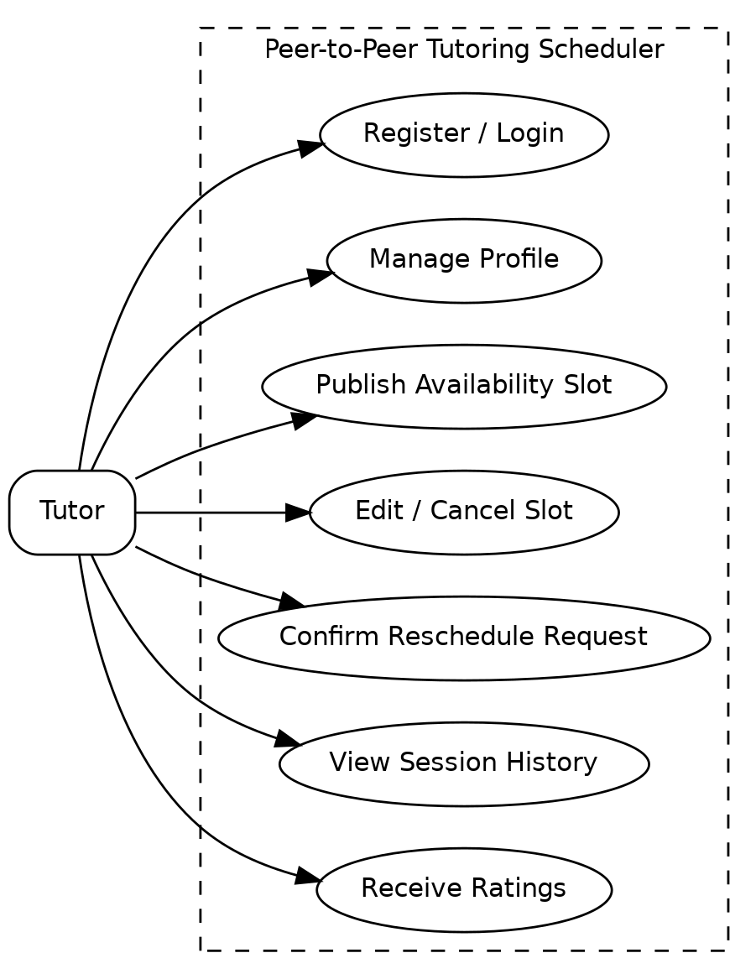

Figure 7.1 - Tutor use-case diagram

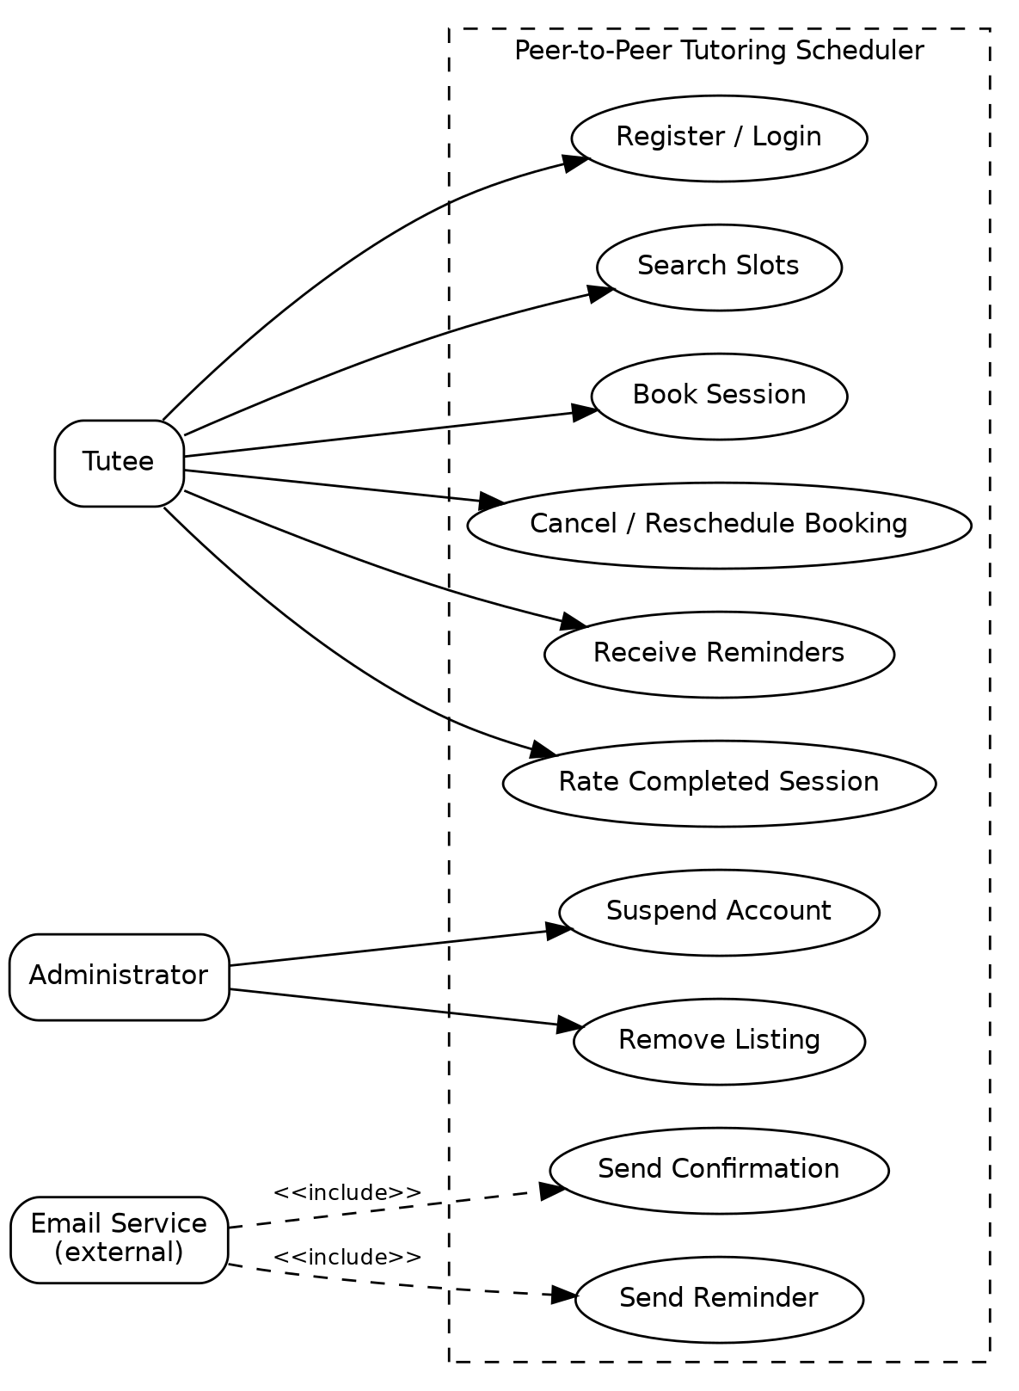

Figure 7.2 - Tutee, Administrator and Email Service use-case diagram

7.2 Booking conflict resolution - process flow

This diagram walks through TUT-F-022 step by step: a tutee's booking request only succeeds if the slot is still available at the time of the atomic check and the subsequent lock/transaction does not detect a conflicting reservation. If two tutees race for the same slot, exactly one commits and the other receives a conflict error, matching AC-022.

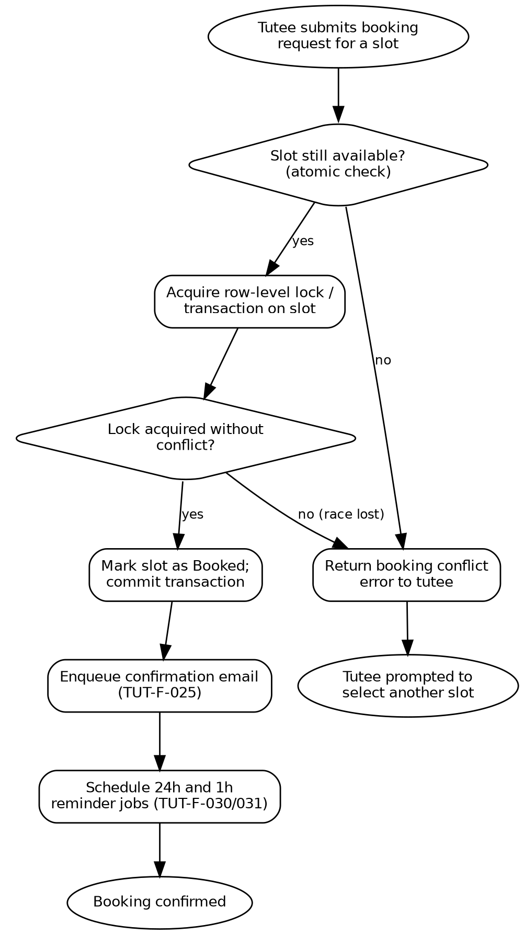

Figure 7.3 - Booking conflict resolution process flow

7.3 Slot lifecycle - state diagram

A slot starts as Available. It moves to Booked once a tutee successfully reserves it (TUT-F-021/022), and from there either to Completed once the session time passes, or back to Available if the booking is cancelled within the notice window (TUT-F-023), which frees the slot for someone else to book. An unbooked slot can also be deleted directly by the tutor, moving it to Removed (TUT-F-013).

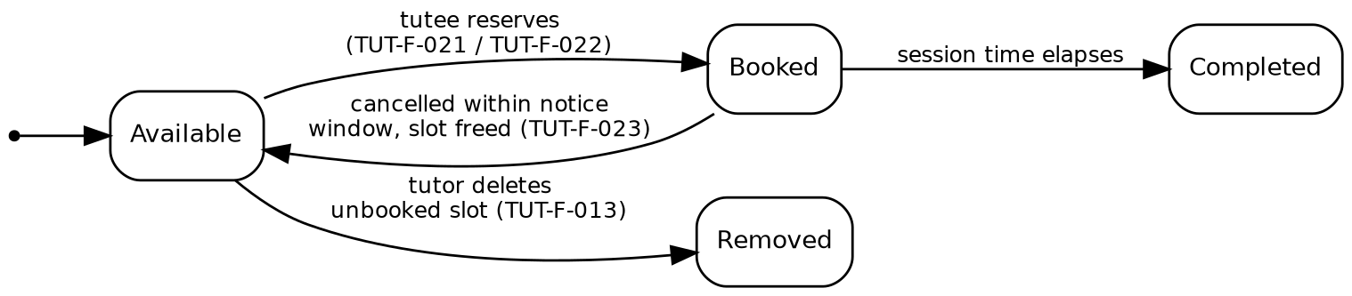

Figure 7.4 - Slot lifecycle state diagram

7.4 Data model - ER diagram

The core entities are User, Slot, Booking, Rating, and ReminderJob. A User can act as a tutor on many slots and as a tutee on many bookings. Each slot maps to at most one booking; each booking can have at most one rating and zero or more scheduled reminder jobs.

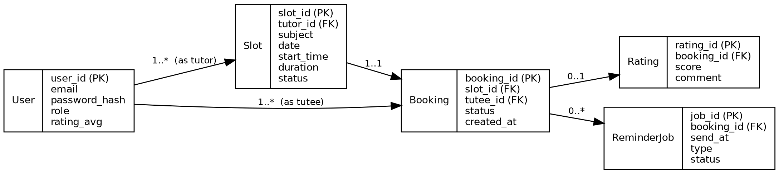

Figure 7.5 - Entity-relationship diagram

8. Requirements Traceability Matrix (RTM)

Status column uses N = Not started, P = In progress, A = Accepted/passed, consistent with the team's sprint board. All rows are currently N since implementation has not begun.
Req ID | Requirement (short) | Sec. | Module | Test case(s) | Status | Comments
TUT-F-001 | Register with institutional email | 4.1 | AuthModule | TC-Auth-01 | N
TUT-F-002 | Email verification before activation | 4.1 | AuthModule | TC-Auth-02 | N
TUT-F-003 | Login returns JWT session token | 4.1 | AuthModule | TC-Auth-03 | N
TUT-F-004 | Profile setup (tutor/tutee/both) | 4.1 | ProfileModule | TC-Prof-01 | N
TUT-F-005 | Time-limited password reset | 4.1 | AuthModule | TC-Auth-04 | N
TUT-F-010 | Create one-off availability slot | 4.2 | AvailabilityModule | TC-Avail-01 | N
TUT-F-011 | Create recurring weekly availability | 4.2 | AvailabilityModule | TC-Avail-02 | N
TUT-F-012 | Prevent overlapping tutor slots | 4.2 | AvailabilityModule | TC-Avail-03 | N
TUT-F-013 | Edit/delete unbooked future slot | 4.2 | AvailabilityModule | TC-Avail-04 | N
TUT-F-014 | Block delete of booked slot | 4.2 | AvailabilityModule | TC-Avail-05 | N
TUT-F-020 | Search slots by subject/date/rating | 4.3 | BookingModule | TC-Book-01 | N
TUT-F-021 | Reserve slot to confirmed booking | 4.3 | BookingModule | TC-Book-02 | N
TUT-F-022 | Atomic booking conflict check | 4.3 | BookingModule | TC-Book-03 | N | Core feature
TUT-F-023 | Cancel booking within notice window | 4.3 | BookingModule | TC-Book-04 | N
TUT-F-024 | Reschedule to new slot, same tutor | 4.3 | BookingModule | TC-Book-05 | N
TUT-F-025 | Immediate booking confirmation email | 4.3 | BookingModule / NotificationModule | TC-Book-06 | N
TUT-F-030 | Schedule 24-hour reminder | 4.4 | ReminderWorker | TC-Rem-01 | N | Background job
TUT-F-031 | Schedule 1-hour reminder | 4.4 | ReminderWorker | TC-Rem-02 | N | Background job
TUT-F-032 | Cancel pending reminders on cancel/reschedule | 4.4 | ReminderWorker | TC-Rem-03 | N
TUT-F-033 | Retry failed reminder with backoff | 4.4 | ReminderWorker | TC-Rem-04 | N
TUT-F-034 | Idempotent reminder delivery | 4.4 | ReminderWorker | TC-Rem-05 | N | Added v1.1
TUT-F-040 | Upcoming/past sessions dashboard | 4.5 | HistoryModule | TC-Hist-01 | N
TUT-F-041 | Post-session 1-5 star rating | 4.5 | RatingModule | TC-Hist-02 | N
TUT-F-042 | Admin suspend account / remove listing | 4.5 | AdminModule | TC-Admin-01 | N
TUT-NF-001 | API response time target (p95 <= 2s) | 5 | BookingModule / API | TC-Perf-01 | N
TUT-NF-002 | 99.5% monthly uptime | 5 | Infra | - | N
TUT-NF-003 | 500 users / 100 concurrent sessions | 5 | Infra | TC-Perf-02 | N
TUT-NF-004 | Responsive 360px - 1920px | 5 | Frontend | TC-UX-01 | N
TUT-NF-005 | WCAG 2.1 AA core flows | 5 | Frontend | TC-UX-02 | N
TUT-NF-006 | Daily backups, 24h RPO | 5 | Infra | TC-Ops-01 | N
PRJ-SR-001 | TLS 1.2+ everywhere | 5.1.2 | Infra | TC-Sec-01 | N
PRJ-SR-002 | Password hashing | 5.1.2 | AuthModule | TC-Sec-02 | N
PRJ-SR-003 | Ownership-based authorization | 5.1.2 | BookingModule | TC-Sec-03 | N
PRJ-SR-004 | Rate-limit login/reset endpoints | 5.1.2 | AuthModule | TC-Sec-04 | N
PRJ-SR-005 | Input validation/sanitization | 5.1.2 | API | TC-Sec-05 | N
PRJ-SR-006 | Data retention & purge/anonymize | 5.1.3 | AuthModule / ProfileModule | TC-Sec-06 | N | Added v1.1

9. Risks and open issues

These are risks the team identified while writing this SRS, not yet mitigated in code. Listing them here is meant to be useful during planning, not a guarantee that every item below is handled by launch.
Risk | Likelihood | Impact | Mitigation / Notes
Timezone and DST edge cases in recurring slot generation crossing daylight-saving transitions. | Medium | Medium | Times are stored in UTC (2.5); add explicit unit tests around DST boundaries before relying on recurring-slot generation.
Email provider outage or rate limiting delays confirmation/reminder delivery. | Medium | Medium | Retry with exponential backoff is already specified (TUT-F-033); failures surface to the admin after 3 attempts.
Race conditions under load beyond the tested 200-concurrent-user benchmark (TUT-NF-001). | Low | High | Load-test past the target before relying on it; revisit optimistic vs. pessimistic locking if contention shows up.
Single-tenant assumption (2.5) may not hold if a second institution wants to use the system. | Low | Medium | Explicitly deferred; multi-tenant support is out of scope for v1.0 and would need its own design pass.
Team velocity vs. course timeline - some Medium-priority items (rescheduling, ratings) may slip. | Medium | Low | High-priority items are implemented first per 1.6; Medium items are treated as stretch goals for the final submission.

