LAB 6 & LAB 7
Screenshot Evidence

LAB 6 – CODE AND BRANCH COVERAGE
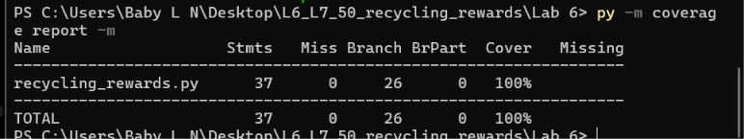
Code and Branch Coverage Report

LAB 7 – INITIAL APPLICATION RUN
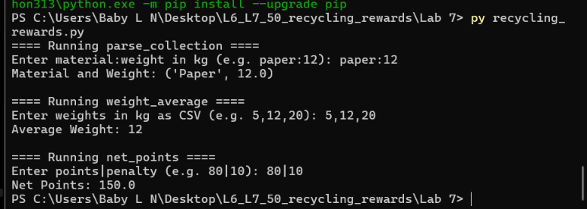
Initial Application Output

LAB 7 – HYPOTHESIS TESTING BEFORE FIX
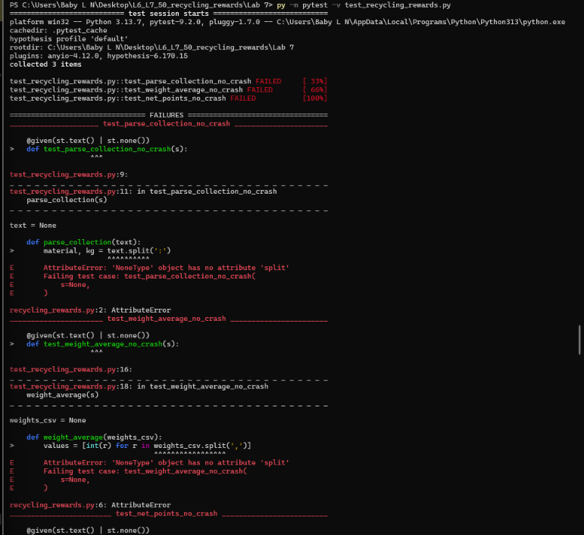
Failing Hypothesis Tests

LAB 7 – FIXED APPLICATION RUN
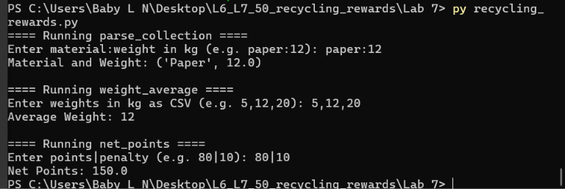

Application Output After Fix

LAB 7 – HYPOTHESIS TESTING AFTER FIX
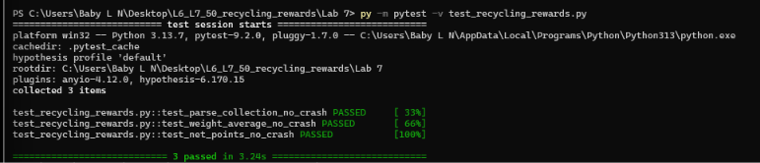
Passing Hypothesis Tests

