Software Requirements Specification (SRS)
Project: Online Bookstore
Version: 1.0
Authors: Team 2 – Nandhana S, Rishi Manjunath, Yogish K J, Madhumitha Dhondi
Date: 15-10-2026
Status: Draft

Revision history
Version | Date | Author | Change summary | Approval
1.0 | 15-10-2026 | Team 2 | Initial SRS baseline for Online Bookstore v1.0, with use-case diagrams embedded | Pending

Approvals
Role | Name | Signature / Email | Date
QA Lead | Nandhana S
Developer | Rishi Manjunath
Test Engineer | Yogish K J
Product Owner | Madhumitha Dhondi
Project Guide | Prof. Arpitha K

Table of Contents
1. Introduction
2. Overall description
3. External interface requirements
4. System features (detailed)
5. Non-functional requirements (detailed)
6. Quality attributes & Acceptance tests
7. System models and diagrams (UML use-case diagrams)
8. Requirements Traceability Matrix (RTM)

1. Introduction

1.1 Purpose
This document is the Software Requirements Specification (SRS) for the Online Bookstore (OBS) v1.0, a web-based e-commerce application that lets users discover, search for and purchase books online. It defines the functional requirements, non-functional requirements, security objectives and requirements, external interfaces and verification criteria for the system.
It is the requirements baseline for the Software Architecture and Design Specification (SAD) and the Software Test Plan (STP), and the Requirements Traceability Matrix (Section 8) links every requirement to its design reference, module and test cases.

1.2 Scope
The Online Bookstore v1.0 covers the following:
- User registration, login and role handling (Customer, Seller, Administrator).
- Book catalogue browsing and search by title, author, ISBN and category, and display of book details.
- Shopping cart management, checkout validation and server-side calculation of the order total (price, shipping, tax and discount).
- Payment through a payment simulator, unique order ID generation, order confirmation and stock updates.
- Order history and order status tracking, order cancellation with stock restoration, and refund calculation.
- Seller management of listings, price and stock, and administrator management of users, categories, listings and orders.
The following are out of scope for v1.0:
- Real publisher or distributor inventory, live courier and logistics systems, and physical warehouse, packaging and delivery operations.
- Real financial settlement; a payment simulator is used in place of a payment gateway.
- Third-party email or SMS provider internals.
- Book reviews and ratings, wishlists, personalised recommendations and advanced filtering, which are future enhancements (SAD §4.6).
Note: SAD §1.2 lists user authentication, seller accounts, payment integration and order tracking as optional extensions pending Product Owner confirmation. This SRS confirms them as in scope for v1.0, consistent with the Software Test Plan. Payment is simulated, and order tracking means viewing the order status held by the system.

1.3 Audience
Product Owner, QA Lead, Test Engineer, Development Team, DevOps Engineer and the Project Guide who reviews the requirements.

1.4 Definitions
Term | Meaning
OBS | Online Bookstore
SRS | Software Requirements Specification
SAD | Software Architecture and Design Specification
STP | Software Test Plan
RTM | Requirements Traceability Matrix
UAT | User Acceptance Testing
RBAC | Role-Based Access Control
API | Application Programming Interface
REST | Representational State Transfer, the style of web API used between frontend and backend
JSON | JavaScript Object Notation, the data exchange format used by the API
UI | User Interface
ISBN | International Standard Book Number
HTTPS / TLS | Hypertext Transfer Protocol Secure / Transport Layer Security
P95 | 95th percentile response time
Listing | A book offered for sale in the catalogue by a seller, with its price, condition and stock quantity
Payment simulator | A software component that imitates a payment gateway and returns deterministic success or failure outcomes; no real money is moved
Overselling | Selling more copies of a book than are in stock

1.5 References
- Online Bookstore – Software Architecture and Design Specification (SAD), Version 1.0, 13 October 2026.
- Online Bookstore – Software Test Plan (STP), Version 1.0, 13-10-2026.

2. Overall description

2.1 Product perspective
The Online Bookstore is a self-contained web application that follows a three-tier architecture (SAD §3.5): a React and Vite presentation layer, a Java and Spring Boot business logic layer exposing REST APIs that exchange JSON, and a MySQL data layer holding book, inventory, user, order and order-item data. The frontend never accesses the database directly. The only external system the application interacts with is the payment simulator.

2.2 Major product functions (detailed)
- Register and log in, with role-based access for Customers, Sellers and Administrators
- Browse and search the book catalogue by title, author, ISBN and category
- View book details, including price, condition, availability and seller
- Manage a shopping cart (add, update quantity, remove)
- Validate checkout and calculate the order total on the server
- Pay through the payment simulator, generate a unique order ID, confirm the order and update stock
- View order history and track order status
- Cancel eligible orders, restore stock and calculate refunds
- Seller management of listings, price and stock
- Administrator management of users, categories, listings and orders
- Consistent error handling and logging without exposing sensitive data (SAD §4.4)

2.3 User roles and characteristics (expanded)
- Customer: General web users who expect accurate book details, correct prices and availability, a simple checkout and the ability to view their orders. No technical knowledge is assumed.
- Seller: Lists books for sale and maintains the price and stock of their own listings.
- Administrator: Maintains users, categories, listings and orders, and requires strict access control to prevent unauthorised use of administrative functions.
- Payment simulator: External system actor that returns a deterministic payment success or failure for each payment request.

2.4 Operating environment
- Client: current desktop browsers (Chrome, Edge, Firefox), with a responsive layout for tablet and mobile viewports.
- Frontend: React and Vite. Backend: Java and Spring Boot, exposing REST APIs with JSON (SAD §3.6).
- Database: MySQL 8.x.
- Source control: Git and GitHub.

2.5 Constraints
- Student-project scope: development time and resources limit the number of features and the implementation complexity.
- Limited hosting budget: affordable development and deployment infrastructure must be used.
- Payments are made through a payment simulator; there is no real financial settlement.
- Inventory accuracy: stock levels must stay accurate and consistent during order processing.
- Prices, totals and stock must be calculated and validated on the server, never trusted from the client (SAD §4.3).
- The technology stack is as defined in the SAD (React, Vite, Java, Spring Boot, MySQL, REST/JSON).

2.6 Assumptions and dependencies
- The database and application are available during development and testing, and seeded book, category, seller and stock data is approved for use.
- The payment simulator provides deterministic success or failure outcomes.
- Catalogue browsing, search and book details are available to all visitors; checkout, order history, order tracking and cancellation require an authenticated Customer. This is an assumption to be confirmed by the Product Owner.
- The shipping, tax, discount, cancellation-eligibility and refund rules are configurable and their values are to be confirmed by the Product Owner.

3. External interface requirements

3.1 User interfaces
The primary interface is a responsive web UI with clear sections for the homepage, book catalogue, search, shopping cart and checkout, plus role-specific pages for sellers (listing management) and administrators (users, categories, listings and orders). The UI shall show book titles, authors, prices, descriptions and availability, confirmation messages after successful actions and clear error messages when operations fail, including field-level errors at checkout. The UI should use readable fonts, sufficient colour contrast, clear labels and keyboard-friendly controls (SAD §4.5).

3.2 Hardware interfaces
The system has no dedicated hardware interfaces. It runs on standard client devices with a web browser and on standard server hosting.

3.3 Software interfaces
- Frontend–backend: The frontend communicates with the backend through REST APIs using JSON (SAD §4.3).
- GET /api/books: Request: optional search query or category parameters. Response: list of books with ID, title, author, price and available stock. Errors: 400 Bad Request, 500 Internal Server Error.
- POST /api/orders: Request: book IDs, quantities and checkout details. Response: order ID, order status and total amount. Errors: 400 for invalid input, 409 for insufficient stock, 500 for unexpected failures.
- Other endpoints: Interfaces for authentication, cart, order history and cancellation, seller functions and administrator functions follow the same conventions and are to be added to the API design.
- Database: Only the backend accesses MySQL; database credentials are never present in frontend code.
- Payment simulator: The backend submits payment requests to the payment simulator and receives a success or failure outcome. The simulator can run in a mock or stub mode with deterministic outcomes.

3.4 Communications
- Client–server communication in the deployed system shall use HTTPS/TLS (OBS-SR-003).
- Data is exchanged as JSON. Failures are returned as standardised error responses using HTTP status codes (400, 401, 403, 404, 409, 500) that do not expose database details or other sensitive information.

4. System features (detailed)
Each requirement below includes acceptance criteria and a reference test case from the STP. Functional requirement IDs follow the format OBS-F-###. Priority is High, Medium or Low. The system has 16 functional requirements (OBS-F-001 to OBS-F-016).

4.1 Authentication and user management
Description: Allow users to register and log in, and identify the role of each user so that role-based access can be enforced.
Req ID | Requirement | Type | Priority | Source / Stakeholder | Acceptance criteria / Test case ref | Comments / Dependencies
OBS-F-001 | The system shall allow a new user to register an account by supplying the required details, including a unique email address and a password, and shall reject registration with an email address that is already registered, returning a validation message. | Functional | High | Customer / Product Owner | AC-OBS-F-001: Registration with valid, unique details creates an account; registration with a duplicate email is rejected with a validation message.  Tests:  TC-AUTH-01  TC-AUTH-02 | Password handling per OBS-SR-001
OBS-F-002 | The system shall authenticate users with their registered credentials and identify the role of each authenticated user (Customer, Seller or Administrator); invalid credentials shall be rejected safely without exposing sensitive information. | Functional | High | Customer / Security | AC-OBS-F-002: Valid credentials start an authenticated session with the user's role; invalid credentials are safely rejected.  Test: TC-AUTH-03 | Role is used by OBS-SR-002

4.2 Book catalogue and details
Description: Let users browse and search the catalogue and view complete details of each book.
Req ID | Requirement | Type | Priority | Source / Stakeholder | Acceptance criteria / Test case ref | Comments / Dependencies
OBS-F-003 | The system shall display a catalogue of available books and shall allow users to search and browse by title, author, ISBN and category, returning the matching books. | Functional | High | Customer | AC-OBS-F-003: Searching by title, author, ISBN and category each returns the matching books.  Test: TC-SEARCH-01 | Listings are paginated (SAD §3.7); API: GET /api/books
OBS-F-004 | The system shall provide a book details page that displays the title, author, publisher, price, condition, stock availability and seller of the book. | Functional | High | Customer | AC-OBS-F-004: The details page shows title, author, publisher, price, condition, stock and seller.  Test: TC-SEARCH-02 | Depends on OBS-F-003, OBS-F-015

4.3 Shopping cart and checkout
Description: Let customers collect books in a cart, validate checkout details and see a server-calculated order total.
Req ID | Requirement | Type | Priority | Source / Stakeholder | Acceptance criteria / Test case ref | Comments / Dependencies
OBS-F-005 | The system shall allow a customer to add in-stock books to a shopping cart, shall block the addition of out-of-stock books, and shall allow item quantities to be updated and items to be removed, with the cart totals updating accordingly. | Functional | High | Customer | AC-OBS-F-005: An in-stock book can be added; an out-of-stock book is blocked; totals update after quantity changes and removals.  Test: TC-CART-01 | Depends on OBS-F-004
OBS-F-006 | The system shall validate checkout on the server, including that all required delivery address fields are present and that the requested books are available in the requested quantities; if validation fails, checkout shall be blocked and the errors shown against the relevant fields. | Functional | High | Customer / Product Owner | AC-OBS-F-006: Submitting checkout with a missing address field is blocked and a field error is shown.  Test: TC-ORD-01 | Insufficient stock returns HTTP 409 (SAD §4.3); API: POST /api/orders
OBS-F-007 | The system shall calculate the order total on the server from the current book prices and ordered quantities, including shipping, tax and discount according to the configured rules, and shall display the total to the customer. | Functional | High | Customer / Business | AC-OBS-F-007: The displayed total matches the expected value computed from price, shipping, tax and discount.  Test: TC-BILL-01 | Client-supplied prices are never trusted (SAD §4.3); shipping, tax and discount rule values to be confirmed by the Product Owner

4.4 Payment, orders and stock
Description: Process payment through the payment simulator, create uniquely identified orders, confirm them and keep stock consistent.
Req ID | Requirement | Type | Priority | Source / Stakeholder | Acceptance criteria / Test case ref | Comments / Dependencies
OBS-F-008 | The system shall process payment through the payment simulator. When payment succeeds, the order shall be confirmed and stock reduced; when payment fails, the order shall not be confirmed and stock shall not be reduced. | Functional | High | Customer / Business | AC-OBS-F-008: A successful payment confirms the order and reduces stock; a failed payment leaves the order unconfirmed and stock unchanged.  Tests:  TC-PAY-01  TC-PAY-02 | Payment simulator gives deterministic success/failure
OBS-F-009 | The system shall generate a unique order ID for every order. | Functional | High | Business / Customer | AC-OBS-F-009: Each of several orders created receives a different order ID.  Test: TC-ORD-02 | Duplicate submissions must not create duplicate orders (SAD §3.1)
OBS-F-010 | The system shall update the stock quantity of each book when an order is confirmed, and the stock quantity shall never become negative. | Functional | High | Operations / Business | AC-OBS-F-010: After ordering the last copies of a book, stock is updated correctly and is never negative.  Test: TC-STK-01 | Uses database transactions (SAD §3.7); see OBS-NFR-004
OBS-F-011 | The system shall display an order confirmation containing the required order details, including the order ID, order status, total amount and the ordered books with quantities. | Functional | High | Customer | AC-OBS-F-011: The confirmation shows all required order details correctly.  Test: TC-ORD-03 | Depends on OBS-F-008, OBS-F-009

4.5 Order history, tracking, cancellation and refund
Description: Let customers view and track their own orders, cancel eligible orders and receive a calculated refund.
Req ID | Requirement | Type | Priority | Source / Stakeholder | Acceptance criteria / Test case ref | Comments / Dependencies
OBS-F-012 | The system shall allow an authenticated customer to view their own order history and to track the status of each order; a request for an invalid or unauthorised order ID shall be answered safely with a 404 or 403 response. | Functional | Medium | Customer | AC-OBS-F-012: The customer's own orders are listed with the correct status; an invalid or unauthorised order ID returns a safe 404/403.  Tests:  TC-TRK-01  TC-TRK-02 | Tracking is the order status held in the system (no courier integration); see OBS-SR-005
OBS-F-013 | The system shall allow a customer to cancel an eligible order, setting its status to CANCELLED and restoring the stock of the cancelled items; cancellation of an ineligible or already cancelled order shall be rejected safely. | Functional | Medium | Customer / Business | AC-OBS-F-013: An eligible order becomes CANCELLED and its stock is restored; an ineligible or already cancelled order is rejected safely.  Tests:  TC-CAN-01  TC-CAN-02  TC-CAN-04 | Cancellation eligibility rules to be confirmed by the Product Owner
OBS-F-014 | The system shall calculate the refund amount for a cancelled order according to the configured refund policy. | Functional | Medium | Business | AC-OBS-F-014: The calculated refund matches the configured refund policy.  Test: TC-CAN-03 | Refund policy to be confirmed by the Product Owner; depends on OBS-F-013

4.6 Seller listing management
Description: Let sellers maintain their own book listings, prices and stock.
Req ID | Requirement | Type | Priority | Source / Stakeholder | Acceptance criteria / Test case ref | Comments / Dependencies
OBS-F-015 | The system shall allow a seller to add and update book listings and to edit the price and stock of their own listings; changes shall persist and appear in search results, and a seller shall not be able to edit another seller's listing. | Functional | High | Seller / Product Owner | AC-OBS-F-015: A seller's new or updated listing persists and appears in search; edits to own price and stock persist; editing another seller's listing is denied.  Tests:  TC-SELL-01  TC-SELL-02 | Requires seller role (OBS-SR-002)

4.7 Administration
Description: Let administrators manage users, categories, listings and orders.
Req ID | Requirement | Type | Priority | Source / Stakeholder | Acceptance criteria / Test case ref | Comments / Dependencies
OBS-F-016 | The system shall allow an administrator to manage users, categories, listings and orders; changes shall persist and be reflected in the system, and requests by non-administrators shall be denied. | Functional | Medium | Administrator / Product Owner | AC-OBS-F-016: Administrator changes to users, categories, listings and orders persist and are reflected in the system; non-administrator attempts are denied.  Tests:  TC-ADMIN-01  TC-ADMIN-02 | Requires administrator role (OBS-SR-002)

5. Non-functional requirements (detailed)
The non-functional requirements below are measurable and tied to the test plan. IDs follow the format OBS-NFR-###.
Req ID | Requirement | Category | Priority | Acceptance criteria / Measurement
OBS-NFR-001 | The search endpoint (GET /api/books) shall respond within 2 seconds for 95% of requests (P95 ≤ 2 s) under the agreed load. | Performance | High | P95 ≤ 2 s under the agreed load. Test: TC-PERF-01
OBS-NFR-002 | The order endpoint (POST /api/orders) shall respond within 3 seconds for 95% of requests (P95 ≤ 3 s) under the agreed load, excluding payment-simulator latency. | Performance | High | P95 ≤ 3 s excluding simulator latency. Test: TC-PERF-02
OBS-NFR-003 | The system shall achieve an availability of at least 99% over the test window. | Reliability | High | Availability ≥ 99% over the test window. Test: TC-REL-01
OBS-NFR-004 | When concurrent orders compete for the last available copies of a book, the system shall not oversell: no more copies shall be sold than are in stock and stock shall never be negative. | Concurrency / Data integrity | High | Concurrent orders for the last copy result in no overselling. Test: TC-CONC-01
OBS-NFR-005 | Passwords shall be stored only as salted one-way hashes; no plaintext or reversibly encrypted password shall be stored. | Security | High | Inspection of password storage shows salted hashes only. Test: TC-SEC-01

5.1 Security

5.1.1 Security Objectives
ID | Security objective | Related requirements
SO-1 | Confidentiality: protect user credentials and order data from unauthorised disclosure, in storage, in transit and in logs and error messages. | OBS-NFR-005, OBS-SR-001, OBS-SR-003
SO-2 | Integrity: prevent prices, stock levels and order records from being altered or corrupted through malformed input, injection or client-side manipulation. | OBS-SR-004, OBS-F-006, OBS-F-007
SO-3 | Access control: ensure each user can perform only the operations permitted for their role and can access only their own private data. | OBS-SR-002, OBS-SR-005

5.1.2 Security Requirements
Req ID | Requirement (shall...) | Type | Priority | Acceptance criteria / Test case ref
OBS-SR-001 | Passwords shall not appear in plaintext in the database, application logs, API responses or error messages. | Security | High | AC-OBS-SR-001: Only salted hashes are present in the database and no plaintext passwords appear in logs. Test: TC-SEC-01
OBS-SR-002 | The system shall enforce role-based access control (Customer, Seller, Administrator) on all protected endpoints, returning 401 for unauthenticated requests and 403 for authenticated users without the required role. | Security | High | AC-OBS-SR-002: Protected endpoints called with no credentials or the wrong role return 401 or 403 as applicable. Test: TC-SEC-02
OBS-SR-003 | All client–server communication in the deployed system shall use HTTPS/TLS. | Security | High | AC-OBS-SR-003: HTTPS/TLS is enabled in the deployment environment. Test: TC-SEC-03
OBS-SR-004 | The system shall validate all user input on the server and use parameterised database queries so that SQL-injection and script-injection payloads are handled safely. | Security | High | AC-OBS-SR-004: Injection and script payloads in input fields are rejected or neutralised, with no data disclosure, alteration or script execution. Test: TC-SEC-04
OBS-SR-005 | The system shall prevent a user from retrieving another user's private order data. | Security | High | AC-OBS-SR-005: A request for another user's order is denied. Test: TC-SEC-05

6. Quality attributes & Acceptance tests

6.1 Quality attributes
Req ID | Quality attribute requirement | Attribute | Priority | Acceptance criteria / Measurement
OBS-QA-001 | The web UI shall be usable on desktop and mobile viewport widths with a responsive layout, and validation and error messages shall be clear to the user. | Usability | Medium | Layout is responsive at desktop and mobile widths and validation errors are clearly shown. Test: TC-UX-01
OBS-QA-002 | The database shall enforce referential integrity through foreign-key constraints so that no orphan records exist (for example, a book referenced by orders cannot be deleted). | Data integrity | High | Foreign-key violations are rejected and no orphan records remain. Test: TC-DATA-01

6.2 Exit criteria for acceptance
- All planned test cases are executed.
- No Critical or Blocker defects remain open.
- All High-priority acceptance criteria have passed.
- No unresolved overselling or data-integrity defects remain.
- RTM coverage is complete.

6.3 Acceptance test suites
Suite | Test cases | Requirements
Authentication | TC-AUTH-01, TC-AUTH-02, TC-AUTH-03 | OBS-F-001, OBS-F-002
Catalogue and search | TC-SEARCH-01, TC-SEARCH-02 | OBS-F-003, OBS-F-004
Cart, checkout and billing | TC-CART-01, TC-ORD-01, TC-BILL-01 | OBS-F-005, OBS-F-006, OBS-F-007
Payment, orders and stock | TC-PAY-01, TC-PAY-02, TC-ORD-02, TC-STK-01, TC-ORD-03 | OBS-F-008 to OBS-F-011
Order tracking, cancellation and refund | TC-TRK-01, TC-TRK-02, TC-CAN-01, TC-CAN-02, TC-CAN-03, TC-CAN-04 | OBS-F-012, OBS-F-013, OBS-F-014
Seller | TC-SELL-01, TC-SELL-02 | OBS-F-015
Administrator | TC-ADMIN-01, TC-ADMIN-02 | OBS-F-016
Performance, reliability and concurrency | TC-PERF-01, TC-PERF-02, TC-REL-01, TC-CONC-01 | OBS-NFR-001 to OBS-NFR-004
Security | TC-SEC-01, TC-SEC-02, TC-SEC-03, TC-SEC-04, TC-SEC-05 | OBS-NFR-005, OBS-SR-001 to OBS-SR-005
Usability and data integrity | TC-UX-01, TC-DATA-01 | OBS-QA-001, OBS-QA-002

7. System models and diagrams

7.1 UML Use-Case diagram – Customer
Figure 1 shows the use cases available to the Customer and the Payment Simulator external actor. Checkout includes the order total calculation and payment; order cancellation includes the refund calculation. Use cases other than Register, Log In, Browse and Search Books, and View Book Details require a logged-in Customer (Section 2.6).
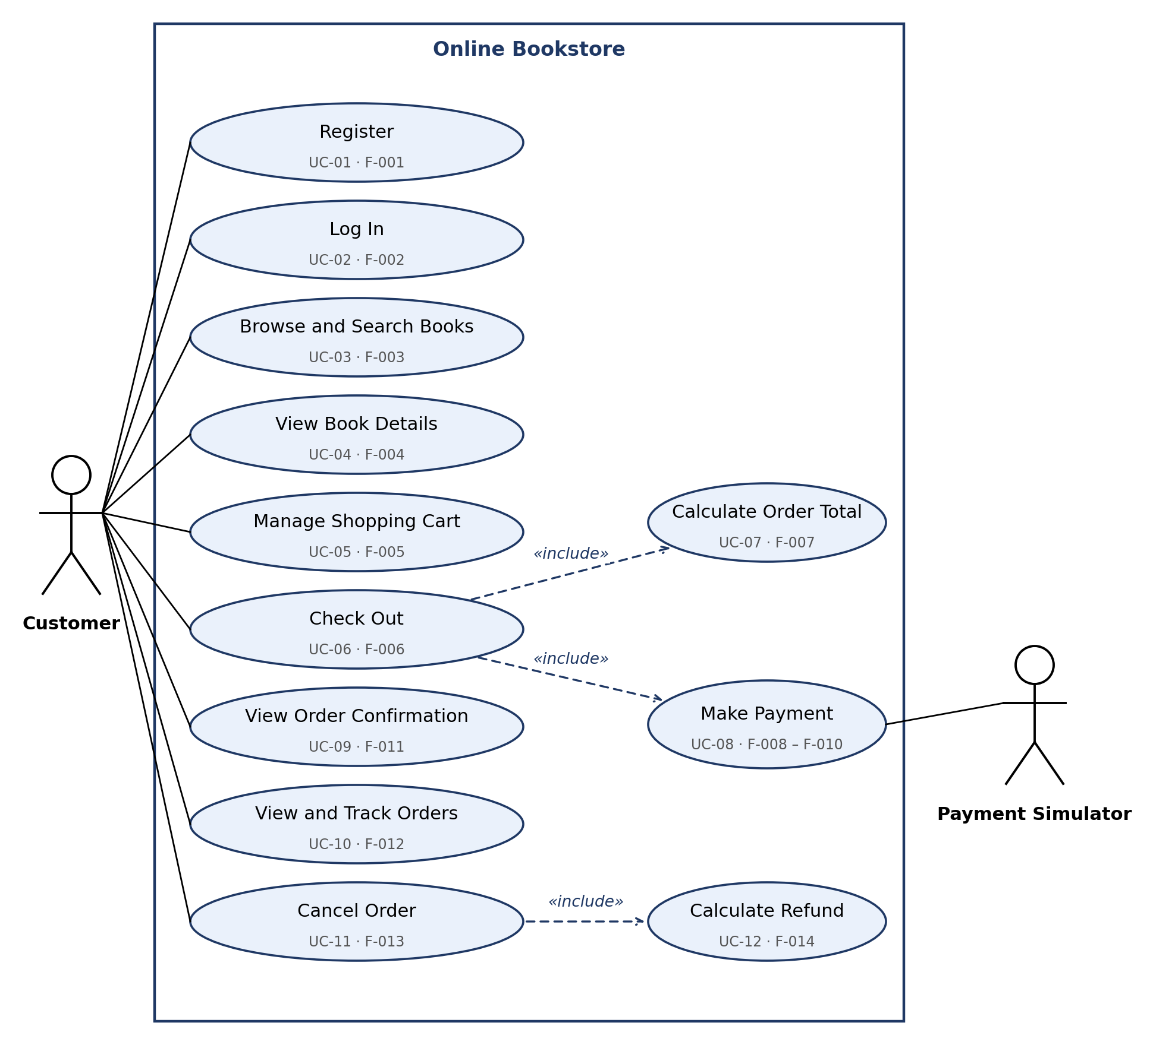
Figure 1: Use-case diagram – Customer and Payment Simulator

7.2 UML Use-Case diagram – Seller and Administrator
Figure 2 shows the use cases for the Seller and Administrator roles. Both roles must log in before using their functions.
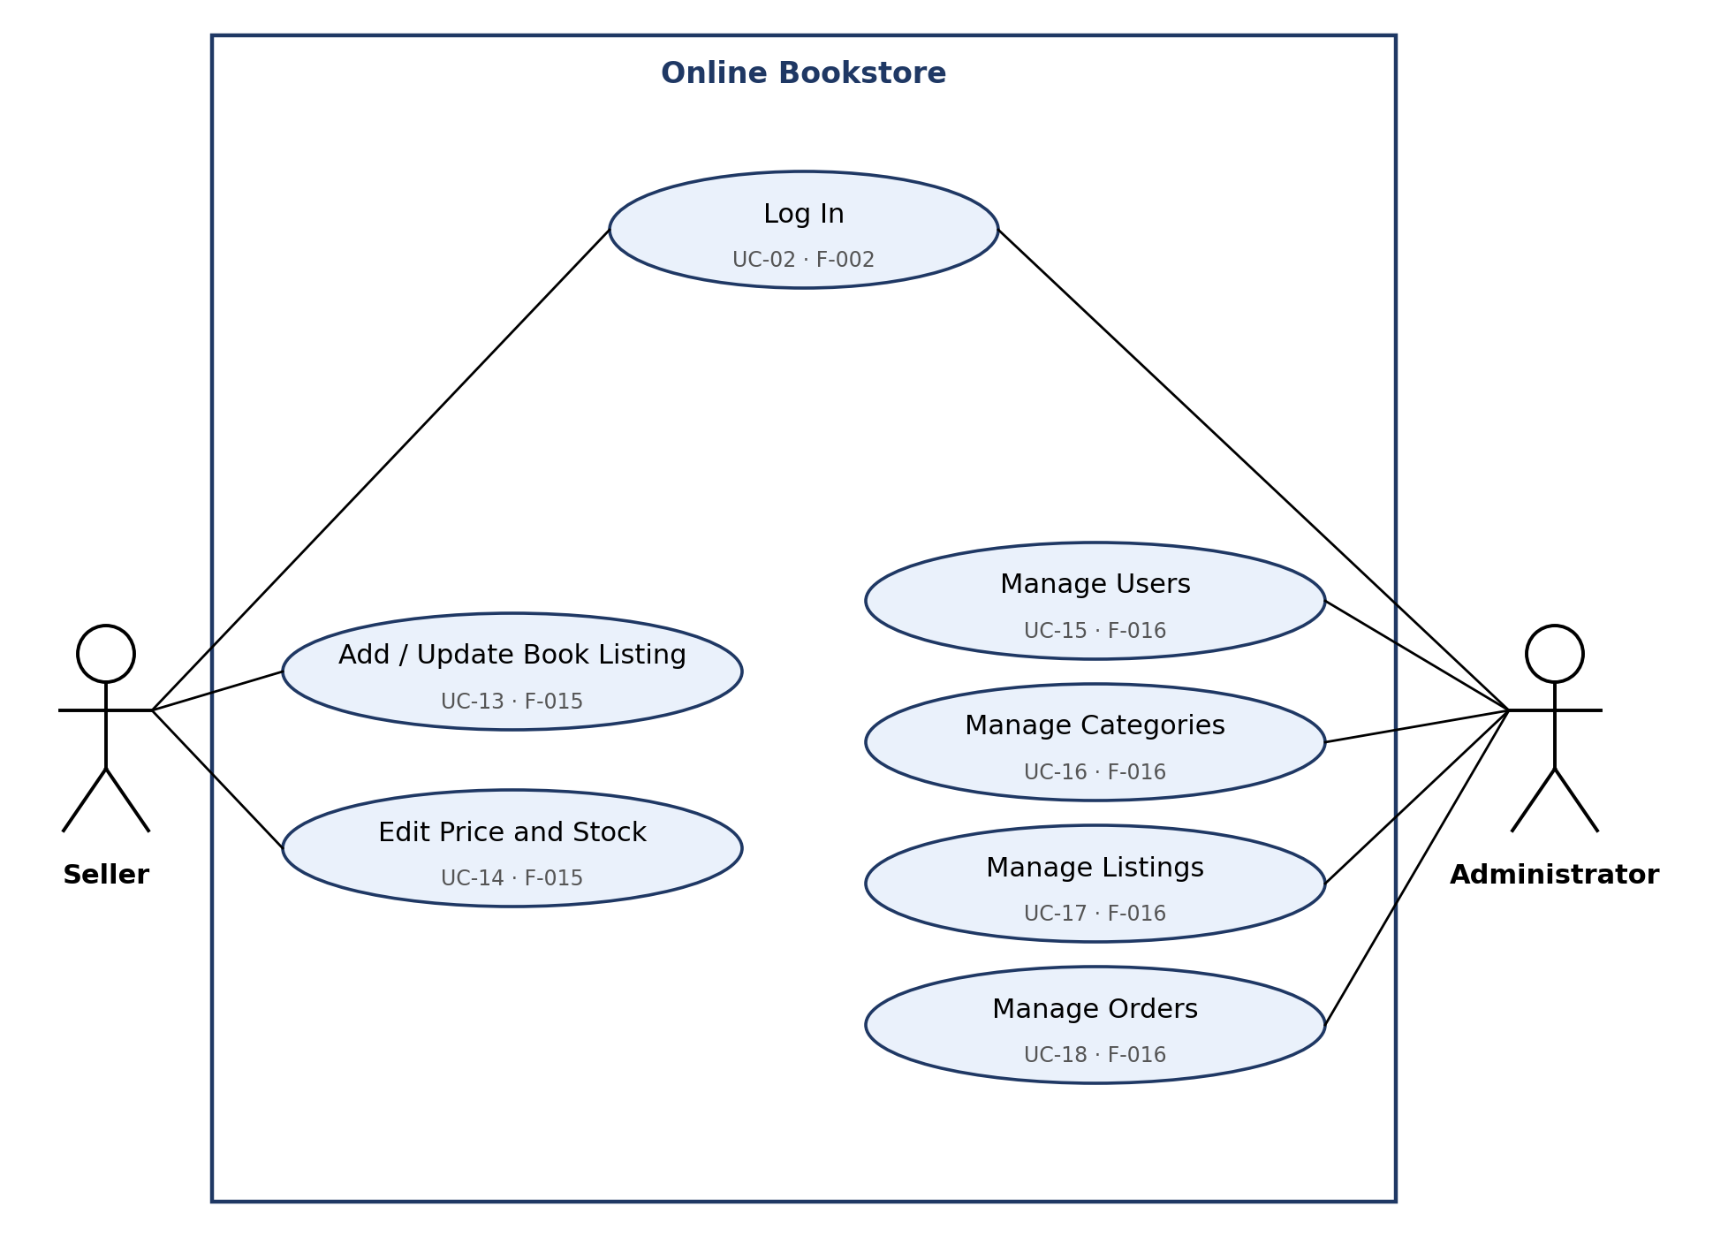
Figure 2: Use-case diagram – Seller and Administrator

7.3 Use-case summary
ID | Use case | Actor(s) | Requirement(s)
UC-01 | Register | Customer | OBS-F-001
UC-02 | Log In | Customer, Seller, Administrator | OBS-F-002
UC-03 | Browse and Search Books | Customer | OBS-F-003
UC-04 | View Book Details | Customer | OBS-F-004
UC-05 | Manage Shopping Cart | Customer | OBS-F-005
UC-06 | Check Out | Customer | OBS-F-006
UC-07 | Calculate Order Total | System (included by UC-06) | OBS-F-007
UC-08 | Make Payment | Payment Simulator (included by UC-06) | OBS-F-008, OBS-F-009, OBS-F-010
UC-09 | View Order Confirmation | Customer | OBS-F-011
UC-10 | View and Track Orders | Customer | OBS-F-012
UC-11 | Cancel Order | Customer | OBS-F-013
UC-12 | Calculate Refund | System (included by UC-11) | OBS-F-014
UC-13 | Add / Update Book Listing | Seller | OBS-F-015
UC-14 | Edit Price and Stock | Seller | OBS-F-015
UC-15 | Manage Users | Administrator | OBS-F-016
UC-16 | Manage Categories | Administrator | OBS-F-016
UC-17 | Manage Listings | Administrator | OBS-F-016
UC-18 | Manage Orders | Administrator | OBS-F-016

8. Requirements Traceability Matrix (RTM)
Status: N = not yet implemented or verified, P = partially implemented or verified, A = achieved and verified. All requirements start at N.
Req ID | Requirement short | Section ref / Design Spec | Module | Test case(s) | Status (N/P/A) | Comments
OBS-F-001 | Register account | 4.1 / SAD §3.9 | Authentication and user management | TC-AUTH-01  TC-AUTH-02 | N
OBS-F-002 | Login and role handling | 4.1 / SAD §3.9 | Authentication and user management | TC-AUTH-03 | N
OBS-F-003 | Browse and search books | 4.2 / SAD §4.3 | Book catalogue search and browsing | TC-SEARCH-01 | N
OBS-F-004 | Book details display | 4.2 / SAD §3.4 | Book details and stock availability | TC-SEARCH-02 | N
OBS-F-005 | Cart management | 4.3 / SAD §3.4 | Shopping cart | TC-CART-01 | N
OBS-F-006 | Checkout validation | 4.3 / SAD §4.3 | Checkout and order | TC-ORD-01 | N
OBS-F-007 | Order total calculation | 4.3 / SAD §4.3 | Pricing / total calculation | TC-BILL-01 | N
OBS-F-008 | Payment via simulator | 4.4 / SAD §3.2, §4.3 | Payment simulator integration | TC-PAY-01  TC-PAY-02 | N
OBS-F-009 | Unique order ID | 4.4 / SAD §4.3 | Checkout and order | TC-ORD-02 | N
OBS-F-010 | Stock update | 4.4 / SAD §3.7 | Checkout and order | TC-STK-01 | N
OBS-F-011 | Order confirmation | 4.4 / SAD §4.3 | Checkout and order | TC-ORD-03 | N
OBS-F-012 | Order history and tracking | 4.5 / SAD §3.9, §4.6 | Customer order history / tracking | TC-TRK-01  TC-TRK-02 | N
OBS-F-013 | Order cancellation | 4.5 / SAD §4.6 | Cancellation and refund | TC-CAN-01  TC-CAN-02  TC-CAN-04 | N
OBS-F-014 | Refund calculation | 4.5 / SAD §4.6 | Cancellation and refund | TC-CAN-03 | N
OBS-F-015 | Seller listing management | 4.6 / SAD §3.2 | Seller listing management | TC-SELL-01  TC-SELL-02 | N
OBS-F-016 | Administrator functions | 4.7 / SAD §3.2 | Administrator users / categories / listings / orders | TC-ADMIN-01  TC-ADMIN-02 | N
OBS-NFR-001 | Search response time | 5 / SAD §3.1 | REST API and database layer | TC-PERF-01 | N
OBS-NFR-002 | Order response time | 5 / SAD §3.1 | REST API and database layer | TC-PERF-02 | N
OBS-NFR-003 | Availability | 5 / SAD §3.1, §4.4 | REST API and database layer | TC-REL-01 | N
OBS-NFR-004 | No overselling under concurrency | 5 / SAD §3.7 | Checkout and order | TC-CONC-01 | N
OBS-NFR-005 | Password storage security | 5 / SAD §3.9 | Authentication and user management | TC-SEC-01 | N
OBS-SR-001 | No plaintext passwords | 5.1.2 / SAD §3.9 | Authentication and user management | TC-SEC-01 | N
OBS-SR-002 | Role-based access control | 5.1.2 / SAD §3.9 | REST API and database layer | TC-SEC-02 | N
OBS-SR-003 | HTTPS/TLS | 5.1.2 / SAD §3.9 | Deployment / REST API | TC-SEC-03 | N
OBS-SR-004 | Input validation, injection safety | 5.1.2 / SAD §3.9 | REST API and database layer | TC-SEC-04 | N
OBS-SR-005 | Order data isolation | 5.1.2 / SAD §3.9 | Customer order history / tracking | TC-SEC-05 | N
OBS-QA-001 | Usability / responsive UI | 6.1 / SAD §4.5 | Responsive web UI | TC-UX-01 | N
OBS-QA-002 | Data integrity | 6.1 / SAD §3.7, §4.4 | REST API and database layer | TC-DATA-01 | N

