SOFTWARE ARCHITECTURE
AND DESIGN SPECIFICATION
Project: Online Bookstore
Version: 1.0
Status: Draft
Authors: Team 2
Date: 13 October 2026

Revision History
Version | Date | Author | Change summary

Approvals
Role | Name | Signature / Date
QA Lead | Nandhana S | Nandhana S
Developer | Rishi Manjunath | Rishi Manjunath
Test Engineer | Yogish K J | Yogish K J
Product Owner | Madhumitha Dhondi | Madhumitha Dhondi

1. Introduction
1.1 Purpose
The purpose of this Software Architecture and Design document is to describe the overall architecture, major components, data model, interfaces, and design decisions for the Online Bookstore application.
The document provides a common reference for the development team, Product Owner, QA Lead, Test Engineer, and DevOps Engineer. It defines how the frontend, backend, and database interact to provide the core functionality of an online bookstore.
It also establishes the design basis for implementation, integration testing, system testing, and future enhancements.

1.2 Scope
The Online Bookstore is a web-based e-commerce application that enables users to browse, search for, and purchase books online.
The application is intended to provide a convenient interface for discovering books, viewing their details, adding books to a shopping cart, and placing orders.
The proposed system includes the following features:
Display a catalogue of available books.
Search for books by title, author, or category.
View book details, including price and availability.
Add books to a shopping cart.
Update quantities or remove books from the cart.
Validate book availability and stock during checkout.
Calculate the total order amount on the server.
Create and store customer orders and order items.
Provide appropriate messages for invalid requests, unavailable books, and failed operations.
Support automated testing and continuous integration through a version-controlled development workflow.
User authentication, seller accounts, online payment gateway integration, shipment tracking, reviews, and advanced administration are optional extensions and are not assumed to be implemented in the initial version unless confirmed by the Product Owner.

1.3 Audience
This document is intended for:
Product Owner: Defines and verifies expected system behaviour and project scope.
QA Lead: Establishes test scope, acceptance criteria, and requirement traceability.
Test Engineer: Uses the design to create and execute functional and integration tests.
Development Team: Implements the frontend, backend, business logic, and database.
DevOps Engineer: Configures source control, automated builds, testing, and integration workflows.
Faculty Guide: Reviews the proposed design and implementation approach.

1.4 Definitions and Acronyms
Term | Meaning
SAD | Software Architecture and Design
CI | Continuous Integration
API | Application Programming Interface
CRUD | Create, Read, Update, Delete
RTM | Requirements Traceability Matrix
RBAC | Role-Based Access Control
TLS | Transport Layer Security
SKU | Stock Keeping Unit / inventory identifier
ADR | Architecture Decision Record

2. Document Overview
2.1 How to Use This Document
The architecture is designed to achieve the following objectives:
Modularity: Separate the user interface, business logic, and database access.
Maintainability: Allow individual components to be modified with minimal impact on other components.
Testability: Support unit, API, integration, and system testing.
Reliability: Validate requests and handle errors consistently.
Data integrity: Maintain valid order records and accurate inventory quantities.
Usability: Provide clear navigation, book information, and checkout feedback.
Security: Validate all critical operations on the server and protect database access.
Extensibility: Allow future additions such as authentication, payments, and seller management.

2.2 Related Documents
Software Requirements Specification (SRS)
Software Test Plan (STP)
Requirements Traceability Matrix (RTM)

3. Architecture
3.1 Architecture Goals and Constraints
Architecture Goals
1. Usability: Customers should be able to search for books, view book details, and complete checkout through a clear, simple, and accessible workflow.
2. Reliability: Orders and payment outcomes should be recorded consistently. Duplicate submissions must be handled to prevent the creation of duplicate orders.
3. Performance: Book catalogue browsing and search should remain responsive under normal project-scale traffic.
4. Security: The system should use TLS for secure communication, password hashing for account security, authorization checks to control access, input validation to prevent invalid requests, and safe handling of payment-provider tokens.
5. Maintainability: The system should separate the presentation layer, business logic, and data persistence so that individual components can be tested, modified, and maintained independently.
Architecture Constraints
The architecture is subject to the following constraints:
Student-project scope: Development time and available resources may limit the number of features and the complexity of the implementation.
Limited hosting budget: The system must use affordable development and deployment infrastructure.
External payment-provider dependency: If online payments are implemented, the system will depend on an external provider for payment processing and payment-status information.
Inventory accuracy: The system must maintain accurate stock levels and prevent inconsistent inventory updates during order processing.

3.2 Stakeholders and Concerns
1. Customer
Customers expect accurate book details, correct prices, and up-to-date availability information. They also require a secure checkout process and the ability to view or track their orders.
2. Administrator
The administrator is responsible for maintaining an accurate book catalogue, managing stock levels, and processing orders. The system must provide appropriate access controls to prevent unauthorized users from performing administrative operations.
3. Project Team
The project team requires a modular architecture, testable components, understandable code, and a manageable development and deployment process. Clear separation of responsibilities helps team members implement, test, and integrate different components efficiently.
4. Payment Provider
If payment integration is included, the payment provider requires valid API requests, secure token-based communication, and reliable handling of payment-status callbacks. The bookstore must correctly interpret payment outcomes and update order statuses accordingly.
5. Business Owner / Instructor
The business owner or instructor expects the system to satisfy the project requirements and demonstrate the major bookstore workflows. Important concerns include requirement coverage, functional correctness, clear documentation, and a working demonstration of the implemented features.

3.3 Component (UML) Diagram
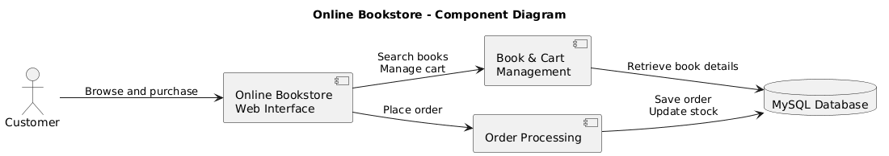

3.4 Component Descriptions
Customer: Browses books, searches the catalogue, manages the cart, and places orders.
Online Bookstore Web Interface: Provides the user interface for interacting with the system.
Book & Cart Management: Handles book searches, displays book details, and manages cart operations.
Order Processing: Validates orders, checks stock, calculates the total, and processes checkout.
MySQL Database: Stores book information, inventory, and order records.

3.5 Chosen Architecture Pattern and Rationale
The Online Bookstore follows a three-tier architecture, separating the application into three layers:
Presentation Layer: Uses React and Vite to provide the interface for browsing books, managing the cart, and placing orders.
Business Logic Layer: Uses Java and Spring Boot to handle book searches, order processing, price calculations, and inventory management.
Data Layer: Uses MySQL to store book details, inventory, orders, and order items.
Rationale:
Modularity: Separates responsibilities across layers.
Maintainability: Makes updates and debugging easier.
Testability: Allows individual layers to be tested independently.
Scalability: Supports future features and increased usage.
Security: Ensures database operations are handled by the backend.

3.6 Technology Stack and Data Stores
The project uses the following technologies to develop and manage the Online Bookstore.
Technology Stack:
Frontend – React and Vite: Builds the user interface and supports frontend development.
Backend – Java and Spring Boot: Implements business logic and REST APIs.
Database – MySQL: Stores and manages structured application data.
Communication – REST APIs and JSON: Enables data exchange between the frontend and backend.
Version Control – Git and GitHub: Supports collaboration and source-code management.
Testing Tools: Support unit, integration, and API testing.

3.7 Key Risks and Mitigations
The Online Bookstore may face technical and operational risks that could affect its reliability, security, and usability.
Inventory Inconsistency: Multiple users may purchase the same book when stock is limited.
Mitigation: Validate stock during checkout and use database transactions to update inventory consistently.
Security Vulnerabilities: Invalid inputs or unauthorized requests may compromise the application.
Mitigation: Implement server-side validation, authentication where required, and secure database access.
System Failure: Backend or database failures may interrupt purchases.
Mitigation: Implement error handling, logging, and regular database backups.
Performance Issues: Large numbers of books or users may slow searches and transactions.
Mitigation: Optimize database queries and use pagination for book listings.
Integration Errors: Communication between frontend, backend, and database may fail.
Mitigation: Perform API and integration testing throughout development.

3.8 Requirements Traceability
Requirements traceability ensures that every project requirement is connected to its design, implementation, and testing activities.
Requirement Identification: Assign a unique ID to each functional and non-functional requirement.
Design Mapping: Link requirements to the relevant architecture components and modules.
Implementation Tracking: Identify the frontend, backend, or database component responsible for each requirement.
Test Case Mapping: Associate each requirement with one or more test cases to verify its implementation.
Coverage Review: Track test results and identify requirements that are incomplete or untested.
A Requirements Traceability Matrix (RTM) will be maintained to connect requirement IDs, system modules, test cases, and testing status. This helps the QA team verify that all requirements are implemented and tested.

3.9 Security Architecture and Threat Model
The security architecture aims to protect user information, prevent unauthorized access, and maintain the integrity of book and order data.
Security Measures:
Input Validation: Validate user inputs on the backend to prevent malformed requests and injection attacks.
Access Control: Implement authentication and role-based authorization if customer and administrator accounts are included.
Secure Database Access: Use parameterized queries and keep database credentials out of frontend code.
Data Protection: Use HTTPS in deployment to protect data transmitted between the client and server.
Error Handling: Avoid exposing database details or sensitive information in error messages.
Logging and Monitoring: Record important application events and errors without logging passwords or other sensitive data.
Threat Model:
SQL Injection: Malicious input may manipulate database queries. Mitigation: Use parameterized queries and input validation.
Unauthorized Access: Users may attempt to access restricted functions or other users' orders. Mitigation: Enforce authentication and authorization where applicable.
Price or Stock Manipulation: A user may alter client-side prices or quantities. Mitigation: Calculate prices and validate stock on the backend.
Data Exposure: Sensitive information may be disclosed through insecure communication or logs. Mitigation: Use HTTPS and restrict access to sensitive data.
Denial of Service: Excessive requests may affect application availability. Mitigation: Apply request limits and appropriate error handling where feasible.
These measures form the proposed security design. Features such as user authentication, administrator roles, and HTTPS must be implemented and tested according to the final project scope.

4. Design
4.1 Design Overview
The Online Bookstore follows a three-tier architecture consisting of the presentation, business logic, and data layers. These layers work together to provide a simple and reliable platform for buying and selling books online.
Presentation Layer: Provides the interface for browsing books, searching titles, managing the cart, and placing orders.
Business Logic Layer: Handles book searches, order validation, price calculations, and inventory updates.
Data Layer: Stores book details, stock information, orders, and order items in MySQL.
This modular design improves maintainability, testing, and future scalability.

4.2 UML-Style Sequence Diagrams
Diagram 1: Browse Books
This diagram shows how a customer searches for books and receives results from the database.
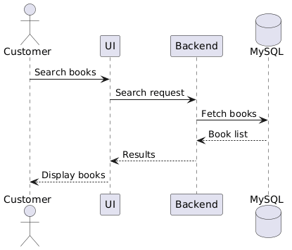
Diagram 2: Place an Order
This diagram shows the checkout process, including stock validation and order confirmation.
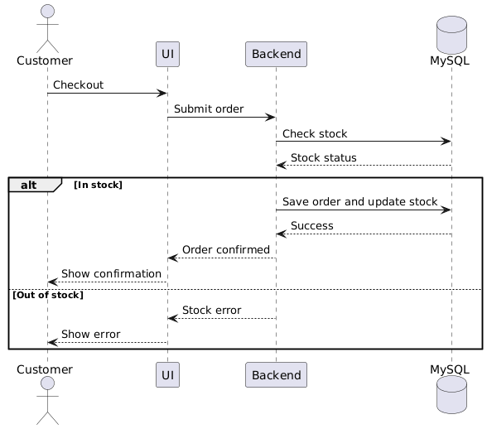

4.3 API Design
The system uses REST APIs to enable communication between the frontend and backend.
Component 1: Book Catalogue
Endpoint: /api/books
Method: GET
Request: Optional search query or category parameters.
Response: List of books containing details such as ID, title, author, price, and available stock.
Errors: 400 Bad Request, 500 Internal Server Error.
Component 2: Order Processing
Endpoint: /api/orders
Method: POST
Request: Book IDs, quantities, and relevant checkout details.
Response: Order ID, order status, and total amount.
Errors: 400 Bad Request for invalid input, 409 Conflict for insufficient stock, 500 Internal Server Error for unexpected failures.
The backend must calculate prices and validate stock rather than trusting values supplied by the frontend.

4.4 Error Handling, Logging, and Monitoring
The application uses standardized error responses to communicate failures clearly and consistently.
Error Handling: Handles invalid inputs, unavailable books, insufficient stock, database failures, and unexpected exceptions.
Logging: Records important events, errors, and failed transactions without storing passwords or sensitive information.
Monitoring: Tracks API response times, order failures, application availability, and database errors.
Recovery: Uses database transactions to prevent incomplete order creation or inconsistent inventory updates.
These practices help the team identify defects and maintain application reliability.

4.5 UX and Accessibility
The Online Bookstore interface focuses on simplicity, accessibility, and ease of navigation.
Navigation: Provides clear sections for the homepage, book catalogue, search, shopping cart, and checkout.
Book Display: Shows book titles, authors, prices, descriptions, and availability.
Shopping Cart: Displays selected books, quantities, and the total price.
Accessibility: Uses readable fonts, sufficient colour contrast, clear labels, and keyboard-friendly controls.
Feedback: Displays confirmation messages after successful actions and clear errors when operations fail.
Responsive Design: Supports different screen sizes, including desktops, tablets, and mobile devices.
The goal is to make book discovery and purchasing straightforward for users.

4.6 Open Issues & Next Steps
The following items can be addressed as development progresses.
Authentication: Determine whether customer registration, login, and administrator roles are required.
Payment Integration: Evaluate a secure payment gateway if online payments are included in the project scope.
Order Management: Implement order history, order status tracking, and cancellation where required.
Inventory Reliability: Test simultaneous purchases to prevent overselling.
Testing: Complete unit, integration, API, and end-to-end testing.
Deployment: Configure the frontend, backend, and database for deployment and establish appropriate backups.
Future Enhancements: Recommendations based on browsing history, book reviews and ratings, wishlists, advanced filtering, and personalized book suggestions could be added in future versions.

5. Appendices
5.1 Glossary
REST API: Interface enabling communication between the frontend and backend.
JSON: Format used to exchange data between application components.
SQL: Language used to manage and query relational databases.
CRUD: Create, Read, Update, and Delete operations on data.
UML: Unified Modeling Language used to represent system design.
TLS: Transport Layer Security used to protect data transmitted over a network.
ADR: Architecture Decision Record documenting important design decisions.

5.2 References
IEEE 42010: Architecture description of software-intensive systems.
OWASP: Security guidelines and best practices for web applications.
NIST SP 800-160: Systems security engineering principles.
Spring Boot Documentation: https://spring.io/projects/spring-boot
React Documentation: https://react.dev/
MySQL Documentation: https://dev.mysql.com/doc/

5.3 Suggested Tools
PlantUML: Used to create UML component and sequence diagrams.
draw.io: Used to design architecture diagrams and other visual representations.
Swagger / OpenAPI: Used to document and test REST APIs.
Git and GitHub: Used for version control and team collaboration.
MySQL Workbench: Used to design and manage the database.
Postman: Used to test backend API requests and responses.

