Software Requirements Specification (SRS)

Project: Hospital Patient Record and Appointment Management System
Version: 1.0
Authors: PES1UG24AM435 Krishna Kaushik Reddy K, PES1UG24AM446 Rolla N Harsha Vardhan, PES1UG24AM458 Amulya P, PES1UG24AM921 Rohan Agarwal
Date: 14-10-2026
Status: Draft

Revision history
Version | Date | Author | Change summary | Approval
1.0 | 14-10-2026 | Member 1 | Initial SRS with use-case diagrams and RTM

Approvals
Role | Name | Signature / Email | Date
Course Coordinator

Table of Contents
1. Introduction
2. Overall description
3. External interfaces
4. System features (detailed)
5. Non-functional requirements (detailed)
6. Quality attributes & Acceptance tests
7. UML Use-Case Diagram
8. Requirements Traceability Matrix (RTM)

1. Introduction

1.1 Purpose
This document is a Software Requirements Specification (SRS) for the Hospital Patient Record and Appointment Management System (HMS). It defines functional and non-functional requirements, security requirements, interfaces, and verification criteria for use by the development team, testers, and evaluators.

1.2 Scope
Covers a web-based system through which patients, doctors and administrators manage patient profiles, doctor profiles and availability, appointments, and medical records, with role-based access control and persistent storage in a database. Excludes billing and payments, email/SMS notifications, pharmacy and laboratory integration, analytics and reporting, and integration with external hospital systems.

1.3 Audience
Developers, QA Engineers, Project Mentor, and Assessment Evaluators.

1.4 Definitions
List of acronyms: HMS, SRS, SAD, STP, RTM, FR, NFR, SR, API, REST, JWT, RBAC, UI, TLS, CI, DB. Patient: registered user who manages own profile and appointments. Doctor: healthcare professional who manages availability, appointments and records of own patients. Administrator: user who manages accounts, appointments and system information.

2. Overall description

2.1 Product perspective
The HMS is a new, self-contained web application with a layered architecture (presentation, business logic, data) as described in the SAD. A React.js frontend calls the REST APIs of a Node.js/Express.js backend, which stores data in a MySQL database. Authentication uses JWT and access is restricted by role (Patient, Doctor, Administrator).

2.2 Major product functions (detailed)
- Authenticate users and enforce role-based access
- Patient profile management
- Doctor profile and availability management
- Doctor search and viewing of free slots
- Appointment booking, rescheduling and cancellation without double-booking
- Viewing of appointments by patients and doctors
- Medical record creation, update and read-only patient access
- Administrative management of users and appointments, system overview and audit log
- Persistent storage with backup and restore

2.3 User roles and characteristics (expanded)
- Patient: general public with basic computer skills; expects easy booking and privacy of personal and medical data.
- Doctor: hospital staff with moderate computer skills; needs quick access to appointments, availability control and patient records.
- Administrator: hospital staff responsible for accounts, appointments, system overview and audit review.
2.4 Operating environment
Latest Chrome, Firefox or Edge on desktop or mobile devices; Node.js server runtime; MySQL database; HTTP/HTTPS network connectivity between browser, backend and database.

2.5 Constraints
Technology stack fixed by the SAD (React.js, Node.js/Express.js, MySQL, REST, JWT); patient and medical data accessible only to authorized roles; source code managed in GitHub through pull requests; development and testing limited to two one-week sprints (19-30 Oct 2026).

3. External interface requirements

3.1 User interfaces
Primary UI: responsive web interface with role-specific dashboards (Patient, Doctor, Administrator), consistent navigation, input validation, clear error messages and confirmation after important actions. Accessibility: readable labels and sufficient colour contrast.

3.2 Hardware interfaces
- No special hardware is required
- Standard computers, laptops, tablets or phones with a web browser
- Server or developer machine hosting the Node.js backend and the MySQL database
3.3 Software interfaces
- MySQL database for persistent storage of users, patients, doctors, availability, appointments and medical records.
- Node.js/Express.js REST API (JSON) between frontend and backend.
- Web browser running the React.js frontend.
- GitHub Actions for continuous integration and automated tests.

3.4 Communications
- REST over HTTP using JSON; HTTPS/TLS 1.2+ enforced in deployment.
- Protected endpoints require a JWT in the Authorization header.
- Example endpoints (SAD 4.3): POST /api/appointments, GET/PUT/DELETE /api/appointments/:id, GET /api/records/:patientId, POST /api/records, PUT /api/records/:id.

<< Make sure overall there are at least 15 FRs for overall project, 5 NFRs, 2 security objectives and 5 Security requirements>>

4. System features (detailed)
Each requirement below includes acceptance criteria and a reference test case. IDs follow HMS-F-###.

4.1 Authentication
Description: Authenticate users with email and password, issue JWT sessions and enforce role-based access for Patient, Doctor and Administrator.
Req ID | Requirement | Type | Priority | Source/Stakeholder | Acceptance criteria / Test case ref | Comments / Dependencies
HMS-F-001 | The system shall allow a new user to register as a patient with name, email and password, and shall reject a duplicate email or invalid input. | Functional | High | Patient | AC-HMS-F-001: Valid data creates an account; duplicate email or invalid input is rejected with a clear message. Test: TC-Auth-01, TC-Auth-02, TC-Auth-03 | Needs Users table (DB schema)
HMS-F-002 | The system shall authenticate users by email and password and issue a JWT containing user id, role and expiry time. | Functional | High | All users | AC-HMS-F-002: Valid credentials return a JWT; expired or tampered tokens are rejected. Test: TC-Auth-04, TC-Auth-08 | Requires JWT secret in environment
HMS-F-003 | The system shall show a generic error for invalid credentials and shall not reveal whether the email or the password was wrong. | Functional | High | Security | AC-HMS-F-003: Wrong password and unknown email return the same 401 message. Test: TC-Auth-05, TC-Auth-06 | Failed attempt is logged
HMS-F-004 | The system shall allow each protected function only to its permitted roles (Patient, Doctor, Administrator), returning 401 without a valid token and 403 for a wrong role. | Functional | High | Security | AC-HMS-F-004: Protected routes reject missing tokens (401) and wrong roles (403). Test: TC-Auth-07, TC-Auth-09, TC-E2E-04 | RBAC middleware used by all modules
HMS-F-005 | The system shall allow a logged-in user to log out, ending the session on the client. | Functional | Medium | All users | AC-HMS-F-005: After logout the token is removed and protected pages redirect to login. Test: TC-Auth-10 | Frontend feature
HMS-F-006 | The system shall refuse login for deactivated accounts. | Functional | Medium | Administrator | AC-HMS-F-006: A deactivated user cannot log in. Test: TC-Auth-12 | Depends on HMS-F-053

4.2 Patient Management
Description: Maintain patient profiles and control who may view or change patient information.

Req ID | Requirement (shall...) | Type | Priority | Source/Stakeholder | Acceptance criteria / Test case ref | Comments / Dependencies
HMS-F-010 | The system shall maintain a patient profile (name, date of birth, gender, phone, address) that the patient can view. | Functional | High | Patient | AC-HMS-F-010: A patient sees only their own profile data. Test: TC-Pat-01 | Patients table
HMS-F-011 | The system shall allow a patient to update permitted profile fields; role and identifiers cannot be changed. | Functional | High | Patient | AC-HMS-F-011: Valid update is saved with a confirmation; role or id in the request is ignored. Test: TC-Pat-02, TC-Pat-03 | Depends on HMS-F-010
HMS-F-012 | The system shall validate profile input (for example phone format, date of birth not in the future) and return clear messages. | Functional | High | Patient | AC-HMS-F-012: Invalid phone number or future date of birth returns 400. Test: TC-Pat-04 | Validation library
HMS-F-013 | The system shall deny a patient access to any other patient's information. | Functional | High | Security | AC-HMS-F-013: Request for another patient's data returns 403. Test: TC-Pat-05 | Uses RBAC and user id from JWT
HMS-F-014 | The system shall let a doctor view the profile of a patient who has an appointment with that doctor, and an administrator view any patient profile. | Functional | Medium | Doctor / Administrator | AC-HMS-F-014: Doctor with an appointment gets 200, otherwise 403; administrator gets 200. Test: TC-Pat-06, TC-Pat-07 | Needs appointment data

4.3 Doctor Management
Description: Maintain doctor profiles and availability, and let patients find doctors and see free slots.

Req ID | Requirement (shall...) | Type | Priority | Source/Stakeholder | Acceptance criteria / Test case ref | Comments / Dependencies
HMS-F-020 | The system shall maintain a doctor profile (name, specialization, contact details); doctor accounts are created by an administrator. | Functional | High | Administrator | AC-HMS-F-020: Administrator creates a doctor who can then log in. Test: TC-Doc-01 | Depends on HMS-F-052
HMS-F-021 | The system shall allow a doctor to add and remove availability slots (date, start time, end time) in 30-minute units. | Functional | High | Doctor | AC-HMS-F-021: Slot is saved and listed as free; a patient cannot add slots (403). Test: TC-Doc-02, TC-Doc-06 | Availability table
HMS-F-022 | The system shall reject availability slots that overlap an existing slot of the same doctor. | Functional | Medium | Doctor | AC-HMS-F-022: Overlapping slot returns 409 and is not saved. Test: TC-Doc-03 | Depends on HMS-F-021
HMS-F-023 | The system shall allow a patient to search doctors by name or specialization. | Functional | High | Patient | AC-HMS-F-023: Only matching doctors are returned. Test: TC-Doc-04 | Seeded doctors needed
HMS-F-024 | The system shall show a patient the free slots of a doctor and shall not show booked slots as free. | Functional | High | Patient | AC-HMS-F-024: Booked slots are excluded from the free-slot list. Test: TC-Doc-05 | Used by booking flow

4.4 Appointment Management
Description: Book, view, reschedule and cancel appointments in 30-minute slots without double-booking.

Req ID | Requirement (shall...) | Type | Priority | Source/Stakeholder | Acceptance criteria / Test case ref | Comments / Dependencies
HMS-F-030 | The system shall allow a patient to book a free slot with a doctor after checking availability, and set the status to Confirmed. | Functional | High | Patient | AC-HMS-F-030: Booking a free slot returns 201 with status Confirmed. Test: TC-Apt-01, TC-E2E-01 | Depends on HMS-F-024
HMS-F-031 | The system shall ensure a slot has at most one active appointment, even when two requests arrive at the same time. | Functional | High | Business | AC-HMS-F-031: Second booking of a slot returns 409; simultaneous requests give exactly one success. Test: TC-Apt-02, TC-Apt-03, TC-Int-01 | Needs DB transaction or unique constraint
HMS-F-032 | The system shall reject bookings in the past or for a non-existent doctor. | Functional | High | Business | AC-HMS-F-032: Past slot returns 400; unknown doctor returns 404. Test: TC-Apt-04, TC-Apt-05 | Server-side check
HMS-F-033 | The system shall let a patient view their own appointments and a doctor view their own appointments. | Functional | High | Patient / Doctor | AC-HMS-F-033: Each user sees only their own appointments. Test: TC-Apt-06, TC-Apt-07 | Filtered by user id in JWT
HMS-F-034 | The system shall allow a patient to reschedule an appointment to another free slot and free the old slot. | Functional | High | Patient | AC-HMS-F-034: Reschedule to a free slot succeeds; to a taken slot returns 409 and leaves the original unchanged. Test: TC-Apt-08, TC-Apt-09 | Depends on HMS-F-031
HMS-F-035 | The system shall allow a patient to cancel an appointment and shall maintain its status (Confirmed, Cancelled, Completed); a cancelled slot becomes free. | Functional | High | Patient | AC-HMS-F-035: Cancel sets status Cancelled and the slot can be booked again. Test: TC-Apt-10 | Status stored in Appointments table
HMS-F-036 | The system shall allow a user to modify only their own appointments (administrator excepted). | Functional | High | Security | AC-HMS-F-036: Another patient's appointment cannot be changed (403). Test: TC-Apt-11 | Ownership check

4.5 Medical Record Management
Description: Create, view and update consultation records (diagnosis and notes) with strict access control.

Req ID | Requirement (shall...) | Type | Priority | Source/Stakeholder | Acceptance criteria / Test case ref | Comments / Dependencies
HMS-F-040 | The system shall allow a doctor to create a medical record (diagnosis, notes) for a patient who has an appointment with that doctor. | Functional | High | Doctor | AC-HMS-F-040: Record is stored and returns 201. Test: TC-Rec-01, TC-E2E-02 | Needs appointment link
HMS-F-041 | The system shall allow a doctor to retrieve and update the medical records of their patients and shall store the update time. | Functional | High | Doctor | AC-HMS-F-041: Records are listed; update changes content and update time. Test: TC-Rec-02, TC-Rec-03 | Depends on HMS-F-040
HMS-F-042 | The system shall allow a patient to view their own medical records but not create or edit them. | Functional | High | Patient | AC-HMS-F-042: Own records are returned; create or update attempts return 403. Test: TC-Rec-05, TC-Rec-06 | Role check
HMS-F-043 | The system shall deny access to a patient's medical records for any unauthorized user. | Functional | High | Security | AC-HMS-F-043: Doctor without an appointment and other patients receive 403. Test: TC-Rec-04, TC-Rec-05 | Core privacy requirement
HMS-F-044 | The system shall validate required fields (patient, doctor, diagnosis) before saving a record. | Functional | Medium | Doctor | AC-HMS-F-044: Missing diagnosis returns 400. Test: TC-Rec-07 | Validation library

4.6 Administration
Description: Let the administrator manage accounts and appointments, see a system overview and review the audit log.

Req ID | Requirement (shall...) | Type | Priority | Source/Stakeholder | Acceptance criteria / Test case ref | Comments / Dependencies
HMS-F-050 | The system shall restrict all administrative functions to the Administrator role. | Functional | High | Administrator | AC-HMS-F-050: Patient and doctor tokens get 403 and no token gets 401 on admin routes. Test: TC-Adm-01, TC-Adm-02 | Depends on HMS-F-004
HMS-F-051 | The system shall let an administrator list and view users, patients and doctors, without returning any password data. | Functional | High | Administrator | AC-HMS-F-051: Lists are filterable by role; no password or hash in any response. Test: TC-Adm-03, TC-Adm-04 | Pagination
HMS-F-052 | The system shall let an administrator create doctor accounts and patient accounts. | Functional | High | Administrator | AC-HMS-F-052: Created account is stored and can be used to log in. Test: TC-Adm-05, TC-Doc-01, TC-E2E-03 | Reuses registration validation
HMS-F-053 | The system shall let an administrator deactivate and reactivate user accounts. | Functional | High | Administrator | AC-HMS-F-053: Deactivated user cannot log in; reactivated user can. Test: TC-Adm-06, TC-Adm-07 | Status flag on Users
HMS-F-054 | The system shall let an administrator view all appointments with filters and cancel or change the status of an appointment. | Functional | Medium | Administrator | AC-HMS-F-054: Filtered list is correct; cancel frees the slot. Test: TC-Adm-08, TC-Adm-09, TC-E2E-03 | Uses Appointment service
HMS-F-055 | The system shall show an administrator an overview of counts of patients, doctors and appointments. | Functional | Medium | Administrator | AC-HMS-F-055: Counts equal the database counts. Test: TC-Adm-10 | Read-only queries
HMS-F-056 | The system shall record authentication events and administrative actions in an audit log that an administrator can view. | Functional | Medium | Security | AC-HMS-F-056: Log lists login success and failure and admin actions with time and actor; no passwords. Test: TC-Adm-11, TC-Auth-11 | Audit table

4.7 Data Persistence
Description: Store all data in a MySQL database with integrity, atomic updates and backup support.

Req ID | Requirement (shall...) | Type | Priority | Source/Stakeholder | Acceptance criteria / Test case ref | Comments / Dependencies
HMS-F-060 | The system shall store users, patients, doctors, availability, appointments and medical records in a MySQL database that keeps data across application restarts. | Functional | High | Business | AC-HMS-F-060: Data created before a backend restart is present afterwards. Test: TC-DB-01 | MySQL server required
HMS-F-061 | The system shall enforce referential integrity between related records. | Functional | High | Business | AC-HMS-F-061: Appointment for a non-existent doctor or patient is rejected by the database. Test: TC-DB-02 | Foreign keys
HMS-F-062 | The system shall complete operations that change several records (for example booking) fully or not at all. | Functional | High | Business | AC-HMS-F-062: A failure in the middle of booking leaves no partial record. Test: TC-DB-03 | Transactions
HMS-F-063 | The system shall support backup and restore of the database. | Functional | Medium | Operations | AC-HMS-F-063: A restored backup contains the original data and the application works. Test: TC-DB-04 | Manual procedure

5. Non-functional requirements (detailed)
NFRs below are measurable and tied to test plans. IDs HMS-NF-###.

Req ID | Requirement | Category | Priority | Acceptance criteria / Measurement
HMS-NF-001 | At least 95% of API requests shall complete within 2 seconds with 50 concurrent users, and pages shall load within 3 seconds. | Performance | High | 95th percentile <= 2 s in a 50-user load test. Test: TC-Perf-01
HMS-NF-002 | The system shall handle invalid input and database errors without crashing and shall not show stack traces or internal details to users. | Reliability | High | Malformed requests and a stopped database give clear messages and correct status codes. Test: TC-Rel-01
HMS-NF-003 | A patient shall be able to book an appointment in no more than 5 steps after login, with clear labels, confirmations and error messages. | Usability | Medium | Timed walkthrough completes in 5 steps or fewer. Test: TC-UX-01
HMS-NF-004 | The code shall follow a layered modular structure; every change shall be merged through a reviewed pull request and CI checks shall pass before merge. | Maintainability | Medium | A PR with a failing test is blocked by CI; a passing PR is mergeable. Test: TC-Maint-01
HMS-NF-005 | After any sequence of operations there shall be no orphan records and no slot with two active appointments. | Data Integrity | High | Randomized book, reschedule and cancel sequence leaves consistent data. Test: TC-Int-01
HMS-NF-006 | The web interface shall work on the latest Chrome, Firefox and Edge and be usable at 360 px width and above. | Compatibility | Medium | Login and booking work on all three browsers and at 360 px. Test: TC-Compat-01
HMS-NF-007 | Authentication events and administrative actions shall be logged with timestamp and actor. | Audit/Logging | Medium | Failed login, successful login and admin action appear in the audit log. Test: TC-Aud-01

5.1. Security

5.1.1 Security Objectives
SO-1 Confidentiality: Patient and medical information is visible only to users who are authorized for it (the patient, their treating doctor, and the administrator where permitted).
SO-2 Integrity: Profiles, appointments and medical records can be created or changed only by authorized roles, and stored data stays consistent.
SO-3 Accountability: Authentication events and administrative actions are recorded so that they can be reviewed.

5.1.2 Security Requirements
Req ID | Requirement (shall...) | Type | Priority | Acceptance criteria / Test case ref
HMS-SR-001 | Passwords shall be stored only as bcrypt hashes and shall never be returned in responses or written to logs. | Security | High | No plain-text password in the database, API responses or logs. Test: TC-Sec-01, TC-Sec-03
HMS-SR-002 | JWTs shall be signed with a secret kept in the environment, shall expire, and tampered or expired tokens shall be rejected. | Security | High | Tampered and expired tokens return 401. Test: TC-Sec-02, TC-Auth-08
HMS-SR-003 | Role-based access control shall be enforced on the server for every protected endpoint, not only hidden in the user interface. | Security | High | Every route called with every role returns only permitted results. Test: TC-Sec-04
HMS-SR-004 | All inputs shall be validated and sanitized; database queries shall be parameterized and output escaped. | Security | High | SQL injection and script payloads are rejected or neutralized. Test: TC-Sec-05, TC-Sec-06
HMS-SR-005 | Communication between frontend and backend shall use HTTPS/TLS 1.2+ in deployment and CORS shall be restricted to the frontend origin. | Security | Medium | HTTPS enabled or documented; CORS restricted. Test: TC-Sec-08
HMS-SR-006 | Secrets (JWT secret, database credentials) shall not be committed to the repository and shall be read from environment variables. | Security | High | Repository scan finds no secrets; .env is ignored. Test: TC-Sec-07
HMS-SR-007 | Logs and error responses shall not contain passwords, tokens, stack traces or internal system details. | Security | High | Log review and error responses contain no sensitive data. Test: TC-Sec-03, TC-Sec-09
HMS-SR-008 | Authentication events and administrative actions shall be recorded in an audit log. | Security | Medium | Login success, login failure and admin actions are logged. Test: TC-Aud-01, TC-Adm-11

6. Quality attributes & Acceptance tests
- Exit criteria for acceptance: All high-priority functional requirements implemented and verified, no critical NFR or security failures, and RTM shows all test cases passed.
- Acceptance test suites: Authentication, Patient, Doctor, Appointment, Medical Record, Administration, Persistence, Security, Performance, Usability, Compatibility, Audit, and End-to-end tests.

7. System models and diagrams

7.1 UML Use-Case diagram
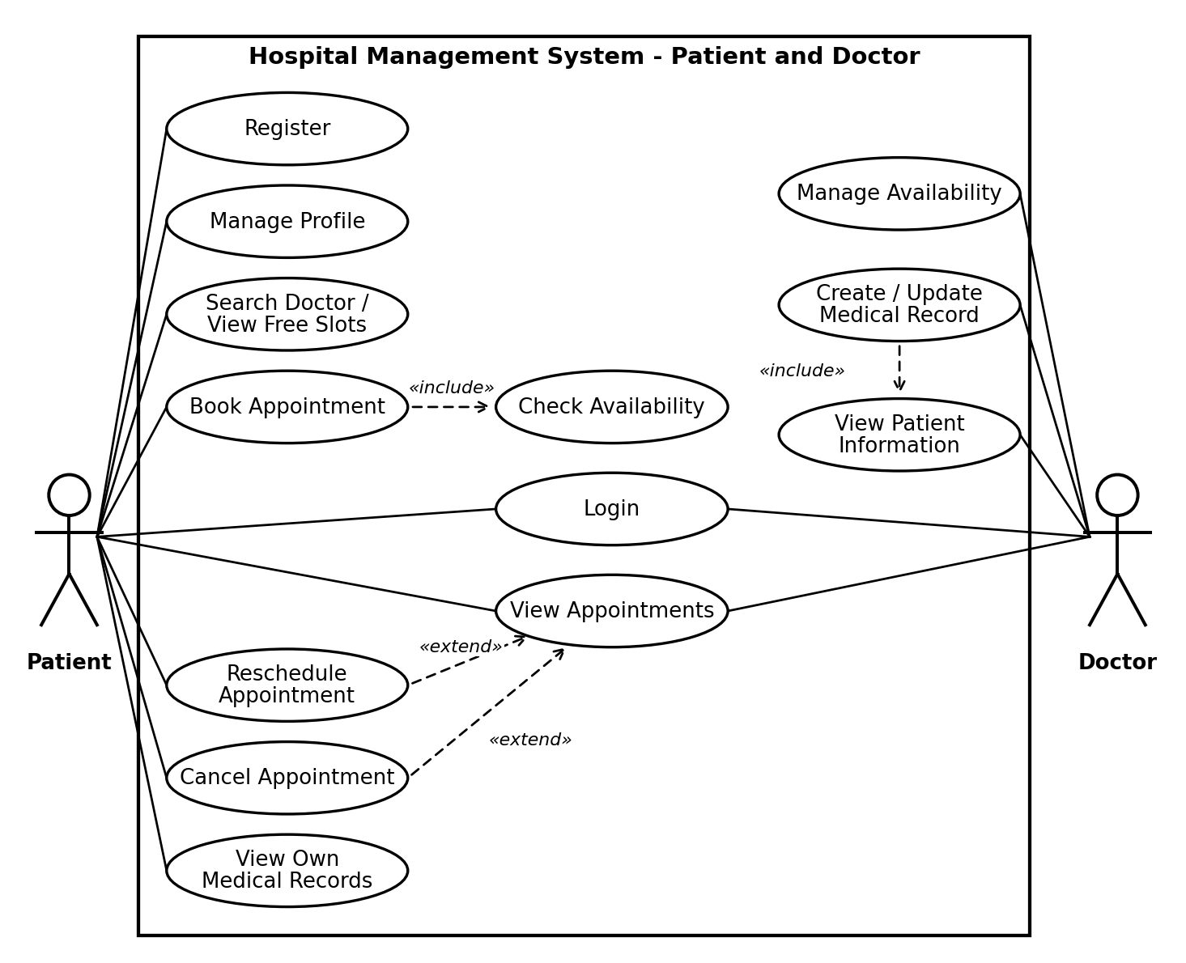
Figure 7.1: Use-case diagram for the Patient and Doctor roles. Book Appointment includes Check Availability; Reschedule and Cancel extend View Appointments; Create / Update Medical Record includes View Patient Information.
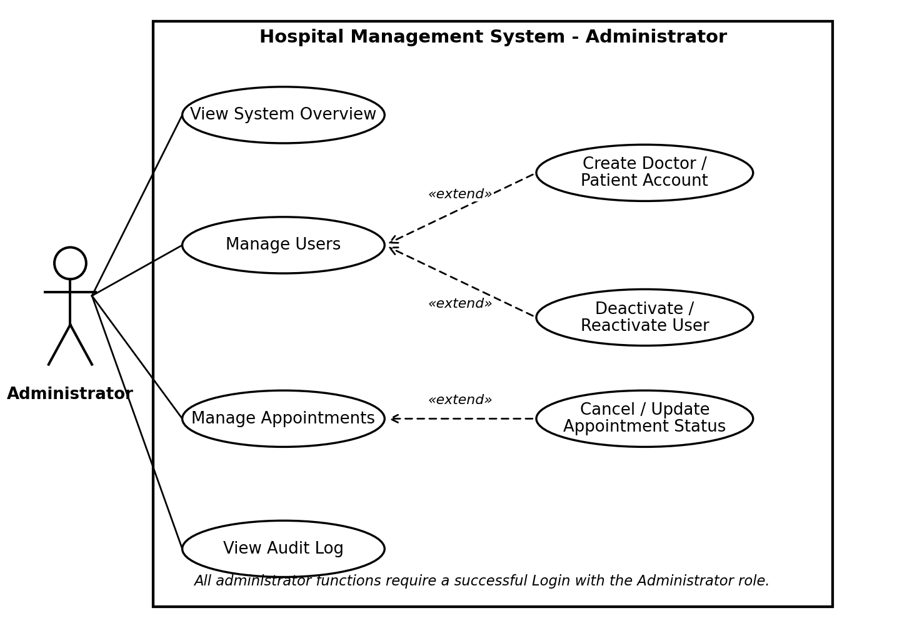
Figure 7.2: Use-case diagram for the Administrator role. Create account, deactivate/reactivate and cancel/update status extend the main administrator use cases.

8. Requirements Traceability Matrix (RTM)

Req ID | Requirement short | Section ref / Design Spec | Module | Test case(s) | Status (N/P/A) | Comments
HMS-F-001 | Register patient | 4.1 / SAD 3.4 | Authentication Service | TC-Auth-01, TC-Auth-02, TC-Auth-03 | N
HMS-F-002 | Login and JWT | 4.1 / SAD 3.4 | Authentication Service | TC-Auth-04, TC-Auth-08 | N
HMS-F-003 | Generic login error | 4.1 / SAD 3.4 | Authentication Service | TC-Auth-05, TC-Auth-06 | N
HMS-F-004 | Role-based access | 4.1 / SAD 3.4 | Authentication Service | TC-Auth-07, TC-Auth-09, TC-E2E-04 | N
HMS-F-005 | Logout | 4.1 / SAD 3.4 | Authentication Service | TC-Auth-10 | N
HMS-F-006 | Deactivated accounts | 4.1 / SAD 3.4 | Authentication Service | TC-Auth-12 | N
HMS-F-010 | Patient profile | 4.2 / SAD 3.4 | Patient Management Service | TC-Pat-01 | N
HMS-F-011 | Update profile | 4.2 / SAD 3.4 | Patient Management Service | TC-Pat-02, TC-Pat-03 | N
HMS-F-012 | Profile validation | 4.2 / SAD 3.4 | Patient Management Service | TC-Pat-04 | N
HMS-F-013 | Patient data isolation | 4.2 / SAD 3.4 | Patient Management Service | TC-Pat-05 | N
HMS-F-014 | Doctor and admin view | 4.2 / SAD 3.4 | Patient Management Service | TC-Pat-06, TC-Pat-07 | N
HMS-F-020 | Doctor profile and creation | 4.3 / SAD 3.4 | Doctor Management Service | TC-Doc-01 | N
HMS-F-021 | Manage availability | 4.3 / SAD 3.4 | Doctor Management Service | TC-Doc-02, TC-Doc-06 | N
HMS-F-022 | Overlap check | 4.3 / SAD 3.4 | Doctor Management Service | TC-Doc-03 | N
HMS-F-023 | Search doctors | 4.3 / SAD 3.4 | Doctor Management Service | TC-Doc-04 | N
HMS-F-024 | View free slots | 4.3 / SAD 3.4 | Doctor Management Service | TC-Doc-05 | N
HMS-F-030 | Book appointment | 4.4 / SAD 3.4 | Appointment Management Service | TC-Apt-01, TC-E2E-01 | N
HMS-F-031 | No double-booking | 4.4 / SAD 3.4 | Appointment Management Service | TC-Apt-02, TC-Apt-03, TC-Int-01 | N
HMS-F-032 | Booking validation | 4.4 / SAD 3.4 | Appointment Management Service | TC-Apt-04, TC-Apt-05 | N
HMS-F-033 | View appointments | 4.4 / SAD 3.4 | Appointment Management Service | TC-Apt-06, TC-Apt-07 | N
HMS-F-034 | Reschedule | 4.4 / SAD 3.4 | Appointment Management Service | TC-Apt-08, TC-Apt-09 | N
HMS-F-035 | Cancel and status | 4.4 / SAD 3.4 | Appointment Management Service | TC-Apt-10 | N
HMS-F-036 | Own appointments only | 4.4 / SAD 3.4 | Appointment Management Service | TC-Apt-11 | N
HMS-F-040 | Create medical record | 4.5 / SAD 3.4 | Medical Record Service | TC-Rec-01, TC-E2E-02 | N
HMS-F-041 | Retrieve and update record | 4.5 / SAD 3.4 | Medical Record Service | TC-Rec-02, TC-Rec-03 | N
HMS-F-042 | Patient read-only access | 4.5 / SAD 3.4 | Medical Record Service | TC-Rec-05, TC-Rec-06 | N
HMS-F-043 | Deny unauthorized record access | 4.5 / SAD 3.4 | Medical Record Service | TC-Rec-04, TC-Rec-05 | N
HMS-F-044 | Record validation | 4.5 / SAD 3.4 | Medical Record Service | TC-Rec-07 | N
HMS-F-050 | Admin-only functions | 4.6 / SAD 3.4 | Admin Service | TC-Adm-01, TC-Adm-02 | N
HMS-F-051 | List and view users | 4.6 / SAD 3.4 | Admin Service | TC-Adm-03, TC-Adm-04 | N
HMS-F-052 | Create accounts | 4.6 / SAD 3.4 | Admin Service | TC-Adm-05, TC-Doc-01, TC-E2E-03 | N
HMS-F-053 | Deactivate and reactivate | 4.6 / SAD 3.4 | Admin Service | TC-Adm-06, TC-Adm-07 | N
HMS-F-054 | Manage appointments | 4.6 / SAD 3.4 | Admin Service | TC-Adm-08, TC-Adm-09, TC-E2E-03 | N
HMS-F-055 | System overview | 4.6 / SAD 3.4 | Admin Service | TC-Adm-10 | N
HMS-F-056 | Audit log | 4.6 / SAD 3.4 | Admin Service | TC-Adm-11, TC-Auth-11 | N
HMS-F-060 | Persistent storage | 4.7 / SAD 3.4 | Hospital Database | TC-DB-01 | N
HMS-F-061 | Referential integrity | 4.7 / SAD 3.4 | Hospital Database | TC-DB-02 | N
HMS-F-062 | Atomic operations | 4.7 / SAD 3.4 | Hospital Database | TC-DB-03 | N
HMS-F-063 | Backup and restore | 4.7 / SAD 3.4 | Hospital Database | TC-DB-04 | N
HMS-NF-001 | Performance | 5 / SAD 3.1 Goals | Appointment / Doctor services | TC-Perf-01 | N
HMS-NF-002 | Reliability | 5 / SAD 4.4 Error Handling | All services | TC-Rel-01 | N
HMS-NF-003 | Usability | 5 / SAD 4.5 UX Design | Frontend | TC-UX-01 | N
HMS-NF-004 | Maintainability | 5 / SAD 3.5 Layered Architecture | CI pipeline | TC-Maint-01 | N
HMS-NF-005 | Data integrity | 5 / SAD 3.1 Goals | Appointment service / Database | TC-Int-01 | N
HMS-NF-006 | Compatibility | 5 / SAD 3.6 Technology Stack | Frontend | TC-Compat-01 | N
HMS-NF-007 | Auditability | 5 / SAD 4.4.2 Logging | Admin Service | TC-Aud-01 | N
HMS-SR-001 | Password hashing | 5.1.2 / SAD 3.9 Password Security | Authentication Service | TC-Sec-01, TC-Sec-03 | N
HMS-SR-002 | JWT signing and expiry | 5.1.2 / SAD 3.9 Authentication | Authentication Service | TC-Sec-02, TC-Auth-08 | N
HMS-SR-003 | Server-side RBAC | 5.1.2 / SAD 3.9 Authorization | Authentication Service (RBAC) | TC-Sec-04 | N
HMS-SR-004 | Input validation | 5.1.2 / SAD 3.9 Input Validation | All services | TC-Sec-05, TC-Sec-06 | N
HMS-SR-005 | HTTPS and CORS | 5.1.2 / SAD 3.9 Data Protection | Backend | TC-Sec-08 | N
HMS-SR-006 | Secret handling | 5.1.2 / SAD 3.9 Database Security | Backend | TC-Sec-07 | N
HMS-SR-007 | No sensitive data in logs | 5.1.2 / SAD 4.4.1 Error Handling | All services | TC-Sec-03, TC-Sec-09 | N
HMS-SR-008 | Audit logging | 5.1.2 / SAD 3.9 Audit and Logging | Admin Service | TC-Aud-01, TC-Adm-11 | N

