Lab 2: Agile Backlog Creation & Sprint Simulation in Jira
Project: Student Startup Crowdfunding Platform (Problem Statement #40)
Jira Project: PS Board | Course: Software Engineering, PES University

1. Epics
Lab 1's functional requirements for the crowdfunding platform were grouped into four Epics in the backlog, each covering a distinct stage of the campaign-to-disbursement workflow:
- Campaign Management – founder-side campaign setup (create campaign, set milestone targets).
- Campaign Backing & Rewards – backer-side pledging and reward tier selection.
- Milestone Evidence & Verification – founder evidence submission and faculty committee review.
- Fund Disbursement – payment processing, tranche release, and audit logging.
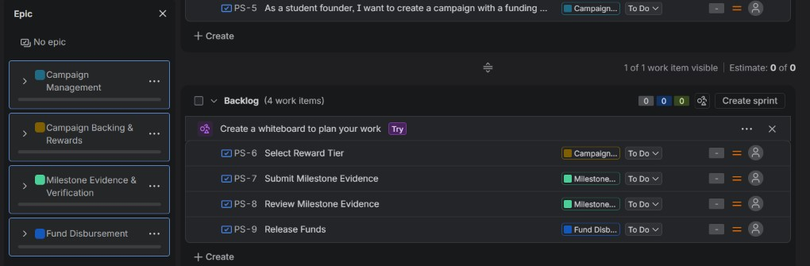
Figure 1. Epic panel showing the four Epics used to organize the backlog.

2. Backlog with Epics and User Stories
The full backlog contains 9 user stories totalling 40 story points before sprint planning, each tagged to its parent Epic:
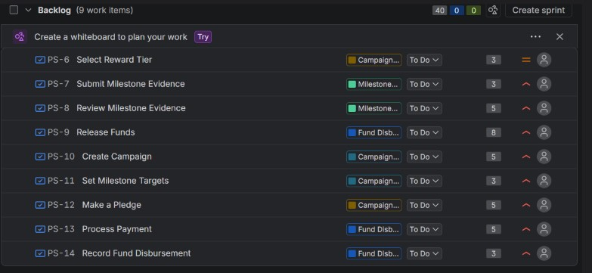
Figure 2. Product backlog — 9 work items (PS-6 to PS-14) grouped by Epic, 40 story points total.

3. Story Point Assignments
Story points were assigned on the Fibonacci scale during planning, based on complexity and uncertainty rather than raw hours:
ID | Story | Epic | Points
PS-6 | Select Reward Tier | Campaign Backing & Rewards | 3
PS-7 | Submit Milestone Evidence | Milestone Evidence & Verification | 3
PS-8 | Review Milestone Evidence | Milestone Evidence & Verification | 5
PS-9 | Release Funds | Fund Disbursement | 8
PS-10 | Create Campaign | Campaign Management | 5
PS-11 | Set Milestone Targets | Campaign Management | 3
PS-12 | Make a Pledge | Campaign Backing & Rewards | 5
PS-13 | Process Payment | Fund Disbursement | 5
PS-14 | Record Fund Disbursement | Fund Disbursement | 3

4. Sprint Boards (Active Sprint View)
Two one-week sprints were run to simulate delivery of the backlog.
Sprint 1 focused on campaign setup and backer-facing flows and closed with 4 stories (16 points) done:
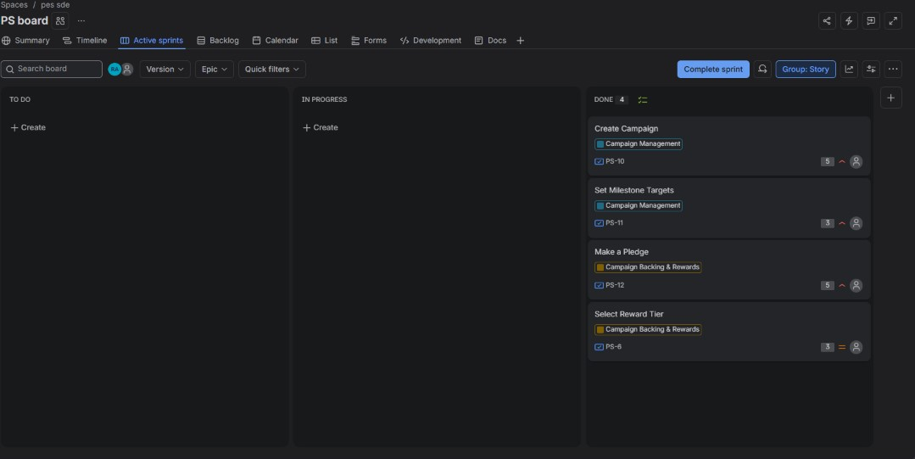
Figure 3. Sprint 1 — Active Sprints board, all 4 items (PS-6, PS-10, PS-11, PS-12) moved to Done.
Sprint 2 covered the milestone-verification and fund-disbursement flows and closed with 5 stories (24 points) done:
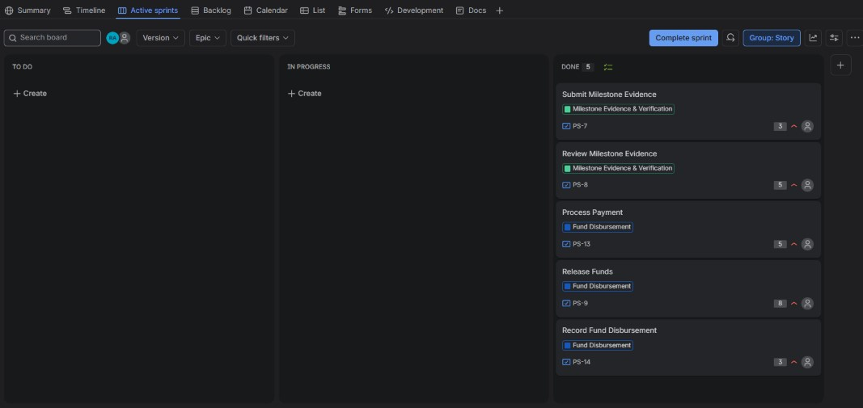
Figure 4. Sprint 2 — Active Sprints board, all 5 items (PS-7, PS-8, PS-9, PS-13, PS-14) moved to Done.

5. Burndown Chart
Sprint 2 opened with 24 story points (PS-13: 5, PS-14: 3, PS-7: 3, PS-8: 5, PS-9: 8) and burned down to 0 by the sprint end. The remaining-work line tracks closely against the ideal guideline for most of the sprint, indicating a fairly even pace of completion rather than one large drop at the end.
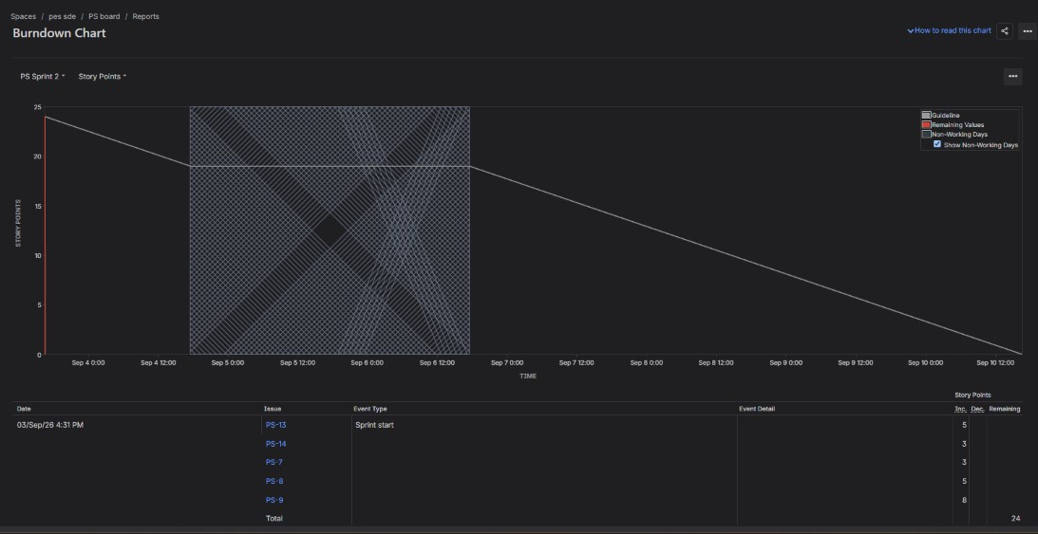
Figure 5. Burndown Chart — PS Sprint 2, Story Points, 24 → 0.

Reflection Questions
1. Did your estimations reflect the actual effort?
Largely yes. The higher-uncertainty, integration-heavy stories were given more points than the simpler UI-only stories: Release Funds (PS-9, 8 pts) touches milestone approval, tranche calculation and the payment gateway call, so it was estimated well above single-screen stories like Select Reward Tier or Record Fund Disbursement (3 pts each). All stories committed to in both sprints were completed within the sprint window, and the burndown line for Sprint 2 stayed close to the ideal guideline rather than dropping sharply near the deadline, which suggests the 3/5/8-point estimates were reasonably close to the real effort rather than badly over- or under-scoped.
2. Was your backlog well-prioritized?
The backlog was organized around the natural dependency order in the requirements: campaign creation and milestone targets (Campaign Management) had to exist before a backer could pledge or select a reward (Campaign Backing & Rewards), and a milestone had to be submitted and reviewed (Milestone Evidence & Verification) before any tranche could be released (Fund Disbursement). Sequencing Sprint 1 around campaign/backing stories and Sprint 2 around verification/disbursement stories followed that dependency chain, so higher-value, foundational functionality (FR-002, FR-003) was delivered before the features that depend on it (FR-001, FR-004, FR-005). One improvement for next time would be to also tag explicit High/Medium/Low priority on each story up front, since the default Medium priority was left unchanged on most items.
3. How did your simulated sprint align with your plan?
Both sprints matched their plan: everything pulled into Sprint 1 (4 stories / 16 points) and Sprint 2 (5 stories / 24 points) reached Done, with nothing left in To Do or In Progress at sprint close, and no scope was added mid-sprint. This one-to-one match between planned and completed points is partly a function of the sprints being simulated rather than executed with real implementation work — in a live sprint with actual coding, testing and review overhead, I'd expect more variance and a less linear burndown.
4. What insights did the burndown chart give about your team’s capacity?
The Sprint 2 burndown line tracking close to the guideline (rather than staying flat and then dropping sharply at the end) suggests the sprint's 24 points were a realistic load for the timebox — work was completed steadily rather than all at once. Story point 'capacity' here (roughly 16–24 points per one-week sprint) is a useful early benchmark, though because this was a simulated sprint rather than one with real coding effort, the true capacity signal will only become reliable once a few sprints are run with actual implementation work behind each story.

