Online Exam Portal
Software Architecture & Design Specification
Software Engineering Mini-Project — Deliverables Part-1
Document ID: OEP-SADS-001
Version 1.0 | Date: 28 September 2026
Prepared by: [Student Name(MANOJ A C, MANOJ GAONKAR, RUTHIK)]
| Roll No.: [PES1UG25CS826, PES1UG25CS827, PES1UG25CS837]
Course: Software Engineering | Institution: [College Name]
Prepared in accordance with IEEE Std 1016-2009 and ISO/IEC/IEEE 42010

Revision History
Version | Date | Author | Description
1.0 | 28-Sep-2026 | [Student Name(s)] | Initial release of the architecture and design specification, derived from OEP-SRS-001.

Table of Contents
1. Introduction
2. Architecture
2.1 Architectural Drivers
2.2 Architecture Pattern
2.3 Component Diagram
2.4 Component Description
2.5 Technology Stack and Deployment
2.6 Traceability to Requirements
2.7 Security Architecture
3. Detailed Design
3.1 Data Design
3.2 UML Sequence Diagrams
3.3 API Design
3.4 Error Handling
3.5 User Interface Design
3.6 Design Decisions and Constraints

1. Introduction

1.1 Purpose
This document describes the software architecture and the detailed design of the Online Exam Portal (OEP). It explains how the requirements of OEP-SRS-001 are realised by a set of components, their interfaces and their interactions, and it provides the basis for implementation and for the test cases of OEP-TP-001.

1.2 Scope
The document covers the logical architecture (components, layers, pattern), the security architecture, the data model, sequence diagrams for the main scenarios, the REST API design and the error-handling strategy of release 1.0.

1.3 Definitions and References
Term / Document | Meaning
SADS | Software Architecture & Design Specification (this document).
REST | Representational State Transfer; an HTTP-based API style.
DTO | Data Transfer Object exchanged through the API.
OEP-SRS-001 | Software Requirements Specification v1.0.
OEP-TP-001 | Test Plan v1.0.
IEEE 1016-2009 | Standard for Software Design Descriptions.

1.4 Document Overview
Section 2 presents the architecture: drivers, pattern, component diagram, component responsibilities, technology stack, traceability to requirements and the security architecture. Section 3 presents the design: data model, UML sequence diagrams, API design, error handling, user-interface overview and design decisions.

2. Architecture

2.1 Architectural Drivers
Driver | Source | Architectural consequence
Handle 500–1,000 concurrent exam takers | NFR-01, NFR-04 | Stateless application services that scale horizontally behind a load balancer; Redis for shared state
No loss of answers, resume after interruption | NFR-07, FR-13 | Server-side autosave of answers in the database; client re-fetches attempt state
Exam fairness and protection of answer keys | SR-07, SR-09 | Server-authoritative timer; answer keys stay in the server; separate Evaluation Service
Strong access control and traceability | SR-03, SR-08 | Central security filter (JWT + RBAC) and dedicated Audit Service
Maintainability and testability | NFR-08 | Modular services with clear interfaces; layered code structure

2.2 Architecture Pattern
The OEP uses a three-tier layered client–server architecture with a RESTful, modular service design:
- Presentation layer: a React single-page application that only talks to the API over HTTPS.
- Application layer: a Spring Boot application organised as independent service modules (Authentication, User, Exam, Question Bank, Attempt, Evaluation, Result & Report, Audit) behind an API gateway/security filter. Inside each module the code follows Controller → Service → Repository layering.
- Data layer: PostgreSQL for persistent data and Redis for token blacklist, rate-limit counters and session-related caches.
Rationale: layering separates concerns and makes each layer replaceable and testable; a modular (“modular monolith”) service design keeps deployment simple for a student project while allowing the busiest modules (Attempt, Evaluation) to be extracted into separate services later; stateless services satisfy the scalability driver. Alternatives considered: a full microservice architecture (rejected — operational overhead too high for the team size) and a server-rendered monolith (rejected — weaker support for a rich timed-exam UI and autosave).

2.3 Component Diagram
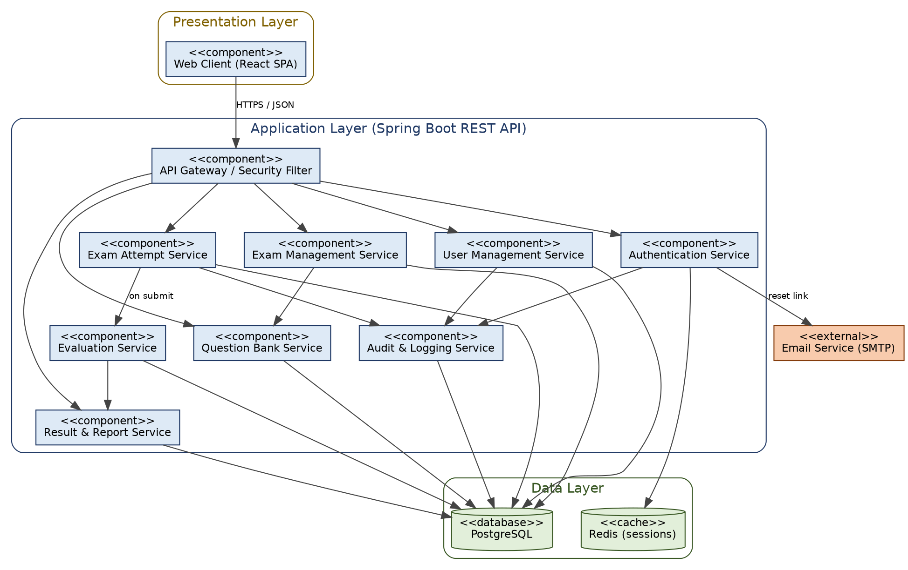
Figure 1: UML component diagram of the Online Exam Portal

2.4 Component Description
Component | Responsibility | Provided interface | Uses
Web Client (React SPA) | Renders role-specific screens, exam timer display, local navigation; never holds answer keys. | Browser UI | API Gateway (HTTPS/JSON)
API Gateway / Security Filter | Terminates TLS, validates JWT, enforces RBAC and rate limits, routes requests, adds correlation ID. | /api/v1/* | Authentication Service, Redis
Authentication Service | Registration, login, lockout, token issue/refresh/blacklist, password reset. | /auth/* | PostgreSQL, Redis, SMTP, Audit
User Management Service | Admin CRUD of users and roles, student groups. | /users/*, /groups/* | PostgreSQL, Audit
Exam Management Service | Create/update/publish exams, assign to groups, configure marking and randomization. | /exams/* | PostgreSQL, Question Bank
Question Bank Service | CRUD and search of questions and options. | /questions/* | PostgreSQL
Exam Attempt Service | Eligibility check, attempt creation, server timer, autosave, submission, resume. | /exams/{id}/attempts, /attempts/* | PostgreSQL, Evaluation, Audit
Evaluation Service | Computes score from stored answers and answer key; applies negative marking. | Internal: evaluate(attemptId) | PostgreSQL
Result & Report Service | Stores and serves results; statistics and CSV export. | /results/*, /reports/* | PostgreSQL
Audit & Logging Service | Append-only recording of security events; admin query. | /audit/* (admin), internal log() | PostgreSQL
PostgreSQL / Redis | Persistent relational storage / in-memory cache and counters. | JDBC / Redis protocol | —

2.5 Technology Stack and Deployment
Concern | Choice
Client | React 18, TypeScript, responsive CSS (360 px and up)
Server | Java 17, Spring Boot 3, Spring Security, Spring Data JPA
Database / cache | PostgreSQL 15 / Redis 7
Build & CI | Maven, JUnit 5, GitHub Actions
Deployment | Docker containers; reverse proxy/load balancer (Nginx) with TLS; two or more application instances

Deployment view: browser → Nginx (TLS termination, load balancing) → N stateless Spring Boot instances → PostgreSQL primary (daily backup, NFR-09) and Redis.

2.6 Traceability to Requirements
Component | Functional requirements | NFR / Security requirements
Web Client | FR-10, FR-12 (display), FR-14, FR-17 (display) | NFR-05, NFR-06, NFR-10
API Gateway / Security Filter | — | SR-02, SR-03, SR-04, SR-06, NFR-01, NFR-04
Authentication Service | FR-01, FR-02, FR-03, FR-04 | SR-01, SR-04, SR-06
User Management Service | FR-05 | SR-03
Exam Management Service | FR-06, FR-08, FR-09, FR-20 | SR-03
Question Bank Service | FR-07 | SR-05, SR-07
Exam Attempt Service | FR-10, FR-11, FR-12, FR-13, FR-15 | NFR-07, SR-07, SR-09
Evaluation Service | FR-16 | NFR-02, SR-07
Result & Report Service | FR-17, FR-18, FR-19 | NFR-02
Audit & Logging Service | FR-21 | SR-08
PostgreSQL / Redis / Backup | — | NFR-03, NFR-09, SR-01
All modules (engineering practice) | — | NFR-08, SR-05, SR-10

2.7 Security Architecture
Security is designed in layers (defence in depth) and maps to the security objectives SO-1 to SO-5 and requirements SR-01 to SR-10 of the SRS.
Layer | Mechanism | Requirement
Network / transport | HTTPS only (TLS 1.2+), HTTP→HTTPS redirect, HSTS header at Nginx | SR-02
Perimeter | API Gateway rate limiting (5 login requests/min/IP), request size limits, CORS whitelist | SR-06
Authentication | Email + password; bcrypt (cost ≥ 12); account lockout after 5 failures; JWT access token (30 min) with blacklist on logout in Redis | SR-01, SR-04, FR-03
Authorization | Role-based access control checked in the Security Filter and again in each service method (@PreAuthorize); object-level check that an attempt belongs to the caller | SR-03
Application | Server-side validation of all DTOs, parameterized queries via JPA, output encoding and Content-Security-Policy in the client, no answer keys in question DTOs | SR-05, SR-07
Exam integrity | Server-authoritative timer; answers after end time + 10 s grace rejected; randomization performed on the server | SR-09, FR-20
Data | Passwords hashed; database access with least-privilege account; encrypted backups | SR-01, NFR-09
Accountability | Audit Service records login/logout/start/submit/admin actions in an append-only table | SR-08, FR-21
Assurance | OWASP ZAP and dependency scans in CI before release | SR-10

Threat model (STRIDE summary)
Threat | Example | Mitigation
Spoofing | Attacker guesses a password or reuses a stolen token | Lockout, rate limiting, bcrypt, short-lived JWT, blacklist on logout
Tampering | Student edits request to change marks or answers after submission | Server-side evaluation; submitted attempts read-only; input validation
Repudiation | User denies having submitted or changed something | Audit log with user, time, IP
Information disclosure | Answer key or another student’s result is read | No key in payload; object-level authorization; TLS
Denial of service | Request flooding during an exam | Rate limiting, stateless scaling, timeouts
Elevation of privilege | Student calls teacher/admin API | RBAC at gateway and service level (HTTP 403)

3. Detailed Design

3.1 Data Design
The main entities and their relationships are summarised below. All primary keys are UUIDs; timestamps are stored in UTC.
Entity | Key attributes | Relationships
User | id, name, email (unique), password_hash, role (STUDENT/TEACHER/ADMIN), status, failed_attempts, locked_until | belongs to many Groups
StudentGroup | id, name | has many Users; assigned to many Exams
Question | id, teacher_id, type (MCQ/MULTI/TF), text, marks, correct_options | has many Options; used in many Exams
Option | id, question_id, text, is_correct | belongs to Question
Exam | id, title, subject, duration_min, start_at, end_at, total_marks, pass_marks, negative_pct, randomize, attempt_limit, status (DRAFT/PUBLISHED) | has many ExamQuestions; assigned to Groups
ExamQuestion | exam_id, question_id, position | joins Exam and Question
Attempt | id, exam_id, student_id, started_at, ends_at, submitted_at, status (IN_PROGRESS/SUBMITTED) | has many Answers; has one Result
Answer | attempt_id, question_id, selected_options, marked_for_review, saved_at | belongs to Attempt
Result | attempt_id, score, percentage, passed, evaluated_at | belongs to Attempt
AuditLog | id, user_id, action, timestamp, ip_address, details (append-only) | references User

3.2 UML Sequence Diagrams

3.2.1 SD-01 User Login
Realises FR-02, FR-03, FR-21, SR-01 and SR-04. The Auth Service verifies the bcrypt hash, records the outcome in the Audit Service and returns a JWT together with the user’s role.
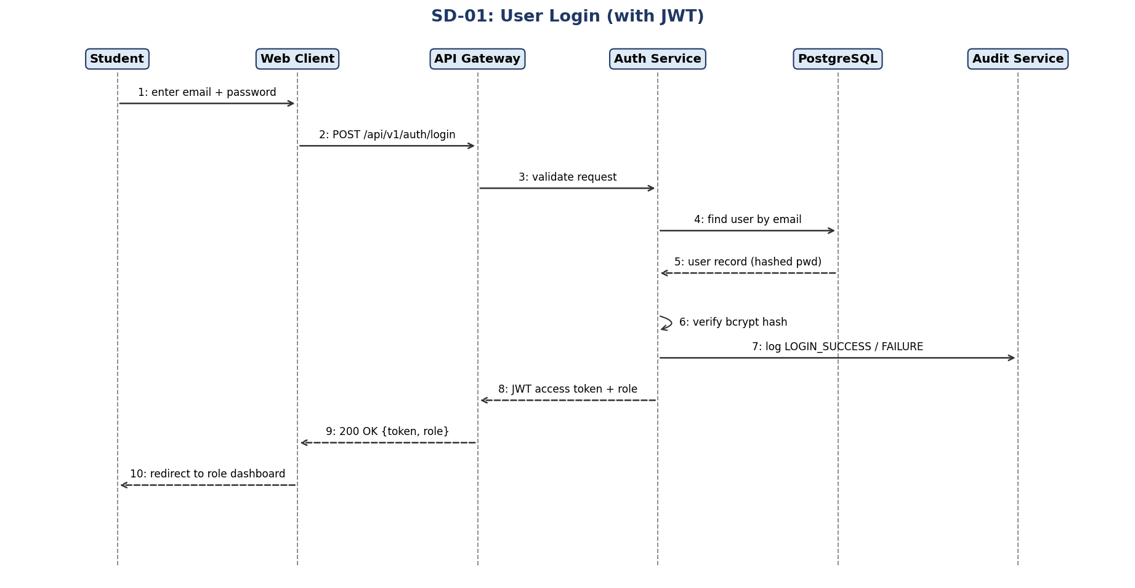
Figure 2: Sequence diagram — User Login

3.2.2 SD-02 Attempt and Submit Exam
Realises FR-11 to FR-16, NFR-07, SR-07 and SR-09. The Attempt Service checks eligibility, starts the server timer, autosaves answers and, on submission, calls the Evaluation Service to compute the score.
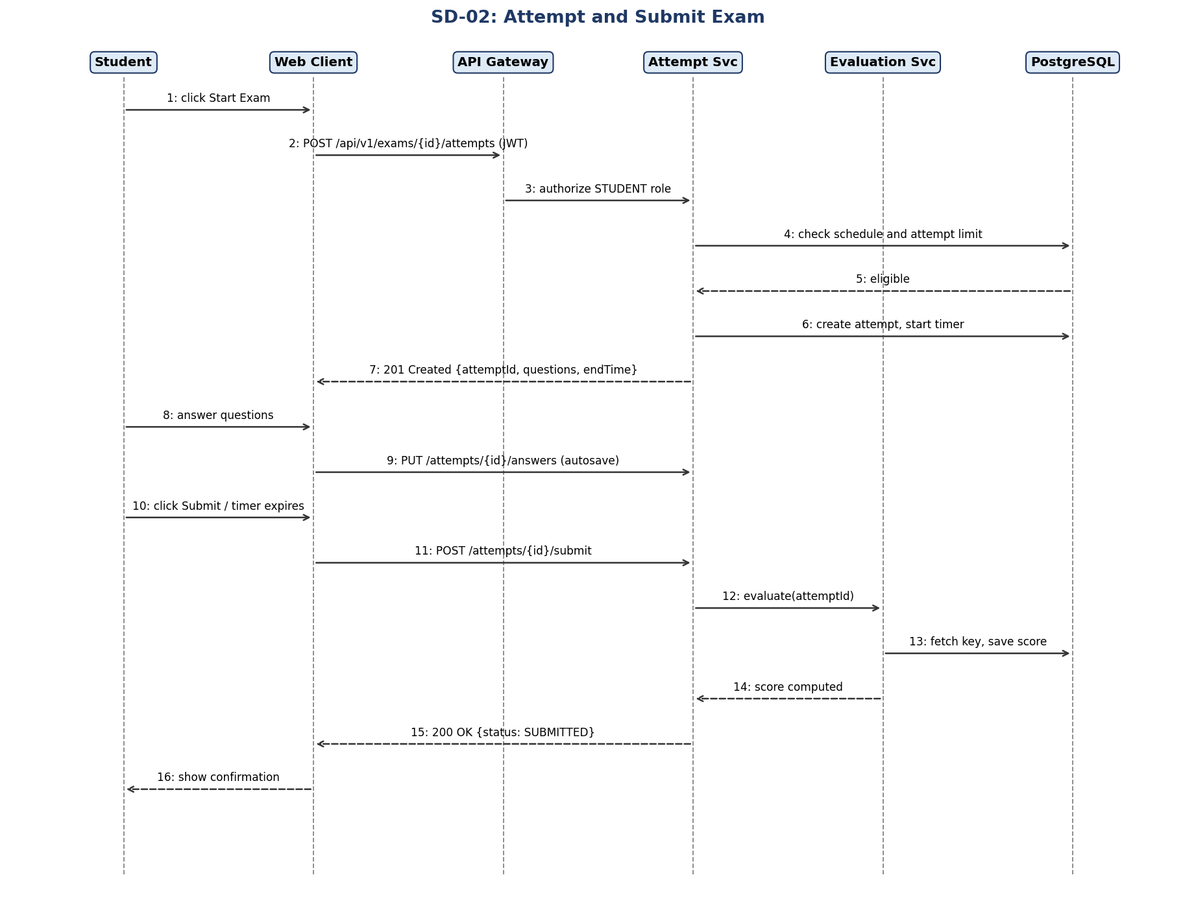
Figure 3: Sequence diagram — Attempt and Submit Exam

3.3 API Design

3.3.1 API Conventions
- Base URL: https://<host>/api/v1; JSON request and response bodies (UTF-8); dates in ISO-8601 UTC.
- Authentication: header “Authorization: Bearer <JWT>” on every endpoint except register, login and password-reset.
- Standard status codes: 200 OK, 201 Created, 204 No Content, 400 Bad Request, 401 Unauthorized, 403 Forbidden, 404 Not Found, 409 Conflict, 422 Unprocessable Entity, 429 Too Many Requests, 500 Internal Server Error.
- Lists support ?page=&size= (default 0/20, max size 100).

3.3.2 Endpoint Summary
Method | Endpoint | Role | Purpose | Req.
POST | /auth/register | Public | Register a student | FR-01
POST | /auth/login | Public | Log in, returns JWT + role | FR-02, FR-03
POST | /auth/logout | Any | Invalidate token | SR-04
POST | /auth/password-reset | Public | Request reset e-mail | FR-04
POST | /auth/password-reset/confirm | Public | Set new password with token | FR-04
GET/POST | /users | Admin | List / create users | FR-05
PUT/DELETE | /users/{id} | Admin | Update (role, status) / delete user | FR-05
GET/POST | /questions | Teacher | List / create questions | FR-07
PUT/DELETE | /questions/{id} | Teacher | Update / delete question | FR-07
POST | /exams | Teacher | Create exam | FR-06, FR-08
PUT | /exams/{id} | Teacher | Update exam settings | FR-06, FR-20
POST | /exams/{id}/publish | Teacher | Publish/unpublish and assign groups | FR-09
GET | /exams/available | Student | List assigned exams (Upcoming/Available/Completed) | FR-10
POST | /exams/{id}/attempts | Student | Start attempt; returns questions (no keys) and endTime | FR-11, FR-12
PUT | /attempts/{id}/answers | Student | Autosave answers / review flags | FR-13, FR-14
POST | /attempts/{id}/submit | Student | Submit attempt | FR-15, FR-16
GET | /attempts/{id}/result | Student | Get score and status | FR-17
GET | /reports/exams/{id} | Teacher | Statistics; ?format=csv exports CSV | FR-18
GET | /reports/summary | Admin | System summary | FR-19
GET | /audit | Admin | Query audit log | FR-21, SR-08

3.3.3 Example: Login
Request — POST /api/v1/auth/login
{
"email": "asha@test.com",
"password": "Exam@2026"
}

Response 200 OK
{
"accessToken": "eyJhbGciOiJIUzI1NiJ9...",
"expiresInSeconds": 1800,
"role": "STUDENT",
"name": "Asha K"
}

3.3.4 Example: Start Attempt
Request — POST /api/v1/exams/7c1e.../attempts (header Authorization: Bearer <JWT>). Response 201 Created
{
"attemptId": "a91f...",
"endTime": "2026-10-05T10:35:00Z",
"questions": [
{ "id": "q1", "type": "MCQ", "text": "2 + 2 = ?", "marks": 1,
"options": [ {"id":"o1","text":"3"}, {"id":"o2","text":"4"},
{"id":"o3","text":"5"}, {"id":"o4","text":"6"} ] }
]
}
Note: no “correct” or “isCorrect” field is returned (SR-07).

3.3.5 Example: Autosave Answers
Request — PUT /api/v1/attempts/a91f.../answers. Response 204 No Content (or 409 if the attempt has ended).
{
"answers": [
{ "questionId": "q1", "selectedOptions": ["o2"], "markedForReview": false },
{ "questionId": "q3", "selectedOptions": [], "markedForReview": true }
]
}

3.4 Error Handling

3.4.1 Strategy
- Validate early: all request DTOs are validated (Bean Validation) at the controller boundary; invalid input returns 400/422 before any business logic runs.
- Central exception handling: a global @ControllerAdvice maps domain exceptions to a uniform error response; stack traces and internal details are never sent to the client (SR-05, SR-10).
- Fail safely: on any authentication or authorization failure the request is denied and an audit entry is written; on evaluation failure the attempt stays SUBMITTED and the evaluation is retried (up to 3 times, then flagged for the Administrator).
- Resilience: database and e-mail calls have timeouts (5 s); the client retries autosave with back-off and keeps unsent answers locally until the network returns (NFR-07).
- Observability: each request has a correlation ID returned in the error body and written to the application log so that support staff can trace a failure.

3.4.2 Standard Error Response
{
"timestamp": "2026-10-05T10:12:44Z",
"status": 403,
"code": "ACCESS_DENIED",
"message": "You are not allowed to perform this action.",
"path": "/api/v1/exams",
"correlationId": "c0f3-9d1a"
}

3.4.3 Error Catalogue
Code | HTTP | Situation | Client behaviour
VALIDATION_FAILED | 400 / 422 | Missing/invalid field, weak password, duration out of range | Show message next to the field
INVALID_CREDENTIALS | 401 | Wrong e-mail or password (message does not reveal which) | Show generic error
ACCOUNT_LOCKED | 423 / 401 | 5 failed attempts; locked for 15 minutes | Show remaining lock time
TOKEN_EXPIRED | 401 | JWT expired or blacklisted | Redirect to login
ACCESS_DENIED | 403 | Role not permitted / object not owned by caller | Show “not allowed” page
NOT_FOUND | 404 | Resource does not exist | Show not-found message
EXAM_NOT_AVAILABLE | 409 | Outside exam window or attempt limit reached | Show reason on exam card
ATTEMPT_CLOSED | 409 | Answer received after end time / already submitted | Show “time is over” and go to result
DUPLICATE_RESOURCE | 409 | E-mail already registered | Show message on e-mail field
RATE_LIMITED | 429 | Too many requests | Wait and retry (Retry-After header)
INTERNAL_ERROR | 500 | Unexpected server error | Show generic message with correlation ID; retry

3.5 User Interface Design
The user interface is a responsive single-page application. The main screens and their navigation are:
Screen | Role | Main elements
Login / Register / Reset | Public | Forms with inline validation and password-policy hints
Student Dashboard | Student | Tabs: Upcoming, Available, Completed; Start button enabled only in window
Exam Attempt | Student | Question panel, question palette (answered / review / unanswered), countdown timer, autosave indicator, Submit button with confirmation
Result | Student | Score, percentage, Pass/Fail, optional review
Teacher Dashboard / Question Bank / Exam Editor | Teacher | Tables with search, question form, exam settings form, publish control
Reports | Teacher, Admin | Statistics cards, result table, Export CSV
User Management / Audit Log | Admin | User table with role/status actions; filterable audit list

3.6 Design Decisions and Constraints
ID | Decision | Reason
DD-01 | Stateless JWT authentication with Redis blacklist | Enables horizontal scaling (NFR-04) while still allowing logout (SR-04)
DD-02 | Server-authoritative timer; client timer for display only | Prevents time tampering (SR-09)
DD-03 | Answers autosaved to the database, not only in the browser | Recovery after connection loss (NFR-07)
DD-04 | Evaluation runs in a separate service module with access to the answer key | Keeps the key away from the client and other modules (SR-07)
DD-05 | Modular monolith instead of microservices | Simpler deployment and testing for the project team; modules can be split later
DD-06 | Append-only audit table | Tamper evidence and accountability (SR-08)

