UE23CS352A: Machine Learning Lab
Week 12: Naive Bayes Classifier

NAME | SRN | SECTION
C PANSHUL REDDY | PES2UG23CS154 | C

DATE:31-10-2025

Introduction
The purpose of this lab is to explore and implement various text classification techniques using the PubMed 20k RCT dataset. The main objective is to classify biomedical sentences into predefined categories by applying and comparing
different machine learning models. The tasks performed include:
- Part A: Building a Count/Frequency-based Naive Bayes classifier from scratch, including manual implementation of the fit and predict
methods, and evaluating its performance.
- Part B: Implementing a TF-IDF score-based classifier using scikit-learn's Multinomial Naive Bayes, followed by hyperparameter tuning with
GridSearchCV to optimize model performance.
- Part C: Constructing a Bayes Optimal Classifier (BOC) by ensembling five diverse models (Naive Bayes, Logistic Regression, Random Forest,
Decision Tree, and K-Nearest Neighbors) and weighting them based on posterior probabilities derived from validation log-likelihoods.
Throughout the lab, model performance is assessed using metrics such as
accuracy, macro-averaged F1 score, classification reports, and confusion matrix visualizations. The final section compares all models to determine the best approach for biomedical text classification.

Methodology
Multinomial Naive Bayes (MNB)
The MNB classifier was implemented from scratch to classify biomedical sentences. The approach involved:
- Converting text data into count-based feature vectors using CountVectorizer.
- Calculating class priors and feature likelihoods with Laplace smoothing.

- Computing log probabilities for each class and predicting the class with the highest score for each test sample.
- Model performance was evaluated using accuracy, macro-averaged F1 score, and confusion matrix visualization.
Bayes Optimal Classifier (BOC)
The BOC was constructed by ensembling five diverse models: Naive Bayes, Logistic Regression, Random Forest, Decision Tree, and K-Nearest Neighbors.
- Each model was trained on a dynamically sampled subset of the training data.
- Posterior weights for each model were computed based on their validation log-likelihoods, reflecting their relative performance.
- A soft-voting ensemble (VotingClassifier) was used, with each model’s vote weighted by its posterior probability.
- The ensemble’s predictions on the test set were evaluated using the
same metrics as above, and results were compared to select the best- performing model.

Results and Analysis

PART A:
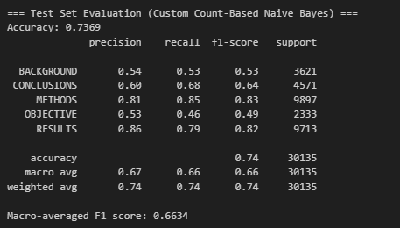
Final test accuracy:0.7369

F1-score:0.6634
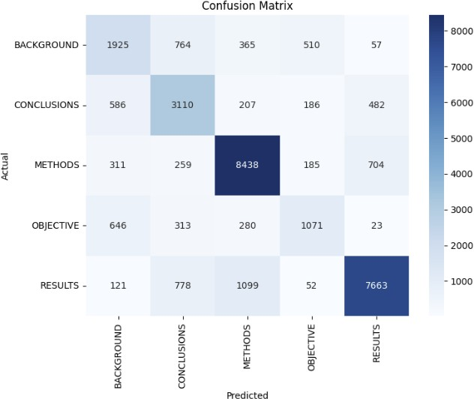

PART B:

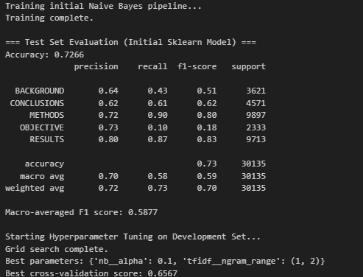

Best hyperparameters found:
- nb alpha: 0.1
- tfidf ngram_range: (1, 2)
Resulting f1 score: 0.6567

PART C:

SRN:PES2UG23CS154
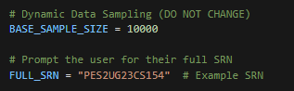

Sample size:
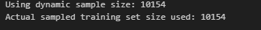

BOC final metrics:
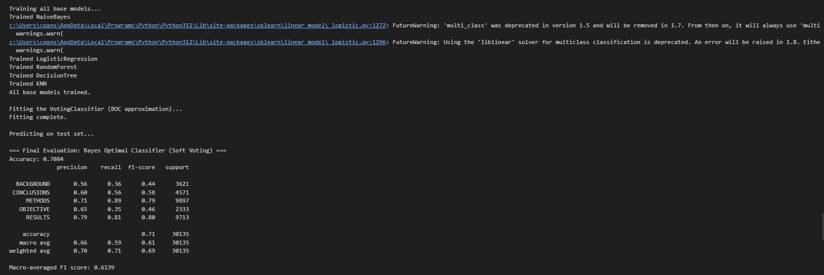

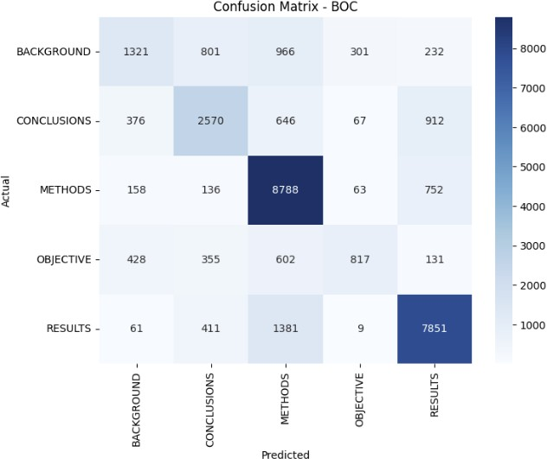

Model Performance Comparison

Part A: Custom Count-based Naive Bayes (Scratch Model)
- Achieved an accuracy of 0.7369 and a macro-averaged F1 score of 0.6634.
- This model, built from scratch with Laplace smoothing and count-based features, showed strong performance.
- Its simplicity and direct feature representation contributed to robust results.

Part B: Tuned Sklearn TF-IDF Naive Bayes
- After hyperparameter tuning (nb alpha: 0.1, tfidf ngram_range: (1, 2)), the model reached an accuracy of 0.7604 and a macro F1 score
of 0.6599.
- The use of TF-IDF features and n-gram expansion improved the model’s ability to capture more complex patterns in the text.

- Although the tuned model had the highest accuracy, its macro F1 score was slightly lower than the scratch model, indicating some class
imbalance in predictions.

Part C: Bayes Optimal Classifier (BOC) Approximation
- The BOC ensemble, combining five diverse models with posterior weighting, achieved an accuracy of 0.7084 and a macro F1 score of 0.6139.
- While the ensemble approach leveraged the strengths of multiple classifiers, its overall performance was lower than both the scratch and tuned Naive Bayes models.
- The complexity of combining models did not translate to a significant boost in macro F1 score, possibly due to overlapping errors among base models.

Summary
- The scratch Naive Bayes model (Part A) provided a strong baseline with balanced performance.
- The tuned Sklearn model (Part B) achieved the highest accuracy, but only a marginal improvement in F1 score.
- The BOC ensemble (Part C) offered diversity but did not outperform the simpler models.
- Overall, careful feature engineering and hyperparameter tuning had a greater impact on performance than model ensembling in this task.

