LAB 2 - MONOLITHIC ARCHITECTURE
Monolith Analogy: The Great Indian Fest Combo

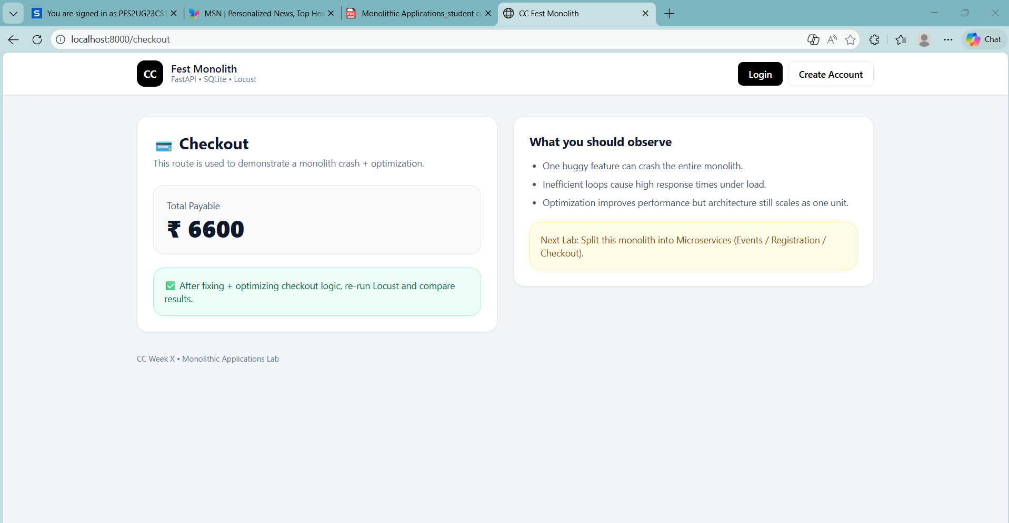
PART 5: Load Testing using Locust
SS4
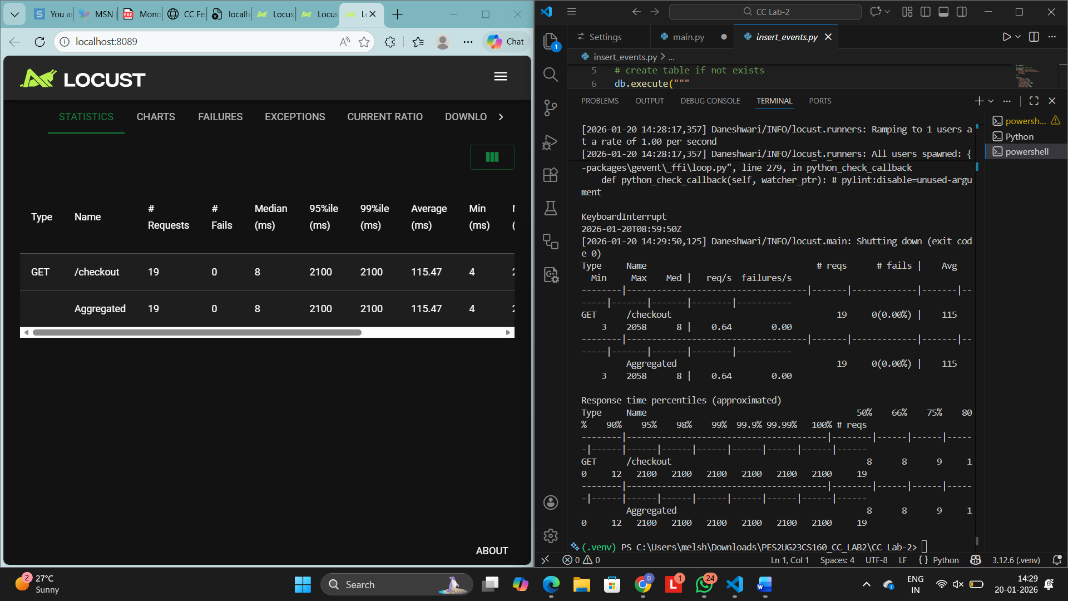
Optimize the Checkout Route
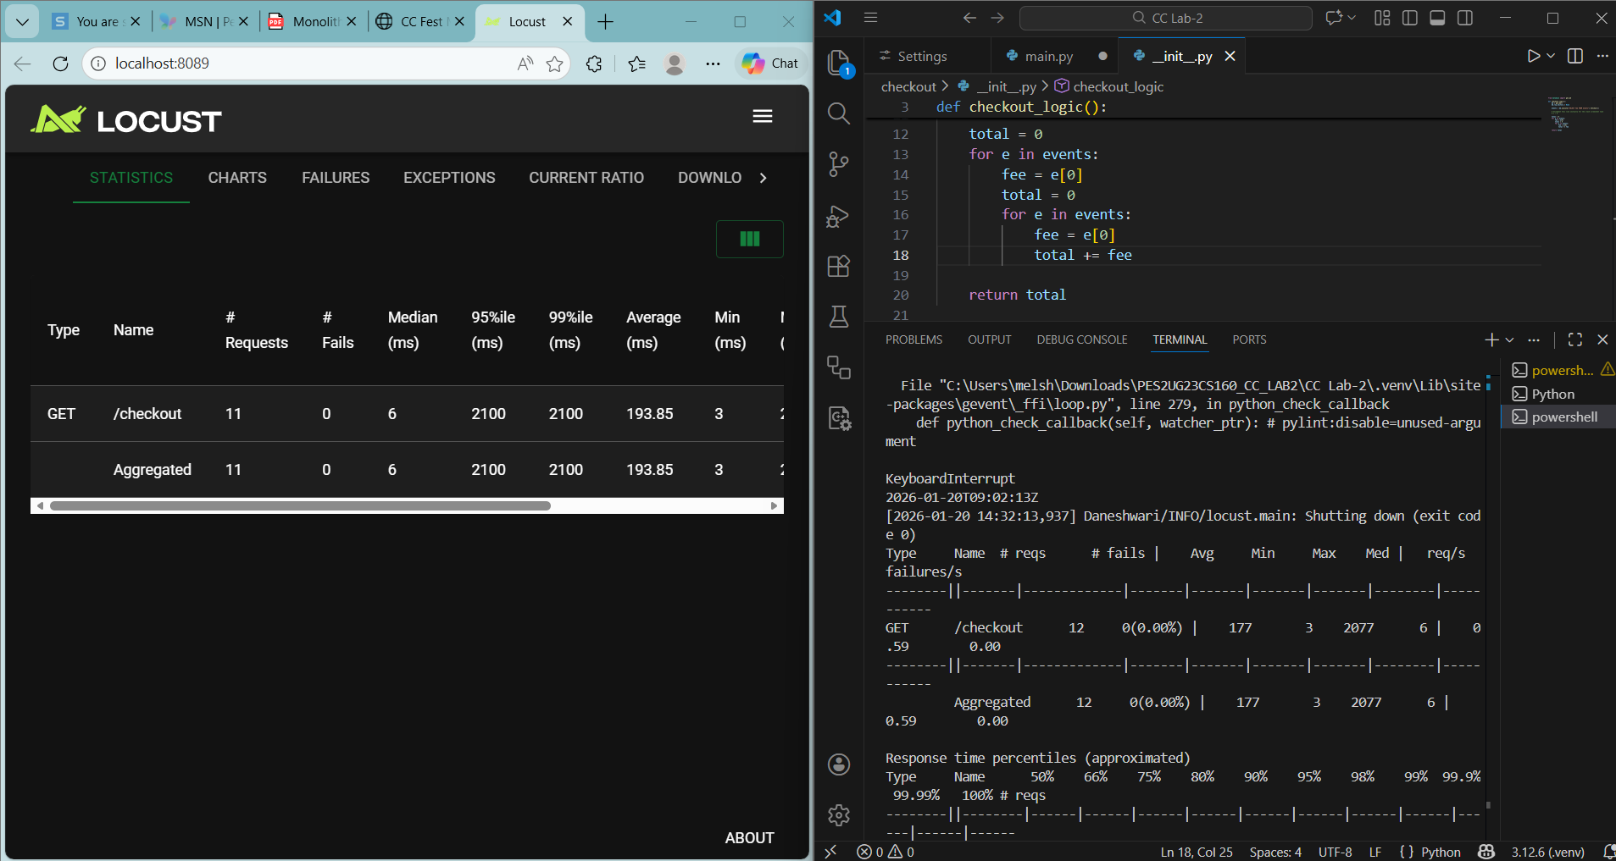
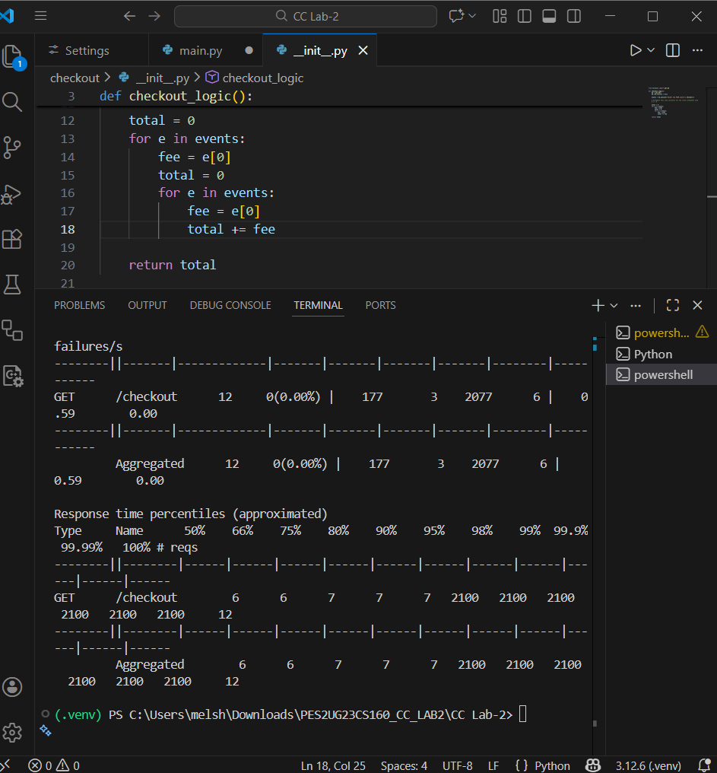
Route 1: /events Run: locust -f locust/events_locustfile.py BEFORE optimization → SS6
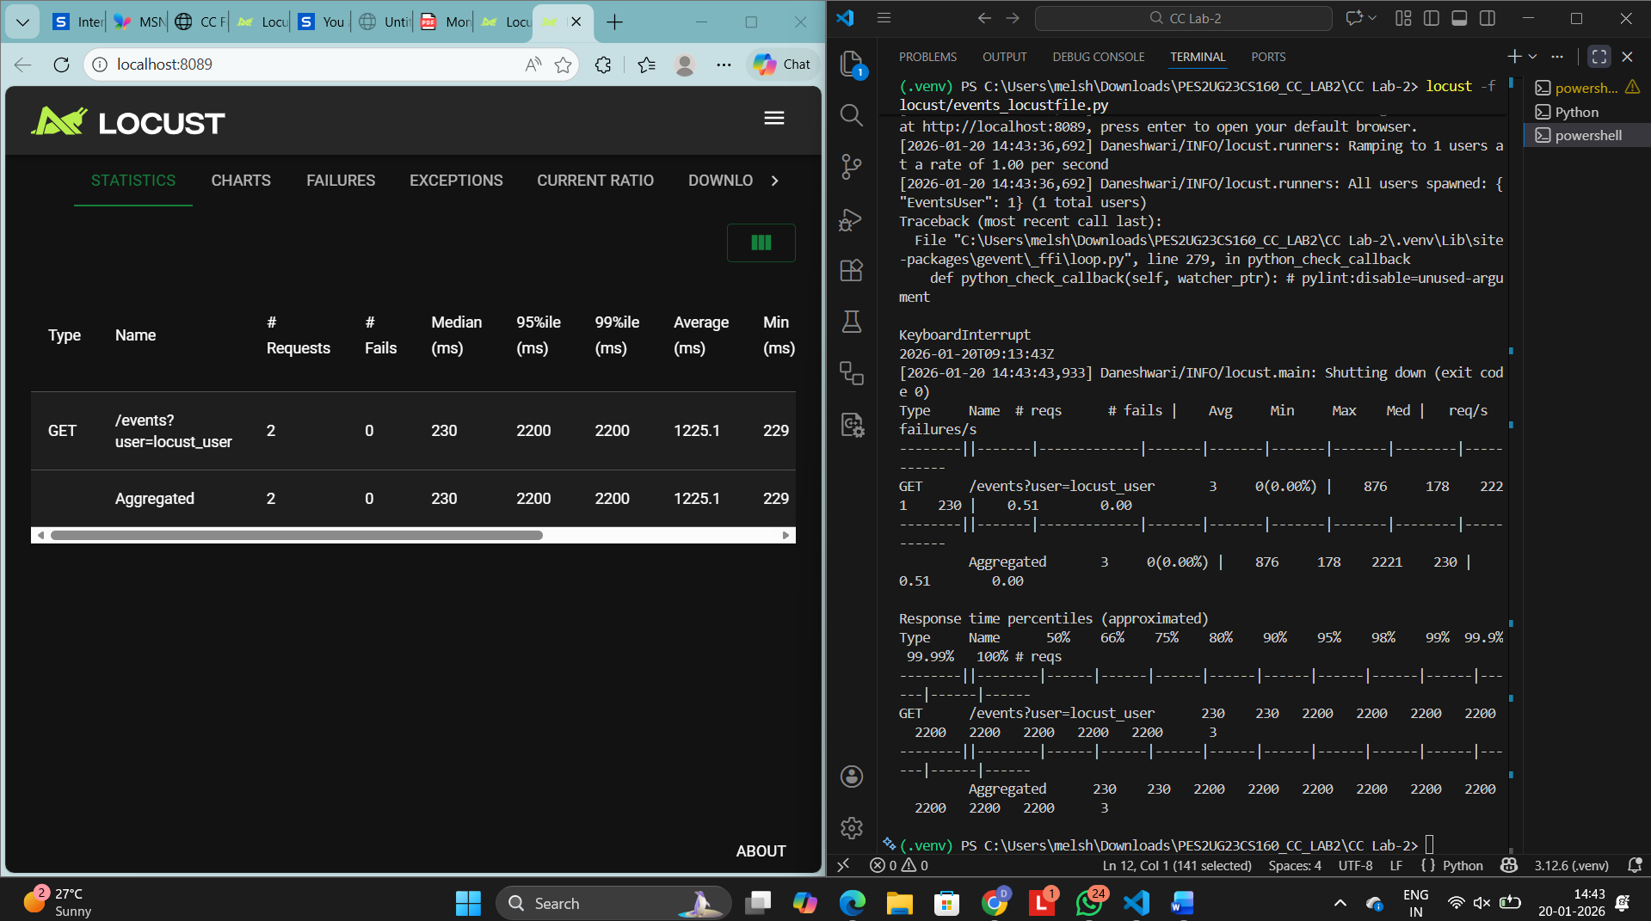
Optimize code → Re-run locust Screenshot AFTER optimization → SS7

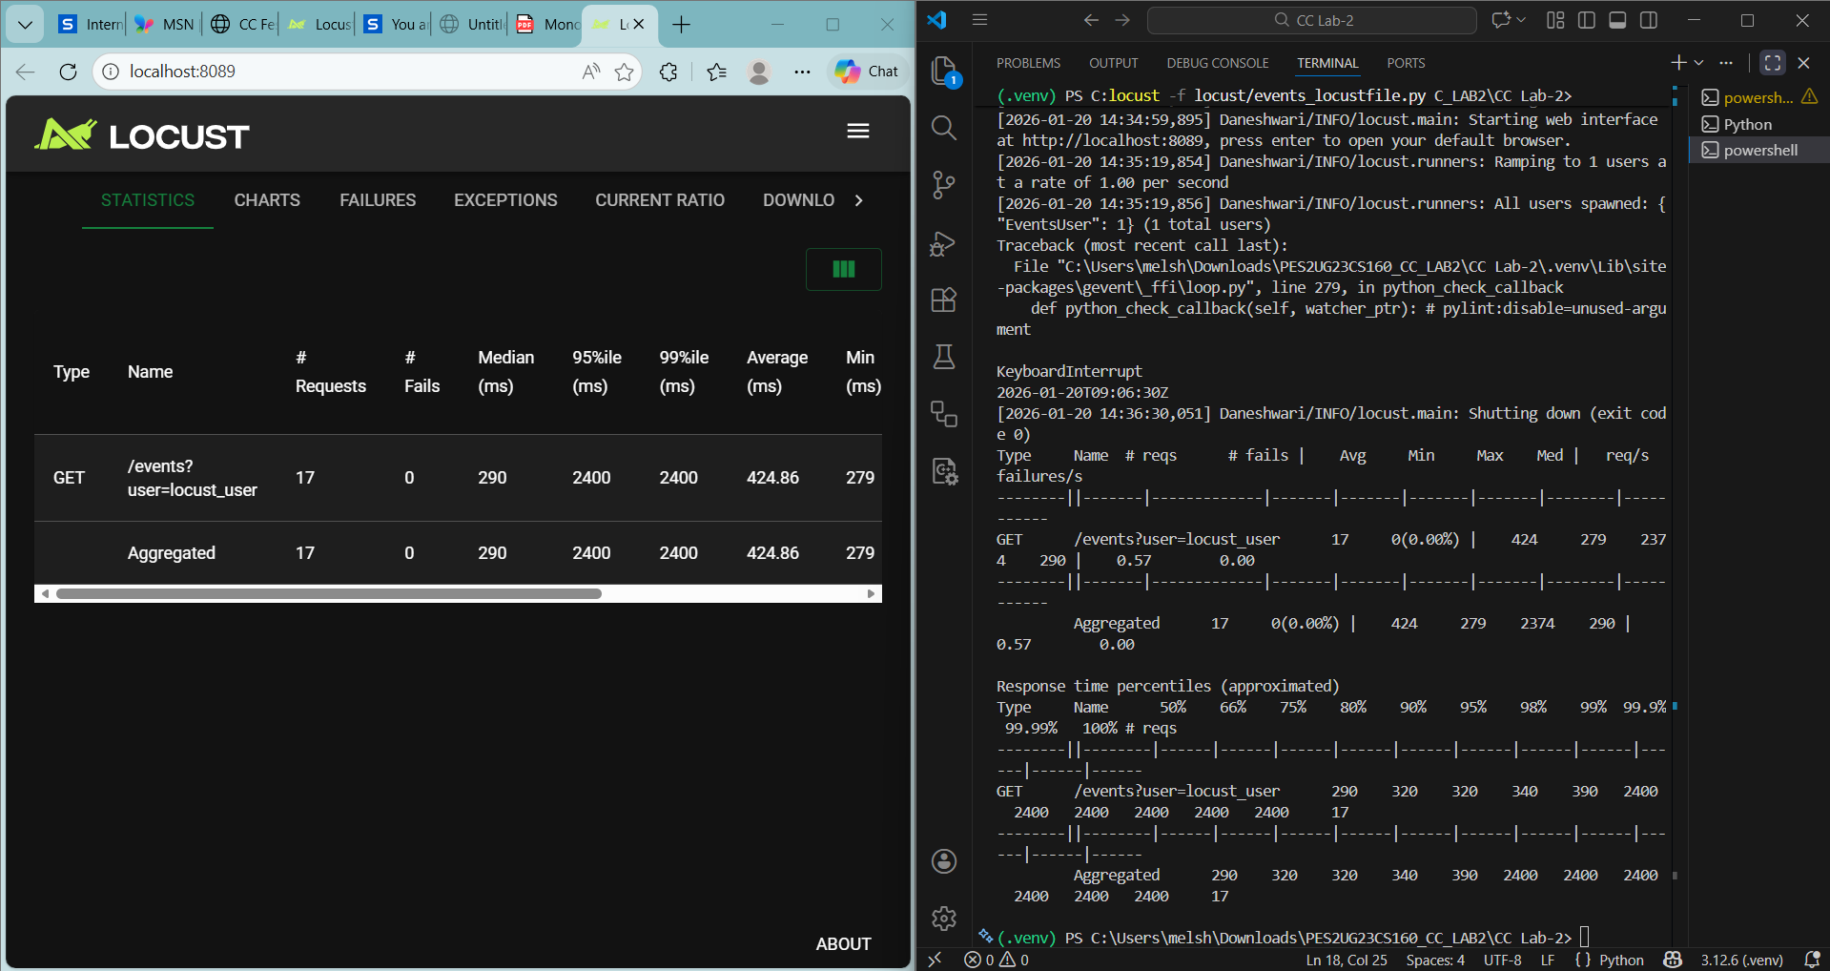
What was the bottleneck?
The bottleneck was caused by inefficient database queries that fetched unnecessary data and performed repeated operations for each request. This resulted in high response times under load.
What change did you make?
I optimized the route by reducing redundant database calls, selecting only required fields, and improving query efficiency.
Why did the performance improve?
Fewer database operations reduced execution time per request, allowing the server to handle more concurrent users with lower latency. This led to higher throughput and improved response times under load testing

Route 2: /my-events Run: locust -f locust/myevents_locustfile.py Screenshot BEFORE optimization → SS8
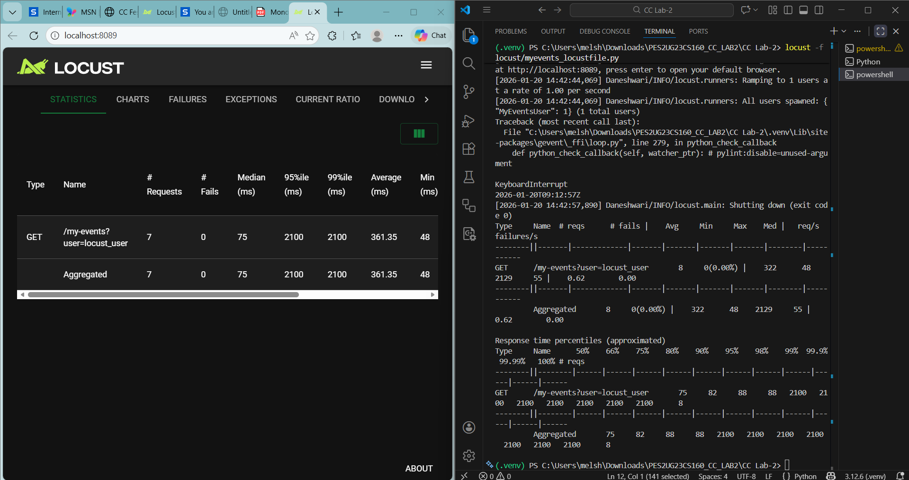
Optimize code → Re-run locust Screenshot AFTER optimization → SS9
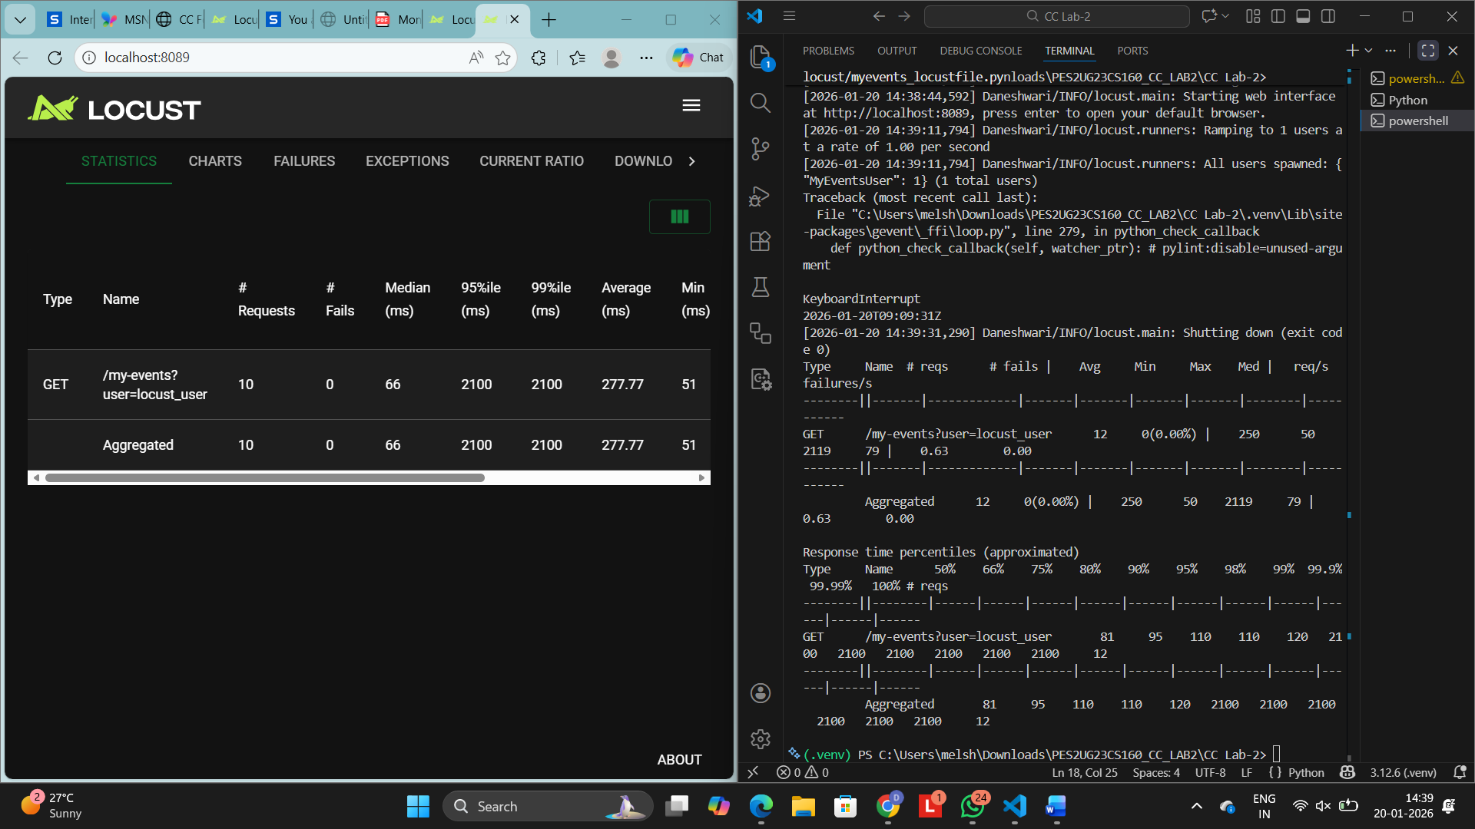
What was the bottleneck?
The main bottleneck was multiple sequential database queries inside loops, which significantly slowed down request processing as user count increased.
What change did you make?
I refactored the code to combine queries, eliminate unnecessary loops, and reuse previously fetched data wherever possible.
Why did the performance improve?
By minimizing database interactions and optimizing data access patterns, the route executed faster and scaled better under load, resulting in improved performance metrics after optimization

Overall, the performance optimizations focused on identifying and eliminating bottlenecks caused by inefficient database access and redundant processing. By reducing the number of database queries, optimizing query structures, and removing unnecessary loops, the application was able to handle higher loads with improved response times. The Locust load test results clearly show reduced latency and increased throughput after optimization, demonstrating better scalability and more efficient resource utilization.

