Environment Variable and Set-UID Lab
NAME:-DANESHWARI M
SRN:- PES2UG23CS160
SEECTION:- C
Task 1: Introduction to Environment Variables
TASK 1.1: Manipulating Environment Variables
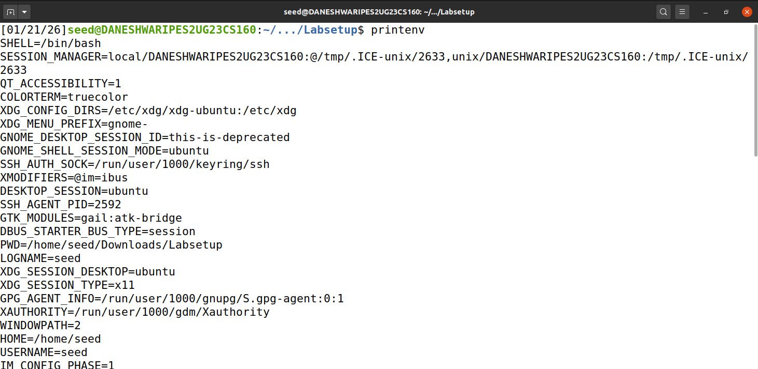
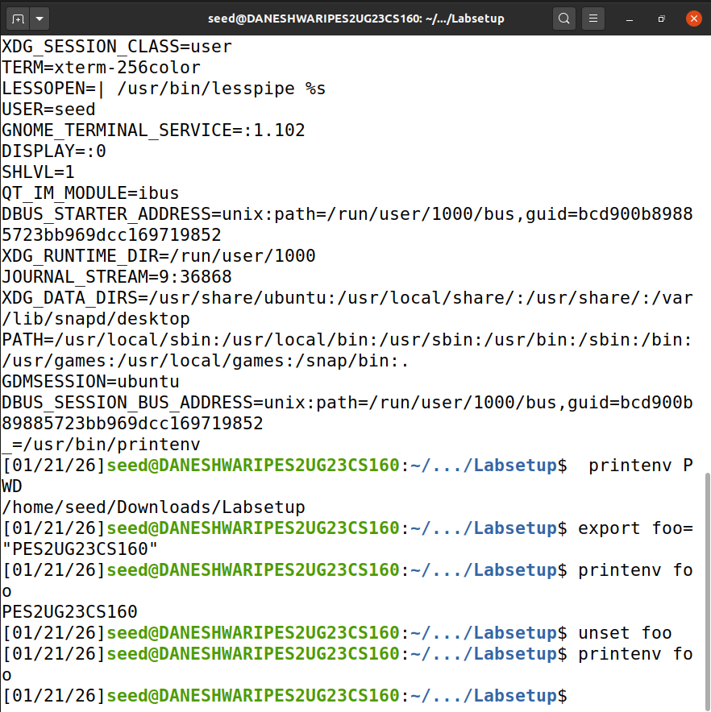
Environment variables store configuration values that affect program behavior.
Using export makes a variable available to child processes, while unset removes it.
The changes are immediately reflected when verified using the printenv command.
TASK 1.2: Passing Environment Variables from Parent Process to Child Process
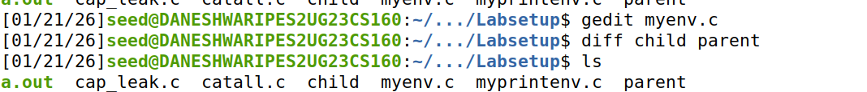
The child process created using fork() inherits all environment variables from its parent process.
This is observed because both the parent and child produce identical outputs when printing environment variables.
The diff command shows no difference, proving that environment variables are copied during process creation.
TASK 2: Environment Variables and its usage with functions
TASK 2.1: Environment Variables and execve()

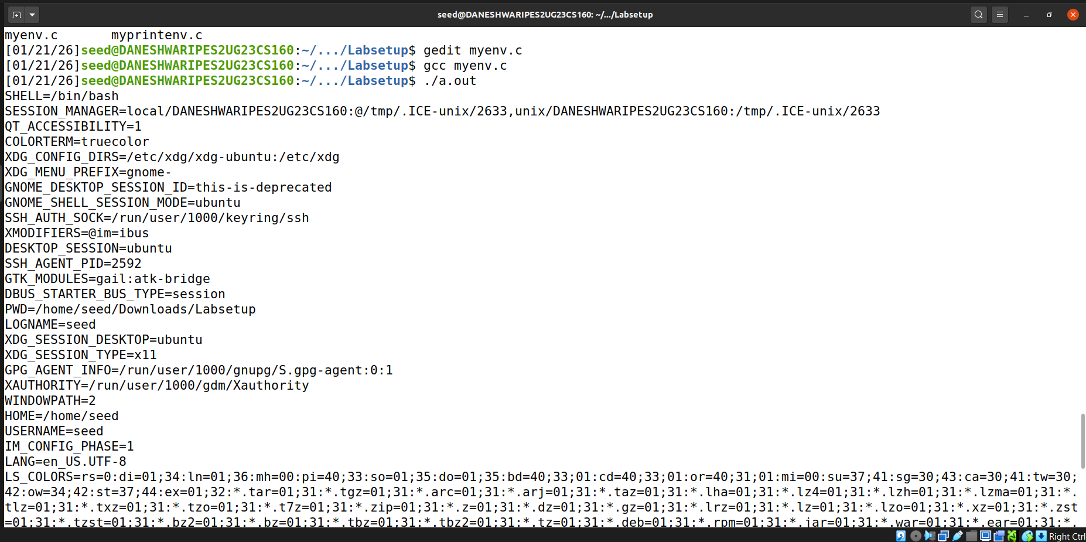
When execve() is invoked with a NULL environment pointer, the new program runs without environment variables.
Passing environ explicitly allows the new program to inherit the caller’s environment.
This shows that execve() does not automatically inherit environment variables.
Task 2.2: Environment Variables and system()
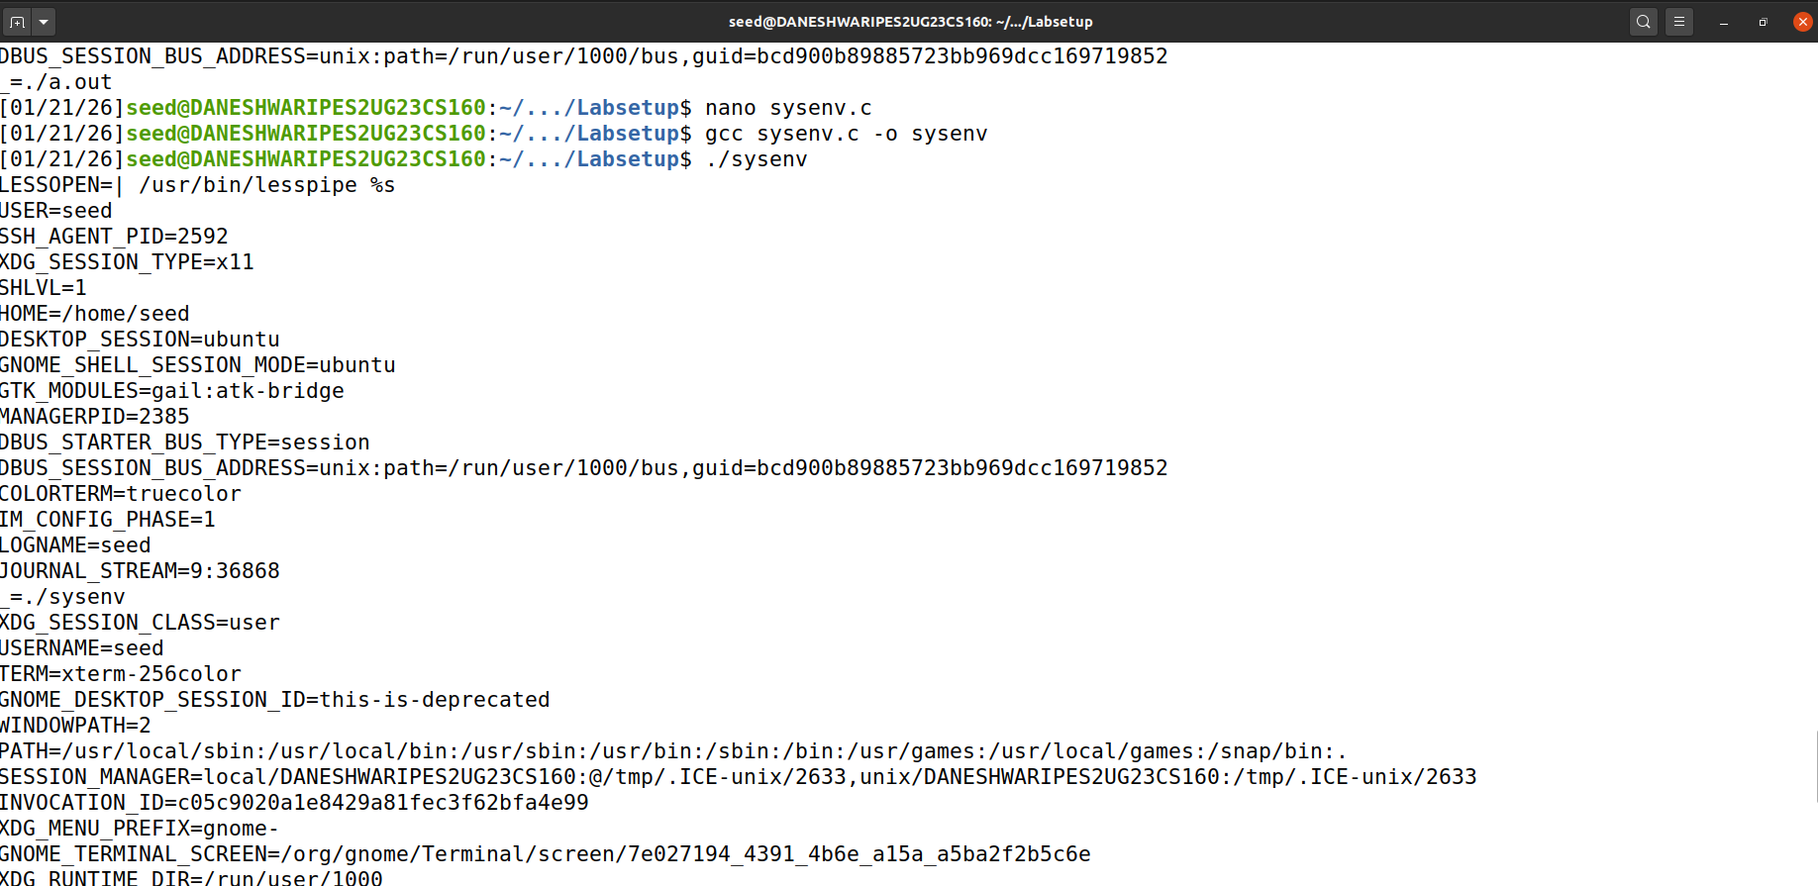
The system() function invokes a shell (/bin/sh) to execute commands.
The shell automatically receives the environment variables of the calling process.
Hence, programs executed via system() inherit environment variables by default.

Task 3: Environment Variables and Set-UID Programs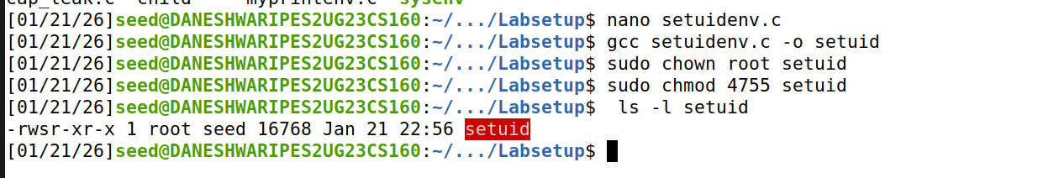

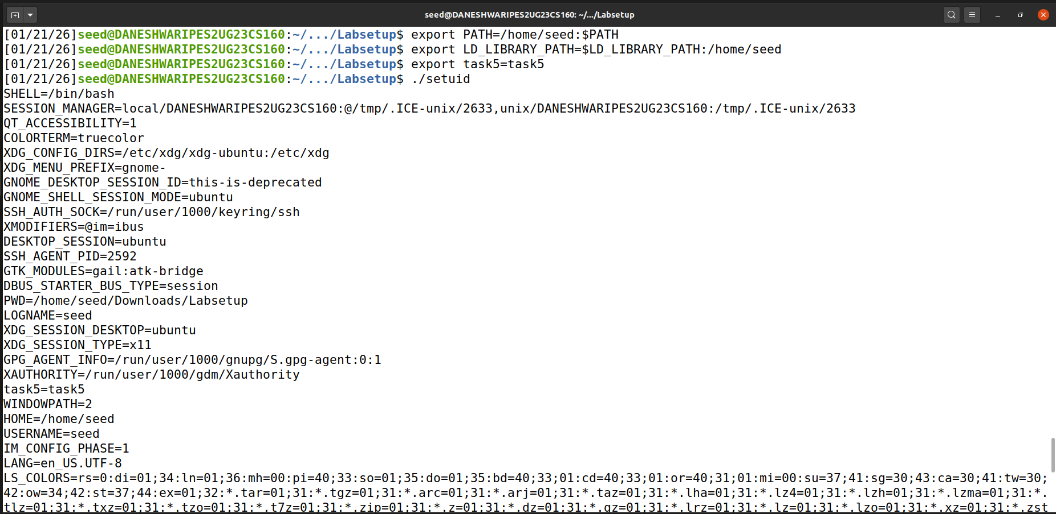
Set-UID programs execute with the file owner’s privileges rather than the user’s.
Most user-defined environment variables are inherited by the Set-UID process.
However, some sensitive variables are sanitized to prevent security risks.

Task 3.1: The PATH Environment Variable and Set-UID Programs 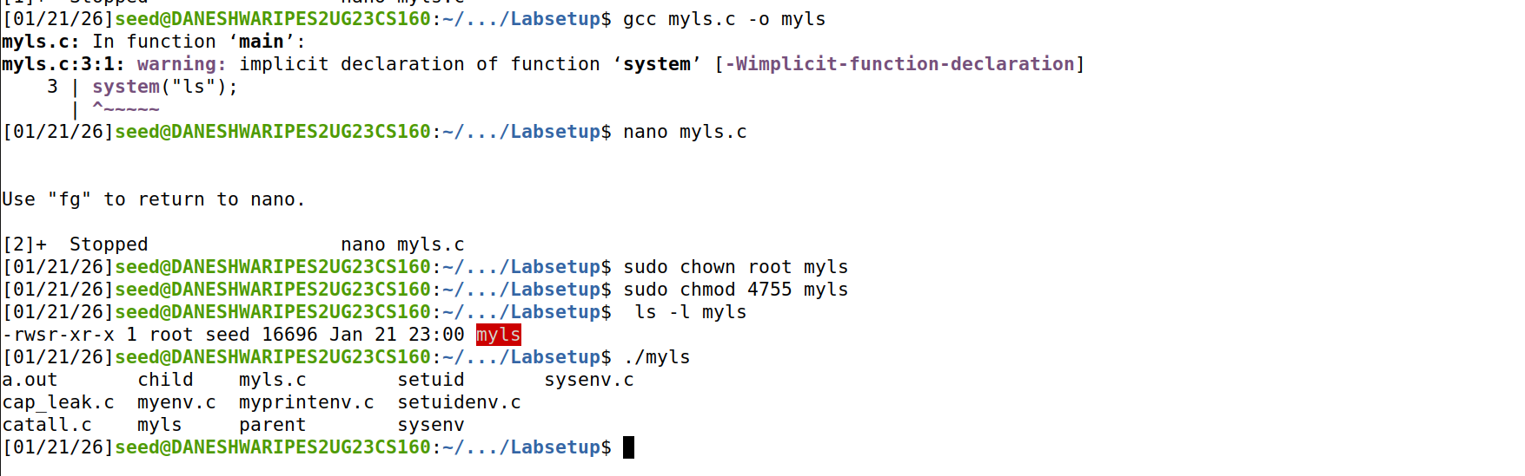
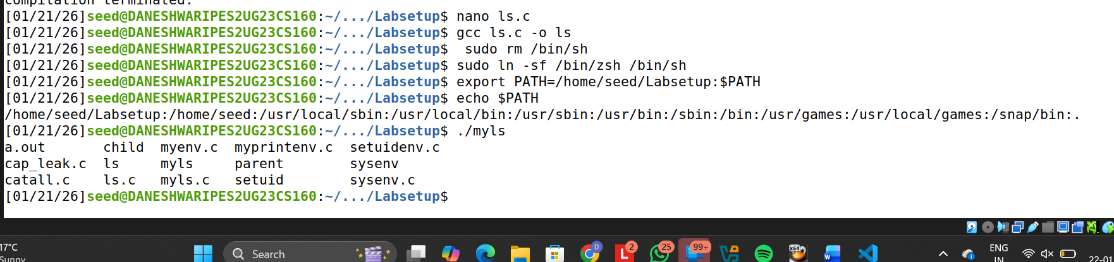
Using system() in a Set-UID program is dangerous because it relies on the PATH variable.
By modifying PATH, a user can force execution of a malicious program instead of a legitimate one.
This demonstrates how environment variables can be exploited for privilege escalation.

Task 3.2: The LD PRELOAD Environment Variable and Set-UID Programs
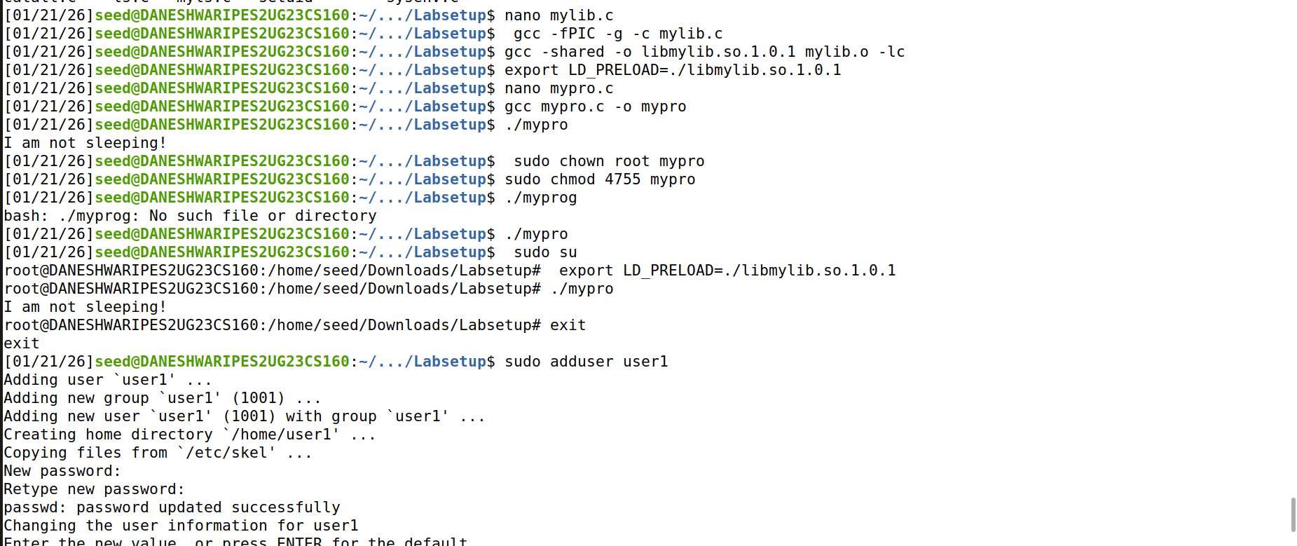
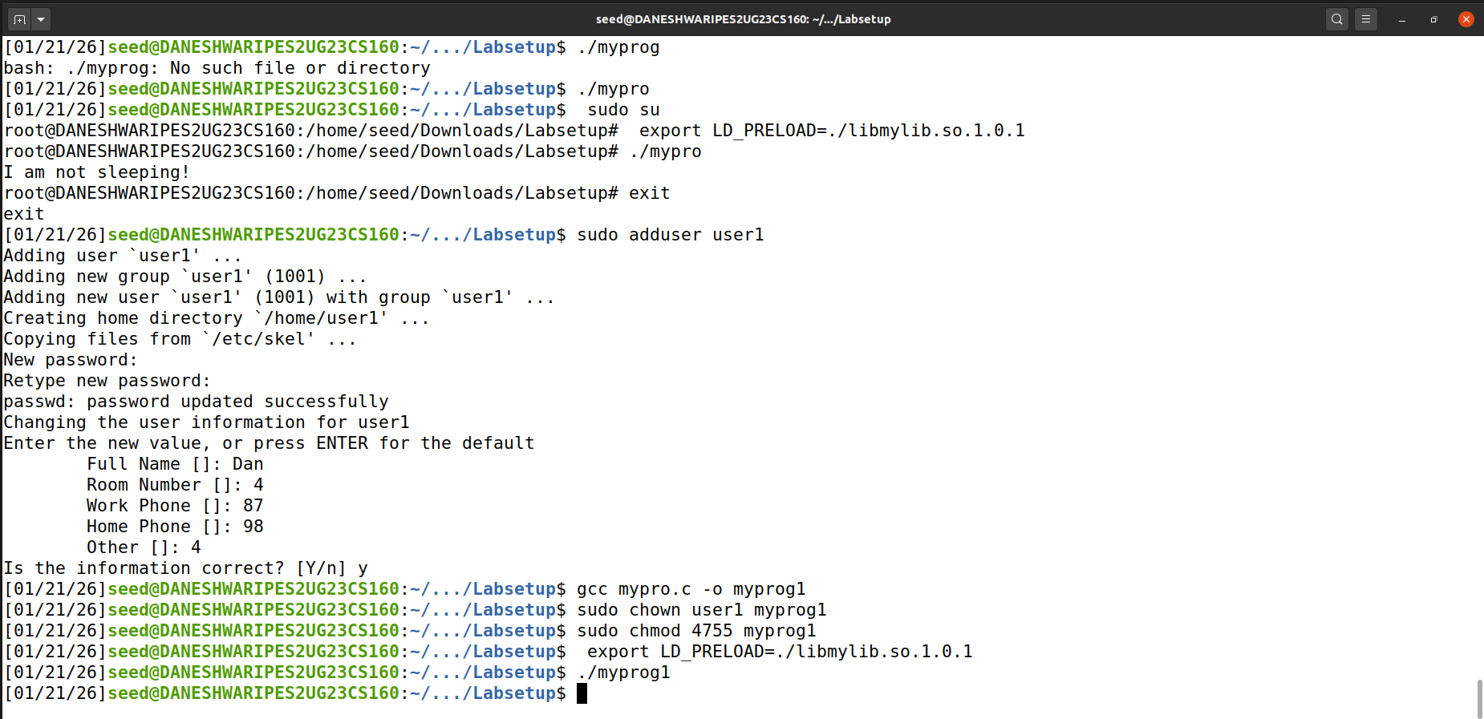
LD_PRELOAD allows users to load custom shared libraries before standard ones.
For Set-UID programs, the dynamic loader ignores LD_PRELOAD set by normal users.
This prevents attackers from injecting malicious libraries into privileged programs.
Task 4: Invoking External Programs Using system() versus execve() 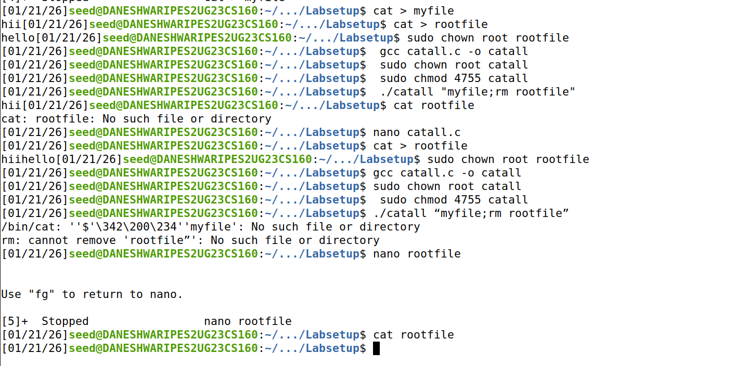
The system() function executes commands through a shell, allowing command injection attacks.
By passing crafted input, users can execute unintended commands with elevated privileges.
Using execve() prevents this attack since it does not invoke a shell.

Task 5: Capability Leaking 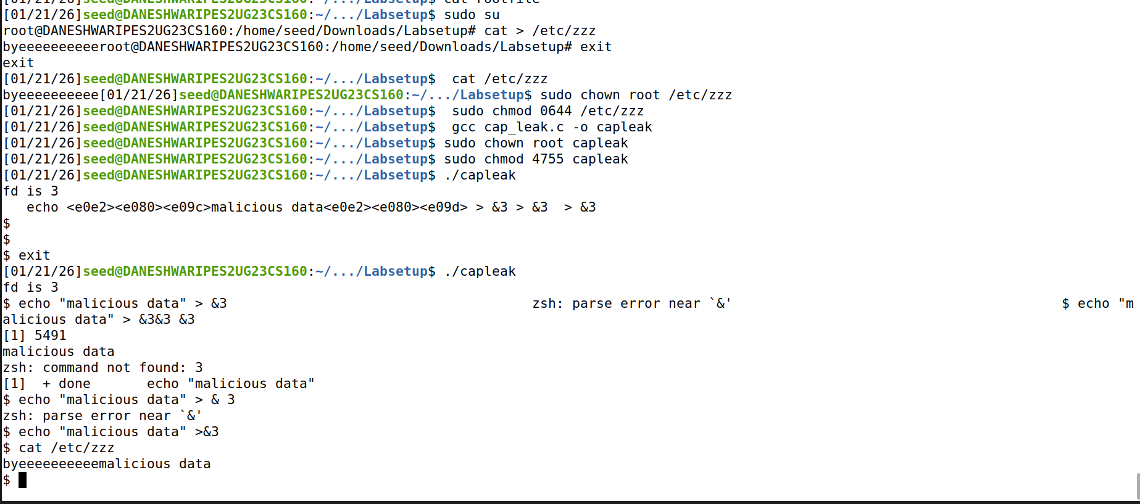
The Set-UID program opens a privileged file before dropping its root privileges.
Although privileges are revoked, the open file descriptor remains accessible.
This leaked capability allows unauthorized modification of protected files.

