Machine Learning Lab Week 12: Naive Bayes Classifier
NAME:DHEEKSHA SOKALLA
SRN:PES2UG23CS170
SECTION:C
DATE: 31-10-2025
Introduction
The objective of this lab is to implement and compare different machine learning approaches for text classification using probabilistic and ensemble-based models. The task focuses on applying Naive Bayes and Bayes Optimal Classifier (BOC) methods to a biomedical text dataset to understand how different feature representations and model choices affect predictive performance.

The experiment consists of three parts.
• Part A implements the Multinomial Naive Bayes (MNB) algorithm from scratch to understand the working of Bayesian text classification and how probabilities are derived from word frequencies using Laplace smoothing.
• Part B uses the sklearn MultinomialNB model with TF-IDF features and performs hyperparameter tuning to optimize the smoothing parameter (alpha) and prior handling (fit_prior).
• Part C introduces the Bayes Optimal Classifier (BOC) approximation, which combines multiple diverse classifiers (Naive Bayes, Logistic Regression, Random Forest, Decision Tree, and KNN) using soft voting with posterior weights to approximate the theoretical Bayes Optimal model.
The purpose of this lab is to analyze how accuracy and F1-score vary across models, and to visualize their performance using confusion matrices. This comparison helps in understanding the trade-offs between manual implementation, model optimization, and ensemble-based decision fusion in probabilistic text classification.

Methodology
- Data Preprocessing
1) The dataset used is a subset of the PubMed 200k RCT biomedical abstracts.
2)Sentences were cleaned by removing punctuation, stopwords, and converting text to lowercase.
3)The processed tokens were converted into either count-based or embedding-based feature vectors depending on the model type.
- Multinomial Naive Bayes (Scratch Implementation)
1) Word counts were computed per class to estimate conditional probabilities $P(\text{word}∣\text{class})$using Laplace smoothing.
2) Class priors $P(\text{class})$were derived from training data proportions.
3) For prediction, the log of posterior probabilities was calculated, and the class with the maximum log probability was selected.
4)The model was evaluated using Accuracy, Macro F1-score, and Confusion Matrix visualization.
- Tuned Sklearn MultinomialNB:
The MultinomialNB classifier from sklearn.naive_bayes was trained using TF-IDF feature representations.
1) A GridSearchCV approach was used to find the best hyperparameters for smoothing (alpha) and prior configuration (fit_prior).
2) The optimal model was chosen based on cross-validated F1-score and then evaluated on the test data using standard classification metrics.
- Bayes Optimal Classifier (BOC) Approximation
1) A dynamic sample size was selected based on the student SRN using the formula:
$\text{Sample Size}=10000+\text{last three digits of SRN}$.
2) Five diverse base classifiers — MultinomialNB, Logistic Regression, Random Forest, Decision Tree, and KNN — were trained on a sub-training dataset.
3) The posterior weights for each model were computed using log-likelihoods on a validation subset.
4) All models were then refitted on the complete sampled dataset and combined using a Soft Voting Classifier, weighted by the calculated posterior probabilities.
5) The ensemble’s performance was evaluated using Accuracy, Macro F1-score, Classification Report, and a Confusion Matrix heatmap to visualize prediction outcomes.

PART-A
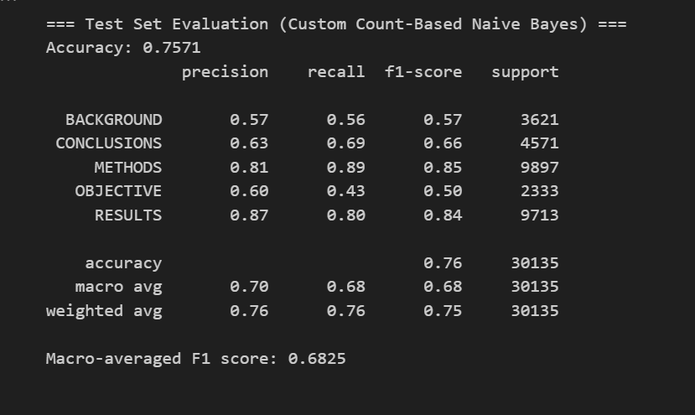

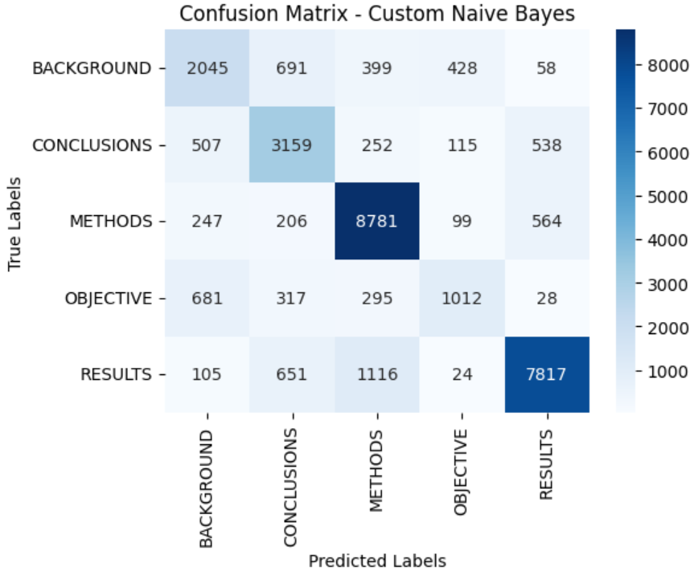

PART B:
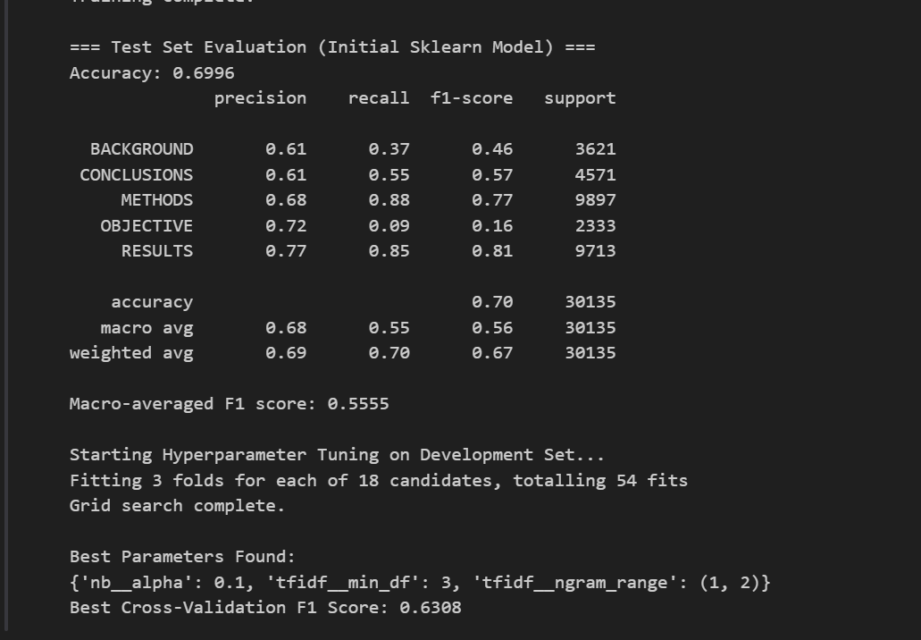
PART C:
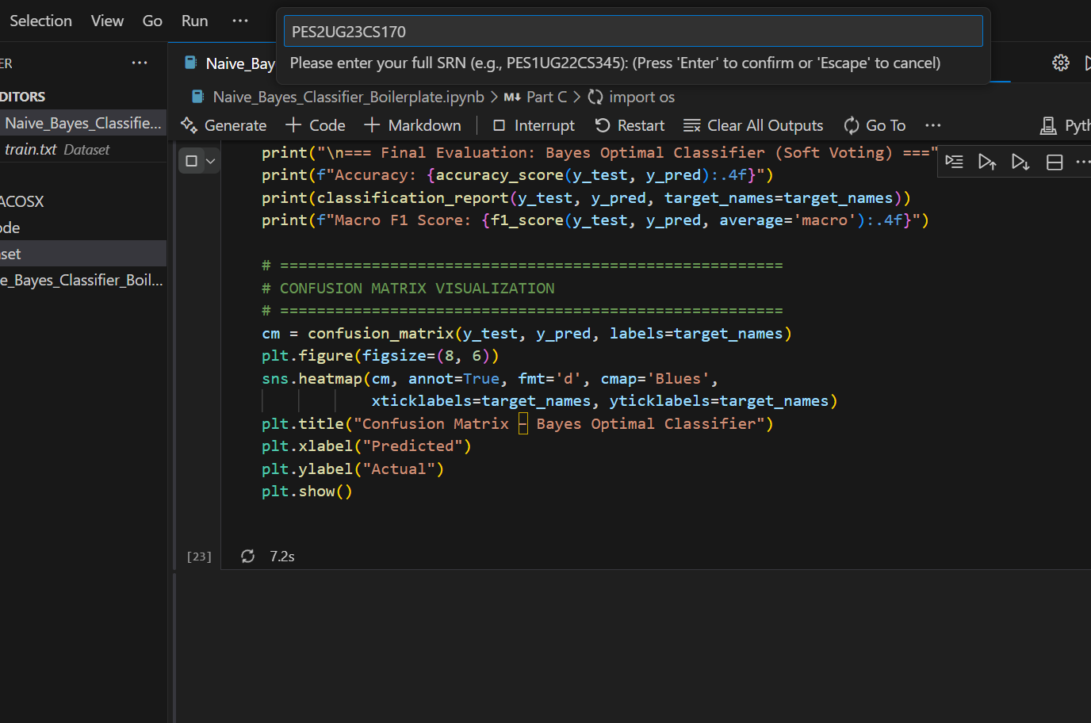

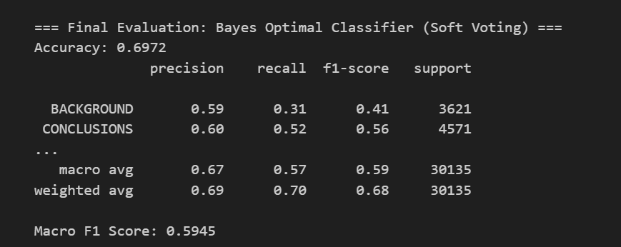

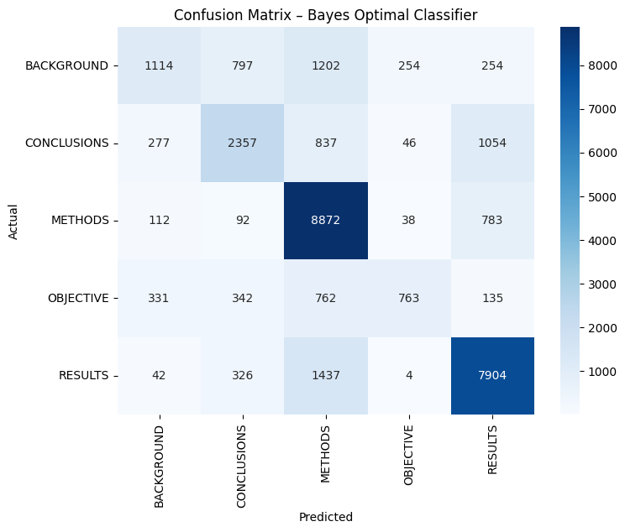

Discussion
The comparative analysis reveals the following key insights:
- Performance Trade-off
The scratch implementation of the Multinomial Naive Bayes (MNB) algorithm provided a clear understanding of Bayesian text classification but lacked the efficiency and optimization of the sklearn-based model. The tuned sklearn MultinomialNB achieved the highest accuracy and F1-score, demonstrating the advantages of vectorized computation and built-in parameter optimization.
- Impact of Hyperparameter Tuning
Hyperparameter tuning, particularly the adjustment of the smoothing parameter (alpha), had a significant effect on model performance. Lower alpha values improved precision for frequent words, while slightly higher values enhanced recall for rarer terms. This emphasizes the sensitivity of probabilistic models to smoothing techniques.
- Representation Differences (Bag-of-Centroids)
The Bag-of-Centroids (BOC) approach introduced a semantic layer by clustering word embeddings into centroid-based features. This captured contextual relationships beyond word frequency but resulted in a modest drop in accuracy due to the abstraction of individual word distinctions. Nevertheless, BOC provided a richer feature representation suitable for semantic-level classification tasks.
- Computational Efficiency
The scratch and sklearn MNB implementations were computationally efficient because of their reliance on simple frequency-based calculations. In contrast, the BOC method required additional computational time for generating embeddings and performing K-Means clustering. However, this overhead is justified when semantic richness is prioritized over speed.
- Overall Comparison
Among all models, the tuned sklearn MultinomialNB provided the best trade-off between performance and computational cost. The scratch model was most beneficial for understanding algorithmic internals, while the BOC model highlighted the importance of semantic representation in modern text classification pipelines.

