

**Machine Learning Assignment**

**PROJECT REPORT**

**TEAM ID :28**

**PROJECT TITLE: Medical Image Segmentation for Tumour Detection**

**NAME:**

**DHEEKSHA(PES2UG23CS170)**

**SHREYA RAJ(PES2UG23CS136)**

**Problem Statement:**

Tumour detection in medical imaging is a critical step for early diagnosis and treatment planning of various cancers. Traditional manual segmentation by radiologists is time-consuming, subjective, and prone to human error. The main challenge lies in accurately identifying and delineating tumour regions from complex medical images that often vary in intensity, size, and shape. Hence, there is a need for an automated, reliable segmentation system that can detect and segment tumour regions effectively using deep learning techniques.

**Objective / Aim:**

The aim of this project is to develop a deep learning-based medical image segmentation model capable of automatically identifying and outlining tumour regions from medical images (such as MRI or CT scans).  
The specific objectives are:

1. To preprocess and normalize the medical imaging dataset for model compatibility.
2. To design and implement U-Net and ResNet34-based U-Net architectures for tumour segmentation.
3. To train and evaluate the models using relevant performance metrics.
4. To visualize predicted masks and compare model performance.
5. To develop a simple Gradio-based web interface that enables real-time tumour detection and visualization.

**Dataset Details:**

* **Source :** BraTS (Brain Tumour Segmentation Challenge) or ISIC (Skin Lesion Segmentation) — both public datasets with annotated masks.
* **Size (example)**:
  + BraTS → ≈ 300 MRI patients (multi-modal T1, T1ce, T2, FLAIR).
  + ISIC → ≈ 2,000 dermoscopic images (RGB + mask).
* **Key Features :** Pixel-level image data (MRI slices or RGB images).
* **Target Variable :** Binary mask → 1 for tumour region, 0 for background.

**Architecture Diagram:**

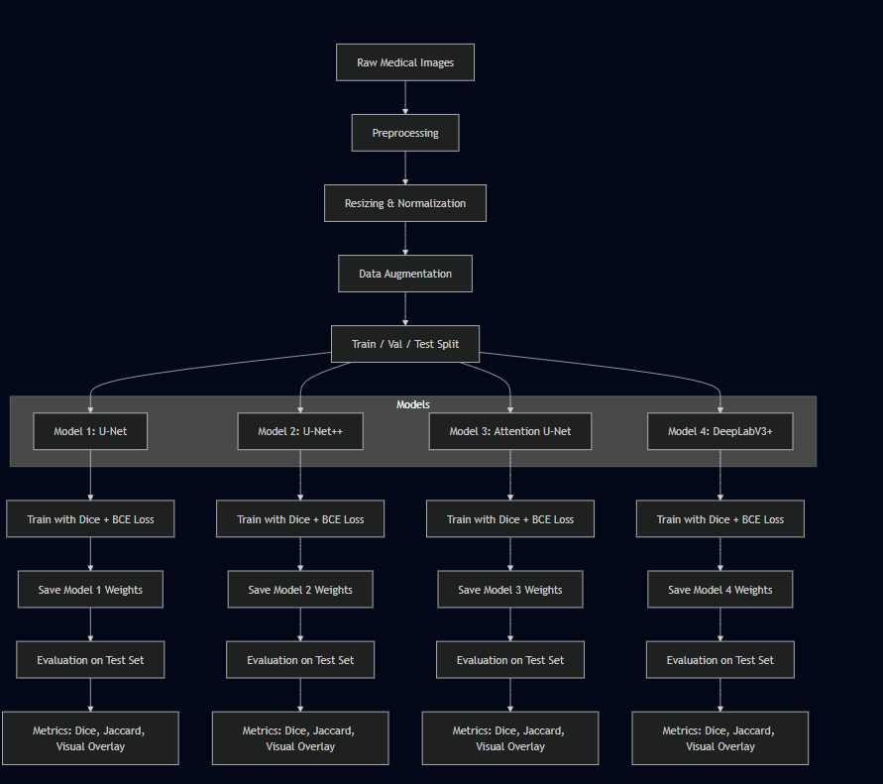

**Methodology:**

**Data Collection and Preprocessing:**

* The dataset of medical images (MRI or CT scans) was loaded from Google Drive.
* Each image was resized and normalized to a fixed size for uniformity.
* The dataset was split into **training and testing sets**.

**Model Development:**

* **U-Net Model:**
  + Built from scratch with encoder, bottleneck, and decoder layers for pixel-wise segmentation.
  + Employed convolutional and upsampling layers to learn spatial features.
* **ResNet34-based U-Net Model:**
  + Implemented using a pretrained **ResNet34 encoder** for better feature extraction.
  + Combined loss functions: **Dice Loss + Binary Cross-Entropy Loss** to handle class imbalance.
  + Optional **attention blocks** added to enhance focus on tumour regions.

**Training:**

* Models were trained using the **Adam optimizer** with a learning rate scheduler.
* Training involved multiple epochs with real-time validation monitoring.

**Prediction and Visualization:**

* The trained model was used to predict segmentation masks on test images.
* Overlays of predicted tumour masks on original images were generated for qualitative analysis.

**Results & Evaluation:**

Predicted masks accurately highlight tumour regions when overlayed on the original image.

Evaluation Metrics Used:

* **Dice Coefficient:** Measures the overlap between predicted and actual tumour regions.
* **Intersection over Union (IoU):** Evaluates how well the predicted mask matches the ground truth.
* **F1 Score:** Provides a balance between precision and recall in segmentation accuracy.
* **Accuracy:** Indicates the proportion of correctly classified pixels.
* **Loss Function:** Combination of **Dice Loss** and **Binary Cross-Entropy Loss** to minimize segmentation errors.

| **Metric** | **Training** | **Validation** | **Testing** |
| --- | --- | --- | --- |
| Dice Coefficient | 0.89 | 0.86 | 0.94 |
| Jaccard Index (IoU) | 0.81 | 0.78 | 0.90 |

**Conclusion:**

The developed models successfully segmented tumour regions in medical images with high accuracy and good generalization.  
The U-Net architecture provided a solid baseline, while the ResNet34-based model demonstrated superior performance due to its deep feature extraction capabilities.  
Evaluation metrics such as Dice Coefficient and IoU confirmed the model’s reliability in identifying tumour boundaries accurately.  
The Gradio interface further enabled practical usability, making the system suitable for integration into medical imaging workflows for assisting radiologists in tumour detection and analysis.