Matplotlib (Plotting Library)
AIM:
To create and visualize a dataset containing study hours and exam scores using Scatter Plot, Line Plot, Histogram, and Bar Chart with Python Matplotlib.
ALGORITHM:
- Import the Pandas, NumPy, and Matplotlib libraries.
- Create a dataset containing StudyHours and ExamScore values.
- Convert the dataset into a Pandas DataFrame.
- Create a Scatter Plot to show the relationship between study hours and exam scores.
- Create a Line Plot to display the progress of exam scores with increasing study hours.
- Create a Histogram to represent the distribution of exam scores using two bins.
- Create a Bar Chart to compare study hours and exam scores.
- Add appropriate labels and titles to each graph.
- Display all four graphs using plt.show().
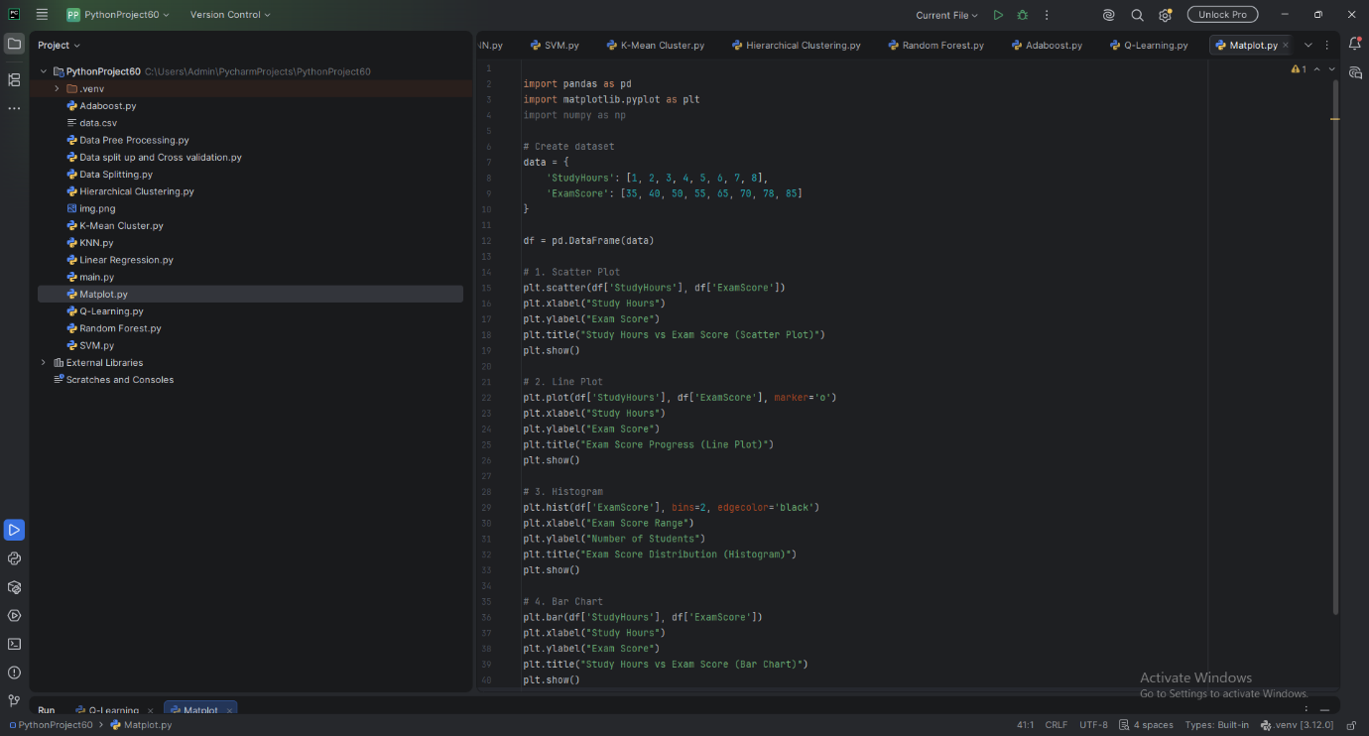
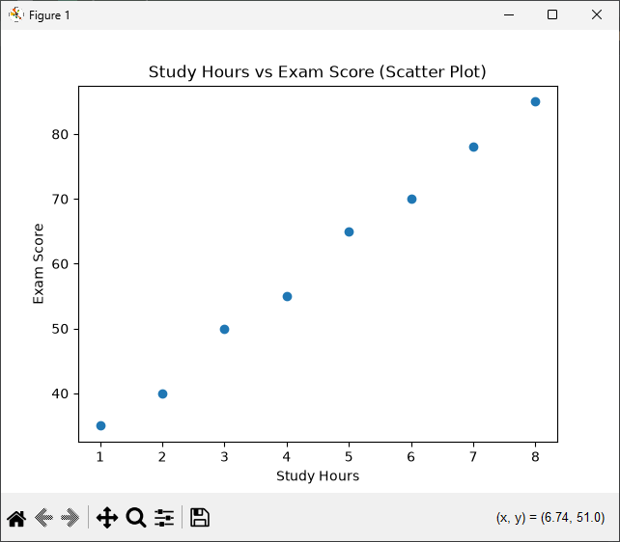
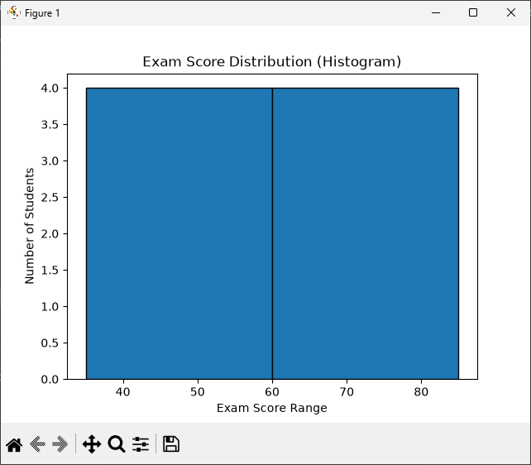
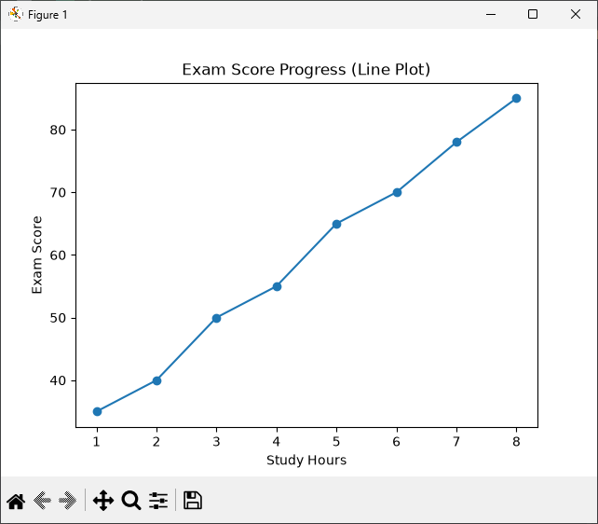
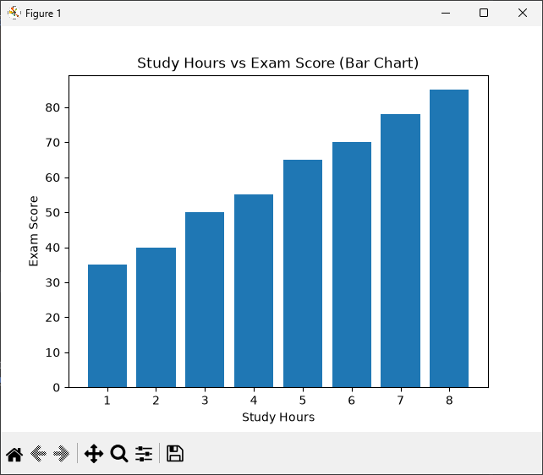

RESULT:
The dataset was successfully created and visualized using Matplotlib. Scatter Plot, Line Plot, Histogram, and Bar Chart were generated to represent the relationship between study hours and exam scores, score progression, and score distribution.

