OUTPUT EXAMPLE

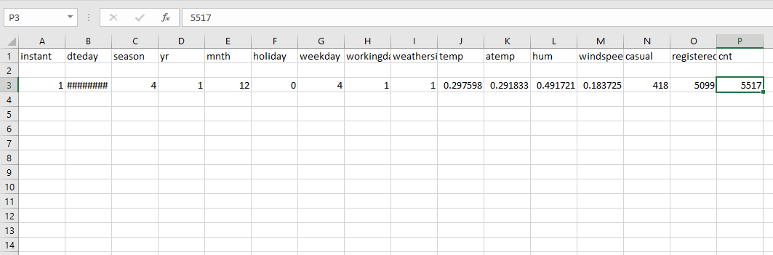

Season: 4

Year: 1

Month: 12

Holiday: 0

Weekday: 4

Working Day: 1

Weather: 1

Temp: 0.297598

Atemp: 0.291833

Humidity: 0.491721

Wind speed: 0.183725

Casual: 418

Registered: 5099

Count: 5517