 | Online Blood Bank System  Technical Design Document
 | Prepared By / Last Updated By | Reviewed By | Approved By
Name
Role
Signature
Date

Table of Contents

1.0 Introduction 3
1.1 Purpose of this document 3
1.2 Project overview 3
2.0 Solution Summary 3
2.1 Scope 3
2.2 Assumptions 3
2.3 Dependencies 3
2.4 Risks 3
3.0 Schematic Diagram 3
4.0 System Design 4
4.1 Proposed design 4
4.2 Component inventory 4
5.0 Database Design 4
5.1 Data Model 4
5.2 Tables Structure 4
6.0 Appendices 4
6.1 Glossary 4
6.2 Other 5
7.0 Terms & Conditions 5
8.0 Change Log 5

Introduction

Purpose of this document
This document is aimed at:
- Providing the necessary inputs to the detailed requirements gathering phase and further on for the SDLC processes.
- This document also serves to establish the traceability between the Business Objectives and the requirements identified in the proposed solution and how they satisfy the stated objectives.
- Provide expectation traceability in terms of the requirements and the user expectation
- Serves as a formal template for documenting the Business Requirements which also includes statutory and regulatory requirements.
The purpose of this document is to systematically capture requirements for the project and the system to be developed. Functional requirements are captured in this document. It also serves as the input for the project scoping.

Project overview

Objectives
Below are the objectives that shall be fulfilled post the execution of this project:
- User registration & credential authentication
- Posting of blood requirement by any registered user
- Fetching donor information and blood availability information according to a user’s need.

Solution Summary

Scope
Online Blood Bank System has the ability to register many users and makes easier to find the blood donors and give information about the blood bank.
- User registration & credential authentication
- Posting of blood requirement by any registered user
- Fetching donor information and blood availability information according to the user’s requirement.
- Also displaying the posted blood group requirements for a user.

Assumptions
The Online blood bank system helps each person, who is need of blood at the right time, by posting the blood requirements for a particular blood group, which will be displayed in the homepage, where a normal site viewer can show interest to donate blood. The main aim of this project is to maintain the complete information of the donors, with different blood groups available at each blood bank of a particular area and to provide a sophisticated platform for their need.

Dependencies
- MS SQL Server 2014 is needed for database operations.
- Without IIS server the application will not run.
- Without Visual Studio 2015 software, we will not be able to run the application.

Risks
As we are using HTTP Session objects, the data is transferred using http, which is less secured than https, so there is a possibility of data corruption.

Schematic Diagram
Home Page

Logout
Registration/Login Page
Donation of blood after filling in required details
Checking availability of
blood of a particular type
Posting of blood requirement in case blood is not available
Sharing experience of donating blood

System Design

Proposed design

Home Page

Logout
Registration/Login Page
Donation of blood after filling in required details
Checking availability of
blood of a particular type
Posting of blood requirement in case blood is not available
Sharing experience of donating blood

Component inventory
- MODEL Classes
User.cs
Feedback.cs
Hospital.cs
BloodPosting.cs
BloodAvailability.cs
RaiseQuery.cs

- DAO Classes
BloodInterface.cs
BloodBL.cs
UserInterface.cs
UserBL.cs
ConnectionHandler.cs
Constants.cs
Queries.cs

- UI Components
AdminHomePage.aspx
BloodAvailability.aspx
BloodRequirementPosting.aspx
DonateBlood_and_BookHospital.aspx
FAQ.aspx
Feedback.aspx
HomePage.aspx
TipsOnDonating.aspx
UserLogin.aspx
UserNotifications.aspx
UserRegistration.aspx
WhyBloodDonation.aspx

Database Design

Data Model

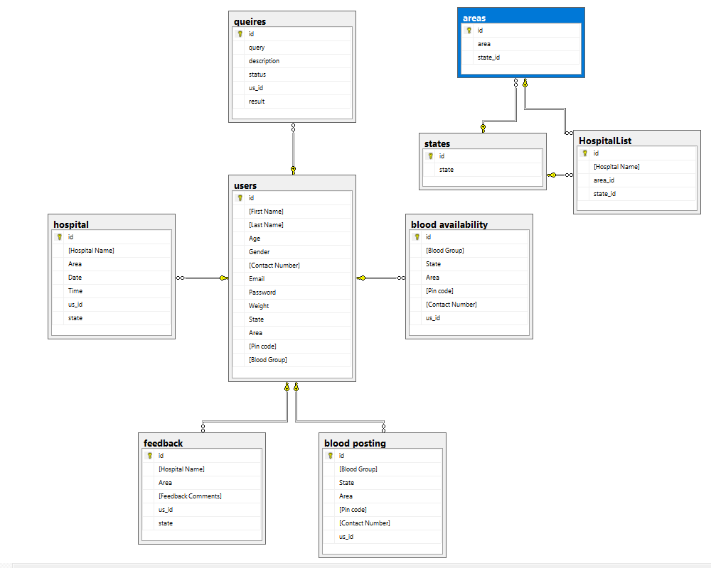

Tables Structure

Table 1.0

Field Name | Field Type | Data Type | Mandatory | Possible Values
First Name | Text(50) | Alphabetic | Yes
Last Name | Text(50) | Alphabetic | Yes
Age | Numeric(2) | Numeric | Yes
Gender | Drop Down | NA |  | Male, Female
Contact Number | Text(10) | Numeric | Yes
Email | Text(15) | Email | Yes
Password | Text(15) | Alphanumeric | Yes
Weight | Numeric(3) | Numeric | Yes
State | Drop Down | NA | Yes
Area | Drop Down | NA | Yes
Pin code | Numeric(6) | Numeric | Yes
Blood Group | Drop Down | NA | Yes | All possible blood groups

Table 2.0

Field Name | Field Type | Data Type | Mandatory | Possible Values
Blood Group | Drop Down | NA | Yes | All possible blood groups
State | Drop Down | NA | Yes
Area | Drop Down | NA | Yes
Pin code | Numeric(6) | Numeric | Yes
Contact Number | Text(10) | Numeric | Yes

Table 3.0

Field Name | Field Type | Data Type | Mandatory | Possible Values
Blood Group | Drop Down | NA | Yes | All possible blood groups
State | Drop Down | NA | Yes
Area | Drop Down | NA | Yes
Pin code | Numeric(6) | Numeric | Yes
Contact Number | Text(10) | Numeric | Yes

Table 4.0

Field Name | Field Type | Data Type | Mandatory | Possible Values
Hospital Name | Text(15) | Alphabetic | Yes
City | Text(15) | Alphabetic | Yes
Date | Drop Down | NA | Yes
Time | Drop Down | NA | Yes

Table 5.0

Field Name | Field Type | Data Type | Mandatory | Possible Values
Hospital Name | Text(15) | Alphabetic | Yes
City | Text(15) | Alphabetic | Yes
Feedback Comments | Text(500) | Alphabetic | Yes

Table 6.0

Field Name | Field Type | Data Type | Mandatory | Possible Values
State | Text(50) | Alphabetic | Yes

Table 7.0

Field Name | Field Type | Data Type | Mandatory | Possible Values
Area | Text(50) | Alphabetic | Yes

Table 8.0

Field Name | Field Type | Data Type | Mandatory | Possible Values
Hospital Name | Text(15) | Alphabetic | Yes

Appendices

Glossary
Acronyms | Definitions

Other

Terms & Conditions
Interns shall be solely responsible for all its acts and omissions under this program. Interns will comply at all times with all applicable laws. Interns shall not use Cognizant’s name, logo and trademark in any promotional materials or other communications with third parties without the prior written consent of Cognizant. Any materials used by interns in relation to program will not infringe the copyrights, trademarks, patents, trade secrets or other intellectual property rights, privacy or similar rights of any person or entity. Interns agrees not to post, draw, make, display any content that is threatening, libelous, obscene, defamatory, abusive, pornographic, or advocates/encourages any conduct that could constitute a criminal offence or give rise to any civil liability. Cognizant its associates’ personal details including but not limited to name, address, contact number shall not be shared or forwarded to any third party, without prior written consent of Cognizant, its associates. All intellectual property provided by Cognizant, as part of program shall be owned exclusively by Cognizant. Intern shall indemnify, defend and indemnify Cognizant its associates, officers, directors from and against any claims, demands, loss, damage, liability, causes of action, judgments, or costs and expenses of every nature (including attorney’s fees and expenses) incurred by Cognizant based on any claim that any breach of terms and conditions of this program

Change Log
Please note that this table needs to be maintained even if a Configuration Management tool is used.
Version Number | Changes made
V<n.n> | <If the change details are not explicitly documented in the table below, reference should be provided here>
V<n.n> | Page no | Changed by | Effective date | Changes effected

