**Online blood bank system**

**Project Abstract**

**Version 1.0**

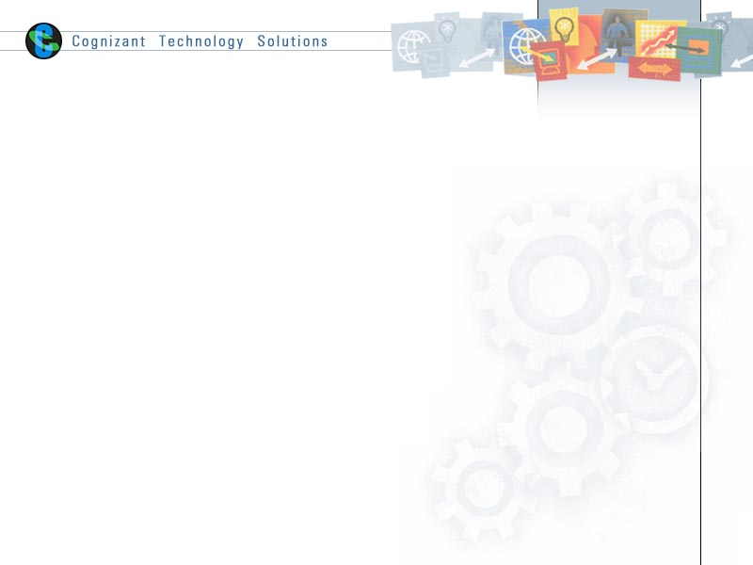

|  |  |  |  |
| --- | --- | --- | --- |
|  | Prepared By / Last Updated By | Reviewed by | Approved By |
| Name | Cognizant Academy |  |  |
| Role |  |  |  |
| Signature |  |  |  |
| Date |  |  |  |

Table of Contents

1.0 Purpose of this document 4

2.0 Business Case 4

3.0 Technologies Recommended 4

4.0 Hardware and Software Requirements 4

5.0 Terms and conditions 5

6.0 References 5

7.0 Change Log 5

# Purpose of this document

This document provides an overview about the business need and the solution that can be provided to fulfil the objective.

# Business Case

For any Healthcare Facility, it is very important to have the real-time updates of the Donors and stock availability and blood requirement. There have been repeated instances of issues reported in managing the donors’, recipients, Hospitals and camp records.

A Solution to track, manage the donors and the related information is critical to address the needs of the patients in any Healthcare facility.

Online blood bank system will bring a relief to most of the healthcare facilities by providing online application which will be easily accessible by any of the Donors, Doctors and Recipients at any time. With this application the Donors, Doctors and Recipients can search for Donors, Blood availability and blood requirement. They can also share their experience of donating blood to motivate Donors.

# Technologies Recommended

|  |  |
| --- | --- |
| Front End | Java (HTML5, CSS3, JavaScript, Angular) |
| Middleware | Java (Spring, Spring MVC, Hibernate MVC , WEB API2) |
| Backend | Oracle/SQL Server |

# Hardware and Software Requirements

|  |  |  |
| --- | --- | --- |
| Technology | Hardware | Software |
| Java | Desktop PC with 8GB RAM | 1. Node.js 10.15.1 2. Angular 5.0 3. Visual Studio Code 1.30 4. Eclipse IDE for Java EE Developers (Oxygen) 5. Maven 3.6.0 6. Tomcat 9 7. MySQL Community Server 8.0 8. MySQL Workbench 8.0.14 9. Putty 10. WinSCP 5.9.4 11. Oracle 11g express version |

# Terms and conditions

Interns shall be solely responsible for all its acts and omissions under this program. Interns will comply at all times with all applicable laws. Interns shall not use Cognizant’s name, logo and trademark in any promotional materials or other communications with third parties without the prior written consent of Cognizant. Any materials used by interns in relation to program will not infringe the copyrights, trademarks, patents, trade secrets or other intellectual property rights, privacy or similar rights of any person or entity. Interns agrees not to post, draw, make, display any content that is threatening, libelous, obscene, defamatory, abusive, pornographic, or advocates/encourages any conduct that could constitute a criminal offence or give rise to any civil liability. Cognizant its associates’ personal details including but not limited to name, address, contact number shall not be shared or forwarded to any third party, without prior written consent of Cognizant, its associates. All intellectual property provided by Cognizant as part of program shall be owned exclusively by Cognizant. Intern shall indemnify, defend and indemnify Cognizant its associates, officers, directors from and against any claims, demands, loss, damage, liability, causes of action, judgments, or costs and expenses of every nature (including attorney’s fees and expenses) incurred by Cognizant based on any claim that any breach of terms and conditions of this program.

# References

# Change Log