PES UNIVERSITY, BANGALORE
Department of Computer Science and Engineering

Software Requirements
Specification
for
Book E-Commerce Platform
Version 1.0 approved
PES University, Department of Computer Science and Engineering
09 September 2026

Table of Contents
Revision History
1. Introduction
1.1 Purpose
1.2 Intended Audience and Reading Suggestions
1.3 Product Scope
1.4 References
2. Overall Description
2.1 Product Perspective
2.2 Product Functions
2.3 User Classes and Characteristics
2.4 Operating Environment
2.5 Design and Implementation Constraints
2.6 Assumptions and Dependencies
3. External Interface Requirements
3.1 User Interfaces
3.2 Software Interfaces
3.3 Communications Interfaces
4. Analysis Models
5. System Features
5.1 User Registration and Authentication
5.2 Book Discovery and Catalog Management
5.3 Shopping Cart and Checkout
5.4 Order and Payment Management
5.5 Reviews and Ratings
5.6 Administrator Management
6. Other Nonfunctional Requirements
6.1 Performance Requirements
6.2 Safety Requirements
6.3 Security Requirements
6.4 Software Quality Attributes
6.5 Business Rules
7. Other Requirements
Appendix A: Glossary
Appendix B: Field Layouts
Appendix C: Requirement Traceability Matrix

Revision History
Name | Date | Reason For Changes | Version
Nidhi R  Prajwal | 09-09-2026 | Initial SRS prepared for the book e-commerce platform | 1.0

1. Introduction

1.1 Purpose
This Software Requirements Specification (SRS) defines the requirements for a web-based Book E-Commerce Platform, Version 1.0. The system supports buying and selling books online through customer, seller, and administrator functions. It covers account management, book discovery, shopping cart and checkout, order processing, payment status, seller listings, reviews, and administrative management.

1.2 Intended Audience and Reading Suggestions
This document is intended for the project manager, developers, testers, designers, documentation team, faculty evaluator, customers, sellers, and administrators. Section 1 introduces the system and scope. Section 2 describes the overall product and operating environment. Section 3 defines external interfaces. Section 4 identifies analysis models. Section 5 specifies system features and functional requirements. Section 6 defines nonfunctional requirements, while the appendices provide the glossary, field layouts, reports, and traceability matrix.

1.3 Product Scope
The product is a web-based marketplace for buying and selling books. Customers can discover books, view details, add books to a cart, place orders, make payments, and track orders. Sellers can manage book listings and received orders. Administrators can manage users, sellers, books, categories, and orders. The goals are convenience, accurate catalog and inventory information, secure transactions, and a simple user experience.

1.4 References
1. PES University, Department of Computer Science and Engineering, Software Requirements Specification Template, Version 1.0.
2. Course project topic: “An e-commerce platform for buying and selling books online.”
3. Course technology options: JavaScript (MERN Stack) / Python (Django).

2. Overall Description

2.1 Product Perspective
The Book E-Commerce Platform is a new, self-contained web application. It uses a client-server architecture consisting of a web front end, backend application services, and a database. Customers, sellers, and administrators interact with the application according to their roles. External payment or notification services may be integrated when required.

2.2 Product Functions
• Customer registration, login, logout, and profile management.
• Search, browse, filter, and view book details.
• Shopping cart management and checkout.
• Order placement, payment processing/status, and order tracking.
• Seller registration/login and book listing management.
• Seller inventory and received-order management.
• Ratings and reviews for purchased books.
• Administrator management of users, sellers, books, categories, and orders.

2.3 User Classes and Characteristics
Customer: Purchases books and uses search, catalog, cart, checkout, orders, and reviews.
Seller: Lists and manages books, prices, availability, inventory, and received orders.
Administrator: Has privileged access to manage users, sellers, books, categories, and orders.
Project Team: Develops, tests, documents, and maintains the academic prototype.

2.4 Operating Environment
The system will operate as a web application accessible through modern browsers such as Google Chrome, Microsoft Edge, and Mozilla Firefox. Development can be performed on Windows or Linux. The planned implementation uses the MERN stack: React for the front end, Node.js and Express.js for the backend, and MongoDB for persistent storage.

2.5 Design and Implementation Constraints
The project is constrained by the course technology options; this SRS assumes MERN is selected. The system shall use a client-server architecture, role-based access control, standard web protocols, and secure coding practices. The database shall support users, sellers, books, categories, carts, orders, order items, payments, and reviews. The implementation must remain feasible for a student mini-project.

2.6 Assumptions and Dependencies
Users are assumed to have internet access and a supported browser. Sellers are assumed to provide valid book and inventory information. Payment may use a suitable payment gateway or an academic simulation. Dependencies include the chosen database, browser, development/deployment environment, and any payment or email service integrated into the implementation.

3. External Interface Requirements

3.1 User Interfaces
The interface shall provide separate views for customers, sellers, and administrators. Common elements include navigation, search, forms, buttons, validation messages, confirmation messages, and error messages. Customer screens include registration, login, catalog, book details, cart, checkout, orders, and reviews. Seller screens include seller login, dashboard, book management, inventory, and order management. Administrator screens include dashboard and management pages. Mandatory fields shall be validated before submission.

3.2 Software Interfaces
The front end shall communicate with the backend through REST-style APIs. The backend shall communicate with MongoDB for persistent storage. Data exchanged includes user information, book information, cart items, order details, payment status, seller listings, and reviews. Role-based authorization shall restrict access to protected APIs.

3.3 Communications Interfaces
The application shall use HTTP/HTTPS for client-server communication. HTTPS should be used during deployment to protect credentials and transaction-related data. JSON shall be used for API requests and responses. If email notifications are implemented, the backend may communicate with an email service through its supported API.

4. Analysis Models
The project shall include a Use Case Diagram showing interactions among Customer, Seller, and Administrator actors. It shall also include an Entity-Relationship/Data Model covering User, Seller, Book, Category, Cart, Order, Order Item, Payment, and Review entities. These diagrams should be maintained in the project’s Diagrams folder.
Figure 1: Use Case Diagram

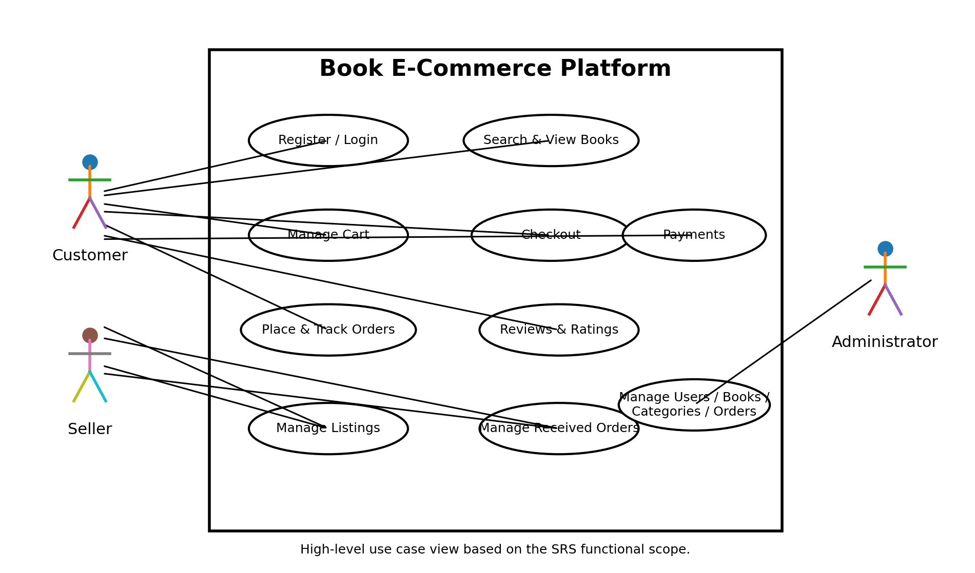
Figure 2: Entity-Relationship / Data Model
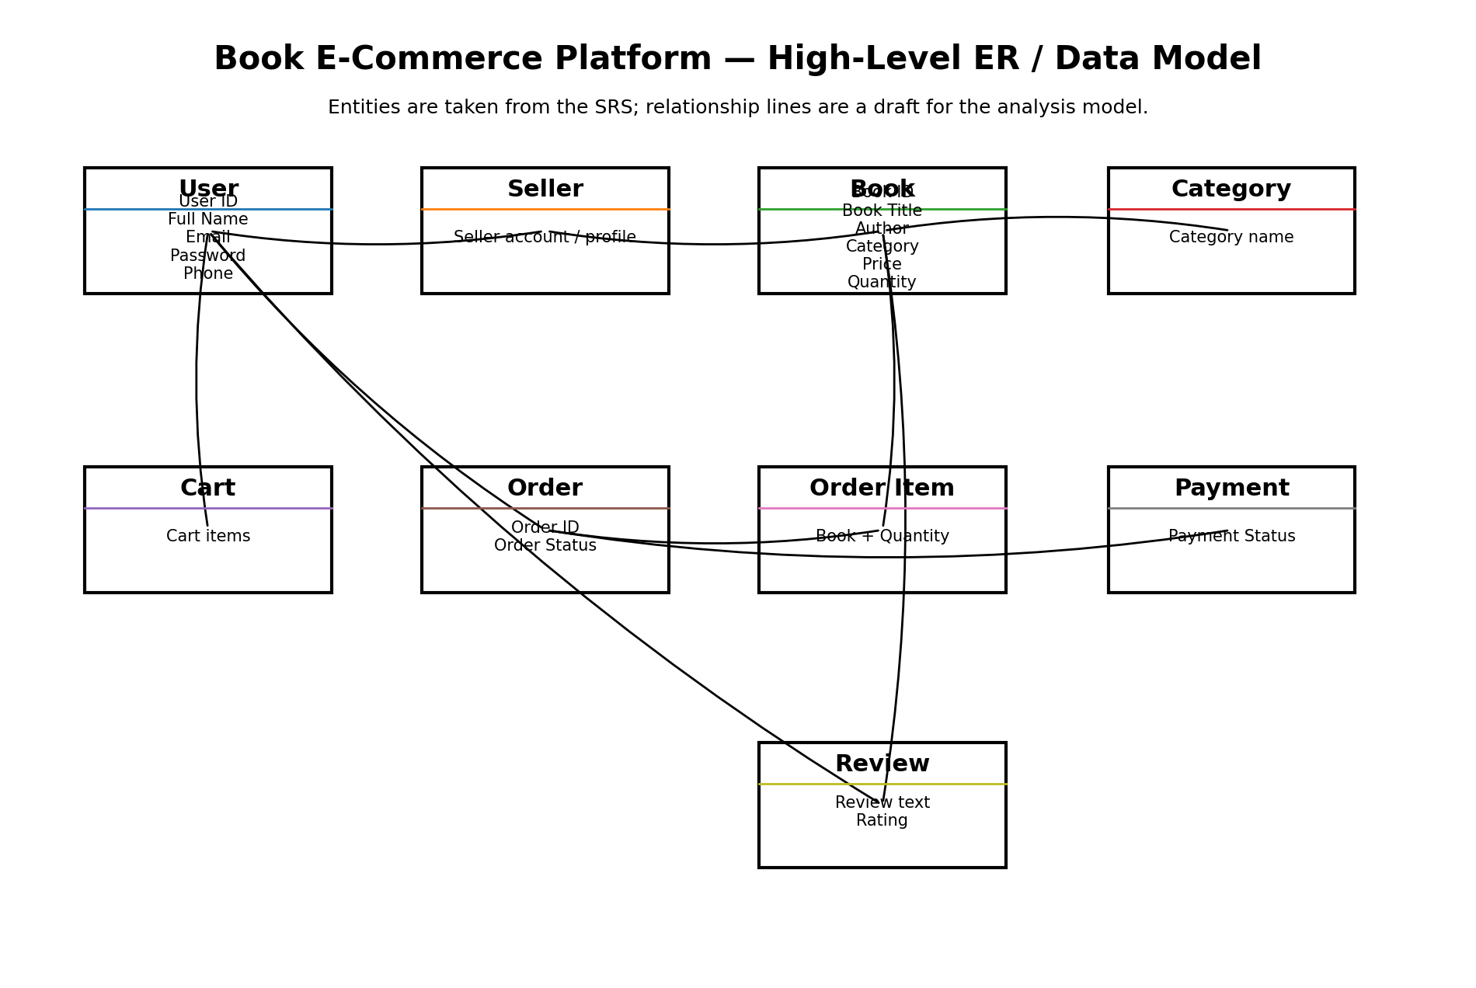

5. System Features

5.1 User Registration and Authentication
Description and Priority: This feature provides the functionality described below. Priority: High.
Stimulus/Response Sequences:
• User selects Register → system displays registration form.
• User enters valid details → system validates and creates the account.
• Invalid or duplicate details → system displays an error.
• Valid credentials → system grants access.
• Invalid credentials → system denies access and displays an error.
Functional Requirements:
REQ-01: The system shall allow customers and sellers to register an account using the required details.
REQ-02: The system shall validate registration details and prevent duplicate or invalid account information.
REQ-03: The system shall allow registered users to securely log in and log out using valid credentials.

5.2 Book Discovery and Catalog Management
Description and Priority: This feature provides the functionality described below. Priority: High.
Stimulus/Response Sequences:
• Customer searches/browses → system displays matching books.
• Customer selects a book → system displays details and availability.
• Seller adds/edits/removes listing → system validates and updates the catalog.
Functional Requirements:
REQ-04: The system shall allow customers to search for books using the book title, author, or category.
REQ-05: The system shall allow customers to view book details, including title, author, price, description, and availability.
REQ-06: The system shall allow sellers to add, update, and remove their book listings.

5.3 Shopping Cart and Checkout
Description and Priority: This feature provides the functionality described below. Priority: High.
Stimulus/Response Sequences:
• Customer selects Add to Cart → system updates cart.
• Customer changes/removes items → system recalculates cart.
• Customer selects Checkout → system validates availability and displays order summary.
Functional Requirements:
REQ-07: The system shall allow customers to add, update, and remove books from the shopping cart.
REQ-08: The system shall calculate the cart total and validate book availability during checkout.

5.4 Order and Payment Management
Description and Priority: This feature provides the functionality described below. Priority: High.
Stimulus/Response Sequences:
• Customer confirms checkout → system creates order.
• Payment is initiated → system records payment status.
• Seller views received order → seller processes it and updates status.
• Customer opens Orders → system displays order history and current status.
Functional Requirements:
REQ-09: The system shall allow customers to place orders for books in their shopping cart.
REQ-10: The system shall allow customers to make payments and view the payment status of their orders.
REQ-11: The system shall allow customers to view their order history and allow sellers to manage orders received for their listings.

5.5 Reviews and Ratings
Description and Priority: This feature provides the functionality described below. Priority: Medium.
Stimulus/Response Sequences:
• Customer opens an eligible purchased book → submits rating/review → system validates and stores the review.
Functional Requirements:
REQ-12: The system shall allow customers to provide ratings and reviews for books they have purchased.
REQ-13: The system shall validate review and rating submissions before storing them.

5.6 Administrator Management
Description and Priority: This feature provides the functionality described below. Priority: High.
Stimulus/Response Sequences:
• Administrator logs in → system verifies administrator role.
• Administrator selects management function → system displays records.
• Administrator creates, updates, or removes permitted records.
Functional Requirements:
REQ-14: The system shall allow administrators to manage users, sellers, books, and orders.
REQ-15: The system shall restrict administrator functions to authorized administrator accounts.

6. Other Nonfunctional Requirements

6.1 Performance Requirements
The system should respond to normal user actions within approximately 3 seconds under the expected mini-project load. Search and catalog pages should load efficiently. Database operations should use suitable indexing where required. The application should support multiple concurrent users within the limits of its deployment environment.

6.2 Safety Requirements
Inputs shall be validated before storage. Checkout shall require confirmation before an order is placed. Destructive actions such as deleting a listing should require confirmation. Error messages shall not expose sensitive information. The system should minimize the risk of inconsistent order records.

6.3 Security Requirements
• Passwords shall not be stored in plain text and shall use secure password hashing.
• Authentication/session information shall be protected.
• Role-based authorization shall prevent unauthorized access to protected functions.
• User, order, and payment-related information shall be protected from unauthorized access.
• Input validation shall be applied to reduce common injection and malformed-input risks.
• HTTPS should be used in deployment.

6.4 Software Quality Attributes
Usability: Interfaces should be simple and consistent.
Reliability: Orders and payment status should be stored consistently.
Maintainability: Frontend, backend, database, and utilities should be modular.
Testability: Functional requirements shall be independently testable.
Portability: The web application should work on common modern browsers and supported operating systems.
Scalability: The design should accommodate additional users, books, sellers, and orders without redesigning core functionality.

6.5 Business Rules
• Only authenticated users may place orders.
• Sellers may manage only their own book listings and related orders.
• Customers may review books only after purchasing them.
• Administrators have higher privileges than customers and sellers.
• A book cannot be ordered when available quantity is insufficient.
• Order status shall use statuses supported by the implementation, such as Pending, Confirmed, Shipped, Delivered, or Cancelled.
• Payment status shall be maintained separately from order status.

7. Other Requirements
Database requirements: Persistent records shall be maintained for users, sellers, books, categories, carts, orders, order items, payments, and reviews. The data model shall preserve required relationships and validation rules. The academic prototype shall use English unless additional localization is implemented. External payment or notification services shall follow their applicable security and usage requirements.

Appendix A: Glossary
Term | Definition
API | Application Programming Interface
CRUD | Create, Read, Update, Delete
Customer | User who purchases books
Seller | User who lists and sells books
Administrator | Privileged user who manages the platform
Cart | Collection of books selected for purchase
Order | Confirmed purchase request containing one or more books
Order Item | Individual book and quantity within an order
Payment | Transaction associated with an order
Review | Customer feedback associated with a book
MERN | MongoDB, Express.js, React, and Node.js

Appendix B: Field Layouts
The following field layouts define important data fields for the academic prototype.
Field | Length | Data Type | Description | Is Mandatory
User ID | 24 | Alphanumeric | Unique identifier for a user | Y
Full Name | 100 | String | Customer/seller name | Y
Email | 100 | String | Login and contact email | Y
Password | 255 | String | Hashed authentication credential | Y
Phone | 15 | String | Contact phone number | N
Book ID | 24 | Alphanumeric | Unique identifier for a book | Y
Book Title | 200 | String | Title of the book | Y
Author | 150 | String | Author name | Y
Category | 100 | String | Book category | Y
Price | 10,2 | Decimal | Selling price | Y
Quantity | 6 | Integer | Available inventory quantity | Y
Order ID | 24 | Alphanumeric | Unique order identifier | Y
Order Status | 30 | String | Current order status | Y
Payment Status | 30 | String | Current payment status | Y
Review | 1000 | String | Customer review text | N
Order Date | 10 | Date | Date on which the order was placed | Y
Rating | 1 | Integer | Customer rating for a purchased book (1–5) | N
Report Requirements
Customer/Order Report | Seller Inventory Report
User ID | Book ID
Customer Name | Book Title
Email | Author
Order ID | Price
Order Status | Quantity Available
Order Date | Listing Status

Appendix C: Requirement Traceability Matrix
This matrix maps each functional requirement to architecture/design, code, and testing references. Exact code file names and test case IDs should be updated after implementation and test execution.

Sl. No | Requirement ID | Brief Description | Architecture Reference | Design Reference | Code File Reference | Test Case ID | System Test Case ID
1 | REQ-1 | Customer/seller registration | MERN client-server architecture | Relevant UI/API/database design | To be assigned during implementation | UT/IT-1 | ST-1
2 | REQ-2 | Registration validation | MERN client-server architecture | Relevant UI/API/database design | To be assigned during implementation | UT/IT-2 | ST-2
3 | REQ-3 | Login/logout | MERN client-server architecture | Relevant UI/API/database design | To be assigned during implementation | UT/IT-3 | ST-3
4 | REQ-4 | Reject invalid credentials | MERN client-server architecture | Relevant UI/API/database design | To be assigned during implementation | UT/IT-4 | ST-4
5 | REQ-5 | Search books | MERN client-server architecture | Relevant UI/API/database design | To be assigned during implementation | UT/IT-5 | ST-5
6 | REQ-6 | View book details | MERN client-server architecture | Relevant UI/API/database design | To be assigned during implementation | UT/IT-6 | ST-6
7 | REQ-7 | Add seller listing | MERN client-server architecture | Relevant UI/API/database design | To be assigned during implementation | UT/IT-7 | ST-7
8 | REQ-8 | Update/remove listing | MERN client-server architecture | Relevant UI/API/database design | To be assigned during implementation | UT/IT-8 | ST-8
9 | REQ-9 | Validate listing data | MERN client-server architecture | Relevant UI/API/database design | To be assigned during implementation | UT/IT-9 | ST-9
10 | REQ-10 | Add to cart | MERN client-server architecture | Relevant UI/API/database design | To be assigned during implementation | UT/IT-10 | ST-10
11 | REQ-11 | Update/remove cart items | MERN client-server architecture | Relevant UI/API/database design | To be assigned during implementation | UT/IT-11 | ST-11
12 | REQ-12 | Calculate cart total | MERN client-server architecture | Relevant UI/API/database design | To be assigned during implementation | UT/IT-12 | ST-12
13 | REQ-13 | Prevent unavailable checkout | MERN client-server architecture | Relevant UI/API/database design | To be assigned during implementation | UT/IT-13 | ST-13
14 | REQ-14 | Place order | MERN client-server architecture | Relevant UI/API/database design | To be assigned during implementation | UT/IT-14 | ST-14
15 | REQ-15 | Record order/status | MERN client-server architecture | Relevant UI/API/database design | To be assigned during implementation | UT/IT-15 | ST-15

