PES UNIVERSITY, BANGALORE

Department of Computer Science and Engineering

Software Architecture and Design Specification

Book E-Commerce Platform

Version 1.0 approved

PES University, Department of Computer Science and Engineering

09 September 2026

Software Architecture and Design Specification

Project: Book E-Commerce Platform
Version: 1.0
Authors: PRASHANT,NIDHI,PRAJWAL,DARSHAN
Date: 27-09-2026
Status: Draft

Revision History

1.0 | 27-09-2026 | PRASHANT | Initial SAD prepared for Book E-Commerce Platform

Approvals

Role | Name | Signature/Date
Product Owner | NIDHI R | 
Developer | PRASHANT | 

QA Lead | Prajwal M Angadi | 
Test Engineer | Darshan A D | 

1. Introduction

1.1 Purpose
This document specifies the architecture and design of the Book E-Commerce Platform. It describes the major system components, architecture pattern, technology stack, security architecture, system design, API interfaces, error handling, and traceability to the Software Requirements Specification (SRS).
1.2 Scope
The Book E-Commerce Platform is a web-based application for buying and selling books. The system supports customer registration and authentication, book search and discovery, shopping cart management, checkout, order placement, payment status management, reviews and ratings, seller book listing management, and administrator management of users, sellers, books, and orders.
1.3 Audience
This document is intended for the project manager, product owner, developers, QA lead, test engineers, testers, faculty evaluators, and other stakeholders involved in the development, testing, maintenance, and evaluation of the Book E-Commerce Platform.
1.4 Definitions
API – Application Programming Interface
CRUD – Create, Read, Update, Delete
MERN – MongoDB, Express.js, React, and Node.js
Customer – User who purchases books
Seller – User who lists and sells books
Administrator – Privileged user who manages the platform
Cart – Collection of books selected for purchase
Order – Confirmed purchase request containing one or more books
Payment – Transaction associated with an order
Review – Customer feedback associated with a book

2. Document Overview

2.1 How to use this document
This document describes the architecture and detailed design of the Book E-Commerce Platform. It provides information about the system architecture, components, architecture pattern, technology stack, security architecture, requirement traceability, sequence diagrams, API design, error handling, and other design considerations.
2.2 Related Documents
Software Requirements Specification (SRS) — Book E-Commerce Platform
Software Test Plan (STP)
Test Cases
Requirement Traceability Matrix (RTM)

3. Architecture
3.1 Goals & Constraints
Goals:
- Provide a simple and user-friendly platform for buying and selling books.
- Support secure user authentication and role-based access for customers, sellers, and administrators.
- Provide efficient book search, catalog, cart, checkout, and order management.
- Maintain reliable and consistent user, book, cart, order, payment, and review data.
- Keep the system modular and maintainable using the MERN stack.
Constraints:
- The system is developed as a student mini-project using the MERN stack.
- The system uses a client-server architecture with React, Node.js/Express.js, and MongoDB.
- The application depends on a supported web browser and internet connectivity.
- Payment and notification services may depend on external services or academic simulation.
- The implementation must remain feasible within the scope and resources of the mini project.

3.2 Stakeholders & Concerns
Stakeholder | Main Concerns
Customer | Easy book search, simple shopping experience, secure login, accurate book and order information
Seller | Easy book listing management, inventory management, and received-order management
Administrator | Secure access, user/seller management, book and category management, and order management
Project Manager / Product Owner | Requirements, project scope, usability, and successful completion of the project
Developer | Modular architecture, maintainability, reliable APIs, database integration, and secure implementation
QA Lead / Test Engineer | Testability, requirement coverage, defect identification, and reliable system behavior
Faculty Evaluator | Compliance with project requirements, documentation quality, and correct implementation

3.3 Component (UML) Diagram
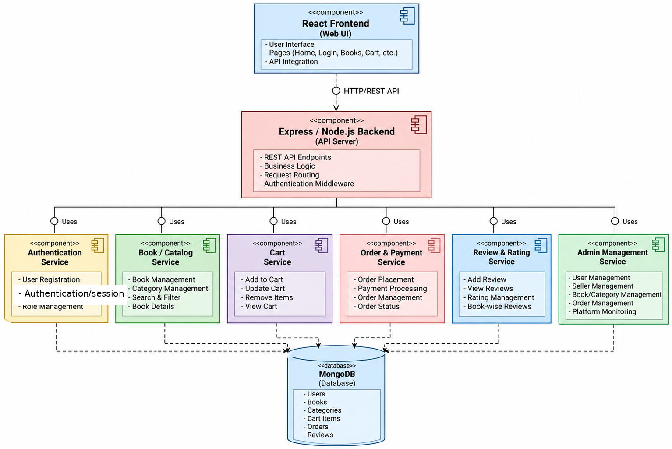

3.4 Component Descriptions
Component | Description
React Frontend (Web UI) | Provides the user interface for customers, sellers, and administrators. It handles pages such as login, book catalog, book details, cart, checkout, orders, and management screens.
Express / Node.js Backend | Acts as the application server. It handles REST API requests, request routing, business logic, authentication middleware, and communication between the frontend and database.
Authentication Service | Handles user registration, login, logout, authentication, and role-based access for customers, sellers, and administrators.
Book / Catalog Service | Manages books and categories and provides book search, filtering, book details, and seller listing management.
Cart Service | Manages shopping cart operations such as adding books, updating quantities, removing items, viewing the cart, and calculating cart information.
Order & Payment Service | Handles order placement, payment processing/status, order management, and order status updates.
Review & Rating Service | Allows customers to submit reviews and ratings for books they have purchased and manages the stored reviews and ratings.
Admin Management Service | Provides administrator functions for managing users, sellers, books, categories, and orders.
MongoDB Database | Stores persistent application data including users, books, categories, cart items, orders, payments, and reviews.

3.5 Chosen Architecture Pattern and Rationale
Architecture consisting of three main layers:
- Presentation Layer: React.js provides the user interface for customers, sellers, and administrators.
- Business Logic Layer: Node.js and Express.js handle authentication, book management, shopping cart operations, order processing, and REST API requests.
- Data Layer: MongoDB stores user information, books, categories, carts, orders, payments, and reviews.
Rationale:
The layered architecture is chosen because it provides a clear separation between the user interface, business logic, and database. This improves maintainability, modularity, scalability, and testing. It also allows the frontend and backend to be developed and maintained independently.

3.6 Technology Stack & Data Stores
Technology Stack:
- Frontend: React.js
- Backend: Node.js and Express.js
- Database: MongoDB
- Communication: REST-style APIs
- Data Format: JSON
- Web Browser: Google Chrome, Mozilla Firefox, and Microsoft Edge
Data Stores : The system uses MongoDB as the primary persistent data store. It stores information related to users, sellers, books, categories, shopping carts, orders, order items, payments, and reviews.

3.8 Traceability to Requirements
Requirement ID | Requirement | Architecture Component
REQ-01 | Customer/seller registration | Authentication Service
REQ-02 | Registration validation | Authentication Service
REQ-03 | Login/logout | Authentication Service
REQ-04 | Search books | Book/Catalog Service
REQ-05 | View book details | Book/Catalog Service
REQ-06 | Add/update/remove book listings | Book/Catalog Service
REQ-07 | Add/update/remove cart items | Cart Service
REQ-08 | Calculate cart total and validate availability | Cart Service
REQ-09 | Place orders | Order & Payment Service
REQ-10 | Make payments and view payment status | Order & Payment Service
REQ-11 | View/manage orders | Order & Payment Service
REQ-12 | Submit ratings and reviews | Review & Rating Service
REQ-13 | Validate reviews and ratings | Review & Rating Service
REQ-14 | Administrator management | Admin Management Service
REQ-15 | Restrict administrator functions | Authentication Service / Admin Management Service

4. Design

4.1 Design Overview
- Presentation Layer: React.js provides the user interface for customers, sellers, and administrators.
- Business Logic Layer: Node.js and Express.js provide REST APIs, routing, authentication, authorization, and application logic.
- Data Layer: MongoDB stores and manages users, sellers, books, categories, carts, orders, payments, and reviews.
- Service Components: Authentication, Book/Catalog, Cart, Order & Payment, Review & Rating, and Admin Management services implement the major functional requirements.
- Communication: The frontend communicates with backend services through REST APIs using JSON.

4.2 UML Sequence Diagrams
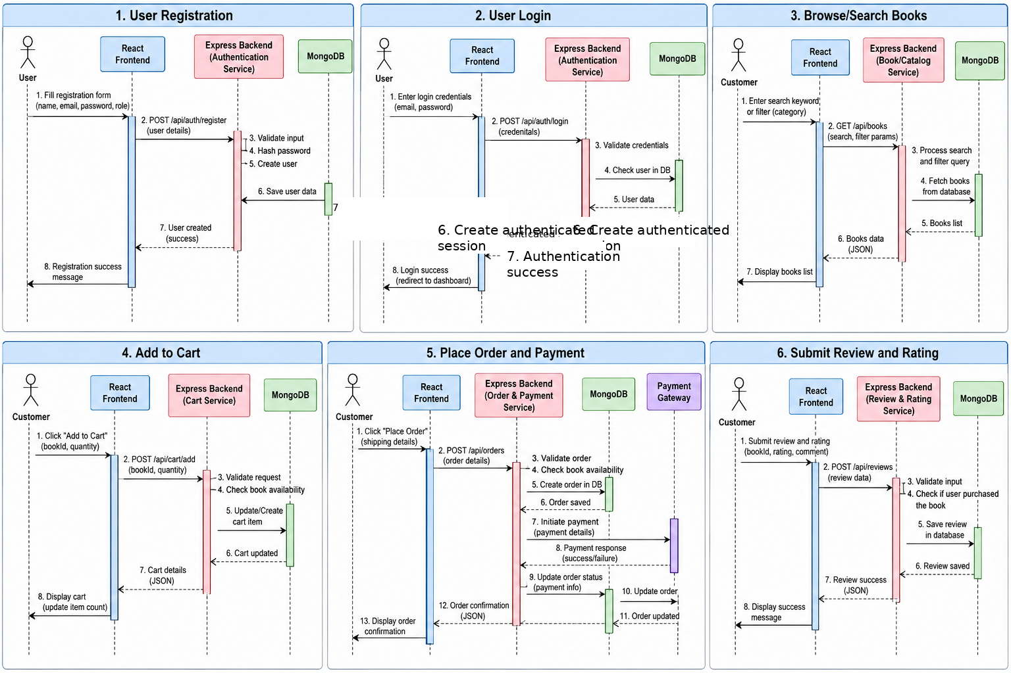

4.3 API Design
The Book E-Commerce Platform is designed to use REST-style APIs for communication between the React frontend and the Node.js/Express backend. APIs exchange data using JSON and protected operations require authentication and role-based access control. The endpoints below represent the core API design and should match the final implementation.
Method | Endpoint | Purpose | Access
POST | /api/auth/register | Register a new customer or seller | Public
POST | /api/auth/login | Authenticate a user | Public
GET | /api/books | Search and retrieve books | Public
GET | /api/books/:id | View book details | Public
POST | /api/books | Add a book listing | Seller
PUT | /api/books/:id | Update a book listing | Seller
DELETE | /api/books/:id | Remove a book listing | Seller
POST | /api/cart | Add a book to cart | Customer
PUT | /api/cart/:id | Update cart item | Customer
DELETE | /api/cart/:id | Remove cart item | Customer
POST | /api/orders | Place an order | Customer
GET | /api/orders | View order history | Customer
POST | /api/reviews | Submit a review and rating | Customer
GET | /api/admin/users | Manage users | Administrator
GET | /api/admin/orders | Manage orders | Administrator

4.6 Open Issues & Next Steps
- Complete implementation of all planned frontend and backend modules.
- Integrate and test the REST APIs with the React frontend.
- Complete database integration and verify data consistency.
- Implement and verify authentication and role-based access control.
- Complete payment processing or payment simulation and failure handling.
- Execute functional and non-functional test cases.
- Update the Requirement Traceability Matrix with final implementation and test-case references.
- Fix identified defects and perform final system validation.

