**AP Invoice Report**

**Steps involved in BI Report Creation**

* Create New data model
* Querying corresponding report
* If needed create parameters and List of Values/Bursting
* Then view the data model in Table view
* Save the sample data and then save.
* Then export
* Open that file in word remote desktop

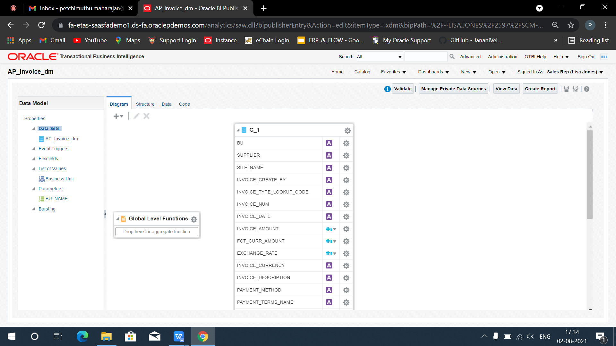

**LIST OF VALUES(LOV)**

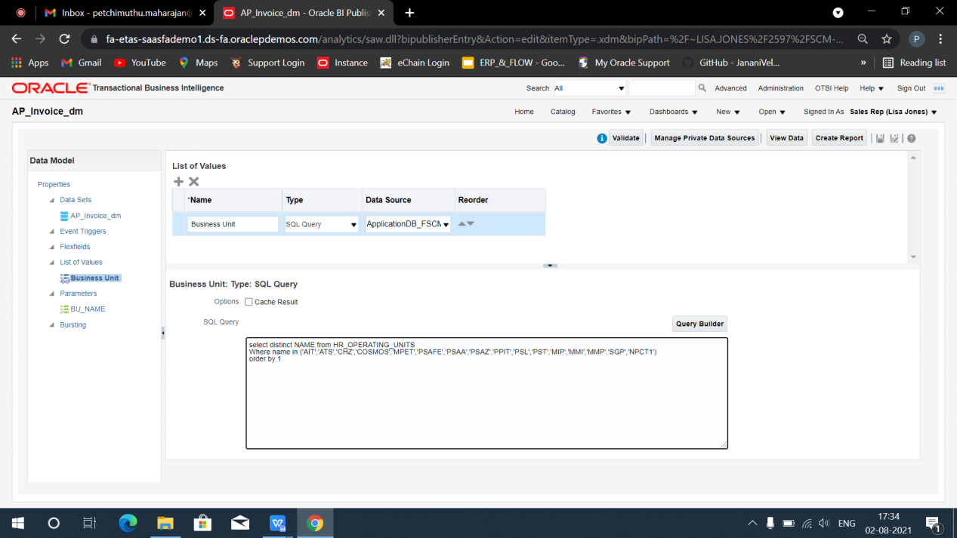

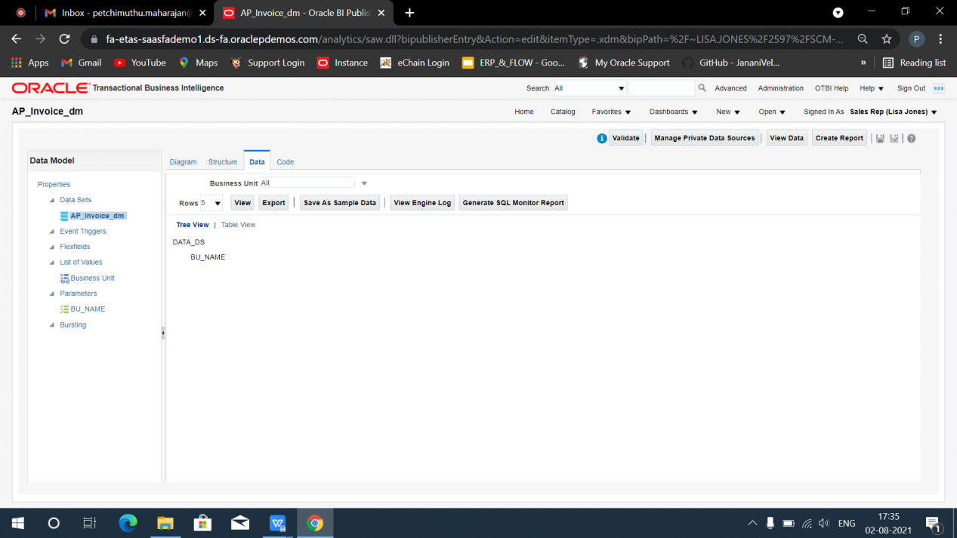

**Steps Involved in Excel Template**

* Open new excel sheet
* Load the sample data
* Then click fields, after clicking Metadata(XDO_METADATA) will be created.
* Create needed column names and insert the fields to its corresponding columns.
* Select the inserted fields and give repeating group.
* Then save in (excel 97-2003 workbook) format and click excel.

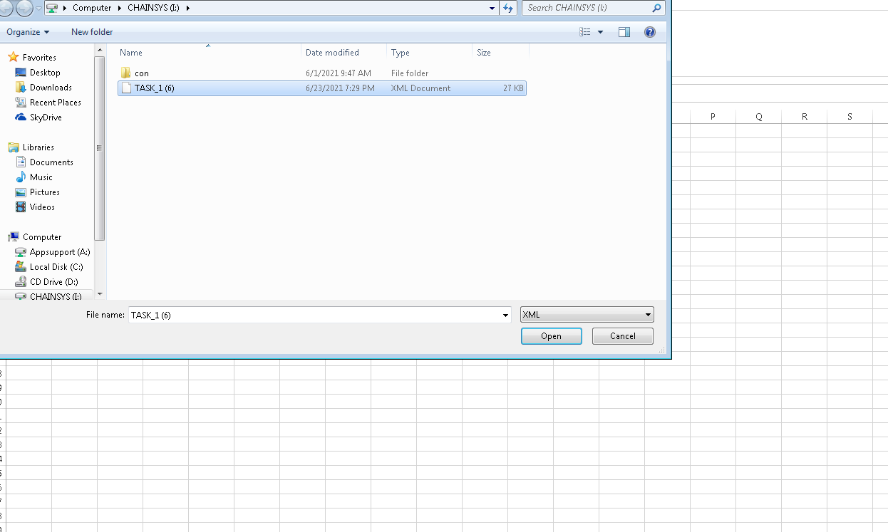

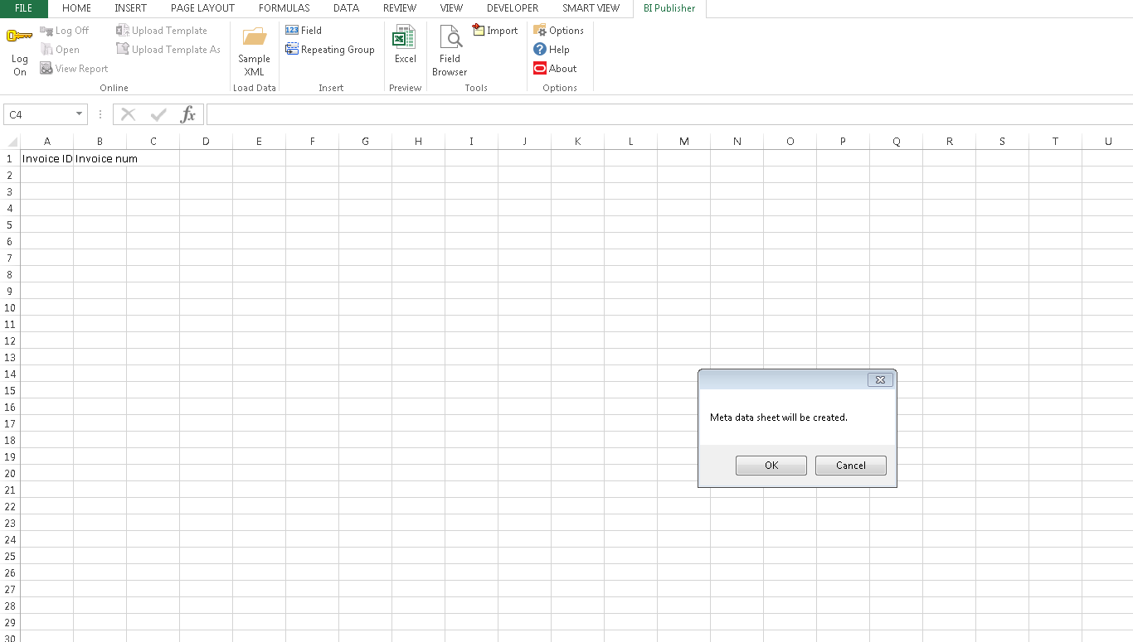

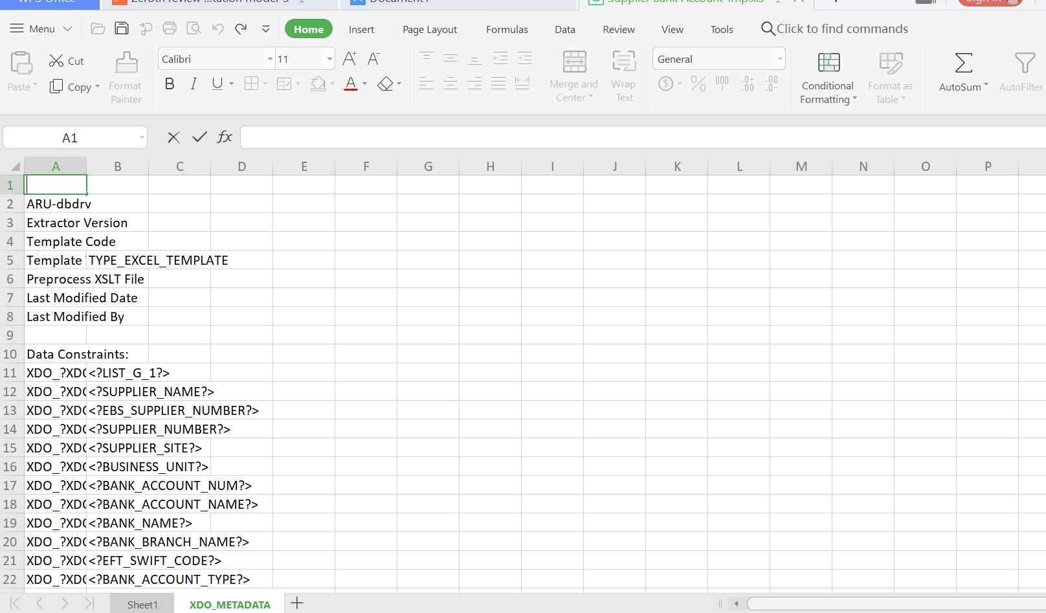

**Template**

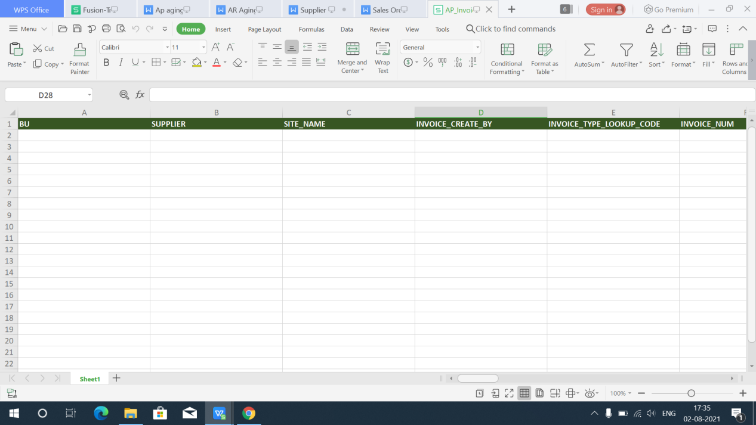

**Report Creation**

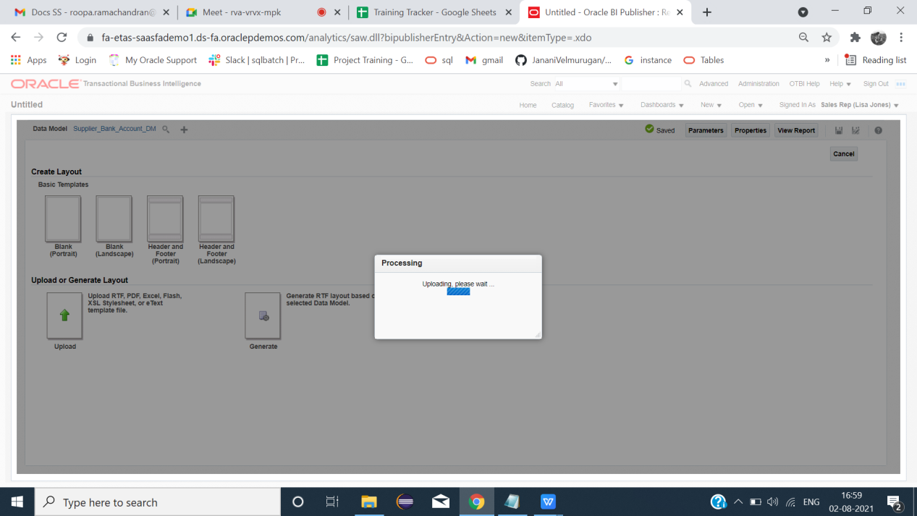

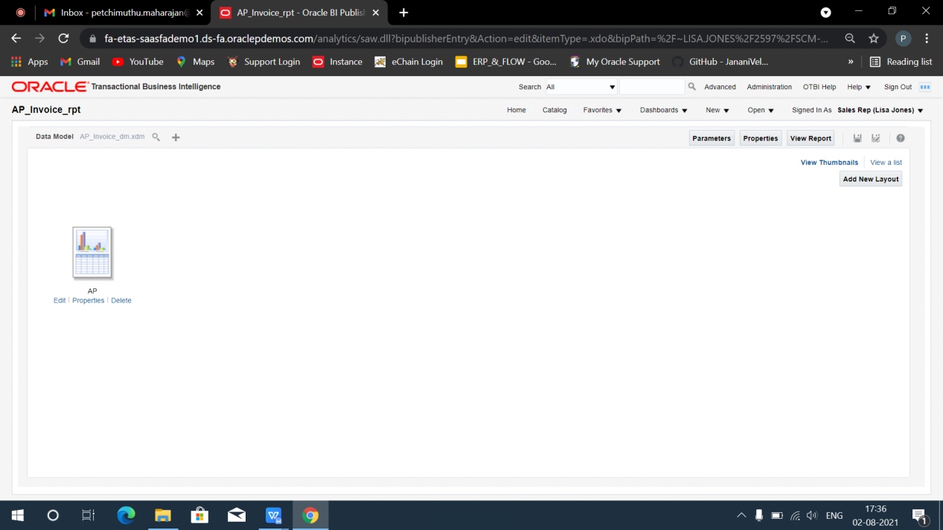

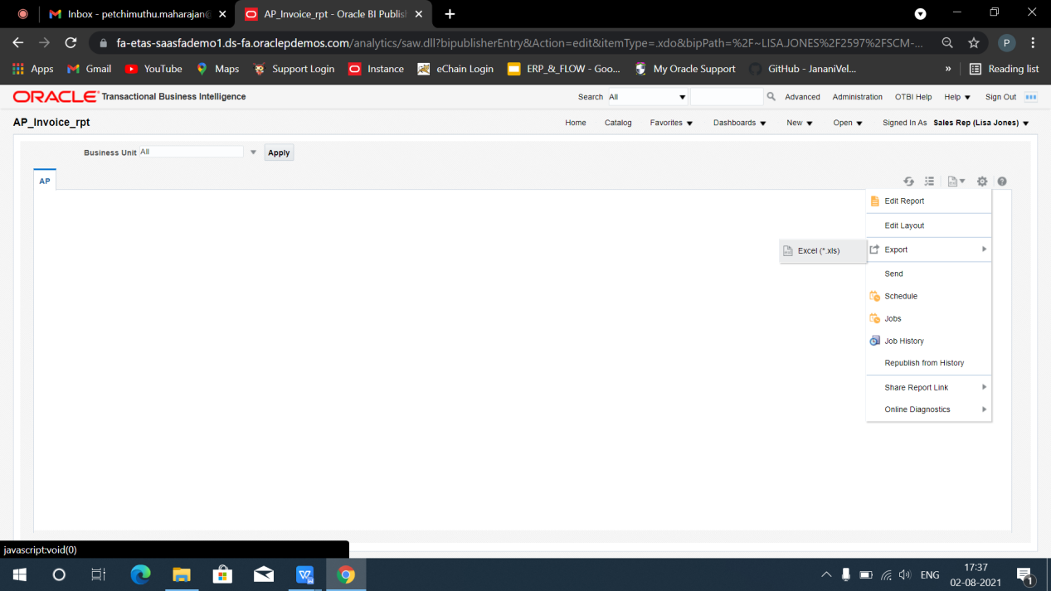

**Report**

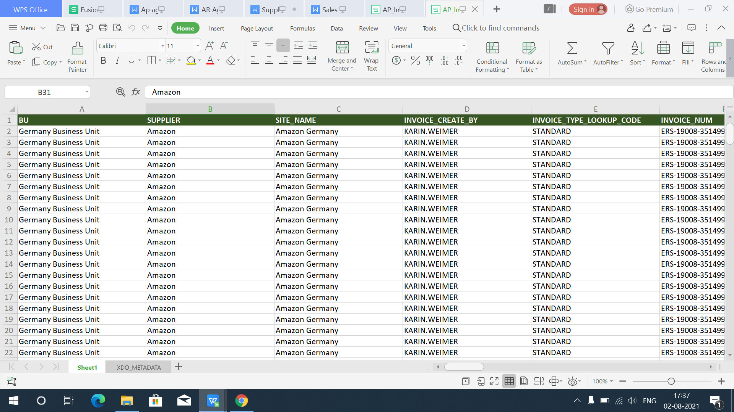

**End**