**TASK 10 - Limiting Records in a Page**

* Create the data model with corresponding columns.
* Navigator--> New --> Data Model --> SQL query.
* Create the data set with parameters.

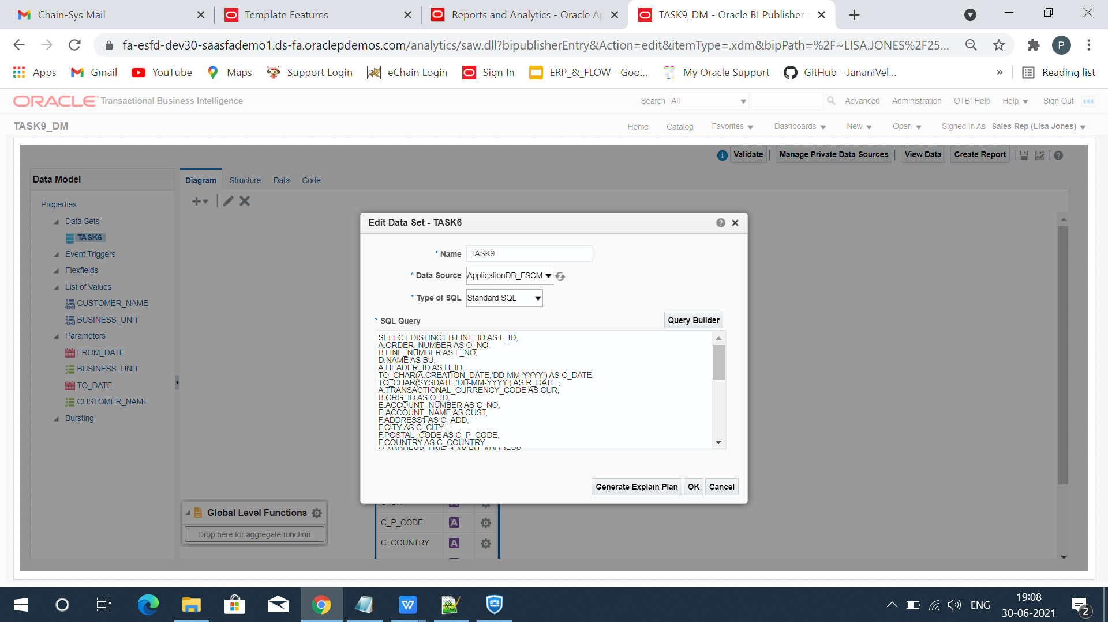

* Create List of values for the parameters.

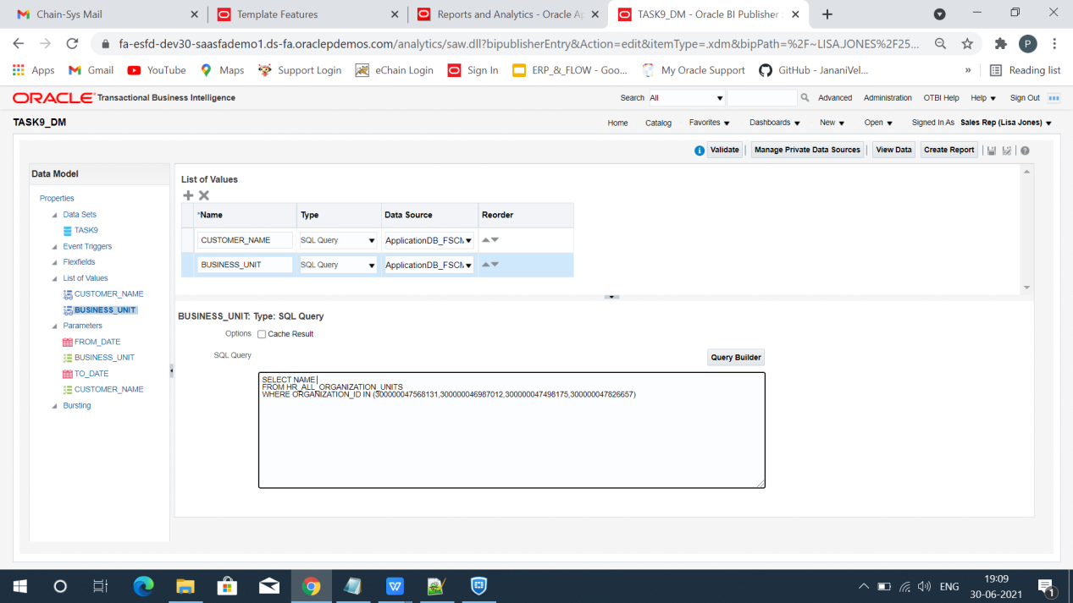

* Map the Parameters with corresponding LOV(s).

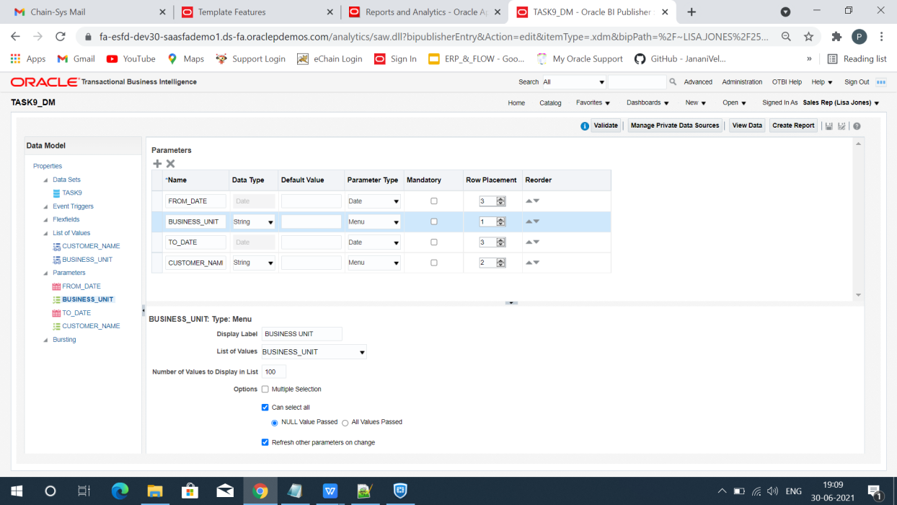

* View the data with 200 rows.
* Click Save as sample data.
* Save and Export the Data Model.

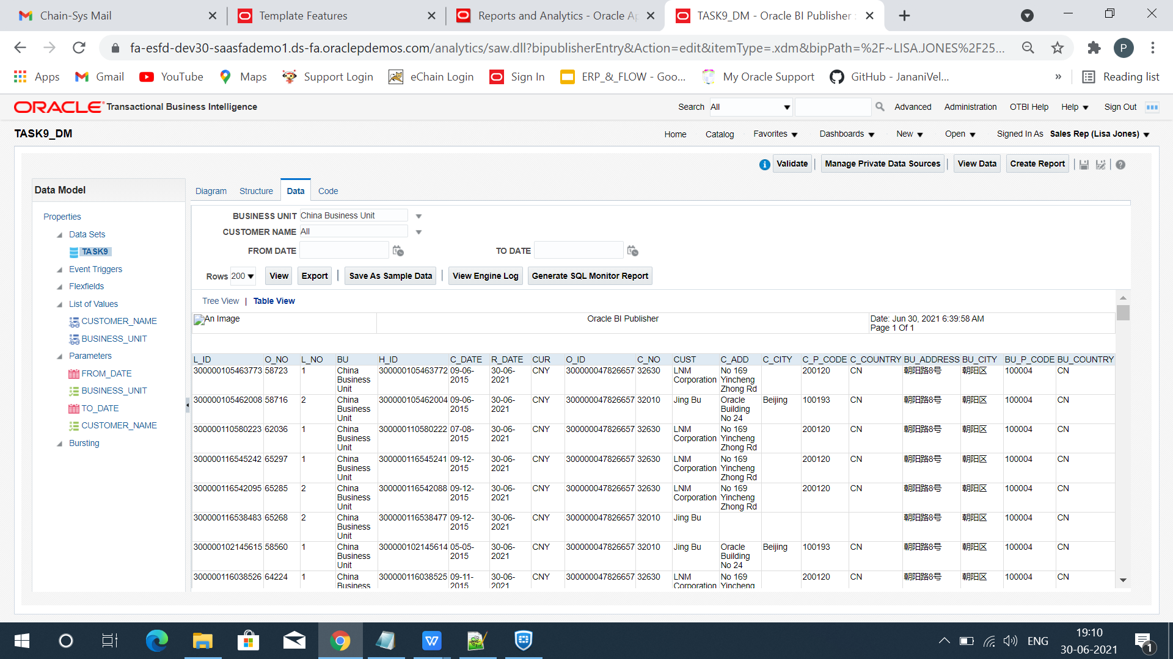

* Load the sample XML data in the BI publisher.
* Design the Layout and insert the elements from the fields menu.

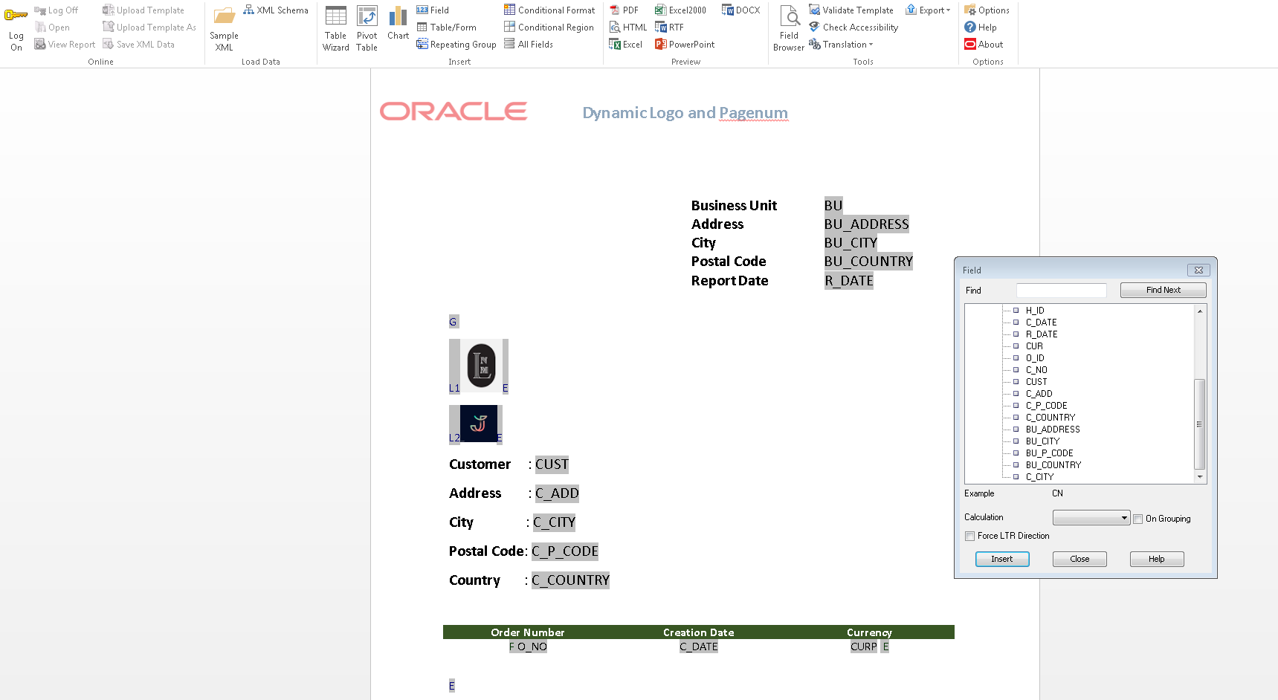

* Use legacy forms in the developer option to create text field.
* [<?for-each-group@section](mailto:<?for-each-group@section:G_1;./CUST?>)**[:](mailto:<?for-each-group@section:G_1;./CUST?>)**[G_1;./CUST?>](mailto:<?for-each-group@section:G_1;./CUST?>) Use this code for creating different sections for the Customers.

<?if:position() mod 30 =0?> <xsl:attribute name="break-before">page</xsl:attribute>

<?end if?> Use this Code before the end group <?end for-each?>

* These are the XML code used.

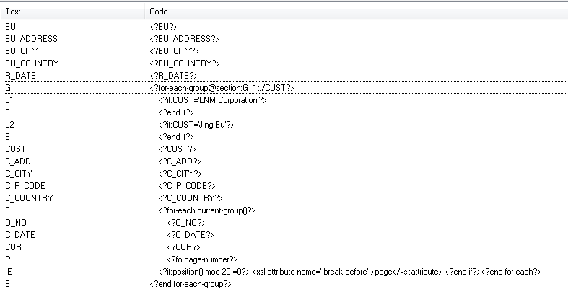

* Save the template in RTF format.
* Navigator --> New --> Report.
* Map the corresponding data model and upload the rtf template.

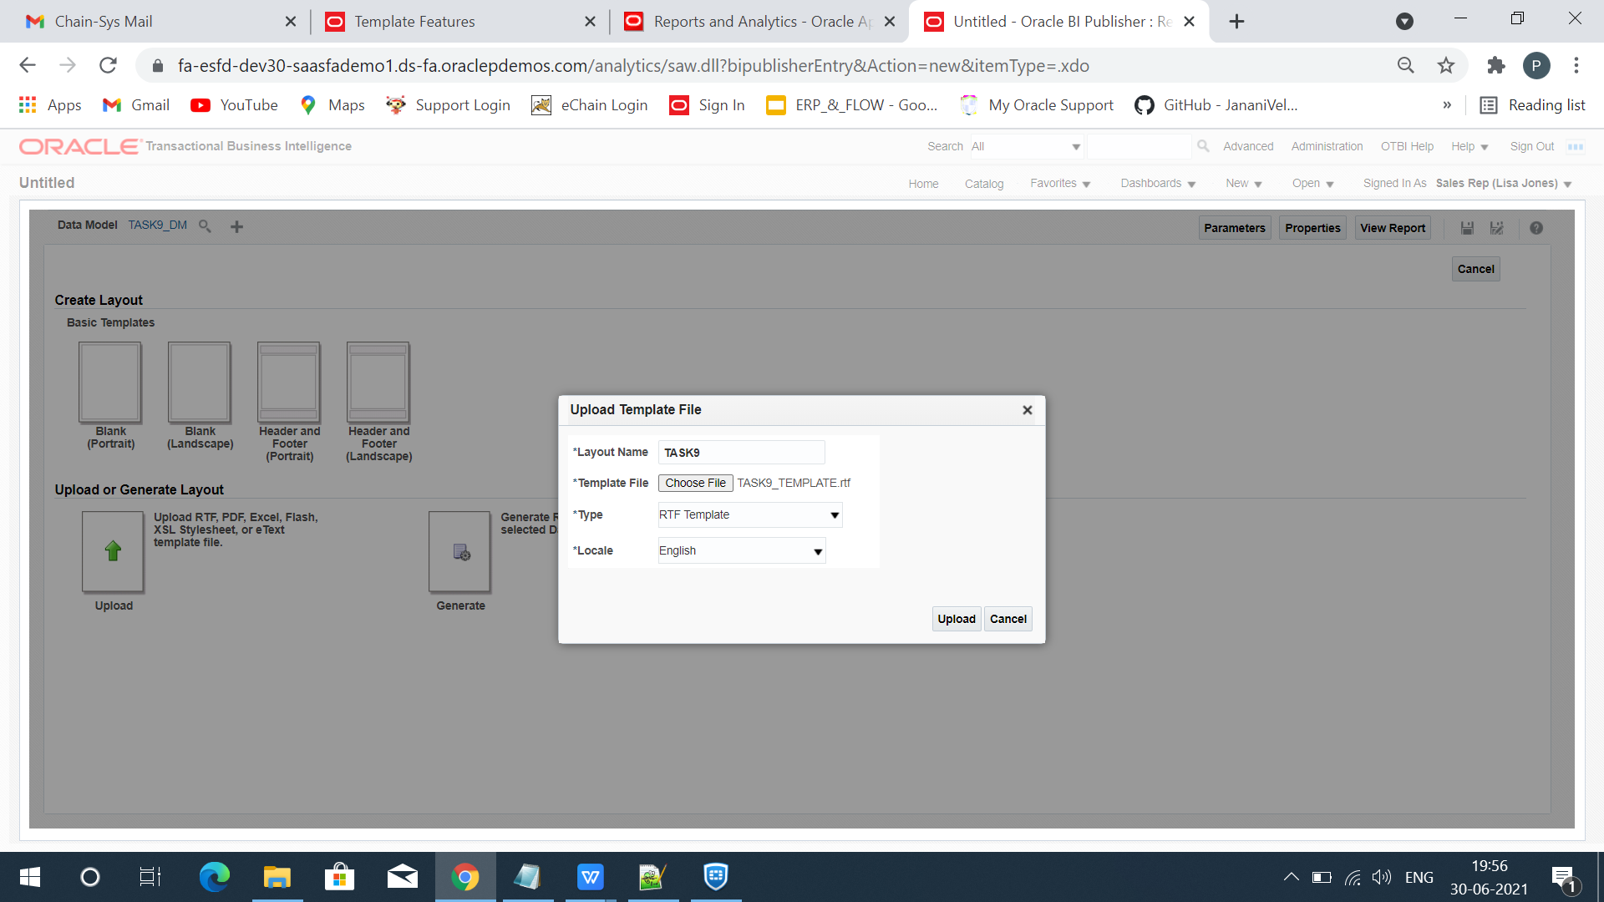

* Save the layout and report.
* Click view report and export it in the PDF format.

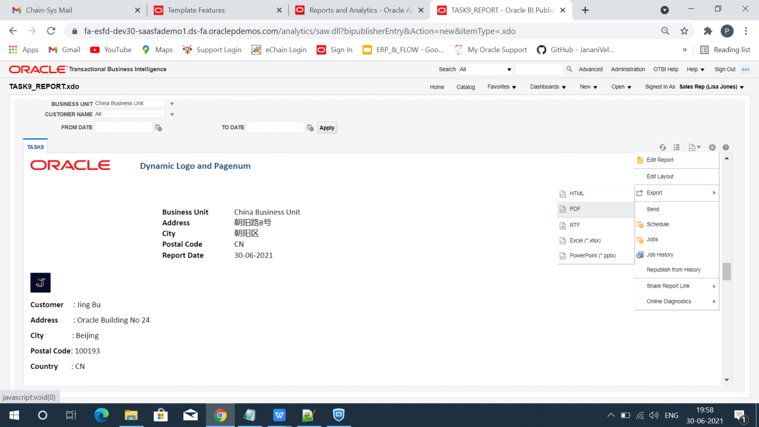

* Report will be downloaded.

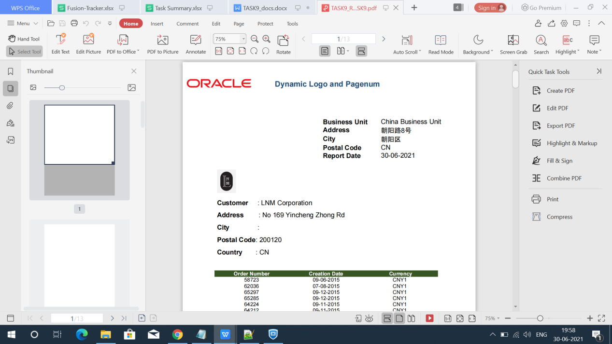

END