**Task 11 - Purchase Order Report**

**Step 1 - Data model:**

* Create a data model with needed Columns and parameters.
* View the data model by selecting corresponding parameters and save the sample data.
* Save the data model and export as XML data.

**Step 2 - Template:**

* Create a Excel template in the MS Excel BI Publisher.
* Load the XML data in Load sample data.
* Design the template using the fields needed from the fields menu from the BI Publisher.

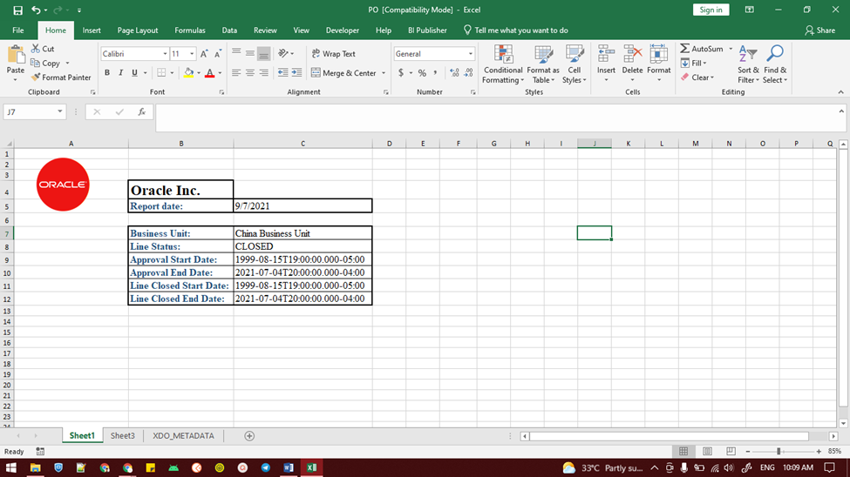

* Create two sheets from parameters and the columns.

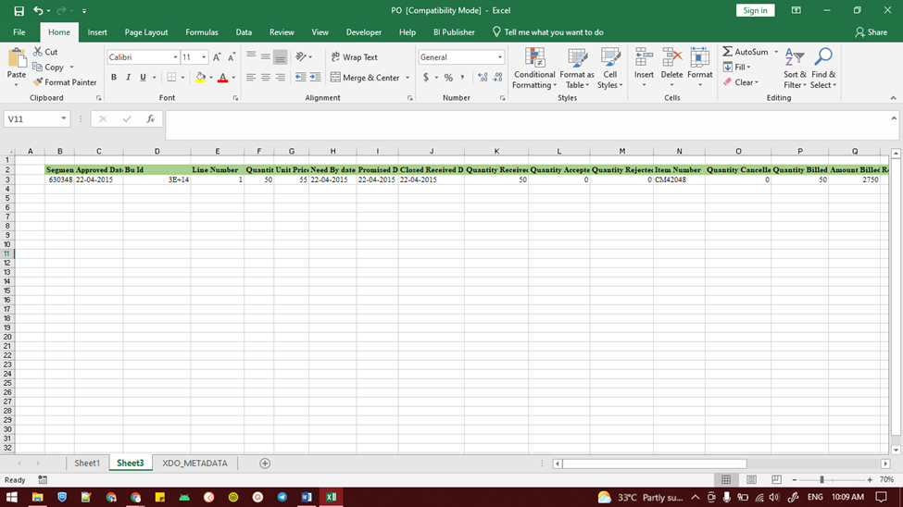

* Save the template in XLS format (Excel 97 - 2003).

Step 3 - Create Report:

* Go to Catalog --> New --> Report.
* Map the corresponding data model in the layout page.
* Upload the Template.

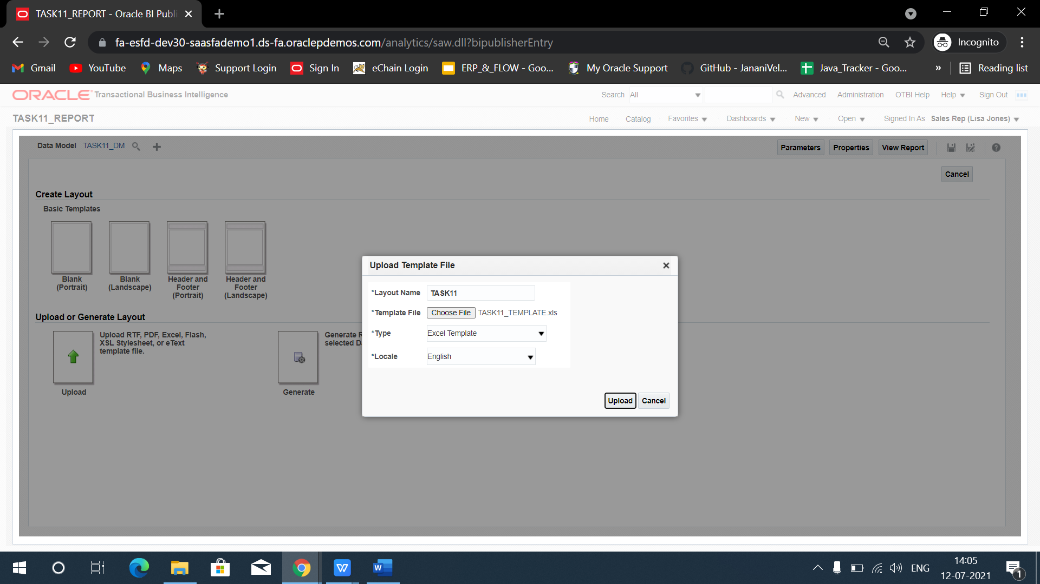

* Save and view the report.
* Select the parameters and click apply.

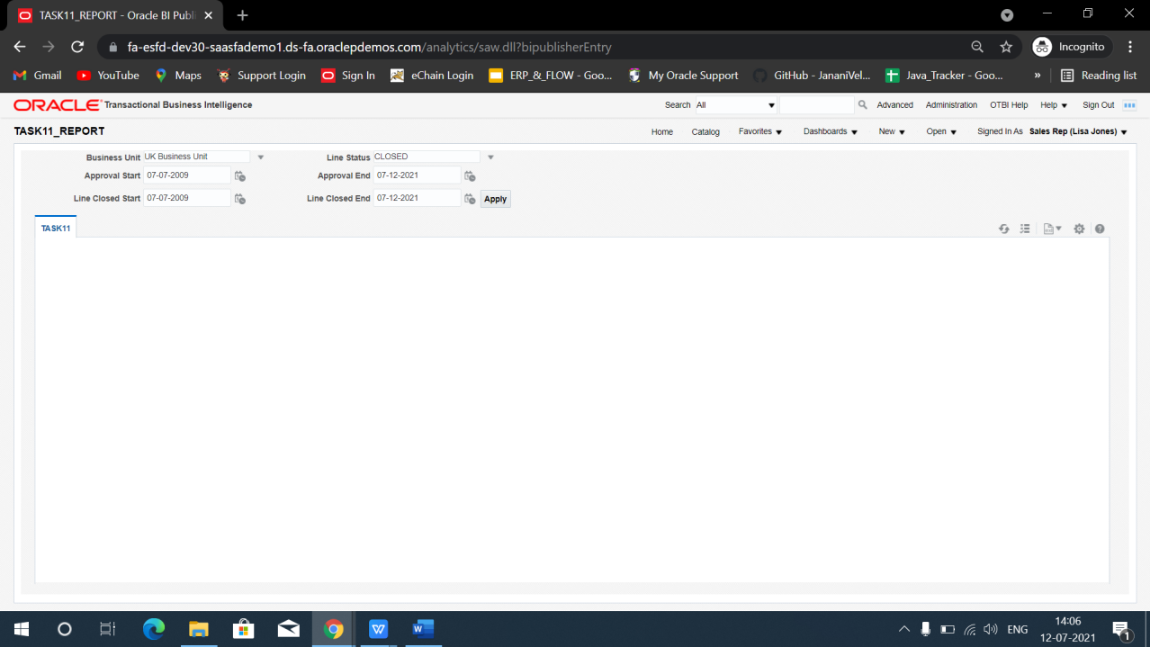

* Result report will be downloaded.

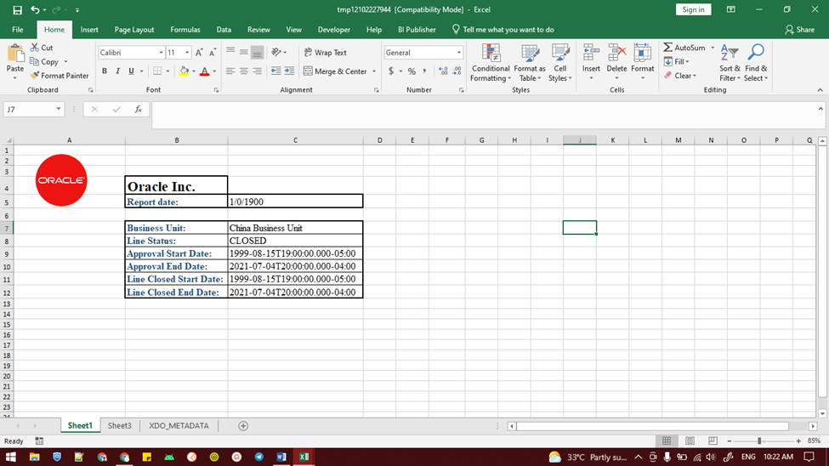

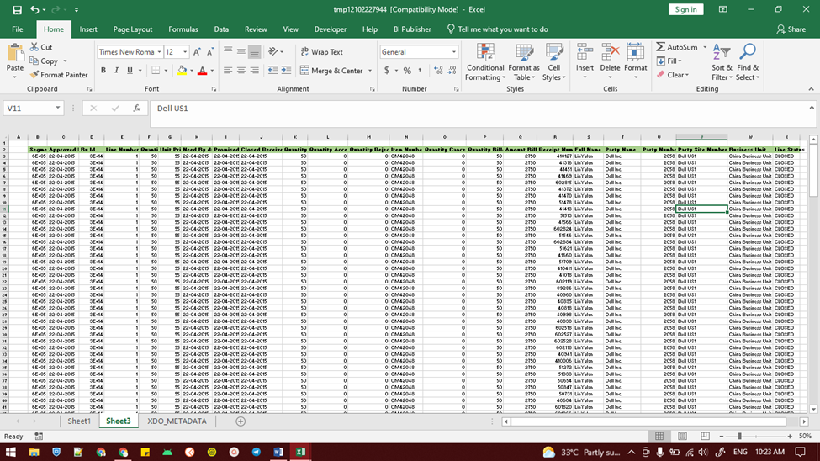

**END**