**VIEW SELECTOR**

**Step:1**

Create an analysis with two columns.

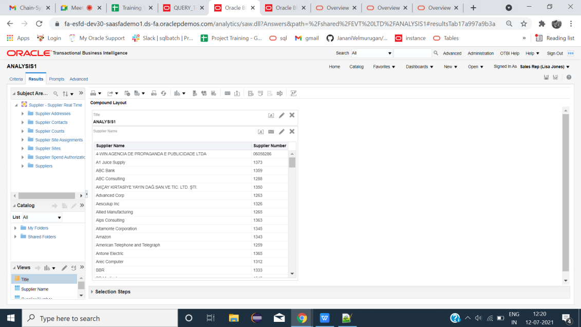

**Step:2**

Create Two tables with the same columns

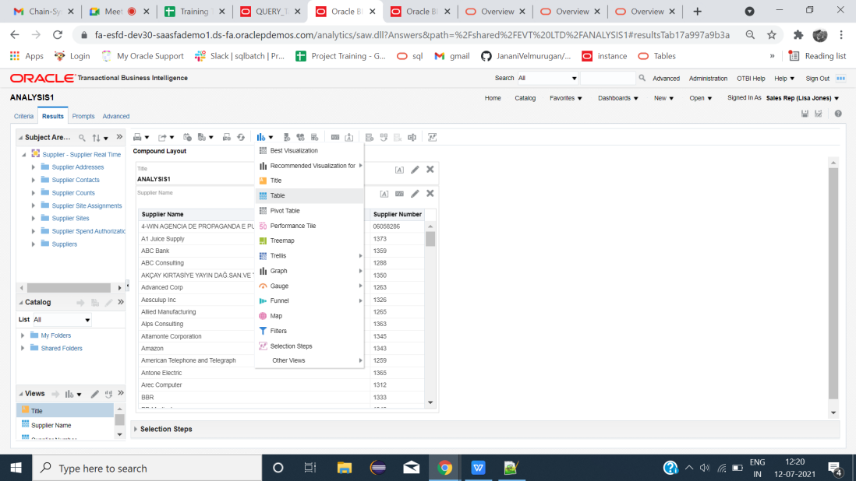

**Step:3**

Exclude the unwanted columns.

|  |  |
| --- | --- |
|  |  |

**Step:4**

Rename the corresponding tables

|  |  |
| --- | --- |
|  |  |

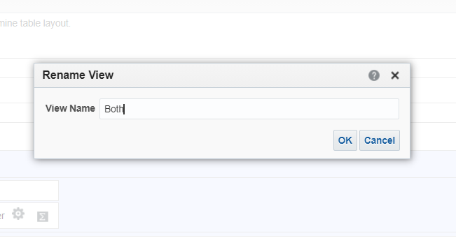

**Step:5**

Click graph icon-->Other views-->View selector

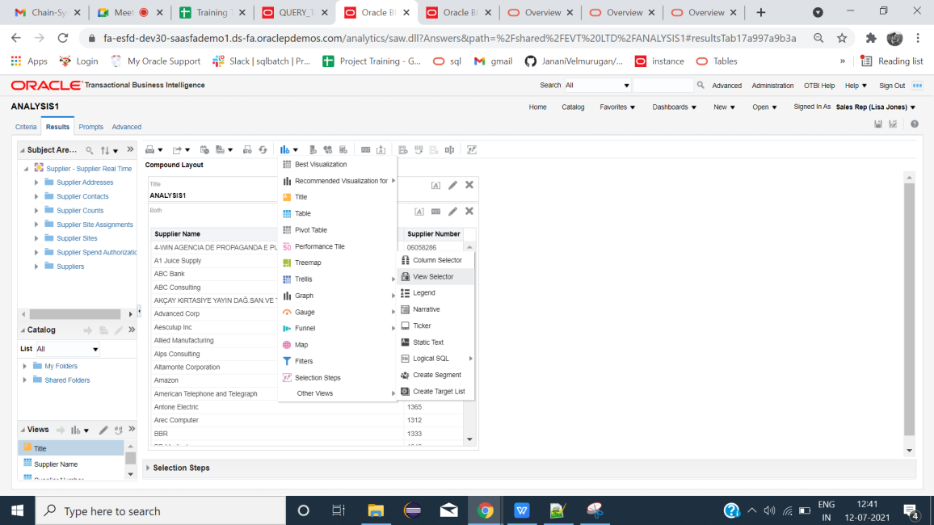

**Step:6**

Insert the needed tables name-->Done

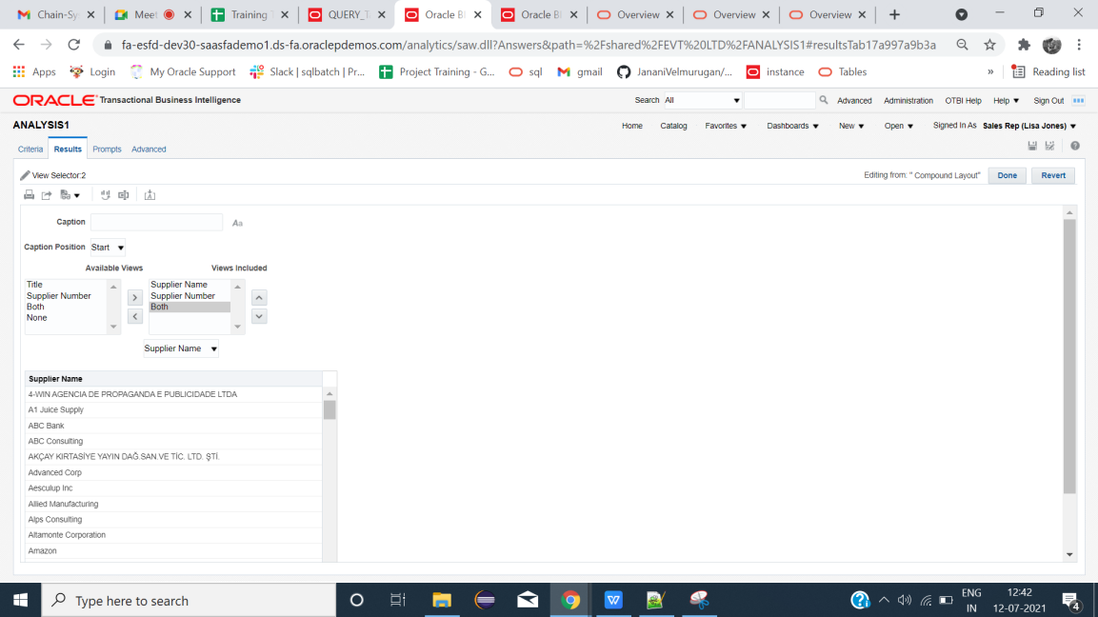

**Step:7**

Remove first three tables from results except view selector.

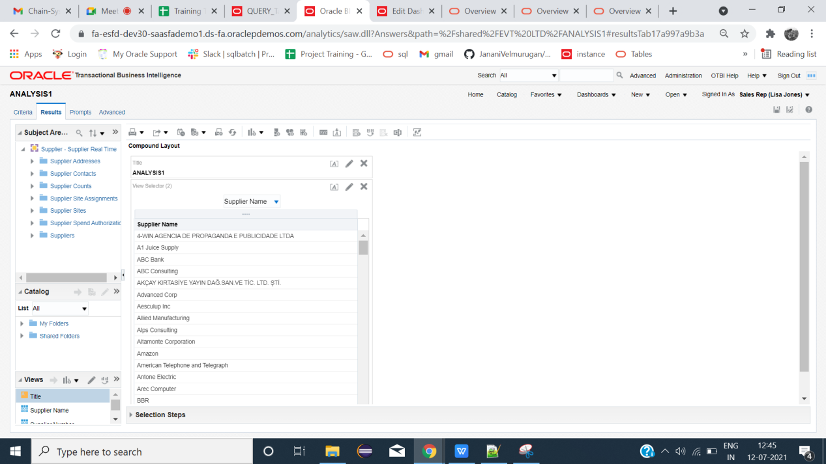

**Step:8**

Create dashboard and insert the analysis-->save-->Run

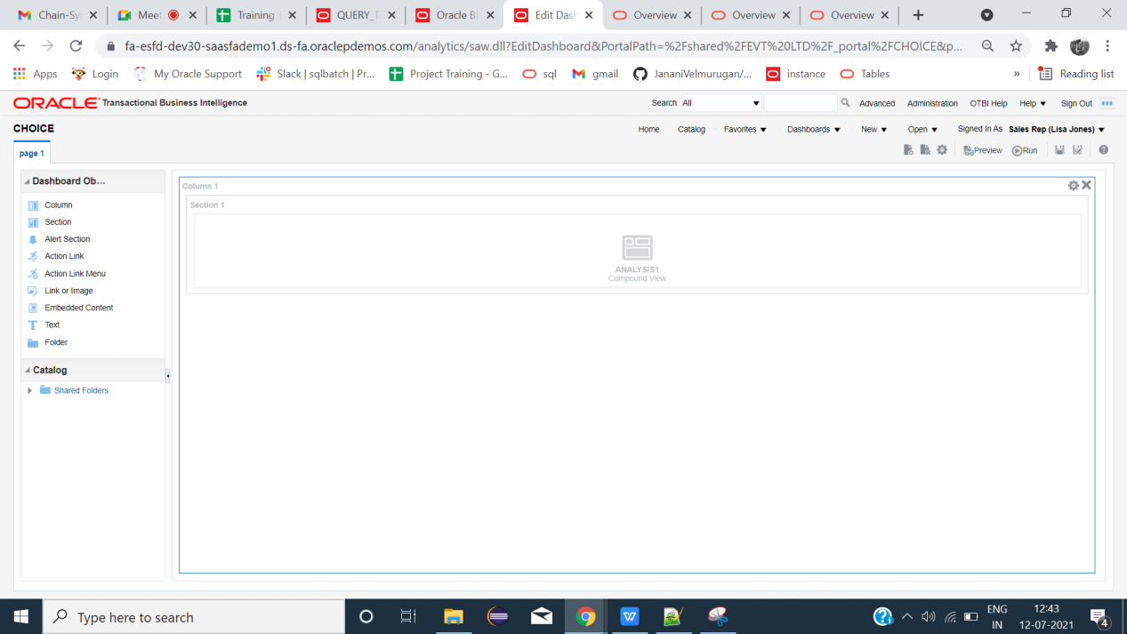

**Result**

Select the needed tables as like prompts.

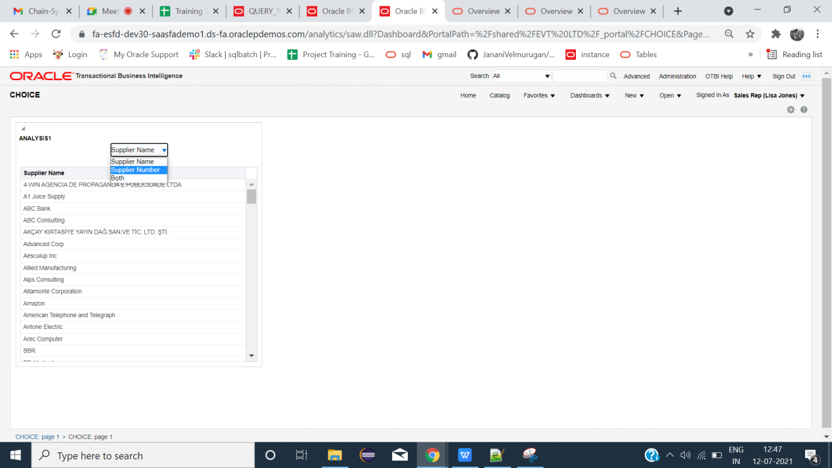

**END**