**AR Aging Report**

**Definition**

Accounts receivable aging (tabulated via an aged receivables report) is a periodic report that categorizes a company's accounts receivable according to the length of time an invoice has been outstanding. It is used as a gauge to determine the financial health of a company's customers.

**Steps involved in BI Report Creation**

* Create New data model
* Querying corresponding report
* If needed create parameters and List of Values/Bursting
* Then view the data model in Table view
* Save the sample data and then save.
* Then export
* Open that file in word remote desktop

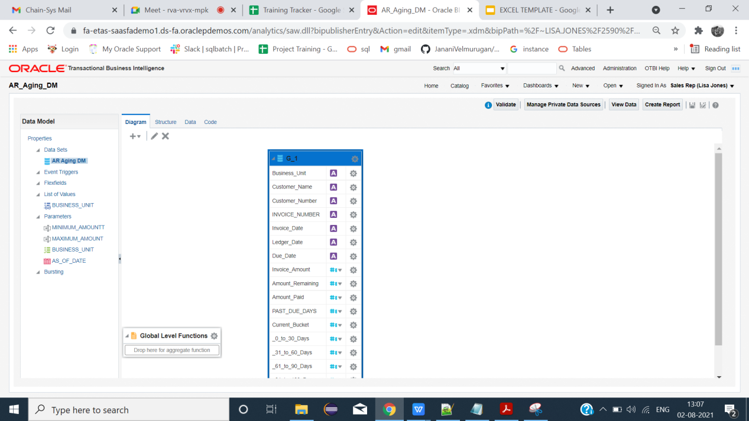

**LIST OF VALUES(LOV)**

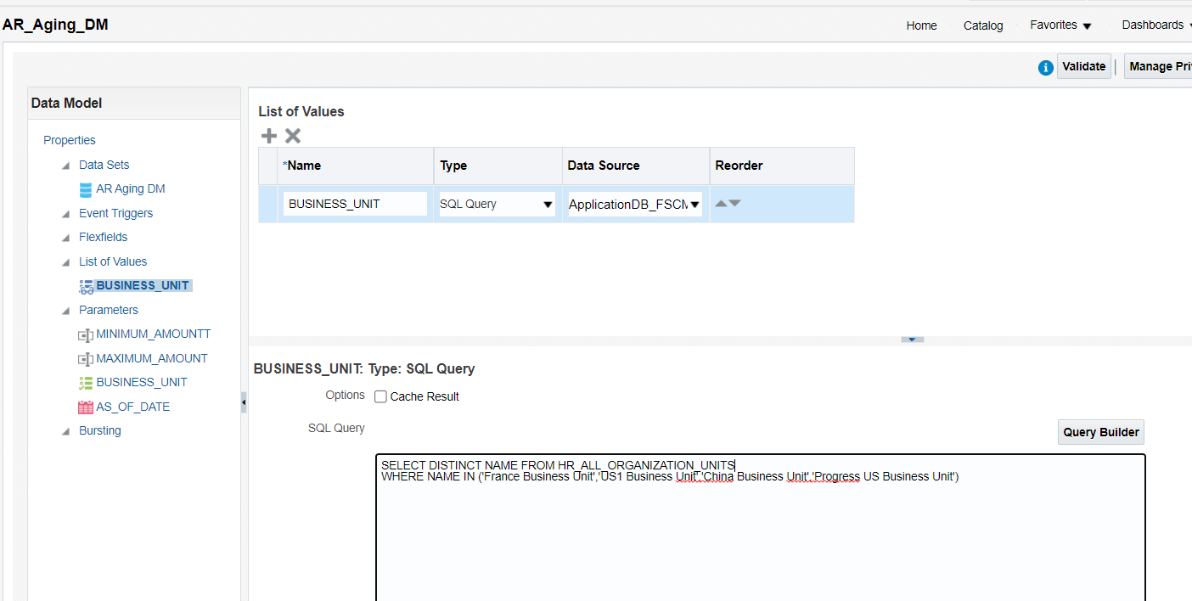

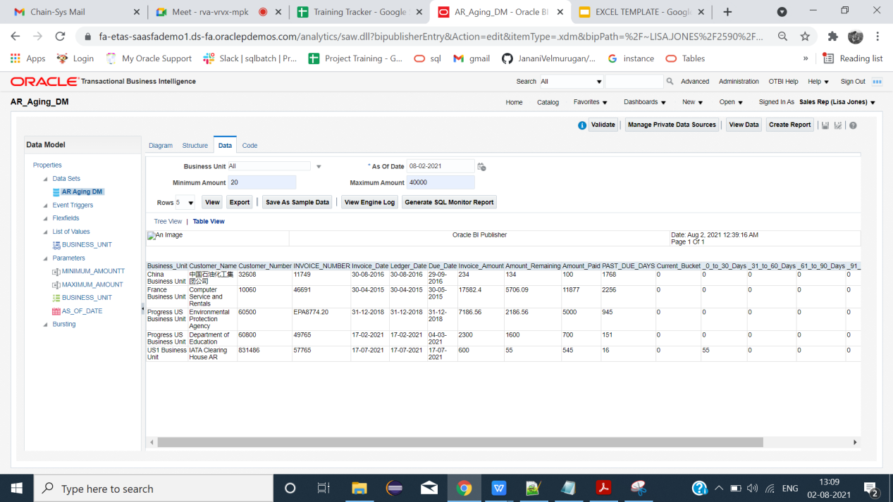

**Steps Involved in Excel Template**

* Open new excel sheet
* Load the sample data
* Then click fields, after clicking Metadata(XDO_METADATA) will be created.
* Create needed column names and insert the fields to its corresponding columns.
* Select the inserted fields and give repeating group.
* Then save in (excel 97-2003 workbook) format and click excel.

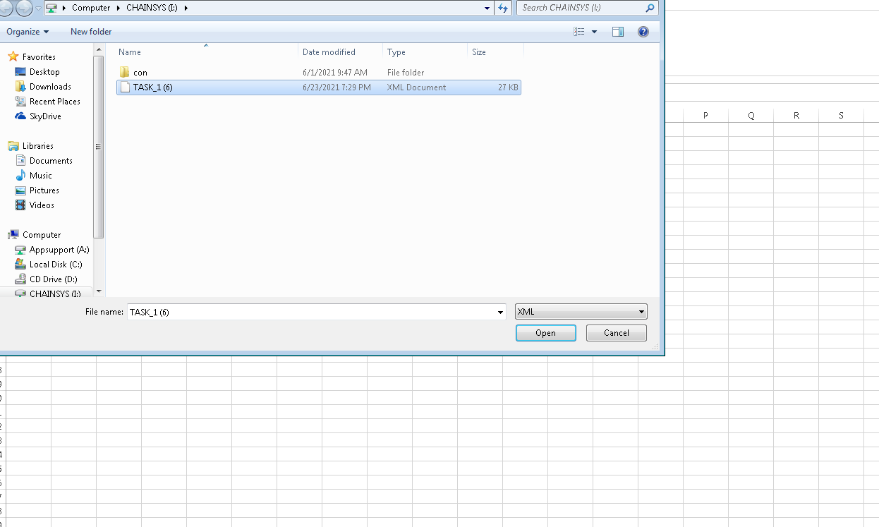

**Template**

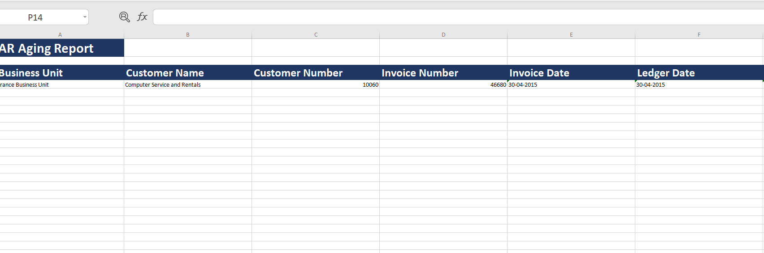

**Report Creation:**

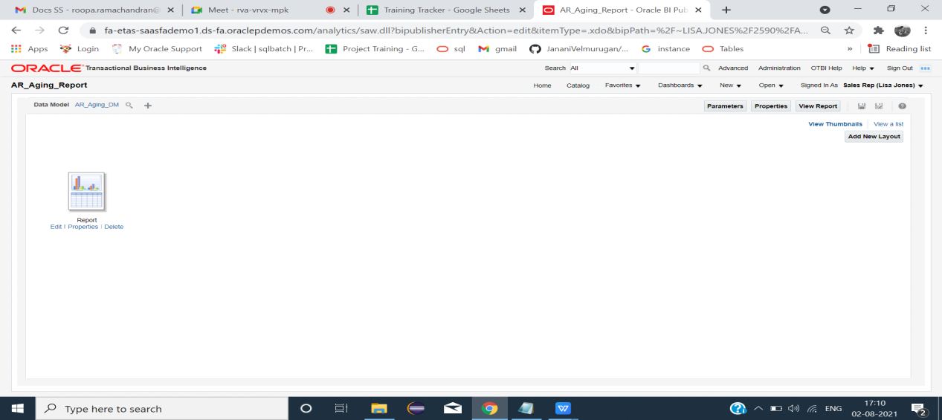

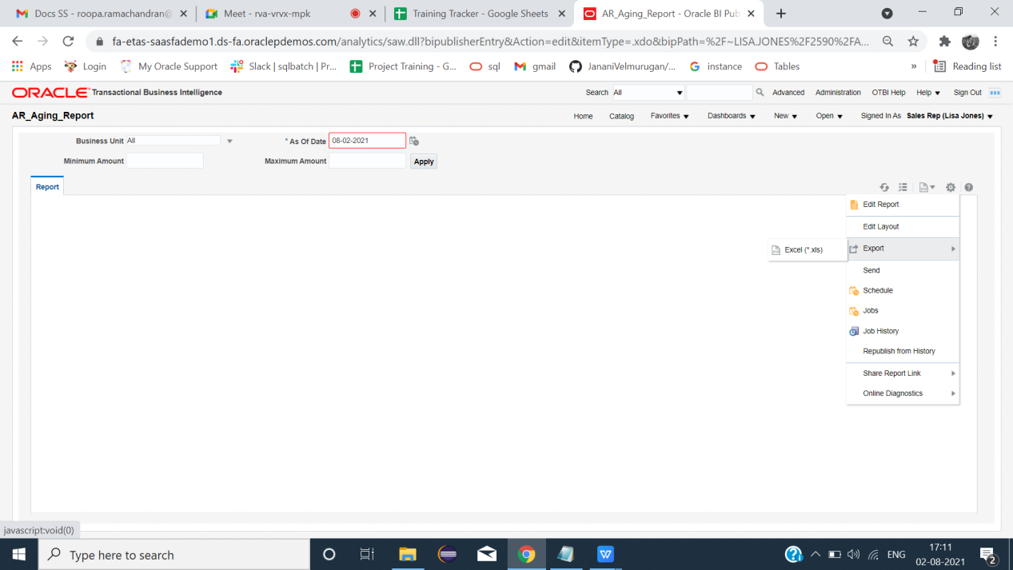

**Report**

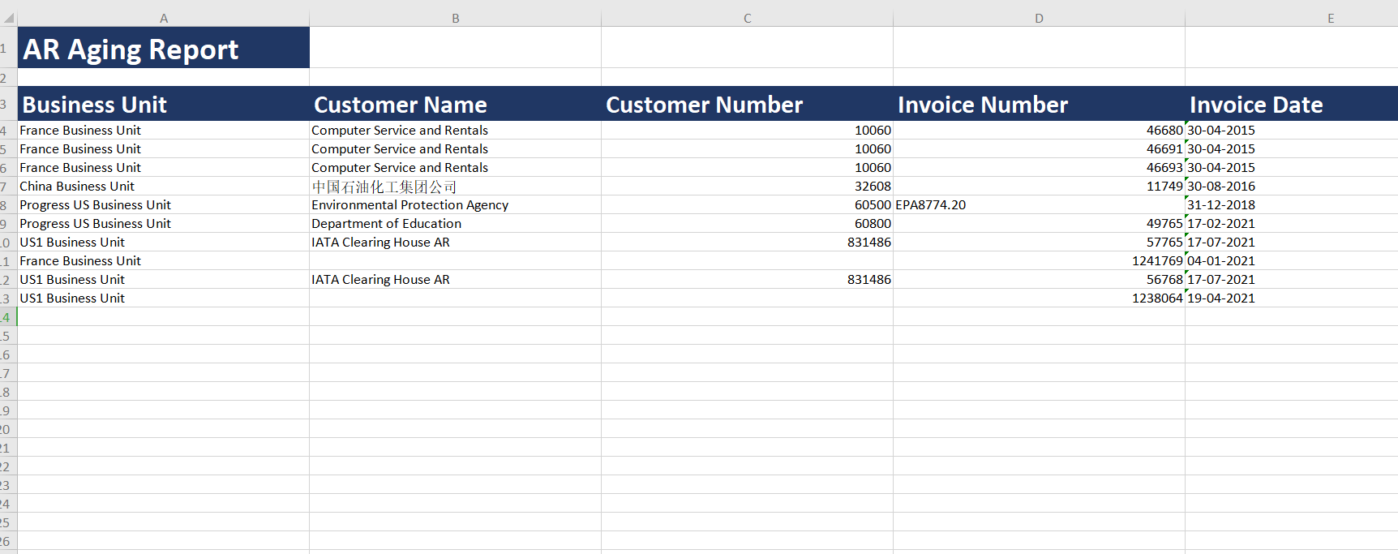

**End**