**TASK 9 - Dynamic Logo and Page Number**

* Create the data model with corresponding columns.
* Navigator--> New --> Data Model --> SQL query.
* Create the data set with parameters.

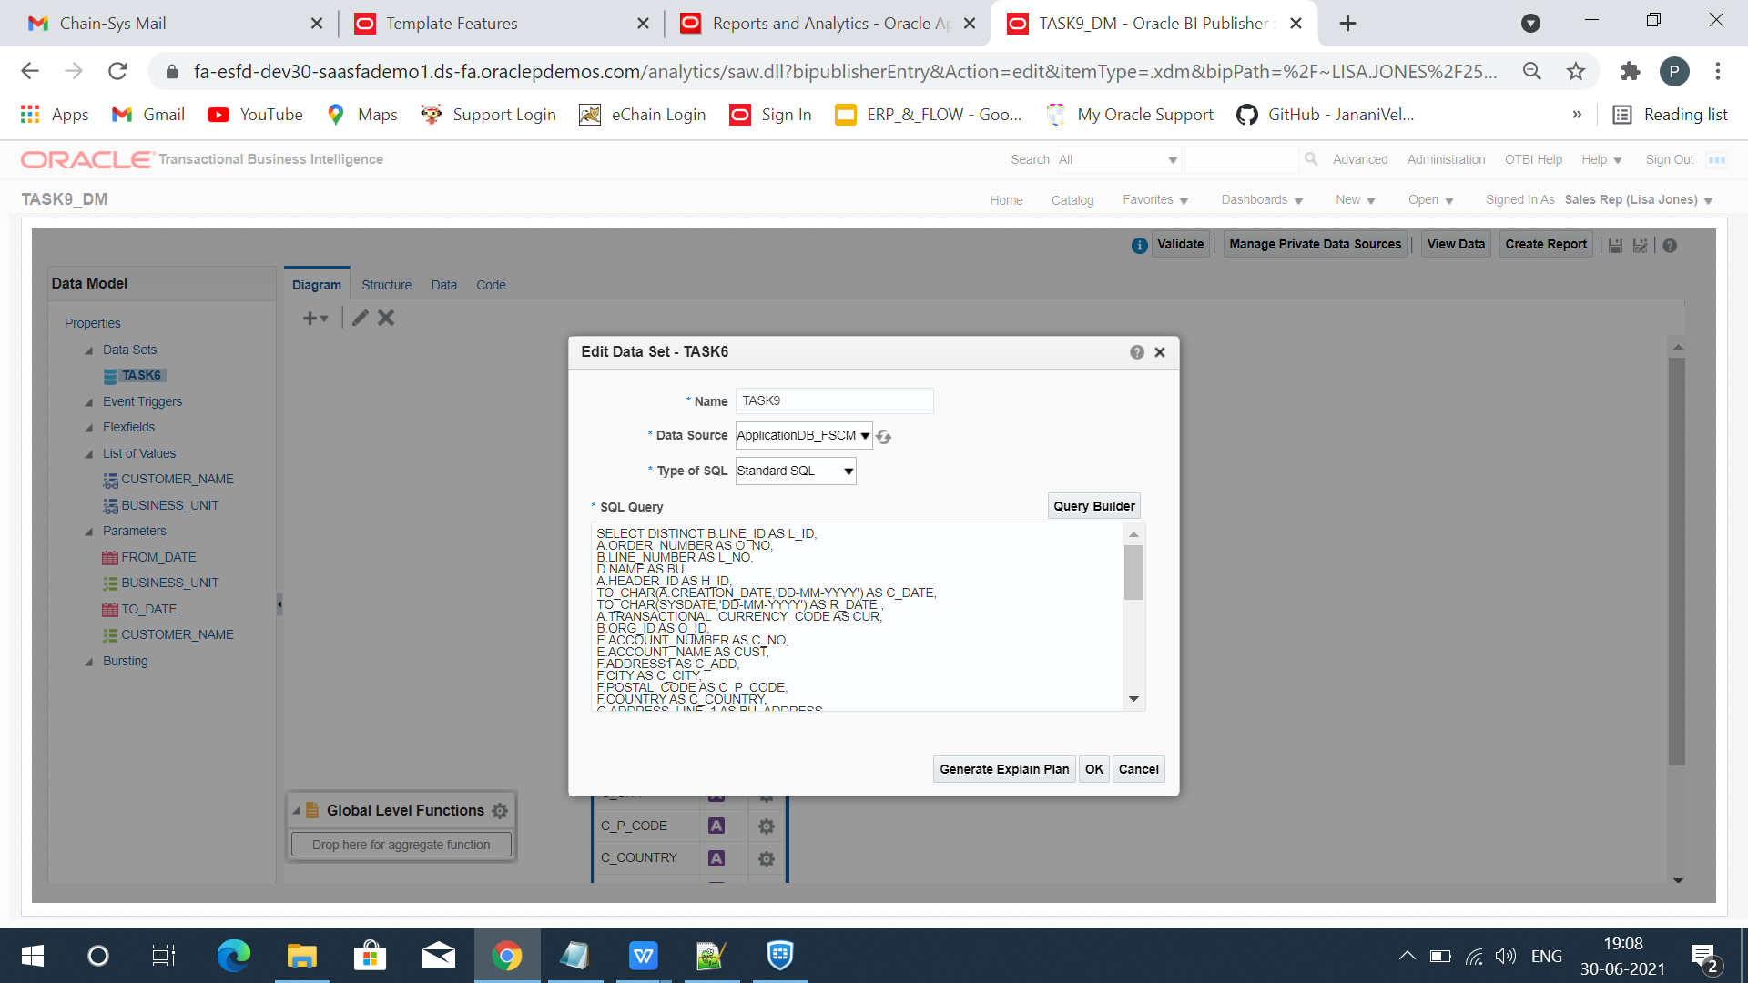

* Create List of values for the parameters.

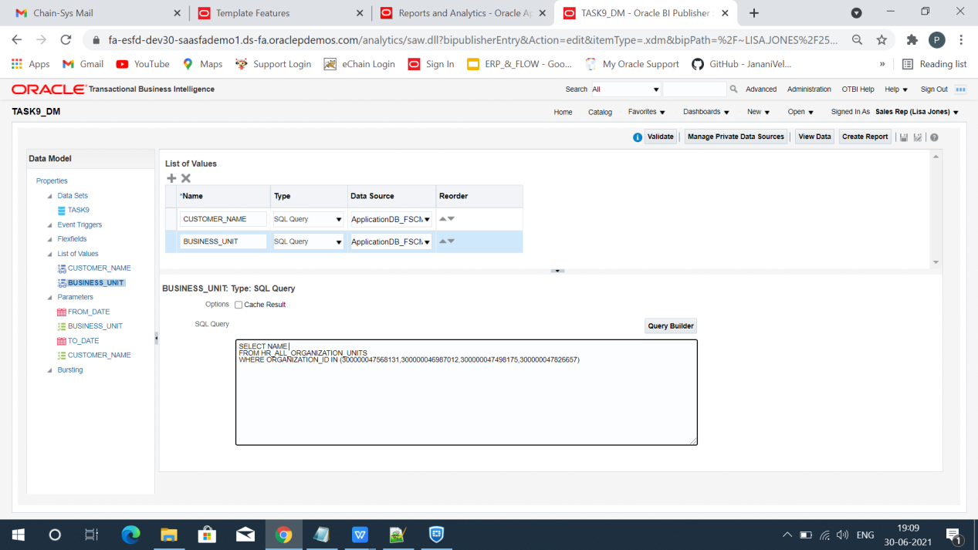

* Map the Parameters with corresponding LOV(s).

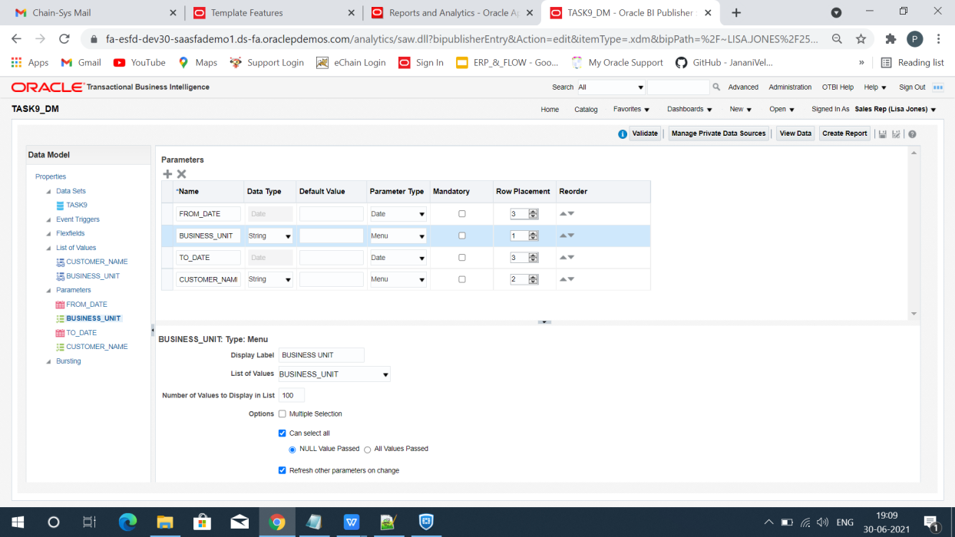

* View the data with 200 rows.
* Click Save as sample data.
* Save and Export the Data Model.

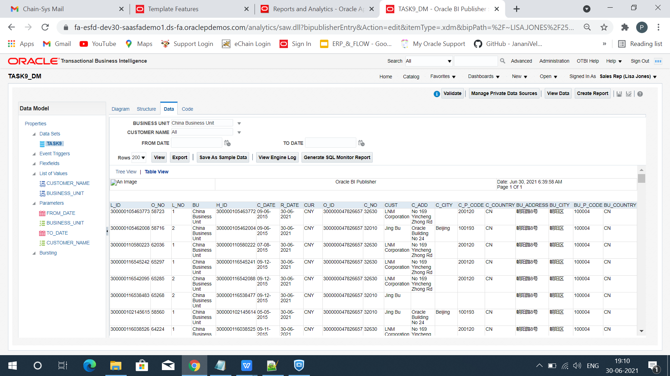

* Load the sample XML data in the BI publisher.
* Design the Layout and insert the elements from the fields menu.

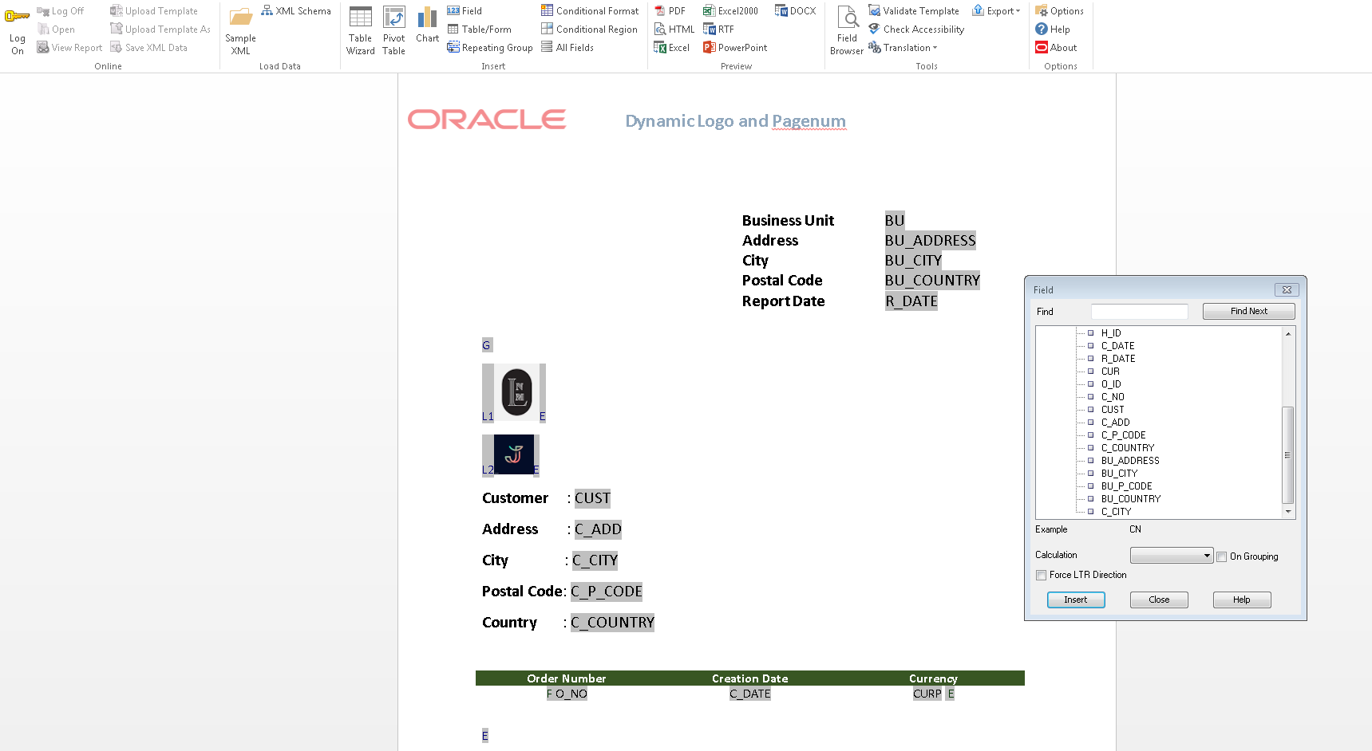

* Use legacy forms in the developer option to create text field.
* Use if condition in the legacy form to set dynamic logo for various Customers.
* Use page break <?split-by-page-break:?> before end group.

* These are the XML code used.

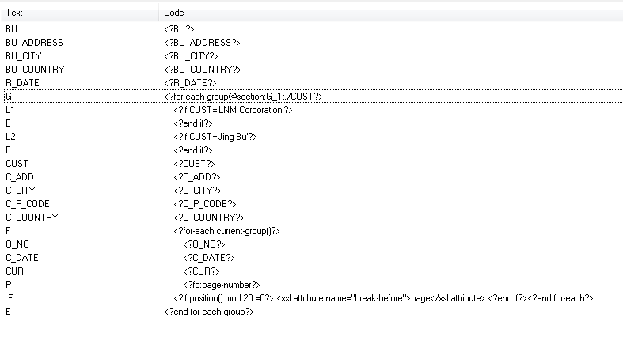

* Save the template in RTF format.
* Navigator --> New --> Report.
* Map the corresponding data model and upload the rtf template.

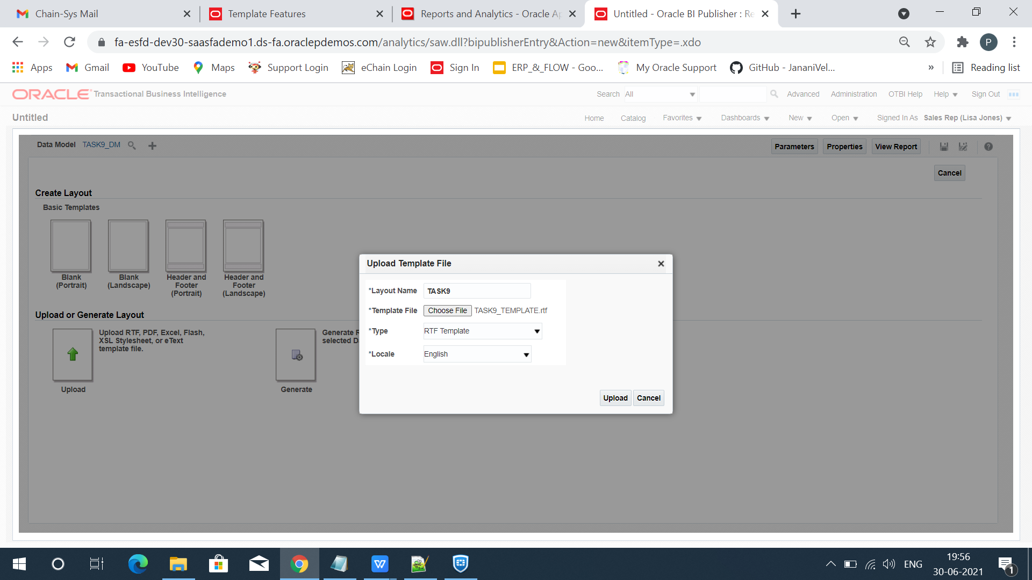

* Save the layout and report.
* Click view report and export it in the PDF format.

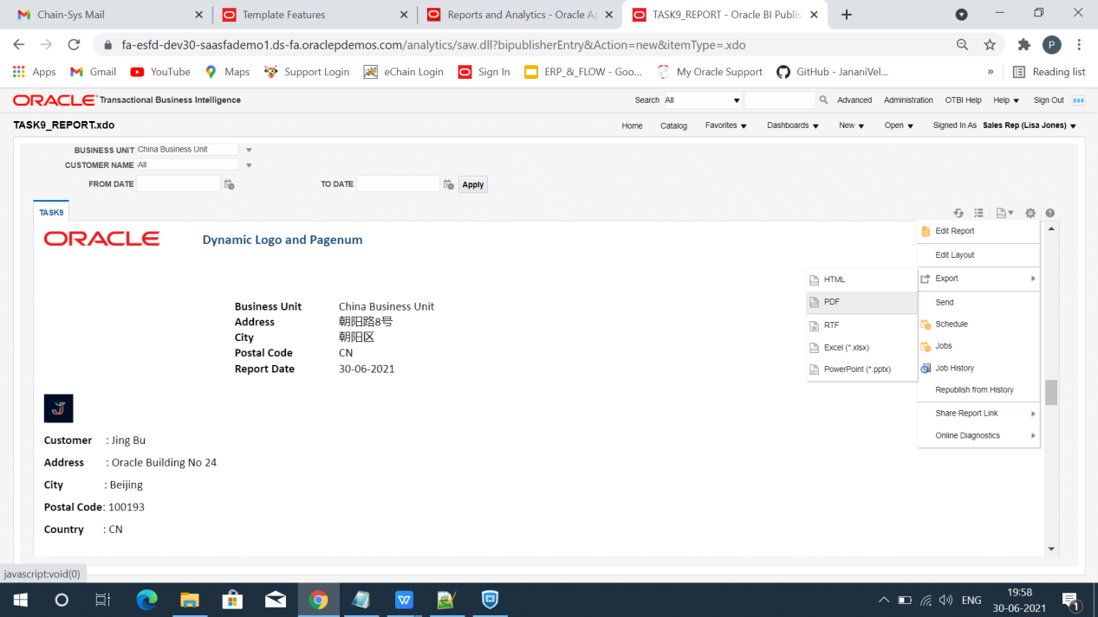

* Report will be downloaded.

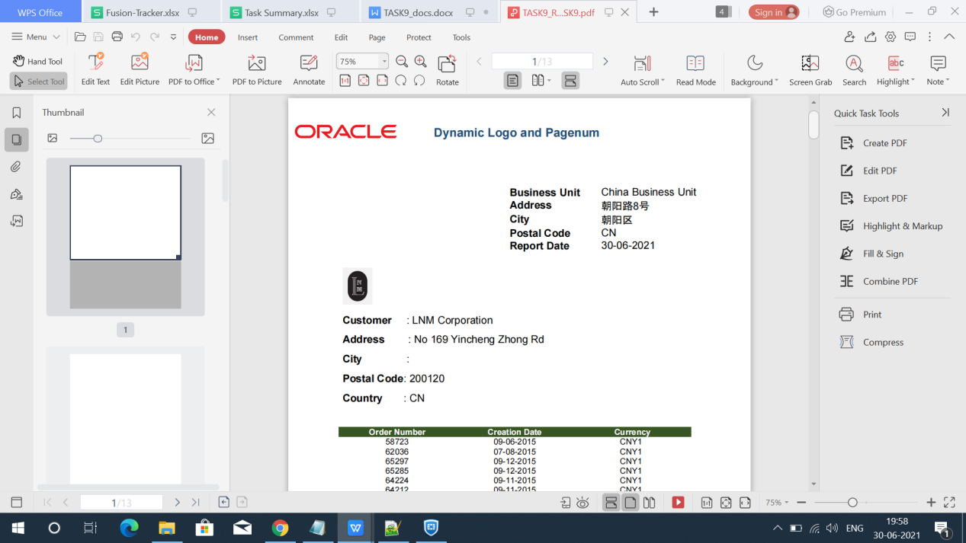

END