

Acknowledgment.

Location : Las Pinas

Date : May 1 2025

**Whereas,** this is to confirm that:

**Maria Lourdes Ligon,**

residing at **Block 5 Lot 2 corner Moses street/ JP Laurel Street** in **Pilar Executive Village,** barangay **Almanza Uno** in the city of **Las Piñas City.**

Has fulfilled all her fees to the home owner association PEVHAI.

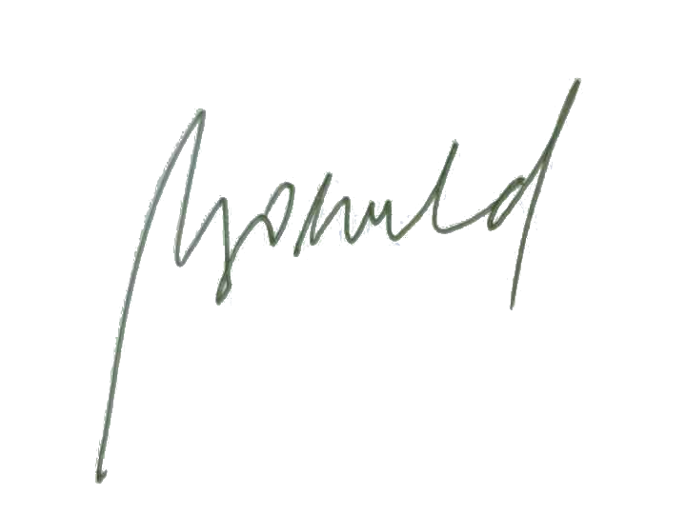

Regards,

Maria Loreta Groeneveld,

Treasurer PEVHAI