April 18, 2025

____________________________

____________________________

____________________________

Sir/Madam;

Greetings!

The Arado Clan will once again be having a family reunion this May 2025. This aims to meet and greet and build stronger bonds among Arado bloodlines around the world. In connection with this, there are many activities that will foster unity, faith, hope and love. There are also chances that will uplift each family members into more responsible citizens in the community through family bonds.

Hence, the said activity will cost expenses that is beyond our limits, since, not all members are financially stable. We are gathering amount for the activity expenses such as the sound system, decoration, mass stipend &offerings and the like.

In view thereof, we appeal before your kind heart to please help us realize such wish to procure these amount. We are very thankful for any amount given.

Above all, thank you so much for sharing part of your blessings Extending help to our family activities can contribute much for our resiliency and empowerment.

Thank you so much for your support and God bless!

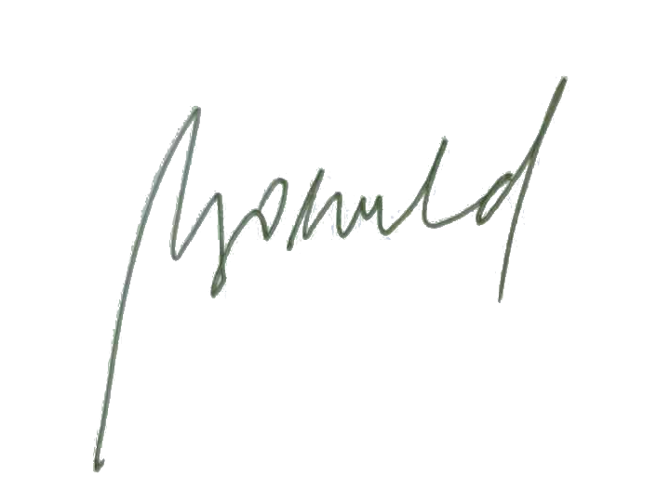 Truly yours,

**MARIA LORETA ARADO - GROENEVELD**

*Arado Clan Treasurer*