March 7, 2024

For : Mr. Jesus M. Salmorin
Vice President
Pilar Development Corporation

Subject : Billing Statements for 2022 and 2023

Dear Sirs:

Greetings!

We are forwarding the Billing Statement for the monthly association dues for the whole year 2022 and 2023

The total amount was computed based on the list of inventory total land area (SQM) multiplied by the rate in Php 2, 5 (P/SQM)

Thank you very much for being a partner in the maintenance and improvement of Pilar Executive Village.

God bless us all

Don Tablizo,
PEVHAI, President

BILLING STATEMENT

LOT AREA, SQM | RATE, Php/SQM | AMOUNT, PHP
10,594 | 2.50
 | Unpaid billing: January 2022  December 2022 | 313530
 | Unpaid billing January 2023  December 2023 | 313530
 | Total | 627060

Prepared by:
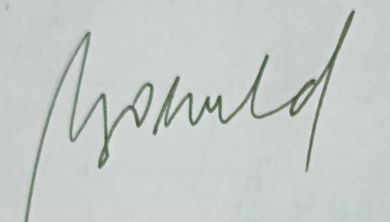

MARIA LORETA A. GROENEVELD
PEVHAI, Treasurer

