Experiment-10
Student Name: Rishma Garg UID: 19BCS6063
Branch: 19AITAIML-1 Section/Group: 1-B
Semester: 6th Date of Performance: 13/05/2022
Subject Name: Network Operating System Lab Subject Code: CSP-396

- Aim/Overview of the practical: Install Active Directory Domains Services in Windows 2008: Installing a new forest by using the graphical user interface (GUI)

- Task to be done: Install Active Directory Domains Services in Windows 2008: Installing a new forest by using the graphical user interface (GUI).

- Steps for experiment/practical:
1. Press the Start Menu button and click on the Server Manager icon which is the management tool in Windows Server 2016.
2. Active Directory Domain Services is a Windows Server role. Click on Add Roles and features option to install the role.
3. In the Before you begin you have nothing to do. Click on Next button. In the Select Installation Type page, Select the Role-based or Feature-based Installation option. Click Next on button.
4. Let the Select a server from the server pool option selected. Specify the server that you want to install the role on, from the Server Pool. Click on Next button.
5. Select the Active Directory Domain Services role. A new windows opens and ask you to install management tools. Installing AD DS role, you just install the core services. Click on Add Features button to install management tools. then click on Next button.
Create a forest using GUI In windows Severs
Step 1: Open the server Manager and click on Manage and then add roles and features.
Step 2 : Select the server Roles as (Active directory Domain Services) and click on add features
Step 3 : Click Next ,Next and Install
Step 4: After Installation Select Add a new forest in deployment configuration and enter Root domain name as NET.COM and click on next.
Step 5: Set password and confirm the password and click on next
Step 6 : After next installation progress appear and then system restart.

- Screenshots of performed task.

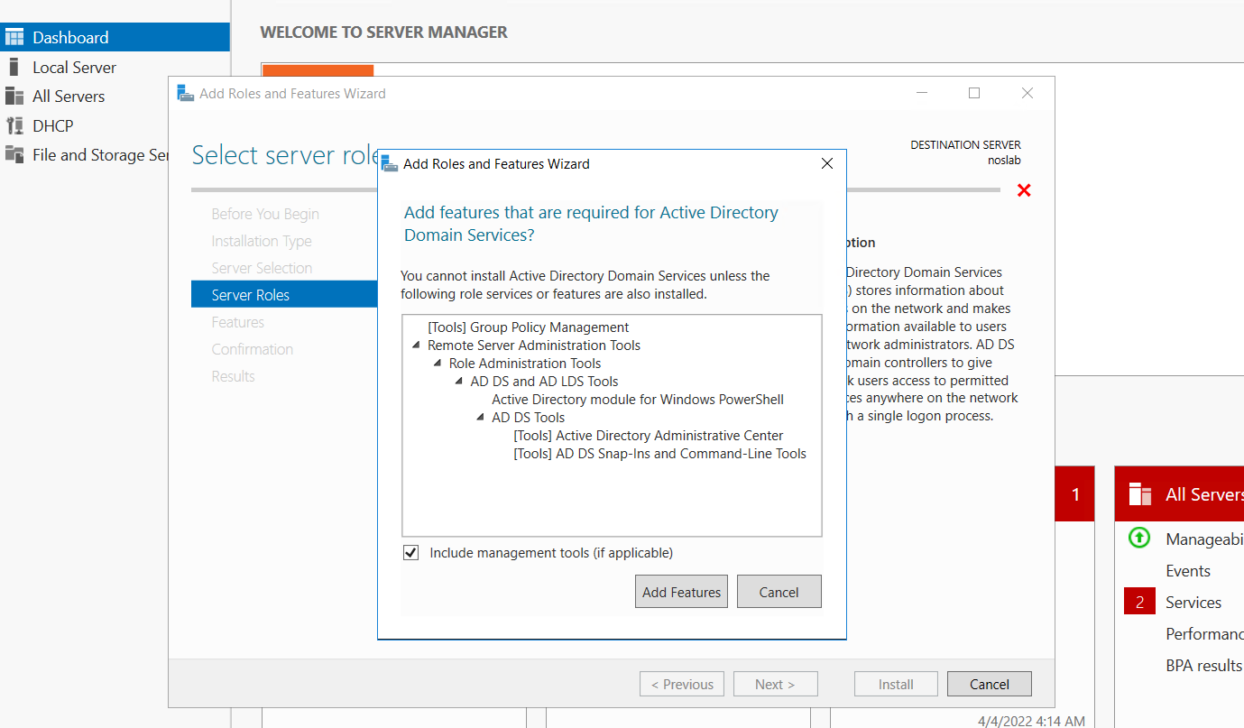

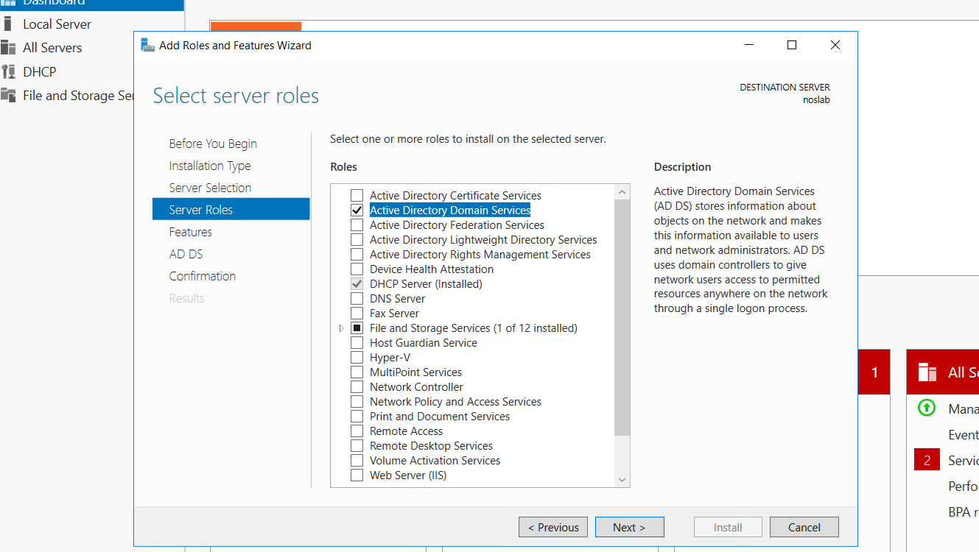
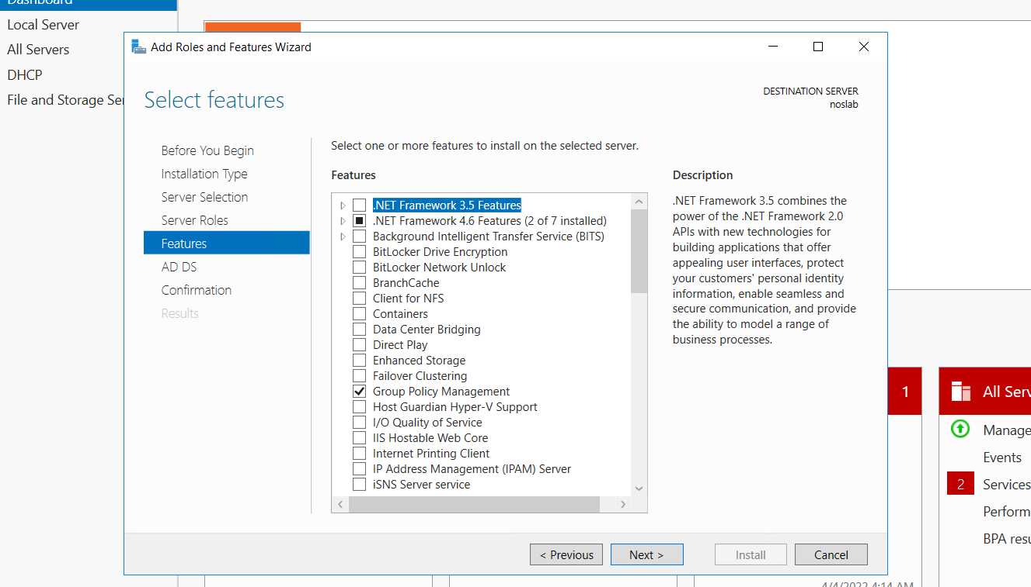

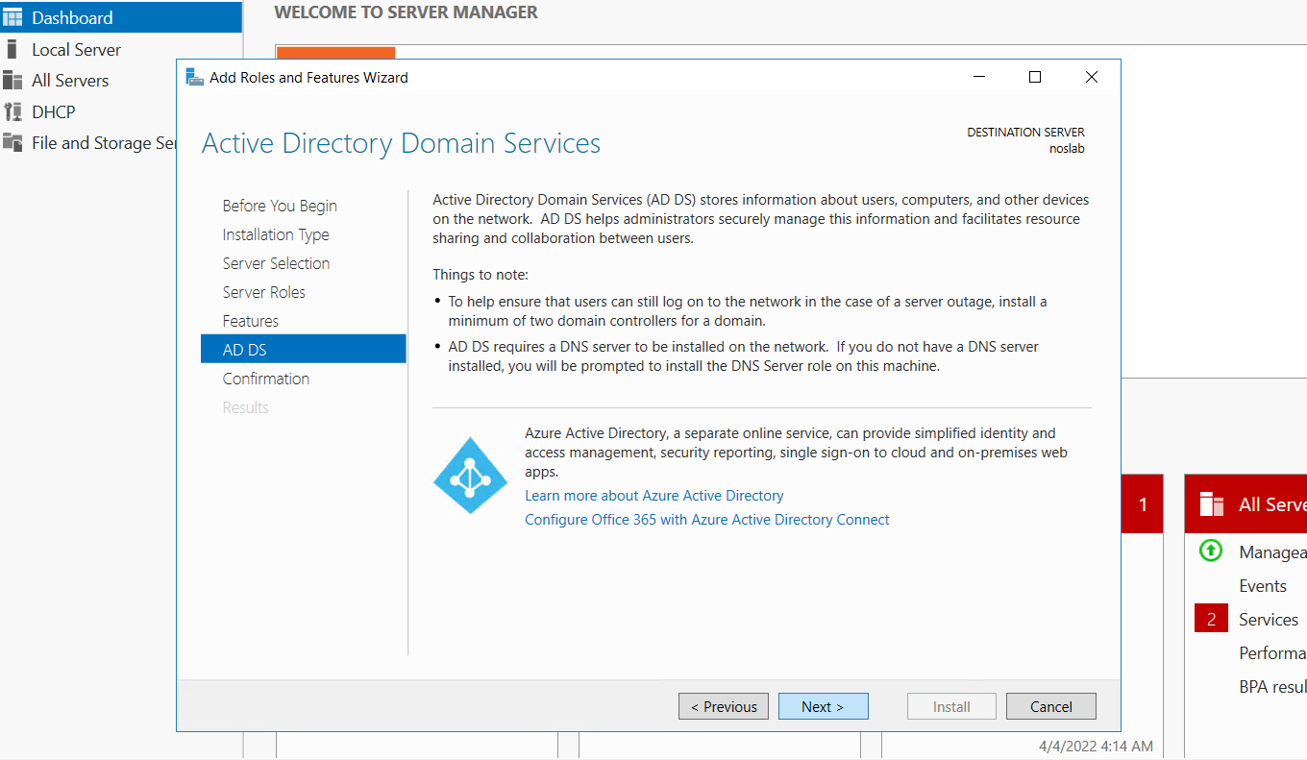
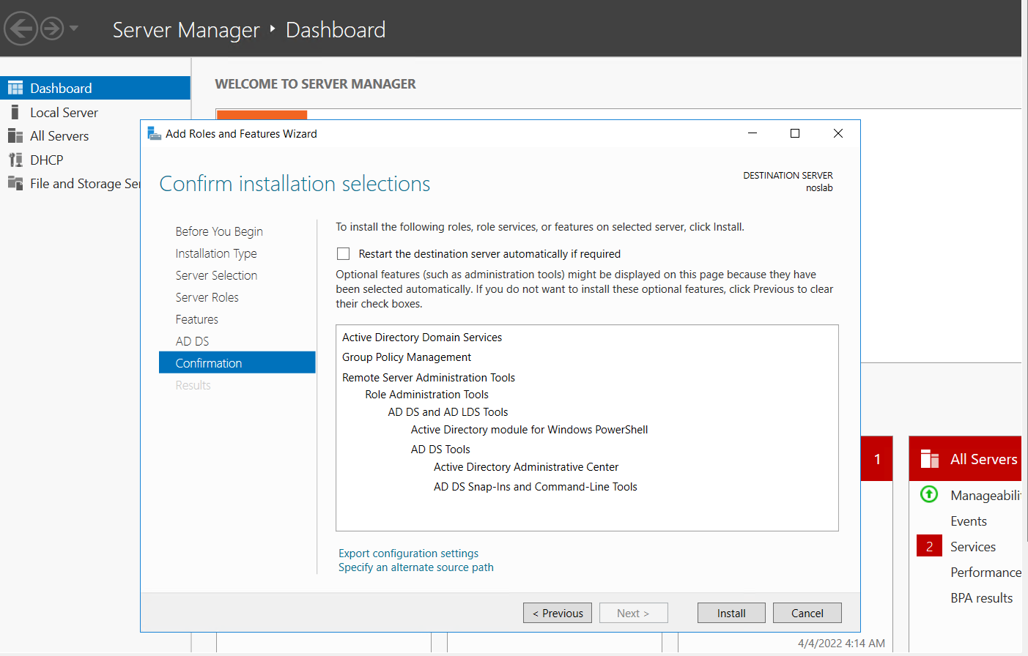
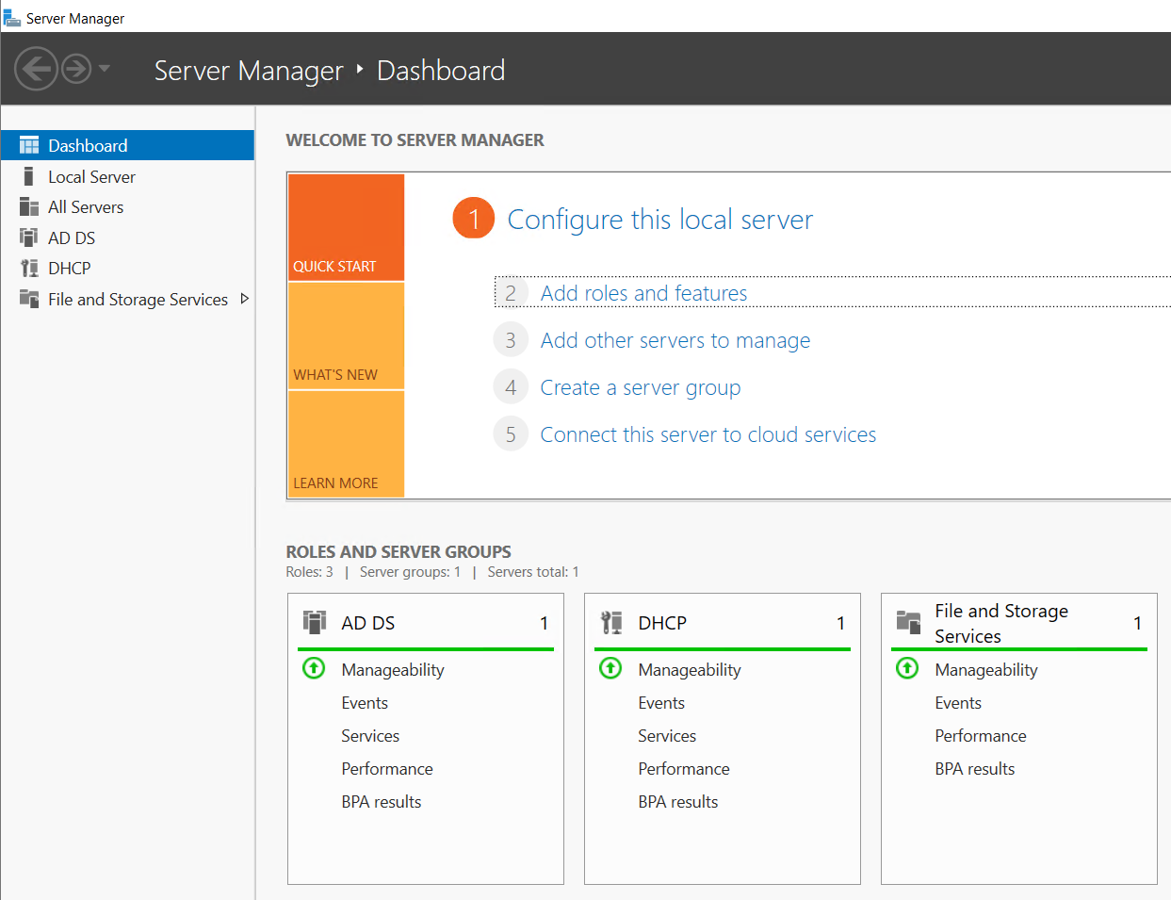
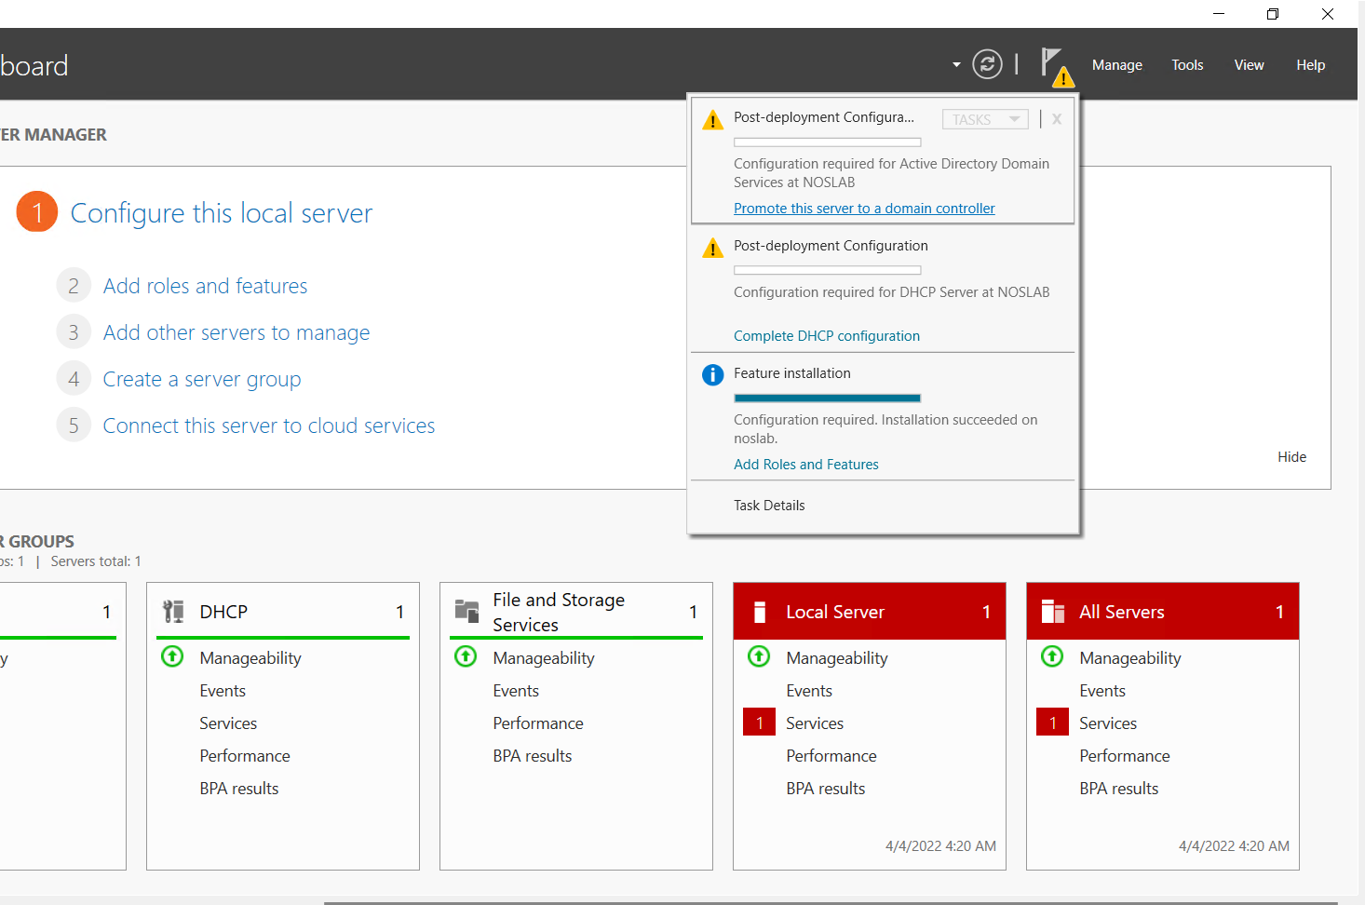

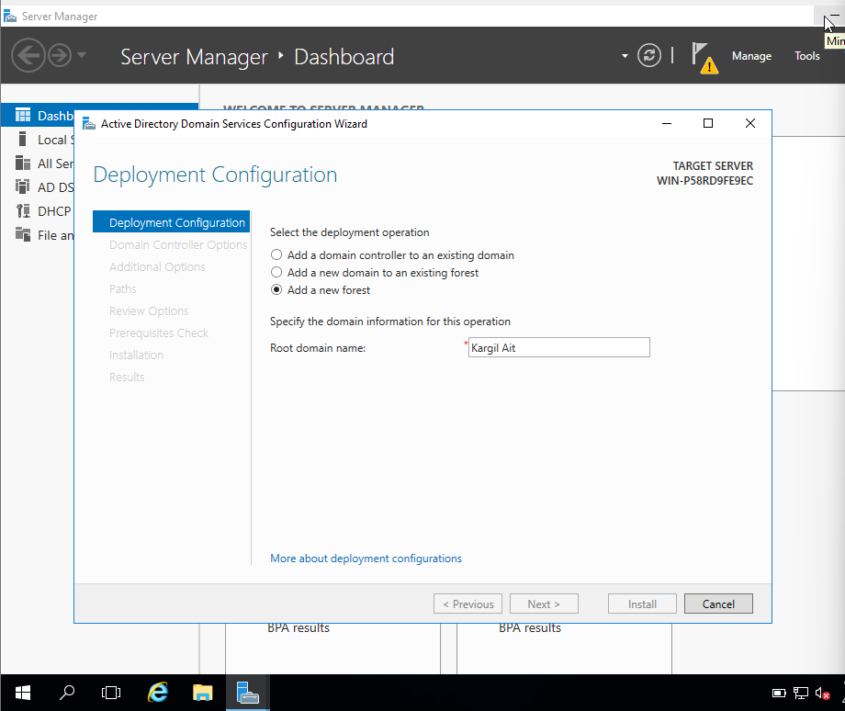
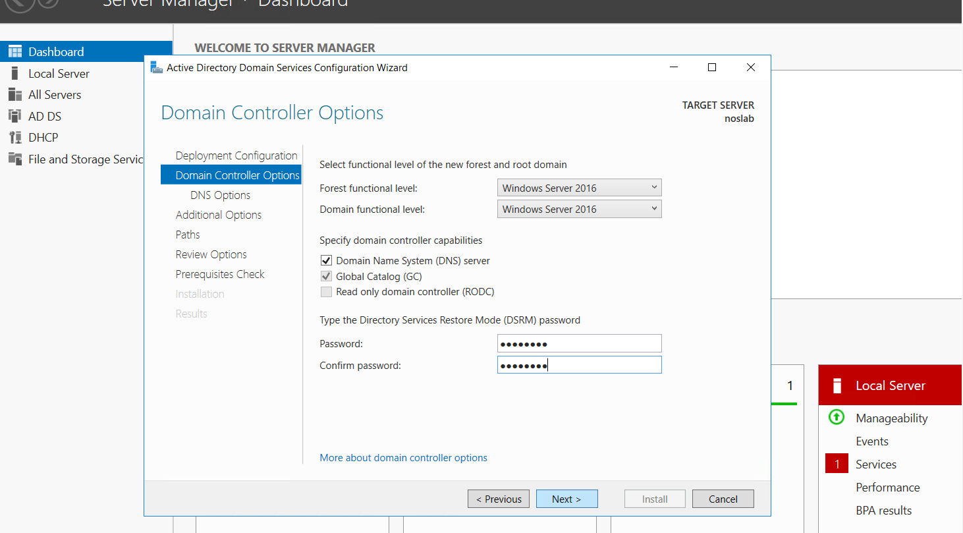
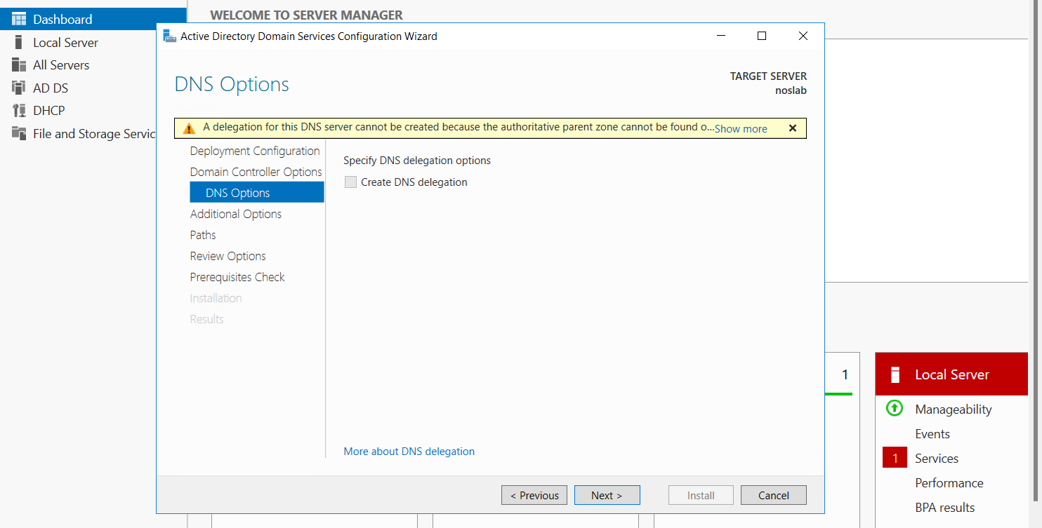

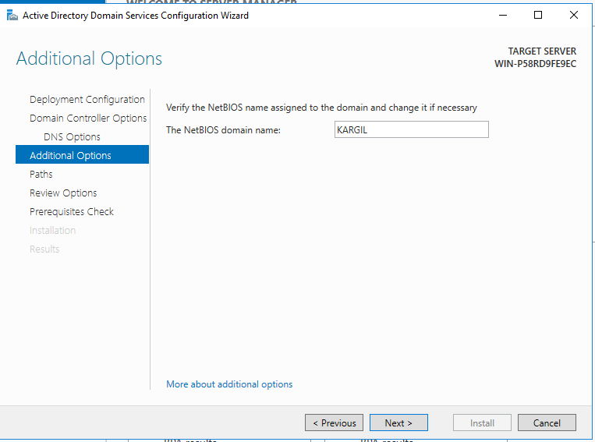

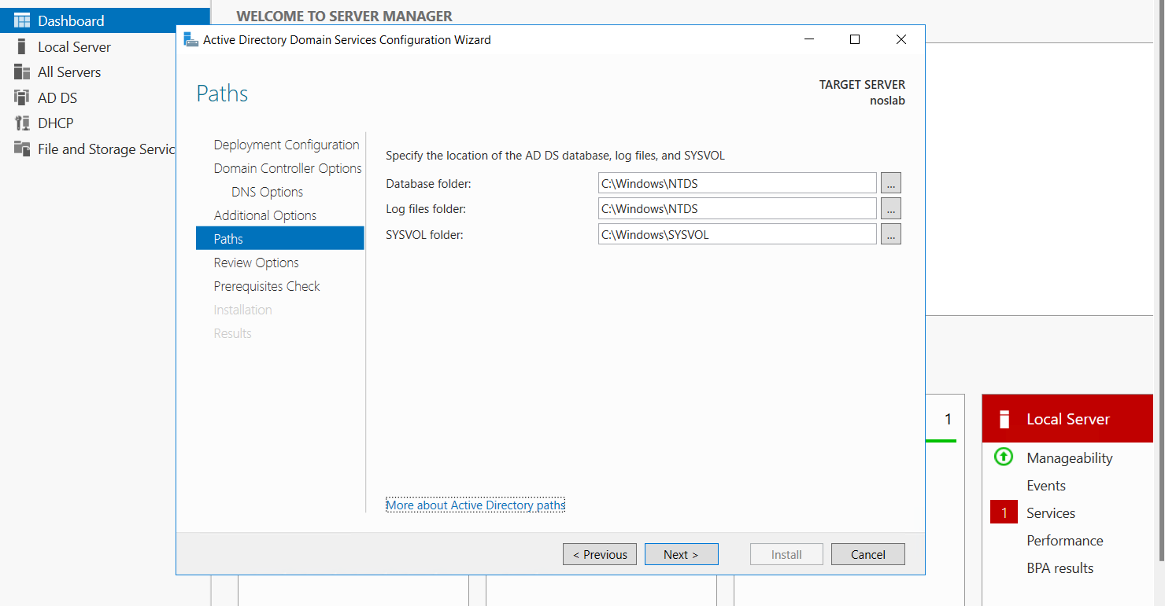
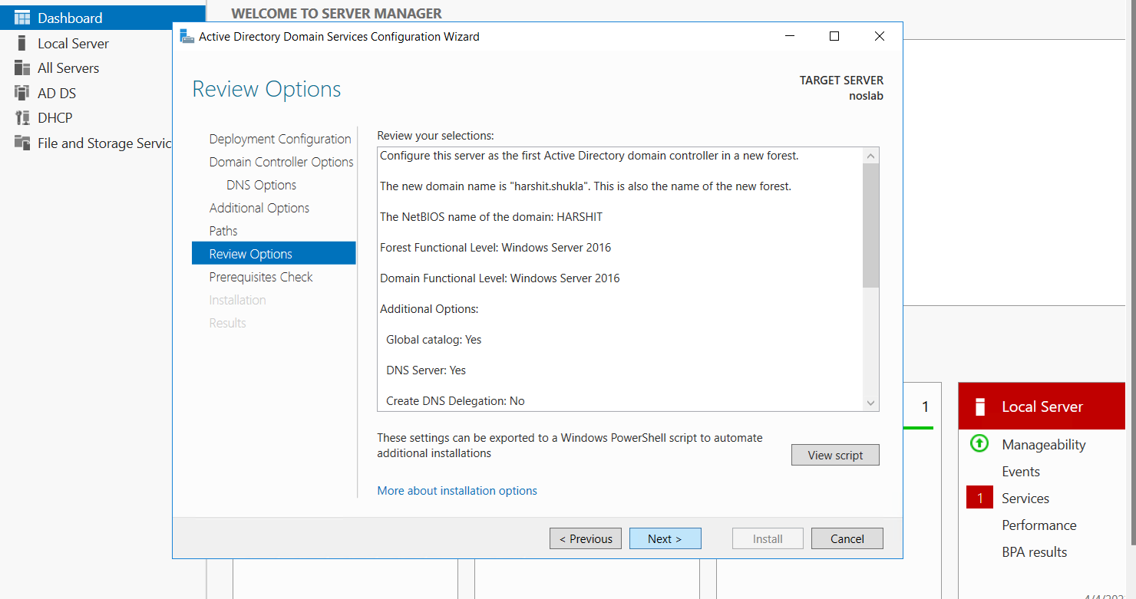

Learning outcomes (What I have learnt):
1. Add new role and features
2. Add active directory domain server
3. Working with GUI for installing ADDS
4. Configuring ADDS
5. Creating a new forest with the help of GUI

