PF-Caelus User Manual
Comprehensive Weather Intelligence Platform

Table of Contents

1. Introduction & Overview
PF-Caelus is a next-generation weather intelligence platform that bridges the gap between professional meteorological tools and consumer-friendly applications. By integrating high-fidelity data from OpenWeatherMap and NASA GIBS, PF-Caelus provides a unified interface for monitoring global weather patterns.

- The platform features a unique dual-view architecture:
  - 2D Map View: Powered by Leaflet, optimized for detailed local analysis, navigation, and precise measurements.
  - 3D Globe View: Powered by CesiumJS, offering a realistic planetary perspective ideal for understanding large-scale atmospheric systems.

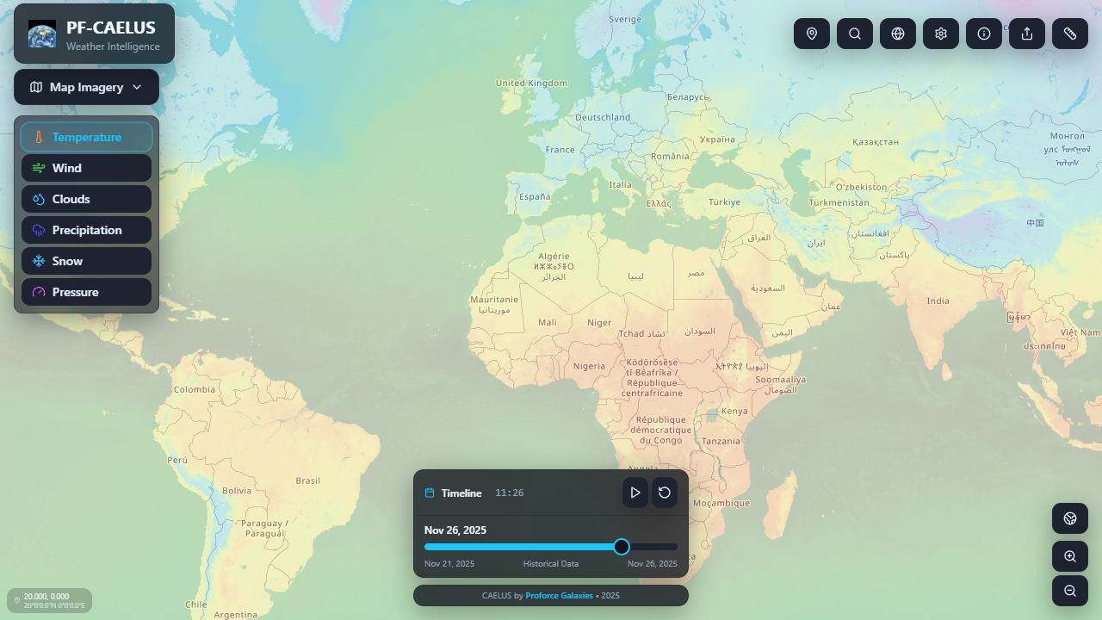
Figure 1: PF-Caelus 2D Map Interface

2. Business & Strategy

Market Positioning
PF-Caelus targets the 'Prosumer' market—users who need more than basic icons but find industrial GIS software too complex. This includes aviation enthusiasts, maritime planners, agricultural consultants, and outdoor event organizers.

SWOT Analysis
Strengths | Weaknesses
• Dual-view (2D/3D) capability  • Real-time AI summaries  • No subscription required (BYO Keys) | • Heavy browser resource usage (3D)  • Dependency on external APIs
Opportunities | Threats
• Mobile app expansion  • Enterprise API integration  • Historical climate data analysis | • API pricing changes  • Competitor platform consolidation

3. Technical Documentation

System Architecture
The application is built as a client-side Single Page Application (SPA) using React 18 and Vite. It leverages a component-based architecture where the map state is managed globally via React Context.

Technology Stack
Component | Technology | Purpose
Frontend Framework | React 18 + TypeScript | UI Logic & Type Safety
Build Tool | Vite | Fast development & bundling
2D Mapping | Leaflet + React-Leaflet | Lightweight map rendering
3D Mapping | CesiumJS + Resium | High-fidelity globe rendering
Styling | Tailwind CSS + shadcn/ui | Responsive & modern UI
State Management | React Context + Hooks | Global settings & map state
Data Fetching | Fetch API + Custom Caching | API integration with TTL cache

Data Flow
- 1. User Interaction: User clicks map or searches location.
- 2. State Update: Coordinates updated in global state.
- 3. Cache Check: System checks in-memory `weatherCache` for valid data (< 5 mins old).
- 4. API Call: If stale, fetches from OpenWeatherMap (Current, Forecast, Air Pollution).
- 5. AI Processing: Raw data sent to AI service (OpenAI/Gemini) for natural language summary.
- 6. Rendering: UI updates with weather panel and map markers.

4. Core Features

Weather Layers
The application supports multiple overlay layers that can be toggled independently:
Layer Name | Data Source | Visualization
Temperature | OpenWeatherMap | Heatmap gradient (Blue -> Red)
Precipitation | OpenWeatherMap | Rain/Snow intensity radar
Wind Speed | OpenWeatherMap | Velocity streamlines
Clouds | OpenWeatherMap | Cloud cover opacity
Pressure | OpenWeatherMap | Isobaric lines
Satellite (3D) | NASA GIBS | True-color satellite imagery

Interactive Tools
- • Measurement Tool: Calculate precise geodesic distances between points.
- • Location Search: Geocoding to find any city or coordinate worldwide.
- • User Locator: One-click zoom to current device location.

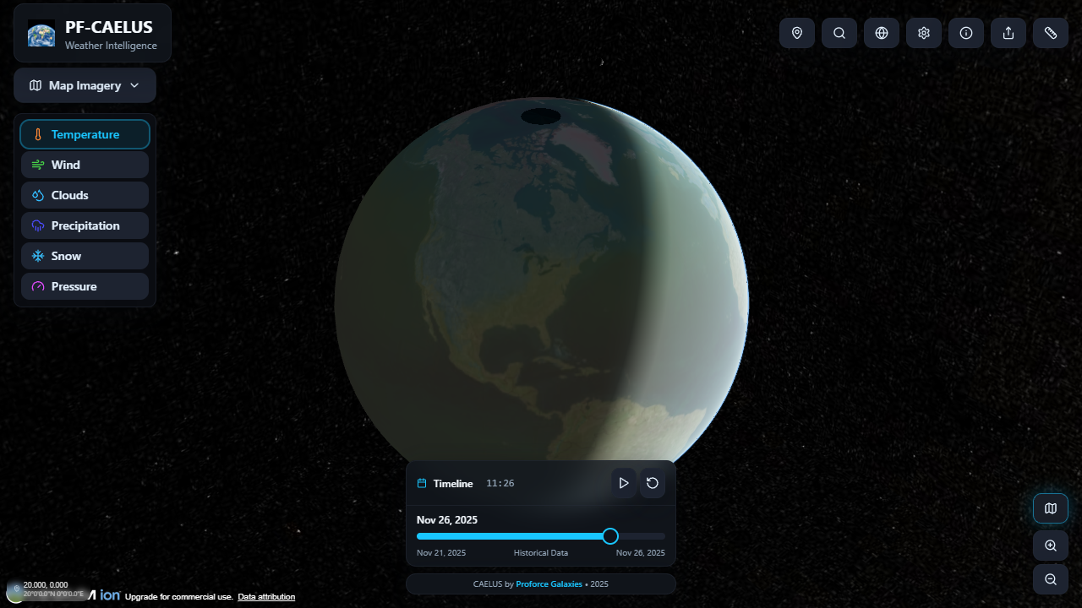
Figure 2: PF-Caelus 3D Globe View with Satellite Imagery

5. User Guide & Training

Basic Navigation
- • Pan: Click and drag the map.
- • Zoom: Use scroll wheel or +/- buttons in bottom right.
- • Rotate (3D): Hold right mouse button and drag to tilt/rotate.

Using Tools
1. Measuring Distance:
- a. Click the ruler icon in the top header.
- b. Click the starting point on the map.
- c. Click the ending point. The distance will appear in a popup.
2. Changing Units:
- a. Click the Settings (gear) icon.
- b. Select your preferred units for Temperature (C/F), Wind (km/h, mph, knots), etc.

6. Deployment & Maintenance

Prerequisites
- • Node.js v18 or higher
- • NPM (Node Package Manager)

Environment Configuration
Create a .env file in the root directory with the following keys:
Variable | Required | Description
VITE_OPENWEATHER_KEY | Yes | API key from OpenWeatherMap
VITE_CESIUM_TOKEN | Yes | Access token for Cesium Ion
VITE_GIBS_API_KEY | No | Optional key for NASA GIBS
VITE_OPENAI_KEY | No | Optional key for AI summaries

Build Commands
- • Development: `npm run dev`
- • Production Build: `npm run build`
- • Preview Build: `npm run preview`

7. Security & Compliance

Data Privacy
- • Location Data: User location is requested via the browser Geolocation API. This data is processed locally to fetch weather and is never stored on PF-Caelus servers.
- • API Keys: Keys are stored in environment variables. For production deployment, it is recommended to proxy API requests through a backend to prevent key exposure.

8. Future Roadmap
Quarter | Feature | Description
Q1 2026 | Mobile Native App | React Native port for iOS and Android.
Q2 2026 | Historical Data | Access to 40-year historical weather archive.
Q3 2026 | User Accounts | Save favorite locations and custom layer presets.
Q4 2026 | Enterprise API | Headless API access for commercial integration.

9. Appendices

Glossary
- • Isobar: A line on a map connecting points having the same atmospheric pressure.
- • GIBS: Global Imagery Browse Services (NASA).
- • Cesium Ion: Platform for streaming 3D geospatial data.

