Application Appreciation Document

SEMP



CHILE

Validation Tool - Application Appreciation Document Sign-off

|  |  |  |
| --- | --- | --- |
| Line IT Project Manager | | |
| **Printed Name and Title** | **Signature** | **Date** |
| Hector Gonzalez  Pfizer account manager |  |  |

|  |  |  |
| --- | --- | --- |
| SAMS Transition/support Manager | | |
| **Printed Name and Title** | **Signature** | **Date** |
| Yuly Buenahora  Pfizer account manager |  |  |

|  |  |  |
| --- | --- | --- |
| << Any Other Signatory >> | | |
| **Printed Name and Title** | **Signature** | **Date** |
| Luis Palazzessi  Pfizer transition lead |  |  |

Revision History

|  |  |  |  |  |
| --- | --- | --- | --- | --- |
| Document Version | Author | Approver | Date | Change Summary/Remarks |
| 1.0 | Deepesh Agarwal | Claudio Faundez | 4 Sept 2015 | Initial document created |

Table of Contents

1. Purpose 6

2. Roles and Responsibilities 6

3. Definition/Abbreviation 7

4. General Section 7

4.1 Application Name 7

4.2 Application Overview 7

4.3 Business 21

4.4 Business Process 23

4.5 Validation Requirements 23

4.6 Documentation Details 23

4.7 App Usage 24

5. Application Support 26

5.1 Application Details 26

5.2 Standards and Conventions 27

5.3 Source Inventory 27

5.4 System Details 28

5.5 Key System Characteristics 29

5.6 Current Processes 29

6. References 30

7. Appendix 30

List of Tables

Table 1: Roles and Responsibilities 6

Table 2: Application usage pattern 24

Table 3: Application usage 24

# Purpose

The purpose of this document is to capture application details obtained during the transition phase. This document will be used as a reference while providing production support and maintenance services.  It will be also used while implementing future bug fixes or enhancements for the application.

# Roles and Responsibilities

| Name | Role | Responsibilities |
| --- | --- | --- |
| Claudio Faundez | Subject Matter Expert | * Provides all the KT sessions categorized into functional and technical overviews |
| Deepesh Agarwal | Primary Support (Infosys-Offshore) | * Provides primary support throughout the life cycle of an electronic invoice |
| Antonio Del Velle | Infosys-Onsite | * Provides support from Onsite throughout the life cycle of an electronic invoice |
| Anil Madhura | Transition Lead  (Infosys-Onsite) | * Provides support and management based tasks for managing this Pfizer project |
| Nikhil Parchure | Transition Manager  (Infosys-Onsite) | * Provides support and management based tasks for managing this Pfizer project |
| Girish Kulkarni | Transition Lead  (Infosys-Offshore) | * Provides support for business overview in accordance to plan |

Table : Roles and Responsibilities

# Definition/Abbreviation

|  |  |
| --- | --- |
| Acronym | Expansion |
| HP | Hewlett Packard, Application maintenance and application support vendor for Pfizer |
| AAD | Application Appreciation Document |
| DB | Database |

# General Section

## Application Name

**SEMP**

## Application Overview

This application is used by Chile Pfizer Intranet User to order medication for them.

This application has an upstream dependency on PeopleSoft Database, POC and Modulo de Seguridad

The application uses .NET 3.5 and Silver light for the front end and SQL server for the back end.

The application has four broad menus: Admin, Tablas, Solicitud, Reports.

**Admin:** It contains

* + Movimiento de Stock,
  + Tratamientos Especiales,
  + T.Especiales por Tipo de Solicitante,
  + Adm de Pedidos

* **Movimiento de Stock** This page helps in entering the quantity for each product**,** there are two types of movements income and egress, income will add units to the stock and egress will decrease the stock.
  + The option “Remito del Ultimo Pedido” will fill the entire grid with the last delivery note received from POC. The user first create a request in the page “Adm de Pedidos” , then the order follows the flow of POC and is sent to the admin then the admin update the stock in this page. The products and quantities received may be different from request due to lack of stock.

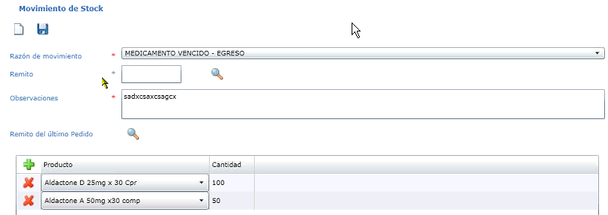

* **Tratamientos Especiales**: This page help in retrieving and sending all the information related to special treatment, the special treatments are a set of products for example “CHAMPIX” when the user rise a request for this treatment it will receive two or more products that are configured in this page.

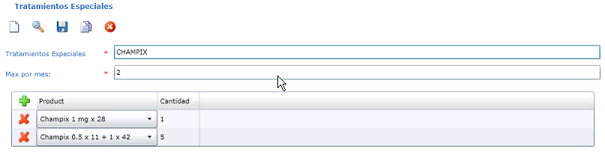

* **T.Especiales por Tipo de Solicitante**: Here the user can assign the different profiles that can rise a request for the special treatments, there are many profiles and not every profile can order the same special treatments, the user can add or delete the profiles.

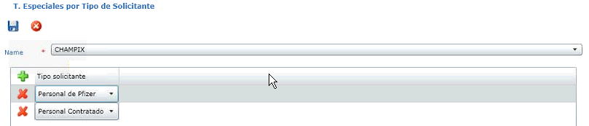

* **Adm de Pedidos**: It contains the quantity (requested amount) information for every drug. All this information goes to POC and is used during order by Admin on “Movimiento de Stock”. The User rise a order that orders goes directly to POC, then the order is delivered and the admin user has to load the stock for the application in this page, once the stock is updated it can be used for all the necessary requests.

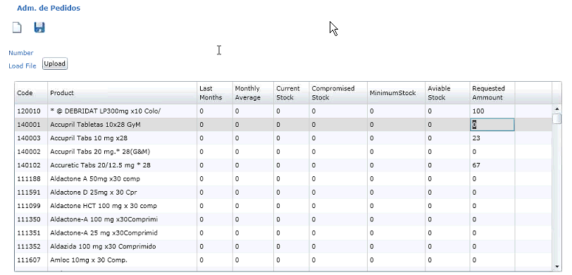

**Tablas:** It contains

* + Locations,
  + Localizacions de usuarios,
  + Adm de Productos,
  + Requisitos,
  + Tipo de Solicitante,
  + Motivo de Rechazo,
  + Motivos de Movimiento de Stock,
  + Adm de Usuarios.

* **Locations**: It is used to search a location, delete a location and create a new location; the location is where the requests are going to be sent.

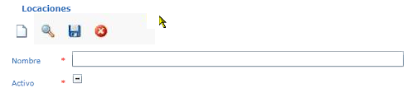

* **Localizaciones de usuarios (Users location):** This page is used to assign a location for each employee, the requests raised by the employee will be sent to this location. In this page we can also clone the location from other users to simplify the job.

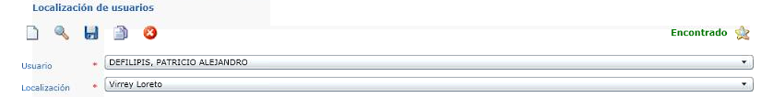

* **Adm de Productos (Product Administration)**: All the active products (drugs) from ERKS are administered here. This page has a point called as Reposition Point which is used to order some drugs to satisfy the drug demand. This page also contains the requisites for ordering the drug, the products from ERKS comes from a view from ERKS applications, this are all the products available, however PPP only work with some products defined by this application.

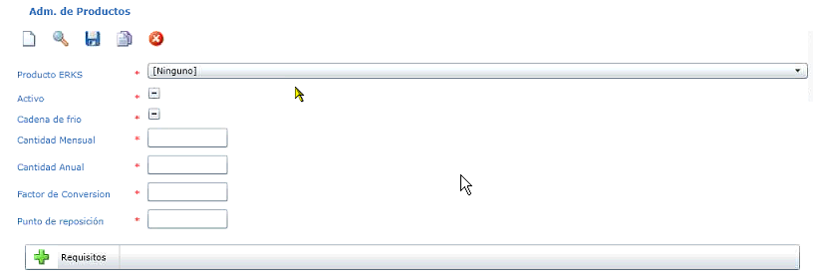

* **Requisitos**: This page is used to Add/Delete/Update all the requisites, this requisites can be added to any product in the configuration, When any user rise a request for a product that have requisites for example medical prescription, the employee has to deliver the requested requisite.

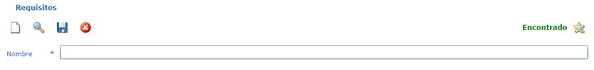

* **Tipo de Solicitante (Type of employee)**: there are two types of employee: Pfizer employee and Contracted employee, there can be created more types however there are only two in use because the service is available right now only for employees and contractors.

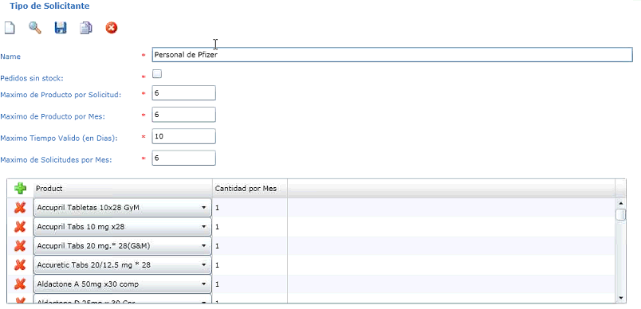

* **Motivo de Rechazo (rejected requests):** In this page the user can Add/delete/update the different reasons of rejection, this reasons will be available when the admin decide to cancel a request.

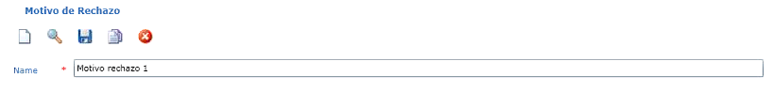

* **Motivos de Movimiento de Stock**: It contains reasons for the movement of stock. It can be ingress or egress, if the user marks “Requiere Remito” check box the application will ask for the delivery note when enter a movement under this concept.

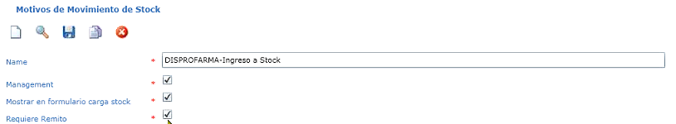

* **Adm de Usuarios** : This is user administration. All the data of employee comes from PeopleSoft, the localization, profile, request for other users and exceed the amount limits of the user can be administrated here and don’t suffer changes with the update of PeopleSoft

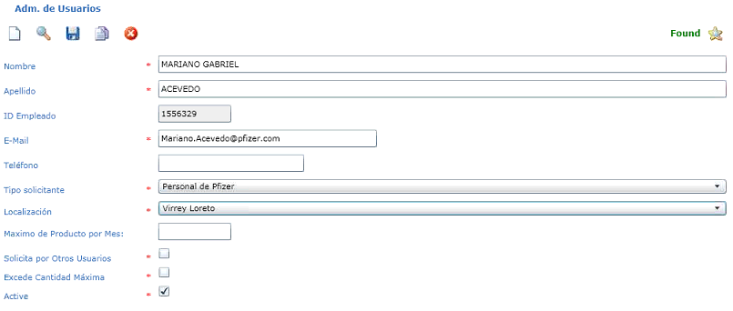

**Solicitud:** It contains

* Cargar Solicitudes
* Consulta e impression de rotulos
* Preparacion Solicitudes
* Entregar Solicitudes
* Solicitudes vencidas
* Anular Solicitudes

* **Cargar Solicitudes**: This tab is used to fill a request. Here an employee will request for a particular amount of drug depending on availability. The user can’t order for more than the amount available. Only some employee can order for more amount than available.
  + Note: the magnify glass at the end of “Solicitante” (Name of the Employee) will show all the request of the user; this is important so everyone can know the dates of their request and details of each request.

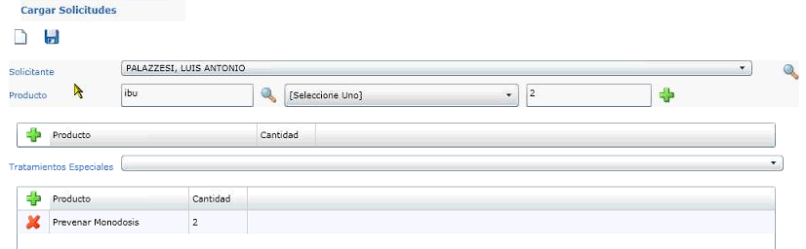

* **Consulta e impression de rotulos**: This is used by admin to see the available requests in a word format, and then the request is prepared.

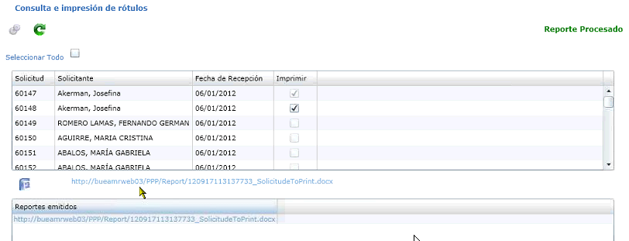

* **Preparacion Solicitudes (prepare the request):** This page is used for preparation of the request. Once the order is finalized is sent to the user.

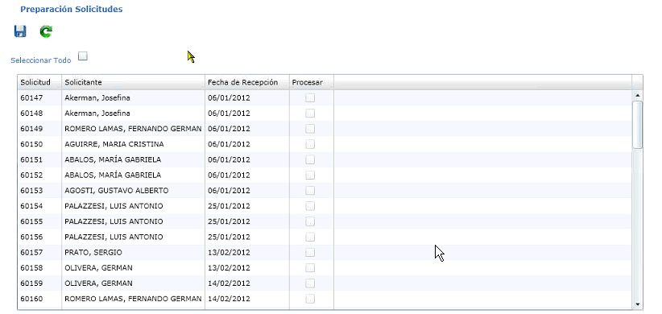

* **Entregar Solicitudes**: This page is used to check whether the product has reached the employee or not, the employee has to sign the printed request, this is the final step of the requests.

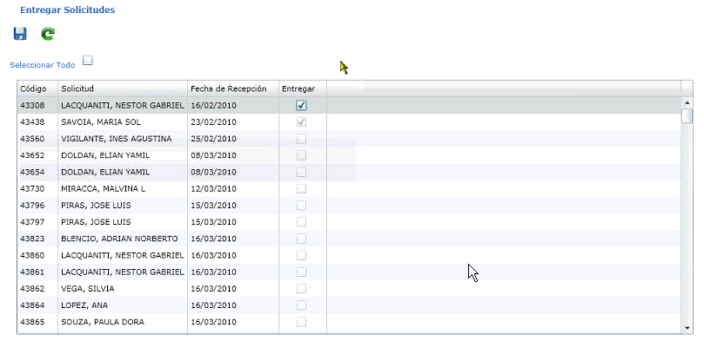

* **Solicitudes vencidas**: This page shows all the request which is pending from more than 10 days. This page is used to delete such request.

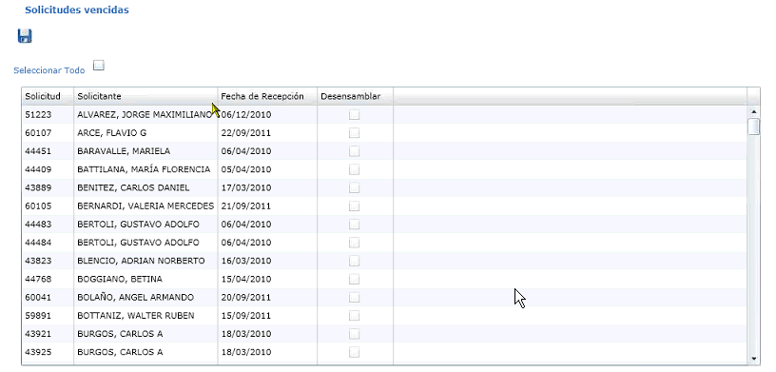

* **Anular Solicitudes**: This page is used to cancel a request. The reasons maybe the product is out of stock or the user has already asked for the product, etc.

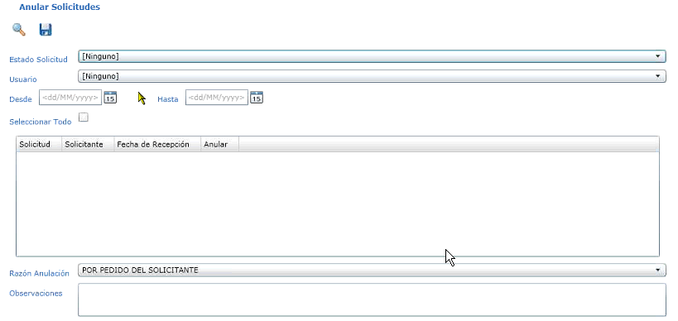

**Reports:** There are 9 reports in the application

* Productos Consumidos por división
* Stock Fisico
* Movimientos de Stock
* Reporte de Solicitudes
* Detalle de productos por solicitud
* Productos disponibles por Tipo de Solicitante
* Reporte de Usuarios
* Ultimo Pedido, Impresion de Rotulos.

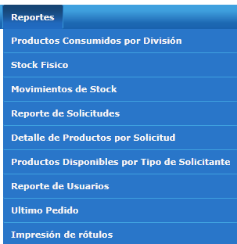

* **Productos Consumidos por division:**  This page is used to create a report of the entire request by Division (marketing, commercial, etc.)

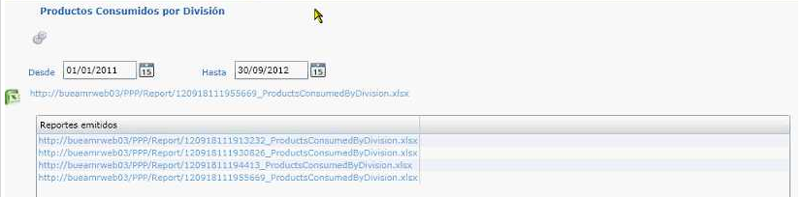

* **Stock Fisico**: This page is used to create a report of the physical stock, all the products the quantity and the pending quantity if any.

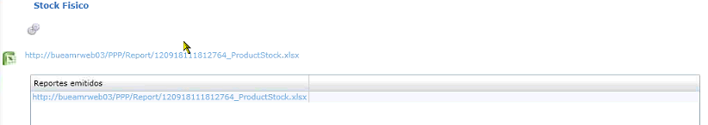

* **Movimientos de Stock**: This page is used to create a report of all the different movements in the stock either is income or egress, the quantity and the user.

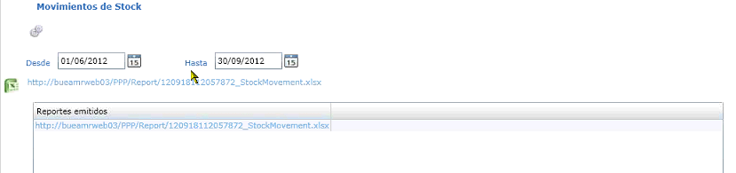

* **Reporte de Solicitudes**: This page is used to create a report of the entire request in the application, status, employee, number of request among other information.

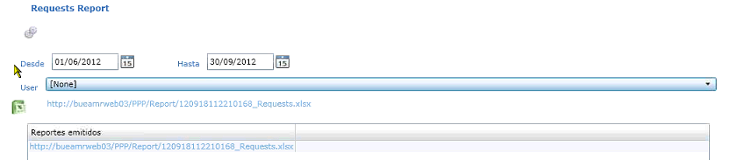

* **Detalle de productos por solicitud­­:** This page is used to create a detailed report of the requests. Here are listed the entire list of request product by product for each employee and the quantities.

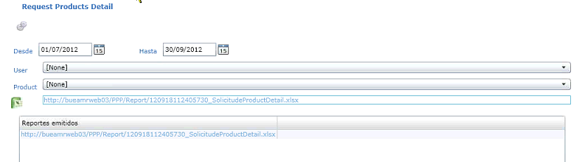

* **Productos Disponibles por Tipo de Solicitante**: This page is used to create a report of the available products for each profile in the system this is configured in “Tipo Solicitante” menu. This report is available for all the users so they can check if the drug is available for their profile.

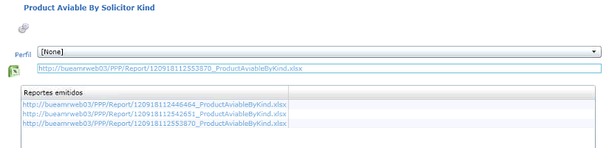

* **Reporte de Usuarios**: This page is used to create a report of all the users available in the application.

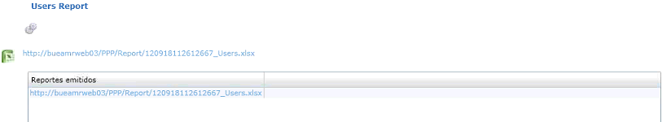

* **Ultimo Pedido**: This page is used to create a report of the last order that was sent to POC.

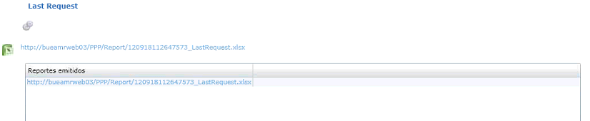

* **Impresion de Rotulos**: This page is used to create a report of the request in the same format as the user can create in the ”Consulta e Impresion de Rotulos” menu, if the actual document where lost or damaged here the user can reprint the document.

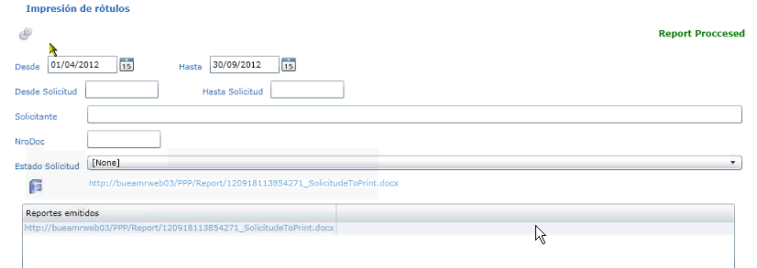

**Application Flow and Architecture:**

* The application starts flow from SEMP.View project. The xaml file in SEMP.View Project will call the file in SEMP.Logic project.
* File from SEMP.Logic will call corresponding file from SEMP.Web.
* This file will first check for access and then will call the corresponding file from SEMP.Data.
* File from SEMP.Data will call Bridge class.
* Bridge class will call the Stored procedures in Database and will perform required retrieval or insertion or deletion.

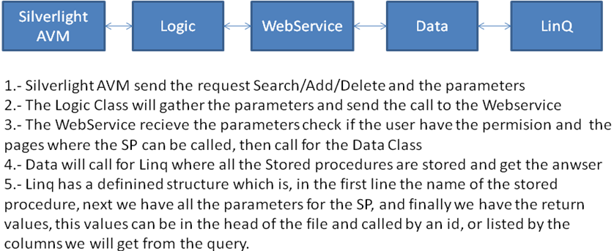

**Code Information:**

**The application has 5 Projects:**

* SEMP.WEB: here are stored the classes called form the web services and also we have here the page SEMP.html, which is just a container that will be constructed by Silverlight AVM’s
* SEMP.Controls: Here are stored all the controls created by user, for a specific function.
* SEMP.Data: Here are stored the classes that calls for database, We can access to the stored procedures by Bridge.dbml file that contains all the Linq parameters that are going to be passed and we obtain the response from sql in the way linq ask for the information, if linq needs an int value we can’t use a tinyint
* SEMP.Logic: Here lies all the business logic, here also we call for the web services within the application.
* SEMP View: Here we can find all the AVM’s for the application, here are constructed all the interfaces the user will see, and the actions required will be fired from these pages.

DATABASE Information:

* All the delete SP do a logic delete this means, the record the user wants to delete won’t be deleted from the DB but it will have a DeleteDate, when this field is null it means the record is alive otherwise is has been deleted
* The Save SP can save or update the record depending if the Principal ID is null or not.
* All the Stored procedures have a error control, and this error control is available in any language selected by the user
* For the Save/update/Delete SP that include a grid, this grid will be treated as an xml which it will be passed to Sql SP and the xml file will be passed into a temporal table for the correct use.
* In the case of the Dropdown List Controls that are used in two or more pages, the Dropdown list will be filled just one time and stored in a control and will be called from any other view.

**Connection with POC, Peoplesoft and ERKS:**

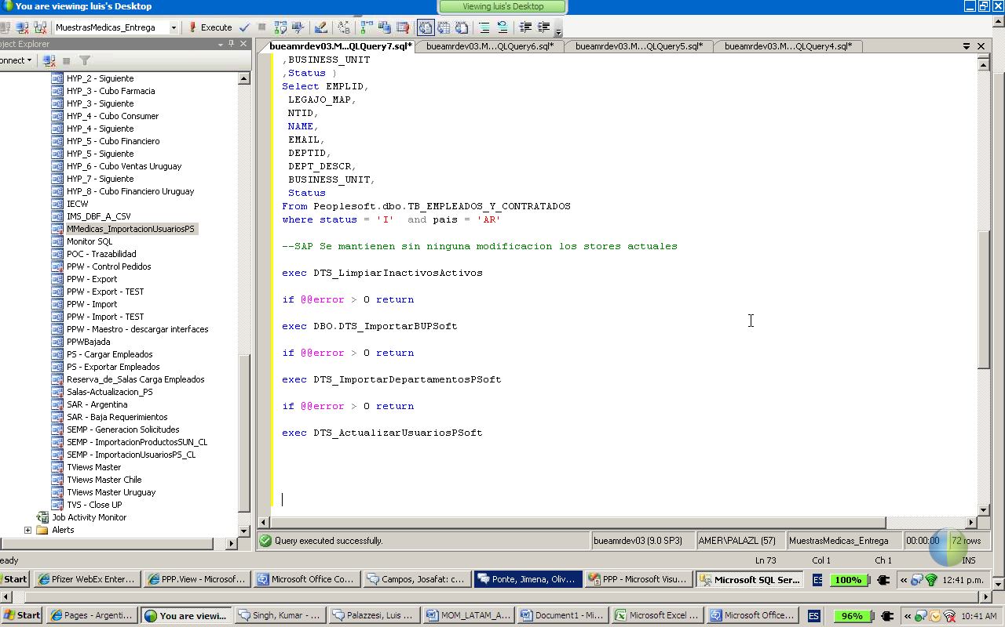

* **Peoplesoft:** The application has a Job called “MMedicas_ImportacionUsuariosPS”. This job is the one which update all the users in the application based on the PeopleSoft database which is updated daily, this job takes the information from PeopleSoft and updates the fields needed in this application.
* **POC:** In the application the user can create orders that go directly to POC, the application has a Stored procedure that directly fill the tables in POC by doing this POC application automatically start the process to deliver the product. Once the Delivery note is complete the application has to create the new incomes by the page “Movimiento de Stock” where it can be imported the last delivery note from POC.
* **ERKS:** The data from ERKS is retrieved using View in the database. This View will get the data from Erks_Pfizer database and update itself.

## Business

Business Overview

* This application is used by Chile Pfizer Intranet User to order medication for them. It works for all domains.
* This application receives tickets mostly at the end of month and hence the criticality of the application is at the end of the month. The user can ask for any medicine based on some business rules that the administrator can set in the application, based on the different profiles
* There are no other alternative in the moment, the application has only some months in production.

Business Requirements

| Req# | Requirement Description | BR# | MSC(Must have, should have , could have) | Scope |
| --- | --- | --- | --- | --- |
| B1. |  |  |  |  |
| B2. |  |  |  |  |

Functional requirements

| Req# | Requirement Description | FR# | MSC(Must have, should have , could have) | Scope |
| --- | --- | --- | --- | --- |
| F1. |  |  |  |  |
| F2. |  |  |  |  |

Business Roles

| Role | Responsibilities | As-Is or To-Be |
| --- | --- | --- |
| Administrator | Has Complete access to the application. |  |
| User | Rise a request and check the status |  |

Business Rules

| **BR#** | **Description** | **Example** | **Source** | **Related Rules** |
| --- | --- | --- | --- | --- |
| BR1. |  |  |  |  |
| BR2. |  |  |  |  |

Business Domain Name

The application to maintain is located under:

* Web portal: <http://bueamrweb03/SEMP/>
* Source code: http://svn.arise.pfizer.com/svn/SEMP
* 3rd party controls: Silverlight, Ajax Toolkit, OpenXML
* Source Code Management: Visual Source safe
* Username: Active Directory, Password: Active Directory
* Application Server: bueamrweb03 (Devlopment)
* Database Server: bueamrdev03 (Devlopment)
* Database Name: MuestrasMedicas_Entrega_Cl
* Authentication: ARG006 - Modulo de Seguridad.

Business Driver

N/A

## Business Process

Business Process Name

### Business Process Overview

N/A

### Preceding Business Processes

N/A

### Business Value

N/A

### Succeeding Business Processes

N/A

## Validation Requirements

The application is validated on login page by Modulo de Seguridad.

cGxP requirement

N/A

21CFR Part11 requirement

N/A

Other regulatory requirement (HIPPA/SoX etc)

N/A

## Documentation Details

### Documents Received

|  |  |  |  |  |  |
| --- | --- | --- | --- | --- | --- |
| **S. No.** | **Document Name** | **Document Description** | **Document Type** | **Document Location** | **Document in sync?** |
|  | Beneficio Medicamentos al Personal - Prevenar |  | Word | [LINK](http://ecf12.pfizer.com/sites/SGVLATAMTransitionRepository/SGV%20Transition%20Library/Forms/AllItems.aspx?RootFolder=%2Fsites%2FSGVLATAMTransitionRepository%2FSGV%20Transition%20Library%2FArgentina%2FARG024%2DProductosParaelPersonal%2FDocumentacion) |  |
|  | PPP Manual Usuario_Julio2012 |  | PDF | [LINK](http://ecf12.pfizer.com/sites/SGVLATAMTransitionRepository/SGV%20Transition%20Library/Forms/AllItems.aspx?RootFolder=%2Fsites%2FSGVLATAMTransitionRepository%2FSGV%20Transition%20Library%2FArgentina%2FARG024%2DProductosParaelPersonal%2FDocumentacion) |  |
|  | PPP_DER |  | PDF | [LINK](http://ecf12.pfizer.com/sites/SGVLATAMTransitionRepository/SGV%20Transition%20Library/Forms/AllItems.aspx?RootFolder=%2Fsites%2FSGVLATAMTransitionRepository%2FSGV%20Transition%20Library%2FArgentina%2FARG024%2DProductosParaelPersonal%2FDocumentacion) |  |
|  | Pantallas PPP | Screenshoots of the application | ZIP | [LINK](http://ecf12.pfizer.com/sites/SGVLATAMTransitionRepository/SGV%20Transition%20Library/Forms/AllItems.aspx?RootFolder=%2Fsites%2FSGVLATAMTransitionRepository%2FSGV%20Transition%20Library%2FArgentina%2FARG024%2DProductosParaelPersonal%2FDocumentacion) |  |

### Documents not available

| **S. No.** | **Document Name** | **Document Description** | **Document Type** |
| --- | --- | --- | --- |
|  | NA |  |  |

## App Usage

It is local application used in Chile region.

Application usage pattern

| **# of users** | **User Type (Role)** | **Interface** | **Activity** | **Access Level** |
| --- | --- | --- | --- | --- |
|  |  |  |  |  |

Table 2: Application usage pattern

| **# of users** | **Functional Branch** | **Peak Daily Transaction** | **Peak Usage team** | **Peak Usage day** | **Date line difference** | **Time Zone difference** |
| --- | --- | --- | --- | --- | --- | --- |
|  |  |  |  |  |  |  |

Table 3: Application usage

Tools

N/A

File Server

N/A

Database (F)

**Database Server:**

| **S. No** | | **Application Component** | | **Platform** | | **Operating System** | | **Deployment Type** | | **Server Name** |
| --- | --- | --- | --- | --- | --- | --- | --- | --- | --- | --- |
| 1 | Database server | | SQL Server 2005 | | Windows Server 2003 | | Production | | Bueamrapp04 | |
| 2 | Database server | | SQL Server 2005 | | Windows Server 2003 | | Testing | | bueamrdev04 | |
| 3 | Database server | | SQL Server 2005 | | Windows Server 2003 | | Development | | bueamrdev03 | |

Application Server

**Application Server:**

| **S. No** | | **Application Component** | | **Platform** | | **Operating System** | | **Deployment Type** | **Server Name** | |
| --- | --- | --- | --- | --- | --- | --- | --- | --- | --- | --- |
| 1 | Application Server | | IIS | | Windows Server 2003 | | Production | | | bueamrweb02 |
| 2 | Application Server | | IIS | | Windows Server 2003 | | Testing | | | bueamrweb04 |
| 3 | Application Server | | IIS | | Windows Server 2003 | | Development | | | bueamrweb03 |

Client

N/A

Programming Language

**Visual C#.Net 3.5** for Application front end.

**Silverlight:** to design the UI pages.

**MS – SQL 2005** to write the database queries.

Operating System (F)

Windows XP (User), Windows Server 2003 (Hosting)

Middleware (F)

N/A

Hardware (F)

N/A

Special Hardware, Software Requirement (F)

N/A

Licensing details (F)

Visual Studio 2008

SQL Server 2005

Internal Contact-Table (F)

N/A

External Contact (F)

N/A

User Location (F)

N/A

# Application Support

## Application Details

### Security (Authentication and Authorization) details

This application is authenticated by ARG-006 Modulo de Seguridad.

### Application Stability and Complexity

Complexity Simple

Stable application

Bronze SLA

### Application Suite Topology

N/A

### Application Sizing details

Simple/Bronze application

Process Diagram

N/A

Application Architecture

N/A

Entity Relationship Diagrams

N/A

## Standards and Conventions

Detailed Design Standards

N/A

Coding Standards

N/A

UI Standards

N/A

Documentation Standards

N/A

Request Numbering Convention

N/A

Database Design Standards

N/A

Other Conventions

N/A

## Source Inventory

*Not Provided*

Schema Organization

N/A

Screens

Refer the application Design specifications document for details.

Reports

All the important reports are:

* Productos Consumidos por division:
* Stock Fisico:
* Movimientos de Stock:
* Reporte de Solicitudes:
* Detalle de productos por solicitud
* Productos Disponibles por Tipo de Solicitante
* Reporte de Usuarios
* Ultimo Pedido
* Impresion de Rotulos

Classes

N/A

Directory Structure

## System Details

Data Model

N/A

Object Model

N/A

Class diagram

N/A

Activity Diagram

N/A

Use Case diagram

N/A

Program-Database Tables Cross-reference

N/A

External Interfaces

N/A

Critical Processes

N/A

Critical Programs

All stored Procedure those are used to generate reports.

Critical Screens

Please refer section 4.2.

Critical Reports

All the reports mentioned in section 5.3.3 are critical reports.

Repeatable patterns

N/A

SOA services

N/A

Implementation view - Layers

N/A

## Key System Characteristics

System Usage Constraints

N/A

Job Scheduling/Sequencing of Batch Jobs

N/A

Transaction Volume and Data Volume

N/A

## Current Processes

Bug fixing procedure (P/S)

N/A

Defect/Enhancement Impact analysis procedure

N/A

Build procedure

N/A

# References

N/A

# Appendix

**Past issues**

There were not much past tickets but there was a problem that user usually faced. Users were unaware of the flow and were unable to find who has to approve the request and who has to approve next.

This problem was because none of the users had an appropriate training of the correct use of the application

**Minor enhancement:**

First was adding a terms and conditions checkbox.

**Minor enhancement 2:**

Second was to export the data to excel file.

Application Appreciation Document Template Authorization

|  |  |  |  |
| --- | --- | --- | --- |
| OWNERSHIP | | | |
| **Owner** | **Doc No** | **Version** | **Effective Date** |
|  |  |  |  |

|  |  |  |
| --- | --- | --- |
| AUTHOR | | |
| **Printed Name and Title** | **Signature** | **Date** |
|  |  |  |

|  |  |  |
| --- | --- | --- |
| REVIEWER | | |
| **Printed Name and Title** | **Signature** | **Date** |
|  |  |  |
|  |  |  |

|  |  |  |
| --- | --- | --- |
| APPROVER | | |
| **Printed Name and Title** | **Signature** | **Date** |
|  |  |  |
|  |  |  |