# **REDCap Auto-Notification DET Plugin – How-To Guide**

This guide describes the configuration, and usage of the REDCap Auto-Notification Data Entry Trigger (DET). This tool provides a way to automatically send emails based data entered into a REDCap form or Survey.

This plugin has been added to the UF CTSI’s REDCap system and is available for your use. Using this plugin is a multi-step process requiring the REDCap form designer to add a project bookmark, configure triggers to send an email, and testing to verify the rules in the trigger were composed correctly.

Follow the steps below to setup the plugin for your project and verify it is working.

## **Add the Auto-Notification Bookmark to your project.**

From the Project Setup tab, select **Add or edit bookmarks**

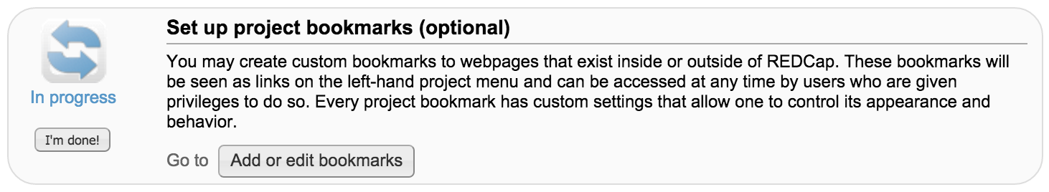

Give the Bookmark a name like “AutoNotify Config (v2.0)” under **Link Label** and paste the following URL into **Link URL/Destination**

<https://redcap.ctsi.ufl.edu/redcap/plugins/autonotify/index.php>

Make sure to check the box to **Append project ID to URL.** The result should look like this:

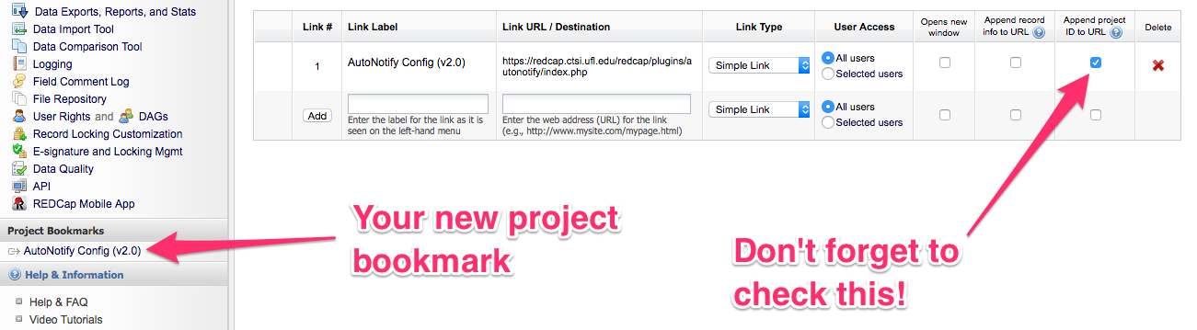

**Configure the Auto-Notification triggers**

Click on your new Bookmark (listed in the left side bar under **Project Bookmarks**) to open and configure your Auto-Notification triggers. Fill in the values according to this guide.

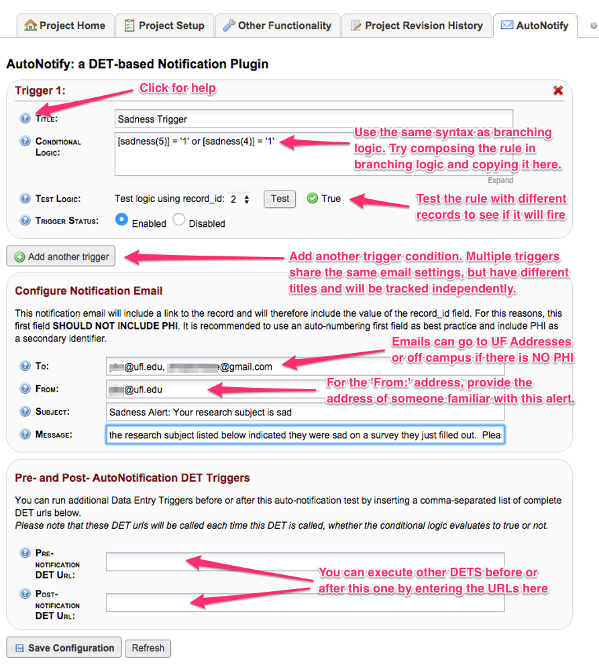

**How many times will a trigger fire?**

The rules will match only one time per RECORD + EVENT + TRIGGER NAME.

Pretend you have a project with many instruments. You have two questions about suicidality that you want to monitor and they are on different instruments.   
  
If you create a single trigger like [q10]=4 OR [q20]=3. In this case, if EITHER of these criteria were met, the rule would fire and send an email. So, if on the first survey they marked ‘4’ for Q10, it would fire. But, if they came back later and took another survey and marked ‘3’ for q20 it WOULD NOT FIRE AGAIN, since that rule had already fired for this record. If you want to have separate emails for each question, you should define two different triggers.  
  
Now, imagine your project is longitudinal and the survey is given each week. The trigger will fire a NEW email for each event. So, if it already fired for baseline and the user comes back 1 month later and answers Q10=4 it will fire again.

The plugin uses the log entries to keep track of which rules/records/events have triggered an alert.



If you change the name of a rule and resave a positive record, it will fire a new alert.

**Emails**

Here’s an example of what the email notification looks like

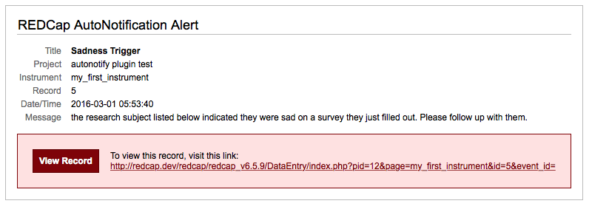

Because the RECORD_ID is included in the email, you *should not use* *this* in projects where the record_id is PHI.

**Saving your notifications**

This plugin uses the DET url to save your configuration as an encoded query string parameter (an). If you have an existing DET, it will move it to the ‘pre-det’ setting so it can be fired.

**Provide Feedback**

The Auto-Notification plugin is NOT part of the standard REDCap support package. As such, REDCap upgrades may impact this functionality. There is potential for a REDCap upgrade to break the Auto-Notification configuration for project(s).