**AUTO-NOTIFICATION DET PLUGIN**

1. INSTALL:  
     
   Get the files here: https://stanford.box.com/s/3lboork2nbz995osyba3  
     
   Where to install?
   1. This script is configured to be installed two directories in from the base redcap folder. In my case, that means you directory structure should look like.  
        
      xxx/redcap_connect.php  
      xxx/plugins/autonotify/index.php  
      xxx/plugins/autonotify/common.php  
      xxx/redcap_v5.x.x/
   2. Make sure you have redcap_connect.php installed on your server.
2. SET LOGGING:  
   Edit the index.php file and set the path/file prefix for logging. Make sure the account your web service is running as has the ability to write to this folder.
   1. // File path and prefix for log file - make sure web user has write permissions  
      $log_prefix = "/var/log/php/autonotify";
3. SET UP BOOKMARK:  
   Add a bookmark to a test project:  
   You can also use xxx/plugins/autonotify/index.php if your server has issues with trailing /’s
4. Give it a shot – you should get something like:  
   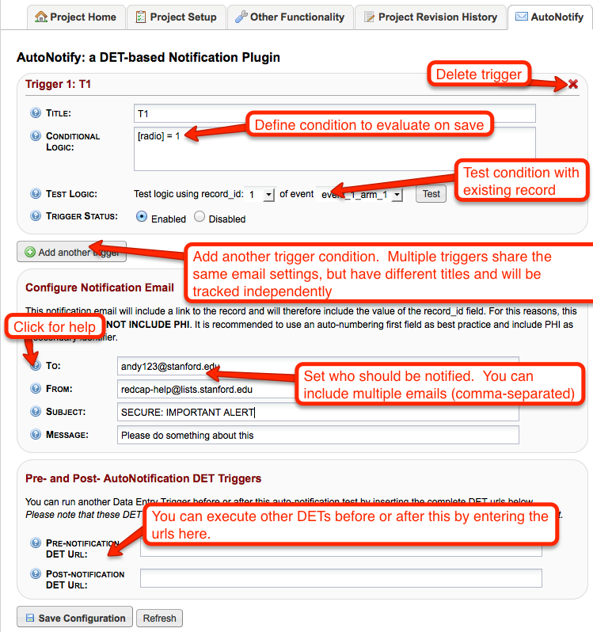
5. TESTING IS YOUR RESPONSIBILITY  
   Be sure to thoroughly test! I AM SURE THERE ARE BUGS – please give me feedback and I can work on fixing them.
6. LOG FILES ARE USEFUL!  
   Tail the log file for information on what’s going on! I also recommend finding your php error log file (sometimes the same as your web server). It is also fun to watch.  
   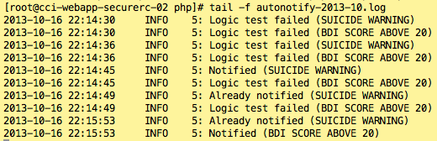
7. HOW MANY TIMES WILL IT FIRE  
   The rules will match only one time per RECORD + EVENT + TRIGGER NAME.
   1. Pretend you have a project with many instruments. You have two questions about suicidality that you want to monitor and they are on different instruments.   
        
      If you create a single trigger like [q10]=4 OR [q20]=3. In this case, if EITHER of these criteria were met, the rule would fire and send an email. So, if on the first survey they marked ‘4’ for Q10, it would fire. But, if they came back later and took another survey and marked ‘3’ for q20 it WOULD NOT FIRE AGAIN, since that rule had already fired for this record. If you want to have separate emails for each question, you should define two different triggers.  
        
      Now, imagine your project is longitudinal and the survey is given each week. The trigger will fire a NEW email for each event. So, if it already fired for baseline and the user comes back 1 month later and answers Q10=4 it will fire again.
   2. The plugin uses the log entries to keep track of which rules/records/events have triggered an alert.   
      
   3. If you change the name of a rule and resave a positive record, it will fire a new alert.
8. EMAILS  
   What do the emails look like (pretty sexy, eh? I copied an email from box.com)? Haven’t tested in on a lot of clients, so lets hope it renders well…  
   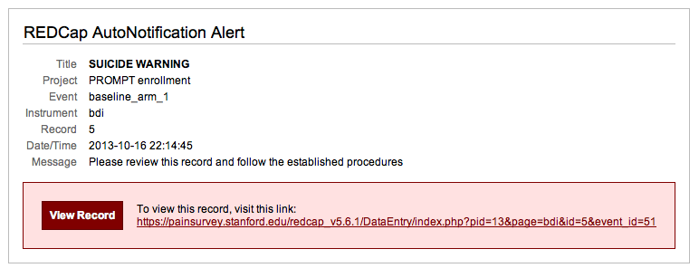
   1. Because the RECORD_ID is included in the email, you **SHOULD NOT USE THIS IN PROJECTS WHERE THE RECORD_ID IS PHI!!!**
      1. In my opinion, the record_id should NEVER have PHI.
9. SAVING YOUR NOTIFICATIONS
   1. This plugin uses the DET url to save your configuration as an encoded query string parameter (an). If you have an existing DET, it will move it to the ‘pre-det’ setting so it can be fired.