We are beginning our journey with Chapter 1: Introduction, which lays out the foundational concept of TinyML, its origins, and the unique challenges and opportunities presented by embedded systems.
The Genesis and Definition of TinyML
The book's focus on TinyML originated from internal projects at Google, specifically the work done by the "OK Google" team. This team was pioneering techniques to run neural networks as small as 14 kilobytes (KB) on specialized digital signal processors (DSPs) within Android phones. These DSPs were critical because they consume only a few milliwatts (mW) of power, allowing the continuous listening necessary for wake-word detection while conserving the device's main battery life.
This groundbreaking work led to the concept of TinyML, which describes a new class of products. These products share key characteristics: they use machine learning (ML) to interpret noisy sensor data, can operate for years using energy harvesting or a battery, and often cost only a dollar or two.
The working definition agreed upon by experts is that TinyML involves running a neural network model at an energy cost of below 1 mW. This low power threshold is crucial because it translates directly to device longevity: a device running on a coin battery can achieve a lifetime of approximately a year. This allows the product to be small enough to fit into any environment and operate without human intervention.
A core principle of TinyML is the necessity of local processing. These devices must turn raw sensor data into actionable information directly on the device itself, as the energy required to transmit continuous data streams anywhere else is inherently too high to be practical.
Hardware Constraints and Opportunities
The book explicitly focuses on hardware platforms that can meet the sub-1 mW energy requirement, which means focusing on the world of embedded devices.
TinyML specifically excludes larger, more powerful boards like the Raspberry Pi or NVIDIA Jetson, which draw hundreds of milliwatts or even 12 watts, making them unsuitable for devices that must operate without a wired power supply. Furthermore, the cheapest 32-bit microcontrollers, which are the target platforms for TinyML, cost much less than a dollar, contrasting with even the lowest-cost alternative development boards. This low price point has made microcontrollers widespread in applications ranging from toys to washing machines. A major hope is to introduce artificial intelligence to these existing ubiquitous devices via a simple software update.
Historically, embedded development involved intimidating 8-bit devices and proprietary toolchains, but this changed with the introduction of user-friendly tools like Arduino and the shift toward powerful 32-bit CPUs like the Arm Cortex-M series.
Despite improvements, embedded devices impose severe resource constraints:
- Limited Memory: They typically have only a few hundred kilobytes of RAM and similar amounts of flash memory for program and data storage.
- Processing Speed: Clock speeds are often measured in just tens of megahertz.
- Software Environment: They do not run full Linux and often actively avoid dynamic memory allocation functions (like malloc() or new) to ensure reliability and longevity. Standard desktop debugging tools are often not available.
However, there are benefits to this simplicity; the lack of interrupting processes can simplify debugging and building a mental model of the system.
The authors acknowledge that the field of embedded machine learning is very young and the underlying technology is rapidly changing. Therefore, the book prioritizes teaching fundamental skills—such as debugging, model creation, and understanding deep learning principles—which will remain valuable even as the infrastructure changes.

The seven steps of the deep learning workflow are:
- Decide on a Goal,
- Collect a Dataset,
- Design a Model Architecture,
- Train the Model,
- Convert the Model,
- Run Inference,
- Evaluate and Troubleshoot

Today we are diving into Chapter 2: Getting Up to Speed on Machine Learning. This chapter serves as a crucial foundation, stripping away the mystique surrounding machine learning (ML) and providing the essential concepts and workflow necessary to begin building TinyML projects.

Understanding Machine Learning
Fundamentally, machine learning is a technique used by computers to make predictions based on past observations. Unlike traditional programming, where the engineer explicitly codes the rules, in ML, the algorithm processes data and discovers the rules itself.
This process involves feeding data into an algorithm to build a model—a type of computer program that embodies the system's relationships. Building this model is called training, and running new data through it to make predictions is called inference.
The approach focused on in this book is deep learning, which uses a network of simulated neurons, represented by arrays of numbers, trained to model complex relationships. It might be surprising, but deep learning is flexible and powerful enough to work within the severe memory and processing constraints of tiny microcontrollers.

The Deep Learning Workflow
Creating a functional deep learning model requires following a structured, iterative workflow. We will examine seven critical steps:

1. Decide on a Goal
You must first define exactly what you want the algorithm to achieve. In TinyML, this often involves a classification problem, where the input data is categorized into a set of known classes (e.g., predicting if a machine state is "normal" or "abnormal").

2. Collect a Dataset
The quality and quantity of data are paramount.
- Data Selection and Diversity: Collect data relevant to the goal, ensuring the data sources used for training (e.g., temperature sensors from specific locations) will also be available when running inference. Aim for a dataset that represents the full range of operational conditions and events that can occur.
- Labeling: This is the process of associating the collected data with its known outcome (the classes). Training the model with this guidance is called supervised learning.

3. Design a Model Architecture
This step is where you select the structure of the network, factoring in the nature of your data, the problem type, and the resource constraints of the target microcontroller (limited RAM and flash memory).
- Tensors: Models operate using tensors, essentially lists or arrays of numbers. A 1D tensor is a vector, a 2D tensor is a matrix, and a single number is a scalar.
- Feature Generation: Raw data, often collected as time series with inconsistent intervals, must be prepared for the model. A common technique is windowing, where a chunk of time is defined, and values within that window are combined (e.g., by averaging) to create a single set of input features.
- Normalization: For the training algorithm to work effectively, feature values must be scaled, ideally into a similar range (like 0 to 1). For example, 8-bit image data (0-255) is normalized by multiplying values by 1/255.

4. Train the Model
Training is the iterative adjustment of the model's internal numbers, called weights and biases (or parameters).
- Process: Data batches are run through the network, and backpropagation incrementally adjusts the parameters so the output aligns closer to the desired label.
- Metrics: Training progress is measured primarily by loss (quantifying how far the prediction is from the target value) and accuracy (the percentage of correct predictions).
- Underfitting vs. Overfitting:
  - Underfitting occurs when the model is too simple or hasn't trained long enough to capture the underlying patterns.
  - Overfitting occurs when the model has memorized the training data exactly but cannot generalize to new, unseen data.
- Defense Against Overfitting: Techniques like regularization (e.g., dropout) and data augmentation (generating new, artificial data points) help combat memorization.
- Evaluation Split: Datasets are typically split into three parts—training (e.g., 60%), validation (e.g., 20%), and test (e.g., 20%)—to monitor performance and ensure generalization. The final check is run once against the test set to confirm stability.
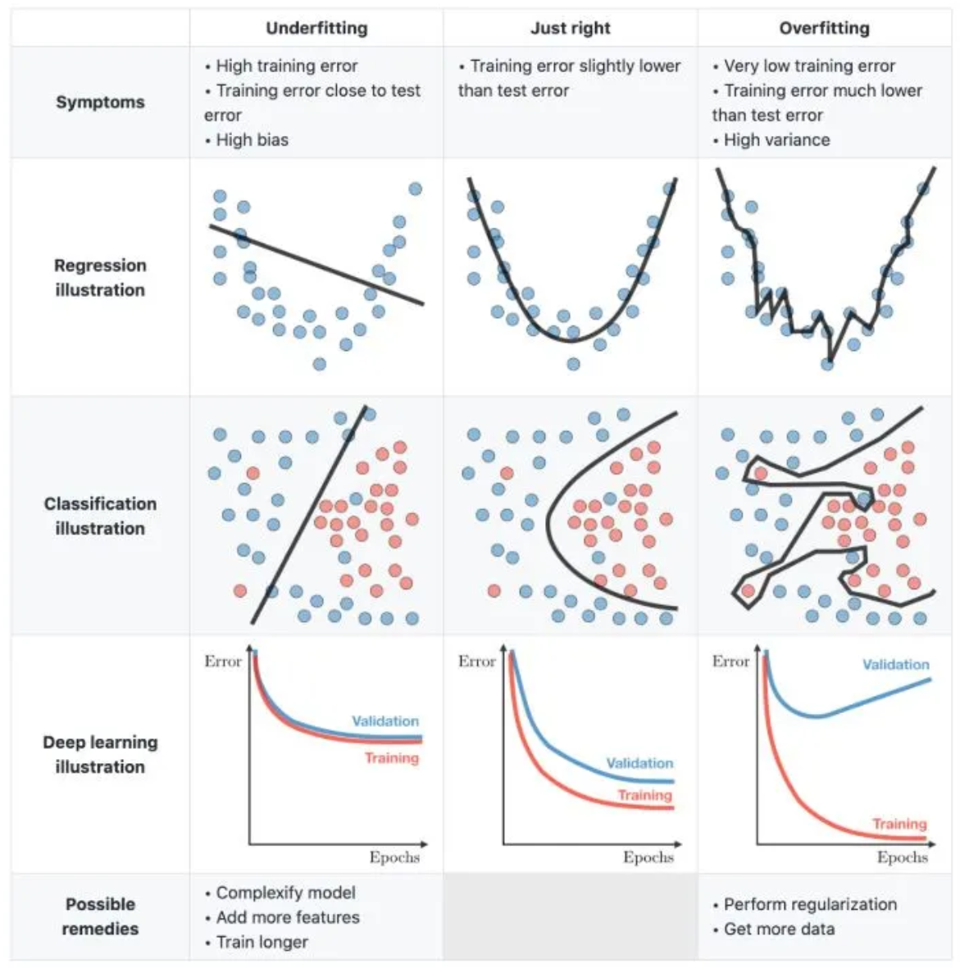

5. Convert the Model
Once training yields an accurate result, the model must be prepared for deployment. The TensorFlow Lite Converter changes the model into the TensorFlow Lite format, a space-efficient representation suitable for low-power devices.
- Quantization: A primary optimization is quantization, which reduces weights and biases from high-precision 32-bit floating-point numbers to 8-bit integers. This drastically cuts model size and allows for faster inference using integer arithmetic.

6. Run Inference
The converted model is loaded using the TensorFlow Lite for Microcontrollers C++ library. The application code feeds the properly formatted input features into the model to run inference, resulting in output predictions.
- Reading Output: For classification tasks, the output is a set of scores (probabilities) for each class. Often, transient issues or noisy sensor data can cause momentary incorrect classifications, so application developers frequently incorporate logic to average inference results over a period of time, acting only upon consistent behavior.

7. Evaluate and Troubleshoot
After deployment, the model's real-world performance is assessed. If performance degrades compared to test results, it may indicate that the training data wasn't fully representative of the actual environment, or that the model unexpectedly overfit the dataset. Troubleshooting involves capturing new data from the deployed device, comparing it to the original dataset, and retraining the model if necessary.
This workflow is entirely iterative; developers often cycle back through the steps—tweaking the architecture, adjusting hyperparameters, or collecting more data—until they achieve a satisfactory result.
That was an excellent summary of Chapter 2's foundational concepts. Now, let's solidify this understanding by examining concrete examples from the book that demonstrate these critical stages of the machine learning workflow.
1. Deciding on a Goal (Classification vs. Regression)
The primary goal dictates the type of problem you are solving:
- Classification: This involves categorising input data into predefined classes. The initial conceptual example discussed in Chapter 3 involves predicting a factory machine's state, classifying the input data as either "normal" or "abnormal". The complex wake-word detection project later in the book is a practical classification problem, distinguishing between four output classes: "yes," "no," "unknown" (other words), and "silence".
- Regression: This involves predicting a numeric output value. The fundamental "Hello World" example in Chapter 4 demonstrates regression: training a model to take a value, x, and predict its sine, y.
2. The Dataset and Labeling (Supervised Learning)
To train a model, you need labeled data, a process known as supervised learning.
- Data Splitting: In the "Hello World" sine wave project, the authors demonstrate best practice by generating 1,000 sample data points and splitting them into three non-overlapping sets: 60% for training, 20% for validation, and 20% for testing.
- Data Sources: The wake-word application uses the publicly available Speech Commands dataset, a collection of audio recordings labeled with the specific command words they contain, such as "yes" or "no".
3. Designing a Model Architecture and Features
Raw sensor input must often be processed into features suitable for the model, taking the target device constraints into account.
- Feature Generation: Raw data is converted into tensors (arrays of numbers). For the complex task of wake-word detection, raw audio samples are first converted into spectrograms (2D arrays representing frequency information over time) before being fed into the network. Similarly, the magic wand application takes raw accelerometer data (x, y, and z values) as its input.
- Normalization: For models processing images, values are typically normalized. For instance, 8-bit image data (ranging from 0 to 255) is scaled to the desired range (like 0 to 1) by multiplying each value by 1/255.
- Model Capacity: The sine wave example illustrates model design iteration. The initial basic model was demonstrated to underfit the data because its predictions were overtly simple and linear. The solution involved increasing the network's capacity by introducing an additional layer of 16 neurons, enabling it to model the complex, non-linear sine curve more accurately.
4. Training and Evaluation
Training relies on metrics like loss and accuracy, and techniques to ensure the model generalizes well.
- Monitoring Metrics: By graphing training and validation loss and mean absolute error (MAE) over epochs, the developer can determine optimal training duration and spot overfitting. The sine wave model demonstrated substantial improvement in validation loss, dropping from around 0.17 to 0.01 after optimization.
- Defense Against Overfitting: Techniques like regularization (e.g., dropout) and data augmentation (generating new, artificial data points) are used to combat overfitting. The magic wand model's training intentionally uses data augmentation, such as applying random noise or warping gestures in time, to effectively enlarge the small dataset.
5. Conversion and Optimization
Once training is complete, the model must be converted for tiny platforms.
- TensorFlow Lite Conversion: The trained model is run through the TensorFlow Lite Converter to produce a space-efficient representation, suitable for use on devices with limited memory.
- Quantization: A crucial optimization is quantization, which reduces weights and biases from 32-bit floating-point numbers to 8-bit integers, drastically cutting model size. The quantized version of the tiny sine model was shown to be 224 bytes smaller than its basic floating-point counterpart and enables faster inference using integer arithmetic.
6. Running Inference and Troubleshooting
Inference is the step where predictions are made, and practical applications often require post-processing logic to ensure reliability.
- Handling Transient Issues: Because real-world sensor data can be messy, transient issues like noisy sensor data can cause momentary incorrect classifications. To mitigate this, model outputs are often averaged over a period of time. For the wake-word detection system, the RecognizeCommands class specifically implements logic to average prediction scores over the past few inferences before confirming a successful command detection.
- Real-world Evaluation: If a model's performance degrades in the real world compared to its test data, it often suggests the training data was not fully representative of the actual environment, requiring re-evaluation or retraining with newly captured data from the deployed device.

