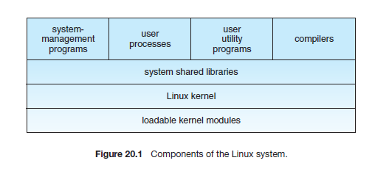
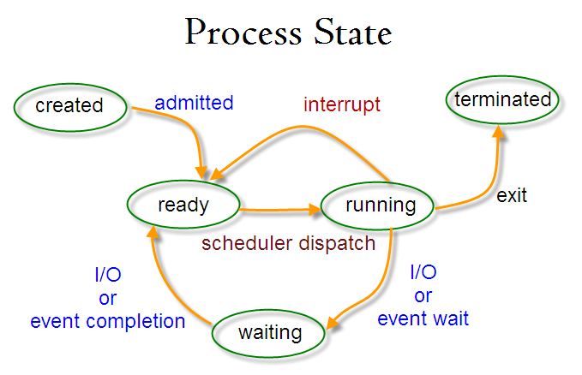
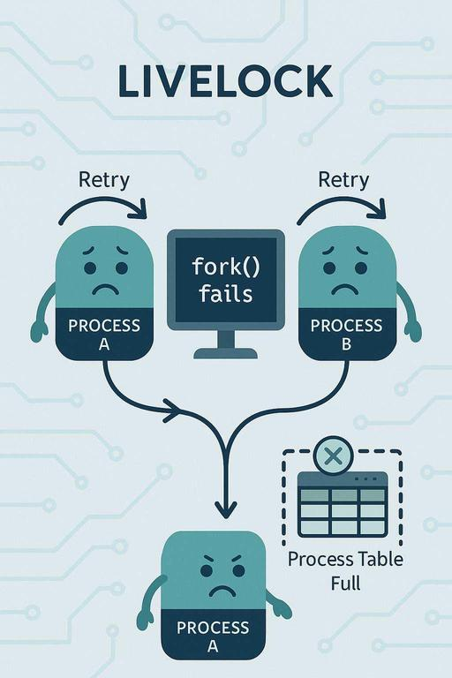
Note:The diagram illustrates a livelock scenario in an operating system where two processes (Process A and Process B) are actively trying to perform an action (fork()), but repeatedly fail because the process table is full.

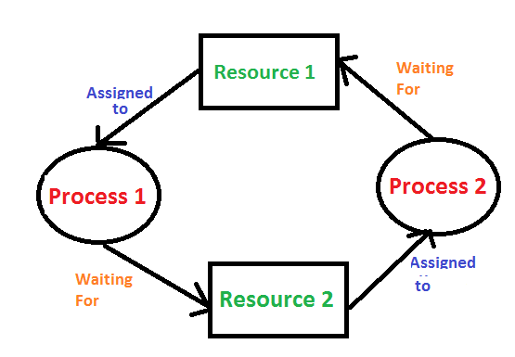
In an operating system, a deadlock occurs when a process or thread enters a waiting state because a requested system resource is held by another waiting process, which in turn is waiting for another resource held by another waiting process

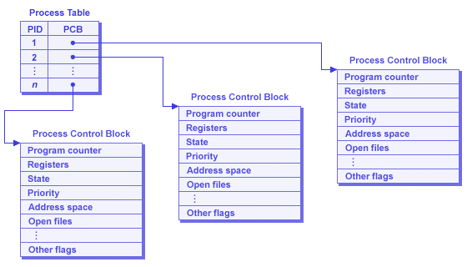
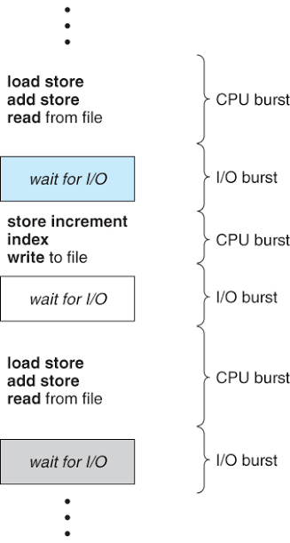
CPU Burst
a CPU burst is a period during which a process or program demands and actively utilizes the Central Processing Unit (CPU) for computation.
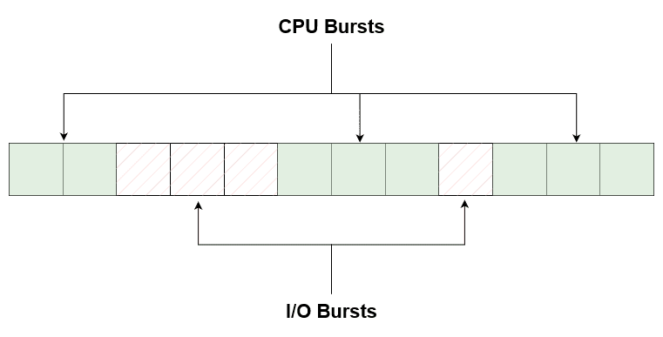
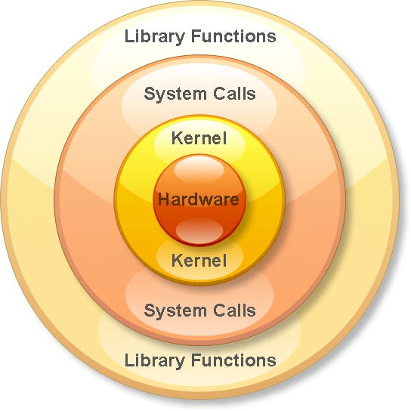

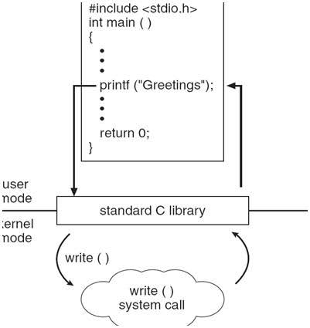
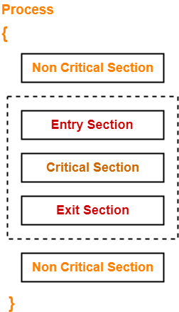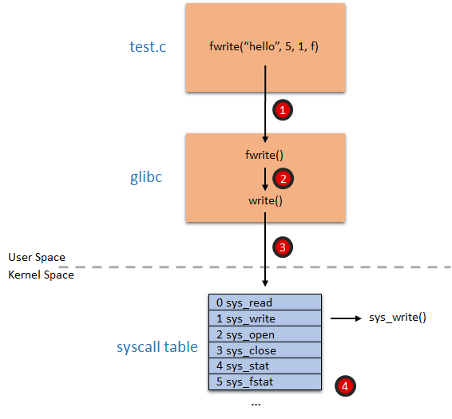
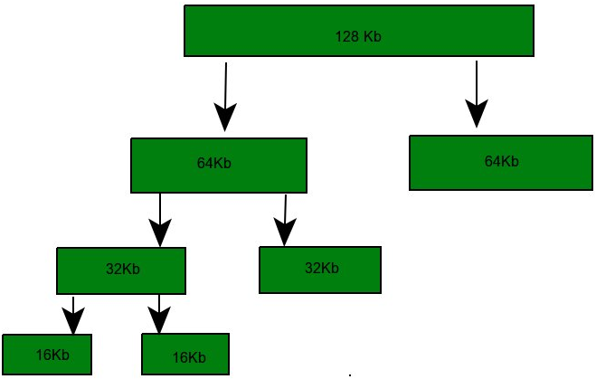
Buddy Allocation System divides a large memory block into smaller power-of-two blocks called buddies to satisfy a request. If needed, a block keeps splitting until the required size is reached. When freed, buddies can merge back into larger blocks, making memory reuse efficient.
Example - If the request of 25Kb is made then block of size 32Kb is allocated.
Slab Allocation- A slab is made up of one or more physically contiguous pages. The slab is the actual container of data associated with objects of the specific kind of the containing cache.
Cache - Cache is a software structure that stores pre-allocated kernel objects of the same type for reuse.

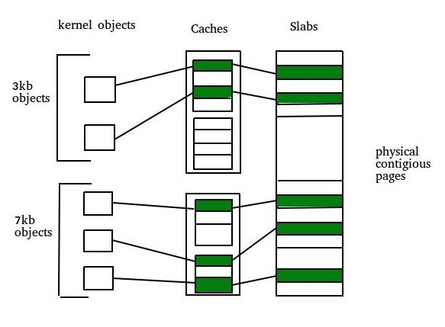
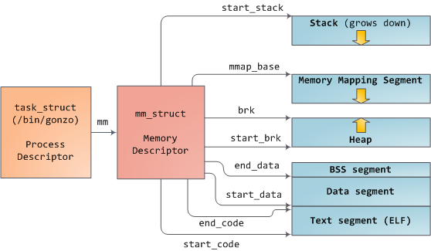
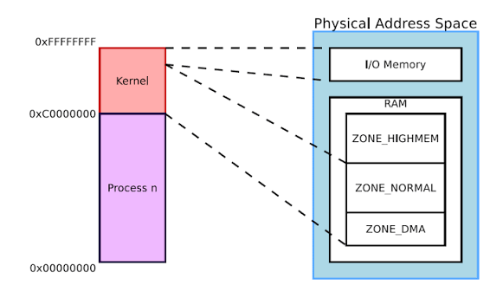
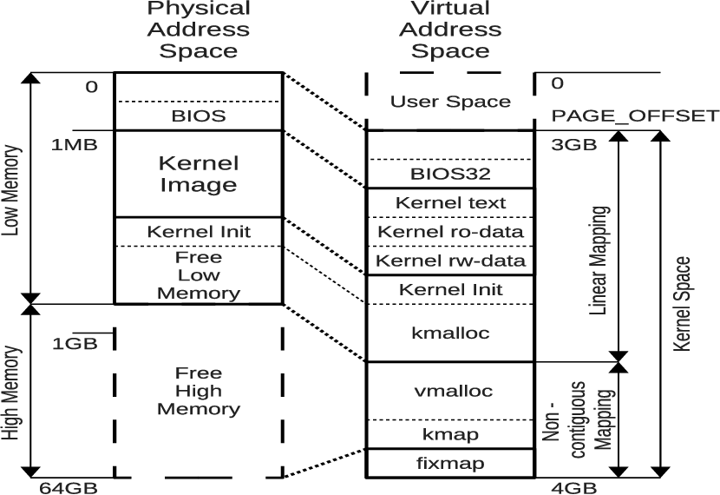

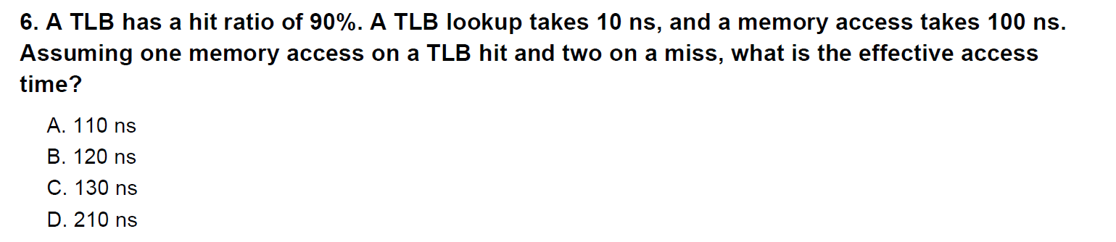

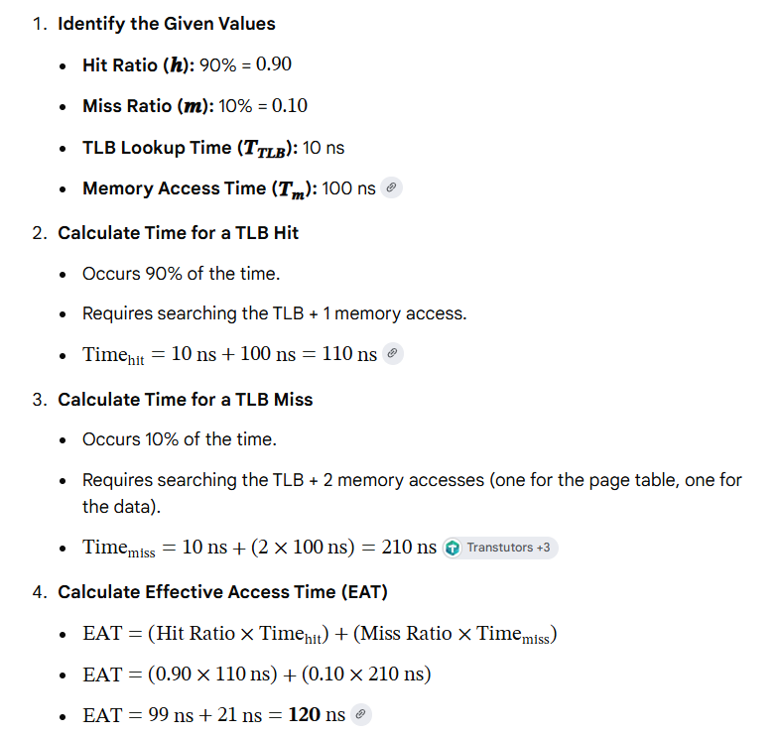

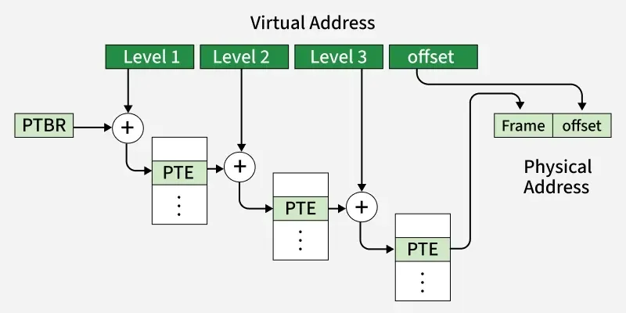

Device or IO Queue
Device queue contains the processes which are waiting for the completion of I/O request. Each device has its own device queue. Devices usually have device controller hardware and device driver software that work as part of the OS to control it. Many Device drivers have device queues in order to handle IO requests specific to the device. For example, if you type in a sentence using your keyboard, the sentence is received by controller and put on Input queue. This IO queue is read by a driver(part of OS) and put on an input queue. From input data queue, it is moved to the ready queue for CPU processing. The Input requests come from Keyboard, Mouse, touchscreen and other such devices. After CPU processing, output requests are sent to Output device.

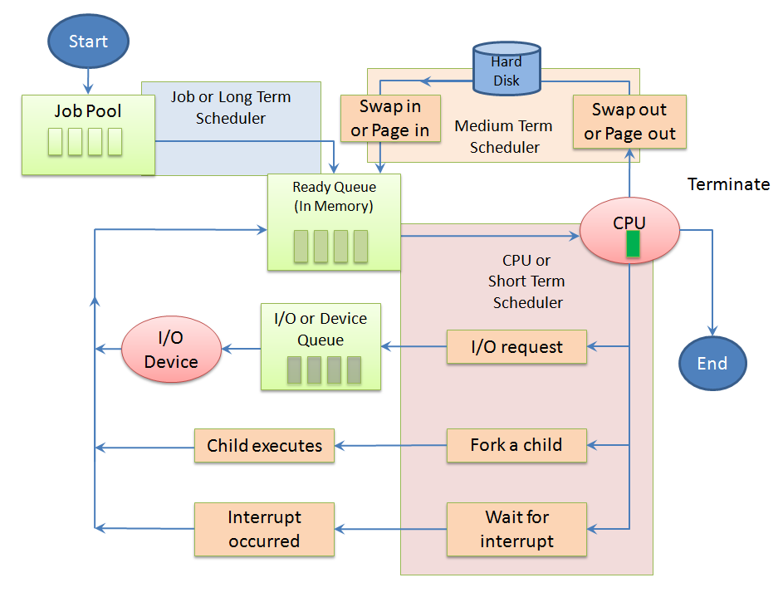Process Scheduling Queues

