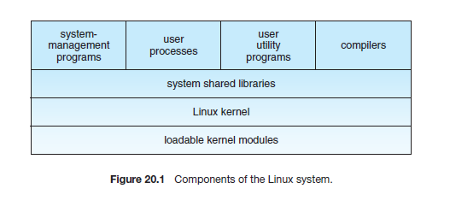
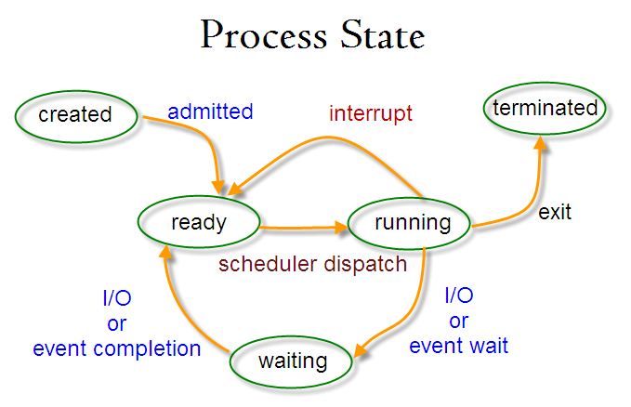
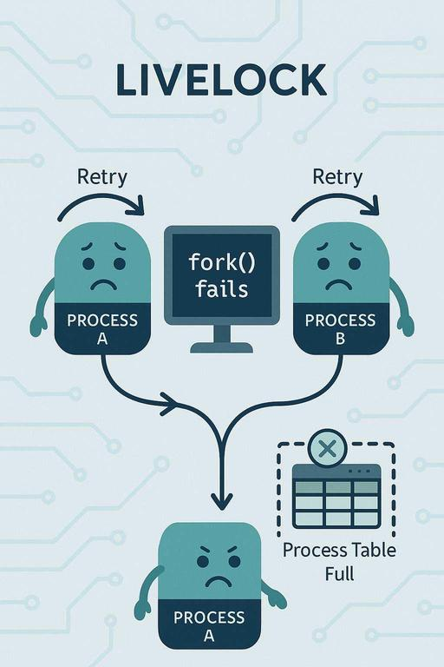
Note:The diagram illustrates a livelock scenario in an operating system where two processes (Process A and Process B) are actively trying to perform an action (fork()), but repeatedly fail because the process table is full.

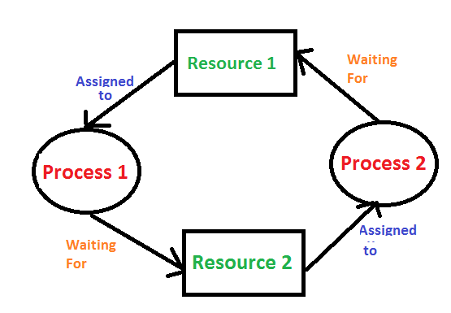
In an operating system, a deadlock occurs when a process or thread enters a waiting state because a requested system resource is held by another waiting process, which in turn is waiting for another resource held by another waiting process

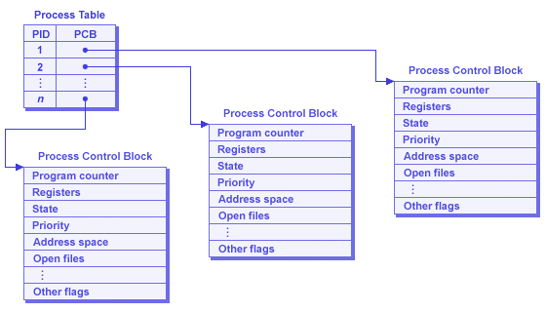
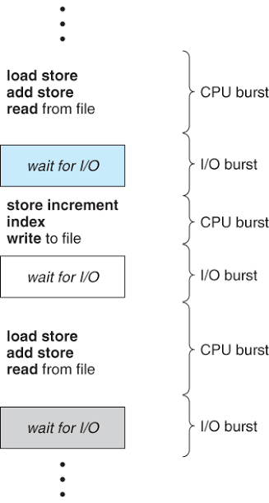
CPU Burst
a CPU burst is a period during which a process or program demands and actively utilizes the Central Processing Unit (CPU) for computation.
